**Credit Card Management System**

**Software Requirements Document**

**V 1.0**



|  |  |  |  |
| --- | --- | --- | --- |
|  | **Prepared By** | **Reviewed by** | **Approved By** |
| **Name** | Cognizant Academy |  |  |
| **Role** |  |  |  |
| **Signature** |  |  |  |
| **Date** |  |  |  |

Contents

1 Introduction 4

1.1 About this document 4

1.1.1 Purpose & Scope of the document 4

1.1.2 Intended Audience 4

1.2 About the Software System 4

1.2.1 Scope of the system 4

1.2.2 Exclusions 5

1.2.3 System Perspective 5

1.2.4 System Environment 5

1.2.5 Architecture diagram 5

1.2.6 Impact of the System 6

1.2.7 Assumptions, Risks / Constraints 6

1.2.8 Design Constraints – from the template 7

2 System Requirements 8

2.1 Functional Requirements –excel mapping 8

2.1.1 Customer Details Module 8

2.1.2 Bank Details Module 8

2.1.3 Apply/Cancel Module 9

2.1.3 Apply/Cancel Page 9

3 Make /Buy analysis 9

3.1 Reusable components 9

4 Terms & Conditions 9

5 Annexure 9

6 Appendix 10

5.1 Source file structure 10

5.2 Mapping document 10

5.3 Target creation script 10

7 Change Log 10

# Introduction

## About this document

### Purpose & Scope of the document

The purpose of the software requirements document is to systematically capture requirements for the project and the system “Credit Card System” to be developed. Both functional and non-functional requirements of this system are captured in this document. It also serves as the input for the project scoping.

The scope of this document is limited to addressing the requirements from a user, quality, and non-functional perspective. It is recommended that design aspects are not added in this document

### Intended Audience

Project Team

## About the Software System

The following section will cover aspects related to

Credit Card System (CCS) application. A **credit card** is a [payment card](http://en.wikipedia.org/wiki/Payment_card) issued to users as a system of [payment](http://en.wikipedia.org/wiki/Payment). It allows the cardholder to pay for goods and services based on the holder's promise to pay for them. **The Credit Card Products** will include the following fields that can be adjusted and viewed by the managers of the Bank:

The following are the modules in this proposed system

1. Customer Details.
2. Bank Details.
3. Apply/Cancel for Credit Card.

### Scope of the system

The scope of the system is explained through its modules as follows

* **Customer Details** -- This Module will be used by the Bank admin to register the existing Customer details into the system. The bank admin should have the details of the Customers to be entered into the system.
* **Bank Details** - This Module will be used by bank admin to enter the bank details received upon a request approval from admin. The system should then update the Customer details in the system along for the corresponding Customer.
* **Apply/Cancel for Credit Card:** The bank admin should be able to request for credit card or cancel the credit card.

### Exclusions

1. The system will operate only on the modules discussed above and will not include any additional functionality.

### System Perspective

The Credit Card System is an independent software system developed to manage the activities like Registering New Customer, approving or cancelling the request, etc. using the architecture.

### System Environment

### Architecture diagram

#### Physical Architecture:

A physical architecture is an arrangement of physical elements, (system elements and physical interfaces) that provides the designed solution for a product, service, or enterprise. It is intended to satisfy logical architecture elements and system requirements. Auto Identification Process follows a three layered architecture namely presentation layer, business logic layer and data access layer.

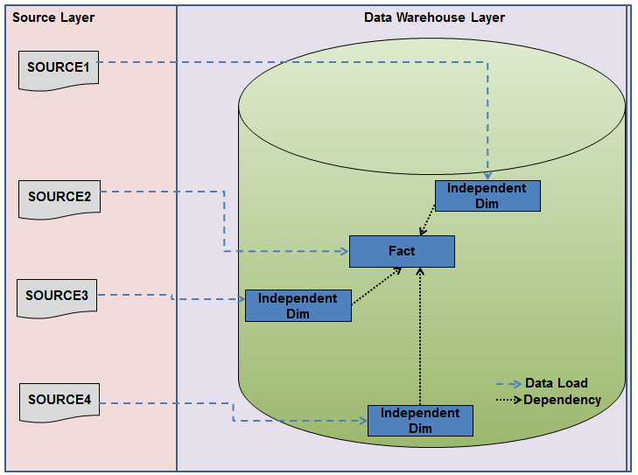

#### Logical Architecture:

The Logical Architecture defines the Processes (the activities and functions) that are required to provide the required [User Services](http://www.iteris.com/itsarch/html/user/userserv.htm). Many different [Processes](http://www.iteris.com/itsarch/html/pspec/pspecs.htm) must work together and share information to provide a User Service. The Processes can be implemented via software, hardware, or firmware. The Logical Architecture is independent of technologies and implementations.

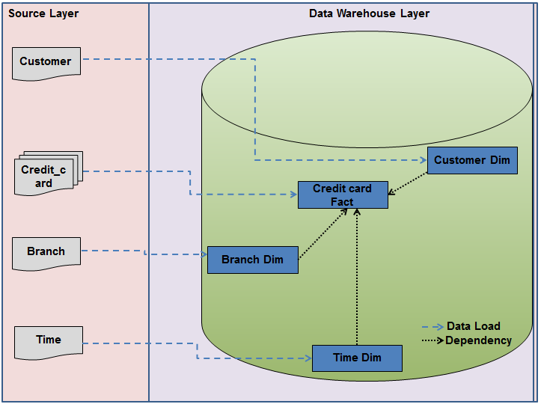

### Impact of the System

This is a new product which is developed for internal users. Expected impact of the product is to automate existing manual processes in order to make them more efficient and cost effective.

### Assumptions, Risks / Constraints

**Assumptions:**

1. The processing admin must possess prior knowledge on **Credit Card System** operations
2. The admin should have the details of the Customers to be registered for applying credit card updated into the system.

### Design Constraints – from the template

1. The customer details module and the Bank details modules should remain independent, without affecting **credit card System**.
2. Application should have single login feature. Login functionality should be the Welcome Page for the application.

# System Requirements

## Functional Requirements –excel mapping

### Customer Details Module

#### Customer Details

|  |  |
| --- | --- |
| Credit Card System  Req-2.1.1 | Customer Details |
| Functional Requirements | 1. To store credit card details of customers. 2. To fetch the card details of a customer. 3. To generate monthly bill for a credit card number. 4. To display the transactions made by a customer (daily, weekly, monthly basis). 5. To fetch customer details who have overdue. 6. To display customer details based on 7. Card type 8. Credit limit range 9. To check the credit card validity. |

### Bank Details Module

#### Bank Details

|  |  |
| --- | --- |
| Credit Card System  Req-2.1.2 | Bank Details |
| **Functional Requirements** | 1. To check for existing account details of a customer. 2. To verify the income of customer. 3. To display Account Information for a customer |

### Apply/Cancel Module

### Apply/Cancel Page

|  |  |  |
| --- | --- | --- |
| Credit Card System  Req-2.1.3 | | Apply/Cancel Page |
| **Functional Requirements** | 1.Verify the documents of the customer  2.Check with the criteria of customer details satisfying the conditions or not | |

# Make /Buy analysis

## Reusable components

# Terms & Conditions

GenCs shall be solely responsible for all its acts and omissions under this program. GenCs will comply at all times with all applicable laws. GenCs shall not use Cognizant’s name, logo and trademark in any promotional materials or other communications with third parties without the prior written consent of Cognizant. Any materials used by GenCs in relation to program will not infringe the copyrights, trademarks, patents, trade secrets or other intellectual property rights, privacy or similar rights of any person or entity. GenCs agrees not to post, draw, make, display any content that is threatening, libelous, obscene, defamatory, abusive, pornographic, or advocates/encourages any conduct that could constitute a criminal offence or give rise to any civil liability. Cognizant its associates’ personal details including but not limited to name, address, contact number shall not be shared or forwarded to any third party, without prior written consent of Cognizant, its associates. All intellectual property provided by Cognizant as part of program shall be owned exclusively by Cognizant. Intern shall indemnify, defend and indemnify Cognizant its associates, officers, directors from and against any claims, demands, loss, damage, liability, causes of action, judgments, or costs and expenses of every nature (including attorney’s fees and expenses) incurred by Cognizant based on any claim that any breach of terms and conditions of this program.

# Annexure

NA

# Appendix

### 5.1 Source file structure



### 5.2 Mapping document



### 5.3 Target creation script



# Change Log

Please note that this table needs to be maintained even if a Configuration Management tool is used.

|  |  |  |  |  |
| --- | --- | --- | --- | --- |
| Version Number | Changes made | | | |
| V1.0 |  | | | |
| V1.1 | *<If the change details are not explicitly documented in the table below, reference should be provided here>* | | | |
| Page no | Changed by | Effective date | Changes effected |
|  |  |  |  |
|  |  |  |  |
|  |  |  |  |
|  |  |  |  |
| V1.2 | *<If the change details are not explicitly documented in the table below, reference should be provided here>* | | | |
| Page no | Changed by | Effective date | Changes effected |
|  |  |  |  |
|  |  |  |  |
|  |  |  |  |