MDS-UPDRS Phenotype Characterisation of Three Genetically Defined Subtypes of Parkinson’s disease

Abstract

Introduction

Methods

Subtype Definitions and Demographics
Overall, 536 participants were diagnosed with idiopathic PD in the PPMI dataset. From the 1237 PD patients in PPMI, 610 were idiopathic, indicating an absence of known genetic influences from genes such as LRRK2, GBA, or SNCA. Subtypes were defined by a genetic signal; thus, participants were removed (n = 74) if whole genome sequencing data was not available.
Subtypes are defined by a complex genetic signal. This signal is derived from individual genotypes and does not confer PD risk. Each subtype-A, B, or C—is characterised by a unique binary genetic signal with no overlap among the groups. Accordingly, each patient in PPMI was classified into one of these three subtypes.
Table 4.4, shows the demographic and disease characteristics at baseline of all patients and in each subtype. The PPMI population demographics reflect typical PD profiles, generally manifesting in the early 60s and predominantly affecting men more than women. The characteristics displayed in Table 4.4 also align with PPMI’s recruitment strategy such as patients being recruited at Hohn and Yahr stages I or II. No significant differences were noted in the demographics or disease characteristics across subtypes A, B, and C.
Table 4.4: Participant Demographics and Disease Status Characteristics at Baseline Overall and by Subtype.
Overall
Subtype
A
B
C
n Patients
536
110
267
159
Demographics
Age at Diagnosis
61
.
3
±
9
.
6
61
.
9
±
9
.
6
60
.
7
±
9
.
2 62
.
0
±
10
.
5
Sex (Male %)
63
%
63
%
65
%
62
%
Years of Education  Disease Status Characteristics at Baseline | 15.5±3 15.5±2.9 15.5±2.9 15.6±3.1
Age | 62.8±9.6 63.1±9.8 62.1±9.2 63.8±10.2
Hohn & Yahr | 1.4±0.7 1.37±0.7 1.38±0.7 1.43±0.7
MDS-UPDRS Total | 28.9±14.6 28.6±14.9 28.5±14.1 29.7±15.3
Part I | 4.52±3.42 4.53±3.04 4.42±3.61 4.69±3.35
Part II | 5.35±4.44 5.25±4.31 5.18±4.28 5.71±4.79
Part III | 19.1±10.5 18.8±10.7 19.0±10.1 19.4±11.2
MOCA | 27.0±2.41 26.9±2.43 27.2±2.18 26.7±2.71

Data Processing
Data was obtained from the publicly available PPMI resource (Marek et al., 2018). The PPMI study tracks the clinical symptoms of PD patients at bi-yearly intervals. Patients in PPMI are recruited at a common pseudo-start time point, defined by a diagnosis with PD for two years or less, prior to taking any PD medication, the expectation not to require PD medication for a period of at least 6 months, a Hohn and Yahr stage of I-II, and the development of at least one motor symptom of PD (Marek et al., 2018). Only idiopathic PD patients were included in the analysis. Patients with monogenic forms of PD were removed to reduce heterogeneity and the potential noise associated with known genetic alterations.
The clinical measurements obtained from PPMI were; MDS-UPDRS, Schwab and England Activities of Daily Living, a Motor Function Questionnaire, Upper and Lower Extremity Function Questionnaires, Montreal Cognitive Assessment (MOCA), Hopkins Verbal Learning Test, Trail Making Tests A & B, Letter Number Sequencing Exam, Digital Symbol Exam, Semantic
Fluency Exam, Boston Naming Test, Lexical Fluency Exam, SCOPA, State Trait Anxiety, Epworth Sleepiness Scale, REM Sleep Behaviour Test, Cognitive and Communication Neurological Quality of Life Tests. These measurements assess a broad spectrum of symptoms encompassing, motor, non-motor, autonomic and other aspects of PD.
Interpolated imputation was performed on each clinical measure. Measures were imputed if at least one corresponding measurement existed within a six-month window surrounding the time point of interest. Where only a single measure was found, it was duplicated; where multiple measures existed, the mean value was used for imputation. Many measures exhibited a zero-inflated binomial distribution with predominantly low scores, as per Figure 4.3. For all measurements, the square root transformation of scores was performed, improving conformity to the normal distribution requirements of OLS regression.
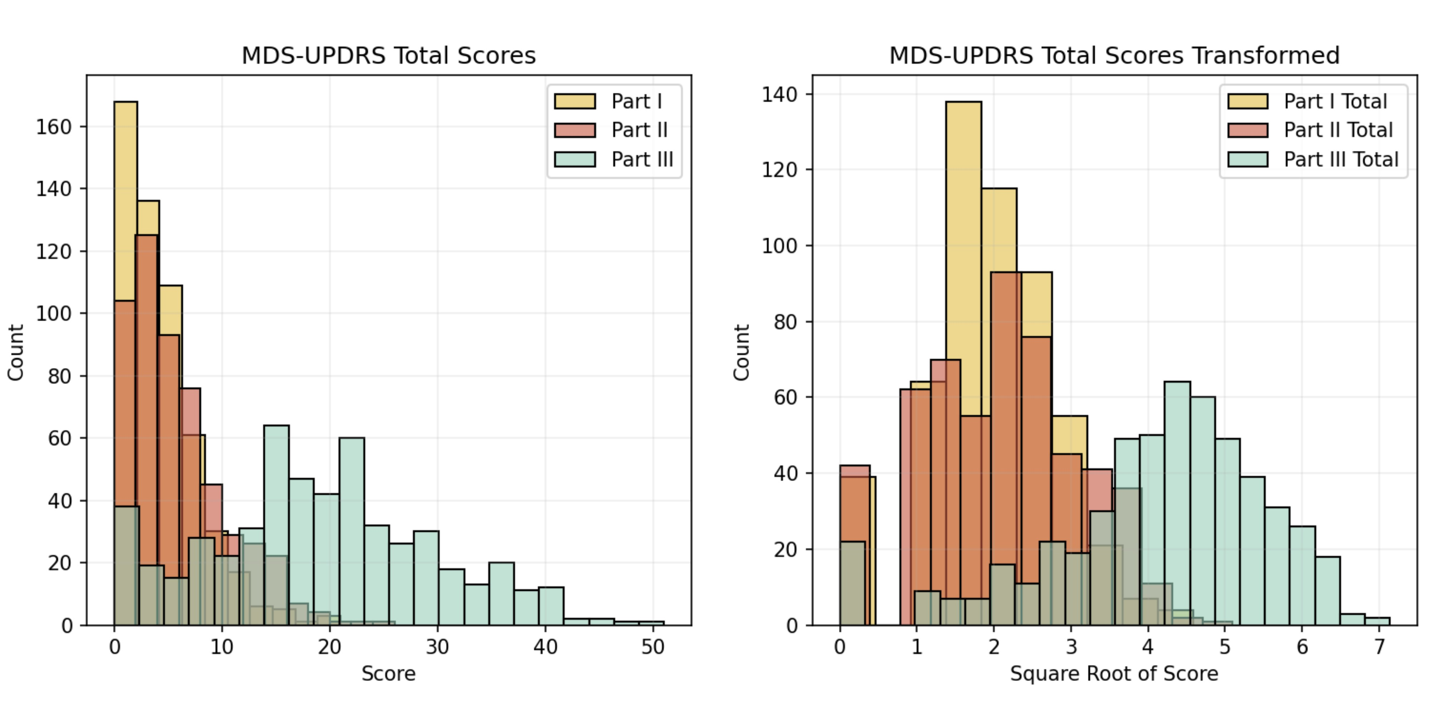
Figure 4.3: Square Root Transformation Applied to Parts I, II, and III of the MDS-UPDRS. The figure illustrates the distribution of values before (left) and after (right) the transformation. Each transformation results in a more pseudo-normal distribution of the measurements.
Genomic modalities of mRNA, DNAm, and CSF were obtained for the multi-omic classification of subtype characteristics. Aside from CSF, the genomic data from PPMI were generated from blood samples. These modalities were chosen as they encompass numerous biomarkers related to PD (Redenšek et al., 2018; Wüllner et al., 2016). Genomic modality samples were available annually up to three years post-baseline in the PPMI dataset. The most recent time point at which a patient’s sample was available was selected for use. If a patient had a sample in one omic type at the final time point but lacked a sample in another, the MOGDx framework’s capability to handle partial data was used, rather than resorting to an earlier sample. This approach ensured that each patient’s samples across different omic types were aligned to a common time point.
Table 4.5: Overview of mRNA, CSF, and DNAm data availability for the classification of PD patients.
 | Raw Features | Processed  Features |  | n Patients
 |  |  | Subtype A | Subtype B Subtype C | Total
mRNA | 52338 | 19829 | 80 | 202 108 | 390
DNAm | 314058 | 300000 | 41 | 109 60 | 210
CSF | 5279 | 4785 | 78 | 193 104 | 375
The genomic data availability in PPMI for the three subtypes is presented in Table 4.5. Of the 536 PD individuals, only 390 unique individuals have a corresponding genomic sample. The mRNA gene expression measure has full coverage, while the CSF and DNAm only have partial coverage, highlighting the requirement for a methodology which can account for missing data. Each modality was processed prior to classification as described in Section B.1.

Results

Discussion

References

