Calendar effects in Chinese stock market
Lei Gaoª and Gerhard Kling^{b}
a Nanjing University of Information Science & Technology, b University of Southampton
THIS IS NOT THE FINAL (POST-REVIEW) VERSION
YOU FIND THE FINAL VERSION HERE:

Gao, L. and G. Kling (2005) Calendar effects in Chinese stock market, Annals of Economics and Finance 6(1), 75-88.
Our paper examines the calendar effects in Chinese stock market, particularly monthly and daily effects. The Shanghai Stock Exchange exhibits significantly higher monthly returns in February and November. This can be explained by the fact that the Chinese year-end is in February. Using individual stock returns, we observe the change of the calendar effect over time. In Shanghai, the year-end effect was strong in 1991 – but disappeared later. Studying weekly effects, we found that Fridays are profitable. Chinese investors are “amateur speculator” who often embezzles business fund for private trading; thus, these funds have to be paid back before weekends.

JEL Classification: K22, G28, C22
Key words: year-end effect, China, anomalies, tax-loss selling

1. Introduction
Capital market efficiency has been a very popular topic for empirical research since Fama (1970) introduced the theoretical analysis of market efficiency and proclaimed the Efficient Market Hypotheses. Subsequently, a great deal of research was devoted to investigating the randomness of stock price movements for the purpose of demonstrating the efficiency of capital markets. Since then, all kinds of calendar anomalies in stock market return have been documented extensively in the finance literature. The most common calendar anomalies are the January effect and the day of the week effect. Showing that market returns follow a seasonal pattern violates the assumption of weak market efficiency in that by observing the past development of returns market participants can make extraordinary profits. Accordingly, Haugen and Jorion (1996) suggested that calendar effects should not be long lasting, as market participants can learn from past experience. Hence, if the monthly effect exists, trading based on exploiting a monthly pattern of returns should yield extraordinary profits – at least for a short time. Yet such trading strategies affect the market in that further profits should not be possible: the calendar effect should break down. Nevertheless, Haugen and Jorion (1996) found that the January effect still exists. Changes of calendar effects over time are of major interest for our paper.
The literature on monthly effects, generally, confirmed the January and year-end effect, which is related to tax-loss selling strategies and behavioral aspects. Rozeff and Kinney (1976) demonstrated that stock returns of the US stock markets are in the first month of the year significantly larger compared to other months. Other major capital markets in developed countries exhibit similar calendar effects: Officer (1975) focused on the Australian Stock Exchange; Tinic, Barone-Adesi and West (1990) on the Canadian market; Aggarwal, Rao and Hiraki (1990) on the Tokyo Stock Exchange; Barone (1990) on the Italian market and Lewis (1989) analyzed stocks listed on the London Exchange. The literature on the so-called disposition effect – that losers are hold too long and winners are sold to early – also refers to a year-end effect (see Odean, 1998). One explanation of the higher returns in January is the tendency to realize losses in December to reduce the taxable speculation gains. Another effect is window dressing, which is related to institutional trading. To avoid reporting to many losers in their portfolios at the year-end, institutional investors tend to sell losers in December. They buy these stocks after the reporting date in January to hold their desired portfolio structure again. This yields higher returns in January compared to other months. Due to the fact that taxation of capital gains is common in all developed countries, China can act as a counter example in that capital gains are free of taxes. Hence, tax motivated selling should not be observable on the Chinese stock exchanges in Shanghai and Shenzhen. Furthermore, the Chinese year-end is in February, and institutional trading is less important compared to other stock markets. Consequently, the above-mentioned explanations for the year-end effect do not apply to the Chinese stock market. Finding a year-end effect in the case of China would contradict the former explanation concerning the year-end effect. Our paper tries to find or reject the year-end effect using Chinese stock market data. Henceforth, we contribute to understanding the year-end phenomenon.
There is also a large body of literature on the day of the week effect of stock returns. Cross (1973) found that the mean return on Friday was higher than the mean return on Monday of the S&P 500 Index during the period from 1953 to 1970. This effect is usually called the weekend effect. French (1980) who also investigated the S&P 500 index verified this finding for the period from 1953 to 1977. Later, Gibbons and Hess (1981) and Smirlock and Starks (1986) reported similar results. The day of the week effect is also observed in stock markets of other countries. Jaffe and Westerfield (1985) examined the weekend effect in Australian, Canadian, Japanese and UK equity markets, and found that the lowest mean returns for both Japanese and Australian stock markets were on Tuesdays. Solnik and Bousquet (1990) also demonstrated a strong and persistent negative return on Tuesday in the case of the Paris Bourse. Barone (1990) confirmed these results that identified the largest decline in Italian stock prices mostly on Tuesday. Afterwards, Agrawal and Tandon (1994), Alexakis and Xanthakis (1995), and Balaban (1995) showed that the distribution of stock returns varies dependent on the respective day of the week for various countries. Moreover, the day of the week patterns are present in other US financial markets including the T-bill market (Flannery and Protopapadakis, 1988), the commodity and stock futures markets (Cornell, 1985; Dyl and Maberly, 1986; Gay and Kim, 1987). In brief, the day of the week effect is a common phenomenon across different countries and different types of markets. The special features of the Chinese stock market make an investigation of the day of the week effect promising. Especially, the speculative behavior and the dominance of small shareholders could affect the day of the week effects.
The purpose of our paper is to investigate the calendar effects in Chinese stock market; thereby, using index data and individual stock returns of the Shanghai and Shenzhen stock exchanges. Besides providing a somewhat static picture on the calendar effects, which has not been done thoroughly thus far, we study the change of calendar effects over time. As Haugen and Jorion (1996) pointed out that one should expect that calendar effects are short-term phenomena due to the learning of market participants. If investors based on past experience are aware of calendar anomalies and can run trading strategies, such effects should disappear over time. The rest of the paper is organized as follows. Part 2 introduces the data sets and discusses the use of individual and market index data for analyzing the current calendar effects and their change over time. Part 3 takes up the monthly effects; hereby, we start with a descriptive analysis followed by regression analyses and estimates for the change of monthly effects over time. The empirical findings for the day of the week effect follow. Then, section 5 proposes explanations for calendar anomalies in the Chinese stock market. Finally, concluding remarks summarize our main findings.

2. Data
To analyze monthly and daily effects in stock returns, we use the market index of the Shanghai and Shenzhen stock exchanges, which is common in the literature. However, to measure the changes of calendar anomalies over time relying on index data is insufficient due to data availability. Obviously, having at best 13 observations for every months since the reopening of the stock exchanges in the 1990s makes it a risky venture to estimate changes of monthly effects over the 13 years. Hence, we use in addition individual stock returns of all stocks listed on both exchanges since the restart of security trading in China. This increases the number of observations dramatically, and one obtains precise estimates for the shift of monthly patterns over time.

3. The monthly effect in both Chinese stock exchanges
3.1. Descriptive statistics
Descriptive statistics of market returns for different months show that – on a first glance – monthly effects are nearly negligible. Table 1 summarizes the average returns as well as the upper and lower boundaries of a 95% confidence interval. When we look at the whole period from 1990 to 2002, the confidence intervals of average monthly returns include in all cases the zero return. Therefore, a clear positive or negative effect cannot be confirmed. Nevertheless, two points are worth mentioning: we just have 12 years and, hence, at best 12 observations for every month; strong assumptions like no serial dependency are required to derive the confidence intervals. The subsequent section deals with the latter issue by using more elaborate techniques, namely regression analyses and ARIMA models. To overcome the problem concerning the low number of observations, individual monthly stock returns of all listed companies are used. Furthermore, this increase in the number of observations allows estimating the shifts of the monthly pattern over time.

3.2. Regression analysis
The starting point of our analysis is the hypothesis of an efficient market; hence, randomness of returns can be assumed. Accordingly, we state that market returns follow a geometric random walk that is that the logarithmic market indices follow a random walk. The first difference, namely the market returns of stock exchange i at time t labeled r_{it}, are stationary processes. Inserting a set of dummy variables denoted d_{j} controls for monthly effects. Note that we always use July as reference month.
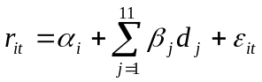 | (1)
If the efficient market hypothesis were true, one would expect that monthly effects do not exist. Hence, we test the joint hypothesis that all coefficients β_{j} are jointly not significantly different from zero. Applying the Huber-White sandwich estimator, one obtains robust t-values in the presence of heteroscedasticity, which we can confirm for
both stock exchanges based on the Cook-Weisberg test procedure. OLS with robust standard errors estimates the regression equation (1) for both stock exchanges. Based on the inspection of autocorrelation (ACF) and partial autocorrelation functions (PACF) for both market returns, one can justify an AR (1) process for both exchanges. In the case of Shenzhen, an additional moving average component could be included. Maximum-likelihood estimation procedures provide outcomes for these ARIMA specifications – but as reported in table 2 – calendar effect can only be observed in the case of the Shanghai Stock exchange. Februaries and November exhibit significantly positive returns compared to other months. Finding an impact of the month February points to the fact that the year-end effect might be shifted to February due to the Chinese calendar. Despite finding significant coefficients for individual months, joint hypothesis tests for both exchanges indicate with an F-value of 1.39 (p-value: 0.185) for Shanghai and an F-statistic of 0.98 (p-value: 0.517) that one can stick to the efficient market hypothesis.
Based on these empirical findings, one can state that there is a weak evidence for an effect in February, which could be explained by the Chinese year-end. Yet joint hypothesis tests stress that monthly effects cannot be confirmed for both exchanges. As already mentioned above, this finding might be due to the fact that only 13 observations of each month are available. Even worse, the structure of the monthly pattern might undergo a considerable change from the reopening of the exchanges to 2002. By using information on individual stock returns of all stocks listed on the Shanghai and Shenzhen stock exchanges, we try to escape this trap by increasing the number of observations tremendously.

3.3. The change of calendar effects over time
To obtain more precise estimates concerning the monthly pattern of stock returns and to analyze the change of this pattern over time, individual data on stocks from 1990 to 2001 is used. In the case of Shanghai, 34790 monthly returns are available, while 29797 observations are received from the Shenzhen stock market.
The starting point of our analysis is the same regression equation as used for analyzing the market returns. Note that we allow individual effects in returns in that intercepts might vary across stocks. Besides regressing equation (1), we try to approximate the non-linear monthly time pattern by a Taylor expansion. The first step is specifying the variable month denoted m that takes values between one and twelve. Then, the squared or cubic variable labeled m² and m³, respectively, are calculated. The set of dummy variables in equation (1) is replaced by sufficient number of powers of the variable month. Note that the index i now stands for individual stocks.
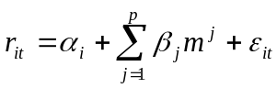 | (2)
Ramsey RESET test indicates the appropriate highest power of the variable month. For both exchanges a model with the power three is sufficient to capture all non-linearities. To compare the results obtained by running regression equation (1) for individual stocks and by estimating the approximation expressed in model (2), figure 1 plots the predicted monthly pattern for Shanghai for both approaches. The approximation has two major advantages compared to working with a set of dummy variables: first, the degrees of freedom are higher, as fewer coefficients have to be estimated; second, the approximation is less dependent on extreme observations that might affect a single coefficient of a dummy variable more severely; third, specifying a reference month is not required if one relies on the approximation. Hence, one obtains a stylized picture about the monthly time pattern. Note that the first advantage, namely more degrees of freedom, becomes vital when we want to insert interaction terms with the years from 1990 to 2001. This is relevant to estimate the shift of the monthly time pattern over the eleven years, which is our major aim. Inspecting figure 1 shows that both approaches come to similar results. We observe that the average returns decline from March/April to December. Hence, we cannot confirm a positive year-end effect for the Shanghai stock exchange, when we base our models on individual data. In light of the advantages inherent with the approximation, we thereafter concentrate on model (2) to uncover the change of the monthly time pattern.
To quantify the changes of the monthly pattern over time, the model (2) is extended by interaction term that permit a shift in intercepts and in slope coefficient. Consequently, the approximated monthly time pattern can change its shape over the period 1990 to 2001. As the insufficient number of observations, does not allow estimating the approximated line for 1990, figure 2 compares the outcomes of 1992 with the most recent data of 2001. Note that this figure plots the fitted curves for the Shanghai stock exchange. Figure 3 does the same for the Shenzhen stock market. The picture is quite similar for both exchanges and also fits to our former estimates based on market indices. Positive returns are observable in the beginning of the year – around the Chinese New Year in February. The returns decline during the year considerably and reach their lowest values in December. The interesting part of our empirical finding, however, is not this static estimation of a special Chinese year-end effect, which is shifted towards February or March, but the estimates of the shift regarding the monthly time pattern. In the case of both exchanges, we found strong evidence that the monthly time patterns becomes more and more flat. Particularly, in the year 2001 nearly no calendar effect can be recognized. This is true for both stock exchanges. Hence, one can state that market participants learnt from their past experience and used the chances inherent with strong monthly patterns at the beginning of the 1990s. Caused by their trading behavior and the entrance of new market participants and larger players like institutional investors, the time pattern disappeared within one decade. Based on our tested joint hypotheses in the previous section and underlined by the estimated curves of the time pattern, one can state that Chinese stock exchanges are closer to the efficient market hypothesis as one might expect.

4. The day of the week effect in Chinese stocks’ returns
Working with daily data from the Shanghai Stock Exchange, we try to identify the day-of-the-week effect for the Chinese stock market. As more than one decade is covered, we have in total 3161 trading days. Hereby, one knows the opening, daily minimum and maximum, as well as the closing price of the market index. Based on that, market returns can be calculated to observe differences of returns during the week. Figure 4 plots the 95% confidence interval for the average daily market return on the respective days. We found a similar pattern compared to previous studies on other stock markets. Mondays are weak trading days compared to the rest of the week; however, only Fridays exhibit significant results. On Fridays the average market return tends to be positive. Generally, the time pattern shows an increase in average returns over the week. Accordingly, we can confirm a considerable deviation of the Chinese stock exchange from its peer markets in that respect. In other markets, Mondays exhibit higher returns compare to the rest of the week. Several studies attempted to explain the day-of-the-week effect. Among them, French (1980) proposed the calendar time hypothesis that states that Monday returns should be higher than other weekdays returns; Gibson and Hess (1981) and Lakonishok and Levi (1982) emphasized the delay between trading and settlements in stocks; Gibson and Hess (1981) and Keim and Stambaugh (1984) argued that measurement errors might affect the results. Despite finding a different weekly pattern in the case of China, one should stress that monthly effects are by far more relevant for determining market returns. The magnitude of weekly effects is rather low, as even on Fridays the lower boundary of the confidence interval reaches 0.17% and is just slightly above zero.

5. Explanation of Calendar effects in Chinese stock market
The existence of calendar or time anomalies denies the Efficient Market Hypothesis, which states there is no identifiable short-term time-based pattern in stock returns and investors cannot predict future market movements by utilizing past information. The monthly effect and the day of the week effect are particularly puzzling, as they usually do not disappear, despite many traders attempt to take advantage of them in advance after they were reported and publicized about two decades ago. We found that the extent of the calendar effect considerably flattened over time in China. Furthermore, the effect is shifted to the Chinese year-end in February. Hence, the February plays the same role as the December for U.S. or European investors. After the year-end, namely in March and April, average returns are by far higher compared to other months. As mentioned above, the calendar effect in China is not due to tax-loss selling, as there are no taxes on capital gains.
One explanation for the observed daily and monthly time patterns might be the fact that Chinese stock investors are “amateur speculator” who often embezzles business fund for private trading. Consequently, Chinese speculators have to lay the embezzled funds back before weekends, yearends and the Spring Festivals that are usually in February. Hence, it seems to be reasonable to engage in short-term trading for one or two days shortly before the weekend. This might explain the observed weekly pattern that considerable profits can be made shortly before the weekend starts. Correspondently, the Chinese stock market reaches its peaks shortly before the money is withdrawn, namely on Fridays. Considering the monthly effects, one has to argue that it is likely that the money is withdrawn close to the Chinese year-end in February and afterwards additional money flows into the market. This could justify the observed monthly pattern showing higher returns in spring compared to the month before the Chinese year-end.

6. Conclusion
The Chinese stock market exhibits daily and monthly calendar effects; thereby, the results differ from finding obtained from other stock markets in the world. In addition, China differs in two major aspects related to calendar effects, from other markets: the year ends in February, so one should not expect a January effect; tax-loss selling is irrelevant, as there are no taxes for capital gains. Especially, lacking taxes and the minor role of institutional trading in China extinguish two main justifications for monthly calendar effects. Hence, finding monthly patterns in China would require additional explanations and might serve as a hint that former explanations cover just a part of the story.
Using data from the Shanghai and the Shenzhen stock exchange, we found in both cases a monthly pattern of market returns. Hereby, the highest returns can be achieved after the Chinese year-end in February. This is, accordingly, a similar finding like the January effect for countries in which the year ends in December. In addition, data on individual stock returns for both exchanges revealed that the time pattern underwent a considerable change over time. In contrast to Haugen and Jorion (1996), market participants seemed to be able to learn from past experience in that they used trading strategies to exploit the calendar anomalies. Due to these trading activities, the pattern flattened over time. Based on our empirical finding, the Efficient Market Hypothesis can be confirmed at least for the current period, as long as we focus solely on calendar anomalies.
It is striking that the day-of-the-week effect follows a different pattern compared to other market, as Mondays are considerably weak and Fridays show significantly positive average returns. Yet the daily effect possesses a minor magnitude and relevance for determining average returns compared to monthly effects. A possible explanation for this phenomenon might be that Chinese “amateur speculators” engage in short term lending before the weekend and invest on the stock exchange. After these trades, the funds are paid back. This explanation is somehow a guess – but it fits to our empirical findings and such speculations – based on narrative evidence – occur regularly in China.

Reference
Alexakis, P. and Xanthakis M., 1995, Day of the week effect on the Greek stock market. Applied Financial Economics 5, 43-50.
Aggarwal, R.; Hiraki, T. and R. P. Rao, 1990, Regularities in Tokyo Stock Exchange security returns: P/E, size, and seasonal influences. Journal of Financial Research 13, 249-263.
Agrawal, A. and K. Tandon, 1994, Anomalies or illusions? Evidence from stock markets in eighteen countries. Journal of International Money and Finance 13, 83-106.
Balaban, E., 1995, Day of the week effects: New evidence from an emerging market. Applied Economics Letters 2, 139-143.
Barone, E., 1990, The Italian stock market: Efficiency and calendar anomalies. Journal of Banking and Finance 14, 483-510.
Cornell, B., 1985, The weekly patterns in stock returns cash versus futures: A note. Journal of Finance 40, 583-588.
Dyl, E., 1977, Capital gains taxation and year-end stock market behavior. Journal of Finance 32, 165-175.
Dyl, E. and E.D. Maberly, 1986, The anomaly that isn’t there: A comment on Friday-the thirteenth. Journal of Finance 43, 1285-1286.
Fama, E.F., 1970, Efficient capital markets: A review of theory & empirical work. Journal of Finance 25, 383-417.

Flannery, M.J. and A.A. Protopadakis, 1988, From T-Bills to common stocks: Investigating the generality of intra-week return seasonality. Journal of Finance 43, 431-450.
French, K., 1980, Stock returns and the weekend effect. Journal of Financial Economics 8, 55-69.
Gay, G. and T. Kim, 1987, An investigation into seasonality in the futures market. Journal of Futures Market 7, 169-181.
Gibbons, M. and P. Hess, 1981, Day of the week effects and asset returns. Journal of Business 54, 579-596.
Gompers, P.A. and M. Andrew, 2001. Institutional investors and equity prices. Quarterly Journal of Economics 116, 229-259.
Haugen, R. and P. Jorion, 1996, The January effect: Still there after all these years. Financial Analysts Journal 52, 27-31.
Jaffe, J. and R. Westerfield, 1985a, The week-end effect in common stock returns: The international evidence. Journal of Finance 40, 433-454.
Jaffe, J. and R. Westerfield, 1985b, Patterns in Japanese common stock returns. Journal of Financial and Quantitative Analysis 20, 261-272.
Keim, D.B. and R. F. Stambaugh, 1984, A further investigation of the weekend effect in stock returns. Journal of Finance 39, 819-835.
Kling, G. and Gao, L., 2004, Do Chinese institutional investors act like institutional investors. Working Paper.
Lakonishok, J.; Shleifer, A.; Thaler, R. and r. Vishny, 1991. Window dressing by pension fund managers. American Economic Review 81, 227-231.
Lewis, M., 1989, Stock market anomalies: A re-assessment based on the U.K. evidence. Journal of Banking and Finance 13, 675-696.
Odean, T., 1998, Are investors reluctant to realize their losses? Journal of Finance 53, 1775-1798.
Officer, R.R., 1975, Seasonality in Australian capital markets: Market efficiency and empirical issues. Journal of Financial Economics 2, 29-52.
Rozeff, M.S. and W.R. Kinney, 1976, Capital market seasonality: The case of stock market returns. Journal of Financial Economics 3, 376-402.
Shefrin, H. and M. Statman, 1985, The disposition to sell winners too early and ride losers too long: Theory and evidence, Journal of Finance 40, 777-790.
Smirlock, M. and L. Starks, 1986, Day of the week and intraday effects in stock returns. Journal of Financial Economics 17, 197-210.
Solnik, B. and L. Bousquet, 1990, Day of the week effect on the Paris Bourse. Journal of Banking and Finance 14, 461-468.
Tinic, S.M.; Barone-Adesi, G. and R.R. West, 1987, Seasonality in Canadian Stock Prices: A Test of the ‘Tax-Loss Selling’ Hypothesis. Journal of Financial and Quantitative Analysis 22, 51-64.
Table 1
Descriptive monthly statistics on average returns and their confidence intervals
All values are in percentage points. The average monthly return plus or minus two times the standard deviations forms the confidence intervals.
 | Shanghai |  |  | Shenzhen
Months | Lower | Mean | Upper | Lower | Mean | Upper
January | -9.46 | -3.94 | 1.57 | -9.70 | -4.14 | 1.42
February | -4.87 | 3.98 | 12.84 | -5.49 | 1.34 | 8.17
March | -0.77 | 3.38 | 7.53 | -2.49 | 2.66 | 7.82
April | -8.70 | 0.35 | 9.41 | -4.27 | 3.55 | 11.37
May | -4.07 | 5.41 | 14.89 | -5.05 | 7.70 | 20.45
June | -12.53 | 8.17 | 28.87 | -5.46 | 2.61 | 10.69
July | -4.97 | 3.49 | 11.94 | -9.15 | 0.03 | 9.21
August | -13.33 | -5.90 | 1.53 | -12.46 | -4.78 | 2.89
September | -10.60 | 6.60 | 23.80 | -10.25 | 0.81 | 11.86
October | -6.34 | -2.07 | 2.21 | -6.36 | -2.42 | 1.52
November | -11.40 | -2.91 | 5.58 | -9.50 | 4.46 | 18.42
December | -1.16 | 6.68 | 14.53 | -2.71 | 1.64 | 6.00

Table 2
OLS regressions and ARIMA models with monthly effects
We estimated simple OLS regressions; hereby, robust p-values are reported applying the Huber-White sandwich estimator. This makes the inference robust against detectable heteroscedasticity. The ARIMA specifications stem from inspecting ACF and PACF plots, and Maximum-Likelihood estimation provides the results.
 | Shanghai Stock Exchange |  | Shenzhen Stock Exchange
Variables | OLS | AR(1) | OLS | AR(1) | ARMA(1,1)
Constant | -0.0590 (0.115) | -0.0590  (0.107) | -0.0478  (0.216) | -0.0478  (0.202) | -0.0478  (0.208)
January | 0.0983  (0.090) | 0.0990  (0.081) | 0.0612 (0.236) | 0.0609  (0.228) | 0.0608  (0.231)
February | 0.0928  (0.031) | 0.0928  (0.029) | 0.0745 (0.110) | 0.0742  (0.092) | 0.0745  (0.097)
March | 0.0625  (0.288) | 0.0626  (0.268) | 0.0833  (0.131) | 0.0826  (0.132) | 0.0835  (0.138)
April | 0.1131  (0.063) | 0.1131  (0.049) | 0.1248  (0.095) | 0.1218  (0.072) | 0.1224  (0.074)
May | 0.1407  (0.203) | 0.1408  (0.180) | 0.0740  (0.187) | 0.0740  (0.137) | 0.0740  (0.157)
June | 0.0939  (0.098) | 0.0939  (0.095) | 0.0482  (0.423) | 0.0482  (0.323) | 0.0482  (0.329)
August | 0.1250  (0.185) | 0.1250  (0.165) | 0.0559  (0.408) | 0.0560  (0.363) | 0.0559  (0.367)
September | 0.0383  (0.373) | 0.0384  (0.371) | 0.0236  (0.586) | 0.0236  (0.560) | 0.0236  (0.587)
October | 0.0299  (0.597) | 0.0299  (0.587) | 0.0924  (0.249) | 0.0924  (0.234) | 0.0924  (0.226)
November | 0.1258  (0.022) | 0.1258  (0.015) | 0.0643  (0.149) | 0.0643  (0.139) | 0.0643  (0.145)
December | 0.0196  (0.673) | 0.0196  (0.668) | 0.0064  (0.892) | 0.0064  (0.891) | 0.0064  (0.893)
AR(1) | - | -0.0607  (0.107) | - | 0.2214  (0.008) | -0.0598  (0.968)
MA(1) | - | - | - | - | 0.2889  (0.846)
Observations | 132 | 132 | 128 | 128 | 128
R² | 0.07 | - | 0.06 | - | -
Figure 1
Predicted monthly time pattern using a set of dummies or an approximation
This graph combines the outcomes of a standard regression with dummy variables for month and an approximation as described in model (2). The predicted values of both approaches show a similar pattern.
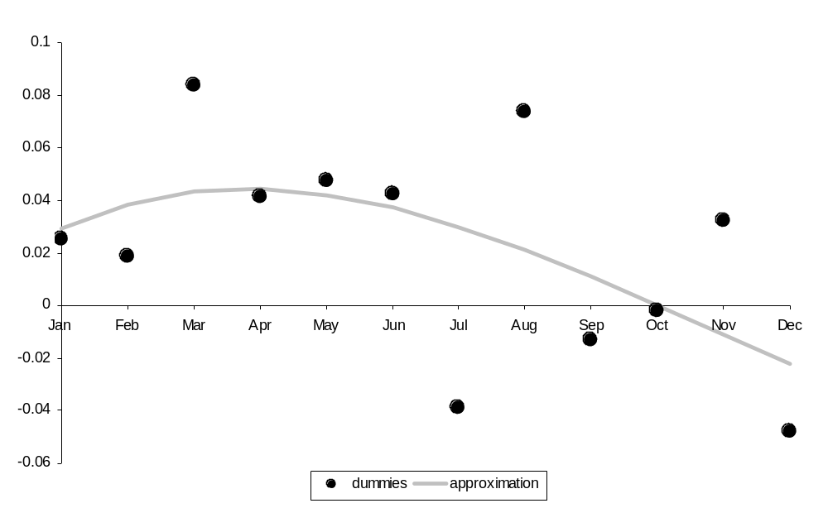

Figure 2
The fitted monthly time pattern in Shanghai in 1992 and 2001
We estimate the model (2) for the year 1992 and 2001 and depict the approximated monthly time pattern for both years.
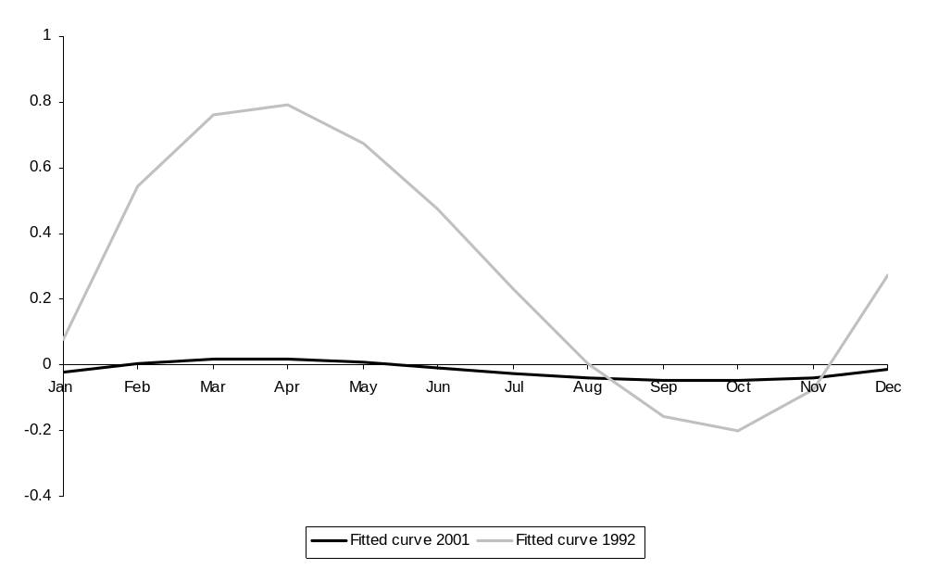

Figure 3
The fitted monthly time pattern in Shenzhen in 1992 and 2001
We estimate the model (2) for the year 1992 and 2001 and depict the approximated monthly time pattern for both years. Due to the fact that we have just 30 observations for 1991, the year 1992, which has 170 observations, serves as reference point.
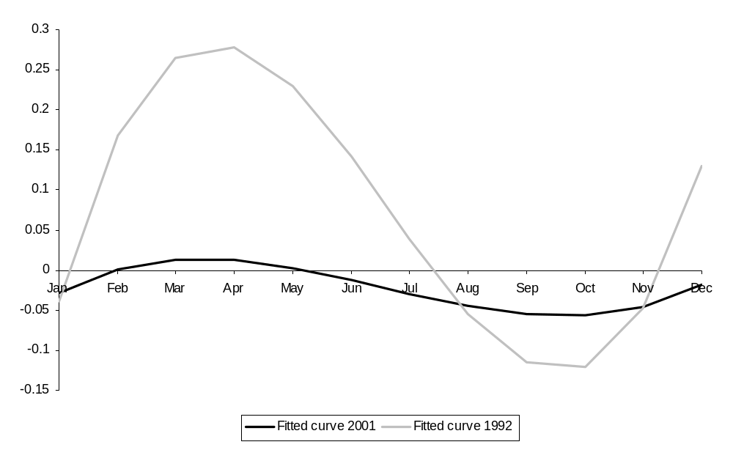
Figure 4
Daily average returns for Shanghai and boundaries of a 95% confidence interval
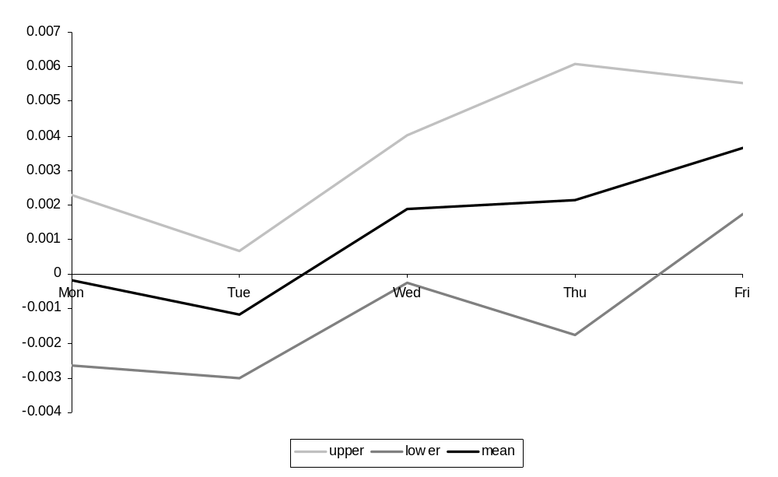

Shefrin and Statman (1985) introduced the term disposition effect.
Among others Dyl (1977), Gompers and Andrew (2001), and Lakonishok et al. (1991) stressed the importance of the taxation and window dressing issue for the observed year-end effect.
Kling and Gao (2004) found that institutional investors play a negligible role in the Chinese stock market.
The Cook-Weisberg test statistic reaches 27.76 (p-value: 0.000) in the case of the Shanghai market return and 10.71 (p-value: 0.001) for the Shenzhen Stock Exchange. Hence, the presence of heteroscedasticity is confirmed for both exchanges.
Haugen and Jorion (1996) found that the January effect still exists.
See Kling and Gao (2004).

