Regression without regrets

M. Baillie, G. Heinze & M. Huebner

3/16/23

Table of contents

# Preface

The focus of this report is to provide guidance on conducting initial data analysis in a reproducible manner in the context of intended regression analyses.

# 1. Multivariate analyses

First load the required packages and data. Note:, from the univariate analyses the analysis data set for the lab parameters has been updated to include transformed variables. Therefore, we load the second iteration of the data data/ADLB_02.rds.

## 1.1 V1: Association with structural variables

Attached the required structural variables to the lab data.

A scatterplot of each predictor with age, with different panels for males and females have been constructed. Associated Spearman correlation coefficients have been computed.

### 1.1.1 Key predictors

|  |  |  |
| --- | --- | --- |
|  |  |  |

|  |  |
| --- | --- |
|  |  |

### 1.1.2 Predictors of medium importance

|  |  |  |
| --- | --- | --- |
|  |  |  |

|  |  |  |
| --- | --- | --- |
|  |  |  |

### 1.1.3 Remaining predictors

|  |  |  |
| --- | --- | --- |
|  |  |  |

|  |  |  |
| --- | --- | --- |
|  |  |  |

|  |  |  |
| --- | --- | --- |
|  |  |  |

|  |  |  |
| --- | --- | --- |
|  |  |  |

|  |  |  |
| --- | --- | --- |
|  |  |  |

|  |  |  |
| --- | --- | --- |
|  |  |  |

|  |  |  |
| --- | --- | --- |
|  |  |  |

|  |  |  |
| --- | --- | --- |
|  |  |  |

|  |  |  |
| --- | --- | --- |
|  |  |  |

|  |  |  |
| --- | --- | --- |
|  |  |  |

|  |  |  |
| --- | --- | --- |
|  |  |  |

|  |  |  |
| --- | --- | --- |
|  |  |  |

|  |  |
| --- | --- |
|  |  |

## 1.2 V2: Correlation coefficients between all predictors

Calaulcate correlation matrix using Spearman correlation coefficient.

The Spearman correlation coefficients are depicted in a quadratic heat map:

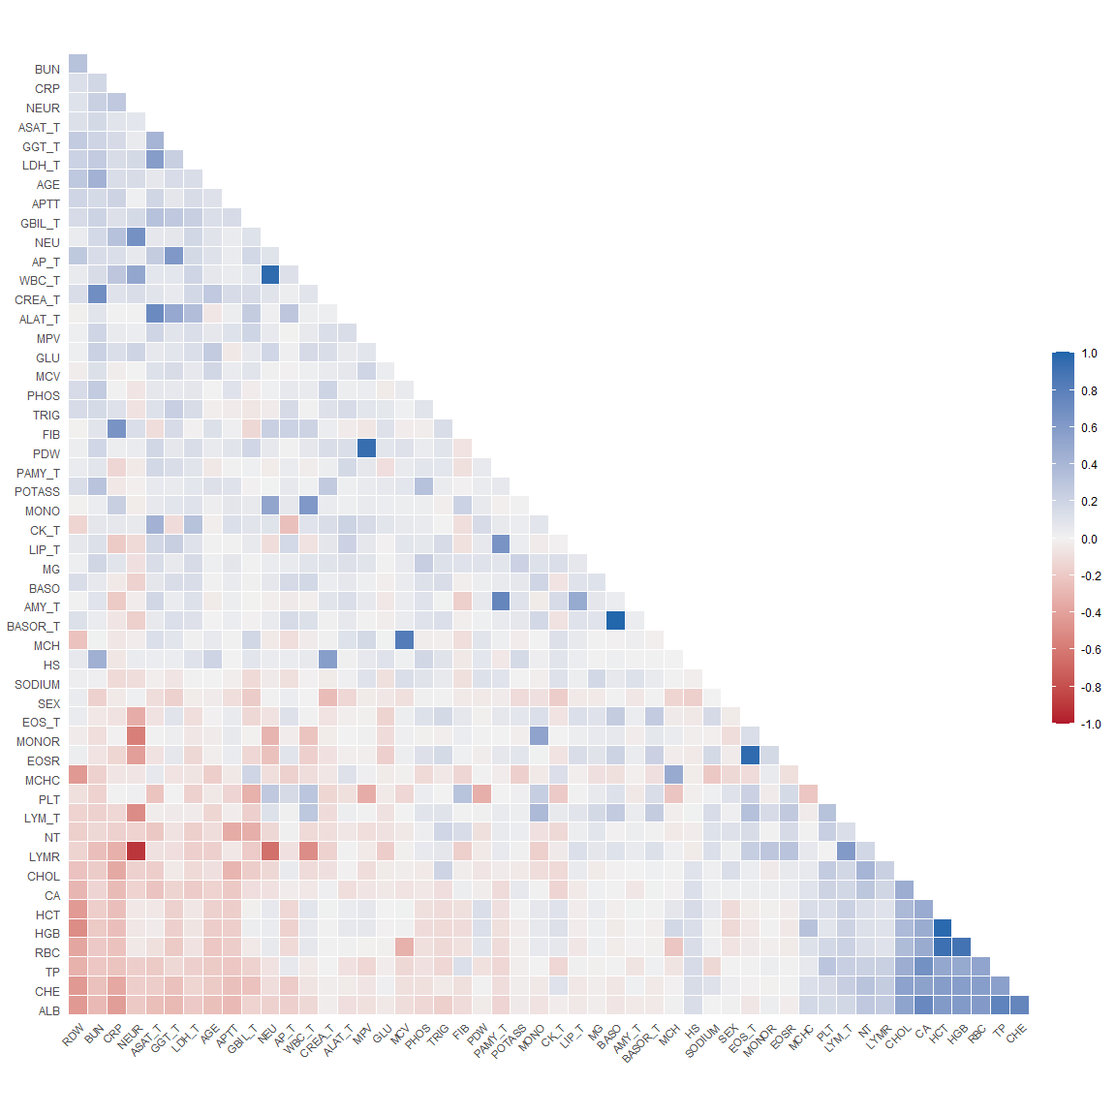

### 1.2.1 VE1: Comparing nonparametric and parametric predictor correlation

Correlation computed with  
* Method: 'pearson'  
* Missing treated using: 'pairwise.complete.obs'

Plot the difference matrix

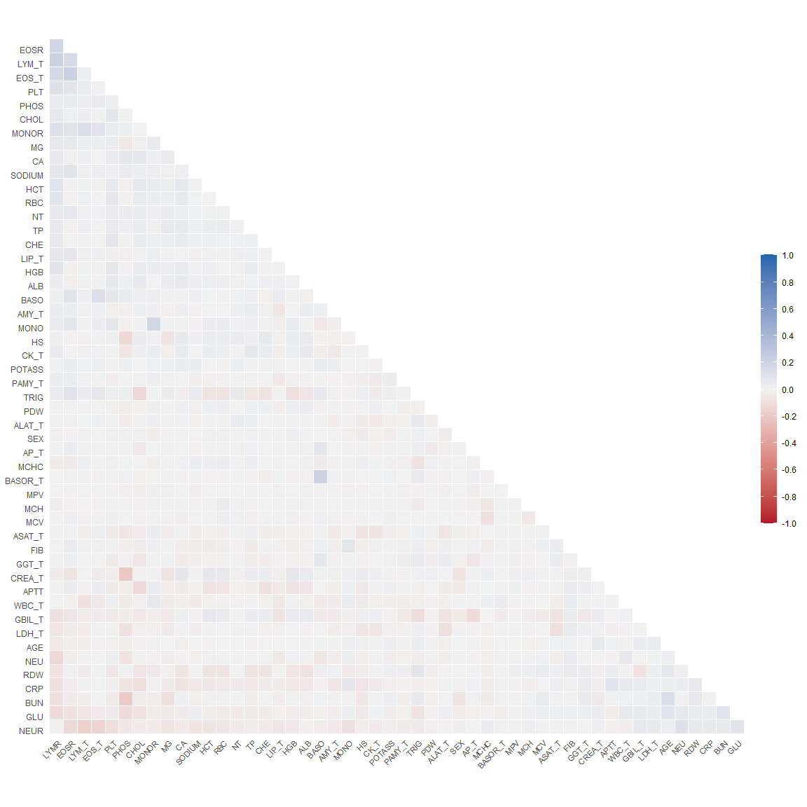

Plot the matrix but suppress differences less then 0.1.

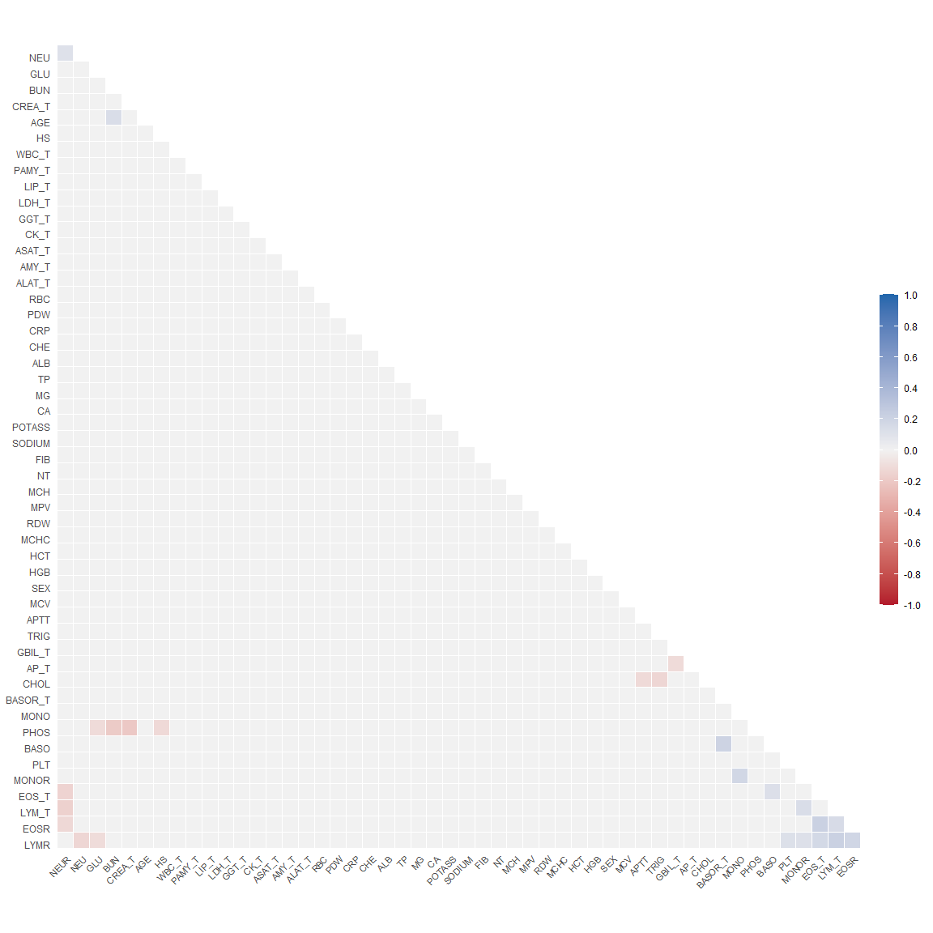

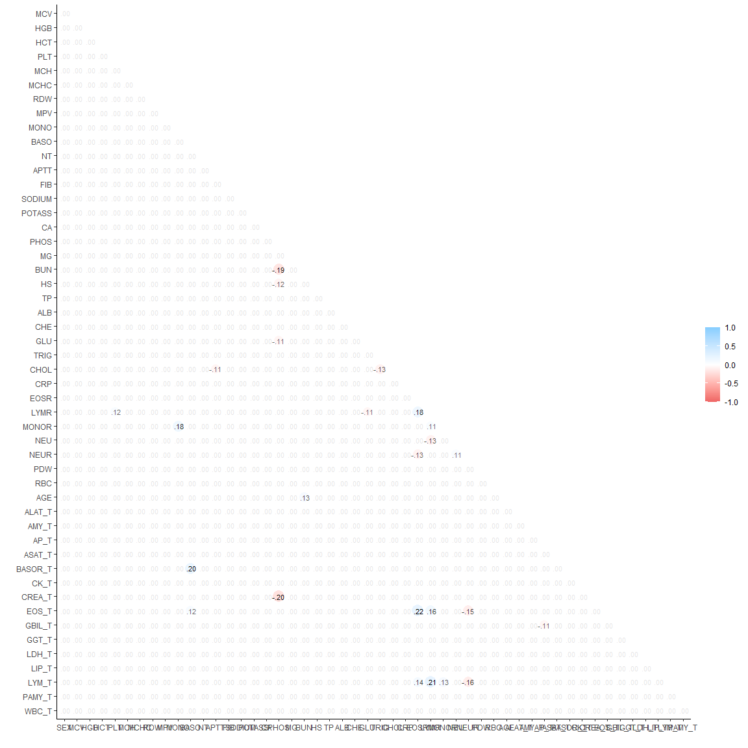

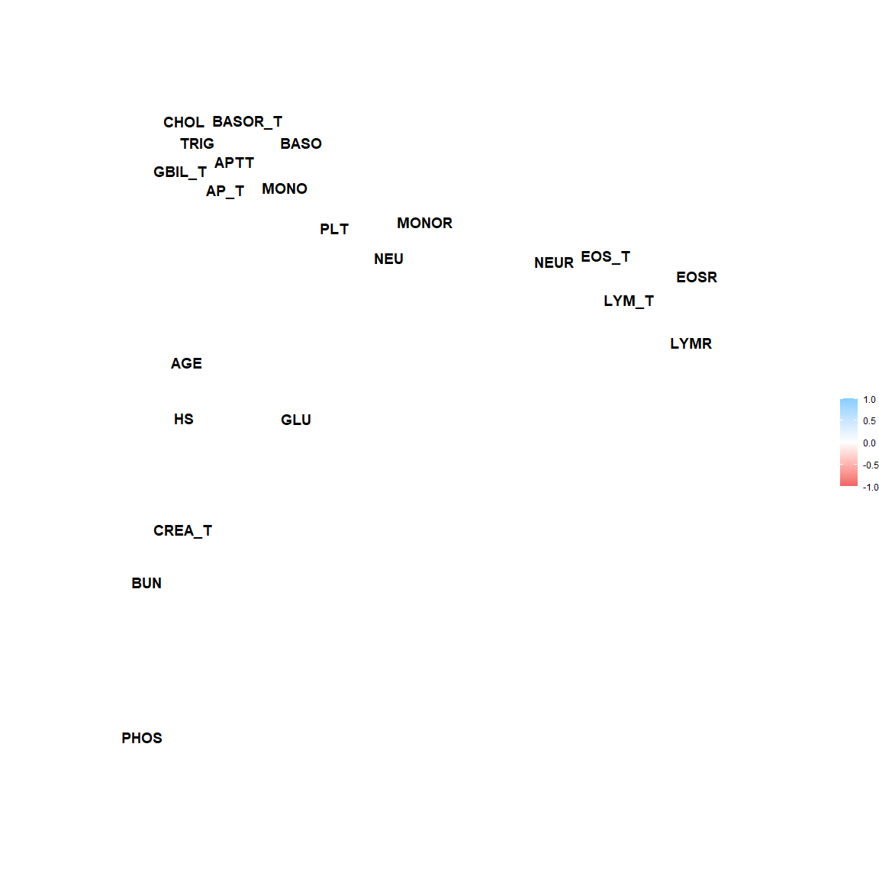

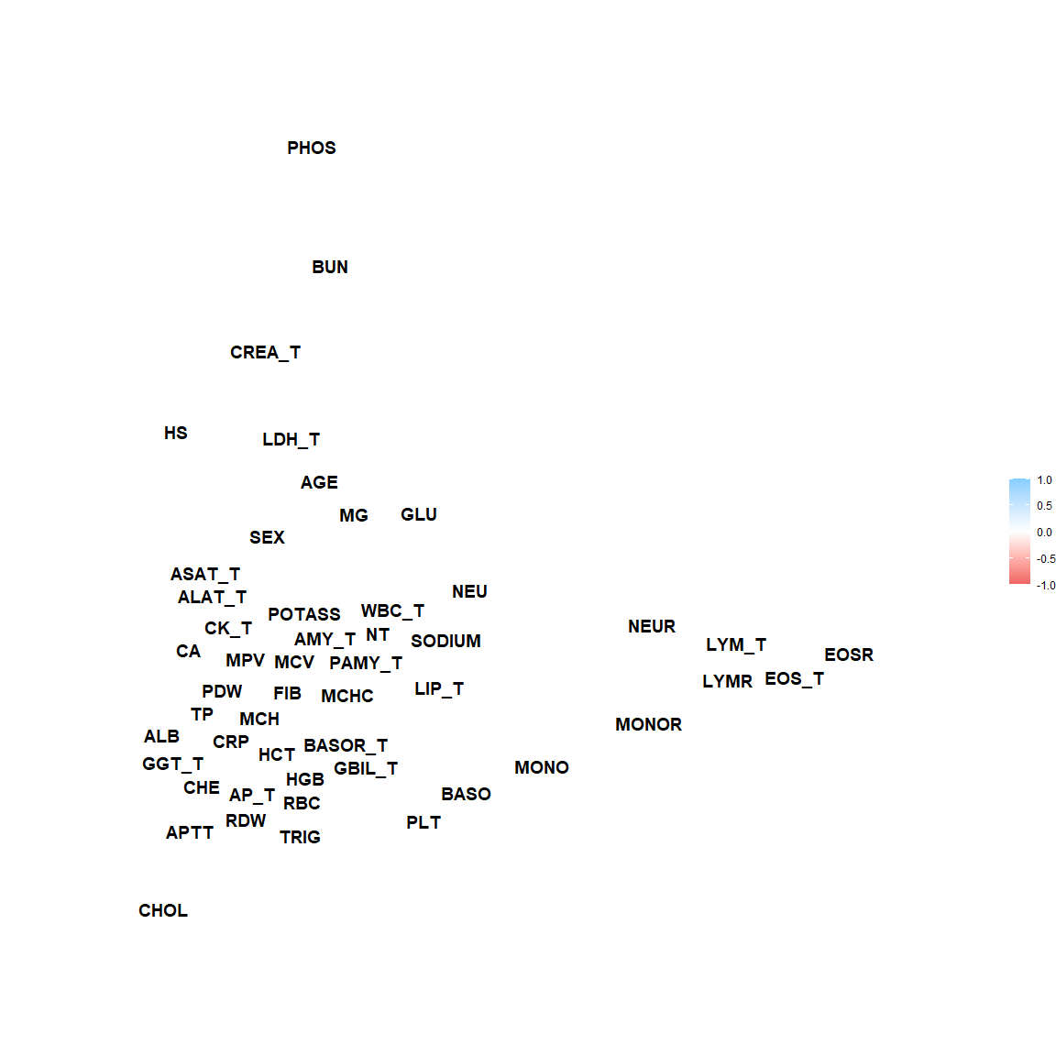

Predictor pairs for which Spearman and Pearson correlation coefficients differ by more than 0.1 correlation units will be depicted in scatterplots:

| x | y | r |
| --- | --- | --- |
| PLT | LYMR | 0.1161529 |
| MONO | MONOR | 0.1761864 |
| BASO | BASOR_T | 0.2003626 |
| BASO | EOS_T | 0.1172575 |
| BUN | AGE | 0.1329799 |
| EOSR | LYMR | 0.1818832 |
| EOSR | EOS_T | 0.2171330 |
| EOSR | LYM_T | 0.1449661 |
| LYMR | PLT | 0.1161529 |
| LYMR | EOSR | 0.1818832 |
| LYMR | MONOR | 0.1108623 |
| LYMR | EOS_T | 0.1643959 |
| LYMR | LYM_T | 0.2145499 |
| MONOR | MONO | 0.1761864 |
| MONOR | LYMR | 0.1108623 |
| MONOR | LYM_T | 0.1319019 |
| NEU | NEUR | 0.1062152 |
| NEUR | NEU | 0.1062152 |
| AGE | BUN | 0.1329799 |
| BASOR_T | BASO | 0.2003626 |
| EOS_T | BASO | 0.1172575 |
| EOS_T | EOSR | 0.2171330 |
| EOS_T | LYMR | 0.1643959 |
| LYM_T | EOSR | 0.1449661 |
| LYM_T | LYMR | 0.2145499 |
| LYM_T | MONOR | 0.1319019 |

|  |  |  |
| --- | --- | --- |
| # A tibble: 26 x 6  x y r grp spearman pearson  <chr> <chr> <dbl> <int> <dbl> <dbl>  1 PLT LYMR 0.116 1 -0.000170 -0.116  2 MONO MONOR 0.176 2 0.538 0.362  3 BASO BASOR_T 0.200 3 0.997 0.797  4 BASO EOS_T 0.117 4 0.246 0.129  5 BUN AGE 0.133 5 0.431 0.298  6 EOSR LYMR 0.182 6 0.311 0.129  7 EOSR EOS_T 0.217 7 0.961 0.744  8 EOSR LYM_T 0.145 8 0.267 0.122  9 LYMR PLT 0.116 9 -0.000170 -0.116 10 LYMR EOSR 0.182 10 0.311 0.129 # ... with 16 more rows |  |  |

|  |  |  |
| --- | --- | --- |
|  |  |  |

|  |  |  |
| --- | --- | --- |
|  |  |  |

|  |  |  |
| --- | --- | --- |
|  |  |  |

|  |  |  |
| --- | --- | --- |
|  |  |  |

|  |  |  |
| --- | --- | --- |
|  |  |  |

|  |  |  |
| --- | --- | --- |
|  |  |  |

|  |  |  |
| --- | --- | --- |
|  |  |  |

|  |  |  |
| --- | --- | --- |
|  |  |  |

### 1.2.2 VE2: Variable clustering

A variable clustering analysis has been performed to evaluate which predictors are closely associated. The dendrogram groups predictors by their correlation.

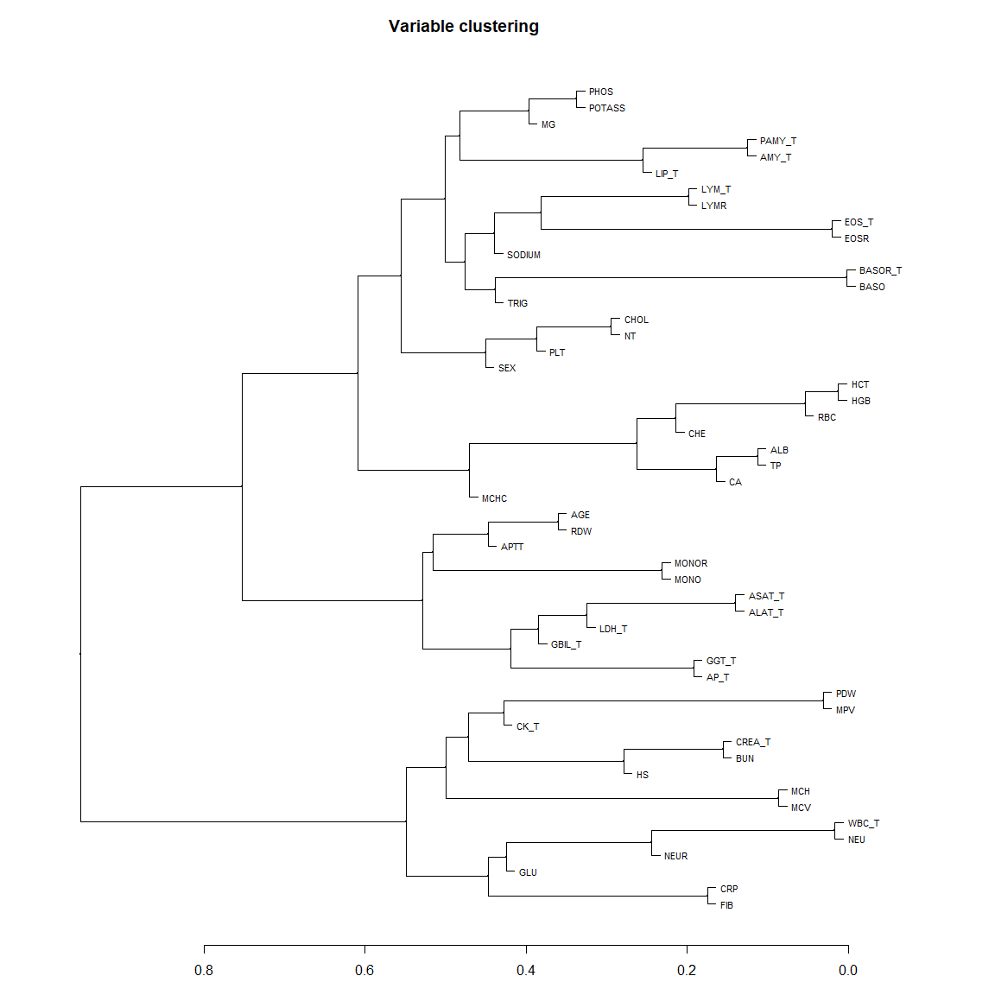

plot network plot

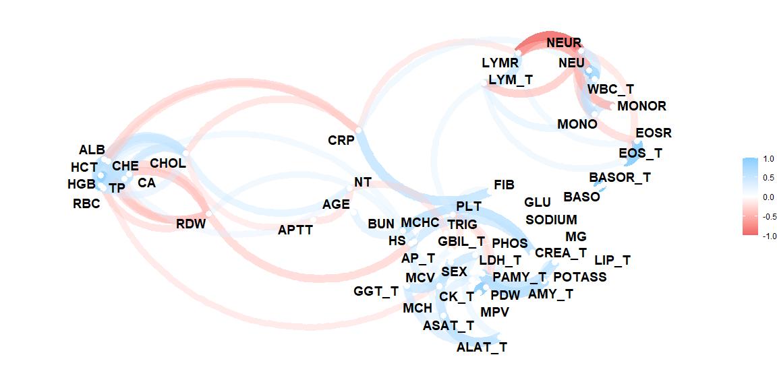

plot network with min cor of 0.3.

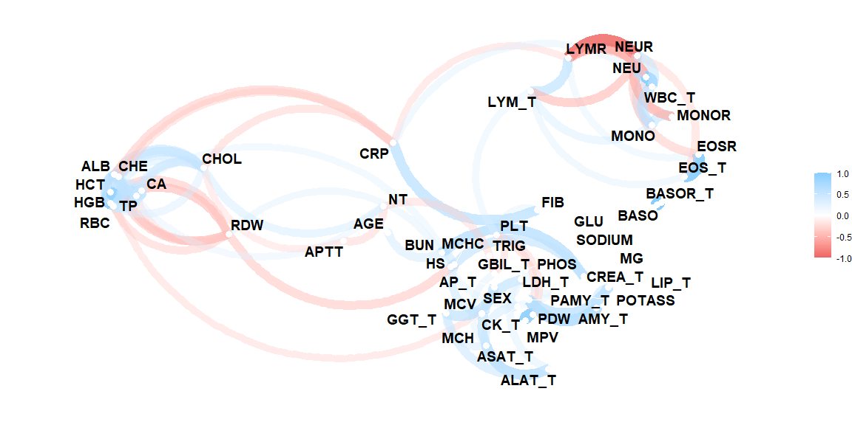

In the following scatterplots we show predictor pairs with Spearman correlation coefficients greater than 0.8:

### 1.2.3 VE3: Redundancy

Variance inflation factors (VIF) will be computed between the candidate predictors. This will be done for the three possible candidate models, and using all complete cases in the respective candidate predictor sets. Since $VIF={\left(1−R^{2}\right)}^{−1}$, we also report the multiple R-squared values. Redundancy was further explored by computing parametric additive models for each predictor in the key predictor model and the extended predictor model. VIFs and multiple $R^{2}$ are reported from those models, again for the three predictor sets.

#### 1.2.3.1 VIF for key predictor model

#### 1.2.3.2 VIF for model with key predictors and predictors of medium importance

#### 1.2.3.3 VIF for all predictor model

#### 1.2.3.4 Redundancy by parametric additive model: key predictor model

#### 1.2.3.5 Redundancy by parametric additive model: key predictors and predictors of medium importance

#### 1.2.3.6 Redundancy by parametric additive model: all predictors