在测试环境 web01 tomcat_mgr下  
ROOT目录其中：  
Download为下载安装包  
Update为自动更新升级包

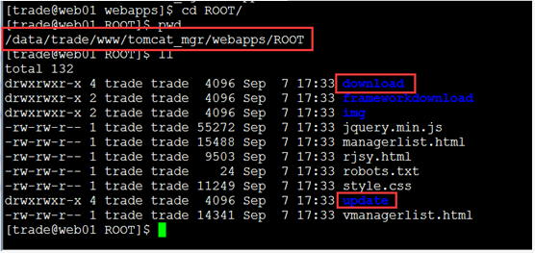

升级1.1.8实盘客户端步骤

* 1. 四个客户端路径

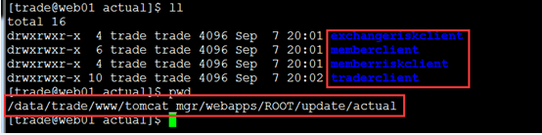

* 2.进入exchangeriskclient（交易所风控端）目录

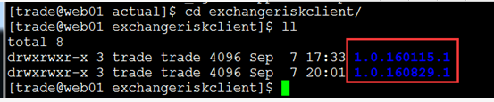

* 3.红框中为升级包版本（由天彧提供）

最新的版本1.0.160829.1，拷贝到这个目录中

* 4，修改oracle T_M_DICTIONARY表

select * from T_M_DICTIONARY

F_code 修改为最新的版本号  
F_code_descn 修改为最新的升级包地址

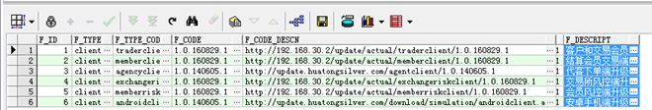

update t_m_dictionary set f_code='1.0.160829.1' where f_id=1  
update t_m_dictionary set f_code_descn='<http://192.168.30.2/update/actual/traderclient/1.0.160829.1'> where f_id=1

update t_m_dictionary set f_code='1.0.160829.1' where f_id=2;  
update t_m_dictionary set f_code_descn='<http://192.168.30.2/update/actual/memberclient/1.0.160829.1'> where f_id=2;

update t_m_dictionary set f_code='1.0.160829.1' where f_id=4;  
update t_m_dictionary set f_code_descn='<http://192.168.30.2/update/actual/exchangeriskclient/1.0.160829.1'> where f_id=4;

update t_m_dictionary set f_code='1.0.160829.1' where f_id=5;  
update t_m_dictionary set f_code_descn='<http://192.168.30.2/update/actual/memberriskclient/1.0.160829.1'> where f_id=5;

* 5.把最新的安装包放入download目录下