<https://developer.wordpress.org/themes/>

https://www.youtube.com/watch?v=cP4FprafrkE&list=PLD8nQCAhR3tT3ehpyOpoYeUj3KHDEVK9h&index=3

1.Turn the wp_debug on

2.Create index.php and style.css (basic information for theme)

Index.php is the html information

Style.css is the information from

3.

Create header.php and footer.php

Modify index.php with

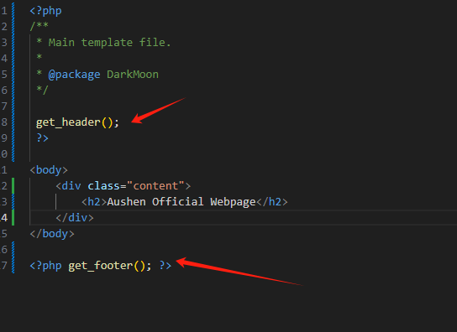

4. chapter 4