Project:

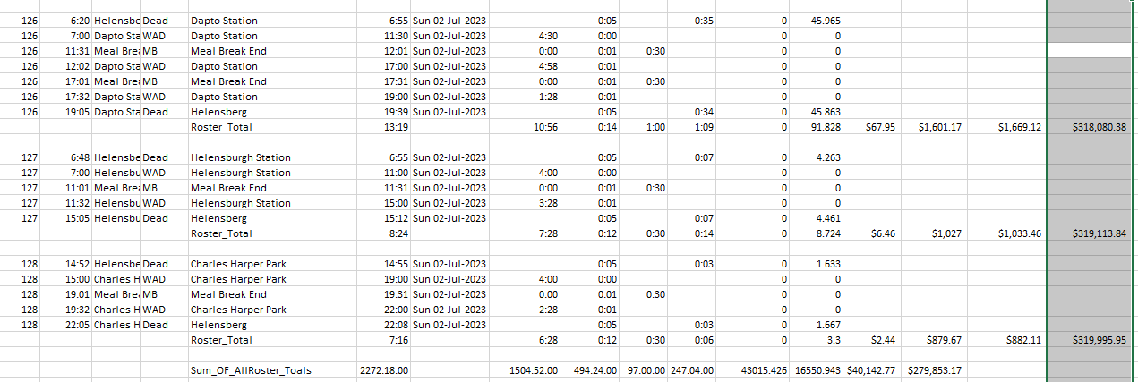

**Key: [h]:mm, Dim avariableName as currency**

Description: after a set of bus driver rosters is made, the office decided to reduce the lengths of the driver shifts by add extra driver for the trip, which means two new routs will be added for each roster, more specifically, the running bus A will be added one routine to drive back depot and at almost same time of bus A driver starts driving back, the bus B will drive out from depot to replace the returning bus.

After all new routines are added, the system will need to count the total-operating hours, layover hours, dead hours, operation Distance and dead distance.

Tool: Excel, VBA

Significant issue solved:

1. Over 24-hour time calculation.
2. “Currency” Variable type

Solutions:

1. Applying Format (“11:30”, “hh:mm”)
2. Setup format as [h]:mm in excel first, and string display in VBA :

1. Code:

Dim hour1 as double

Dim converthour as string

hour1 = hour1 + Cells(startone, 6).Value ‘the 11:30 time length

converthour = hour1

Cells(1943, 6) = converthour

2. Code:

Dim converthour as string

converthour = Cells(startone - 1, 6) - Cells(reverseClock + 1, 2)

Cells(startone, 6) = converthour

3. code:

Dim converthour as Currency