CSE 527 HW 1

*Chenchao Xu*

**2. Multi-marker model for QTL analysis (code_q2.py)**

**a.**

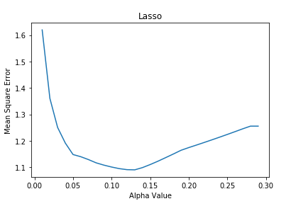

min(lasso_mse) = 1.090

**b.**

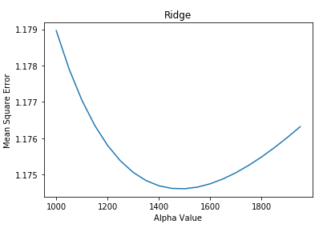

min(ridge_mse) = 1.175

MSE with L2 is much higher that it with L1.

**c.**

train set : validation set = 2:1; randomly splited

And then use both training set and validation set to train the model for test set.

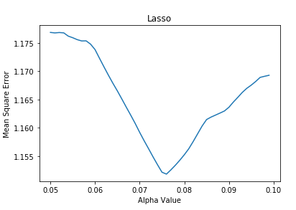

alpha_lasso = 0.076

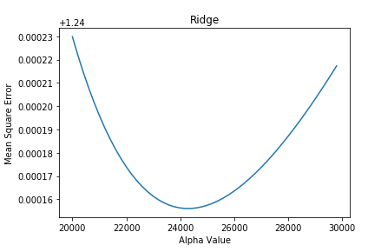

alpha_ridge = 24200

On test set:

lasso_mse_test = 1.120; ridge_mse_test = 1.234; Lasso does better

parameters:

lasso: 0.076, not so far; ridge: 24200, much bigger than that in b

**3. Implementation of the EM-based haplotype reconstruction algorithm (code_q3.py)**

**a.**

hidden variables: haplotype states of individuals

parameters: haplotype frequencies

**b.**

Use current frequency estimates to replace ambiguous genotypes with fractional counts of phased genotypes

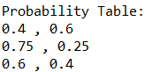

**c.**

Estimate frequency of each haplotype by counting

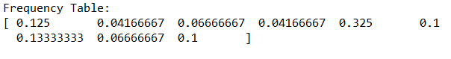

**d.**

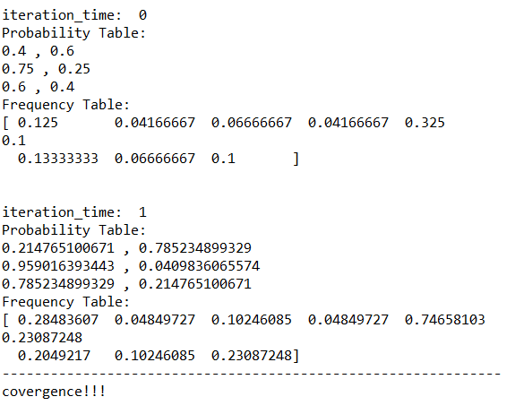

The last iteration_time is 1.