CSE 527 HW 3

*Chenchao Xu*

1. Conditional Independence in Bayesian Networks

(a) true

(b) false

2. Conditional Independence in Undirected Graphical Models

(a) true

(b) false

3. Graphical LASSO

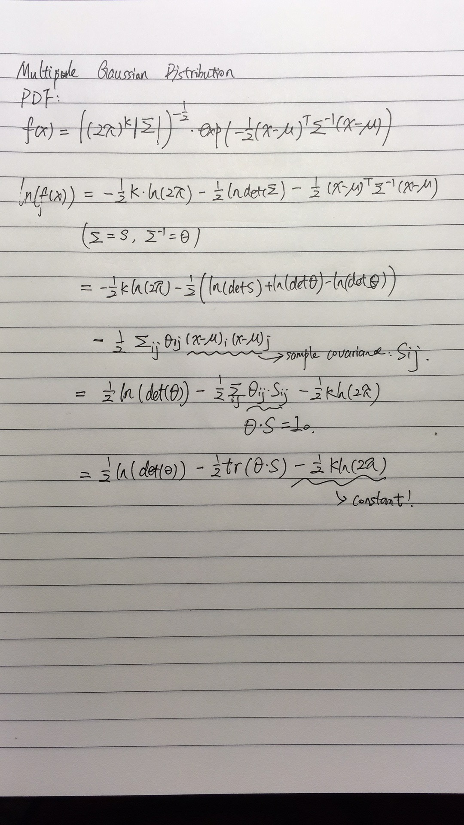

4. please see “CNN.html”