**Four-in-a-Row Online**

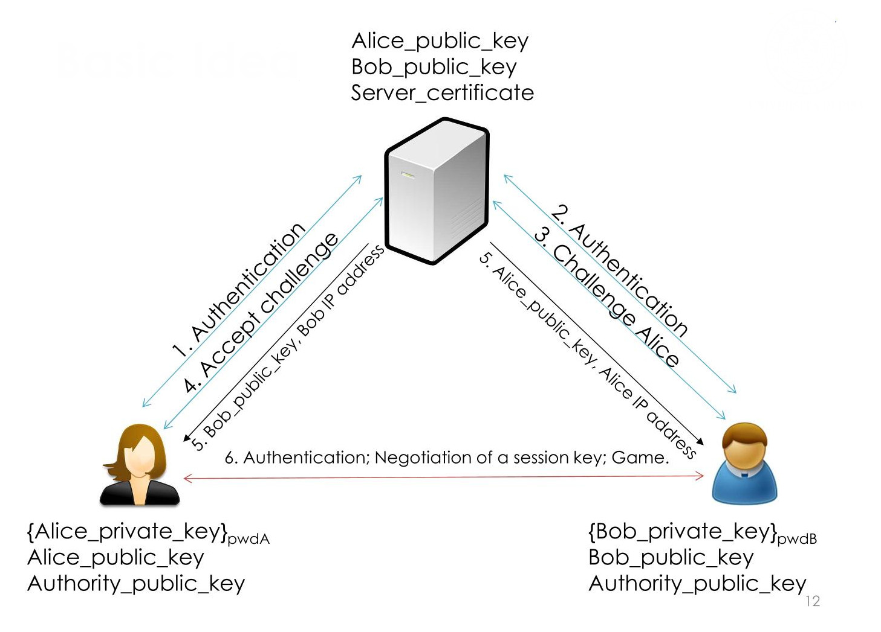

The goal of the project is to desing and implement a client-server application for the “Four-in-a-Row" game.

**Constraint:**

* Use C or C++ language and OpenSSL library for crypto algorithms
* Key establishment protocol must establish one(or more) symmetric session key(s) with public-key crypto
* Session protocol must use session key(s) to communicate
* Communication must be confidential authenticated and protected against replay
* No coding vulnerabilities(use secure coding principles)
* Manage malformed messages

**Assumption:**

* The board is a 6x7(rows,columns)
* Users are already registered on the server through public keyes. Users authenticate through said public key
* The game board must be printed at each move.
* When a client wants to top playing. It shall log-off from the server

**Report:**

Project report must contain:

* Project specification and design choices
* BAN-logic proof of key exchange protocol
* Format of all the exchanged messages

**Application example flow:**

* After the log-in a user can see other availabile users logged to the server
* User can send a challenge to another user
* The user who receives a challenge can either accept or refuse
* If the challenge is accepted, the users proceed to play using a peer-to-peer communication
* When the client application starts, Server and Client must authenticate
  + Server must authenticate with a public key certified by a certification authority
  + Client must authenciate with a public key(pre-installed on server). The corresponding private key is protected with a password on each client
* After authentication a symmetric session key must be negotiated
  + The negotiation must provide Perfect Forward Secrecy
  + All session messages must be encrypted with authenticated encryption mode(eg. CCM,GCM)
  + Session with a server is not interrupted by games
  + After a challenge is accepted he server sends to both clients the ip address and public key of the adversary
* Before starting the game a symmetric session key must be negotiated
  + The negotiation must provide Perfect Forward Secrecy
  + All session messages must be encrypted with authenticated encryption mode(e.g. CCM,GCM)
* When the game ends, clients disconnect fro each other