NAME- BARSHA ROUTH

REG NO- 24MCA0164

**PMCA503P DATABASE SYSTEMS LAB**

**CYCLE SHEET-PL/SQL**

--1 Write a PL/SQL block to get the student register number and print the student details such as sname, address, dob, email and mobile number

DECLARE

reg STUDENT.Reg_no%type := '&reg_no';

name STUDENT.Sname%type;

dob STUDENT.DoB%type;

add STUDENT.Address%type;

mobile STUDENT.Mobile%type;

email STUDENT.Email%type;

BEGIN

SELECT Sname, DoB, Address, Mobile, Email INTO name, dob, add, mobile, email FROM STUDENT WHERE Reg_no = reg;

dbms_output.put_line('Student '||name||' was born on '||dob||', lives in '||add||'. Contact: mobile '||mobile||' Email '||email);

END;

/

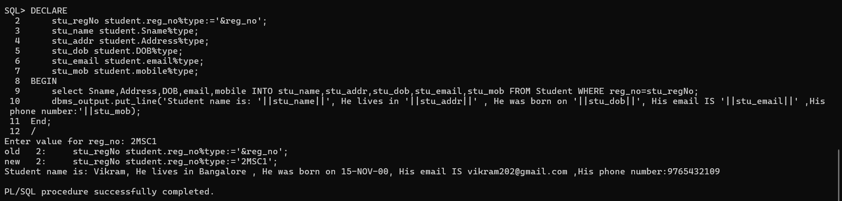

--2. Write a PL/SQL block the get the professor id and update the mobile number of the professor.

DECLARE

    id professor.PROF_ID%type:='&PROF_ID';

    mob professor.MOBILE%type;

BEGIN

    UPDATE Professor set Mobile =9199009966 where PROF_ID=id;

    Select Mobile INTO mob FROM Professor where prof_id=id;

    dbms_output.put_line('Professor with id: '||id||'New Mobile number is'||mob);

End;

/

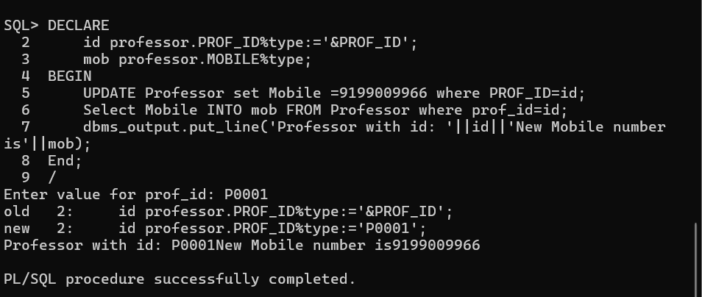

--3 Write a PL/SQL procedure to display the message as ‘Excellent’, ‘Good’, and ‘Fair’ depending on the Grade of a student in a course.

BEGIN

FOR rec IN (

SELECT s.Sname, c.Crs_name, e.Grade

FROM STUDENT s

JOIN ENROLL e ON s.Reg_no = e.Reg_no

JOIN CLASS cls ON e.Cls_code = cls.Cls_code

JOIN COURSE c ON cls.Crs_code = c.Crs_code

WHERE s.Reg_no = '2BCA2'

) LOOP

IF rec.Grade = 'S' THEN

dbms_output.put_line(rec.Sname||' '||rec.Crs_name||' Excellent');

ELSIF rec.Grade = 'A' THEN

dbms_output.put_line(rec.Sname||' '||rec.Crs_name||' Excellent');

ELSIF rec.Grade = 'B' THEN

dbms_output.put_line(rec.Sname||' '||rec.Crs_name||' Good');

ELSIF rec.Grade = 'C' THEN

dbms_output.put_line(rec.Sname||' '||rec.Crs_name||' Fair');

ELSE

dbms_output.put_line(rec.Sname||' '||rec.Crs_name||' Fair');

END IF;

END LOOP;

END;

/

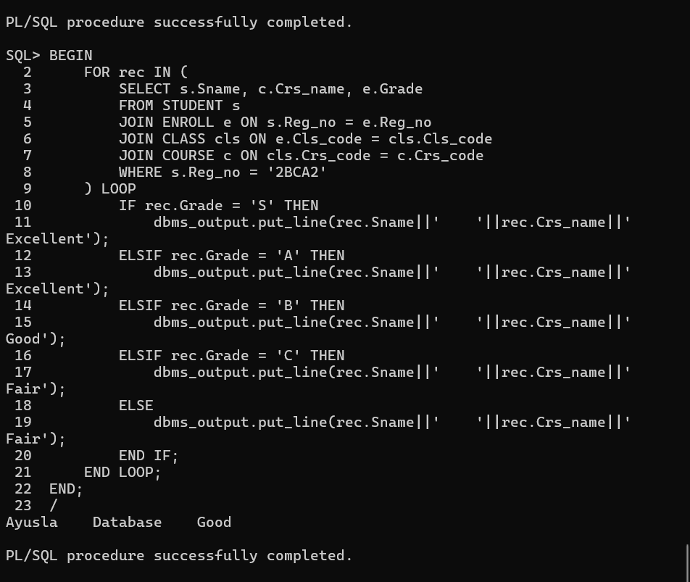

--4. Write a PL/SQL procedure to print the number of ‘S’ grades that a student has obtained.

DECLARE

reg STUDENT.Reg_no%TYPE := '&Reg_no'; -- Student register number

name STUDENT.Sname%TYPE;

c NUMBER(2);

BEGIN

-- Retrieve the student's name

SELECT Sname INTO name

FROM STUDENT

WHERE Reg_no = reg;

-- Count the number of 'S' grades

SELECT COUNT(*) INTO c

FROM ENROLL e

WHERE e.Reg_no = reg

AND e.Grade = 'S';

-- Output the result

dbms_output.put_line('Student ' || name || ' got S grade in ' || c || ' courses.');

END;

/

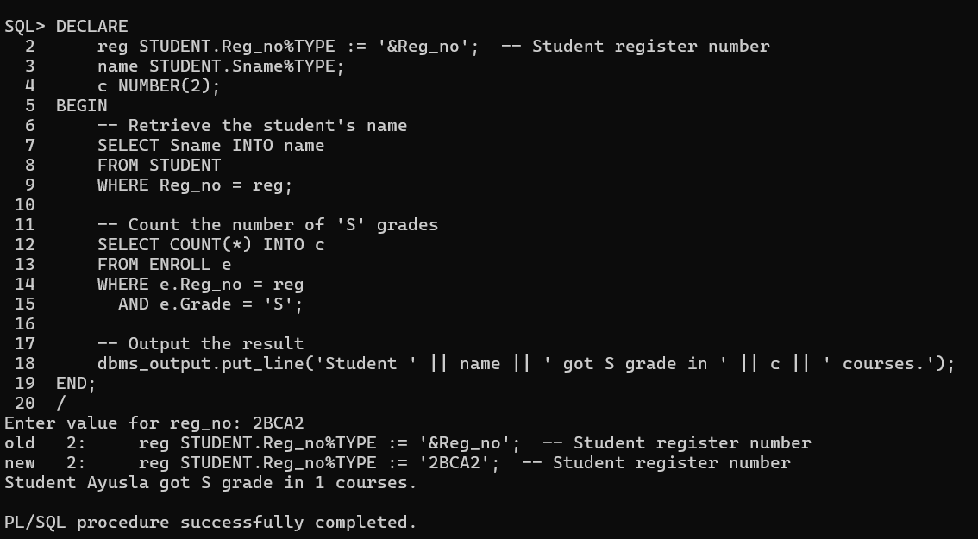

--5 Write a PL/SQL program to print the regno and student names who are studying in the first semester

BEGIN

dbms_output.put_line('Student studying in first semester (Fall 2016) are: ');

FOR rec IN (

SELECT s.Reg_no, s.Sname

FROM STUDENT s

JOIN ENROLL e ON s.Reg_no = e.Reg_no

JOIN CLASS cls ON e.Cls_code = cls.Cls_code

JOIN SEMESTER sem ON cls.Sem_code = sem.Sem_code

WHERE sem.Year = '2016'AND sem.Term LIKE 'Fall'

) LOOP

dbms_output.put_line(rec.Reg_no||' '||rec.Sname);

END LOOP;

END;

/

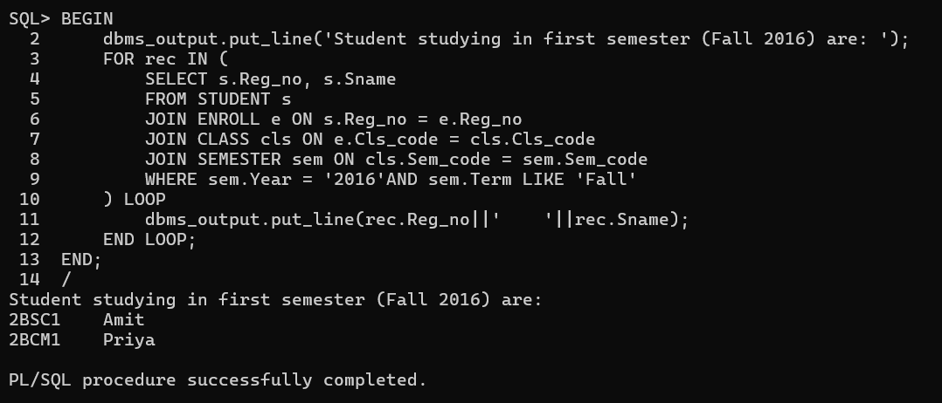

--6 Write a PL/SQL program to find out what are all the courses that a professor has handled in the semester 1 and 2.

DECLARE

PID PROFESSOR.Prof_id%TYPE;

BEGIN

PID := '&pid';

dbms_output.put_line('Courses handled by '|| PID || ' in first and second semester (Fall 2016, Winter 2016) are: ');

FOR rec IN (

SELECT UNIQUE c.Crs_code, c.Crs_name

FROM COURSE c

JOIN CLASS cls ON cls.Crs_code = c.Crs_code

JOIN (SELECT p1.Prof_id FROM PROFESSOR p1 WHERE p1.Prof_id = PID) p ON p.Prof_id = cls.Prof_id

JOIN SEMESTER sem ON cls.Sem_code = sem.Sem_code

WHERE sem.Year = '2016'AND (sem.Term LIKE 'Fall' OR sem.Term LIKE 'Winter')

) LOOP

dbms_output.put_line(rec.Crs_code||' '||rec.Crs_name);

END LOOP;

END;

/

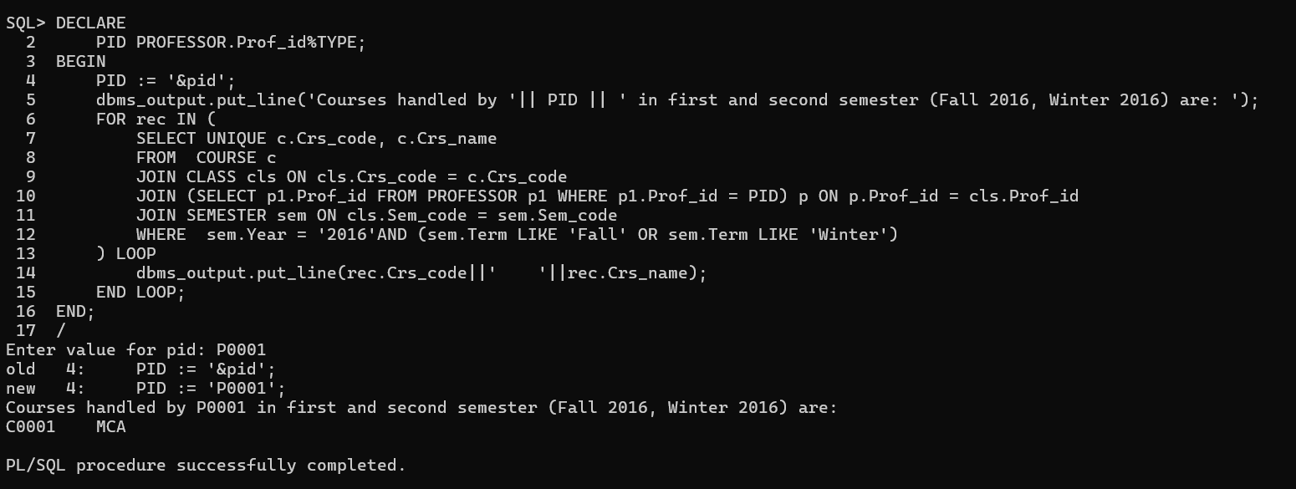

--7 Implement and test a trigger to ensure that a student cannot enroll in a course after the semester has started

CREATE OR REPLACE TRIGGER check_enrollment_date

BEFORE INSERT ON ENROLL

FOR EACH ROW

DECLARE

sem_start_date DATE;

BEGIN

-- Get the semester start date based on the class code

SELECT s.Sdate

INTO sem_start_date

FROM SEMESTER s

JOIN CLASS c ON s.Sem_code = c.Sem_code

WHERE c.Cls_code = :NEW.Cls_code;

-- Check if the current date is after the semester start date

IF SYSDATE > sem_start_date THEN

RAISE_APPLICATION_ERROR(-20001, 'Cannot enroll in a course after the semester has started.');

END IF;

END;

/

INSERT INTO ENROLL (Cls_code, Reg_no, Enroll_time, Grade)

VALUES ('CL004', '2BSC1', SYSTIMESTAMP, 'A');

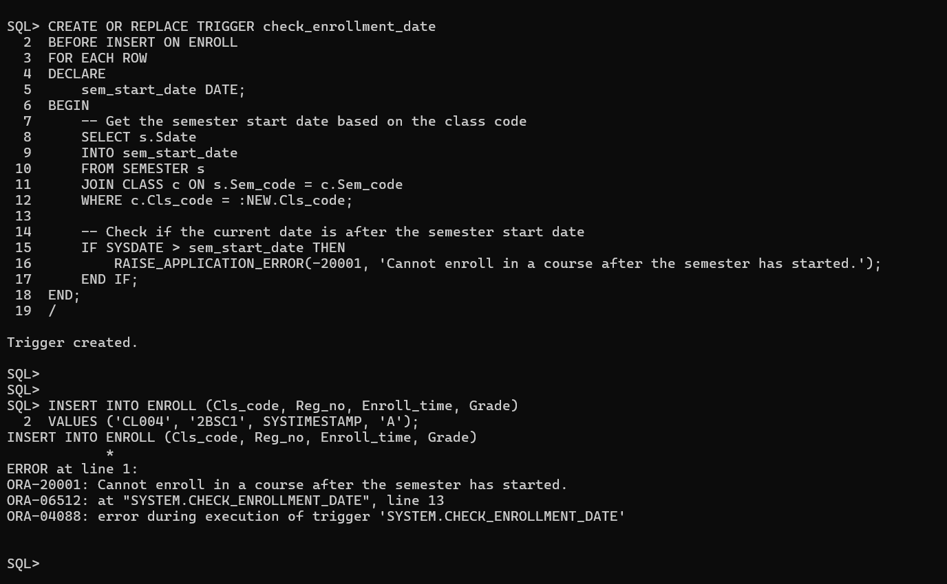

--8 Implement and test a trigger to ensure that number of departments in a school cannot exceed three.

CREATE OR REPLACE TRIGGER check_department_count

BEFORE INSERT OR UPDATE ON DEPARTMENT

FOR EACH ROW

DECLARE

dept_count NUMBER;

BEGIN

-- Count the number of departments associated with the school code in the current record

SELECT COUNT(*)

INTO dept_count

FROM DEPARTMENT

WHERE SCode = :NEW.SCode;

-- If the number of departments is already 3, prevent the insertion

IF dept_count >= 3 THEN

RAISE_APPLICATION_ERROR(-20003, 'Cannot add more than 3 departments to the school.');

END IF;

END;

/

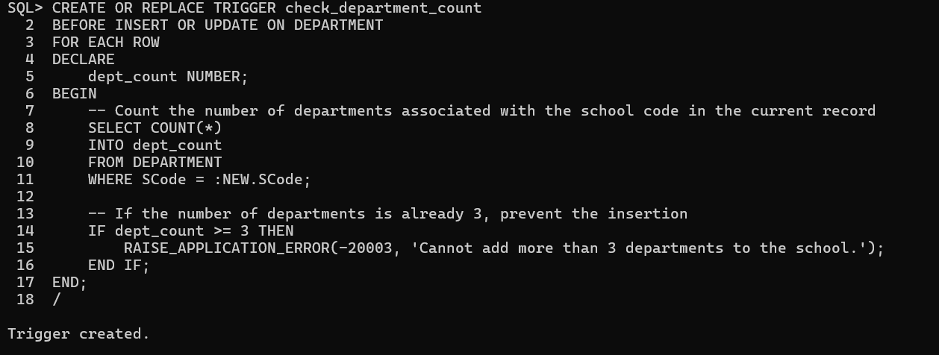

--10. Write a PL/SQL program to interchange the department of Professor Pmat1 and Pphy1.

DECLARE

-- Declare variables to hold the department IDs of Pmat1 and Pphy1

v_dept_pmat1 PROFESSOR.Dept_id%TYPE;

v_dept_pphy1 PROFESSOR.Dept_id%TYPE;

BEGIN

-- Retrieve the current department ID of Professor Pmat1

SELECT Dept_id INTO v_dept_pmat1

FROM PROFESSOR

WHERE Prof_id = 'Pmat1';

-- Retrieve the current department ID of Professor Pphy1

SELECT Dept_id INTO v_dept_pphy1

FROM PROFESSOR

WHERE Prof_id = 'Pphy1';

-- Swap the department of Professor Pmat1 with Professor Pphy1

UPDATE PROFESSOR

SET Dept_id = v_dept_pphy1

WHERE Prof_id = 'Pmat1';

-- Swap the department of Professor Pphy1 with Professor Pmat1

UPDATE PROFESSOR

SET Dept_id = v_dept_pmat1

WHERE Prof_id = 'Pphy1';

-- Commit the changes

COMMIT;

-- Output success message

dbms_output.put_line('Departments of Professors Pmat1 and Pphy1 have been interchanged.');

EXCEPTION

WHEN NO_DATA_FOUND THEN

dbms_output.put_line('One or both of the professors were not found.');

WHEN OTHERS THEN

dbms_output.put_line('An error occurred: ' || SQLERRM);

END;

/

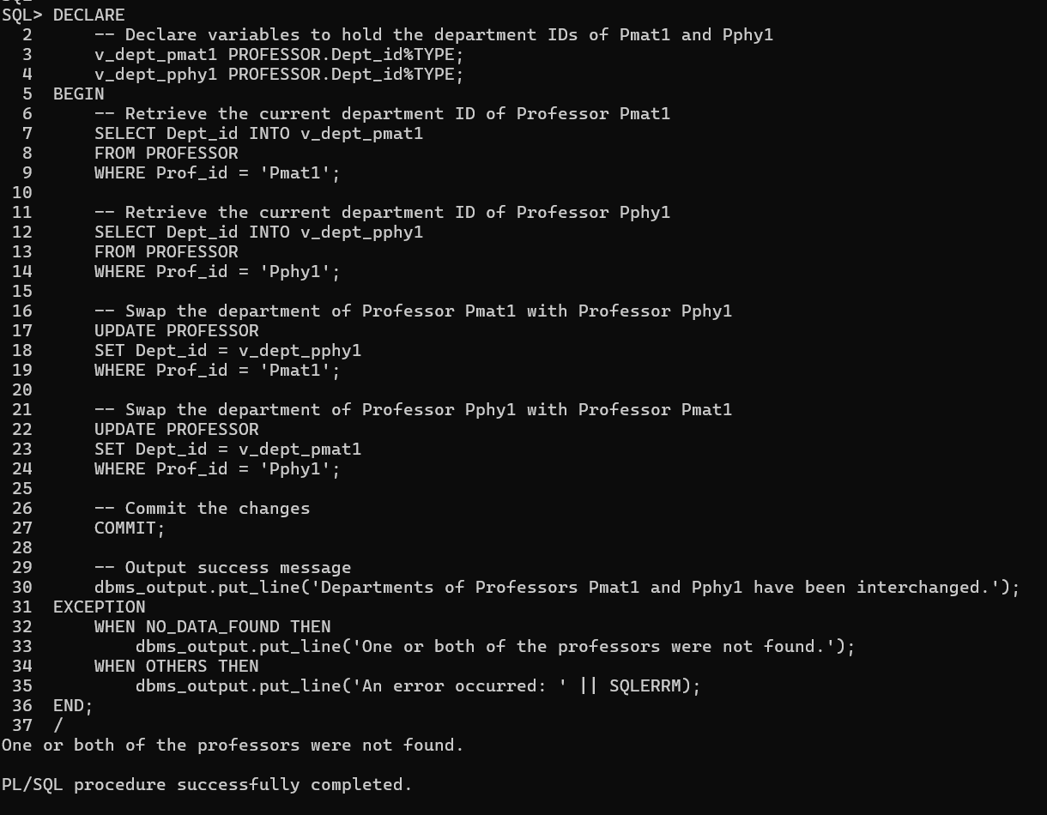

--11 Create a function that takes department ID and returns the name of the Head of the department

CREATE OR REPLACE FUNCTION get_dept_head(dept_id_in DEPARTMENT.Dept_id%TYPE)

RETURN VARCHAR2

IS

v_head_name PROFESSOR.Prof_name%TYPE;

BEGIN

-- Retrieve the name of the head of the department

SELECT p.Prof_name

INTO v_head_name

FROM PROFESSOR p

JOIN DEPARTMENT d ON p.Prof_id = d.Prof_id

WHERE d.Dept_id = dept_id_in;

-- Return the name of the head of the department

RETURN v_head_name;

EXCEPTION

-- Handle case when no head is found

WHEN NO_DATA_FOUND THEN

RETURN 'No head found for this department';

-- Handle other unexpected errors

WHEN OTHERS THEN

RETURN 'An error occurred';

END;

/

SELECT get_dept_head('D0001') FROM dual;

SELECT get_dept_head('D0005') FROM dual;

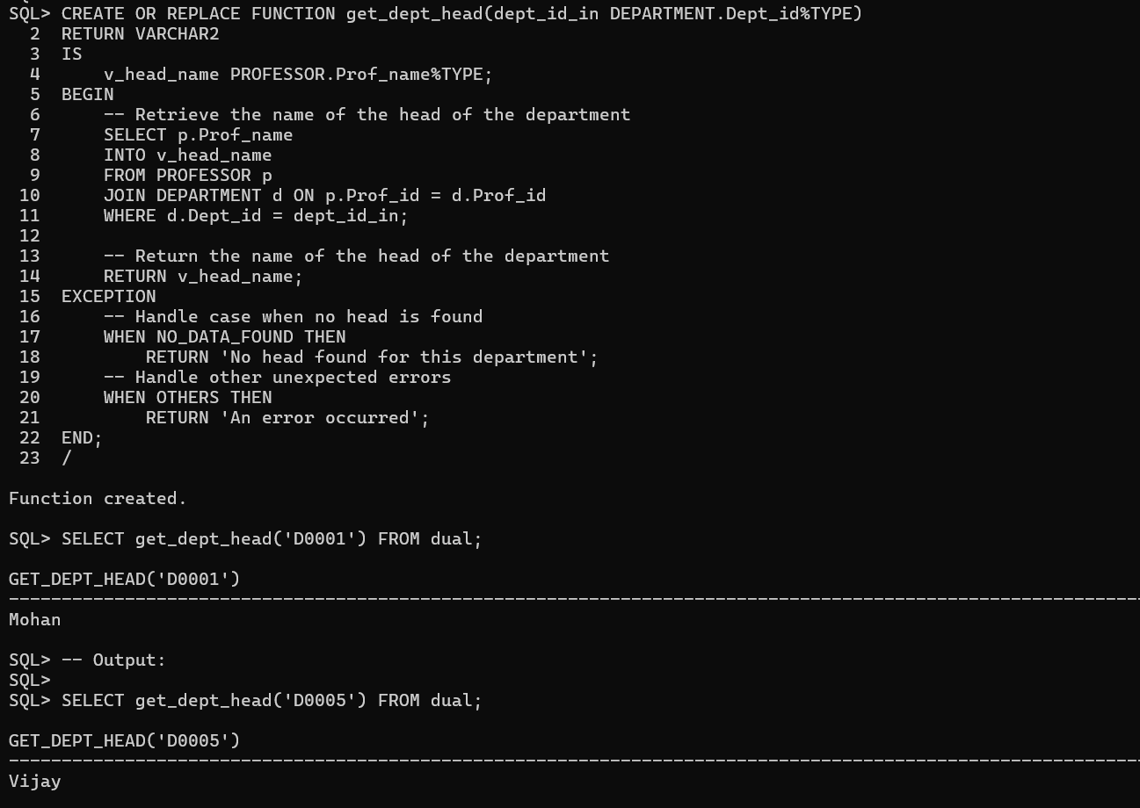

--12. Create a function that displays the age of the student from his DOB.

CREATE OR REPLACE FUNCTION calculate_age(dob_in STUDENT.DoB%TYPE)

RETURN NUMBER

IS

v_age NUMBER;

BEGIN

-- Calculate age using the current date and DOB

v_age := TRUNC(MONTHS_BETWEEN(SYSDATE, dob_in) / 12);

RETURN v_age;

EXCEPTION

-- Handle any unexpected errors

WHEN OTHERS THEN

RETURN NULL; -- Return NULL if there's an error

END;

/

SELECT calculate_age(TO_DATE('2000-05-15', 'YYYY-MM-DD')) AS age FROM dual;

