NAME-Barsha Routh

Reg no-24MCA0164

DATABASE SYSTEMS

PROFESSOR(Prof_id, Prof_name, Email, Mobile, Specialty, Dept_id)

SCHOOL(SCode, Scl_name, Prof_id, Location)

DEPARTMENT(Dept_id, Dname, SCode, Prof_id)

COURSE(Crs_code, Crs_name, Description, Credits, Hours)

CLASS(Cls_code, Slot, Stime, Etime, Crs_code, Prof_id, Room_no, Sem_code, Day_of_week)

SEMESTER(Sem_code, Term, Year, Sdate, Edate)

STUDENT(Reg_no, Sname, Address, DoB, Email, Mobile, Dept_id, Prof_id)

ENROLL(Cls_code, Reg_no, Enroll_time, Grade)

STUDENT_VISA(Reg_no, Visa_status)

PROGRAMME(Prog_code, Prog_name, Prog_preamble, Scode, Dept_id)

1. Create the above tables.

**SOLUTION**

create table PROFESSOR(Prof_id varchar(5),Prof_name varchar(20),Email varchar(20),Mobile number(10),Speciality varchar(10),Dept_id varchar(5));

create table SCHOOL(SCode varchar(5),Scl_name varchar(20),Prof_id varchar(5),Location varchar(10));

create table DEPARTMENT(Dept_id varchar(5),Dname varchar(20),Scode varchar(5),Prof_id varchar(5));

create table COURSE (Crs_code varchar(5),Crs_name varchar(10),Description varchar(30),Credits number(2),Hours number(2));

CREATE TABLE CLASS (Cls_code VARCHAR(5),Slot VARCHAR(5),Stime TIMESTAMP(0),Etime TIMESTAMP(0),Crs_code VARCHAR(5), Prof_id VARCHAR(5),Room_no VARCHAR(5), Sem_code VARCHAR(5), Day_of_week VARCHAR(10));

Create table SEMESTER(sem_code varchar(5),term varchar(6),Year varchar(4),Sdate date,Edate date);

Create table STUDENT(Reg_no varchar(5),Sname varchar(10),Address varchar(20),DoB date,Email varchar(20),Mobile varchar(10),Dept_id varchar(5),Prof_id varchar(5));

Create table ENROLL(Cls_code varchar(5),Reg_no varchar(5),Enroll_time timestamp(0), Grade CHAR(1) CHECK (Grade IN ('S', 'A', 'B', 'C', 'D')));

Create table STUDENT_VISA(Reg_no varchar(5),Visa_status Varchar(20));

Create table PROGRAMME(Prog_code varchar(5), Prog_name varchar(10), Prog_preamble varchar(50), Scode varchar(5), Dept_id varchar(5));

OUTPUT IN THE NEXT QUESTION--

1. Enter data into the above tables. (Learn also how to enter data interactively.). Display the content of each table. Use column formatting while displaying data.

**SOLUTION**

INTERACTIVE ENTRY OF DATA

insert into PROFESSOR values(&Prof_id,&Prof_name,&Email,&Mobile,&Specialty,&Dept_id);

insert into DEPARTMENT values(&Dept_id, &Dname, &SCode, &Prof_id);

insert into SCHOOL values(&SCode, &Scl_name, &Prof_id , &Location);

insert into COURSE values(&Crs_code , &Crs_name , &Description , &Credits , &Hours);

insert into CLASS values(&Cls_code , &Slot , &Stime , &Etime , &Crs_code , &Prof_id , &Room_no, &Sem_code , &Day_of_week);

insert into SEMESTER values(&Sem_code, &Term , &Year, &Sdate, &Edate);

insert into STUDENT values(&Reg_no , &Sname , &Address, &DoB, &Email , &Mobile, &Dept_id , &Prof_id );

insert into ENROLL values(&Cls_code, &Reg_no , &Enroll_time , &Grade);

insert into STUDENT_VISA values(&Reg_no, &Visa_status);

insert into PROGRAMME values(&Prog_code , &Prog_name, &Prog_preamble, &Scode , &Dept_id);

**OUTPUT**

PROFESSOR

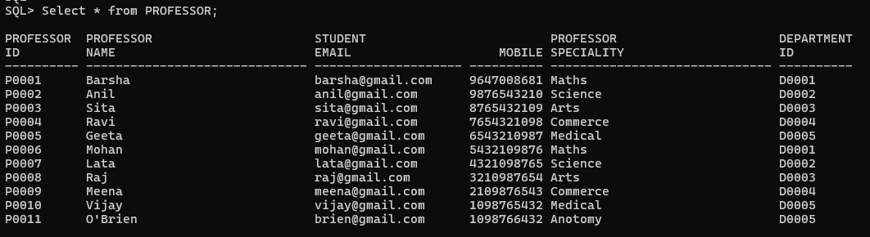

SCHOOL

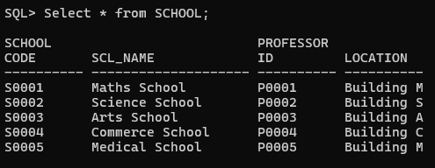

DEPARTMENT

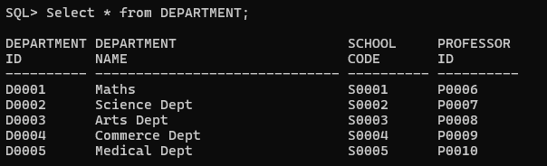

COURSE

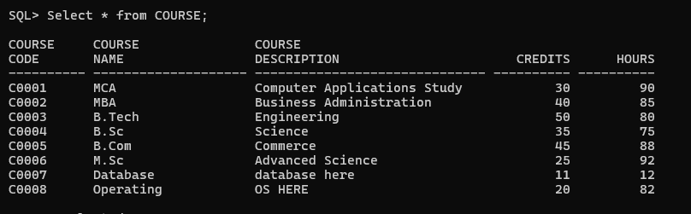

CLASS

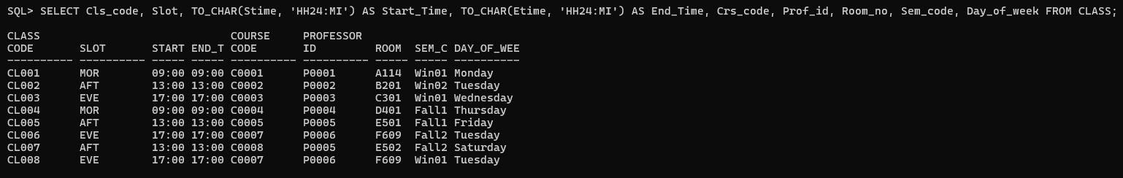

SEMESTER

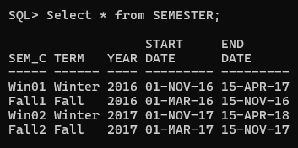

STUDENT

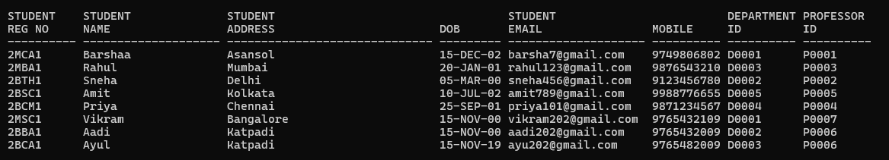

ENROLL

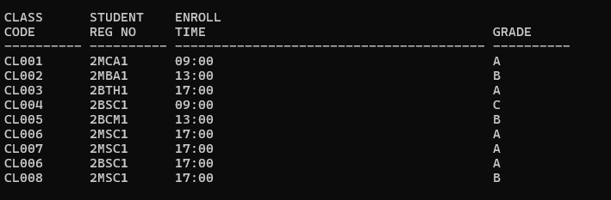

STUDENT VISA

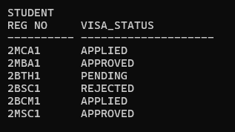

PROGRAMME

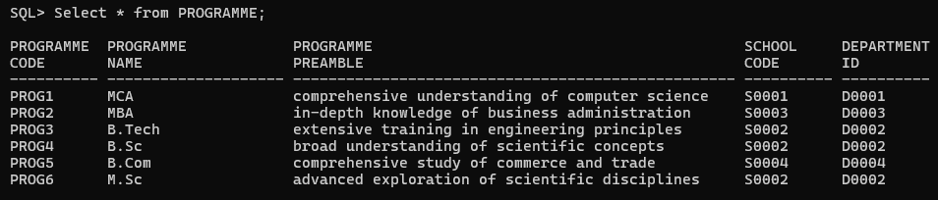

1. **Alter or Recreate the above tables with primary key and foreign key and the following integrity constraints assigning name to integrity constrain**

**SOLUTION**

--PRIMARY KEYS

ALTER TABLE PROFESSOR ADD CONSTRAINT pk_professor PRIMARY KEY (Prof_id);

ALTER TABLE SCHOOL ADD CONSTRAINT pk_school PRIMARY KEY (SCode);

ALTER TABLE DEPARTMENT ADD CONSTRAINT pk_department PRIMARY KEY (Dept_id);

ALTER TABLE COURSE ADD CONSTRAINT pk_course PRIMARY KEY (Crs_code);

ALTER TABLE CLASS ADD CONSTRAINT pk_class PRIMARY KEY (Cls_code);

ALTER TABLE SEMESTER ADD CONSTRAINT pk_semester PRIMARY KEY (Sem_code);

ALTER TABLE STUDENT ADD CONSTRAINT pk_student PRIMARY KEY (Reg_no);

ALTER TABLE ENROLL ADD CONSTRAINT pk_enroll PRIMARY KEY (Cls_code, Reg_no);

ALTER TABLE STUDENT_VISA ADD CONSTRAINT pk_student_visa PRIMARY KEY (Reg_no);

ALTER TABLE PROGRAMME ADD CONSTRAINT pk_programme PRIMARY KEY (Prog_code);

--Add FK

alter table PROFESSOR add constraint fk_Dept foreign key(Dept_id) references DEPARTMENT(Dept_id) deferrable initially deferred;

alter table SCHOOL add constraint fk_Prof_id foreign key(Prof_id) references PROFESSOR(Prof_id) deferrable initially deferred;

alter table DEPARTMENT add constraint fk_Profid foreign key(Prof_id) references PROFESSOR(Prof_id) deferrable initially deferred;

alter table DEPARTMENT add constraint fk_SCode foreign key(SCode) references SCHOOL(SCode) deferrable initially deferred;

alter table CLASS add constraint fk_Crs_code foreign key(Crs_code) references COURSE(Crs_code) deferrable initially deferred;

alter table CLASS add constraint fk_Prfid foreign key(Prof_id) references PROFESSOR (Prof_id) deferrable initially deferred;

alter table CLASS add constraint fk_SemCode foreign key(Sem_code) references Semester(Sem_code) deferrable initially deferred;

alter table STUDENT add constraint fk_Depid foreign key(Dept_id) references DEPARTMENT (Dept_id) deferrable initially deferred;

alter table STUDENT add constraint fk_Proid foreign key(Prof_id) references PROFESSOR (Prof_id) deferrable initially deferred;

alter table Enroll add constraint fk_ClsCode foreign key(Cls_code) references CLASS (Cls_code) deferrable initially deferred;

alter table Enroll add constraint fk_RegNo foreign key(Reg_no) references STUDENT (Reg_no) deferrable initially deferred;

alter table PROGRAMME add constraint fk_SC foreign key(Scode) references SCHOOL (SCode) deferrable initially deferred;

alter table PROGRAMME add constraint fk_DepI foreign key(Dept_id) references DEPARTMENT (Dept_id) deferrable initially deferred;

1. i**) Prof_id must have exactly five characters and their email and mobile number are unique. The email address must have @ as one of the characters and mobile number must have exactly ten characters.**

**ii) Use timestamp data type without fractional parts of seconds for start time and end time column of class table**

**iii) The Sem_code should start with either ‘Win’ or ‘Fall’ and Term column can assume only one of two values {Winter, Fall}.**

**iv) Email and mobile column in student table should have same characteristics as those in professor table.**

**v) The enroll_time in the enroll table should be of timestamp data type without fractional parts of seconds. The grade may assume one of the values in {‘S’, ‘A’, ‘B’, ‘C’, ‘D’}**

**vi) Use ‘on delete cascade’ or ‘on delete set null’ clause as requirements. Use deferrable constraint, if required.**

**vii) Additional (innovative) integrity constraints, if any, may be specified by you.**

--PROFESSOR

alter table PROFESSOR add constraint uk_email unique(Email);

alter table PROFESSOR add constraint uk_Mobile unique(Mobile);

alter table PROFESSOR add constraint chk_Len CHECK(LENGTH(Prof_id)=5);

alter table PROFESSOR add constraint chk_Len_Mob CHECK(LENGTH(Mobile)=10);

alter table PROFESSOR add constraint chk_Email_atTheRate CHECK(Email like '%@%');

--SEMESTER

alter table SEMESTER add constraint chk_SemesCod CHECK(sem_code Like 'Win%' or sem_code like 'Fall%' );

alter table SEMESTER add constraint chk_Term CHECK(Term IN ('Winter', 'Fall') );

--STUDENT

alter table STUDENT add constraint uk_stu_email unique(Email);

alter table STUDENT add constraint uk_stu_Mobile unique(Mobile);

alter table STUDENT add constraint chk_Len_StuMob CHECK(LENGTH(Mobile)=10);

alter table STUDENT add constraint chk_stuEmail_atTheRate CHECK(Email like '%@%');

--ENROLL

alter table Enroll add constraint chk_value CHECK(Grade IN ('S', 'A','B','C','D'));

**4. . In built functions**

**(i) Test the string manipulation functions – UPPER, LOWER, INITCAP, LENGTH, LPAD, RPAD, LTRIM, RTRIM and TRIM, using select queries on data present in the tables. Use one query each for demonstration of one function**

SELECT UPPER(Sname) FROM STUDENT;

SELECT LOWER(Sname) FROM STUDENT;

SELECT INITCAP(Visa_status) FROM STUDENT_VISA;

SELECT LENGTH(Dname) FROM DEPARTMENT;

SELECT LPAD(Visa_status,12,'*') FROM STUDENT_VISA;

SELECT RPAD(Visa_status,12,'*') FROM STUDENT_VISA;

SELECT TRIM(emp_name) FROM Emp1;

SELECT RTRIM(emp_name,' ') FROM Emp1;

SELECT LTRIM(emp_name, ' ') FROM Emp1;

**SOLUTION**

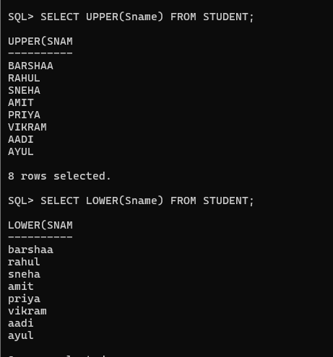

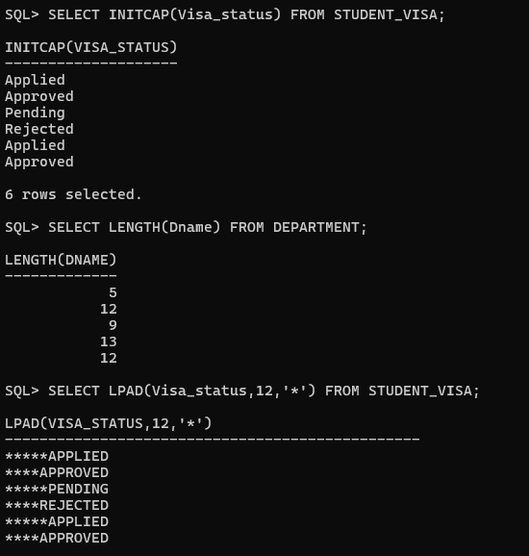

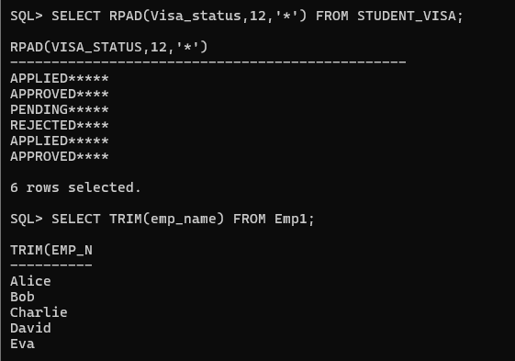

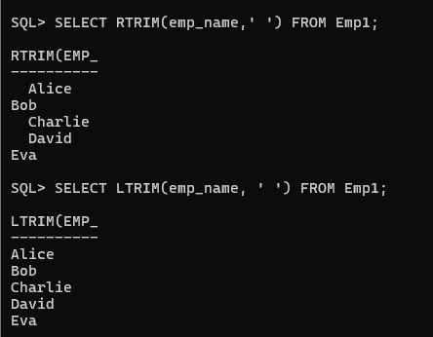

(**ii) Write query to illustrate usage of NVL function and NULLIF function.**

select Empid,emp_name,nvl(BonusAmt,0) as BonusAmt from emp1;

select Empid,emp_name,salary,bonusamt,nullif(salary,Bonusamt) as TotalAmt from emp1;  --not returning null when not equal

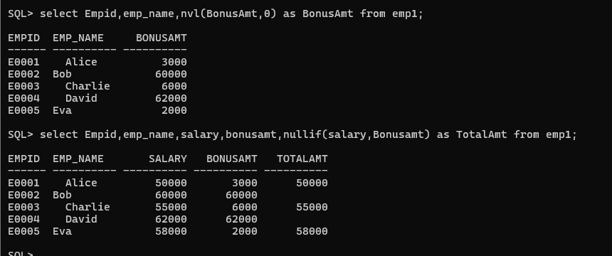

(**iii) Display the name of the students who were born on a specified month.**

select sname from student where extract(month from DOB)=12;

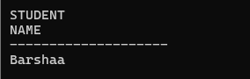

**(iv) Display the name of the students with a specified date of birth.**

select sname from student where DOB = TO_DATE('20-JAN-2001', 'DD-MON-YYYY');

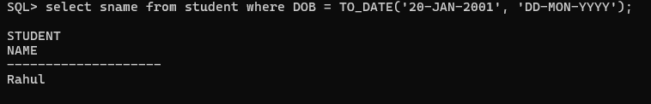

(v**) Display the date of birth of a specified student in the format ‘Day of week, Month dd, yyyy’**.

select TO_CHAR('Day , Month dd,yyyy') from student where sname='Barshaa';

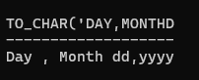

**(vi) Display the hour and minutes of the start time and end time of a specified slot.**

SELECT TO_CHAR(Stime, 'HH24:MI') AS Start_Time, TO_CHAR(Etime, 'HH24:MI') AS End_Time FROM CLASS WHERE Slot = 'MOR';

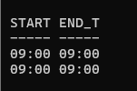

**(vii) Display the day of week of the start date and end date of Winter semester 17–18.**

SELECT

    TO_CHAR(Sdate, 'Day') AS Start_Day,

    TO_CHAR(Edate, 'Day') AS End_Day

FROM SEMESTER

WHERE Term = 'Winter'

  AND Year = '2017';

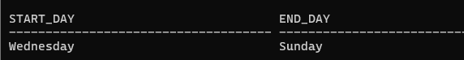

**(viii) Display the duration of Winter semester 17–18 in terms of number of weeks.**

SELECT ROUND((Edate - Sdate) / 7) AS Duration_Weeks FROM SEMESTER WHERE Term = 'Winter' AND Year = '2017';

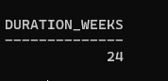

**(ix) Store date in the format dd/mm/yy for DOB of newly admitted student.**

SELECT sname, TO_CHAR(DOB, 'DD/MM/YY') AS NewDob FROM student;

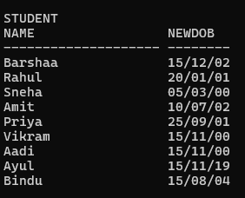

**(x) Test the numeric functions – CEIL, FLOOR, TRUCATE, MIN, MAX, AVG,COUNT using select queries on data present in the tables. Use one query each for demonstration of one function.**

SELECT CEIL(AVG(Credits)) FROM COURSE;

SELECT FLOOR(AVG(Credits)) FROM COURSE;

SELECT TRUNC(AVG(Credits), 1) FROM COURSE;

SELECT MIN(Credits) FROM COURSE;

SELECT MAX(Credits) FROM COURSE;

SELECT AVG(Credits) FROM COURSE;

SELECT COUNT(*) FROM ENROLL;

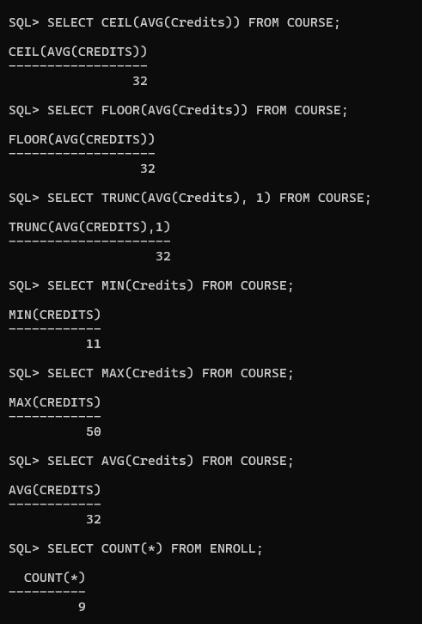

1. **Write Queries for**
2. **Display name, email address and address for those students who live in Katpadi area and whose name has an l as the third character.**

SELECT sname, Email, Address FROM Student WHERE Address = 'Katpadi' AND sname LIKE '___l%';

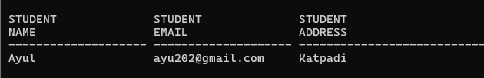

1. **Display name, email address and address for those students who are not from Tamil Nadu.**

SELECT sname, Email, Address FROM Student WHERE Address != 'Tamil Nadu';

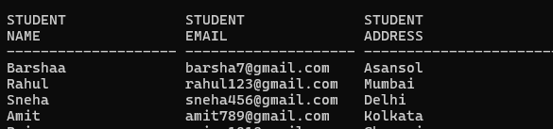

1. **Display name, email address and address of foreign students only.**

SELECT STUDENT.SNAME, STUDENT.EMAIL,STUDENT.ADDRESS FROM STUDENT INNER JOIN STUDENT_VISA ON STUDENT.REG_NO = STUDENT_VISA.REG_NO;

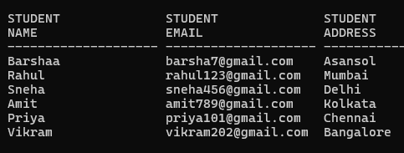

**(iv) List the name of professors along with their specialty who belong to School of Medicine.**

SELECT PROFESSOR.PROF_NAME, PROFESSOR.SPECIALITY FROM PROFESSOR INNER JOIN SCHOOL ON SCHOOL.SCL_NAME = 'Medical School' AND SCHOOL.PROF_ID = PROFESSOR.PROF_ID;

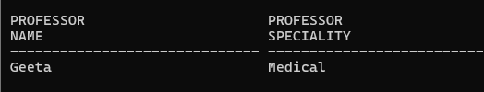

**v.Display name of the school and name of professor who chairs the school.**

SELECT SCHOOL.SCL_NAME, PROFESSOR.PROF_NAME FROM PROFESSOR INNER JOIN SCHOOL ON SCHOOL.PROF_ID = PROFESSOR.PROF_ID;

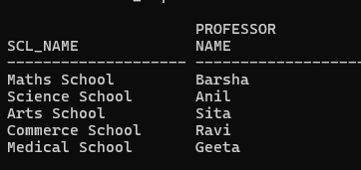

1. **List course code, course name and course description in alphabetic order of course code.**

SELECT CRS_CODE,CRS_NAME, DESCRIPTION FROM COURSE ORDER BY CRS_CODE;

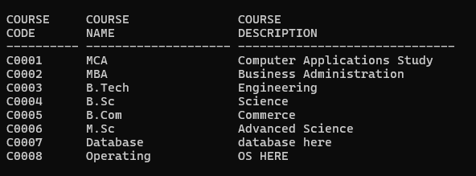

1. **Change the mobile number of a student interactively.**

UPDATE STUDENT SET MOBILE='&MOBILE' WHERE REG_NO='&REG_NO';

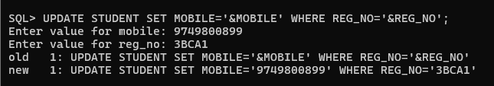

**(viii) Remove enrollment information of a student from a particular course interactively. How would you recover the data?**

SAVEPOINT BEFORE_del;

DELETE FROM ENROLL WHERE REG_NO='&REG_NO';

--we can recover data with the help of ROLLBACK

ROLLBACK TO BEFORE_del;

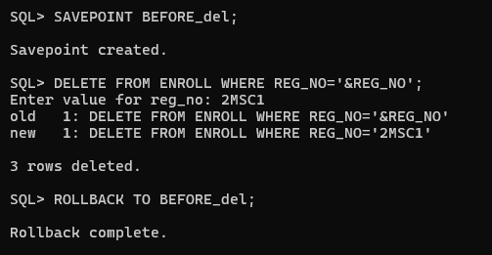

**(ix) Create a duplicate of course table.**

CREATE TABLE COURSE_DUPLICATED AS SELECT * FROM COURSE;

SELECT * FROM COURSE_DUPLICATED;

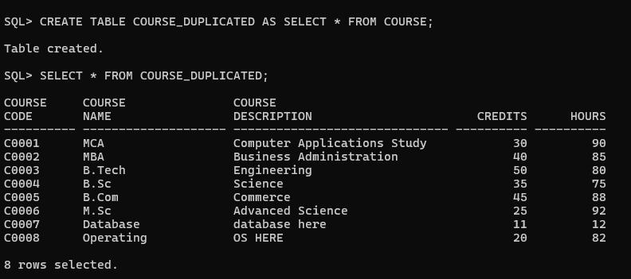

**(x) Create a view for list of students (Reg_no, Sname) and the courses they have registered along with name of professors teaching the course.**

CREATE VIEW STUDENTS_COURSE_VIEW AS

SELECT STUDENT.REG_NO, STUDENT.SNAME, COURSE.CRS_NAME, PROFESSOR.PROF_NAME FROM STUDENT INNER JOIN ENROLL ON ENROLL.REG_NO = STUDENT.REG_NO INNER JOIN CLASS ON ENROLL.CLS_CODE = CLASS.CLS_CODE INNER JOIN COURSE ON COURSE.CRS_CODE = CLASS.CRS_CODE

INNER JOIN PROFESSOR ON PROFESSOR.PROF_ID = CLASS.PROF_ID;

SELECT * FROM STUDENTS_COURSE_VIEW;

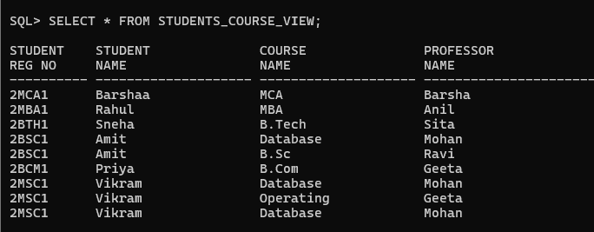

**(xi) List the room number, slot, start time, end time and duration of every class held on Wednesdays in descending order of room number.**

SELECT ROOM_NO, SLOT, TO_CHAR(Stime, 'HH24:MI') AS STIME, TO_CHAR(Etime, 'HH24:MI') AS ETIME, EXTRACT (HOUR FROM ETIME - STIME) AS "DURATION" FROM CLASS WHERE DAY_OF_WEEK = 'Wednesday' ORDER BY ROOM_NO DESC;

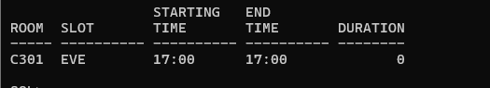

**(xii) Display the name and grade of a student in different courses underwent in fall semester 2017 – 18.**

SELECT STUDENT.SNAME, COURSE.CRS_NAME, ENROLL.GRADE FROM STUDENT INNER JOIN ENROLL ON ENROLL.REG_NO = STUDENT.REG_NO INNER JOIN CLASS ON CLASS.CLS_CODE = ENROLL.CLS_CODE INNER JOIN COURSE ON COURSE.CRS_CODE = CLASS.CRS_CODE INNER JOIN SEMESTER ON SEMESTER.SEM_CODE = CLASS.SEM_CODE AND SEMESTER.TERM = 'Fall' AND SEMESTER.YEAR = 2017;

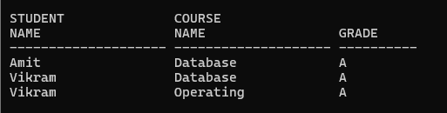

**(xiii) Find out name of students who have taken Database Systems course as well as Operating Systems course in fall semester 2016 – 17.**

SELECT STUDENT.SNAME FROM STUDENT INNER JOIN ENROLL

ON ENROLL.REG_NO = STUDENT.REG_NO INNER JOIN CLASS

ON CLASS.CLS_CODE = ENROLL.CLS_CODE

INNER JOIN COURSE

ON CLASS.CRS_CODE = COURSE.CRS_CODE

AND COURSE.CRS_CODE IN ('C0007',

'C0008')

INNER JOIN SEMESTER

ON SEMESTER.SEM_CODE = CLASS.SEM_CODE

AND SEMESTER.TERM = 'Fall'

AND SEMESTER.YEAR = 2017

GROUP BY

STUDENT.SNAME

HAVING

COUNT(DISTINCT COURSE.CRS_CODE) = 2;

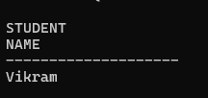

**(xiv) Find out name of students who have taken Database Systems course but have not taken Operating Systems course in winter semester 2017 – 18.**

SELECT STUDENT.SNAME, COURSE.CRS_CODE FROM STUDENT

INNER JOIN ENROLL ON ENROLL.REG_NO = STUDENT.REG_NO

INNER JOIN CLASS ON ENROLL.CLS_CODE = CLASS.CLS_CODE

INNER JOIN COURSE ON COURSE.CRS_CODE = CLASS.CRS_CODE AND COURSE.CRS_CODE IN ('C0007','C0008')

INNER JOIN SEMESTER ON SEMESTER.SEM_CODE = CLASS.SEM_CODE AND SEMESTER.YEAR = 2017

AND SEMESTER.TERM = 'Winter'

MINUS

SELECT STUDENT.SNAME, COURSE.CRS_CODE FROM STUDENT

INNER JOIN ENROLL ON ENROLL.REG_NO = STUDENT.REG_NO

INNER JOIN CLASS ON ENROLL.CLS_CODE = CLASS.CLS_CODE

INNER JOIN COURSE ON COURSE.CRS_CODE = CLASS.CRS_CODE

AND COURSE.CRS_CODE = 'C0008' INNER JOIN SEMESTER ON SEMESTER.SEM_CODE = CLASS.SEM_CODE AND SEMESTER.YEAR = 2018

AND SEMESTER.TERM = 'Win01';



**(xv) List the registration number and name of the students who have registered for maximum number of credits in Winter 17-18 semester.**

SELECT S.Reg_no, S.Sname

FROM STUDENT S

JOIN ENROLL E ON S.Reg_no = E.Reg_no

JOIN CLASS C ON E.Cls_code = C.Cls_code

JOIN COURSE CR ON C.Crs_code = CR.Crs_code

JOIN SEMESTER SEM ON C.Sem_code = SEM.Sem_code

WHERE SEM.Term = 'Win01'

AND SEM.Year = '2016'

GROUP BY S.Reg_no, S.Sname

HAVING SUM(CR.Credits) = (

SELECT MAX(Total_Credits)

FROM (

SELECT SUM(CR.Credits) AS Total_Credits

FROM STUDENT S

JOIN ENROLL E ON S.Reg_no = E.Reg_no

JOIN CLASS C ON E.Cls_code = C.Cls_code

JOIN COURSE CR ON C.Crs_code = CR.Crs_code

JOIN SEMESTER SEM ON C.Sem_code = SEM.Sem_code

WHERE SEM.Term = 'Win01'

AND SEM.Year = '2016'

GROUP BY S.Reg_no

)

);

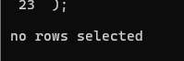

**(xvi) List the name of the course and the number of students registered in each slot for course under different faculty members.**

SELECT COURSE.CRS_NAME, COUNT(ENROLL.REG_NO), SLOT FROM COURSE, ENROLL, CLASS WHERE ENROLL.CLS_CODE = CLASS.CLS_CODE AND CLASS.CRS_CODE = COURSE.CRS_CODE GROUP BY ENROLL.REG_NO, COURSE.CRS_NAME, SLOT;

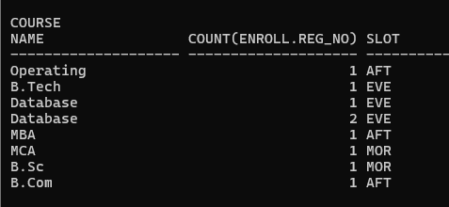

**(xvii) Find out the name of the students who have registered in all the courses being taught by Prof. O’Brien in Winter 17-18.**

SELECT STUDENT.SNAME FROM STUDENT, PROFESSOR, CLASS, ENROLL WHERE ENROLL.CLS_CODE = CLASS.CLS_CODE AND ENROLL.REG_NO = STUDENT.REG_NO AND CLASS.PROF_ID = PROFESSOR.PROF_ID AND PROFESSOR.PROF_NAME = 'O''Brien';

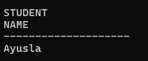

**(xviii) List the registration number of the students who registered in Database Systems course on November 17, 2017**

SELECT STUDENT.REG_NO

    FROM STUDENT, ENROLL, CLASS, COURSE

    WHERE ENROLL.REG_NO = STUDENT.REG_NO

    AND ENROLL.CLS_CODE = CLASS.CLS_CODE

    AND CLASS.CRS_CODE = COURSE.CRS_CODE

    AND TO_CHAR(ENROLL.ENROLL_TIME, 'DD-MM-YYYY') = '17-11-2017'

    AND COURSE.CRS_NAME = 'Database';

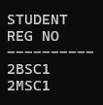

**(xix) Write a query to display the grade of a student given his/her registration number and the course name for Fall semester 17–18.**

SELECT ENROLL.REG_NO

    FROM ENROLL, CLASS, SEMESTER

    WHERE ENROLL.CLS_CODE = CLASS.CLS_CODE

    AND CLASS.SEM_CODE = SEMESTER.SEM_CODE

    AND SEMESTER.SEM_CODE LIKE 'Fall%'

    AND SEMESTER.YEAR = '2017'

    AND ENROLL.REG_NO LIKE '&REG_NO';

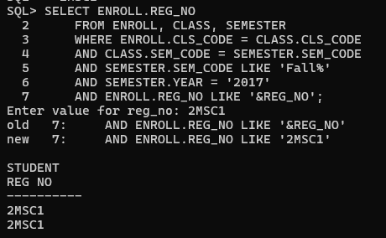

**(xx) List the name of departments and the name professors who is in charge of the department.**

SELECT Dept.Dname AS Department_Name, Prof.Prof_name AS Professor_Name

FROM DEPARTMENT Dept

JOIN PROFESSOR Prof ON Dept.Prof_id = Prof.Prof_id;

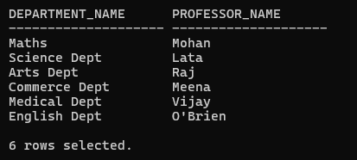

**(xxi) List the name of schools with students’ strength higher than 7000.**

SELECT Sch.Scl_name AS School_Name, COUNT(Stu.Reg_no) AS Student_Strength FROM STUDENT Stu JOIN DEPARTMENT Dept ON Stu.Dept_id = Dept.Dept_id JOIN SCHOOL Sch ON Dept.SCode = Sch.SCode GROUP BY Sch.Scl_name HAVING COUNT(Stu.Reg_no) > 7000;

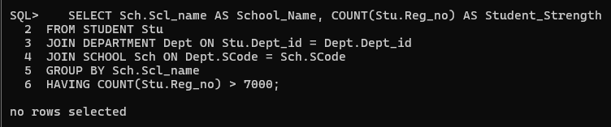

**(xxii) List the name of the department(s) under school of medicine with student strength higher than the average students of all the departments in the school.**

**(xxiii) Given the registration number of a student, display the total credits registered by him/her in Winter 17–18**

SELECT S.Reg_no, SUM(CR.Credits) AS Total_Credits FROM ENROLL E

JOIN CLASS C ON E.Cls_code = C.Cls_code

JOIN COURSE CR ON C.Crs_code = CR.Crs_code

JOIN SEMESTER SEM ON C.Sem_code = SEM.Sem_code

JOIN STUDENT S ON E.Reg_no = S.Reg_no

WHERE S.Reg_no = '2MSC1' AND SEM.Term = 'Win01' AND SEM.Year = '2018' GROUP BY S.Reg_no;

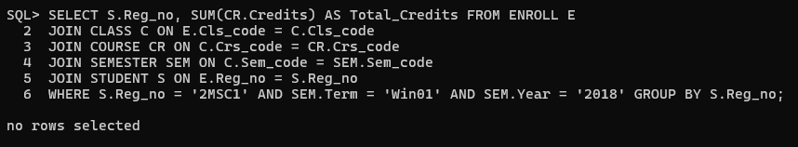

**(xxiv) Given the registration number of a student, display her/his grade in the course she/he registered in Fall 17–18.**

SELECT E.Cls_code, C.Crs_code, C.Crs_name, E.Grade

FROM ENROLL E

JOIN CLASS CL ON E.Cls_code = CL.Cls_code

JOIN COURSE C ON CL.Crs_code = C.Crs_code

JOIN SEMESTER SEM ON CL.Sem_code = SEM.Sem_code

WHERE SEM.Term = 'Fall1'

AND SEM.Year = '2017'

AND E.Reg_no = : &reg_no;

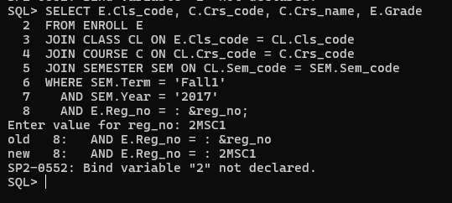

**(xxv) Display the name of the courses that are not being offered in Winter 17–18.**

SELECT C.Crs_name FROM COURSE C WHERE C.Crs_code NOT IN ( SELECT CL.Crs_code FROM CLASS CL JOIN SEMESTER SEM ON CL.Sem_code = SEM.Sem_code WHERE SEM.Term = 'Win01' AND SEM.Year = '2017' );

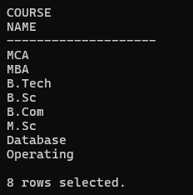

**(xxvi) Write necessary SQL statement to advance the start time and end time of every class by ten minutes in Fall 18–19.**

UPDATE CLASS SET Stime = Stime + INTERVAL '10' MINUTE, Etime = Etime + INTERVAL '10' MINUTE WHERE Sem_code = ( SELECT Sem_code FROM SEMESTER WHERE Term = 'Fall' AND Year = '2017' );



**(xxvii) Write necessary SQL statement to advance the start date and end date of Fall 18–19 semester by one week with respect to Fall semester of 17 – 18.**

**BEFORE**

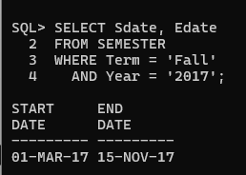

UPDATE SEMESTER

SET Sdate = Sdate + INTERVAL '7' DAY,

Edate = Edate + INTERVAL '7' DAY

WHERE Term = 'Fall'

AND Year = '2017';

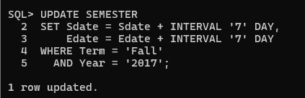

**AFTER**

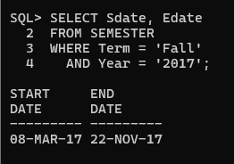

**(xxviii) Find out the name list of students who had secured ‘S’ grade in at least 50% of the courses cleared by her/him.**

SELECT S.Sname

FROM STUDENT S

WHERE

(SELECT COUNT(*)

FROM ENROLL E

WHERE E.Reg_no = S.Reg_no AND E.Grade = 'S') >=

(SELECT COUNT(*) / 2

FROM ENROLL E

WHERE E.Reg_no = S.Reg_no);

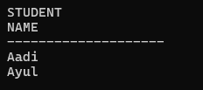

**(xxix) Given the registration number of a student, find out his/her free slots.**

SELECT DISTINCT Cl.Slot

FROM CLASS Cl

WHERE Cl.Slot NOT IN (

SELECT C.Slot

FROM ENROLL E

JOIN CLASS C ON E.Cls_code = C.Cls_code

WHERE E.Reg_no = '2MSC1'

);

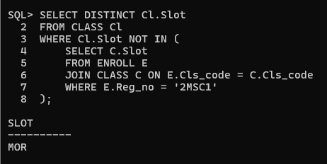

**(xxx) Find out the name list of students who have classes in the afternoon session only a specific day of the week.**

SELECT DISTINCT S.Sname FROM STUDENT S JOIN ENROLL E ON S.Reg_no = E.Reg_no JOIN CLASS C ON E.Cls_code = C.Cls_code WHERE C.Day_of_week = 'Monday' -- Specify the day of the week AND Slot=’Aft’;

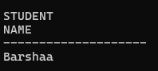

**(xxxi) Add a column named ‘Duration’ (to indicate duration of a class) with appropriate data type to the CLASS table and populate the column from values of start time and end time columns.**

ALTER TABLE CLASS ADD Duration INTERVAL DAY TO SECOND;

UPDATE CLASS SET Duration = Etime - Stime;

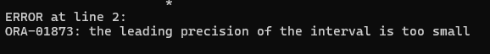

**(xxxiii) Find out the list of students who are undergoing MCA program.**

SELECT S.Reg_no, S.Sname FROM STUDENT S JOIN PROGRAMME P ON S.Dept_id = P.Dept_id WHERE P.Prog_name = 'MCA';

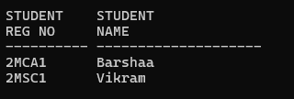

**(xxxiv) Display the name of programs and the name of school offering the program.**

SELECT Prog.Prog_name AS Program_Name, Sch.Scl_name AS School_Name FROM PROGRAMME Prog JOIN SCHOOL Sch ON Prog.SCode = Sch.SCode;

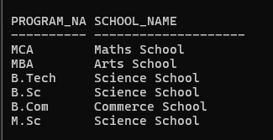

**(xxxv) Display the name of the departments and the name of the program controlled by the department.**

SELECT Dept.Dname AS Department_Name, Prog.Prog_name AS Program_Name FROM DEPARTMENT Dept JOIN PROGRAMME Prog ON Dept.Dept_id = Prog.Dept_id;

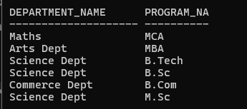

**(xxxvi) Find the school which has highest school strength (i.e number of students)**

SELECT Scl_name, Student_Count FROM ( SELECT Sch.Scl_name, COUNT(Stu.Reg_no) AS Student_Count FROM STUDENT Stu JOIN DEPARTMENT Dept ON Stu.Dept_id = Dept.Dept_id JOIN SCHOOL Sch ON Dept.SCode = Sch.SCode GROUP BY Sch.Scl_name ORDER BY Student_Count DESC ) WHERE ROWNUM = 1;

