Introduction

Liver cirrhosis is a serious chronic liver disease in which healthy liver tissue is gradually replaced by scar tissue, leading to reduced liver function and potentially life- threatening complications. Early detection is often difficult because symptoms may be subtle or absent in the initial stages. This project develops an educational Liver Cirrhosis Risk Checker, a Python-based rule‑based expert system that collects user inputs such as alcohol consumption, viral hepatitis history, obesity, fatigue, jaundice, and abdominal swelling to assess the likelihood of cirrhosis. The system demonstrates how multiple risk factors and symptoms can be analyzed using weighted rules and inference, provides explainable outputs, and emphasizes safe guidance, highlighting that it is strictly an educational tool and not a substitute for professional medical diagnosis.

Statement of the Problem

Early detection of liver cirrhosis is challenging because symptoms often appear late or are nonspecific, making it difficult for individuals to assess their risk without professional evaluation. Students need a safe, explainable tool to understand how expert systems can assist in preliminary risk assessment by analyzing multiple factors simultaneously. The problem addressed in this project is: How can we design a transparent, classroom-ready system that evaluates liver cirrhosis risk based on symptoms and lifestyle factors while clearly differentiating low-risk and high-risk scenarios, without replacing professional medical advice?

Objectives of the Study

    - Build a Python-based rule engine to assess the risk of liver cirrhosis using weighted symptoms and lifestyle factors.
    - Implement explanations that show which risk factors contributed to the
suggested risk level.
    - Include safety alerts for high-risk indicators, emphasizing the need for professional medical consultation.
    - Demonstrate the system’s functionality through sample runs and discuss its
accuracy and limitations for educational purposes.

Significance of the Study

This project holds academic significance by helping students understand how rule- based expert systems can process multiple symptoms and risk factors to provide explainable outputs. Practically, it demonstrates safe, preliminary risk assessment for liver cirrhosis, guiding users to seek timely medical advice when high-risk indicators are present. The system emphasizes ethical use and safety, making it a valuable educational tool while clearly distinguishing that it is not intended for actual diagnosis or treatment.

METHODOLOGY AND DATA COLLECTION

  - Knowledge Engineering Target Condition: Liver Cirrhosis
Risk Factors / Differentials: Alcohol abuse, viral hepatitis (B or C), obesity-related fatty liver, chronic medication use, and genetic predisposition.
Feature Selection: Fatigue, jaundice, abdominal swelling (ascites), easy bruising or bleeding, loss of appetite, weight loss, alcohol consumption, history of viral hepatitis, obesity, and other clinical indicators. Safety red flags include severe abdominal pain, confusion (hepatic encephalopathy), and gastrointestinal bleeding.
Weights: Assign higher weights to features that are strongly indicative of liver cirrhosis. For example: jaundice, ascites, and prolonged alcohol use carry higher weight; fatigue and loss of appetite carry moderate weight; and obesity or mild liver enzyme elevation carry lower weight.
  - System Design (Architecture and Flowchart)

Architecture of Liver Cirrhosis Risk Checker

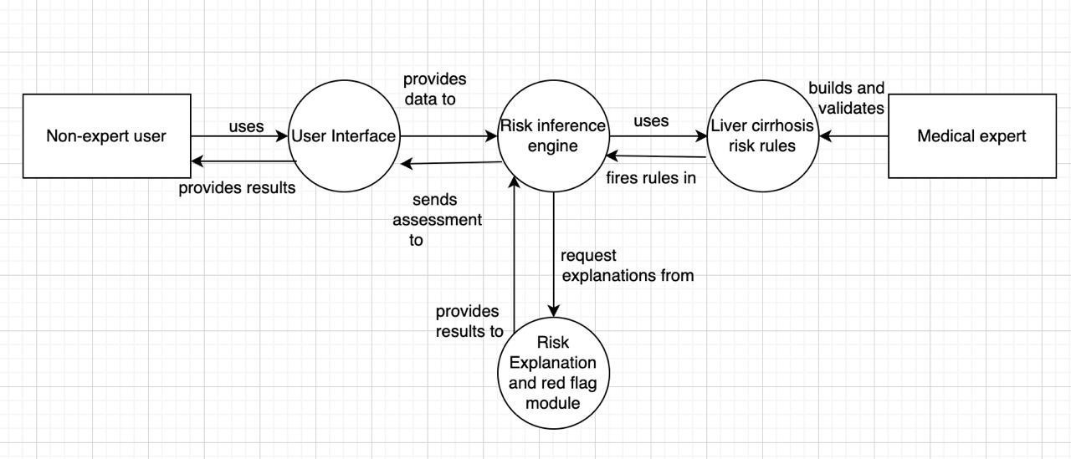

fig: architecture of Liver Cirrhosis Risk Checker

Flowchart
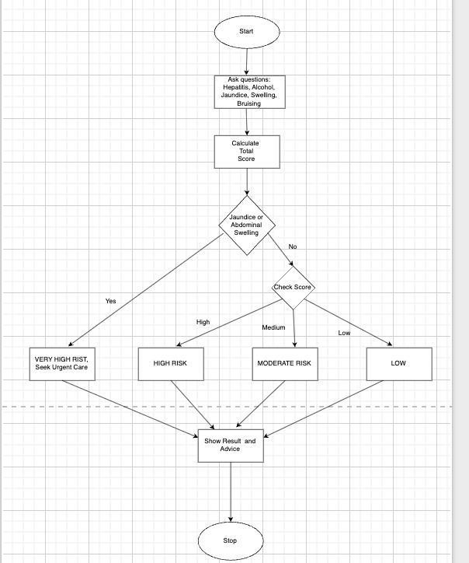

Fig: flowchart of Liver Cirrhosis Risk Checker

Pseudocode

BEGIN

Initialize a risk score risk_score = 0 has_red_flag = false IF has_red_flag = true THEN
PRINT "VERY HIGH RISK: Urgent medical evaluation is strongly
recommended."
PRINT "You have symptoms (jaundice or swelling) that require immediate attention."

ELSE
// If no red flags, classify based on total score IF risk_score >= 50 THEN
PRINT "VERY HIGH RISK: Significant risk factors present. Please consult a
doctor."
ELSE IF risk_score >= 30 THEN
PRINT "HIGH RISK: Multiple risk factors identified. A medical consultation is advised."
ELSE IF risk_score >= 15 THEN
PRINT "MODERATE RISK: Some risk factors present. Consider discussing with a doctor."

ELSE
PRINT "LOW RISK: Few significant risk factors identified based on your inputs."

END IF END IF

BEGIN // Initialize a risk score risk_score = 0 has_red_flag = false ASK "History of Hepatitis B or C? (yes/no): " -> hepatitis
ASK "Heavy alcohol consumption? (yes/no): " -> alcohol
ASK "Yellowing of skin/eyes (Jaundice)? (yes/no): " -> jaundice ASK "Unexplained abdominal swelling? (yes/no): " -> swelling ASK "Easy bruising? (yes/no): " -> bruising
IF hepatitis = "yes" THEN risk_score = risk_score + 30

END IF

IF alcohol = "yes" THEN risk_score = risk_score + 25

END IF
IF jaundice = "yes" THEN risk_score = risk_score + 35 has_red_flag = true

END IF
IF swelling = "yes" THEN risk_score = risk_score + 30 has_red_flag = true

END IF
IF bruising = "yes" THEN risk_score = risk_score + 15

END IF
IF has_red_flag = true THEN
PRINT "VERY HIGH RISK: Urgent medical evaluation is strongly recommended."
PRINT "You have symptoms (jaundice or swelling) that require immediate attention."

ELSE

IF risk_score >= 50 THEN
PRINT "VERY HIGH RISK: Significant risk factors present. Please consult a doctor."
ELSE IF risk_score >= 30 THEN
PRINT "HIGH RISK: Multiple risk factors identified. A medical consultation is advised."
ELSE IF risk_score >= 15 THEN
PRINT "MODERATE RISK: Some risk factors present. Consider discussing with a doctor."

ELSE
PRINT "LOW RISK: Few significant risk factors identified based on your inputs."
END IF

END IF END

Data Sources and Assumptions

Category Details Sources/References

Risk Factor Patterns Risk rules (e.g., heavy
alcohol use, hepatitis history, jaundice, abdominal swelling) are simplified for educational purposes. Weighting of scores is illustrative and not intended as a clinical risk stratification tool.
Data Usage No personal identifiable information, medical records, or lab data are used or stored. The system relies solely on anonymous, self-reported user inputs (yes/no answers) to hypothetical questions.
American Liver Foundation (ALF) guidelines on Cirrhosis. WHO publications on liver disease. Mayo Clinic & Cleveland Clinic patient education resources on cirrhosis symptoms and causes. General principles of medical educational tool design.

Limitations and Assumptions
The red-flag symptom list (jaundice, ascites) is critical but not exhaustive. Assumes user answers are accurate.
Academic AI and health education literature on expert system design; illustrative case study design.

Sources:

American Liver Foundation. "Cirrhosis of the Liver." Retrieved from https://liverfoundation.org/liver-diseases/

RESULTS AND DISCUSSION

  - Implementation

The full Python program is provided as liver_cirrhosis_risk_checker.py. It implements: A weighted scoring system for risk factors associated with liver cirrhosis.
Red-flag prompts (e.g., jaundice, abdominal swelling) that trigger an urgent-care notice if present, overriding the standard risk score.
A categorical risk output (Low, Moderate, High, Very High) based on the calculated score.
Transparent explanations listing the specific risk factors that contributed to the final score and category.

Effectiveness and Limitations

Strengths: Explainable, rule-based logic; clear risk categorization; prioritization of critical symptoms via red-flag safety features; prominent ethical disclaimers.
Limitations: Educational weights and thresholds only; does not use quantitative data (e.g., liver enzyme levels, imaging results); lacks comorbidity context (e.g., impact of obesity with diabetes); not validated against clinical datasets; relies on accurat e self- reporting by the user.

Comparison with Clinical CDSS (Clinical Decision Support System)

Clinical decision support systems used in hepatology integrate complex clinical guidelines, electronic health record (EHR) data (e.g., lab results, imaging reports), and are validated for sensitivity and specificity. This educational project prioritizes conceptual clarity and pedagogical transparency over clinical accuracy or completeness. It serves as a simplified model to demonstrate how risk factors can be computationally assessed, not to replicate the functionality of a medical-grade CDSS.

CONCLUSION

Summary and Feedback: This project successfully implemented an educational, rule- based expert system designed to assess an individual's risk factors for liver cirrhosis.

The system utilizes a transparent weighted scoring mechanism, incorporates critical red-flag symptom checks to prompt urgent medical advice, and provides clear explanations for its conclusions. Through this implementation, key practical AI concepts were reinforced, including knowledge engineering, the design of an inference engine, and the importance of explainability in automated systems, providing a solid foundation for understanding rule-based reasoning in a health context.
Suggestions and Recommendations: Future enhancements to this prototype could include incorporating severity scales for symptoms (e.g., quantifying alcohol units), adding optional inputs for basic vital signs, and exploring probabilistic methods like Bayesian networks to handle uncertainty.

REFERENCES

- American Liver Foundation. (2023). Cirrhosis of the Liver. Retrieved from https://liverfoundation.org/liver-diseases/cirrhosis/
- World Health Organization (WHO). (2021). Global Hepatitis Report. Retrieved
from https://www.who.int/publications/i/item/9789240027077
- Mayo Clinic. (2023). Cirrhosis - Symptoms and causes. Retrieved from https://www.mayoclinic.org/diseases-conditions/cirrhosis/symptoms- causes/syc-20351487
- National Institute of Diabetes and Digestive and Kidney Diseases (NIDDK). (2018). Cirrhosis. In Liver Disease. Retrieved from https://www.niddk.nih.gov/health-information/liver-disease/cirrhosis

Appendix

Google Colab: https://colab.research.google.com/drive/14Fc0a1ii6ieex8Exc9YrL6bgWjaX4bz8

