

“Experience of Global Education ….. World Impact”
0 | 3 | 2 | 4 | 2 | 0 | 2 | 6





(Affiliate to Lincoln University College, Malaysia)
Itahari, Sunsari, Nepal

FACULTY OF BIT ASSIGNMENT COVER PAGE

Student's Name | Barsha Magar
Year/Semester | 3rd year / 5th semester |  | Intake |  | 2023
Program | Bachelor of Information Technology (BIT)
Subject Name/ Subject Code | Multimedia BIT364
LC Number | LC00023000800
Lecturer's Name | Nabin Niraula
Assignment Title      (1) (2) | Project report of multimedia
No. of Page (excluding this page) | 28
Required words | 1000-1500 | Actual # of words |  | 1500
Soft copy included: | yes / No
DECLARATION BY STUDENTS:
I certify that this assignment is my own work in my own words. All resources have been acknowledged and the content has not been previously submitted for assessment to LINCOLN or elsewhere. I also confirm that I have kept a copy of this assignment.

Signed: Date:

Green Peace Lincoln College
Department of Information Technology

PROJECT REPORT
On
The Reminder

Submitted in partial fulfillment of the requirements for Bachelor of Information Technology (BIT) – 5th Semester Subject: Multimedia Technology

Submitted By: Barsha Magar
Roll No: LC00023000800 | Section: A

Submitted To:
Nabin Niraula Department of Information Technology
Academic Year: 2023 / 2026

Declaration
I hereby declare that the project report entitled:
"The Reminder"
Submitted for the partial fulfillment of BIT 5th Semester Multimedia subject is a record of original work done by me under the guidance and supervision of Nabin Niraula, Department of Information Technology, and Green Peace Lincoln College.
The contents of this report have not been submitted to any other institution or university for the award of any degree or diploma.

Signature:
Name: Barsha Magar Roll No: LC00023000800
Date: 24/03/2026

Acknowledgement
I would like to express my sincere gratitude and appreciation to all those who helped me in the successful completion of this multimedia project.

First and foremost, I am deeply thankful to Nabin Niraula, my subject teacher for Multimedia Technology, whose guidance, constructive feedback, and continuous encouragement helped me throughout the project.

I am also grateful to the Head of the Department of Information Technology, Green Peace Lincoln College, for providing the necessary resources and infrastructure to carry out this project.

Special thanks to my classmates and friends for their valuable suggestions, assistance, and moral support during the development of this project.

Finally, I would like to thank my family for their constant support and encouragement throughout my academic journey.

Signature:
Name: Barsha Magar

Table of Contents
Declaration ii
Acknowledgement iii
Table of Content iv
Chapter 1: Introduction 1
  - Background of the Project 1
  - Objectives of the Project 1
  - Scope of the Project 1
Chapter 2: Tools and Technologies Used 2
  - Hardware Requirements 2
  - Software and Tools 2
Chapter 3: Project Planning and Pre-Production 3
  - Concept and Story/Script 3
  - Storyboard 3
  - Production Schedule 4
Chapter 4: Production 5
  - Shooting / Recording 5
  - Challenges Faced During Production 5
Chapter 5: Post-Production 6
  - Video Editing Process 6
  - Audio Editing and Sound Design 6
  - Visual Effects and Transitions 7
  - Final Output Details 7
Chapter 6: Screenshots / Snapshots 8
Chapter 7: Conclusion and Future Enhancements 9
References 10
Appendix 11,27

Chapter 1: Introduction

Background of the Project
This project was undertaken as part of the Multimedia Technology course in the 5th Semester of the BIT program to create a short 3D animated story titled "The Reminder." The animation depicts a young boy playing football near his house who is gently reminded by his grandfather to move to a safer location to avoid breaking the window. To complete this project, I used Sketchfab for the 3D house model, Mixamo for character animation, Prisma3D for scene setup and animation, and CapCut for final editing and transitions.

Objectives of the Project
    - To understand and apply the complete 3D animation production workflow from pre- production to post-production.
    - To demonstrate skills in 3D modeling, character animation, video editing, and the use of professional multimedia tools.
    - To effectively utilize software such as Sketchfab, Mixamo, Prisma3D, and CapCut for creating a complete animated short film.

Scope of the Project

    - Pre-production: Concept development, scriptwriting, and storyboarding.

    - Production: 3D model acquisition, character rigging, animation, and scene setup.

    - Post-production: Video editing, transitions, audio mixing, and final export.

    - The final video has a duration of approximately 2 minutes and covers a short animated story about a boy learning an important lesson from his grandfather.

Chapter 2: Tools and Technologies Used

  - Hardware Requirement

SN | Hardware | Purpose
1 | Smart Phone | Reference audio recording
2 | Laptop | 3D animation, editing and post-production
3 | Mouse | Precision control for animation

Software and Tools

SN | Software Tools | Purpose
1 | Sketchfab | Downloading 3D house model (village house)
2 | Maximo | Character rigging and animation (movement)
3 | Prisma3D | 3D scene setup, camera placement, lighting and  animation
4 | CapCut | Video editing, transitions, text overlays and final  export

Chapter 3: Project Planning and Post-Production

Concept and Story/ Script
The concept of this video project was developed around a simple yet meaningful message: children should listen to their elders and play in safe areas. The story was built around the central idea of responsibility and care.
    - Genre: Short Animated Story / Educational
    - Target Audience: Children and General Public
    - Durations: 2 minutes
    - Language: English

Storyboard

Scene | Visual Description | Text/Narration | Camera | Duration
1 | Village house exterior, boy  playing football | None | Wide Shot | 15 sec
2 | Boy kicking ball, looking at  window | (Sound: ball  bounce) | Medium Shot | 10 sec
3 | Powerful kick towards window | (Sound: kick) | Close-up | 15 sec
4 | Ball misses window, boy sighs | (Sound: whoosh) | Medium Shot | 10 sec
5 | Grandfather appears, gestures to boy | "Don't play here. The window  might break." | Medium Shot | 20 sec
6 | Boy nods with understanding | None | Close-up | 15 sec
7 | Boy moves to safe area | (Sound: footsteps) | Wide Shot | 15 sec
8 | Boy plays happily in safe area | "Always play in a  safe place." | Wide Shot | 10 sec
9 | Grandfather smiles, end credits | "Always play in a  safe place." | Wide Shot/Fade  Out | 10 sec

Production Schedule

Task | Assigned | Date
Project Lead, Concept, Script, Storyboard,  Final Editing | Rahul Chaudhary | 06/02/2026
3D Model Acquisition (Sketchfab),  Environment Setup | Prakash Subedi | 10/02/2026
Character Rigging  (Mixamo) - Boy Character | Nirmal Shankhar | 13/02/2026

Character Rigging (Mixamo) - Grandfather Character | Prajwal Chaudhary | 17/02/2026
3D Animation (Prisma3D) - Character  Movements | Pralad Yadav | 20/02/2026
3D Animation (Prisma3D) - Camera Work & Lighting | Nikhil Chaudhary | 24/02/2026
Character Rigging  (Mixamo) - Boy Character | Sudip Chaudhary | 27/02/2026
Audio Editing, Sound  Effects, Background Music | Barsha Magar | 01/03/2026

Chapter 4: Production

  - 3D Animation Creation Process
The animation was created over a period of [25 days] with team members contributing to different stages:
Step | Task | Team Member(s) | Details
1 | 3D Model Acquisition | Prakash Subedi | Downloaded "village house" 3D model from Sketchfab and imported into  Prisma3D.
2 | Environment Setup | Prakash Subedi | Arranged the house  model in the scene and set up the background.
3 | Character Rigging - Boy | Nirmal Shankhar | Used Mixamo to rig the boy character with walking and running  animations.
4 | Character Rigging - Grandfather | Prajwal Chaudhary | Used Mixamo to rig the grandfather character with gesturing and walking  animations.
5 | Character Movements | Pralad Yadav | Applied animations to both characters within Prisma3D and positioned them in the  scene.
6 | Character Movements | Nikhil Chaudhary | Set up camera angles (Wide Shot, Medium Shot, Close-up) and  adjusted lighting for daytime effect.
7 | Ball Trajectory & Keyframe Animation | Sudip Chaudhary | Created keyframe animation for the football's flight path and ensured realistic  movement.
8 | Audio Editing & Sound Effects | Barsha Magar | Added background music, sound effects (kick, bounce, whoosh, footsteps), and balanced audio  levels.
9 | Final Video Editing | Rahul Chaudhary | Edited footage in CapCut, added transitions, text overlays, and exported  final 2-minute video.

Challenges Faced During Production

During the production phase, the following challenges were encountered and resolved:

    - Character Movement Issues – Used Mixamo to auto-rig both characters and applied pre-made animations for smooth movement.
    - Ball Trajectory Animation – Used keyframe animation in Prisma3D to create a realistic arc for the football's flight path.
    - Camera Angles in 3D Space – Adjusted camera positions and used keyframes to create dynamic shots for each scene.
    - Lighting and Shadows – Tweaked light intensity and direction in Prisma3D to achieve realistic daytime effect.
    - Scene Timing for 2 Minutes – Carefully timed each scene according to the script to ensure the total duration was exactly 2 minutes.

Chapter 5: Post-Production

Video Editing Process
The rendered animation footage was imported into CapCut for editing. The editing workflow involved the following steps:
    - Importing the rendered animation clips from Prisma3D (9 scenes total).
    - Arranging clips on the timeline according to the storyboard sequence.
    - Trimming and cutting clips to match the desired 2-minute duration.
    - Adding transitions between scenes (fade, dissolve).
    - Inserting text overlays for dialogue/subtitles at appropriate timings.
    - Adding background music and sound effects.
    - Exporting the final video in the required format.

Audio Editing and Sound Design

    - Background Music: Royalty-free soft instrumental music for storytelling mood (2 minutes duration)
    - Sound Effects: Football kick sound, ball bouncing, whoosh sound, footsteps, door opening, ambient outdoor sounds
    - Voice-over/ Narration: Silent with text overlays for dialogue
    - Audio Levels: Balanced using CapCut to ensure clear, consistent audio throughout the 2-minute video.

Visual Effects and Transitions

The following visual effects and transitions were applied in the video:

SN | Effect/ Transition | Scene(s) Applied | Tools Used
1 | Fade In/ Fade Out | Opening and Closing Scenes | CapCut
2 | Cross Dissolve | Between major Segments | CapCut
3 | Text Overlay | Dialogue scenes (Scene 5 & 8) | CapCut

4 | Slow Motion | Ball kick scene (Scene 3) | CapCut
5 | Zoom Effect | Grandfather's warning scene (Scene 5) | CapCut
6 | Ken Burns Effect | Opening wide shot | CapCut

Final Output Details

Parameters | Details
Video Format | MP4
Resolutions | 1920 × 1080 (Full HD)
Frame Rate | 30 fps
Durations | 2 Minutes 00 Seconds
File Sizes | [According to final export]
Aspect Ratio | 16:9
Audio CodeC | AAC
Audio Bitrate | 128 kbps
Total Scenes | 9 Scenes

Chapter 6: Screenshot / Snapshots

Screenshot 1:
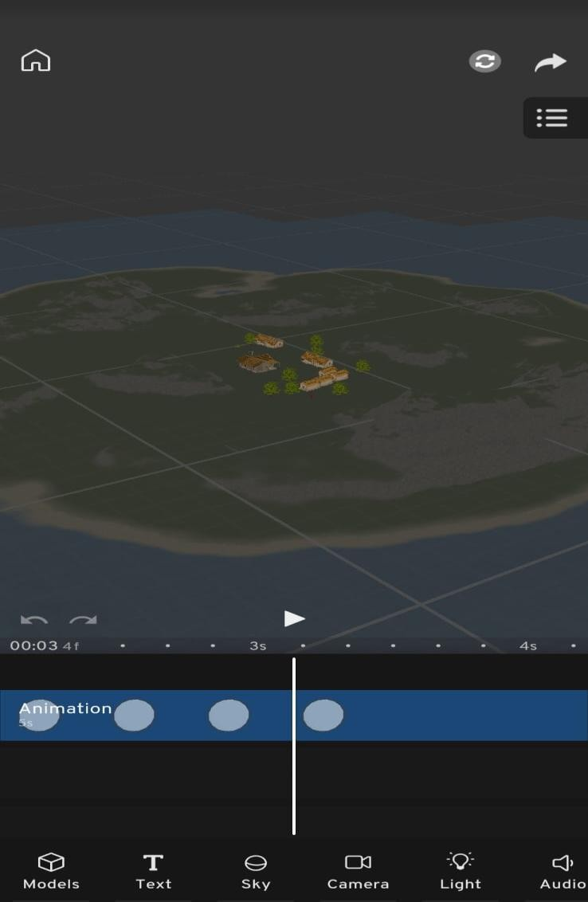

Screenshot 2:

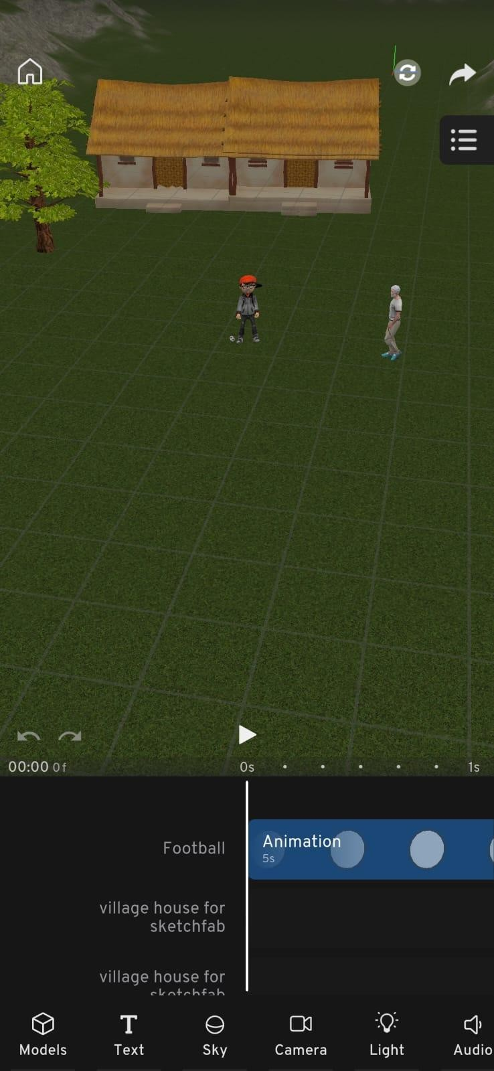

Screenshot 3:

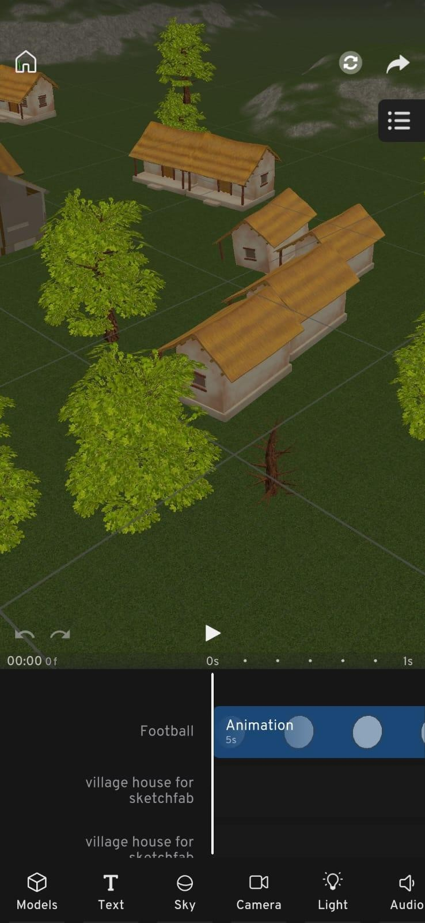

Chapter 7: Conclusion and Future Enhancements

Conclusion
This multimedia video project successfully demonstrated the complete lifecycle of 3D animation production, from pre-production planning to final post-production, resulting in a 2-minute animated short film titled "The Reminder." Throughout this project, practical skills in 3D modeling, character rigging, animation, video editing, and the use of professional multimedia software were developed and effectively applied.

The project effectively conveys an important message about responsibility, respecting elders, and the importance of playing in safe areas. The 2-minute duration allowed for proper storytelling with a clear beginning, middle, and end, keeping the audience engaged from start to finish. The use of industry relevant tools such as Sketchfab, Mixamo, Prisma3D, and CapCut provided a complete production workflow that successfully bridged the gap between theoretical knowledge and real-world multimedia production skills.

In conclusion, this project was a valuable learning experience that significantly enhanced our understanding of 3D animation and multimedia technology as a whole.

  - Future Enhancements

The project can be better in the future:

    - Adding more detailed character expressions and lip-sync animation to make the characters more realistic and emotionally engaging.
    - Improving audio quality with professional voice-over instead of text overlays to enhance storytelling and audience connection.
    - Extending the video duration to 3-5 minutes to include more scenes, character interactions, and deeper story development.
    - Adding subtitles in multiple languages to reach a wider and more diverse audience across different regions.
    - Publishing the final video on platforms such as YouTube or Vimeo for broader distribution and public feedback.

  - My Role in the Project
My role in this project was focused on audio design and sound management. I used CapCut to addbackground music for the 2-minute animation, added sound effects including football kick, ball bouncing, whoosh, footsteps, door opening, and ambient outdoor sounds downloaded from royalty-free sources, used Audacity for noise reduction and audio cleaning, and balanced audio levels using CapCut's audio mixing tools to ensure clear and consistent sound throughout the video.

8.References

Appendix

A: Full Script
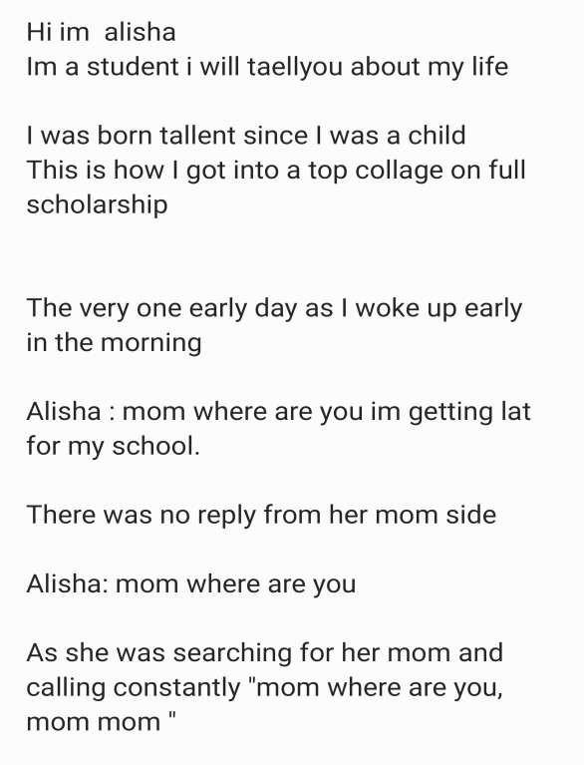

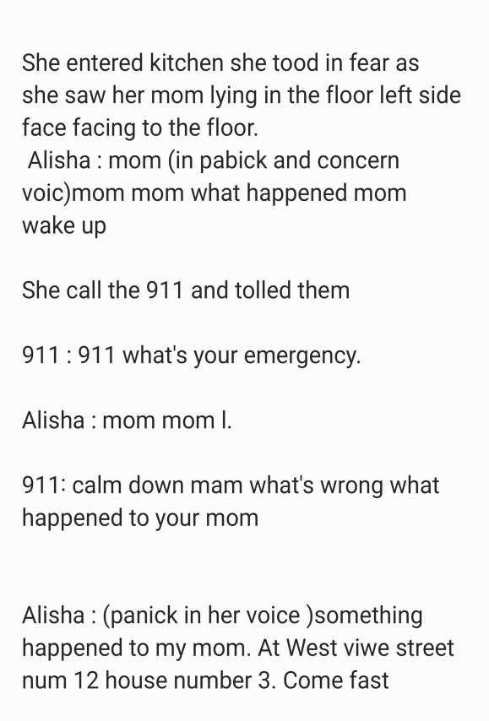



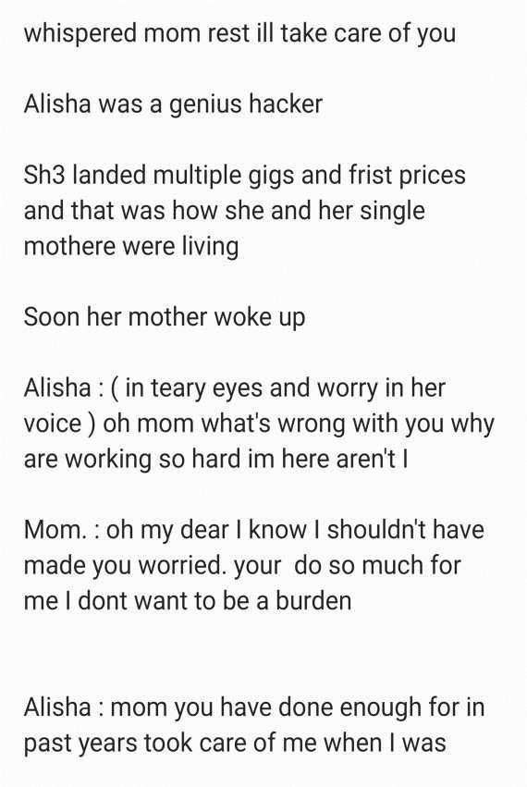

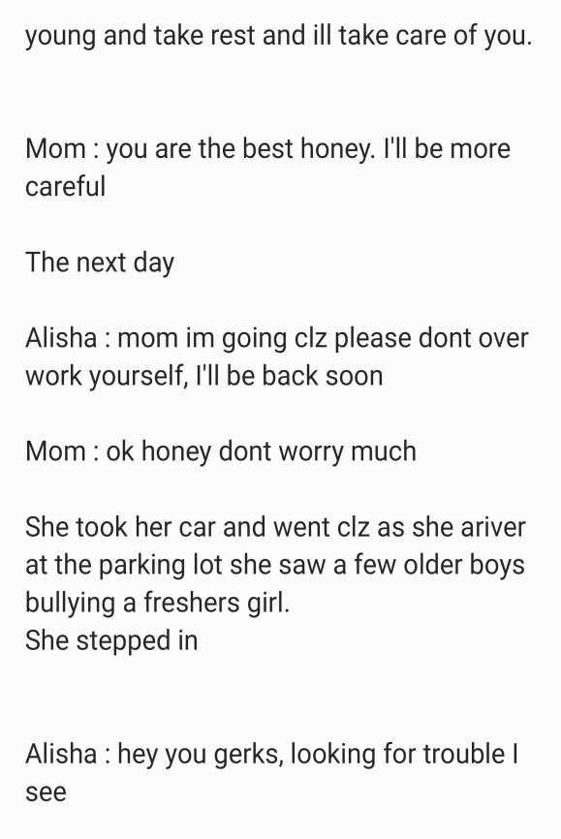



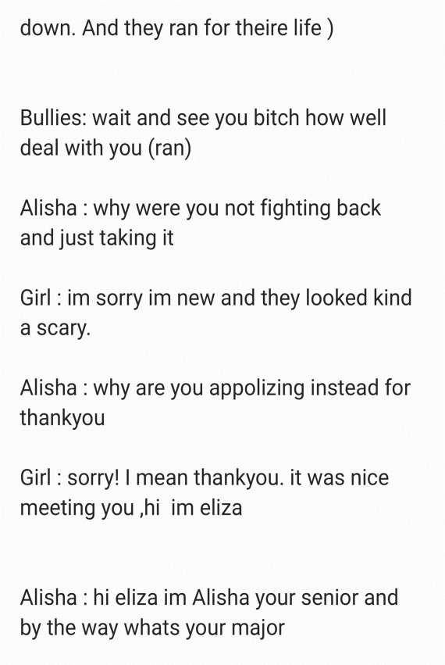

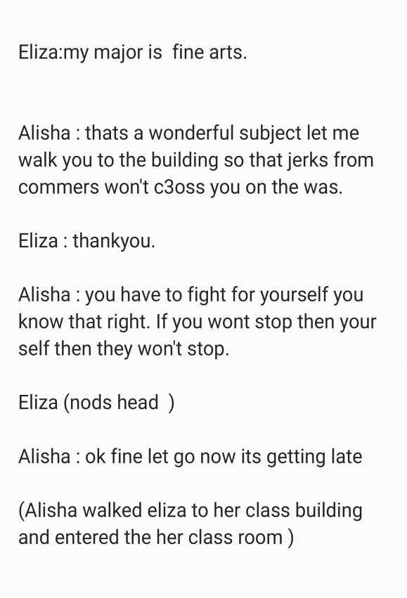

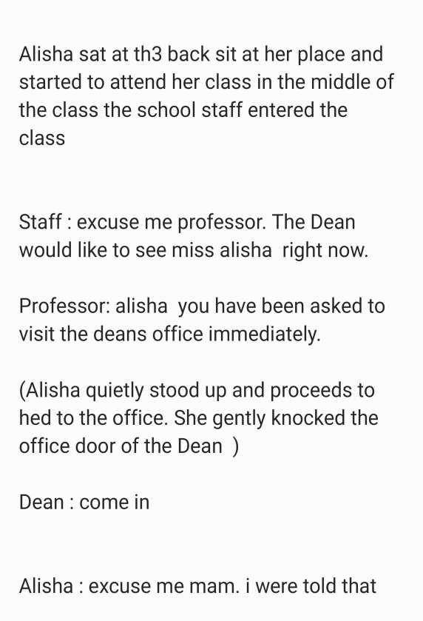

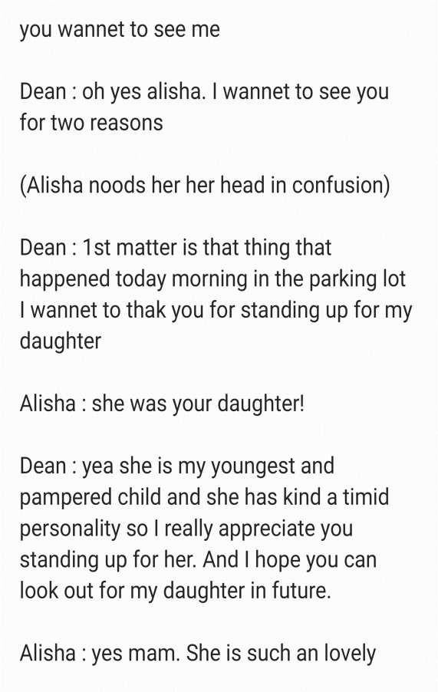



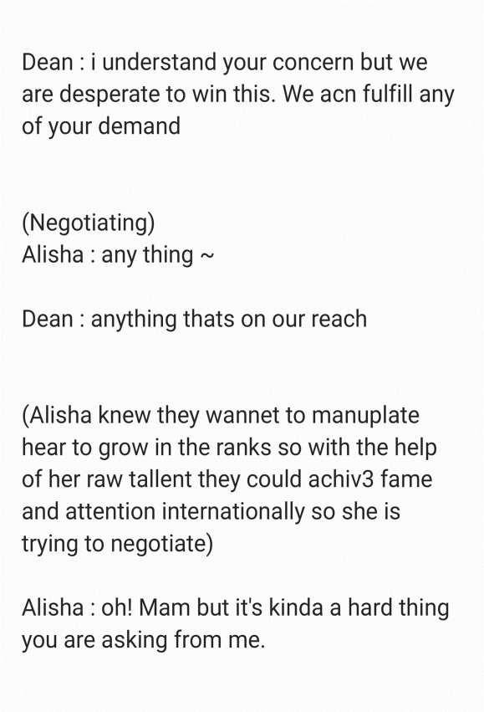





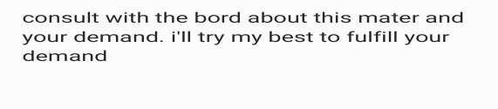
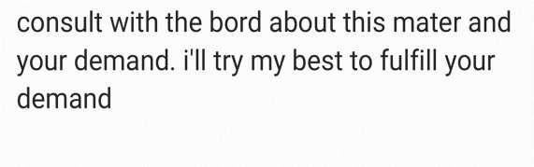

B: Storyboard Sketches
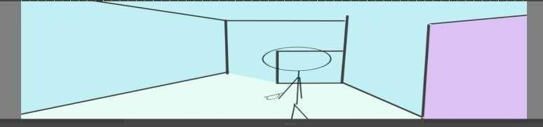
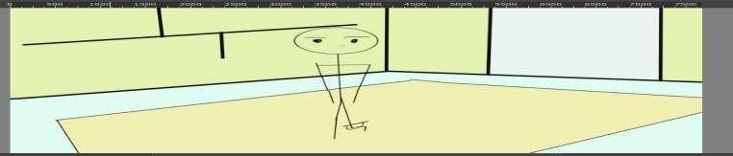
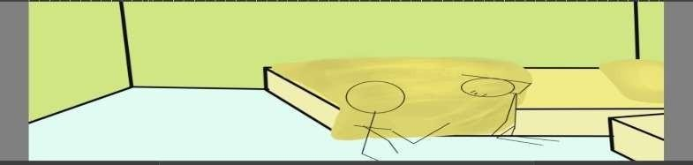
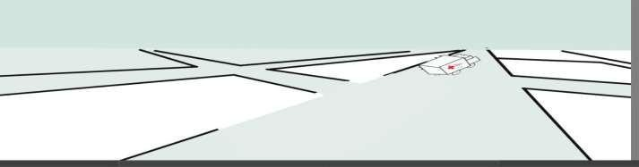

C: Team Roles and Contribution

SN | Student Name / Roll No. | Role and Contribution
1 | Rahul Chaudhary | Project Lead, Concept, Script, Storyboard, Final Editing
2 | Prakash Subedi | 3D Model Acquisition (Sketchfab), Environment Setup
3 | Nirmal Shankhar | Character Rigging (Mixamo) - Boy Character
4 | Prajwal Chaudhary | Character Rigging (Mixamo) - Grandfather Character
5 | Pralad Yadav | 3D Animation (Prisma3D) - Character Movements
6 | Nikhil Chaudhary | 3D Animation (Prisma3D) - Camera Work & Lighting
7 | Sudip Chaudhary | Character Rigging (Mixamo) - Boy Character
8 | Barsha Magar | Audio Editing, Sound Effects, Background Music

