

**Tribhuvan University**

**Faculty of Humanities and Social Sciences**

**“Gadget Ecommerce Website”**

**“TechMart”**

**Submitted to**

**Department of Bachelor of Computer Application**

**Bhaktapur Multiple Campus**

**In partial fulfillment of the requirements for the Bachelors of Computer Application**

**Submitted by**

**Ishu Duwal, Ravi Basnet**

**2023**

**Under the Supervision of**

**Supervisor Name**



**Tribhuvan University**

**Faculty of Humanities and Social Sciences**

**Bhaktapur Multiple Campus**

**Supervisor’s Recommendation**

I recommend that the project titled “Gadget Ecommerce Website” prepared by Ishu Duwal and Ravi Basnet under my supervision, be evaluated as part of their Bachelor of Computer Application degree requirements.

Mr. Madan Nath

Supervisor

BCA program Coordinator

BCA Department

Bhaktapur Multiple Campus, Dudhpati, Bhaktapur



**Tribhuvan University**

**Faculty of Humanities and Social Sciences**

**Bhaktapur Multiple Campus**

**LETTER OF APPROVAL**

This is to certify that Ishu Duwal and Ravi Basnet have completed their project titled “Gadget Ecommerce Website” as a part of their Bachelor in Computer Application degree requirements. Based on our evaluation, we find that the project is satisfactory in terms of scope and quality for the required degree.

|  |  |
| --- | --- |
| Mr. Madan Nath  Supervisor  BCA Department  Bhaktapur Multiple Campus  Dudhpati, Bhaktapur | **SIGNATURE of HOD/ Coordinator**  Name and Academic Designation  Department name and full address of the college |
| **SIGNATURE of Internal Examiner**  **Internal Examiner** | **SIGNATURE of External Examiner**  **External Examiner** |

**BHAKTAPUR MULTIPLE CAMPUS**

Ref No:

Date:

**Subject: Approval of Project Proposal**

The proposed project “Gadget Ecommerce Website” by Ishu Duwal and Ravi Basnet has been approved for further development as part of their fourth semester, Bachelor in Computer Application (BCA) requirements.

Proposal Evaluation Committee

1. ___________________
2. ___________________
3. ___________________
4. ___________________

___________________

Mr. Campus Chief

Table of Contents

1: Introduction 6

1.1 Introduction of Proposed Project 6

1.2 Scope and Limitation 6

1.2.1 Scope 6

1.2.2 Limitation 6

2. Problem Statement 7

3. Objectives 8

4. Methodology 9

4.1 Requirement Identification 9

4.1.1 Study of existing system 9

4.2 Feasibility Study 10

4.2.1. Technical 10

4.2.2. Operational 10

4.2.3. Economic 10

4.3. Waterfall model 11

4.4. Use Case Diagram 12

4.5. High Level Design of System 13

5. Gantt Chart 14

# 1: Introduction

## 1.1 Introduction of Proposed Project

The proposed project is an online Ecommerce gadget website that aims to provide customers with a convenient and user-friendly platform to purchase their desired electronic gadgets. The website will offer a wide range of products, including laptops, gaming consoles, and accessories. Customers can easily browse through products, and make purchases. Our target audience is tech-savvy individuals who are interested in the latest gadgets and electronics. TechMart brings you latest gadgets at competitive prices.

We provide detailed product descriptions to help you make an informed decision. Whether you are looking for the latest laptop or new gaming accessory, you can trust TechMart to provide you with quality products at affordable prices. TechMart stock products from leading brands such as Samsung, HP, Acer, Sony, ensuring you get the best quality and value for your money. One can explore the latest tech gadgets and accessories to enhance your daily life. We are dedicated to provide an extensive selection of high-quality products at competitive prices to meet your diverse needs

## 1.2 Scope and Limitation

### 1.2.1 Scope

* TechMart will provide customers with a wide range of electronic gadget options to choose from.
* TechMart allows customers to browse, compare prices and features, and make purchases easily and conveniently.
* TechMart will ensure timely delivery of orders to customers and provide reliable customer service.

### 1.2.2 Limitation

* The Gadget Ecommerce website may only be available to customers within a certain geographical location.
* The website may not be able to accommodate special requests or requirements beyond the offered customization options.
* The website may face technical issues that could affect its performance or accessibility.

# 2. Problem Statement

The increasing demand for gadgets and technology has led to the rise of ecommerce gadget websites. However, many of these websites face several challenges that hinder their growth and success in the competitive online market.

One of the major problems faced by ecommerce gadget websites is the challenge of attracting and retaining customers. With numerous options available online, customers are increasingly selective in their choice of ecommerce websites. The security of customer data is another challenge faced by ecommerce gadget websites. With the rise of cyber-attacks and data breaches, customers are increasingly wary of sharing their personal and financial information online.

Ecommerce gadget websites face challenges related to order fulfillment, payment processing, and customer support. Efficient order processing, timely delivery, and responsive customer support are essential for ensuring customer satisfaction and repeat business.

Overall, the challenges faced by ecommerce gadget websites are complex and multifaceted, requiring a comprehensive approach to address them. By understanding this challenge and devising effective strategies to overcome them, ecommerce gadget websites can thrive in the competitive online marketplace.

The current system of purchasing electronic gadgets from physical stores can be time-consuming and limiting for customers who have specific requirements or preferences. Customers may not always have access to the latest products, and their options may be limited by the availability of physical stock. Furthermore, visiting multiple stores to compare prices and features can be a tedious process. Our proposed online Ecommerce gadget aims to address these issues by providing a platform that allows customers to browse through a wide range of products, compare prices and features, and make informed purchases from the comfort of their own homes.

# 3. Objectives

The main objective of TechMart is to provide a convenient and efficient way for users to browse and purchase electronic gadgets, devices and accessories.

* Create a user-friendly and easy-to-use online Ecommerce gadget website that allows customers to browse and purchase electronic gadgets easily.
* Provide a secure payment system that accepts various payment methods and ensures user data privacy.
* Enable users to create an account, save their products, view their purchase history and receive notifications about arrivals.
* TechMart is designed to make your shopping experience easy and convenient.
* It allows customers to search for products easily and compare prices and features.
* Offers a wide range of products, including the latest models and accessories, to customers.
* Timely delivery of orders and efficient customer service should be ensured to provide a seamless buying experience for customers.
* TechMart will provide detailed product information and customer reviews to help customers make informed purchase decisions.

# 4. Methodology

## 4.1 Requirement Identification

TechMart is an ecommerce gadget website that allows users to buy gadgets and computer peripherals. The website has a user registration process, enabling its users to create an account to access the buying features. The user should be able to browse and select from a list of gadgets available for purchase. The system provides detailed information about each gadget, including specifications, features, and customer reviews.

The system allows users to add items to their shopping cart and proceed to checkout. The payment gateway should be secure and easy to use, enabling users to make payments for their selected gadgets. Users should be able to view their purchase history, and cancel orders.

The website will be fully responsive in mobile, tablets, and desktop, enabling users to browse and purchase gadgets. It will be optimized for different screen sizes and device types. In summary, a gadget ecommerce website should have a user-friendly interface, secure payment processing, detailed gadget information, search and filter options, order tracking, and customer support. These requirements are to meet project needs and ensure an enjoyable shopping experience for users.

### 4.1.1 Study of existing system

Online gadget e-commerce websites such as Amazon, Best Buy, Itti and Newegg offer a similar user-friendly interface to search for gadgets, select products, and make payments. They provide customers with detailed information about product specifications, customer reviews, and ratings to help them make informed decisions. These websites use a database to store product information, pricing, and availability, and utilize online payment gateways to facilitate secure transactions.

## 4.2 Feasibility Study

### 4.2.1. Technical

A technical feasibility study is conducted to assess the viability of implementing a proposed system in terms of its technical aspects. It aims to determine whether the system can be developed using existing technologies and if there are any technical challenges or limitations that may hinder its implementation.

In Context of TechMart, the technical feasibility study would evaluate the feasibility of developing and operating such website. It would assess whether the necessary technologies and resources are available to build and maintain the website effectively. In this particular case, based on the available information, there are no technical barriers or limitations identified that would prevent the development of the ecommerce gadget website. It suggested that the required technologies and resources are readily accessible, and the necessary technical knowledge and skills are available to implement the proposed system successfully.

### 4.2.2. Operational

Operational feasibility refers to the assessment of how easily a proposed system can be implemented and operated within an organization. It involves evaluating factors such as user-friendliness, ease-to-use, and the level of training or expertise required to operate the system effectively.

Based on the provided information, it is stated that the system will be easy to use due to its user-friendly interface. It is emphasized that individuals with minimal English language proficiency can operate the system without extensive training. However, to ensure comprehensive operational feasibility, it is important to consider other factors as well. These may include conducting user testing or usability studies to validate the easy-to-use, considering accessibility features for individuals with disabilities, and assessing the level of support or documentation available to users. To use our website, any person with minimum understanding of English language can easily operate the website.

### 4.2.3. Economic

Economic feasibility refers to the evaluation of whether a proposed system is financially viable and cost-effective. It involves assessing the costs associated with developing and operating the system, as well as estimating potential revenues or benefits that can be derived from its implementation.

In the case of an ecommerce gadget website, the economic feasibility study would focus on determining if the proposed system is economically viable. It would involve calculating and estimating the costs involved in developing the website, such as software development, hosting, domain registration, and any other relevant expenses.

Based on the information provided, it is mentioned that the cost associated with the development of the ecommerce gadget website is the cost of internet connectivity. This implies that there are no significant barriers or costs that would hinder the economic feasibility of the project.

## 4.3. Waterfall model

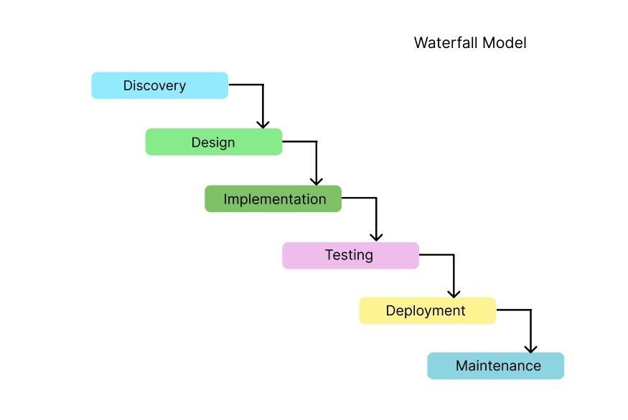

Figure 1 Waterfall model

## 4.4. Use Case Diagram

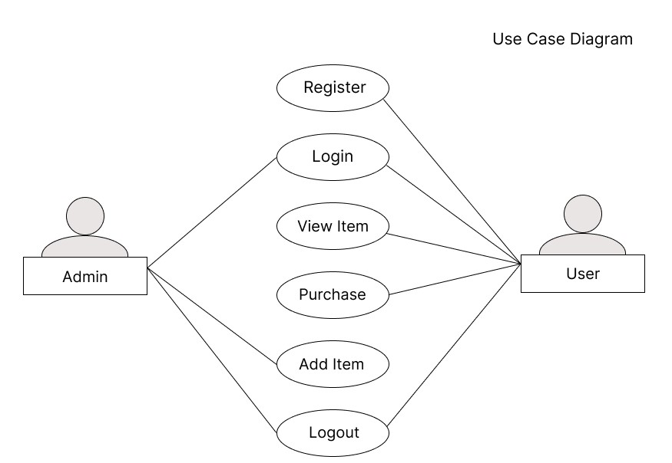

Figure 2 Use Case diagram

## 4.5. High Level Design of System

(System flowchart, Methodology Proposed System, Working mechanism of proposed system)

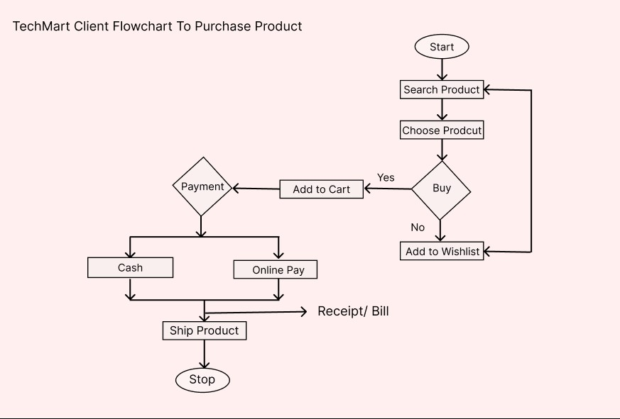

Figure 3 Customer flowchart to purchase

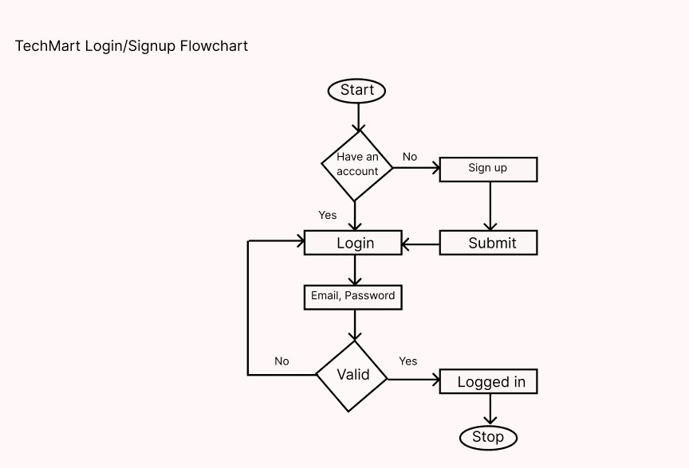

Figure 4 login, signup flowchart

# 5. Gantt Chart

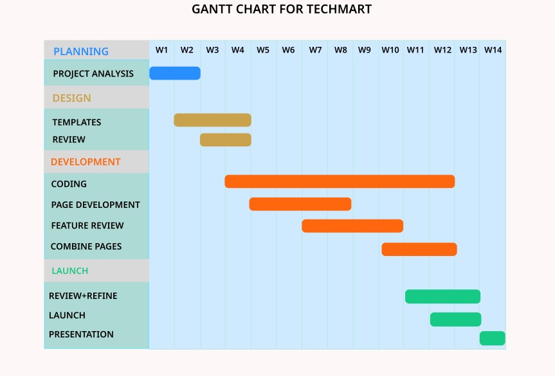

Figure 5 Gantt Chart

# 5. Conclusion

This project will greatly contribute to improving the management of a gadget ecommerce website. Users can rely on this system to purchase and request gadgets conveniently. The system aims to enhance user interaction and ensure transparency in the availability of stock. Through this platform, customers can easily connect with the ecommerce website and access gadgets when needed.

The platform aims to enhance the overall user experience and establish trust and satisfaction among our customers. By implementing this system, we anticipate resolving common challenges associated with gadget ecommerce, such as ensuring smooth transactions, offering a wide range of products, and providing reliable customer support. Customer can confidently rely on the platform’s clear product descriptions, images, and user reviews to make informed decisions and find the perfect gadget that meet their needs.

In summary, this project introduces a transformative solution to the gadget ecommerce landscape, revolutionizing how customers engage with and acquire their desired gadgets. By fostering a user-friendly interface, transparent information on stock availability. The platform guarantees an exceptional and personalized shopping journey for gadget enthusiasts.

# 6.Expected Outcome

Upon completion of the project, TechMart will provide a seamless and efficient platform for users. Customers will have access to a wide range of gadgets, enabling them to explore and purchase their desired products conveniently. The expected outcome of the project includes the following:

1. Improved User Experience:

The website will offer an intuitive and user-friendly interface, ensuring that customers can easily navigate and find gadgets they are looking for.

1. Enhanced Transparency:

The platform will provide transparent information regarding the availability of gadgets, enabling customers to make informed purchasing decisions based on accurate stock levels.

1. Digital Connectivity:

Users will have the ability to connect digitally with the ecommerce website, facilitating smooth transactions.

1. Wide Product Range:

The website will showcase a diverse collection of gadgets, catering to various preferences and requirements of customers, ensuring a comprehensive shopping experience.

1. Secure Online Transactions:

The platform will prioritize the implementation of robust security measures to ensure that customers’ personal and financial information remains safe during online transactions.