Title
ApexFlow

Summary
Paste from proposal

Table of Contents
Table of Contents
1. Title 1
2. Summary 1
3. Table of Contents 1
4. Introduction 2
Project description 2
Progress so far 2
Links 2
5. Views 2
{View 1} 2
1. UI components 2
2. Data binding 2
3. Responsive design 2
6. Controllers 2
7. Routes 2
8. Model 2
Schema 2
Validation 2
Sample Data 2
9. Starting the API 5

Introduction

Project description

Progress so far

Links

Views

{View 1}

UI components

Data binding

Responsive design

Insert actual views,not proposal views

Controllers
Describe and show (code snippet). State whys

Routes
Describe and show (code snippet). State whys

Model

Schema

Validation

Sample Data

- The schema I have built is called `trackdaySchema`. It contains the track name, date, price, available spaces, the address and its coordinates (will be important for the map api later).
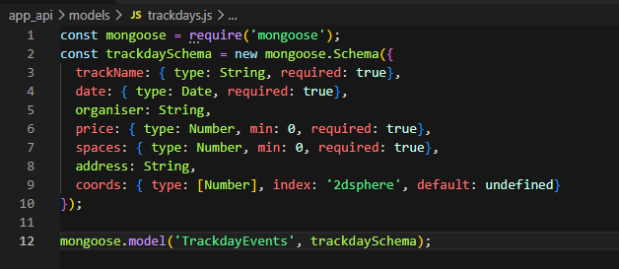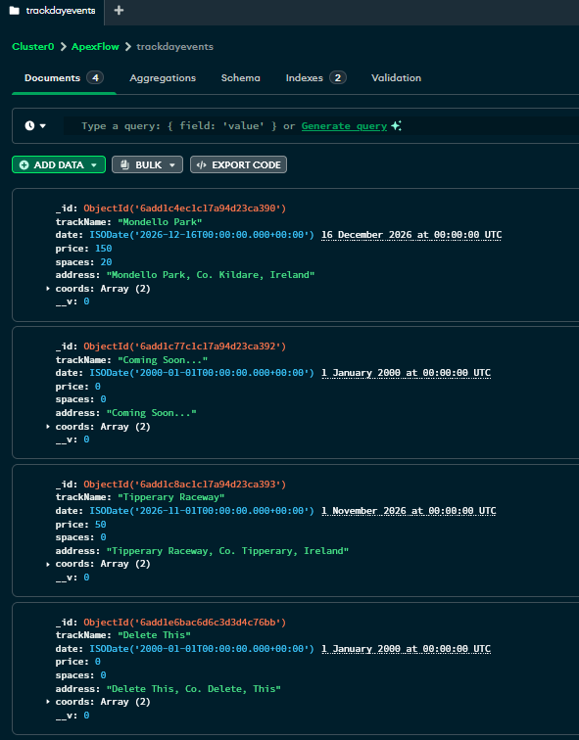

Starting the API

Postman Positives
POSTMAN GET RACKDAYS
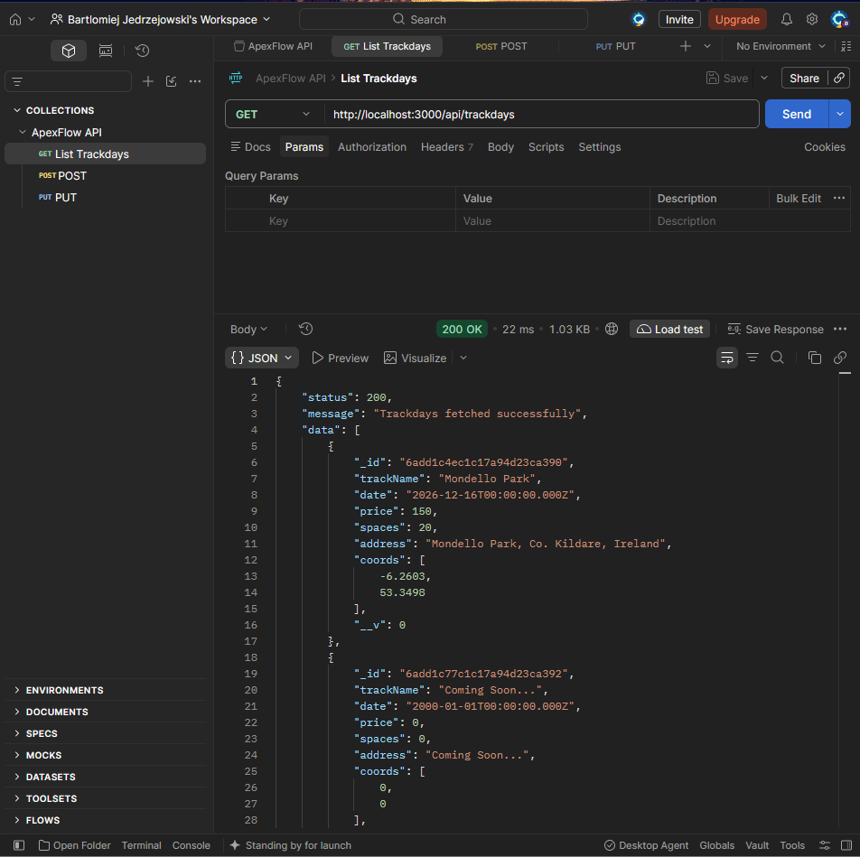
Get trackday by id
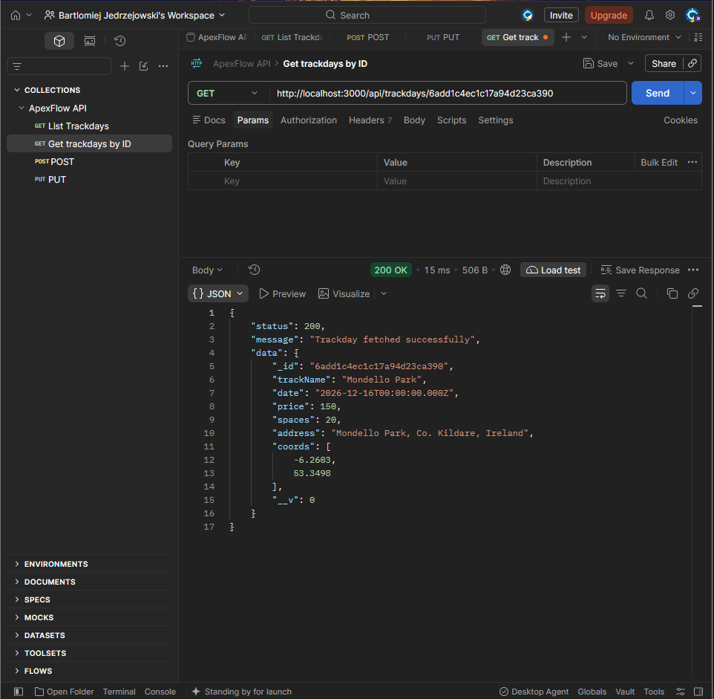

POST create trackday
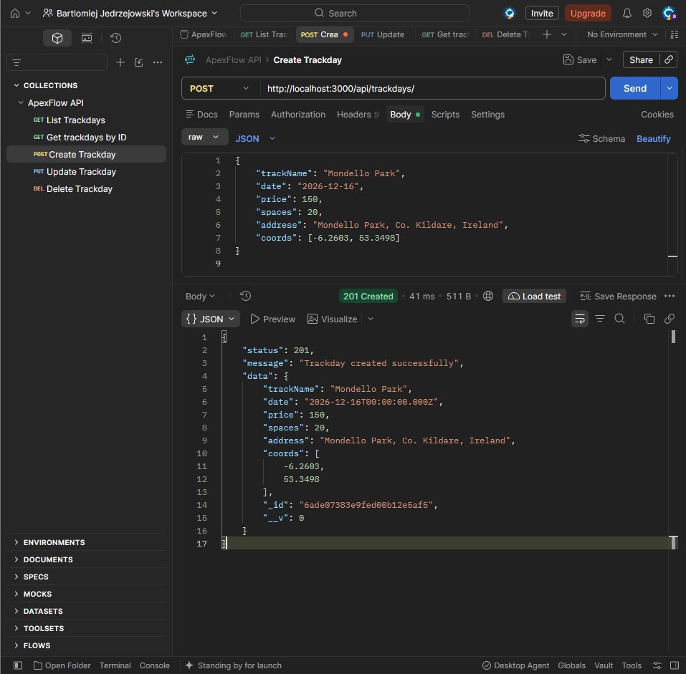
update trackday
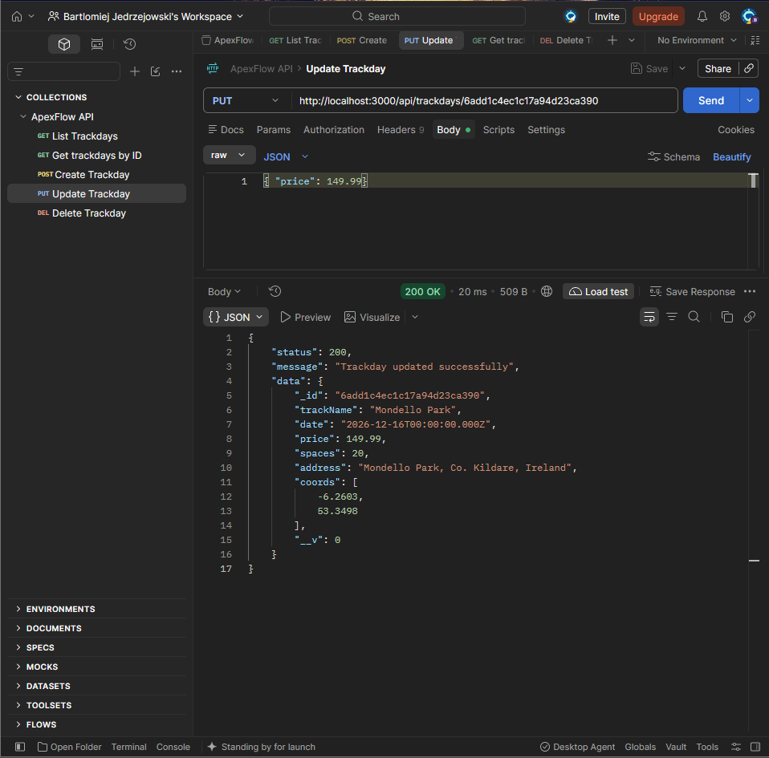
Delete trackdays
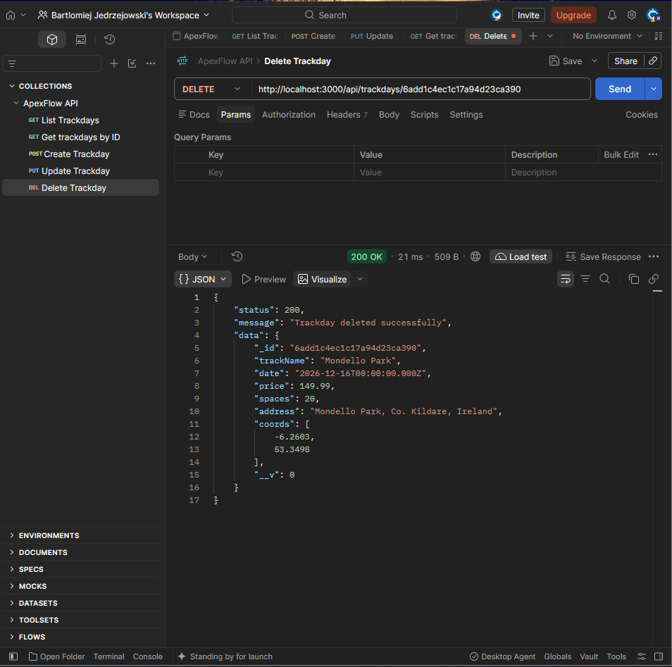

Postman Negatives
