

**HUSACCT**

**Getting started**

***Eclipse, EGit and HUSACCT***

Team 1: Donovan de Kuiper, Leo Wakelkamp, Coen van Driel, Thijs Schalk, Bart Steijlen

Author: Thijs Schalk

Teachers: Leo Pruijt, Christian Köppe, Michiel Borkent.

Date: 28-05-2013

Table of contents

Requirements 2

Tutorials 2

Installing EGit (Github plugin for Eclipse) 2

Adding the HUSACCT Git repository as a project to your workspace 3

Setting up the HUSACCT projects' Build Path 11

Check if JDK Compliance setting is set to 1.7 14

Creating a branch in your Eclipse project to switch between branches 16

# Requirements

* Github account
* Eclipse (Juno or newer)
* JDK 1.7

# Tutorials

## Installing EGit (Github plugin for Eclipse)

1. In Eclipse go to Help -> Eclipse Marketplace
2. Search for egit
3. Install EGit - Git Team Provider  
   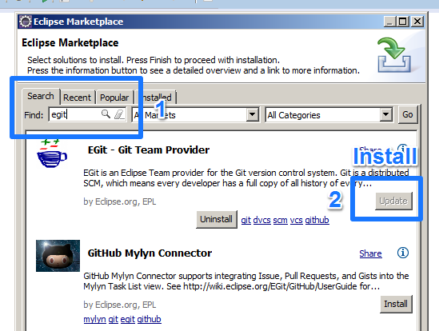
4. Follow further instructions

## Adding the HUSACCT Git repository as a project to your workspace

1. Go to File -> Import
2. Select Git -> Projects from Git  
   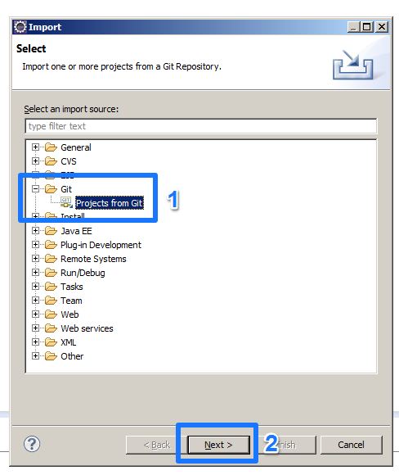
3. Select URI and hit Next  
   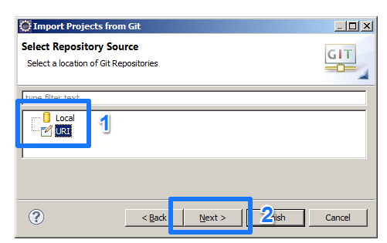
4. Now paste the URL of your fork (which can be found on your github fork page) into the first field. In this example I'll be using the main HUSACCT repository: **https://github.com/HUSACCT/HUSACCT.git**.  
   Enter your Git account details and hit Next.  
   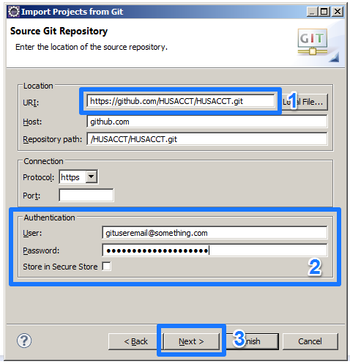
5. Select which branches you want to use. It's recommended to leave them all checked. Hit Next.  
   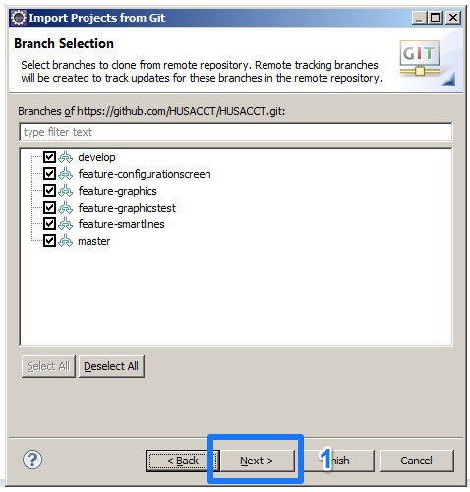
6. Now hit Browse and create a folder **in your Eclipse workspace** called HUSACCT. Select that folder as your Destination directory. Make sure this is not a subdirectory of a directory in your Eclipse Workspace. You can also set an initial branch. This is the branch which is shown by default in your Project Explorer. Switching between branches will be explained later in this document.  
   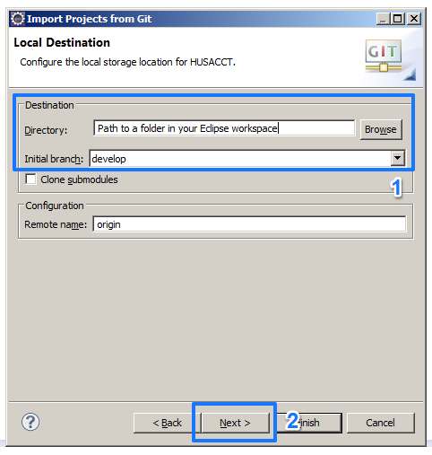
7. After it is done downloading the project files from Git into a folder in your Eclipse workspace, you'll see this screen. We're now going to create a new Eclipse project and link that to the project you've just downloaded.  
   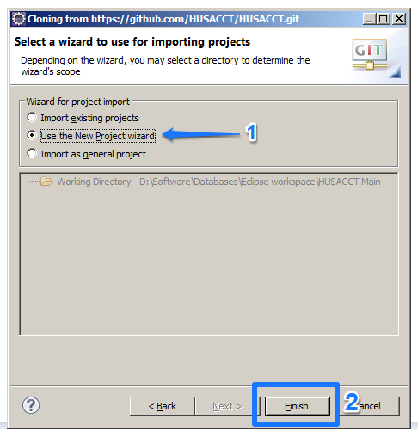
8. Select Java Project and hit Next.  
   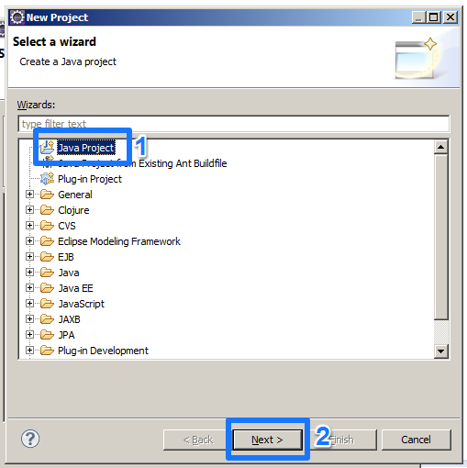
9. This part is extremely important. Make sure you enter the name of the folder you've created in the workspace as Project name. Eclipse will create a new project based on the contents of this folder.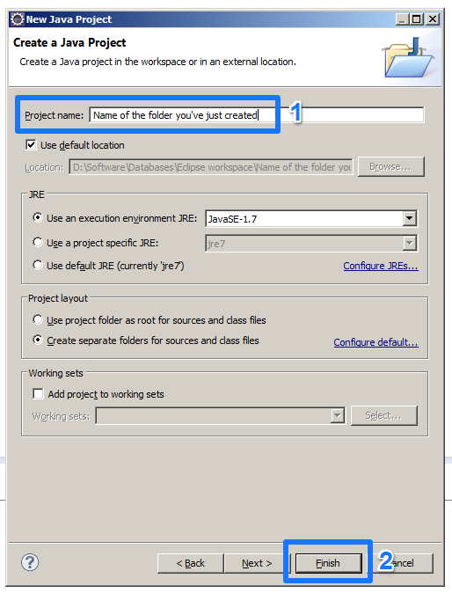
10. After the workspace has been built, you should see the project in your Project Explorer as shown below. Make sure you change the Package Presentation to Hierarchical for a more pleasant view.  
    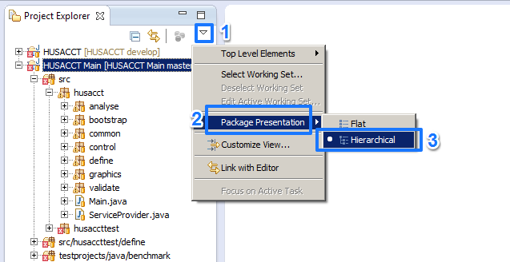

### Setting up the HUSACCT projects' Build Path

1. Right click the project in your Project Explorer and select Properties  
   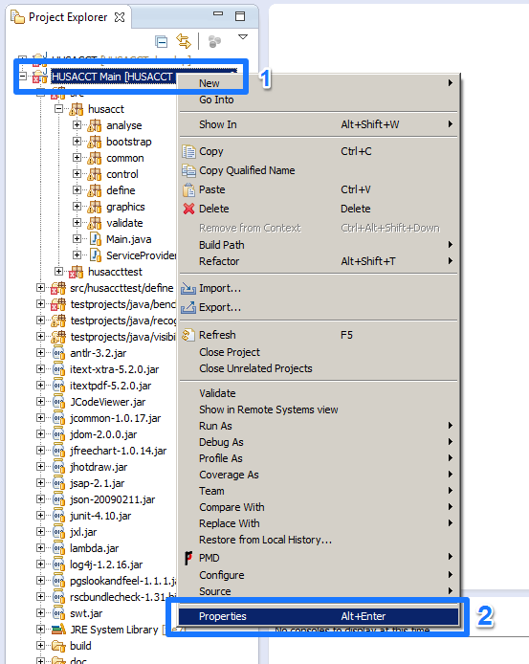
2. Click Java Build Path:  
   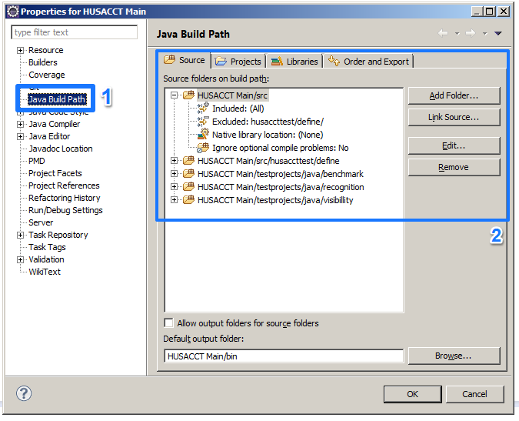
3. Remove all Source folders except HUSACCT Main/src and remove the excluded source folders under HUSACCT Main/src  
   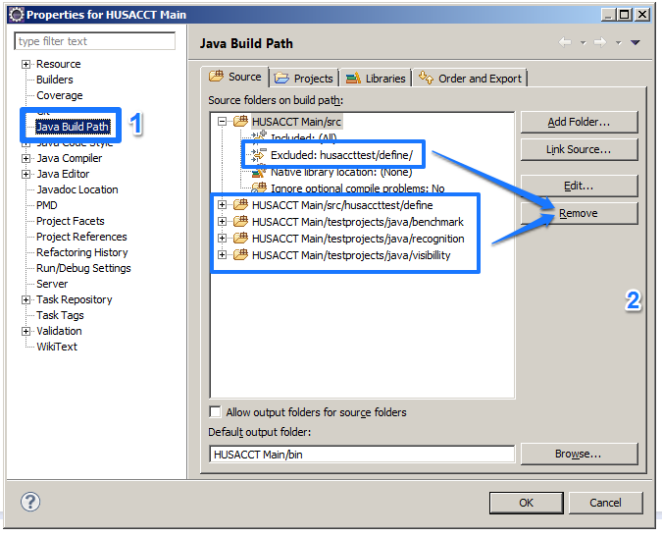
4. It should now look like this:  
   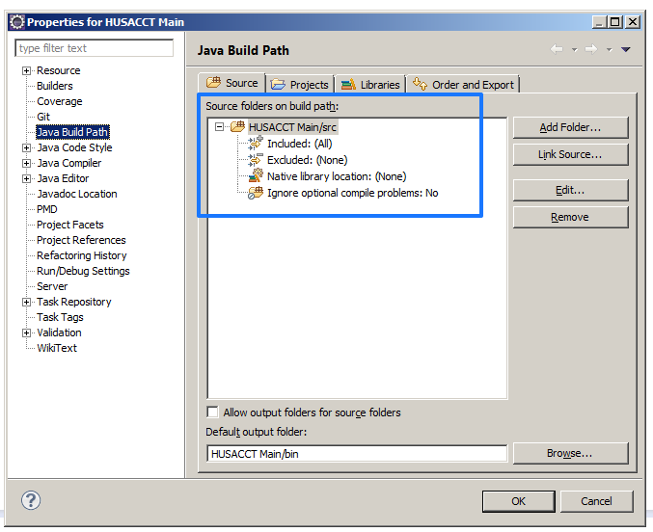

### Check if JDK Compliance setting is set to 1.7

1. Go to Window -> Preferences  
   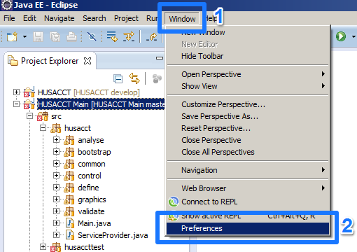
2. Click on Java -> Compiler and make sure the Compiler compliance level is set to JDK v1.7.  
   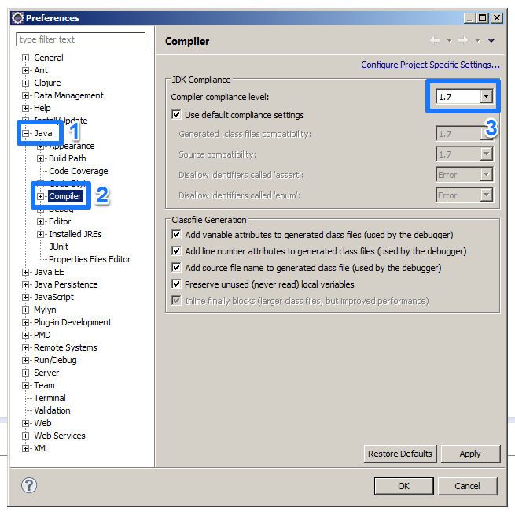

## Creating a branch in your Eclipse project to switch between branches

1. Right click your Eclipse project and select Team -> Switch To -> New Branch  
   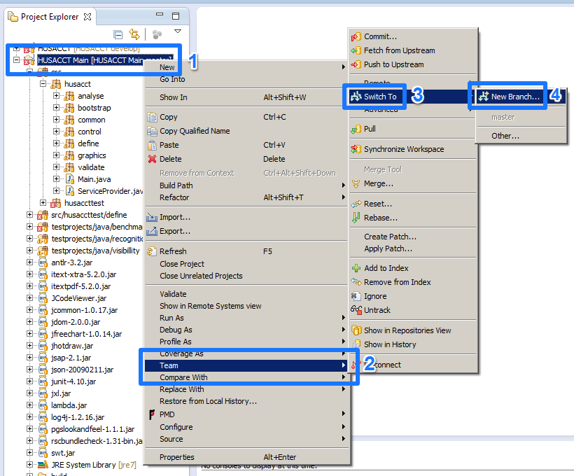
2. Select one of the refs/remotes/origin/* branches and hit Finish.  
   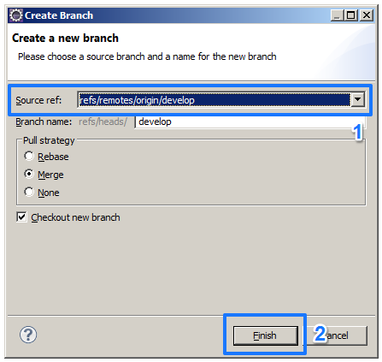
3. As you can see, branch was switched (1). You can easily switch between branches by right clicking on your project and clicking on Team -> Switch To -> *The branch you want to switch to*  
   