# Import DICOM files

MRI data is stored in DICOM files (*.IMA). DICOM not only contains data but also “headers” containing meta-data with scanning parameters. DICOM has to be converted to NIfTI (*.nii) files in order to process MRI data in SPM. NIfTI files still contain both image and header data.

Input

*.ima files

Output

*.nii files

* Localizer files: 3 s*-0001-00001-000001-*
* Structural image: 1 s*-0002-00001-000176-01
* Fieldmap: 2 s*-0003-00001-000038-* 🡪 magnitude
* Fieldmap: 1 s*-0004-00001-000038-02 🡪 phase
* Functional images: f*-0005-*
* Functional images: f*-0006-* (in case of 2 runs)

Script

**import_SPM12.m**

* 1. The dicom files should be stored in /PPxx/DICOM.
  2. Copy the data of each participant to the corresponding DICOM-folder. Depending on the number of functional runs you recorded, you should find:
     + LOCALIZER_0001
     + T1_MPRAGE_0002 (Structural images)
     + FIELD_MAP_0003 (Siemens or Gre, it doesn’t matter)
     + FIELD_MAP_0004
     + EP2D_BOLD_0005 (Functional images)
     + EP2D_BOLD_0006
     + …

The numbers of the folder may differ sometimes if you repeated a step along the way.

* 1. Enter prefix of subject folders (i.e., ‘PP’).
  2. Input PP nrs.
  3. Check if datapaths and output directories correspond to your data structure
  4. Adjust string on top so it included all PP’s you want to convert.

# Reorientation

Reorientation should be performed before automatic spatial processing. If scans do not match approximately, the algorithms may get stuck in a local minimum. Therefore, it’s advised to put all images approximately in standard MNI space (i.e., realign it to the SPM template) before doing anything else. To do this, we need to locate the **anterior** and **posterior commissures (AC** and **PC).**

## Auto reorient

* auto_reorient_SPM12
* spm_auto_reorient_CRC

## Manually reorient

N.B. Additional help to find commissures:

<http://imaging.mrc-cbu.cam.ac.uk/imaging/FindingCommissures>

Also check:

<https://www.jiscmail.ac.uk/cgi-bin/webadmin?A2=ind1708&L=spm&P=R63566&1=spm&9=A&J=on&d=No+Match%3BMatch%3BMatches&z=4>

<https://www.youtube.com/watch?v=AwNJAUKLhqY>

<https://en.wikibooks.org/wiki/SPM/How-to#How_to_automatically_reorient_images.3F>

The anterior commissure is shown in red, and the posterior commissure in yellow.

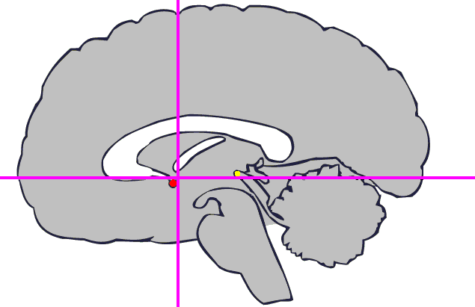

The image below shows the anterior commissure on an iconic brain from the MNI series (see the MNI space page for details). The **AC i**s at the virtual intersection of the red lines.

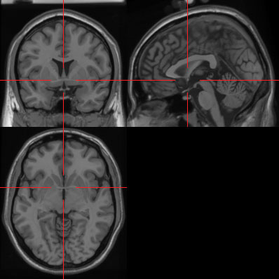

The AC is best seen on slice 91 in X, 131 in Y and 67 in Z of the iconic brain image.

Below is an image showing the **PC** on the same brain, again at the (truncated) intersection of the red lines. The PC can best be seen at slices X 91, Y 103 and Z 70. Note that this brain is not exactly oriented according to the Talairach system, *as the two commissures are not on the same axial plane*.

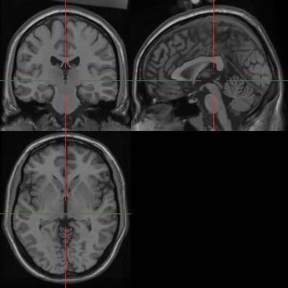

It may be useful to download the iconic brain image (or a more compressed version with the voxels outside the brain set to zero) and scroll through it using the SPM display function, or a tool like Analyze or MRIcro, to get used to the landmarks around the commissures.

Input

* Structural scan: s*-0002-00001-000176-01

Output

* Same files are reoriented
* s*-0002-00001-000176-01_reorient = reorientation matrix

Steps

1. At the SPM administrator, click Display.
2. First, display a canonical T1 image. It’s located in spm12\canonical
3. ***Press “Origin”*** to move the crosshair to the origin of the coordinate system (i.e., the AC; also not the orientation of the image, i.e., horizontal line crosses the PC).
4. Now, reorient your images in the same way as the canonical image. Load the raw structural image.
5. CLICK ON THE ‘ORIGIN’-BUTTON FIRST. The position underneath Crosshair Position should show as mm 0.0 0.0 0.0.
6. Subsequently, change the parameters to go to the appropriate position:

• right, forward, up = use the opposite direction;

• pitch = tilting the head back and forward,

• roll = rolling the head to the sides,

• yaw = turning the head from left to right and vice versa.

1. Finally, click reorient and select all the functional, structural, and fieldmap images of that participant.
2. Save reorientation matrix.
3. At the SPM administrator, use Check Reg to display an image of the series (structural) and the EPI-template (single_subj_T1 file in the spm\canonical folder) to make sure that the reorientation is sufficient.
4. Back-up the reoriented images in a separate folder! This makes it easier to redo preprocessing steps at a later stage.

# Fieldmap

skipped

# Preprocessing pipeline

Script

**preproc_SPM12**

## Slice time correction (a)

Slice time correction corrects for the fact that slices are acquired on different time points. This is required, according to some, since statistical analyses assume that every data point is collected at the same point in time, relative to the task. Others argue that this is not necessary (see Poldrack). In our case, the slices are acquired interleaved, i.e., first the evens slides acquired and then the odd ones.

Settings:

* Nr of slices = 38
* TR = repetition time: time to scan one volume = 2s
* TA = time between first and last slice = TR-(TR/# slices) = 2-(2/30) = 1.9474
* Slice order = [2,4,6,8,10,12,14,16,18,20,22,24,26,28,30,32,34,36,38,1,3,5,7,9,11,13,15,17,19,21,23,25,27,29,31,33,35,37].
* Reference slice = 19. You need to use the slice spatial number as reference slice, i.e., 19 corresponds to slice 19 corresponds to slice 38 in slice order vector.

Output

* af*: slice time corrected functional images

## Realign: estimate & write (r)

Movement leads to mismatch of location of subsequent images in the time series (i.e., bulk motion). This has particularly dramatic effects on the edges, since the difference in activation of a voxel that was located in non-brain tissue before movement may become very large after movement. Movement can also disrupt the signal itself (i.e., spin history effect). This cannot be corrected using standard movement correction.

In this step, movement correction involves 6 correction parameters that are estimated relative to a reference slice. After correction, the images are resliced to create a realigned version of the original data. Rigid body transformation is used (only the position, not the shape of the head can change).

Poldrack advises to apply slice time correction AFTER motion correction! Or don’t do slice time correction at all!

The images are also unwarped. There are severe geometric distortions in regions where there is an air-tissue interface (e.g. orbitofrontal cortex and the anterior medial temporal lobes). In these areas in particular the observed image is a severely warped version of reality, much like a funny mirror at a fair ground. When one moves in front of such a mirror, ones image will distort in different ways and ones head may change from very elongated to seriously flattened. If we were to take digital snapshots of the reflection at these different positions it is rather obvious that realignment will not suffice to bring them into a common space. The method deals with residual movement related variance induced by the susceptibility-by-movement interaction. This means that the time-series will be undistorted to some "average distortion" state rather than to the true geometry. If one wants additionally to address the issue of anatomical fidelity one should combine Unwarp with a measured **fieldmap**., i.e., with fieldmap corrections, motion induced deformations are corrected.

Remarks

* With 2 sessions, the sessions are realigned to each other by first realigning the first scan from each session to the first scan of the first session. Then the images within each session are realigned to the first scan of the session.
* Phase map = map created during *Fieldmap correction*. The vdm* file is assumed to be already in alignment with the first scan of the first session.
* Target for correction is the average (? See Taylor expansion point).

Output

* raf*: f unctional images are realigned to the first image using 6 parameter (rigid

body) spatial transformation and unwarped (fieldmap correction)

* meanaf*: mean image (?)
* rp_af*: realignment parameters
* spm*.ps: movement parameters (saved in main folder)

## Coregister

Function and structural images are being coregistered.

Remarks

* Reference image = Image that remains stationary, i.e., source image is realigned to this one.
* Source image = structural (s*:)
* Other images = images that need to stay realigned to the source image (none).
* Registration parameters are stored in the headers of the "source" and the "other" images.
* Reslicing is done in Normalization (it is also done this way in the Face example in SPM manual).

Output

* s* : The structural image is coregistered to the reference image using a rigid-body

transformation (in 3D). See realignment! SPM will have changed the header of the source file which in this case is the structural image s*.

* cs*: coregistered structural

## Segment

In this step, the anatomical image is separated in grey matter, white matter, CSF, bone, and soft tissue. This function segments, bias corrects and spatially **normalizes** - all in the same model.

Input

* s*

Output

* mcs*: bias-corrected image
* c1s*: grey matter
* c2s*: white matter
* c3s*: CSF
* c4s*: bone
* c5s*: soft tissue
* s*-0002-00001-000176-01_seg8
* y_s* spatial normalisation deformation field file that will be used in the next section to

normalise the functional data.

## Normalization (w)

Spatially transforming data into a common space to allow intergrated (across persons) analyses. In our case, images are normalized to MNI space.

Remarks

* The normalization was already estimated during segmentation. Therefore, we choose Normalise: Write here.
* Image to align = The image that the template (atlas) data is warped into alignment with. The result is a set of warps, which can be applied to this image, or any other image that is in register with it. In our case this is the mean unwarped image
* Images to write = These are the images for warping according to the estimated parameters. They can be any images that are in register with the image used to generate the deformation. In our case, these are the resliced images acquired after realign and unwarp.
* (If you wish to superimpose a subject’s functional activations on their own anatomy you

will also need to apply the spatial normalization parameters to their (bias-corrected) anatomical image.)

Input

* y_s* spatial normalization deformation field
* raf*: realigned, timing corrected functional images
* ms*: bias corrected structural image

Output

* wraf*: normalized functional images
* wms*: normalized bias corrected structural image

## Smoothing (s)

A Gaussian kernel is used to remove high-frequency information. This increases the signal-to-noise ratio for signals with larger spatial scales (which we are generally interested in, instead of voxel specific activity). It also reduces the mismatch across individuals. Smoothing is also required for some analysis methods (e.g., Gaussian random fields).

Settings

* FWHM = full width at half-maximum. Measures the width of the distribution at the point where it is at half of its maximum. The larger, the greater the smoothing. In our case this is set at [6 6 6].

*How much smoothing?*

* No larger than the activation signals you want to detect.
* Rule of thumb: twice the voxel dimension [2 2 2].

Output

* swraf*: smoothed functional images

# Check preprocessing

This requires the CONN toolbox: <https://www.nitrc.org/projects/conn>

Some explanation: <https://www.youtube.com/watch?v=ro3nk_RegDU&t=110>

Script

**preprocCheck_SPM12.m**

Input

* swraf*: smoothed functional images
* wms*: normalized bias corrected structural image

Steps

1. Run the script
2. Quality Assurance (QA) plots

* Select:
  + QA normalization: functionalDataset1 + outline MNI…
  + QA normalization: structural data + outline MNI…
* if the structural was normalized, it should overlay with MNI template
  + QA realignment: functional center-slice
* Check realignment across sessions
  + QA artifacts: functional movie across all time points
* Select dataset 1 (= unsmoothed)
* Use Explore for more details

1. Also check:

* Functional tools: display single slice for all subjects
* Slices should be show same positions
* Covariates 1st level
* This shows the movement parameters
* Movement drifts (slow changes) are not a problem. SPM takes care of this by adding the 6 movement correction parameters to the design matrix.
* Movement spikes are a problem! As a rule of thumb, translation or rotations between two adjacent timepoints of more than ½ of the voxel dimension is of concern (Poldrack) or greater that the largest voxel size (2 x 2 x 2; Laurens).
* Bad trials can be removed, e.g. by omitting the relevant onset times. An alternative is to make a vector with 1’s for bad trials.
* **BUT: see Art paragraph**

*(N.B. you can also check the movement parameters in the .ps files. Use e.g. GhostScript to open it).*

# ART

ART identifies bad scans (outliers), estimates movement parameters and computes motion-task correlations.

This requires the CONN toolbox: <https://www.nitrc.org/projects/conn>

Script

**Conn_ART.m**

Input

* raf*: realligned, slice timing corrected images

Settings

* art_thresholds(1) = 5: threshold value for global-signal (z-value; default 5)
* art_thresholds(2) = .9: threshold value for subject-motion (mm; default .9)

*Note: the default art_thresholds(1:2) [5 .9] values correspond to the "intermediate"*

*(97th percentile) settings, to use the "conservative" (95th percentile) settings use*

*[3 .5], to use the "liberal" (99th percentile) settings use [9 2] values instead.*

Output

Per subject:

* art_screenshot.jpg
* art_regression_outliers_and_movement_raf*.mat:

to be used as regressors in model specification, instead of rp* files

* art_regression_outliers_raf*.mat
* art_movement_stats_raf*.mat
* art_regression_timeseries_raf*.mat

# Sanity check

Assure that the data makes sense so far. Contrast motor activity with no motor activity or left and right responses. Creates .mat with regressors names, durations, and onsets. Next, it specifies a SPM with motor or non-motor related regressors, which are convolved with HRF. Rp and outlierc regressors are also included. Finally, relevant contrasts are created.

Script

**sanityCheck_SPM12.m**

Input

* *.csv: behavioral data
* swraf*: realligned, slice timing corrected, normalized, smoothed

images

* art_regression_outliers_and_movement_raf*-0006-*.mat

Output

In *sanity* folder:

* onsets onsetsSanityCheck*.mat: names, durations, onsets blocks
* onsetsTrialsMain.mat: names, durations, onsets trials
* SPM: final SPM model with trial, block, and rp+outlier regressors
* Beta’s

Activity is in right hemi. Weird! Response should be with right hand.

# 1st level analysis

## Onsets

Since we’re dealing with a mixed design, we need to extract the names, durations, and onsets for both blocks and trials and save this in a .mat file that can be entered in the 1st level SPM design specification batch under “multiple regressors” (.multi).

Script

**onsets_SPM12.m**

Input

* *.csv: behavioral data

Output

* onsetsBlocksMain.mat: names, durations, onsets blocks
* onsetsTrialsMain.mat: names, durations, onsets trials

## 1st level SPM

First specifies a SPM with only block regressors, which have length = block duration and are convolved with HRF + time derivatives. Next, these regressors are included (together with the rp and outlier regressors) in the second SPM which contains the trial (FIR) regressors. <https://www.jiscmail.ac.uk/cgi-bin/webadmin?A2=SPM;3e5782f7.0806>

Script

**firstLevelMixDes_SPM12.m**

Input

* swraf*: realligned, slice timing corrected, normalized, smoothed

images

* onsetsBlocksMain.mat: names, durations, onsets blocks
* onsetsTrialsMain.mat: names, durations, onsets trials
* art_regression_outliers_and_movement_raf*-0006-*.mat

Settings

* FIR duration = 20s
* FIR nr of bins = 10

Output

* multiRegr.mat: block and rp+outlier regressors
* SPM_block.mat: First SPM model with only block regressors
* SPM: final SPM model with trial, block, and rp+outlier regressors
* Beta’s