The quest for correlation between dengue and historical weather measurements

Bart Boerman

May 13, 2019

This document describes my effort to be competitive in predicting in the dengue forecasting competition, DengAI, hosted by DrivenData. I used the competition as a capstone project in the Professional Certificate in Data Science course hosted on EDX by HarvardX. Dengue fever is a mosquito-borne disease that occurs in tropical and sub-tropical parts of the world. Symptoms are similar to the flu in mild cases, in severe cases however, dengue fever can cause death. I followed a CRISP-DM like process: background study, analyze and prepare data, configure machine learning model, validate and submit results to leaderboard. Predictive power of time series can be increased by adding moving averages. The final model is able to predict the seasonal pattern of dengue. The conclusion proposes using ensemble modelling to add the capability to predict outbreaks.

# Problem description

The dataset is a time series about laboratory confirmed dengue cases in two cities: San Juan and Iquitos. Test data for each city spans for five and three years respectively. The test set is a pure future hold-out, meaning the test data are sequential to and non-overlapping with any of the training data. Both the training and test data contain missing values. Station meteorological readings are in Celsius while the reanalysis readings are in Celsius.  
  
The goal of the competition is to predict the total dengue cases for each city per week in the test set. The evaluation metric is mean absolute error. My mission is to add predictive power to the data by investigating moving averages and rolling correlation between the total dengue cases and metrological variables included in the data set. I used this competition to gain experience with time series decomposition, anomaly detection (outliers) and the algorithm open sourced by Facebook for time series forecasting: Prophet.

# Methods

I performed the following tasks to design and test a forecasting model that predicts dengue cases with Facebook’s forecasting model Prophet.

* Study background and formulate design considerations for the forecast model.
* Perform data wrangling: load datasets, convert Kelvin to Celsius.
* Exploratory data analysis.
* Impute missing values with Kalman Smoothing.
* Feature engineering, design and train forecast model.
* Re-evaluate analysis and design.

# Results background study

## Epidemiology perspective:

* Dengue is endemic, it occurs every year. The forecast model will benefit from research of seasonality and anomaly’s.
* Both humans and mosquitos can only transmit the virus after an incubation period. Which suggests that we need to investigate lagging values within the data to find the best correlations with the current number of dengue cases. The total dengue cases per week only contains confirmed cases. Performing lab tests and gathering the results also takes time.

## Ecology and geological perspectives:

* *Aedes aegypti*, the principal mosquito of dengue viruses, is an insect closely associated with humans and our dwellings. The mosquito lays her eggs on the sides of containers with water. Eggs hatch into larvae after a rain or flooding. This indicates that total precipitation during a period could be predictive.
* It is very difficult to control or eliminate these mosquitoes because they have adaptations to the environment that make them highly resilient. Seasonality is most likely to repeat it selve in the nearby future.
* The data spans two different geological locations. One forecast model per city allows for specific business rules which probably will yield the best overall results.

## Historical facts about dengue outbreaks

The test data about San Juan starts at 29-04-2008 and ends at 25-06-2013. An online blog, see references, described two outbreaks in Puerto Rice during this timeframe:

* Epidemic declared 26 February 2010 that lasted until 30 December 2010, and claimed 28 lives.
* Epidemic declared 08 October 2012 that lasted until 17 July 2014 (almost 2 years!).

# The two different geological locations: San Juan and Iquitos

## Anomalies detected with R package Anomalize

Data points that are outliers, or an exceptional event, are considered anomalies. The Anomalize package is designed for time series and contains two methods for automated anomaly detection: Inner Quartile Range (IQR) and Generalized Extreme Studentized Deviate test (GESD). Anomaly detection can be easily done on small datasets by plotting the data with boxplots, however, it becomes increasingly more difficult on large time series. Hence, I decided to give Anomalize a try and used GESD to spot anomalies. In GESD anomalies are progressively evaluated removing the worst offenders and recalculating the test statistics and critical values.  
  
It first decomposes , divides, the subject in the time series, total dengue cases per week, into four columns that are observed, season, trend, and remainder. The anomalies are detected in the remainder, which is observed minus its season and trend components. The default method ‘STL’ for decomposition is used and a 12 months frequency and trend to calculate data for the plot below.   
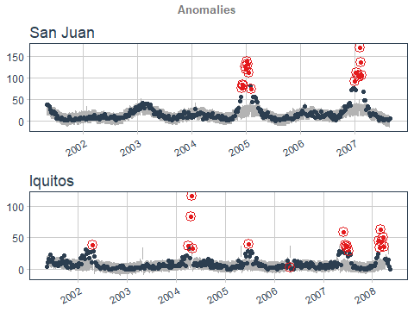

## How does seasonality differ between the two cities?

Dengue cases in both cities show seasonal patterns. However, the start and the end of the dengue seasons differ between the cities. The seasonal pattern below is based on data calculated by the Anomalize package with decomposition method ‘STL’.

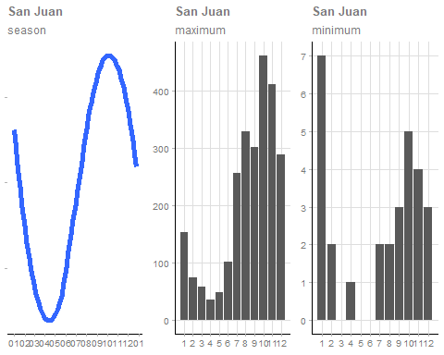 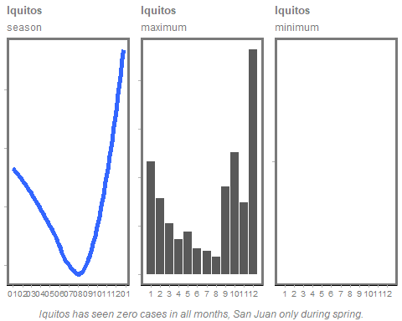

# San Juan and the quest for correlation

Initial trial runs resulted in a more than triple mean absolute error for the forecast of San Juan compared to Iquitos. Hence, I decided to prioritize on San Juan for explorative data analysis. The data violates two Pearson correlation assumptions: it has numerous outliers and shows non-normal distributions. Therefore I assumed that correlations based on Spearman’s rank-order correlation are a better fit with the data.

## Correlation of total dengue cases with features

The figure below illustrates the distributions and correlations between the selected features and the total dengue cases per week.  
  
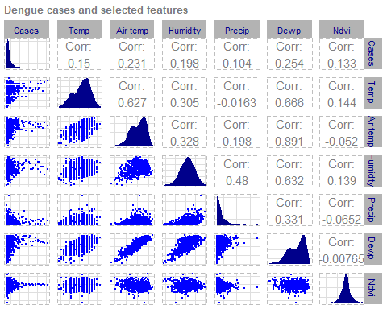

## Improving correlation by adding lagging features

Not Surprisingly, the correlation of total dengue cases with climate features over the same week, in which the dengue cases were reported, is disappointing.  
I wrote a function that adds lagging versions of the variables by iteration through look back periods starting from 1 to 25 weeks. Next I added the an interaction variable, temperature multiplied by humidity, because both variables contribute to the growth of the mosquito population. The resulting interaction variable has the best correlation with dengue cases, but can we trust this relationship to be predictive in the future? Are correlations static?  
  
First, let’s have a look at the illustration below with distributions and correlations of the moving averages added to the data. Please note that a rolling sum was used for precipitation amount in millimeters and moving averages for all others.  
  
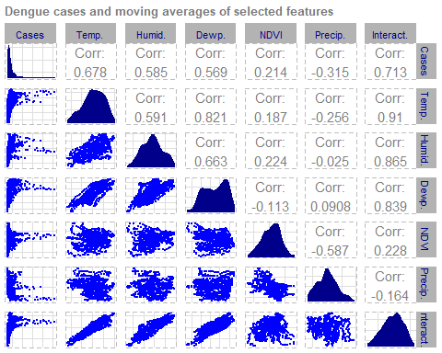

By determining the best look back period for the moving averages the correlations show a significant improvement. The interaction variable has the highest correlation. Correlations in timeseries are not static. Which is illustrated by the figure shown below.

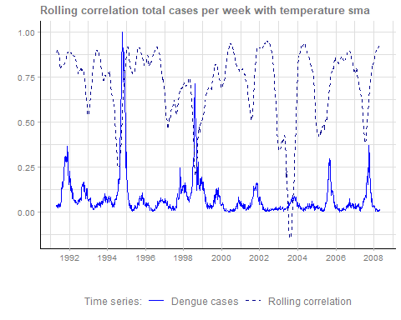

The rolling correlation, 52 weeks look back period, of the temperature moving averages is mostly above 0.75 but potentially drops to 0.25 or even as low as 0.016. In 2003 it reverses from a positive correlation to a negative correlation with the total dengue cases.

# San Juan, what patterns are revealed by scatter plots?

The scatter plots reveal distinct patterns. Unfortunately these patterns coincide with seasonal patterns: outbreaks always reach their highest level in the last quarter of the year and so do the values of the variables. The distinctive characteristics of the patterns is therefore limited. I used a rolling sum for precipitation, but the scatter plot indicates that a plain lagging value might be a better fit.

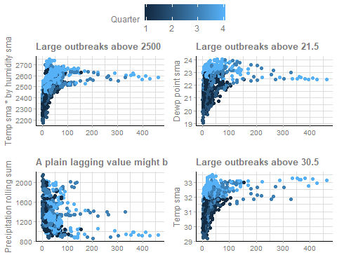

# Machine learning model

## About Prophet

Prophet is forecasting tool open sourced by Facebook available in Python and R. It includes an algorithm and ready to go plots for visual analysis. I choose this package in R out of curiosity and because it is said to be optimized for time series with an reasonable number of missing observations or large outliers. At its core, the Prophet procedure is an additive regression model with four main components:

* Piecewise linear or logistic growth curve trend. Prophet automatically detects changes in trends by selecting changepoints from the data.
* Yearly seasonal component modeled using Fourier series and weekly seasonal component using dummy variables.
* A user-provided list of important holidays.

## Settings I used for predicting dengue cases

I configured the algorithm with the following settings for both San Juan and Iquitos:

* Changepoint prior scale. If trend changes are being overfit (to much flexibility) or underfit (not enough flexibility) you can adjust the strength of the sparse prior using this setting. By default this parameter is set to 0.05. Increasing it will make the trend more flexible.
* Yearly seasonality. The default Fourier order for seasonality is 10. It determines how quickly the seasonality can change. I did some trial runs and concluded that 5 provides the best result.
* By default Prophet fits additive seasonality’s (mode), meaning the effect of the seasonality is added to the trend to get the forecast. I assumed that in the dengue time series, the seasonality is not a constant additive factor as assumed by Prophet, rather it grows with the trend. I used multiplicative as seasonality mode.

## Variables selected as additional regressors

Extra regressors are put in the linear component of the model, so the underlying model is that the time series depends on the extra regressor as either an additive or multiplicative factor. The extra regressor must be known for both the history and for future test dates. It thus must either be something that has known values (such as temperature), or something that has separately been forecasted.

### San Juan

I modeled with different combinations of additional regressors. The interaction variable, which was most promising, turned out to be the best performer during cross validation on train data, but actually made things worse on the leaderboard using test data. A combination of temperature and dewpoint resulted in the best final score on the leaderboard.

### Iquitos

For Iquitos I ran the model with air temperature and dew point.

# Model evaluation

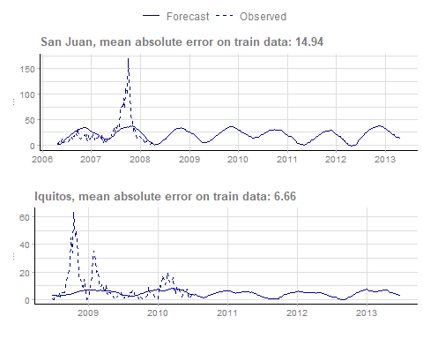

# Discussion

* The challenge was to forecast the total dengue cases per week during a future period of multiple years. Predicting just one, or a view, data points ahead will result in a huge improvement of accuracy. It would also allow usage of traditional autoregression models.
* I did not succeed in finding cross validation results comparable with the final result on the leaderboard with the unseen test data. Plausible explanation is that I did not find the cause and effect relationship between outbreaks and provided variables in the data.
* Exploratory data analysis on anomalies did not indicate root cause of outbreaks. It seems that we need additional data to be able to predict the outbreaks.
* I was able to forecast the outbreaks by adding a multiplier to the time series of San Juan: ‘0’ for timeframes without an outbreak, ‘0.5’ during minor outbreaks (e.g. 1991) , ’1.5’ during medium outbreaks (e.g. 1998) and ‘2’ during huge outbreaks (e.g. 1994). The timeframes for outbreaks in the unseen test data can be derived from the following blog: <https://www.puertoricodaytrips.com/dengue-puerto-rico/>. This approach resulted in rank 154 of 5456 on the leaderboard. I dropped the approach from this study because it felt like cheating.

# Conclusion

* My mission was to find the metrological effects that have the highest correlation with the total dengue cases per week. Exploratory data analysis on correlations showed that moving averages will increase the predictive power of the metrological variables. Correlation is however not static which I illustrated in the example with the rolling correlation of the derived interaction variable.
* The approach I followed did not result in a model that will predict outbreaks. It will however forecast with reasonable accuracy the pattern taking into account metrological variables.
* The model does defeat the DengAI benchmark, published by DrivenData, by 7,46%.**[number of years history, full or just 6]**
* I think prophet deserves to be in the data science tool box for forecasting time series, because it is relative simple to setup and therefore can be used to demonstrate predictive power of a scenario during a prove of concept and could potentially be the, or part of, the final solution if it suits your data.

# References

## Resources consulted during background study

I read, and used, content on the following websites during the background study about dengue:

* <https://www.who.int/denguecontrol/mosquito/en/>
* <https://www.cdc.gov/dengue/epidemiology/index.html>
* <https://gisgeography.com/ndvi-normalized-difference-vegetation-index/>

## Resources consulted for technical design

I recommend reading the following online posts which I used as a basis for the technical solution:

* <https://facebook.github.io/prophet/docs/multiplicative_seasonality.html>
* <https://www.datacamp.com/community/tutorials/detect-anomalies-anomalize-r>

## R packages used in software code

The following R open source packages are used in the software code which is described, or used, in this document:

* **‘tidyverse’**, a collection of R packages for data science. Includes ‘dplyr’ for data wrangling tasks like data manipulation and combining multiple files into a train and a test (unseen) dataset. Ships with ‘ggplot2’ for data visualization.
* **‘lubridate’** provides date functions, e.g. extract month and year from a date.
* **‘imputeTS’** great at imputing missing values in structured time series with, among others, Kalman Smoothing.
* **‘TTR’** for calculating moving averages.
* **‘weathermetrics’** includes a function to convert from Kelvin to Celsius.
* **‘tibbletime’** on its own has useful functions for manipulating time-based tibbles. Working with time-based tibbles is a prerequisite for the ‘anomalize’ package.
* **‘anomalize’** enables a tidy workflow for detecting anomalies (outliers) in structured time series. I used it for anomaly detection and time series decomposition.
* **‘prophet’** is a forecasting tool open sourced by Facebook. It is the core of the forecasting model described in this document.
* **‘GGally’** is used to visualize pairwise comparison of multivariate data.
* **‘ggpubr’** arranges multiple data visualizations into one figure.
* **‘ggthemes’**, provides ‘ggplot2’ themes and scales that replicate the look of data visualizations.