Business Requirements

* The Application must serve variable amount of traffic. Most users are active during business hours. During big

events and conferences the traffic could be 4 times more than typical.

* The Customer takes guarantee to preserve your notes up to 3 years and recover it if needed.
* The Customer ensures continuity in service in case of datacenter failures.
* The Service must be capable of being migrated to any regions supported by the cloud provider in case of

emergency.

* The Customer is planning to have more than 100 developers to work in this project who want to roll out multiple

deployments a day without interruption / downtime.

* The Customer wants to provision separated environments to support their development process for development, testing, production in the near future.
* The Customer wants to see relevant metrics and logs from the infrastructure for quality assurance and security

purposes.

Architecture Draft

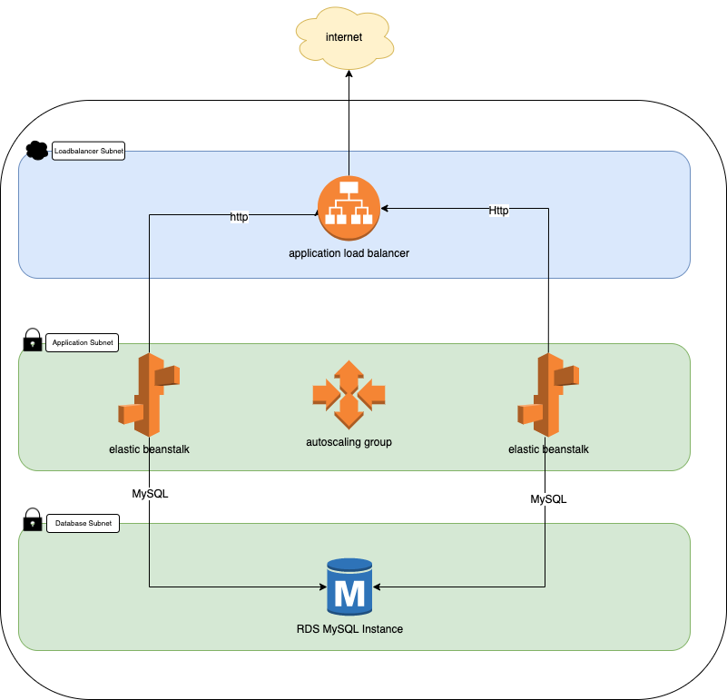

Core components:

|  |  |
| --- | --- |
| * AWS Elastic Beanstalk (node.js) in autoscaling group (min=1 max=4) * RDS Database (MySQL) in Multi-AZ | * One VPC * 2 x Public Subnets for Load Balancer * 2 x Private Subnets (with NATGW) for APP * 2 x Private Subnets (without Internet) for DB |

Application redesign:

* SQLite database has been replaced by MySQL. One of the project requirements was “Application must serve variable amount of traffic.” It means that it needs to be more scalable and ready for the multiple

 instances of the same application accessing a database at the same time. One of official SQLite recommendation is migrate to the client/server database engine because they usually support a higher level of concurrency and offer better performance: <https://www.sqlite.org/faq.html#q5>

* Database initialization script (db.js) has been rewritten to create MySQL schema.
* package.json has been modified to initiate database schema before start application
* bcrypt library has been replaced by bcryptjs: This change was due to problems with building the elastic beanstalk application using the “bcrypt” library. Both libraries are functionally the same, bcryptjs is a pure js module.

Cloud Environment:

* Environment has been prepared to build automatically using Terraform (0.12.x) scripts. Terraform is using Cloud Posse modules, available on Apache2 license: <http://github.com/cloudposse/>

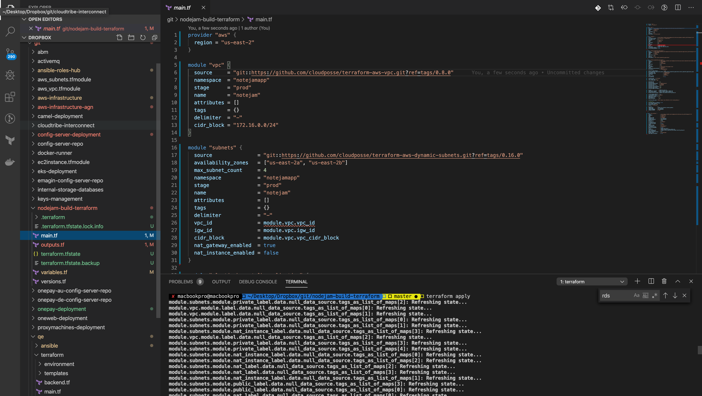

* Application can be deployed From Elastic Beanstalk dashboard or with usage of Elastic Beanstalk CLI by dev/devops team members. (this can be automated with some CI/CD tools like Jenkins/Gitlab etc)

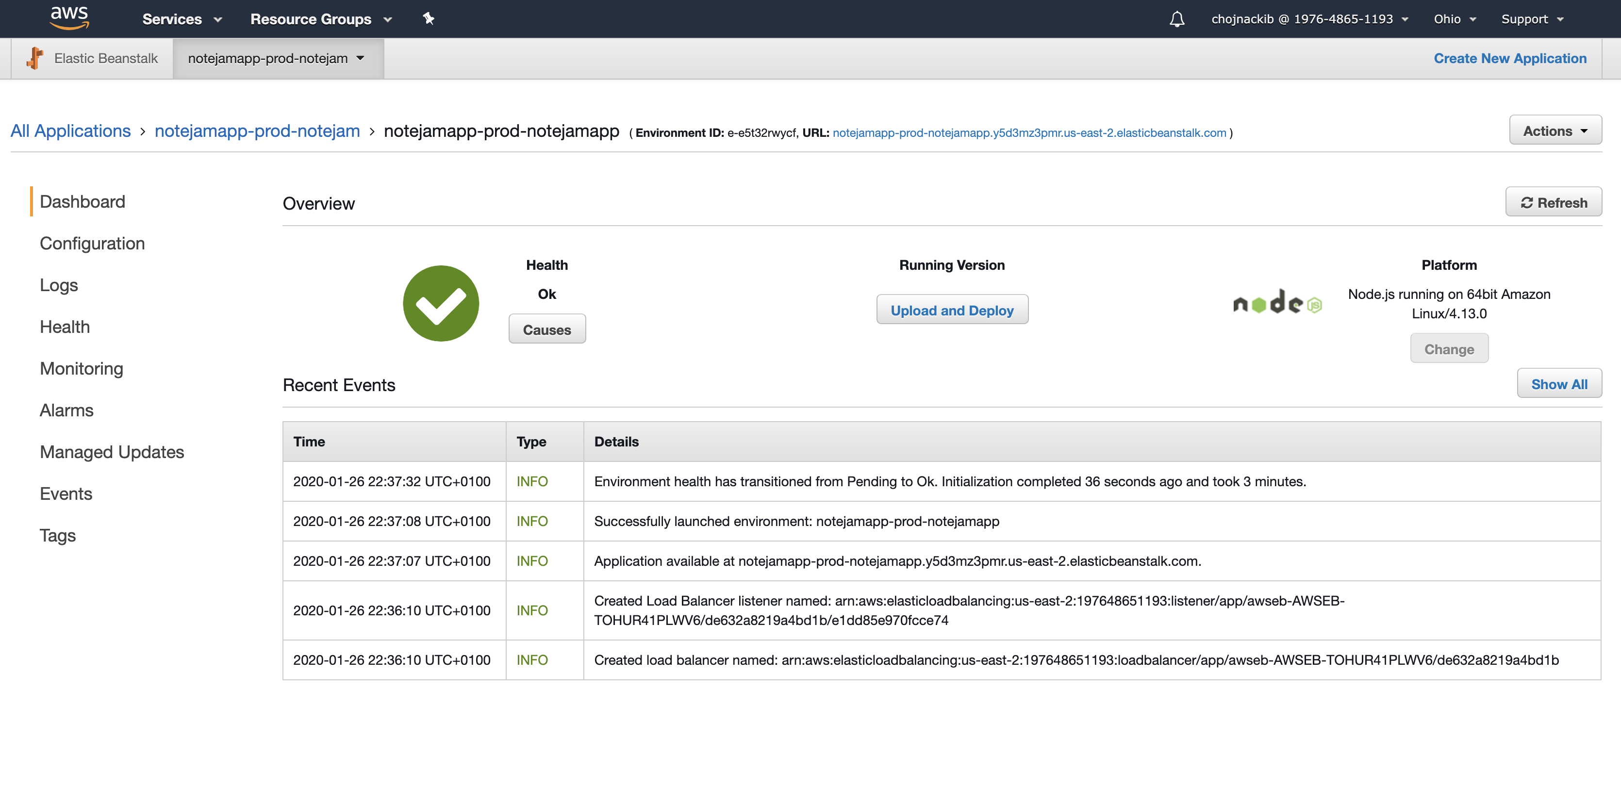

* Database setup to be daily snapshotted. There is possible to recover data from snapshot.

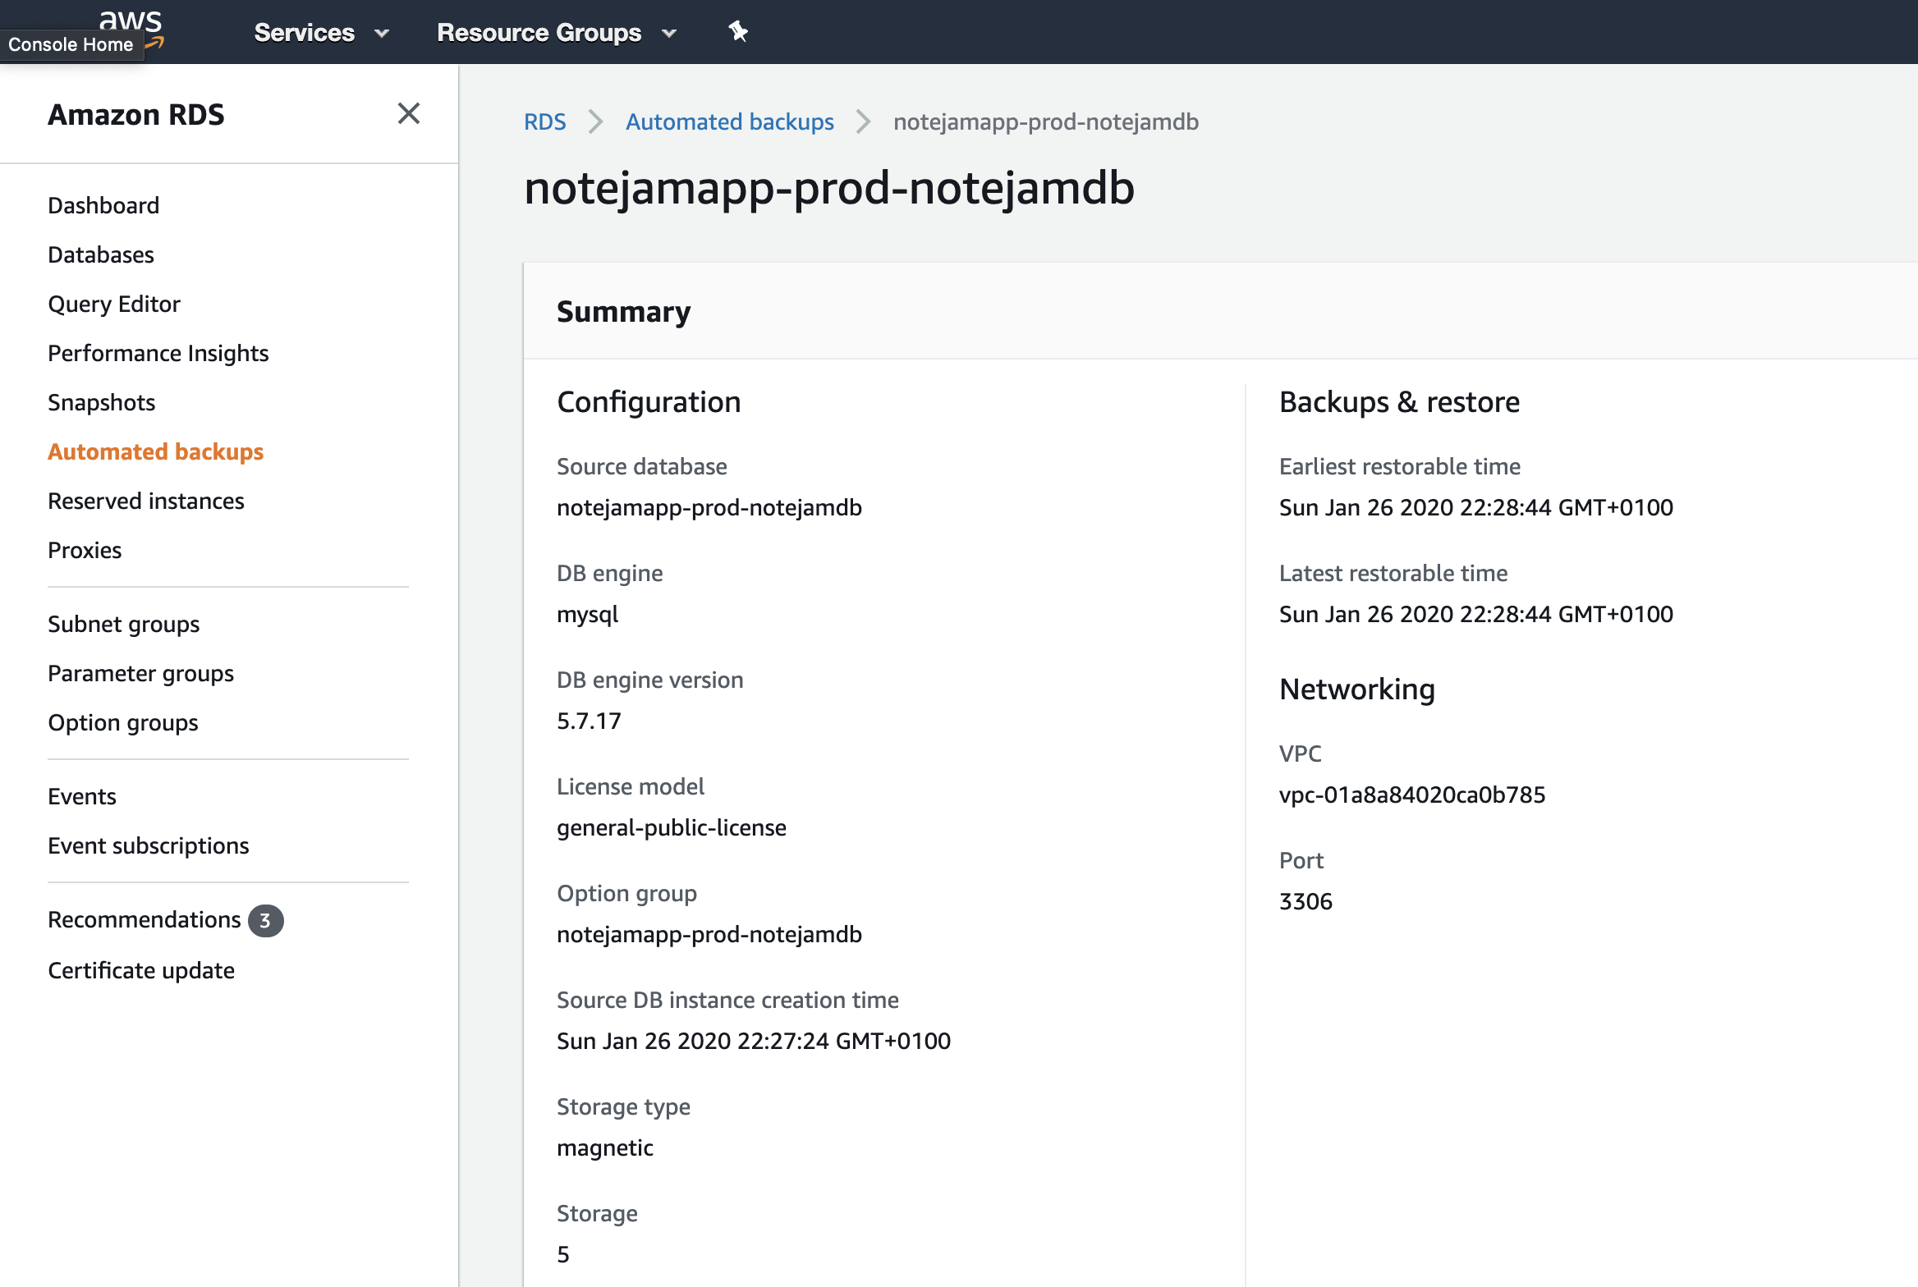

* Application is working in Multi-AZ. In case of failure of one datacenter application will be able to work from second AZ.
* There is possibility to deploy all environments in different Region using attached Terraform scripts
* Rolling deployment has been setup “by default”. All deployments should be procced without any downtime.

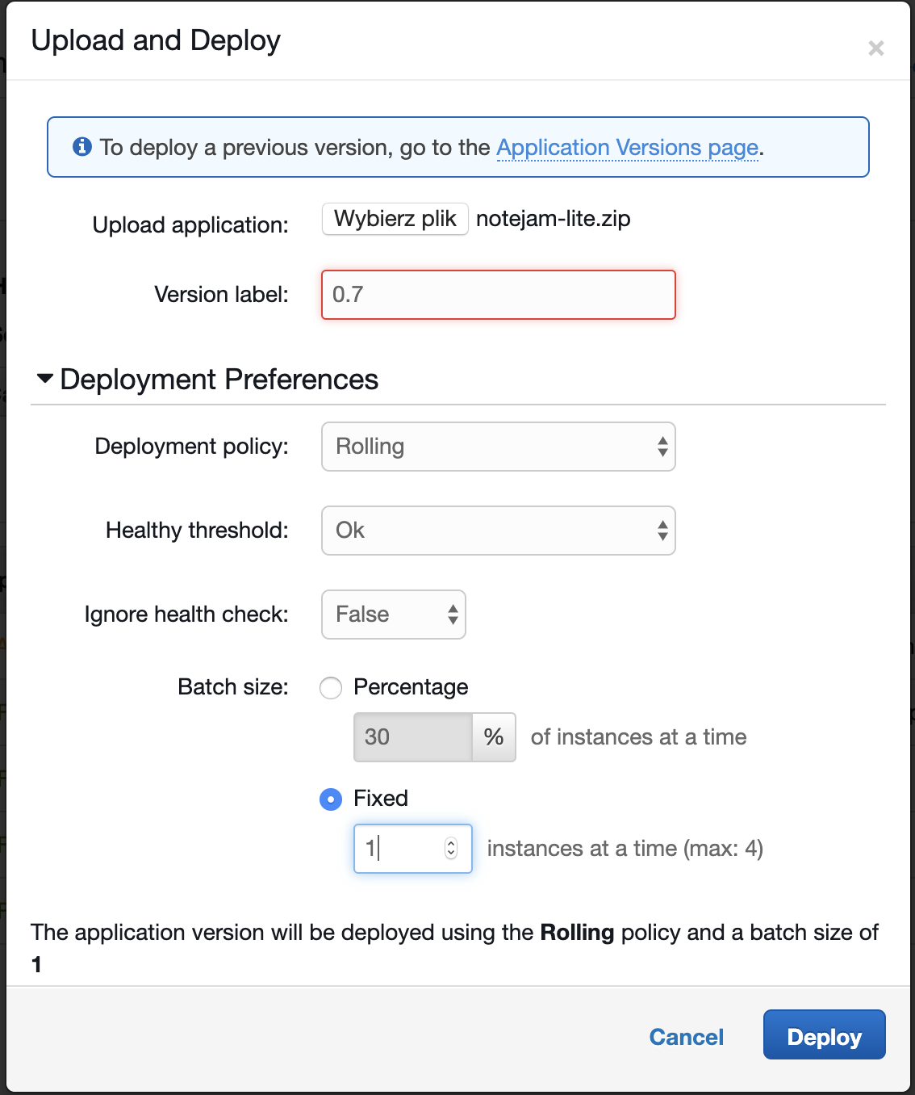

* Second “DEV” Environment for development porpoise has been created.

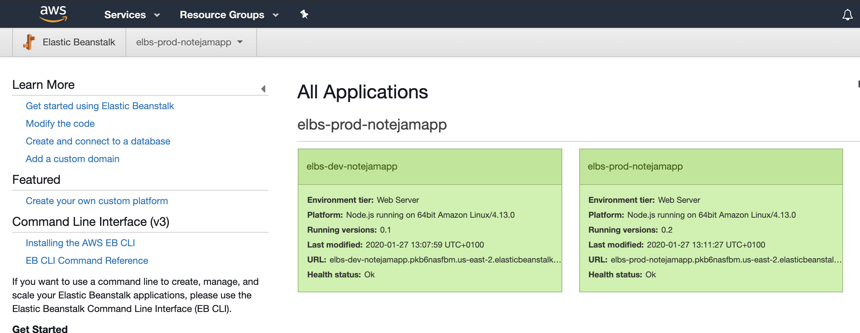

* All metrics are available from Elastic beanstalk metrics sheet.

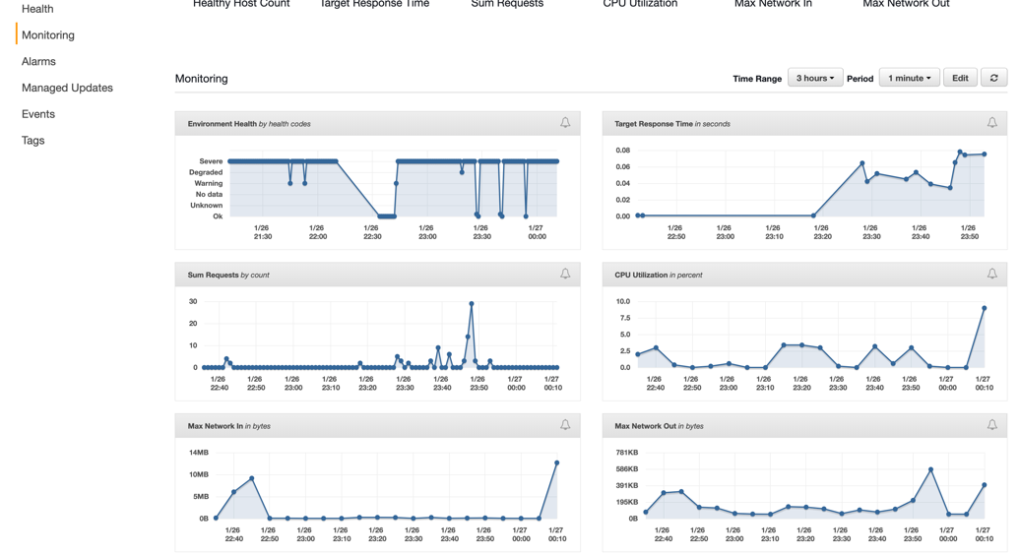

Terraform Deployment:

* Please install and configure aws cli on your workstation to be able to connect to your AWS Account
* Please install terraform (recommended version 0.12.19 or higher)
* Check variables.tf to setup:
  + AWS Region
  + Network Range
  + DEV and Production Database Password
* Please provide commands:
  + “terraform init” to initiate terraform
  + “terraform plan” to check what exactly will be build
  + “terraform apply” to build infrastructure

Application Deployment:

* On Elastic Beanstalk Environment menu, please select “Upload & Deploy” button
* Please upload zipped latest source files of your application, and chose “Deployment Preferences”. There are setup Rolling deployment by default, but you can modify deployment strategy as needed.

TODO:

* There is possible to implement CI/CD pipelines for application deployment using “AWS Code”. Application can be kept in git repository on “AWS Code Commit” or external git services. There is possible to create automatic deployment action, using git as a trigger to automatically deliver new version of application.
* I case that in the future developers might need to use microservices as a more sophisticated tool, we could use Fargate instead of Beanstalk in this architecture. This would ease CI/CD part as you can force Fargate Cluster to deploy new tasks automatically from terraform. New task definition would be linked with given docker image from ECR based on tag provided as terraform variable.