**Ski center – Date warehouse design**

**Business process**

The Date warehouse is designed for the business process of distributing people on the slope. This process is described in the document Specification of business processes in D&B Ski.

**Relational Database schema**

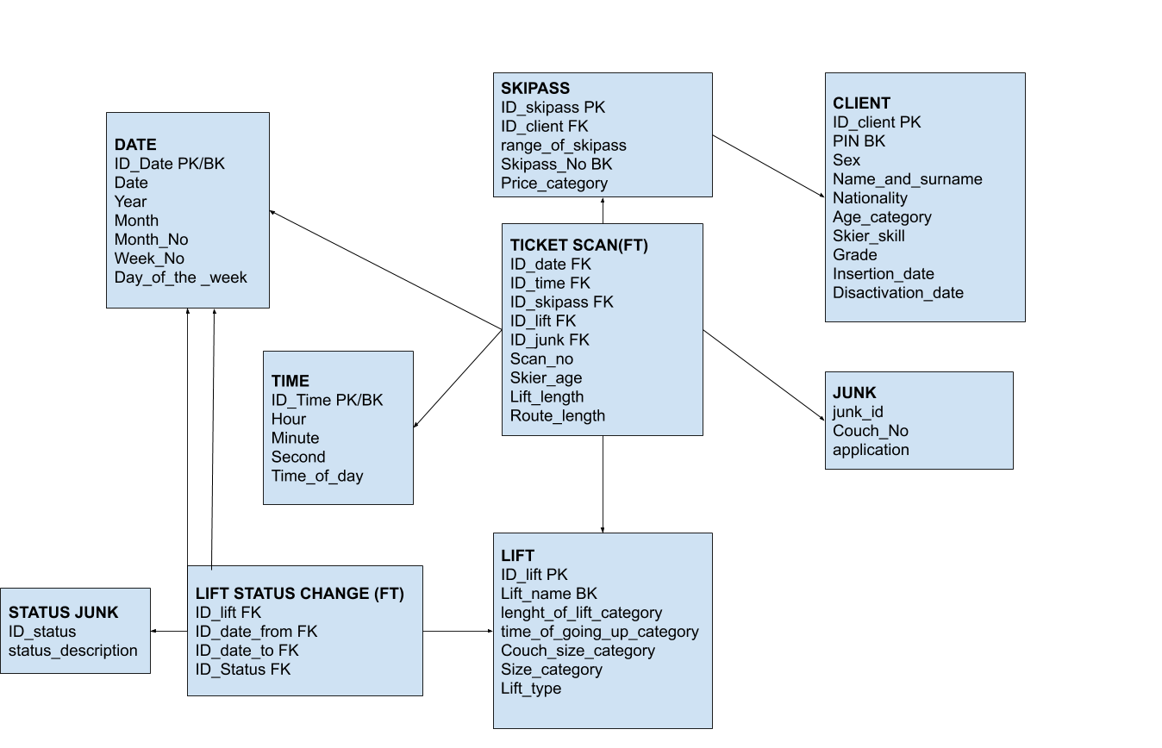

|  |  |  |  |
| --- | --- | --- | --- |
| **TABLE NAME** | **ATTRIBUTE** | **ATTRIBUTE TYPE** | **DESCRIPTION** |
| **TICKET SCAN (FACT TABLE)** | **One tuple describes one fact of a ticket scan** | | |
| ID_date FK | Numeric | FK Date  Date of the ticket scan |
| ID_time FK | Numeric | FK Time  Time of the ticket scan |
| ID_skipass FK | Numeric | FK Skipass  The ticket that was scanned |
| ID_lift FK | Numeric | FK Lift  The lift for which the skipass was scanned |
| ID_junk FK | Numeric | FK Junk  Junk attributes |
| Scan_no | Numeric | The number of how many times the skipass was already scanned |
| Skier_age | Numeric | The age of the skier |
| Lift_length | Numeric | The length of the lift. |
| Route_length | Numeric | Route length equals the lift_length*1,5 |
| **LIFT STATUS CHANGE (FACT TABLE)** | One tuple describes one change in the status of the lift. | | |
| ID_lift FK | Numeric | FK Lift  Lift that the status change references |
| ID_date_from FK | Numeric | FK Date  Date of change to current status |
| ID_date_to FK | Numeric | FK Date  Date of change from current status |
| ID_Status | varchar(8) | FK Status  The name of the status. |
| **SKIPASS**  **(DIMENSION TABLE)** | One tuple describes one ski pass. | | |
| ID_skipass PK | Numeric | PK |
| ID_client FK | Numeric | FK client that the skipass belongs to. |
| range_of_skipass | varchar(10) | The range of lifts the skipass allows the skier to use. Allowed values:  green, blue, red. |
| Skipass_No BK | 11 digits | The identification number of the skipass. |
| Price_category | varchar(15) | The category of the price. Allowed values:  very cheap, cheap, medium, expensive, very expensive. |
| **CLIENT** | One tuple describes one client in the specific age category with specified skill_level | | |
| ID_client PK | Numeric | PK |
| PIN BK | 11 digits | Personal Identification Number. |
| Sex | varchar(6) | Sex of the skier. |
| Name_and_surname | varchar(50) | Name and surname. |
| Nationality | varchar(30) | The nationality of the skier. |
| Age_category | varchar(20) | The age category of the skier. Allowed values: less than 16,  between 16 and 20, between 21 and 27, between 28 and 35, between 36 and 49, between 50 and 65, between 66 and 75, more than 75. |
| Skier_skill | varchar(15) | The skill of the skier. Allowed values: junior, beginner, mid, upper-mid, expert. |
| Grade | varchar(15) | The grade the client gives for his experience. Allowed values: very bad, bad, neutral, good, very good, perfect. |
| Insertion_date | Date | The date of entering the instance into the system. |
| Deactivation_date | Date | The date when the instance loses its relevance. |
| **LIFT**  **(DIMENSION TABLE)** | One tuple describes one lift. | | |
| ID_lift PK | Numeric | PK |
| Lift_name BK | varchar(20) | The name of the lift. |
| lenght_of_lift_category | varchar(30) | The length of the lift. Allowed values: between 0 and 300, between 300 and 500, between 500 and 1000, more than 1000. |
| time_of_going_up_category | varchar(30) | The time it takes for the couch to travel to the top.  Allowed values: less than 10 minutes, between 10 and 15 min, between 15 and 20 min, between 20 and 25 min, more than 25 min. |
| Couch_size_category | varchar(7) | The size category of the couch. Allowed values: single, double , quadruple, six-seater. |
| Size_category | varchar(7) | Category of the number of couches on the lift.  Allowed values: less than 30, between 30 and 40, between 40 and 50, between 50 and 60, more than 60. |
| Lift_type | varchar(15) | The type of the lift. Allowed values: drag ski lift, ski couch, ski gondola. |
| **TIME**  **(DIMENSION TABLE)** | One tuple describes one second. | | |
| ID_Time | Numeric | PK |
| Hour | Numeric | Hour. Allowed values from 0 – 23. |
| Minute | Numeric | Minute. Allowed values from 0 – 59. |
| Second | Numeric | Second. Allowed values from 0 – 59. |
| Time_of_day | Varchar(20) | Time of day. Allowed values: between 0 and 8, between 9 and 12, between 13 and 15, between 16 and 20, between 21 and 23. |
| **DATE**  **(DIMENSION TABLE)** | One tuple describes one day. | | |
| ID_Date | Numeric | PK |
| Date | Date | Date |
| Year | 4 digits | Year |
| Month | Varchar(10) | Month. Allowed values: January, February, March, April, May, June, July, August, September, October, November and December. |
| Month_No | Numeric | Month’s numeric value |
| Week_No | Numeric | Week’s numeric value |
| Day_of_the _week | Varchar(10) | Day of week. Allowed values: Monday, Tuesday, Wednesday, Thursday, Friday, Saturday and Sunday |
| **STATUS_JUNK (DIMENSION TABLE)** | The tuples correspond to “all” possible statuses the lift can be in. | | |
| Status_id | Numeric | PK |
| Status | varchar(8) | The name of the lift status. Allowed values: active, inactive. |
| **JUNK**  **(DIMENSiON TABLE)** | The tuples correspond to “all” possible combinations of values for Couch_No, Application and Lift_status. | | |
| Junk_id | Numeric | PK |
| Couch_No | Numeric | Number of the specific couch on the lift. |
| Application | Varchar(10) | Whether the application  is already present in the system. Allowed values:  active, inactive. |

Dimensional model

Fact definitions

Fact 1 Ticket scan fact: Scan of the skipass done on a specified day, at a specified time for the specific lift that belong to a specific client in the specific age range with a specific skill-level that covers specific range and is of specific price range.

Fact table: Ticket_scan

Granularity:

- a specified scan,

- a specified lift with specified number of couches category,

- a specified second of scan,

- a specified date of scan,

- a specified client in the specified age category, with the specified skil_levell, nationality and sex.

- a specified ticket within one price category.

Measures and aggregation functions:

Number of ticket scan facts – COUNT (1)

Number of skipasses - DISTINCT COUNT (ID_skipass)

Number of km done by skiers - SUM(Route_length)

Fact 2 Lift status change fact: Changing the status of the lift.

Fact table: Lift_status_change

Granularity:

- a change in the status of a specified lift at specified day in specified time.

Measures and aggregation functions:

Number of change of the status facts – COUNT(1)

**Dimension definitions**

Dimensions for Fact 1 Ticket scan fact

|  |  |  |
| --- | --- | --- |
| **DIMENSION/DIMENSION ATTRIBUTE** | **TABLE/COLUMN** | **TYPE** |
| Skipass | Skipass | Dimension |
| Skipass range | Skipass.range_of_skipass | Dimension attribute |
| Skipass number | Skipass.Skipass_No | Dimension attribute |
| Skipass price category | Skipass.Price_category | Dimension attribute |
| Lift | Lift | Dimension |
| Lift name | Lift.Lift_name | Dimension attribute |
| Lift length | Lift.lenght_of_lift_category | Dimension attribute |
| Lift time of going up | Lift.time_of_going_up_category | Dimension attribute |
| Lift size category of the couch | Lift.Couch_size_category | Dimension attribute |
| Lift size category | Lift.Size_category | Dimension attribute |
| Lift type | Lift.Lift_type | Dimension attribute |
| Client | Client | Dimension |
| Client PIN | Client.PIN | Dimension attribute |
| Client sex | Client.Sex | Dimension attribute |
| Client name | Client.Name_and_surname | Dimension attribute |
| Client nationality | Client.Nationality | Dimension attribute |
| Client age category | Client.Age_category | Dimension attribute |
| Client skier skil | Client.Skier_skill | Dimension attribute |
| Client grade of service | Client.Grade | Dimension attribute |
| Client insertion date | Client.Insertion_date | Dimension attribute |
| Client deactivation date | Client.Deactivation_date | Dimension attribute |
| Client hierarchy | • Client.Skier_skill  •• Client.Age_category  ••• Client.PIN | Hierarchical dimension |
| Scan time hierarchy | • Time.TimeOfDay  •• Time.Hour  ••• Time.Minute  •••• Time.Second | Hierarchical dimension |
| Scan date hierarchy | • Date.Year  •• Date.Month  ••• Date.Date | Hierarchical dimension |
| Scan date | Date | Dimension |
| Scan year | Date.Year | Dimension attribute |
| Scan month | Date.Month | Dimension attribute |
| Scan day | Date.Date | Dimension attribute |
| Junk | Junk | Dimension |
| Couch number | Junk.Couch_No | Dimension attribute |
| Application | Junk.Application | Dimension attribute |
| Status | Status_junk | Dimension |
| Lift status | Status_junk.status | Dimension attribute |

Dimensions for Fact 2 Lift status change fact

|  |  |  |
| --- | --- | --- |
| **DIMENSION/DIMENSION ATTRIBUTE** | **TABLE/COLUMN** | **TYPE** |
| Lift | Lift | Dimension |
| Lift name | Lift.Lift_name | Dimension attribute |
| Lift length | Lift.lenght_of_lift_category | Dimension attribute |
| Lift time of going up | Lift.time_of_going_up_category | Dimension attribute |
| Lift size category of the couch | Lift.Couch_size_category | Dimension attribute |
| Lift size category | Lift.Size_category | Dimension attribute |
| Lift type | Lift.Lift_type | Dimension attribute |
| Status change date hierarchy | • Date.Year  •• Date.Month  ••• Date.Date | Hierarchical dimension |
| Status change date | Date | Dimension |
| Status change year | Date.Year | Dimension attribute |
| Status change month | Date.Month | Dimension attribute |
| Status change day | Date.Date | Dimension attribute |
| Status | Status_junk | Dimension |
| Lift status | Status_junk.status | Dimension attribute |

**Checking the feasibility of queries based on the multidimensional model**

1. Compare the average quality rating with number of skiers during this and previous month.  
Measure: Number of skipasses  
Dimension: Client (dimension attributes: Grade)  
Dimension: Date (dimension attributes: Month)

2. Compare the number of lifts which status is “active” to the number of skiers on the slopes during a day.  
Measure: Number of skipassess  
Dimension: Status (dimension attributes: status)  
Dimension: Date (dimension attributes: Date)

3. How many times (in % of whole downhills) did skiers use ski couch lift, and how many times have they used drag ski lift?  
Measure: Number of ticket scans  
Dimension: Lift (dimension attributes: Lift_type)

4. What skipass type is most commonly used in terms of range (1, 2 or 3) compared to last year?  
Measure: Number of skipasses  
Dimension: Skipass (dimension attributes: Range_of_skipass)

5. How many skipasses was most commonly used in terms of age (segmentation) ?  
Measure: Number of skipasses  
Dimension: Client (dimension attributes: Age-category)

6. Have the application increased number of intermediate people compared to the last year?  
Measure: Number of skipasses  
Dimension: Junk (dimension attributes: Application)  
Dimension: Client (dimension attributes: Skill-level)

7. Did the number of older people increase after using application?  
Measure: Number of skipasses  
Dimension: Client (dimension attributes: Age-category)  
Dimension: Junk (dimension attributes: Application)

8. Have the number of downhills per day increased after using application?   
Measure: Number of ticket scans  
Dimension: Junk (dimension attributes: Application)

9. Have the number of km driven by skier increased after using application?   
Measure: Number of km done by skiers  
Dimension: Junk (dimension attributes: Application)

10. People of what age interval made the most km downhills?   
Measure: Number of km done by skiers  
Dimension: Client (dimension attributes: Age-category)

**Checking if there are Date in the Date sources needed to fill the Date warehouse**

|  |  |  |
| --- | --- | --- |
| **TABLE NAME** | **COLUMN** | **SOURCE** |
| **TICKET SCAN** | **One tuple describes one fact of a ticket scan** | |
| ID_date FK | Scan date Id. Foreign key from dimension table. Based on time_of_skipassing stored in Gatepassing table in Skibase source |
| ID_time FK | Time Id. Foreign key from dimension table. Based on time_of_skipassing stored in Gatepassing table in Skibase source |
| ID_skipass FK | Scanned Ticket Id. Foreign key from dimension table. Based on foreign key in table Skipass in Skybase source and Price in fact table Price_list. |
| ID_lift FK | Lift Id. Foreign key from dimension table. Based on Lift name. Based on Lift table in Skibase source. |
| ID_junk FK | Junk Id. Foreign key from dimension table. Based on numberOfCouch,  Application, Lift_status from Sheet “Employee” from CEO Excel |
| Scan_no | Scan number of the ticket. Based on amountOfScansPerSkier and gatePassingBySkipass in Gatepassing table in Skibase source. |
| Skier_age | Skier age. Calculated from date_of_birth from Client table from Skibase source |
| Lift_length | Length of the lift based on length_of_lift from Lift table from Skibase source. |
| Route_length | Route length is equal Lift_length *1,5. Lift_length is based on length_of_lift from Lift table from Skibase source. |
| **LIFT STATUS CHANGE** | One tuple describes one change in the status of the lift. | |
| ID_lift FK | ID of lift. Foreign key from dimension table. Based on Lift name. Based on Lift table in Skibase source. |
| ID_date_from FK | Status change ID. Foreign key from dimension table Based on Skipass range. Based on Skipass table in Skibase source. |
| ID_date_to FK | Status change ID. Foreign key from dimension table Based on Skipass range. Based on Skipass table in Skibase source. |
| **SKIPASS** | One tuple describes one ski pass. | |
| ID_skipass PK | Skipass Id. Surrogate key - generated by database |
| ID_client FK | Client Id. Foreign key from dimension table. Value based on data from Skibase. |
| range_of_skipass | Skipass range. Based on range_of_skipass form Skipass table from Skibase source. |
| Skipass_No | Number of skipass based on skipass range and foreign key client_id from table Skipass from Skibase. |
| Price_category | Allowed values:  cheap, medium, expensive  Calculated from Price from Price_List from Skibase source. |
| **CLIENT** | One tuple describes one client in the specific age category with specified skill_level | |
| ID_client | Client Id. Surrogate key - generated by database |
| PIN | Client Personal Identification Number. Taken from ClientPesel from Client table in Skibase source |
| Sex | Sex of skier based on clientSex in table Client from Skibase source. |
| Name_and_surname | Name and surname of skier based on clientNameSurname in table Client from Skibase source. |
| Nationality | Nationality of skier based on clientNationality in table Client from Skibase source. |
| Age_category | Age interval of skiers based on age_of_birth in table Client from Skibase source. |
| Skier_skill | Skill of skier based on clientSkillLevel in table Client from Skibase source. |
| Grade | Grade of skier based on clientGrade in table Client from Skibase source. |
| Insertion_date | Date of enter Skier to the system based on clientInsertDate in table Client from Skibase source. |
| Deactivation_date | Date of expected changes in client based on clientCheckDate in table Client from Skibase source. |
| **LIFT** | One tuple describes one lift. | |
| ID_lift PK | Lift Id. Surrogate key - generated by database |
| Lift_name BK | Lift name. Based on lift_name from Lift table from Skibase source. |
| lenght_of_lift_category | Allowed values: between 0 and 300, between 300 and 500, between 500 and 1000, more than 1000.  Calculated from lendth_of_lift from Lift table from Skibase source. |
| time_of_going_up_category | Allowed values: less than 10 min, between 10 and 15 min, between 15 and 20 min, between 20 and 25 min, more than 25 min.  Calculated from time_of_going_up from Lift table from Skibase source. |
| Couch_size_category | Allowed values: single, double , quadruple, six-seater.  Calculated from People_per_couch from Lift table from Skibase source. |
| Size_category | Allowed values: less than 30, between 30 and 40, between 40 and 50, between 50 and 60, more than 60.  Calculated from Price from Price_List from Skibase source. |
| Lift_type | Type of lift based on liftType in table Lift_Type from Skibase source. |
| **DATE** | One tuple describes one day. All the data in this table are generated tuple by tuple based on any calendar, before ETL process | |
| **TIME** | One tuple describes one hour (independently of date). All the data in this table are generated tuple by tuple based on clock, before ETL process. | |
| **JUNK** | The tuples correspond to "all" possible combinations of values for Application and Couch_number and are generated before ETL process. | |
| Junk_id | Surrogate key - generated by database. |
| **STATUS JUNK** | The tuples correspond to "all" possible combinations of values for Status and are generated before ETL process. | |
| Status_id | Surrogate key - generated by database. |