**Bartek Podgórski**

**175852**

**Data Engineering II y.**

**Group nr.2**

***Database project***

***“Political Party in Poland”***

**Task analysis**

**Customer:** opposition political party.

**Users:** politicians of opposition parties, journalists, ordinary citizens.

**Purpose:** database enabling the settlement of the winning party and its politicians from election promises during the term of office.

**Assumptions and limitations:**

* The political party rules without a coalition partner.
* We have not non-attached Members.
* In my model every politician is deputy.

**Scenarios (for instance):**

* Journalists want to settle the political party's compliance with deadlines for promises.
* How many were deputy’s presence at the voting?
* How looks Jerzy’s Pawlak property statement?
* How did Jan Nowak vote at voting about Artificial Intelligence?

**Inquiries to the database:**

* How deputy Urbanczyk voted in the case of amber gold
* Is Jan Nowak on the ethics committee?
* Whether the promise of X was fulfilled on time?

**ERD diagram**

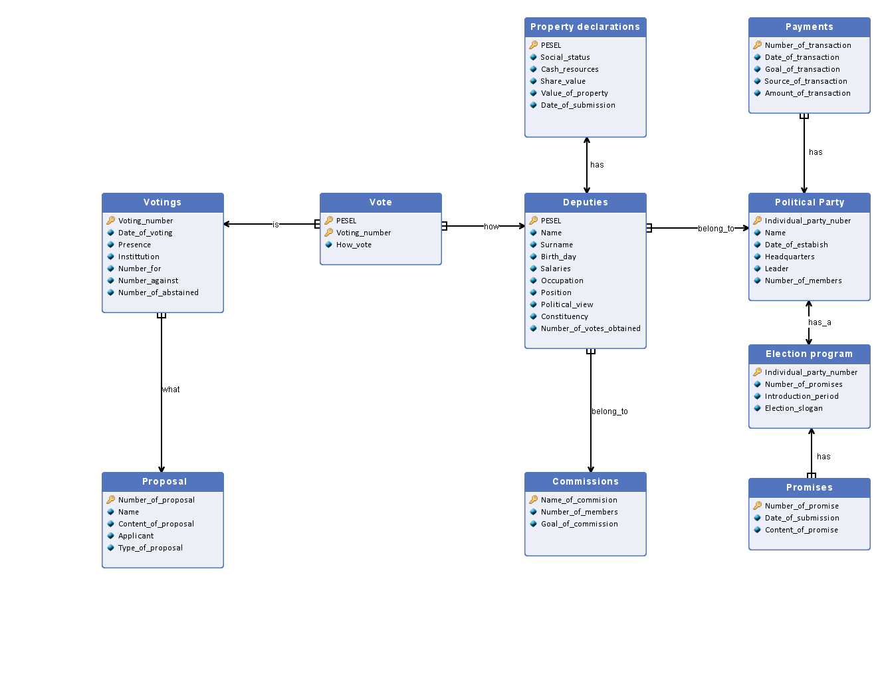

**Description of ERD diagram**

In this section I would like to describe my attributes and relations.

|  |  |  |  |  |
| --- | --- | --- | --- | --- |
| **Entities** | **Description of entities** | **Attributes** | **Description of attributes** | **Domain of attributes** |
| **Voting’s** | In this entity we have a detailed description of voting in institutions. In addition, in this entity we will find the exact results of the voting and the date of the voting, each voting has its own individual number. We add values ​​to this entity after we receive the minutes of each meeting and never delete them. Estimated number of voting’s is 550. | Voting_number | It is a primary key. Every voting has individual number. | It is a natural number from the range 1 to 550. |
| Date_of_voting | It is date of voting. | It is 8 numbers in range 0-9 in format: day (2 numbers)-month (2 numbers)-year (4 numbers). |
| Presence | It is a number how many deputies were presence at the voting. | It is a natural number from the range 1 to 460. |
| Institution | This is the name of the institution where the voting takes place. | It is a text that adopts values ​​such as the Diet or Senate. |
| Number_for | It is a number of all votes “for” in individual voting. | It is a natural number from the range 0 to 460. |
| Number_against | It is a number of all votes “against” in individual voting. | It is a natural number from the range 0 to 460. |
| Number_abstained | It is a number of all votes “abstained” in individual voting. | It is a natural number from the range 0 to 460. |
| **Vote** | In this entity we have an information about how deputy was voted in voting. We add values ​​to this entity after we receive the minutes of each meeting and never delete them. | PESEL | It is a foreign key from Deputies entity which we use with Voting_number as primary key | It is 11 numbers which are in range 0-9. |
| Voting_number | It is a foreign key from Voting number entity which we use with PESEL as primary key | It is a natural number from the range 1 to 550. |
| How_vote | It is an option how deputy can vote. | It is a text which can be for, against, abstained or not_present. |
| **Proposal** | In this entity we have information on the proposals for voting. There can be many votes over a given application. This entity also specifies what type of application it is and what it concerned, what title it had and what party submitted the application. Data to this entity are entered after receiving the meeting minutes and we never delete them. The expected number of applications is 400 | Number_of_proposal | It is a primary key. Every proposal has individual number. | It is a natural number from the range 1 to 400. |
| Name | It is a title of proposal. | this is a text that contains up to 40 characters. |
| Content_of_proposal | It is a content of proposal, because we because we need to know the details of the content of the application | this is a text that contains up to 1000 characters. |
| Type_of_ proposal | It is a type of proposal | this is a text that contains up to 20 characters, the most often value is statute or law. |
| Applicant | It is a name of political party which apply a proposal | this is a text that contains up to 100 characters. |
| **Commissions** | In this entity, we have information on the committees that deputies are composed of. Each committee must have at least 3 members and each committee have its own individual name. Data to this commission are added at the beginning of the commission's creation and deleted when the commission's work is completed. Expected number of committees 150. | Name_of_commission | It is a primary key. | this is a text that contains up to 100 characters. |
| Number_of_members | It is a number how many deputies are in commission. | It is a natural number from the range 3 to 25. |
| Goal_of_commission | It is an information about main task of commission. | this is a text that contains up to 1000 characters. |
| **Deputies** | In this entity we have all information about politicians. Depend on it we can inform about for instance salaries or political view. Data to this entity are added after results of election and there are not deleted. Prediction number of deputies is 350 deputies. | PESEL | It is a Polish identity number which is individual for every citizen. It is primary key. | It is 11 numbers which are in range 0-9. |
| Name | It is a name of deputy. | It is a text which range to 15 characters. |
| Surname | It is a surname of deputy. | It is a text which range to 25 characters. |
| Birth_day | It is a date of birth of deputy. | It is 8 numbers in range 0-9 in format: day (2 numbers)-month (2 numbers)-year (4 numbers). |
| Salaries | It is a mount of money which deputy get money. | It is a natural number bigger than or equal zero in PLN. |
| Occupation | It is a job in which deputy has experienced. | It is a text which range to 30 characters. |
| Position | It is a position, which has a deputy in institutions. | It is a text like ordinary deputy, senator, marshal or minister. |
| Political_view | It is description of political view of deputy. | It is a text in range to 200 characters. |
| Constituency | It is a place from which deputy ran. | It is a natural number in range from 1-100. |
| Number_of_votes_obtained | It is a number which deputy got in election. | It is a natural number in range from 0-1000000. |
| **Property declarations** | It is a special financial statement which have to be made by all deputy on the beginning of the cadence.  It includes all money and property which belong to deputy. Data to this entity are added when deputy give their property declaration to public, and they can be change when deputy change it. Prediction number is 350. | Pesel | It is a Polish identity number which is individual for every citizen. It is primary key | It is 11 numbers which are in range 0-9 |
| Social_status | It is a social status in society | It is a text which is like single, married, divorced or widowed |
| Cash_resources | It is a cash resources like money in bank account or in hand | It is a natural number bigger than or equal zero in PLN |
| Share_value | It is a value of share in stock exchange | It is a natural number bigger than or equal zero in PLN |
| Value_of_property | It is a value of property like car, home, ground | It is a natural number bigger than or equal zero in PLN |
| Date_of_submission | It is a date when property declaration was submissioned | It is 8 numbers in range 0-9 in format: day (2 numbers)-month (2 numbers)-year (4 numbers) |
| **Political Party** | In this entity you can find information about name of political party, basic information about it and the number of deputies which belong to the political party. Data to this entity are added after results of election and there are not deleted. Predicted number is 1, because we have only one winner party. | Individual_party_number | It is individual number for every political party given by special commission. It is a primary key | It is a natural number bigger than 0 |
| Name | It is a name of political party | It is a text which range to 30 characters |
| Date_of_estabish | It is date when political party was established | It is 8 numbers in range 0-9 in format: day (2 numbers)-month (2 numbers)-year (4 numbers) |
| Headquarters | It is an address of main office | It is a text which is in range 0-50 characters |
| Leader | It is a name and surname of leader | It is a text which is in range 0-35 characters |
| Number_of_members | It is a number of deputies which belong to political party | It is a natural number bigger than 0 |
| **Payments** | In this entity you can find information about transaction which get party from various company. Every transaction has individual number and amount of money which include. Data are added after every transaction and they are not deleted. Predicted number is about 140. | Number_of_transaction | It is individual number for every transaction. It is primary key | It is a natural number bigger than 0 |
| Date_of_transaction | It is date when transaction was made | It is 8 numbers in range 0-9 in format: day (2 numbers)-month (2 numbers)-year (4 numbers) |
| Goal_of_transaction | It is a name and goal transaction, so why transaction was made | It is a text in range to 200 characters |
| Source_of_transaction | It is a name of company which make a transaction | It is a text in range to 50 characters |
| Amount_of_transaction | It is amount of money which included transaction | It is a natural number bigger than or equal zero in PLN |
| **Election program** | In this entity we have information about set of promises which I name election program. Every party has their individual program, which include time to introduce promises and slogan. Data to this entity are added during an election campaign and they are not deleted. Every party has only one program. | Individual_party_number | It is individual number for every political party given by special commission. It is a primary key | It is a natural number bigger than 0 |
| Number_of_promises | It is amount of promises in program of party | It is a natural number bigger than 0 |
| Introduction_period | It is time which have a party to realize their promises | It is a time; which range is 0-4 in years |
| Election_slogan | It is a main slogan in election campaign | It is a text in range to 50 characters |
| **Promises** | In this entry we have an information about promises which was submissioned in election campaign, we can find here date of submissed and content too. Data to this entity are added during and after an election campaign and they are not deleted. Predicted number is 90. | Number_of_promise | It is individual number for every promise. It is primary key | It is a natural number bigger than 0 |
| Date_of_submission | It is date when the promise was submissed | It is 8 numbers in range 0-9 in format: day (2 numbers)-month (2 numbers)-year (4 numbers) |
| Content_of_promise | It is a content of promise, because we have to remember what party promised us | It is a text in range to 500 characters |

**Relations**

|  |  |  |
| --- | --- | --- |
| **Relation** | **Type** | **Description** |
| **promises-election program** | N:1 | I use this type of relation, because every election program has to have a lot of promises, and the promise can be in only one election program. |
| **election program-political party** | 1:1 | I use this type of relation, because every political party has only one program and every program has only one party. |
| **Payments- political party** | N:1 | I use this type of relation, because every political party has to has a money from different source to realize their promises and the payments concern on one party. |
| **political party-deputies** | N:1 | Political party has many members, and deputy can belong to only one party. |
| **Commissions- deputies** | N:1 | Every deputy has to be in commission, but every commission has to has at least three members |
| **Property declarations-deputies** | 1:1 | Every deputy has to has only one declaration, and every declaration has only one deputy |
| **Deputies-vote** | N:1 | Every deputy has only one vote, but the vote can have various way |
| **Vote-voting’s** | N:1 | Vote is important only in one voting, but in one voting we have a lot of votes |
| **Voting’s-proposal** | N:1 | Every voting has at least one proposal, but proposal can have many voting. |

**ERD schema**

**Description:**

**Foreign key – yellow emphasize**

**Primary key – red line**

**Schema**

* **Promises (**Number_of_promise, Date_of_submission, Content_of_promise**)**
* **Election program (**Individual_party_number, Number_of_promises, Introduction_period, Election_slogan**)**
* **Political party (**Individual_party_number, Name, Date_of_establish, Headquaters, Leader, Number_of_members**)**
* **Payments (**Number_of_transaction, Date_of_transaction, Goal_of_transaction, Source_of_transaction, Amount_of_transaction**)**
* **Deputies (**PESEL, Name, Surname, Bith_day, Salaries, Occupation, Position, Political_views, Constituency, Number_of_votes_obtained**)**
* **Property declarations (**PESEL, Social_status, Cash_resources, Share_value, Value_of_property, date_of_submission**)**
* **Commissions (**Name_of_commission, Number_of_members, Goal_of_commission**)**
* **Vote (**PESEL, Voting_number, How_vote**)**
* **Votings(**Voting_number, Date_of_voting, Presence, Institution Number_for, Number_against, Number_abstained**)**
* **Proposal (**Number_of_proporsal, Name, Content_of_proporsal, Applicant, Type_of_proporsal**)**