03 OW albopictus Temperature Data Exploration

Katie Susong

22nd September 2020

# set wd  
setwd("~/Documents/CBS PhD/albopictus OW/")  
  
#libaries  
shhh <- suppressPackageStartupMessages # It's a library, so shhh!  
shhh(library(ggplot2))  
shhh(library(lubridate))  
shhh(library(dplyr))  
  
#import data frames- WIDE  
OWw <- read.csv("Data/OWALL.wide_KMS_092220.csv")  
#format corrections  
OWw$DateTime <- ymd_hms(OWw$DateTime)  
  
  
  
# import data frames - TIDY  
OW <- read.csv("Data/OWALL.f_KMS_092220.csv")  
#format corrections  
OW$DateTime <- ymd_hms(OW$DateTime)

##### 1. What is the temperature difference between Ambient and Tire each day

This differnce was added to the wide table during formating. Now I will graph each of the data frames to show temperature difference (Tire - Ambient) so that when the tire temperature is warmer the difference is positive

ggplot(OWw,aes(DateTime, Diff)) +  
 geom_line(aes(col=ABC), linetype = 2)+  
 facet_grid(~Location) +  
 theme_bw() +   
 ggtitle("The Diffence in Ambient and Tire Temperature")

## Warning: Removed 3 row(s) containing missing values (geom_path).

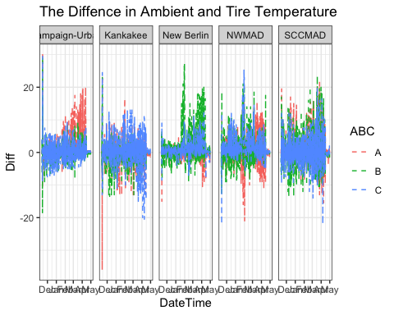

# filter to winter months   
OWw %>%  
 filter(DateTime > "2018-12-01 00:00:00", DateTime < "2019-03-01 00:00:00") %>%  
ggplot(aes(DateTime, Diff)) +  
 geom_line(aes(col=ABC), linetype = 2)+  
 facet_grid(~Location) +  
 theme_bw() +   
 ggtitle("The Diffence in Ambient and Tire Temperature During Winter")

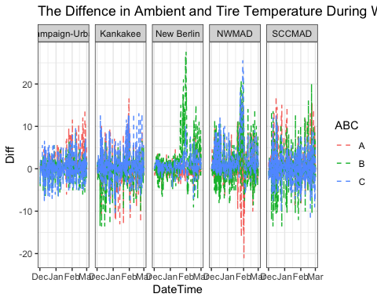

# avg the replicates   
OWw %>%  
 group_by(Location, DateTime) %>%  
 summarise(DiffAvg = mean(Diff)) %>%  
 ggplot(aes(DateTime, DiffAvg)) +  
 geom_line()+  
 facet_grid(~Location) +  
 theme_bw() +  
 ggtitle("The Average Diffence in Ambient and Tire Temperature")

## Warning: Removed 2 row(s) containing missing values (geom_path).

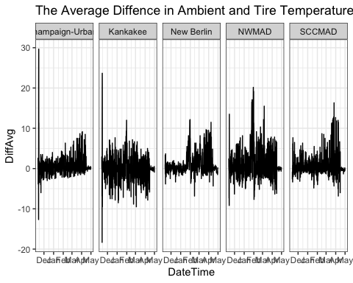

# avg the replicates and filter to winter months  
OWw %>%  
 group_by(Location, DateTime) %>%  
 summarise(DiffAvg = mean(Diff)) %>%  
 filter(DateTime > "2018-12-01 00:00:00", DateTime < "2019-03-01 00:00:00") %>%  
 ggplot(aes(DateTime, DiffAvg)) +  
 geom_line()+  
 facet_grid(~Location) +  
 theme_bw() +  
 ggtitle("The Average Diffence in Ambient and Tire Temperature During Winter")

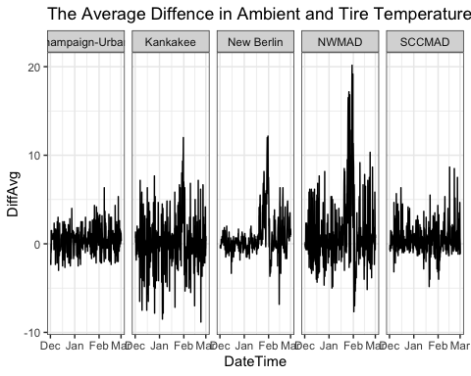

* There are not clear repeating trends at any location or across the locations.
* There is not any seasonal trend.
* Early and late season warm tires could be due to sun.
* The very late season shows uniform tempertures
* **Champaign-Urban** has two similar replicates.
* **New Berlin** rarely has colder tires but the warm spike in FEB is only seen in replicate B. This replicate also seems to stay warmer for longer
* Further south locations (**Champaign-Urban**) have lover temperature differnce in the winter months
* In **New Berlin** there is less temperature swings in temperature differnce in DEC and JAN.
* **NWMAD** has the greatest differnce in temperature during the winter period

##### 2. How many observation were below -12C?

# generate count by location:  
OW$Below12 <- ifelse(OW$Value < -12, 1, 0) # create a 0/1 column for tempertures below -12  
# pipe   
OW_below12 <- OW %>%  
 group_by(Location, ABC, Type) %>%   
 # summary includes count of observations below zero, total observation and percent  
 dplyr::summarise(Below12 = sum(Below12),N = n(), Perc = round(sum(Below12)/n()*100, 2))

Two replicats had a very low number of observations below -12C, **New Berlin** and **NWMAD**. For each location the temperture was only below -12C for one day.

subset(OW, Location == "New Berlin" & ABC == "B" & Type == "Tire" & Value < -12)

## X Location Number Type Value DateTime ABC Below12  
## 4789 4789 New Berlin 2 Tire -12.5 2019-02-09 03:00:00 B 1  
## 4790 4790 New Berlin 2 Tire -13.5 2019-02-09 06:00:00 B 1  
## 4791 4791 New Berlin 2 Tire -14.0 2019-02-09 09:00:00 B 1

subset(OW, Location == "NWMAD" & ABC == "C" & Type == "Tire" & Value < -12)

## X Location Number Type Value DateTime ABC Below12  
## 32072 32072 NWMAD 12 Tire -13.5 2019-03-04 06:00:00 C 1

#### How many days were below -12C?

OW$Date <- date(OW$DateTime)  
OW_below12_DAY <- OW %>%  
 group_by(Date, Type) %>%  
 # summary includes count of observations below zero, total observation and percent  
 dplyr::summarise(Below12 = sum(Below12),N = n(), Perc = round(sum(Below12)/n()*100, 2))  
  
# filter OW_below12_DAY for days with observations below 12 in the tires   
(filter(OW_below12_DAY, Below12 >0, Type == "Tire"))

## # A tibble: 25 x 5  
## # Groups: Date [25]  
## Date Type Below12 N Perc  
## <date> <fct> <dbl> <int> <dbl>  
## 1 2018-12-09 Tire 2 120 1.67  
## 2 2019-01-14 Tire 1 120 0.83  
## 3 2019-01-19 Tire 2 120 1.67  
## 4 2019-01-20 Tire 16 120 13.3   
## 5 2019-01-21 Tire 20 120 16.7   
## 6 2019-01-24 Tire 3 120 2.5   
## 7 2019-01-25 Tire 52 120 43.3   
## 8 2019-01-26 Tire 36 120 30   
## 9 2019-01-27 Tire 35 120 29.2   
## 10 2019-01-28 Tire 3 120 2.5   
## # … with 15 more rows

There were 25 day with at least 1 temperture observation below -12