05 OW albopictus Explore Summary Data

Katie Susong

12th October 2020

# set wd  
setwd("~/Documents/CBS_PhD/albopictus_OW")  
  
# libaries  
shhh <- suppressPackageStartupMessages # It's a library, so shhh!  
shhh(library(ggplot2))  
shhh(library(dplyr))  
shhh(library(gridExtra))

Import Dataframe

summary <- read.csv("~/Documents/CBS_PhD/albopictus_OW/Data/OW_summary_12012021.csv")  
  
# summary for AA, diapause without controls  
AA2 <- filter(summary,Species == "AA", Diapause == "Y", Location != c("Control27","Control4"))  
AA2$Location <- factor(AA2$Location , levels=c("New Berlin", "NWMAD","SCCMAD" ,"Kankakee", "Champaign-Urbana"))

## SUMMARY VALUES

#### Summary of Jan mean for AA survival

Summary is for diapausing eggs for AA and then for AT

summary %>%  
 filter(Total.Larvae >0, Species == "AA", Diapause == "Y") %>%  
 summarise(meanT=mean(JANmeanT), meanA= mean(JANmeanA))

## meanT meanA  
## 1 3.468889 1.476667

summary %>%  
 filter(Total.Larvae >0, Species == "AT", Diapause == "Y") %>%  
 summarise(meanT=mean(JANmeanT), meanA= mean(JANmeanA))

## meanT meanA  
## 1 -1.2812 -2.5844

#### Summary of AA with survival

Only includes diapausing AA egg strips

summary %>%  
 filter( PerSur >0, Species == "AA", Diapause == "Y") %>%  
 summarise(Number = Number, Strip = Strip, Location = Location, PerSur = PerSur)

## Number Strip Location PerSur  
## 1 10 16 NWMAD 0.085  
## 2 11 27 NWMAD 0.096  
## 3 12 6 NWMAD 2.007  
## 4 12 28 NWMAD 1.597  
## 5 2 31 New Berlin 0.055  
## 6 Control 27 9 Control27 9.500  
## 7 Control 4 14 Control4 15.433  
## 8 Control 4 11 Control4 14.008  
## 9 Control 4 29 Control4 8.878

#### Summary of AT Survial

##### All AT strips at New Berlin

Includes summary of all strips at Bew Berlin with AT, the mean and varience of surival fro diaupause eggs and the mean and varience for non-diapause eggs

#total summary  
summary %>%  
 filter(Species == "AT", Location == "New Berlin") %>%  
 summarise(Number = Number, Strip = Strip, Location = Location,Diapause = Diapause, PerSur = PerSur)

## Number Strip Location Diapause PerSur  
## 1 1 45 New Berlin Y 2.892  
## 2 1 117 New Berlin N 0.000  
## 3 1 64 New Berlin Y 40.799  
## 4 2 116 New Berlin N 0.174  
## 5 2 71 New Berlin Y 42.752  
## 6 2 49 New Berlin Y 10.246  
## 7 3 91 New Berlin Y 0.120  
## 8 3 96 New Berlin N 0.000  
## 9 3 74 New Berlin Y 44.565

#mean and varience  
summary %>%  
 filter(Species == "AT", Location == "New Berlin") %>%  
 group_by(Diapause) %>%  
 summarise(MeanSur = mean(PerSur), sdSur = sd(PerSur))

## `summarise()` ungrouping output (override with `.groups` argument)

## # A tibble: 2 x 3  
## Diapause MeanSur sdSur  
## <fct> <dbl> <dbl>  
## 1 N 0.0580 0.100  
## 2 Y 23.6 21.3

##### All AT strips at NWMAD

Includes summary of all strips at NWMAD with AT, the mean and varience of surival fro diaupause eggs and the mean and varience for non-diapause eggs

#total summary  
summary %>%  
 filter(Species == "AT", Location == "NWMAD") %>%  
 summarise(Number = Number, Strip = Strip, Location = Location,Diapause = Diapause, PerSur = PerSur)

## Number Strip Location Diapause PerSur  
## 1 10 66 NWMAD Y 58.082  
## 2 10 46 NWMAD Y 19.302  
## 3 10 114 NWMAD N 0.347  
## 4 11 113 NWMAD N 0.536  
## 5 11 76 NWMAD Y 63.233  
## 6 11 89 NWMAD Y 0.153  
## 7 12 87 NWMAD Y 0.000  
## 8 12 81 NWMAD Y 54.331  
## 9 12 102 NWMAD N 0.000

#mean and varience  
summary %>%  
 filter(Species == "AT", Location == "NWMAD") %>%  
 group_by(Diapause) %>%  
 summarise(MeanSur = mean(PerSur), sdSur = sd(PerSur))

## `summarise()` ungrouping output (override with `.groups` argument)

## # A tibble: 2 x 3  
## Diapause MeanSur sdSur  
## <fct> <dbl> <dbl>  
## 1 N 0.294 0.272  
## 2 Y 32.5 29.5

## PLOTS

### Survival Verse Mean winter Temperature

a <- ggplot(AA2, aes(JANmeanT, PerSur,col = Location))+  
 geom_point(size = 3) +  
 geom_vline(xintercept = -2.5, linetype = "dashed") +  
 theme_bw() +  
 xlab("Mean Tire Temperature for Jan. (??C)") +  
 ylab("Percent Survival") +  
 xlim(-7,-0)  
  
b <- ggplot(AA2, aes(JANmeanA, PerSur,col = Location))+  
 geom_point(size = 3) +  
 geom_vline(xintercept = -2.5, linetype = "dashed") +  
 theme_bw() +  
 xlab("Mean Ambient Temperature for Jan. (??C)") +  
 ylab("Percent Survival") +  
 xlim(-7,-0)  
  
grid.arrange(a,b)

## Warning: Removed 2 rows containing missing values (geom_point).

## Warning: Removed 4 rows containing missing values (geom_point).

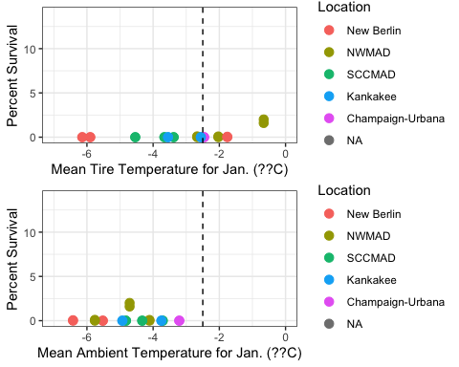

# survival vs days below -12  
c <- ggplot(AA2, aes(DaysB12T, PerSur,col = Location))+  
 geom_point(size = 3) +  
 theme_bw() +  
 xlab("Total Days Below -12??C in Tires") +  
 ylab("Percent Survival") +  
 ylim(0,5) +  
 xlim(0,30)  
  
d <- ggplot(AA2, aes(DaysB12A, PerSur,col = Location))+  
 geom_point(size = 3) +  
 theme_bw() +  
 xlab("Total Days Below -12??C, Ambient") +  
 ylab("Percent Survival")+  
 ylim(0,5) +  
 xlim(0,30)  
  
grid.arrange(c,d)

## Warning: Removed 2 rows containing missing values (geom_point).

## Warning: Removed 2 rows containing missing values (geom_point).

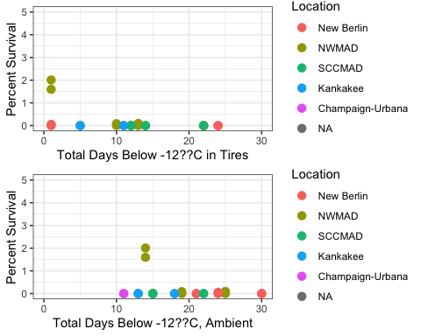

#survival vs contig. days below -12  
e <- ggplot(AA2, aes(DaysB12conT, PerSur,col = Location))+  
 geom_point(size = 3) +  
 theme_bw() +  
 xlab("Continuous Days Below -12??C in Tires") +  
 ylab("Percent Survival") +  
 ylim(0,5) +  
 xlim(0,30)  
  
f <- ggplot(AA2, aes(DaysB12conA, PerSur,col = Location))+  
 geom_point(size = 3) +  
 theme_bw() +  
 xlab("Continuous Days Below -12??C, Ambient") +  
 ylab("Percent Survival")+  
 ylim(0,5) +  
 xlim(0,30)  
  
grid.arrange(e,f)

## Warning: Removed 2 rows containing missing values (geom_point).  
  
## Warning: Removed 2 rows containing missing values (geom_point).

