Hobos

GMB

January 23, 2020

## North - South temperarutre

This file was made to explore and analyse the temperature data from Brad Tucker’s tires with Aedes spp. eggs.

The data is loaded and contains 40678 rows and 8 columns.

Now we manipulate the data so we can look at it over time.

Number of observatinos by Site and Date

|  |  |  |  |  |  |  |  |  |  |  |  |  |  |  |  |  |  |  |  |  |  |  |  |  |  |  |  |  |  |  |  |  |  |  |  |  |  |  |  |  |  |  |  |  |  |  |  |  |  |  |  |  |  |  |  |  |  |  |  |  |  |  |  |  |  |  |  |  |  |  |  |  |  |  |  |  |  |  |  |  |  |  |  |  |  |  |  |  |  |  |  |  |  |  |  |  |  |  |  |  |  |  |  |  |  |  |  |  |  |  |  |  |  |  |  |  |  |  |  |  |  |  |  |  |  |  |  |  |  |  |  |  |  |  |  |  |  |  |  |  |  |  |
| --- | --- | --- | --- | --- | --- | --- | --- | --- | --- | --- | --- | --- | --- | --- | --- | --- | --- | --- | --- | --- | --- | --- | --- | --- | --- | --- | --- | --- | --- | --- | --- | --- | --- | --- | --- | --- | --- | --- | --- | --- | --- | --- | --- | --- | --- | --- | --- | --- | --- | --- | --- | --- | --- | --- | --- | --- | --- | --- | --- | --- | --- | --- | --- | --- | --- | --- | --- | --- | --- | --- | --- | --- | --- | --- | --- | --- | --- | --- | --- | --- | --- | --- | --- | --- | --- | --- | --- | --- | --- | --- | --- | --- | --- | --- | --- | --- | --- | --- | --- | --- | --- | --- | --- | --- | --- | --- | --- | --- | --- | --- | --- | --- | --- | --- | --- | --- | --- | --- | --- | --- | --- | --- | --- | --- | --- | --- | --- | --- | --- | --- | --- | --- | --- | --- | --- | --- | --- | --- | --- | --- | --- | --- |
|  | 2018-11-19 | 2018-11-20 | 2018-11-21 | 2018-11-22 | 2018-11-23 | 2018-11-24 | 2018-11-25 | 2018-11-26 | 2018-11-27 | 2018-11-28 | 2018-11-29 | 2018-11-30 | 2018-12-01 | 2018-12-02 | 2018-12-03 | 2018-12-04 | 2018-12-05 | 2018-12-06 | 2018-12-07 | 2018-12-08 | 2018-12-09 | 2018-12-10 | 2018-12-11 | 2018-12-12 | 2018-12-13 | 2018-12-14 | 2018-12-15 | 2018-12-16 | 2018-12-17 | 2018-12-18 | 2018-12-19 | 2018-12-20 | 2018-12-21 | 2018-12-22 | 2018-12-23 | 2018-12-24 | 2018-12-25 | 2018-12-26 | 2018-12-27 | 2018-12-28 | 2018-12-29 | 2018-12-30 | 2018-12-31 | 2019-01-01 | 2019-01-02 | 2019-01-03 | 2019-01-04 | 2019-01-05 | 2019-01-06 | 2019-01-07 | 2019-01-08 | 2019-01-09 | 2019-01-10 | 2019-01-11 | 2019-01-12 | 2019-01-13 | 2019-01-14 | 2019-01-15 | 2019-01-16 | 2019-01-17 | 2019-01-18 | 2019-01-19 | 2019-01-20 | 2019-01-21 | 2019-01-22 | 2019-01-23 | 2019-01-24 | 2019-01-25 | 2019-01-26 | 2019-01-27 | 2019-01-28 | 2019-01-29 | 2019-01-30 | 2019-01-31 | 2019-02-01 | 2019-02-02 | 2019-02-03 | 2019-02-04 | 2019-02-05 | 2019-02-06 | 2019-02-07 | 2019-02-08 | 2019-02-09 | 2019-02-10 | 2019-02-11 | 2019-02-12 | 2019-02-13 | 2019-02-14 | 2019-02-15 | 2019-02-16 | 2019-02-17 | 2019-02-18 | 2019-02-19 | 2019-02-20 | 2019-02-21 | 2019-02-22 | 2019-02-23 | 2019-02-24 | 2019-02-25 | 2019-02-26 | 2019-02-27 | 2019-02-28 | 2019-03-01 | 2019-03-02 | 2019-03-03 | 2019-03-04 | 2019-03-05 | 2019-03-06 | 2019-03-07 | 2019-03-08 | 2019-03-09 | 2019-03-10 | 2019-03-11 | 2019-03-12 | 2019-03-13 | 2019-03-14 | 2019-03-15 | 2019-03-16 | 2019-03-17 | 2019-03-18 | 2019-03-19 | 2019-03-20 | 2019-03-21 | 2019-03-22 | 2019-03-23 | 2019-03-24 | 2019-03-25 | 2019-03-26 | 2019-03-27 | 2019-03-28 | 2019-03-29 | 2019-03-30 | 2019-03-31 | 2019-04-01 | 2019-04-02 | 2019-04-03 | 2019-04-04 | 2019-04-05 | 2019-04-06 | 2019-04-07 | 2019-04-08 | 2019-04-09 |
| Champaign-Urbana | 48 | 48 | 48 | 48 | 48 | 48 | 48 | 48 | 48 | 48 | 48 | 48 | 48 | 48 | 48 | 48 | 48 | 48 | 48 | 48 | 48 | 48 | 48 | 48 | 48 | 48 | 48 | 48 | 48 | 48 | 48 | 48 | 48 | 48 | 48 | 48 | 48 | 48 | 48 | 48 | 48 | 48 | 48 | 48 | 48 | 48 | 48 | 48 | 48 | 48 | 48 | 48 | 48 | 48 | 48 | 48 | 48 | 48 | 48 | 48 | 48 | 48 | 48 | 48 | 48 | 48 | 48 | 48 | 48 | 48 | 48 | 48 | 48 | 48 | 48 | 48 | 48 | 48 | 48 | 48 | 48 | 48 | 48 | 48 | 48 | 48 | 48 | 48 | 48 | 48 | 48 | 48 | 48 | 48 | 48 | 48 | 48 | 48 | 48 | 48 | 48 | 48 | 48 | 48 | 48 | 48 | 48 | 48 | 48 | 48 | 48 | 44 | 48 | 48 | 48 | 48 | 48 | 48 | 48 | 48 | 48 | 48 | 48 | 48 | 48 | 48 | 48 | 48 | 48 | 48 | 48 | 48 | 48 | 48 | 48 | 48 | 48 | 48 | 48 | 48 | 48 | 48 |
| Kankakee | 48 | 48 | 48 | 48 | 48 | 48 | 48 | 48 | 48 | 48 | 48 | 48 | 48 | 48 | 48 | 48 | 48 | 48 | 48 | 48 | 48 | 48 | 48 | 48 | 48 | 48 | 48 | 48 | 48 | 48 | 48 | 48 | 48 | 48 | 48 | 48 | 48 | 48 | 48 | 48 | 48 | 48 | 48 | 48 | 48 | 48 | 48 | 48 | 48 | 48 | 48 | 48 | 48 | 48 | 48 | 48 | 48 | 48 | 48 | 48 | 48 | 48 | 48 | 48 | 48 | 48 | 48 | 48 | 48 | 48 | 48 | 48 | 48 | 48 | 48 | 48 | 48 | 48 | 48 | 48 | 48 | 48 | 48 | 48 | 48 | 48 | 48 | 48 | 48 | 48 | 48 | 48 | 48 | 48 | 48 | 48 | 48 | 48 | 48 | 48 | 48 | 48 | 48 | 48 | 48 | 48 | 48 | 48 | 48 | 48 | 48 | 45 | 48 | 48 | 48 | 48 | 48 | 48 | 48 | 48 | 48 | 48 | 48 | 48 | 48 | 48 | 48 | 48 | 48 | 48 | 48 | 48 | 48 | 48 | 48 | 48 | 48 | 48 | 48 | 48 | 48 | 48 |
| New Berlin | 48 | 48 | 48 | 48 | 48 | 48 | 48 | 48 | 48 | 48 | 48 | 48 | 48 | 48 | 48 | 48 | 48 | 48 | 48 | 48 | 48 | 48 | 48 | 48 | 48 | 48 | 48 | 48 | 48 | 48 | 48 | 48 | 48 | 48 | 48 | 48 | 48 | 48 | 48 | 48 | 48 | 48 | 48 | 48 | 48 | 48 | 48 | 48 | 48 | 48 | 48 | 48 | 48 | 48 | 48 | 48 | 48 | 48 | 48 | 48 | 48 | 48 | 48 | 48 | 48 | 48 | 48 | 48 | 48 | 48 | 48 | 48 | 48 | 48 | 48 | 48 | 48 | 48 | 48 | 48 | 48 | 48 | 48 | 48 | 48 | 48 | 48 | 48 | 48 | 48 | 48 | 48 | 48 | 48 | 48 | 48 | 48 | 48 | 48 | 48 | 48 | 48 | 48 | 48 | 48 | 48 | 48 | 48 | 48 | 48 | 48 | 43 | 48 | 48 | 48 | 48 | 48 | 48 | 48 | 48 | 48 | 48 | 48 | 48 | 48 | 48 | 48 | 48 | 48 | 48 | 48 | 48 | 48 | 48 | 48 | 48 | 48 | 48 | 48 | 48 | 48 | 48 |
| NWMAD | 48 | 48 | 48 | 48 | 48 | 48 | 48 | 48 | 48 | 48 | 48 | 48 | 48 | 48 | 48 | 48 | 48 | 48 | 48 | 48 | 48 | 48 | 48 | 48 | 48 | 48 | 48 | 48 | 48 | 48 | 48 | 48 | 48 | 48 | 48 | 48 | 48 | 48 | 48 | 48 | 48 | 48 | 48 | 48 | 48 | 48 | 48 | 48 | 48 | 48 | 48 | 48 | 48 | 48 | 48 | 48 | 48 | 48 | 48 | 48 | 48 | 48 | 48 | 48 | 48 | 48 | 48 | 48 | 48 | 48 | 48 | 48 | 48 | 48 | 48 | 48 | 48 | 48 | 48 | 48 | 48 | 48 | 48 | 48 | 48 | 48 | 48 | 48 | 48 | 48 | 48 | 48 | 48 | 48 | 48 | 48 | 48 | 48 | 48 | 48 | 48 | 48 | 48 | 48 | 48 | 48 | 48 | 48 | 48 | 48 | 48 | 45 | 48 | 48 | 48 | 48 | 48 | 48 | 48 | 48 | 48 | 48 | 48 | 48 | 48 | 48 | 48 | 48 | 48 | 48 | 48 | 48 | 48 | 48 | 48 | 48 | 48 | 48 | 48 | 48 | 48 | 48 |
| SCCMAD | 48 | 48 | 48 | 48 | 48 | 48 | 48 | 48 | 48 | 48 | 48 | 48 | 48 | 48 | 48 | 48 | 48 | 48 | 48 | 48 | 48 | 48 | 48 | 48 | 48 | 48 | 48 | 48 | 48 | 48 | 48 | 48 | 48 | 48 | 48 | 48 | 48 | 48 | 48 | 48 | 48 | 48 | 48 | 48 | 48 | 48 | 48 | 48 | 48 | 48 | 48 | 48 | 48 | 48 | 48 | 48 | 48 | 48 | 48 | 48 | 48 | 48 | 48 | 48 | 48 | 48 | 48 | 48 | 48 | 48 | 48 | 48 | 48 | 48 | 48 | 48 | 48 | 48 | 48 | 48 | 48 | 48 | 48 | 48 | 48 | 48 | 48 | 48 | 48 | 48 | 48 | 48 | 48 | 48 | 48 | 48 | 48 | 48 | 48 | 48 | 48 | 48 | 48 | 48 | 48 | 48 | 48 | 48 | 48 | 48 | 48 | 47 | 48 | 48 | 48 | 48 | 48 | 48 | 48 | 48 | 48 | 48 | 48 | 48 | 48 | 48 | 48 | 48 | 48 | 48 | 48 | 48 | 48 | 48 | 48 | 48 | 48 | 48 | 48 | 48 | 48 | 48 |

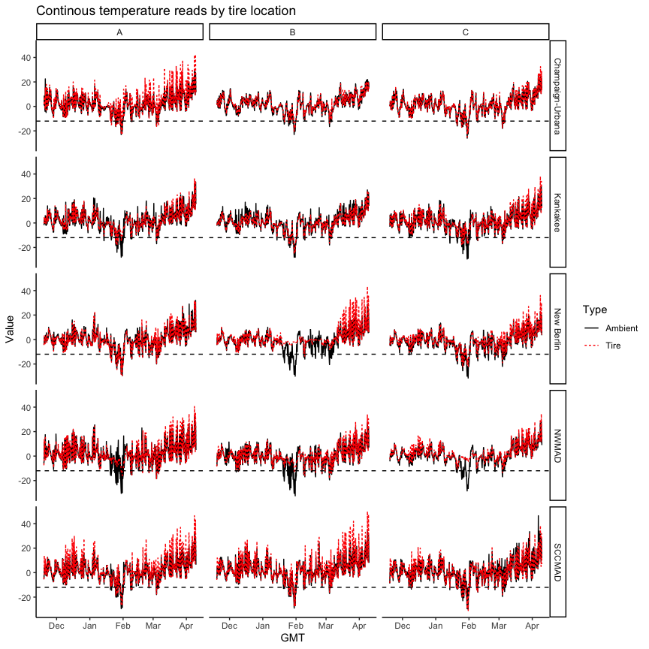

We reduced the data set from 2018-11-19 to 2019-04-09. And renamed number 1 to 15 with ABC

A = 1, 4, 7, 10, 13 B = 2, 5, 8, 11, 14 C = 3, 6, 9, 12, 15

Next we want to answer some of the questions:

1. What is the temperature difference between Ambient and Tire each day
2. How many observation were below -12C?
3. How many freeze - thaw cycles occur
4. ….

I can’t find my notes from our previous meeting with the exact questions.

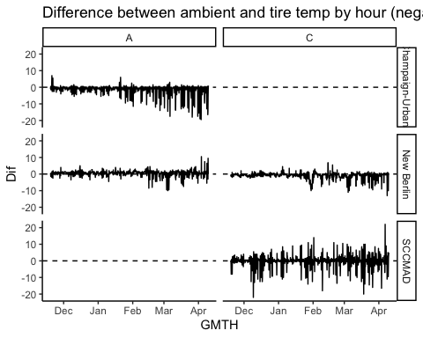 We tried to summarize by hour, this did not work very well. We lost a lot of observations. Next we tried by day.

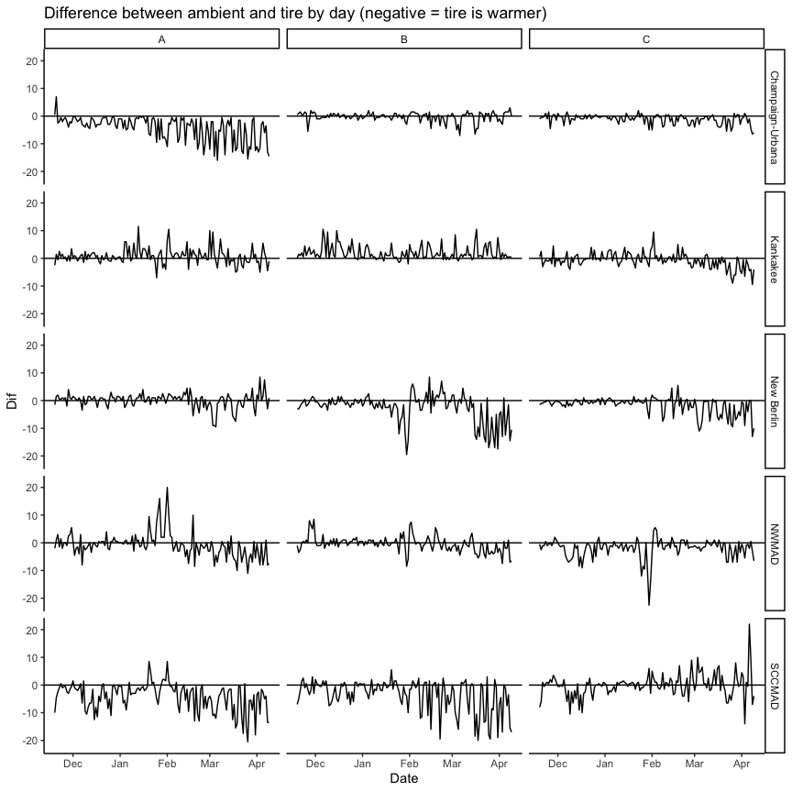 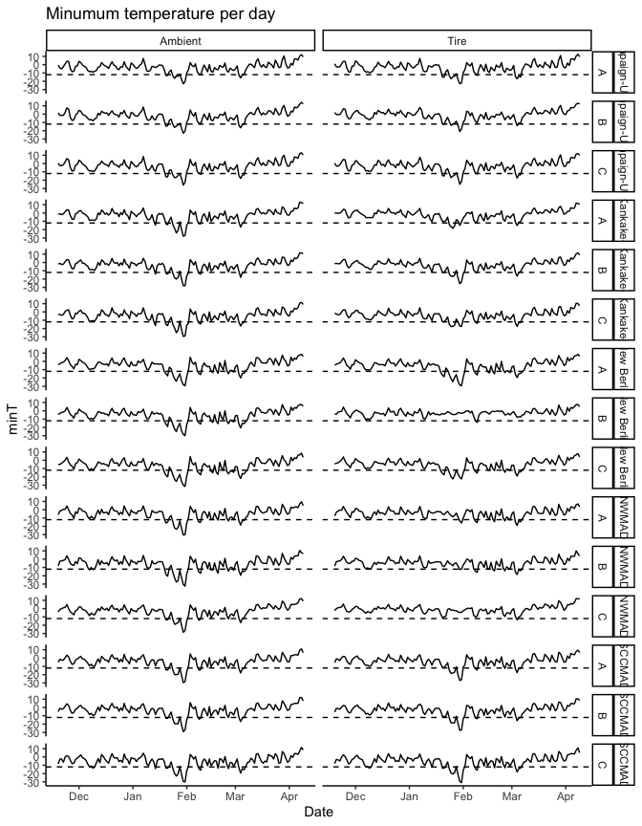

Percentage of reads below -12C

|  |  |  |  |
| --- | --- | --- | --- |
| Location | ABC | Ambient | Tire |
| Champaign-Urbana | A | 2.56 | 2.91 |
| Champaign-Urbana | B | 2.73 | 1.76 |
| Champaign-Urbana | C | 3.79 | 3.61 |
| Kankakee | A | 4.23 | 1.32 |
| Kankakee | B | 5.46 | 3.44 |
| Kankakee | C | 5.55 | 2.29 |
| New Berlin | A | 7.31 | 7.58 |
| New Berlin | B | 8.19 | 0.26 |
| New Berlin | C | 9.25 | 6.87 |
| NWMAD | A | 5.90 | 2.29 |
| NWMAD | B | 7.57 | 1.94 |
| NWMAD | C | 4.67 | 0.09 |
| SCCMAD | A | 4.84 | 3.79 |
| SCCMAD | B | 4.14 | 3.79 |
| SCCMAD | C | 6.43 | 5.46 |

## Location Number Type Date Time AMPM Value Unit MilTime  
## 4789 New Berlin 2 Tire 2019-02-09 12:18 AM -12.5 C 00:18  
## 4790 New Berlin 2 Tire 2019-02-09 3:18 AM -13.5 C 03:18  
## 4791 New Berlin 2 Tire 2019-02-09 6:18 AM -14.0 C 06:18  
## GMTH GMT ABC Min10  
## 4789 2019-02-09 00:00:00 2019-02-09 00:18:00 B 1  
## 4790 2019-02-09 03:00:00 2019-02-09 03:18:00 B 1  
## 4791 2019-02-09 06:00:00 2019-02-09 06:18:00 B 1

## Location Number Type Date Time AMPM Value Unit MilTime  
## 32072 NWMAD 12 Tire 2019-03-04 5:50 AM -13.5 C 05:50  
## GMTH GMT ABC Min10  
## 32072 2019-03-04 05:00:00 2019-03-04 05:50:00 C 1

In New Berlin B, there were 3 reads below 12C In NWMAD C there was 1 read below 12C.

It does hit -13.5 and -14.

## Tables

Average (min and max) temperatur per month

|  |  |  |  |  |  |  |  |
| --- | --- | --- | --- | --- | --- | --- | --- |
| Location | Type | 2018_11 | 2018_12 | 2019_1 | 2019_2 | 2019_3 | 2019_4 |
| Champaign-Urbana | Ambient | 2.3 ( -9 , 22.5 ) | 1.9 ( -9.5 , 16 ) | -3.3 ( -26 , 16.5 ) | -0.4 ( -13 , 14 ) | 3.5 ( -18 , 25 ) | 12 ( -3.5 , 29 ) |
| Champaign-Urbana | Tire | 2.5 ( -9 , 18 ) | 2.1 ( -9.5 , 20 ) | -2.7 ( -25 , 21.5 ) | 0.2 ( -13 , 23 ) | 4.3 ( -17.5 , 37 ) | 12.8 ( -3.5 , 42.5 ) |
| Kankakee | Ambient | 1.4 ( -8.5 , 14 ) | 1.5 ( -11.5 , 19 ) | -4.4 ( -29.5 , 20.5 ) | -1.3 ( -16 , 18 ) | 3.3 ( -18 , 23 ) | 12.1 ( -5 , 33.5 ) |
| Kankakee | Tire | 1.5 ( -7 , 14 ) | 1.6 ( -9.5 , 18 ) | -3.5 ( -25.5 , 15.5 ) | -1.2 ( -14 , 14.5 ) | 3.2 ( -17.5 , 28 ) | 11.9 ( -4 , 38 ) |
| New Berlin | Ambient | -0.2 ( -11 , 10 ) | -0.3 ( -12.5 , 16 ) | -6.3 ( -31.5 , 21.5 ) | -3.7 ( -19 , 11.5 ) | 1.4 ( -22 , 27 ) | 9.7 ( -5 , 32 ) |
| New Berlin | Tire | -0.1 ( -9.5 , 10 ) | -0.3 ( -11 , 15 ) | -4.5 ( -29.5 , 23 ) | -2.9 ( -19 , 16 ) | 2.5 ( -19.5 , 34.5 ) | 10.5 ( -4 , 43.5 ) |
| NWMAD | Ambient | 0.7 ( -11 , 18 ) | 1.1 ( -13 , 21 ) | -4.8 ( -32.5 , 25.5 ) | -2.1 ( -17.5 , 23 ) | 2.9 ( -19.5 , 28 ) | 11.2 ( -6 , 32.5 ) |
| NWMAD | Tire | 0.9 ( -9.5 , 16.5 ) | 1.3 ( -12 , 22 ) | -1.7 ( -16 , 24.5 ) | -1.6 ( -16 , 21 ) | 3.9 ( -19 , 32 ) | 11.9 ( -5 , 40.5 ) |
| SCCMAD | Ambient | 1 ( -8.5 , 13 ) | 1.6 ( -13.5 , 23 ) | -4.2 ( -30 , 19.5 ) | -1.2 ( -16.5 , 24 ) | 3.4 ( -19.5 , 33.5 ) | 12.4 ( -4.5 , 46.5 ) |
| SCCMAD | Tire | 1.3 ( -8.5 , 14 ) | 2 ( -13.5 , 30 ) | -3.8 ( -31 , 26.5 ) | -0.6 ( -16 , 30 ) | 4.6 ( -18 , 42 ) | 13.3 ( -4.5 , 50 ) |

Average (min and max) difference per month

|  |  |  |  |  |  |  |  |
| --- | --- | --- | --- | --- | --- | --- | --- |
| Location | ABC | 2018_11 | 2018_12 | 2019_1 | 2019_2 | 2019_3 | 2019_4 |
| Champaign-Urbana | A | -1 ( -4 , 7 ) | -2 ( -4.5 , 0 ) | -3.1 ( -9.5 , 0 ) | -4.7 ( -14 , -0.5 ) | -7.2 ( -16 , -0.5 ) | -8.6 ( -14.5 , -2 ) |
| Champaign-Urbana | B | 0.3 ( -5.5 , 2 ) | -0.1 ( -1.5 , 1 ) | -0.2 ( -3 , 2 ) | -0.4 ( -4.5 , 1.5 ) | -0.7 ( -7 , 2 ) | 0.3 ( -3 , 3 ) |
| Champaign-Urbana | C | -0.5 ( -4.5 , 1.5 ) | -0.4 ( -3.5 , 1.5 ) | -0.8 ( -5 , 2 ) | -1.3 ( -5 , 0.5 ) | -1.6 ( -5.5 , 1 ) | -2.3 ( -6.5 , 1 ) |
| Kankakee | A | 0.5 ( -2.5 , 3.5 ) | 0.4 ( -2 , 2.5 ) | 1.2 ( -7 , 11.5 ) | 1.6 ( -4 , 10.5 ) | 0.5 ( -5 , 10 ) | -0.6 ( -5 , 5.5 ) |
| Kankakee | B | 2 ( 0 , 4.5 ) | 3.1 ( -0.5 , 10.5 ) | 1 ( -2 , 5.5 ) | 1.9 ( -0.5 , 7 ) | 2.3 ( -1 , 10.5 ) | 0.9 ( -0.5 , 3 ) |
| Kankakee | C | -0.4 ( -3 , 4.5 ) | -0.3 ( -4 , 4 ) | 0.4 ( -3.5 , 4 ) | 0.3 ( -3.5 , 9.5 ) | -2.3 ( -9 , 1.5 ) | -4.1 ( -9.5 , -0.5 ) |
| New Berlin | A | 0.8 ( -2 , 4 ) | 0.3 ( -3.5 , 3 ) | 0.5 ( -2.5 , 4 ) | 0.3 ( -5.5 , 4.5 ) | -1.7 ( -9.5 , 4.5 ) | 2.2 ( -3 , 8.5 ) |
| New Berlin | B | -0.8 ( -3 , 1.5 ) | -0.8 ( -3.5 , 1.5 ) | -3.5 ( -19.5 , 2.5 ) | 0.9 ( -4.5 , 8.5 ) | -5.8 ( -17.5 , 4.5 ) | -7.4 ( -14.5 , 1 ) |
| New Berlin | C | -0.8 ( -2 , 0 ) | -0.6 ( -2.5 , 1 ) | -0.7 ( -6.5 , 1.5 ) | -0.8 ( -7.5 , 5.5 ) | -4.2 ( -11 , 0.5 ) | -4.2 ( -13 , 0 ) |
| NWMAD | A | 0.8 ( -2 , 5.5 ) | -0.8 ( -8 , 4 ) | 2.1 ( -3 , 16 ) | -0.4 ( -8.5 , 20 ) | -3.8 ( -11 , 2.5 ) | -4.4 ( -8 , 1 ) |
| NWMAD | B | 1.9 ( -3.5 , 8.5 ) | 0.2 ( -2 , 3 ) | -0.3 ( -8.5 , 4 ) | 0.4 ( -3 , 7.5 ) | -2 ( -5.5 , 3.5 ) | -3.2 ( -7.5 , 1 ) |
| NWMAD | C | -0.3 ( -2.5 , 2 ) | -3 ( -9 , 2 ) | -3.5 ( -22.5 , 2 ) | -0.3 ( -4.5 , 5.5 ) | -1.9 ( -7 , 1 ) | -2.3 ( -6.5 , 0.5 ) |
| SCCMAD | A | -2.2 ( -10 , 0.5 ) | -4.2 ( -12.5 , 1.5 ) | -1.4 ( -9 , 8.5 ) | -3.6 ( -13 , 8.5 ) | -7.6 ( -20.5 , 0.5 ) | -6.3 ( -13.5 , -1.5 ) |
| SCCMAD | B | -1.5 ( -7 , 3 ) | -1.8 ( -7.5 , 2 ) | -1.5 ( -10 , 5.5 ) | -3.6 ( -19.5 , 2.5 ) | -7 ( -20 , 3 ) | -8.1 ( -17 , 0 ) |
| SCCMAD | C | -0.1 ( -8 , 3.5 ) | -2.2 ( -10.5 , 2.5 ) | -0.1 ( -3.5 , 6 ) | 0.7 ( -6 , 9 ) | 0.9 ( -6.5 , 10 ) | 1.6 ( -14 , 22 ) |

##IGNORE

Wroking with Time Series package in R you can pull all kinds of information. Lets see if it works.

All nice and well. Lets get back to the questions.

There are 3 tire stacks at each location. For some reason there aren’t matching data for each time frame and tire stack, we lost 12000 observations when trying to match.