MYBLE · /about · VISUAL MOCK-UP
Layout preview — not the final design. Shows block order, which photo sits where, and what the copy says.

myble ● | How it works What we make Pricing Trust [ Design yours ]
◆ SiteHeader (variant="app") — unchanged, reused as-is.

OUR STORY
It started because I couldn't buy it.
Myble didn't start from a business plan. It started from a piece of furniture that didn't exist — and three weekends of my life spent making one.
◆ Hero: no image. Generous whitespace, left-aligned, max-width ~2/3 of the column.

│ 01 ├─ 02 ├─ 03 ├─ 04 ├─ 05
Sticky "measuring tape" rail runs down the left edge of the whole story section on desktop. Tick marks every 8px, mono 01–05 labels, an indigo segment that fills as you scroll, active block number goes dark. Hidden on mobile.

01  The thing I couldn't buy  I needed one very specific thing. A speaker at the bottom. Records in the middle. A turntable on top. The right height, the right width, the right depth for the corner it had to live in.  I looked. Nobody makes that. Not in that size, not for that money. The closest thing was always too tall, too shallow, or built for someone else's room.  So I drew it onto a photo of my own wall, and decided to build it myself. | 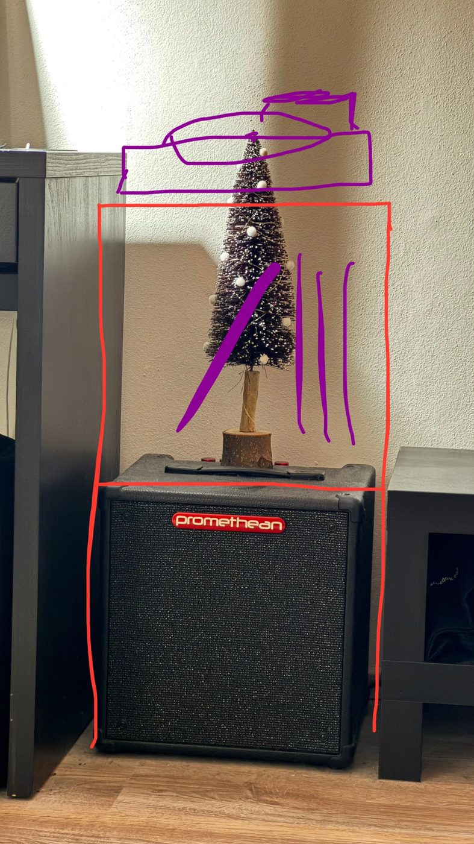  — The brief: one drawing, one wall, one very specific gap.
◆ Block 01 — image RIGHT. Single photo, no offset card. This is the only photo with priority loading.

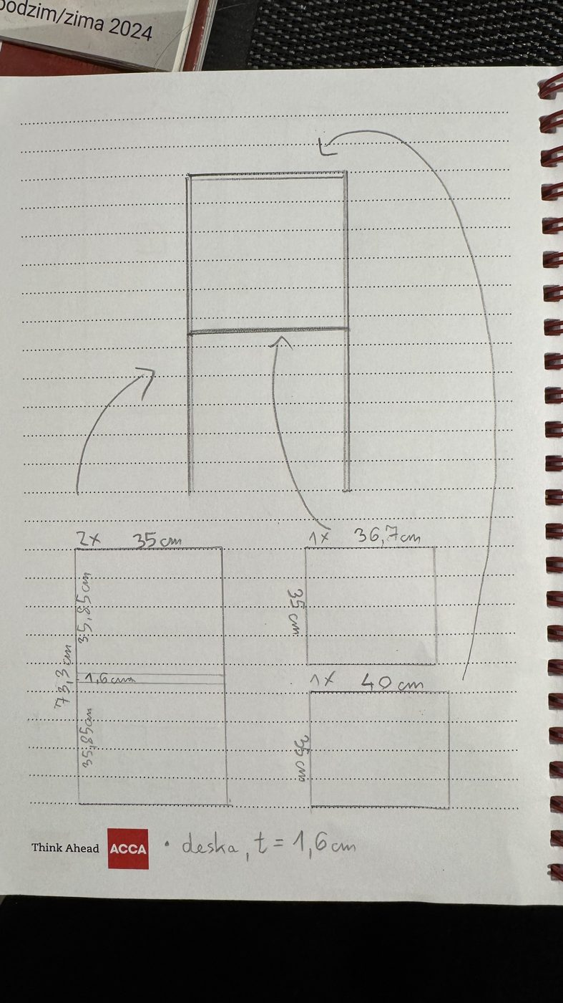  — Two evenings in a notebook, to describe a box.  chips on photo:  73,3 × 35 cm  t = 16 mm  offset card(s), rotated:  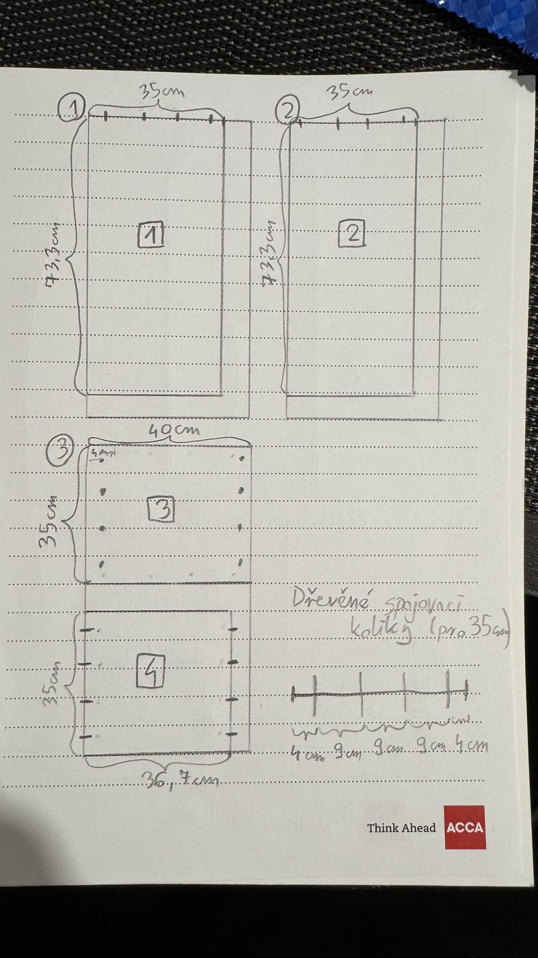 | 02  Two evenings of arithmetic  Then came the part nobody warns you about: the maths.  Every panel, to the millimetre. Which piece overlaps which. How thick the board is, and what that does to every other dimension. Where the dowels go — 4, 9, 9, 9, 4 — and what happens to the whole thing if one of them is 2 mm off.  Two evenings and a notebook later, I had a cut list. Four panels. 73.3 × 35. 40 × 35. 36.7 × 35. Board thickness 1.6 cm.
◆ Block 02 — image LEFT. The cut-list page sits as a rotated card over the main photo's lower-right corner; straightens on hover.

03  A queue, a saw, and a tram ride  Next: a shop on the other side of town that sells board by the whole sheet.  You don't buy four panels. You buy one big sheet and ask them to cut it into four — at a counter, in a queue, hoping you wrote your numbers down right, because you can't un-cut a board.  Then you carry it home. Raw panels, a plastic bag, a tram. The pieces were finally the right size. I still had nothing that looked like furniture. | 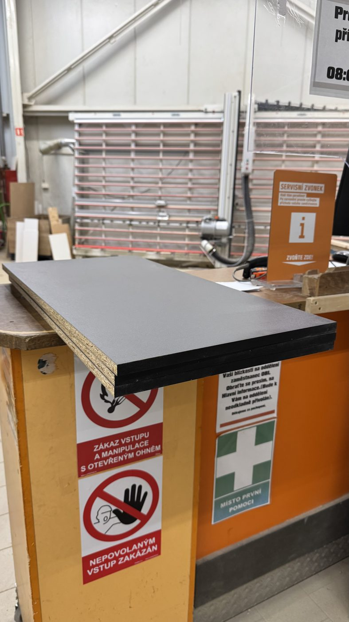  — Cut to size at a counter. Carried home in a bag.  offset card(s), rotated:  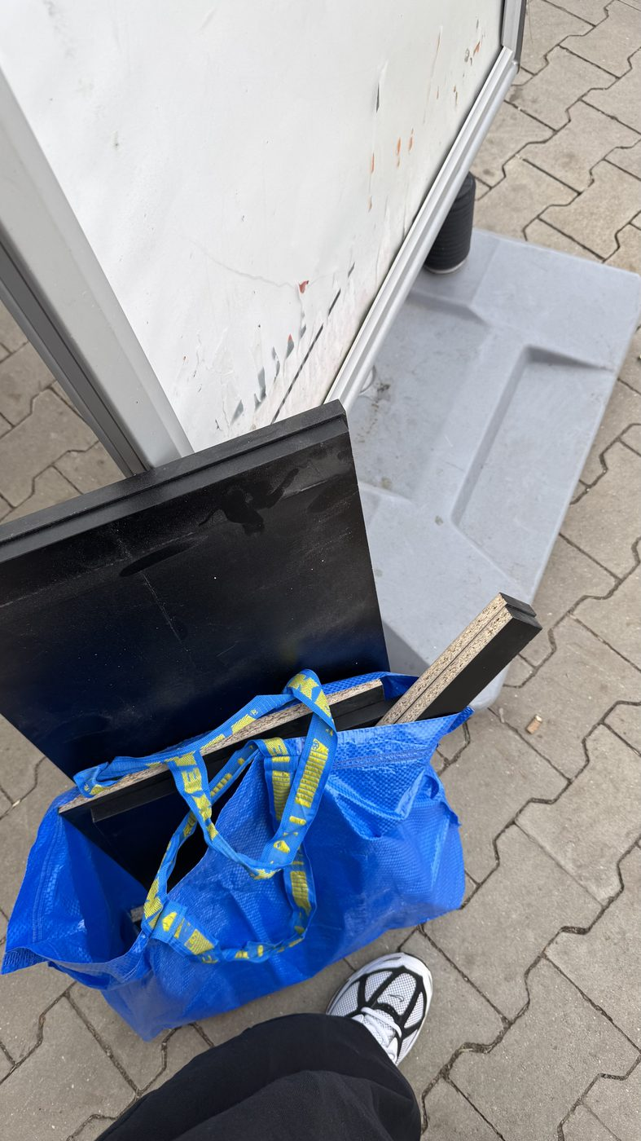
◆ Block 03 — image RIGHT. No retailer named anywhere in this block, by design.

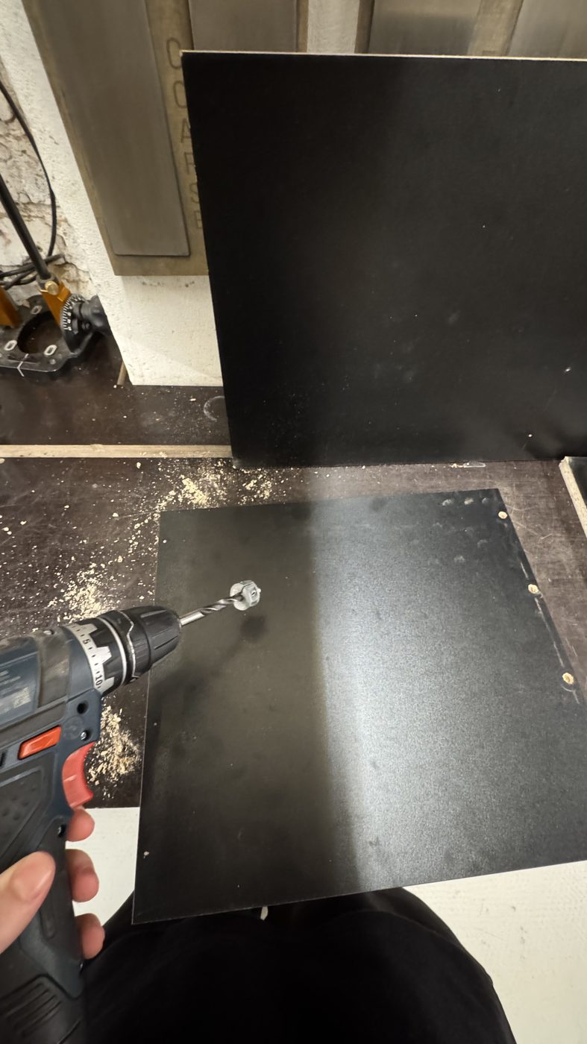  — Rented drill, rented hour. Twelve holes that all had to be right.  chips on photo:  4 · 9 · 9 · 9 · 4 cm  offset card(s), rotated:  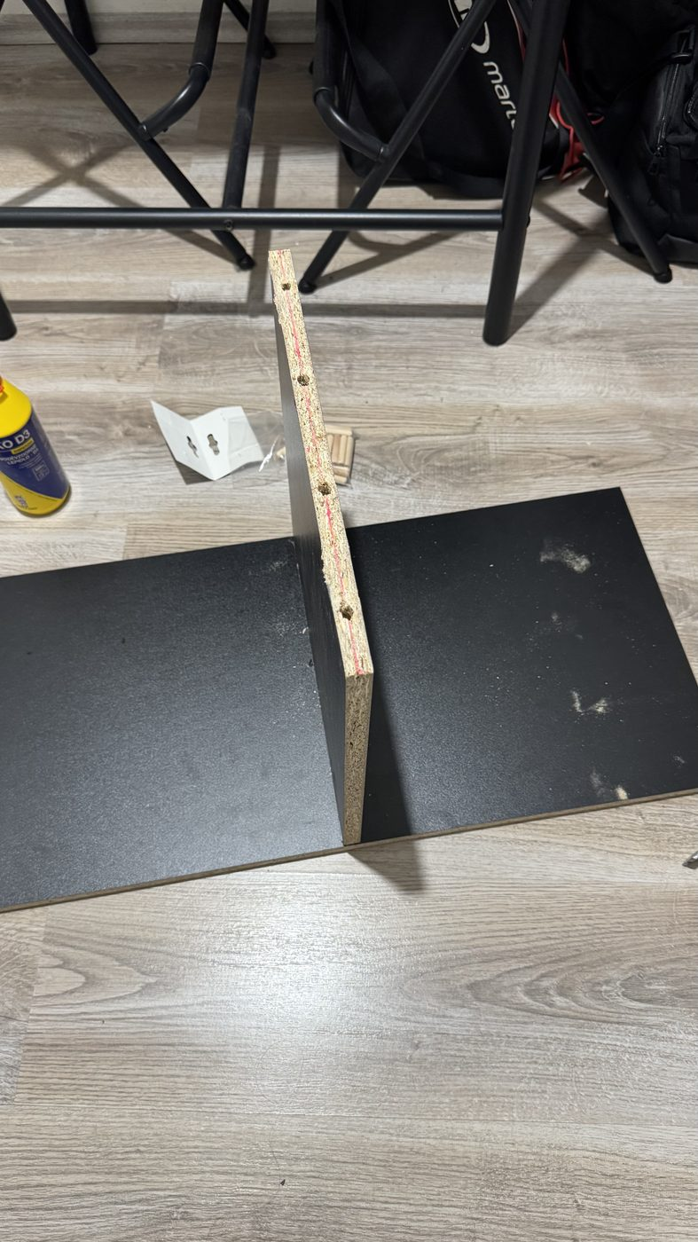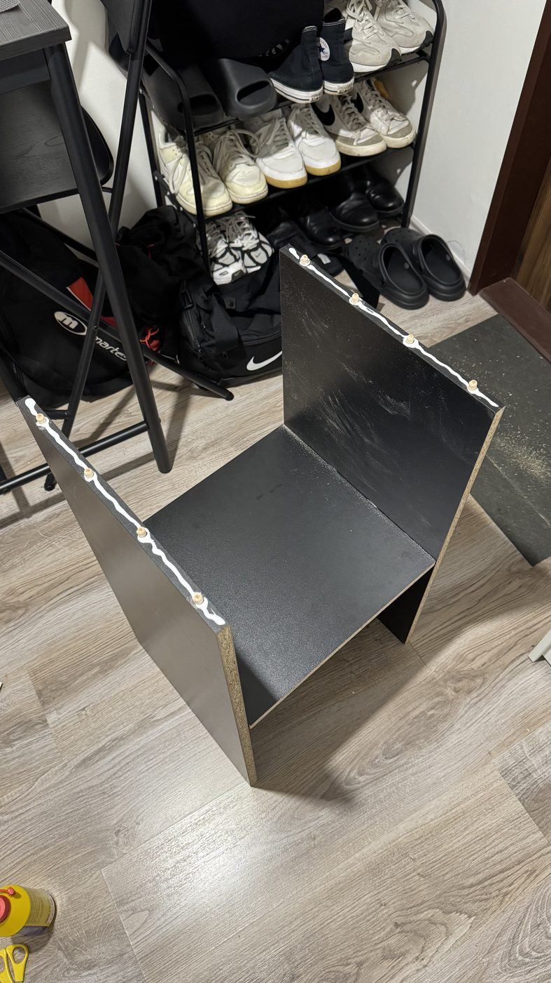 | 04  I don't own a drill  Most people living in a flat don't.  So I booked an hour in a workshop you can rent by the hour, hauled my panels across the city a second time, and drilled every dowel hole myself — square to the face, right depth, right spacing. A couple of millimetres off and the panel doesn't sit flush.  Back home: glue, dowels, and the slow part where you find out whether all that arithmetic was right.
◆ Block 04 — image LEFT. Two offset cards in a slight fan (−6° and +4°).

05  It fits  It fit. Exactly, to the centimetre, the way it did on paper.  Speaker at the bottom. Records in the middle. Turntable on top. The thing I'd drawn over a photo of my own wall, now standing against that wall.  I was proud of it. I still am.  callback strip: drawn → built  The block-01 sketch reappears here as a small thumbnail beside the finished photo — the page's payoff. Same composition, three weekends apart. | 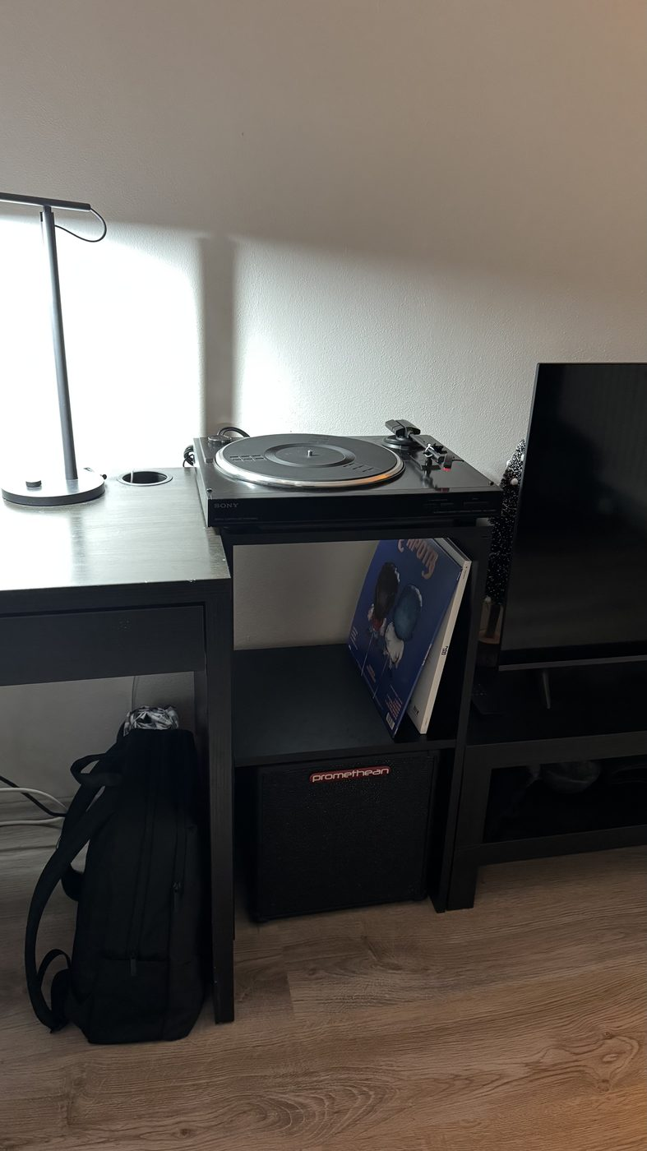  — Left: the drawing. Right: the same thing, three weekends later.  chips on photo:  fits to the centimetre  offset card(s), rotated:  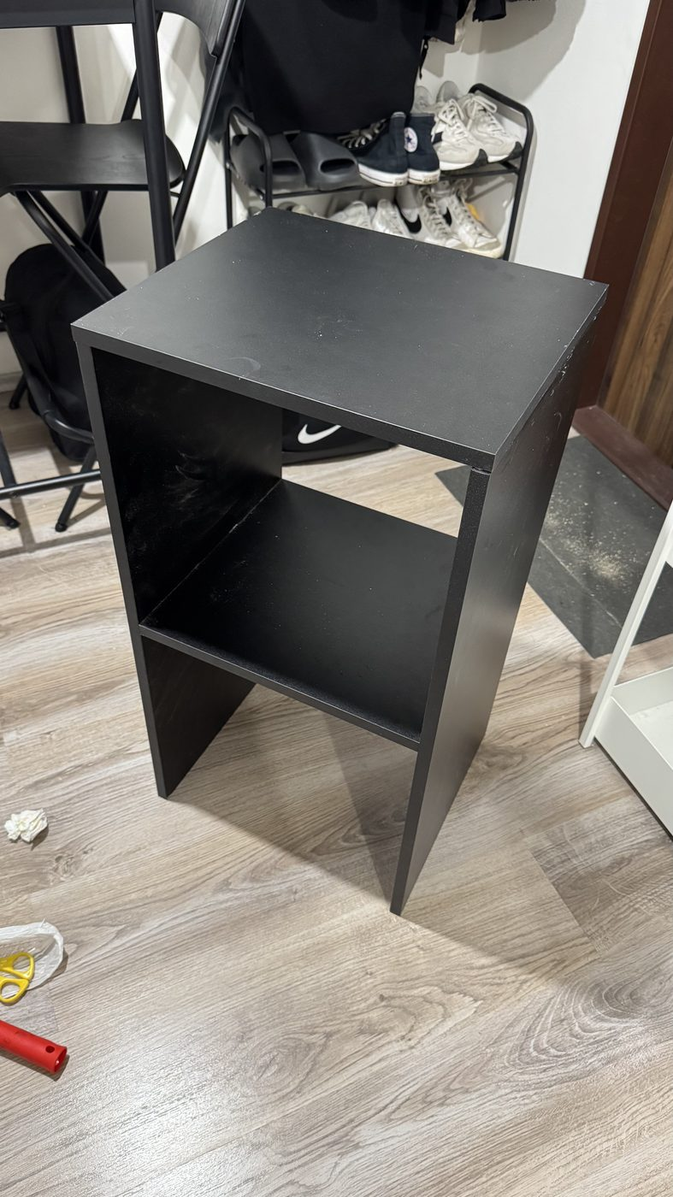
◆ Block 05 — image RIGHT. Deliberately NOT a before/after wipe slider: the two shots are framed differently and wouldn't align.

But look at what it cost
Not the materials. Those were cheap.
The design cost. The measuring, and the re-measuring. A trip across town for boards, another for a drill I don't own, an evening spent deciding whether 1.6 cm of board thickness comes off the shelf or off the sides.
Weeks of it. For one piece of furniture that fits one wall.
And that isn't a hobbyist's problem. It's everyone's — anyone with an awkward alcove, a sloped ceiling, a 63 cm gap, or something they own that nothing on a shop floor is built to hold.
◆ Full-bleed bg-zinc-900 band. The emotional pivot — no images, no list, just type.

MY WAY  3  weekends  2  trips across town  1  rented drill  12  holes drilled by hand  0  shops that sold it | WITH MYBLE  ~15  minutes in your browser  0  trips  0  tools you don't own  1  delivery — cut, drilled, labelled
◆ Still on dark. Left column deliberately dimmer; the Myble column carries the indigo accent and a faint indigo ring. Rows stagger in.

AND THAT'S WHERE WE COME IN
So we built the hard part

01  You draw it  In the browser, in centimetres, in minutes. No notebook, no arithmetic. | 02  We do the maths  Thicknesses, joints, dowel positions, whether the shelf will sag. Solved before you order.
03  It arrives cut, drilled and labelled  Every panel to the millimetre, every hole already there. | 04  You assemble it  About 30 minutes, almost no tools. The good part of my three weekends, without the rest.

Same result: furniture that fits your space exactly. Without the drawing, the queue, the tram and the borrowed drill.
◆ On white. Same card treatment as the homepage "how it works" steps — 4 across on desktop, 2×2 on tablet.

Your wall, your centimetres.
You already know what you need. Draw it — we'll handle the rest.
Create your furniture now
See how it works →
◆ Primary → /design. Secondary → /#jak. PostHog event on the primary click.

SiteFooter — unchanged

Notes

Czech version
Every string above exists in CS too. The page reads the same in both languages — same blocks, same photos, same order. Full Czech copy is in ABOUT_PAGE_COPY.md.

Numbers to confirm
"Three weekends", "two evenings", "two trips across town" and "twelve holes" are my placeholders. Tell me the real figures and I'll patch both languages.
The panel dimensions (73.3 × 35, 40 × 35, 36.7 × 35, t = 1.6 cm) and the dowel spacing (4 · 9 · 9 · 9 · 4) are read straight off your notebook photos and are correct.

What this mock-up is not
Word can't rotate the offset cards, pin the mono chips onto the photos, or show the scroll animation — those are described in the ◆ notes and specced properly in the Claude Code prompt. Treat the photo sizes here as indicative: on the real page the main photo fills roughly 40% of the column width.

