Correlation Results Comparison

# Context

This study attempted to replicate the findings of Wingen et al. (2020) by investigating the correlation between trust in psychology and the replicability of research findings. The primary objective was to determine if a positive correlation - like the one observed in the original study - existed. We recruited 80 participants who completed two key measures.

The first measure was a 1-7 scale consisting of 5 items designed to assess participants' level of trust in the field of psychology. This scale aimed to gauge their overall confidence in the reliability and validity of psychological research. We then took the mean of the 5 items, where higher values mean greater trust.

The second measure involved participants estimating the percentage of findings from a set of 100 studies that would successfully replicate, from the Open Science Collaboration (2015). This aspect of the study aimed to assess participants' perceptions of the field's ability to replicate research results.

The study was conducted as a replication effort to investigate if greater trust in the field of psychology would be associated with higher expectations of replicability. Our hypothesis was there would be a positive correlation between trust in psychology and estimates of replicability.

# Version 1

A Pearson’s correlation found there was a non-significant small positive correlation between trust in psychology and estimates of replicability, *r*(78) = .16, *p* = .085, 95% CI = [-.03, 1.00].

Figure 1

*A scatterplot showing a positive correlation between trust in psychology ratings and the replicability estimate of 100 psychology studies.*

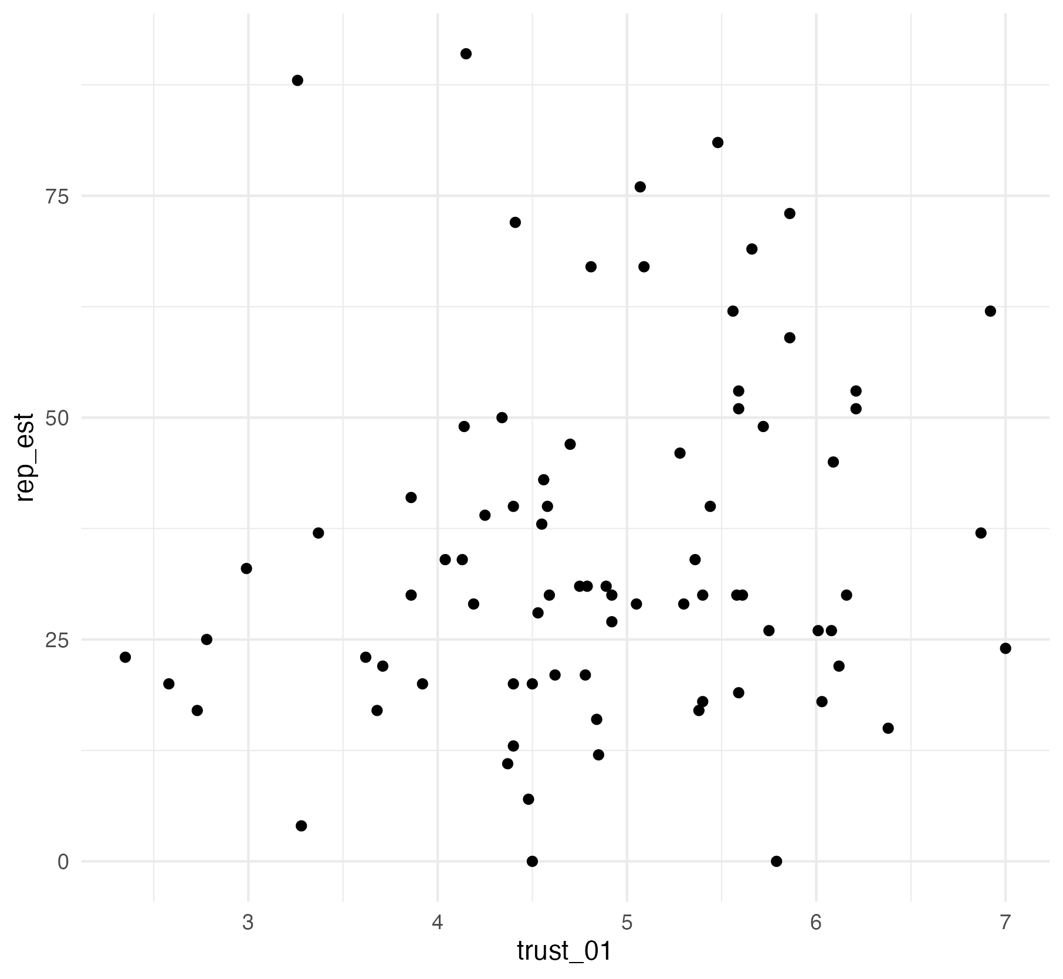

# Version 2

We hypothesised that there is a positive correlation between trust in psychology and estimates of replicability. The mean rating for trust in psychology was 4.86 (*SD* = 1.02) and the mean replicability estimate was 35.24 (*SD* = 19.91). Figure 1 provides a scatterplot for the relationship between trust in psychology and estimates of replicability.

We checked outliers and there were no extreme values in the sample. Data met the assumption of normality and homoscedasticity. Although the trust in psychology scale could be interpreted as ordinal, we treated it as interval data after calculating the mean of five items.

Figure 1

*A scatterplot showing a positive correlation between trust in psychology ratings and the replicability estimate of 100 psychology studies.*

We applied a one-tailed Pearson’s correlation test as we predicted a positive correlation and we found there was a non-significant small positive correlation between trust in psychology and estimates of replicability, *r*(78) = .16, *p* = .085, 95% CI = [-.03, 1.00].

We predicted a positive correlation between trust in psychology and estimates of replicability, but we did not support our hypothesis as the one-tailed Pearson’s correlation was not statistically significant.

# Version 3

We hypothesised that there is a positive correlation between trust in psychology and estimates of replicability. The mean rating for trust in psychology was 4.86. The *SD* rating for trust in psychology was 1.02. The mean replicability estimate was 35.24. The *SD* replicability estimate was 19.91. Figure 1 provides a scatterplot for the relationship between trust in psychology and estimates of replicability.

Figure 1

*A scatterplot showing a positive correlation between trust in psychology ratings and the replicability estimate of 100 psychology studies.*

We used a Pearson’s correlation test. There were 78 degrees of freedom and the t-value was 1.39. The value for r was 0.16. The *p*-value was 0.08 and the confidence interval ranged from -0.03 to 1.00.

We predicted a positive correlation between trust in psychology and estimates of replicability, but we did not support our hypothesis.

# Version 4

We checked outliers and there were no extreme values in the sample. Data met the assumption of normality and homoscedasticity. Although the trust in psychology scale could be interpreted as ordinal, we treated it as interval data after calculating the mean of five items.

The mean rating for trust in psychology was 4.86075 (*SD* = 1.01855) and the mean replicability estimate was 35.2375 (*SD* = 19.91199).

We applied a one-tailed Pearson’s correlation test as we predicted a positive correlation and we found there was a non-significant small positive correlation between trust in psychology and estimates of replicability, *r*(78) = .15509, *p* = .08477, 95% CI = [-.03108, 1.0000].

We predicted a positive correlation between trust in psychology and estimates of replicability, but we did not support our hypothesis as the one-tailed Pearson’s correlation was not statistically significant.

# Version 5

We hypothesised that greater trust in psychology would lead to higher estimates of replicability. The mean rating for trust in psychology was 4.86 (*SD* = 1.02) and the mean replicability estimate was 35.24 (*SD* = 19.91). Figure 1 provides a scatterplot for the relationship between trust in psychology and estimates of replicability.

We checked outliers and there were no extreme values in the sample. Data met the assumption of normality and homoscedasticity. Although the trust in psychology scale could be interpreted as ordinal, we treated it as interval data after calculating the mean of five items.

Figure 1

*A scatterplot showing a positive correlation between trust in psychology ratings and the replicability estimate of 100 psychology studies.*

We applied a one-tailed Pearson’s correlation test as we predicted a positive correlation and we found a marginally significant small positive correlation between trust in psychology and estimates of replicability, *r*(78) = .16, *p* = .085, 95% CI = [-.03, 1.00].

We predicted greater trust in psychology would lead to higher estimates of replicability and the marginally significant positive correlation somewhat supports our hypothesis.