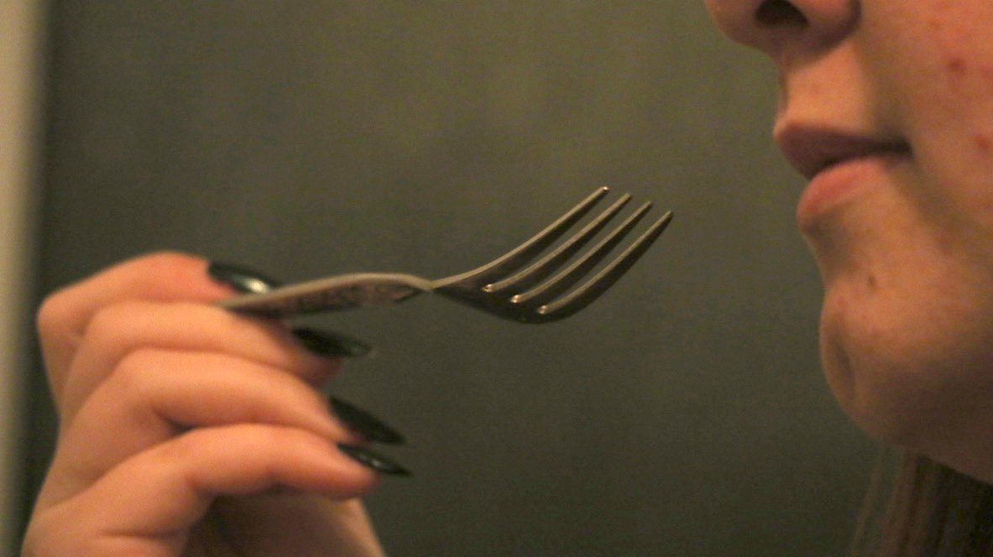

Fixation cross (250ms)

Image presentation (200ms or 500ms)

Z or M keyboard response (2000ms time limit)

.

+

+

+

: