We’re talking an elastic collision here, like between two billiard balls. If their mass and their speed are the same, their momentum will have the same magnitude but opposite directionright ***before***the collision, as shown by the **blue** velocity vectors below.

[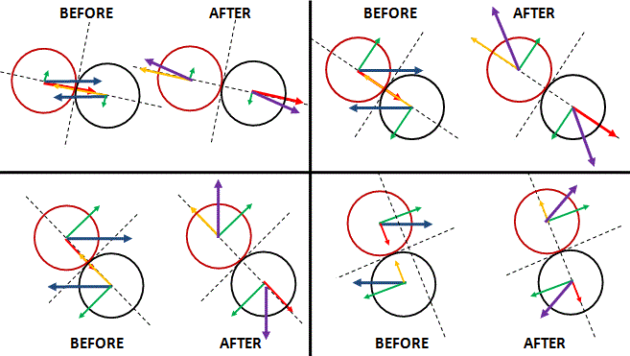](https://readingpenrose.files.wordpress.com/2014/10/elastic-collision2.gif)

To analyse what happens, we must identify the contact point and the plane of collision (represented by the tangent line in the four illustrations above), and then the normal line, which connects the centre of both balls. We then identify the two components of the velocity vector along the normal and tangent line respectively. The red and yellowish vectors represent the normal components, while the green vectors represent the tangential components. Using both the conservation for momentum as well as the conservation law for kinetic energy, it’s fairly easy to [show](http://archive.ncsa.illinois.edu/Classes/MATH198/townsend/math.html) (but I won’t do it here: just click on the link if you want details) that the normal components are being exchangedas a result of the collision, while the tangential components just stay the same. We can then find the velocity vectors ***after*** the collision by adding the exchanged normal vectors and the (identical) tangential vectors, which gives us the **purple** velocity vectors. As you can see, the purple vectors are just like the blue vectors: they have the same magnitude but opposite direction. Hence, if particle a ends up going in an angle θ, then b must end up in an angle π − θ, not some other random direction. Note that I’ve drawn four different situations above to show that any angle θ and π − θ is actually possible, except the angle θ = 0 (which implies that π − θ would be π), because the particles aren’t supposed to go through each other.

Taken from <http://readingpenrose.com/essentials/>