Wrocław, 14.10.2015

Report 1, B3

Authors: Paweł Iwanow, Bartłomiej Zalas

Project Title

Event World

Project Description

Goal of the project is to provide database of events. Each registered user can search for an events in him/her neighborhood, add new ones, assign himself/herself as participant of given event, assign rate to events.

UML Class Diagram

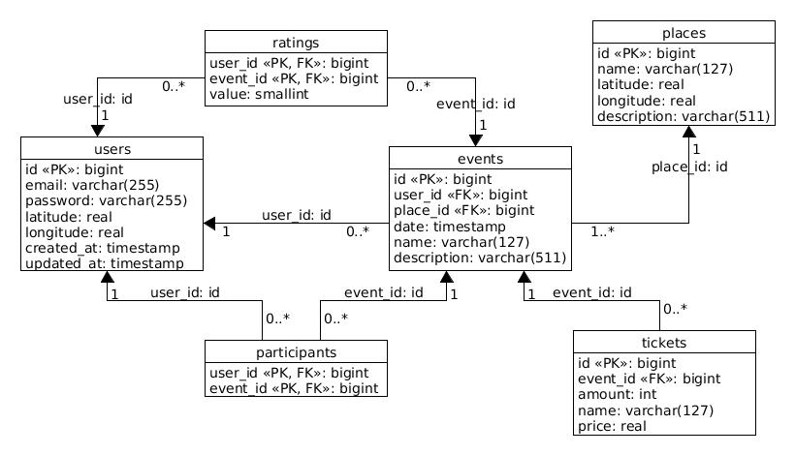

Transaction Description

**Add event with predefined participants and tickets**

1. add event, 2. add participants, 3. add tickets, 4. add place , 5 update last activity of user

**Delete event**

1. delete event 2. delete place if no more events 3. delete ratings, 4. delete participants, 5. delete tickets

**Get my places**

1. get user (lat and long) 2. find all events 3. for all events get places // jeden select

**Register as participant**

1. add to table participant, 2. update tickets, 3. update last activity of user

**Get top rated events in last 7 days**

1. calculate (select) average rate 2. get events with date < 7 days order by rate // jeden select