FastCms docs

**Contents:**

* Technologies and installation
* Admin docs
* User docs

**Technologies and installation:**

In my project I used technologies like JS, PHP, of course html and JS library – AJAX:

1. JavaScript (JS) - a high-level programming language used to create dynamic and interactive web pages. It runs in web browsers and can also be used on the server-side with Node.js.
2. PHP - a server-side scripting language used primarily for web development. It can generate dynamic web pages and handle forms, cookies, sessions, and databases.
3. HTML - stands for Hypertext Markup Language, it is a markup language used for creating web pages and other documents that can be displayed in a web browser.
4. AJAX (Asynchronous JavaScript and XML) - a technique used in web development to create fast and dynamic web pages without reloading the entire page. It involves sending and receiving data asynchronously between the client and server using JavaScript and XML, or JSON.

Our application is built to help lot of peoples start a bit of web pages creating.

You need to install [Xampp](https://www.apachefriends.org/pl/download.html) and Import database.

Instaltion:

1. Download installer from web

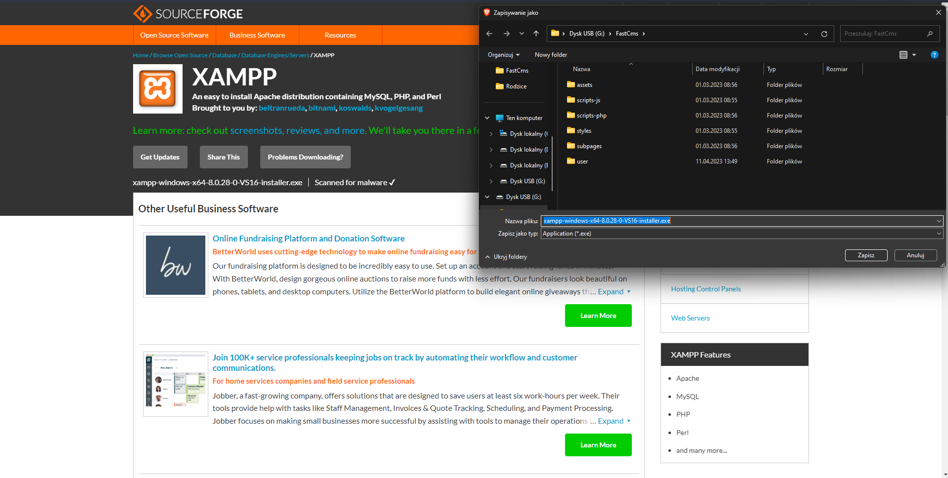

1. Open it with admin rights
2. Click next 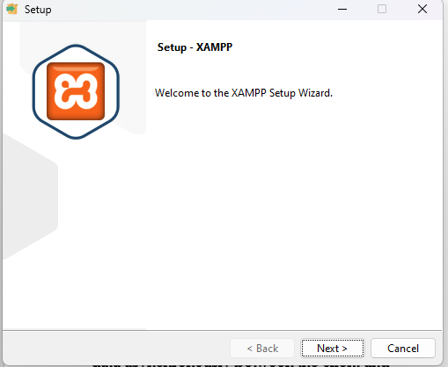
3. Choose required parts and click next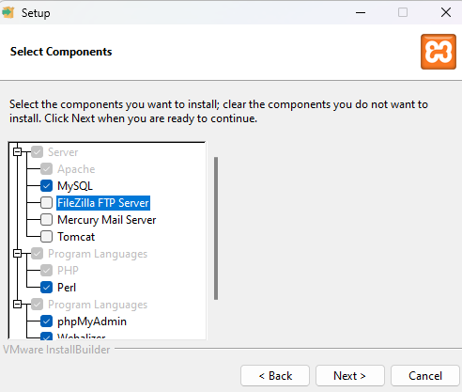
4. Choose your installation path and click next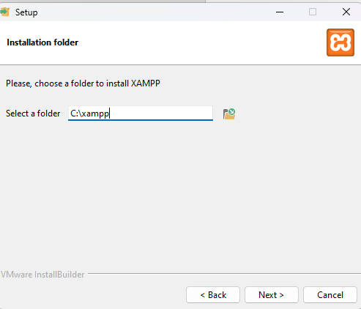
5. Wait till the end and click finisz
6. Turn on xampp and start two modules

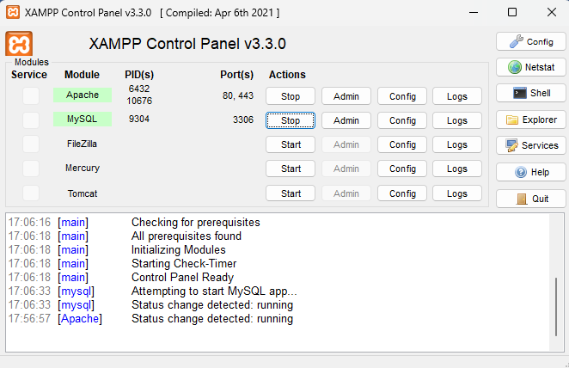

1. Get on [localhost/phpmyadmin](http://localhost/phpmyadmin/index.php), click create than create DataBase FastCms and import it 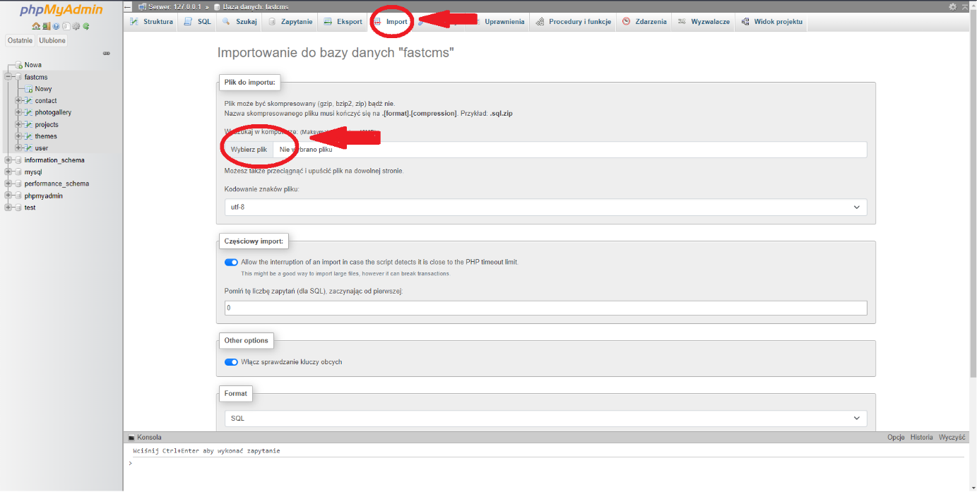

**Admin docs:**

Creating account and logging in:

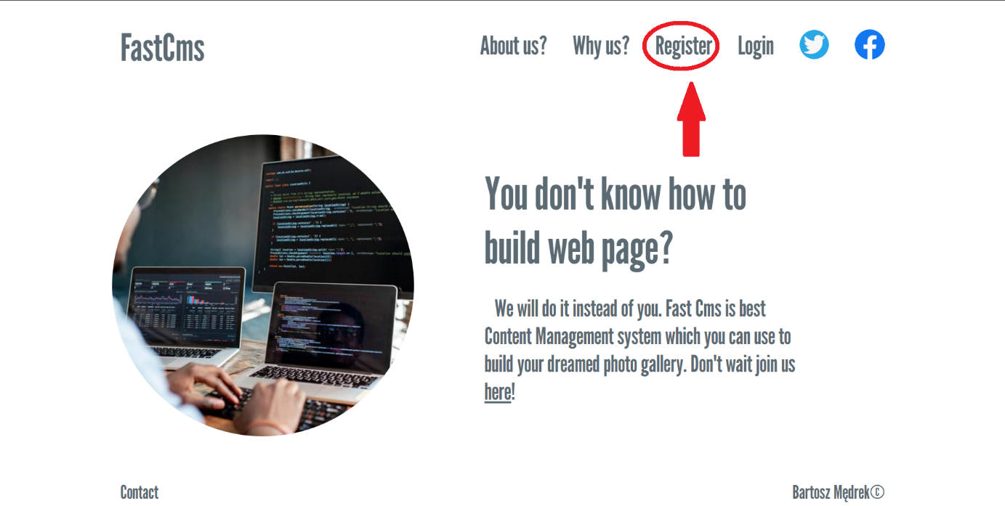

Fill all data and click submit:

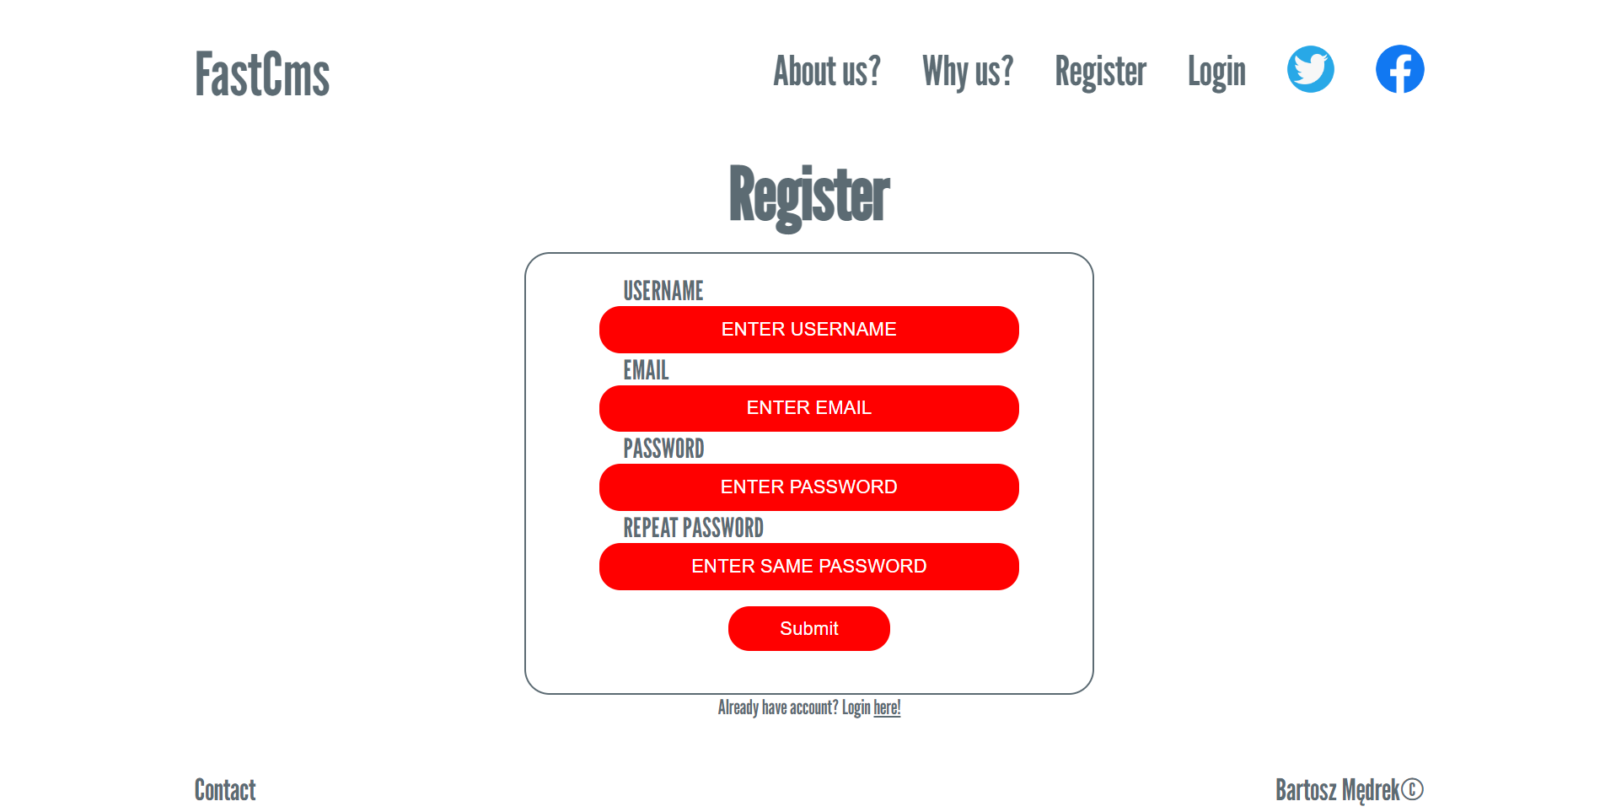

Next type password and click submit: 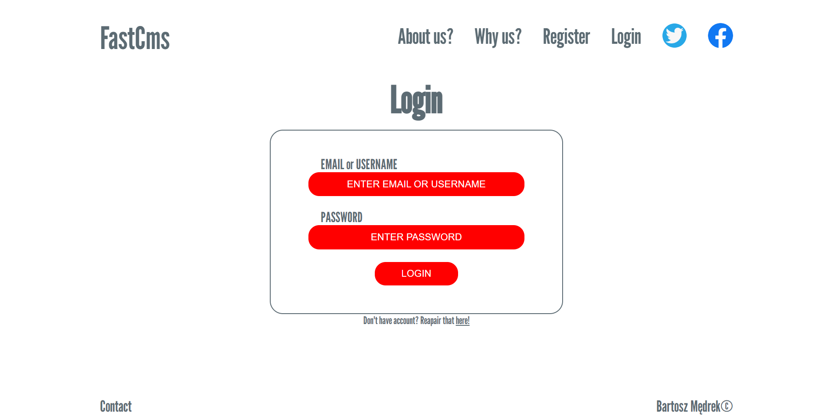

Managing users: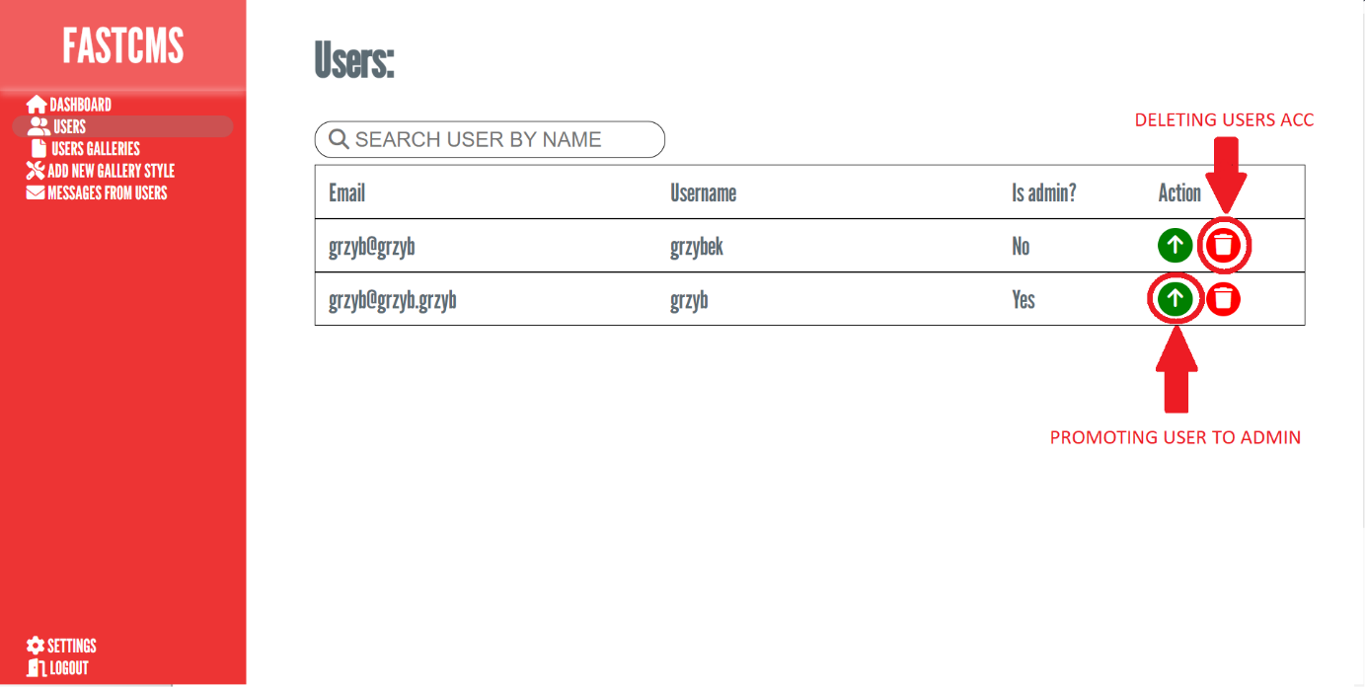

Managing users galleries: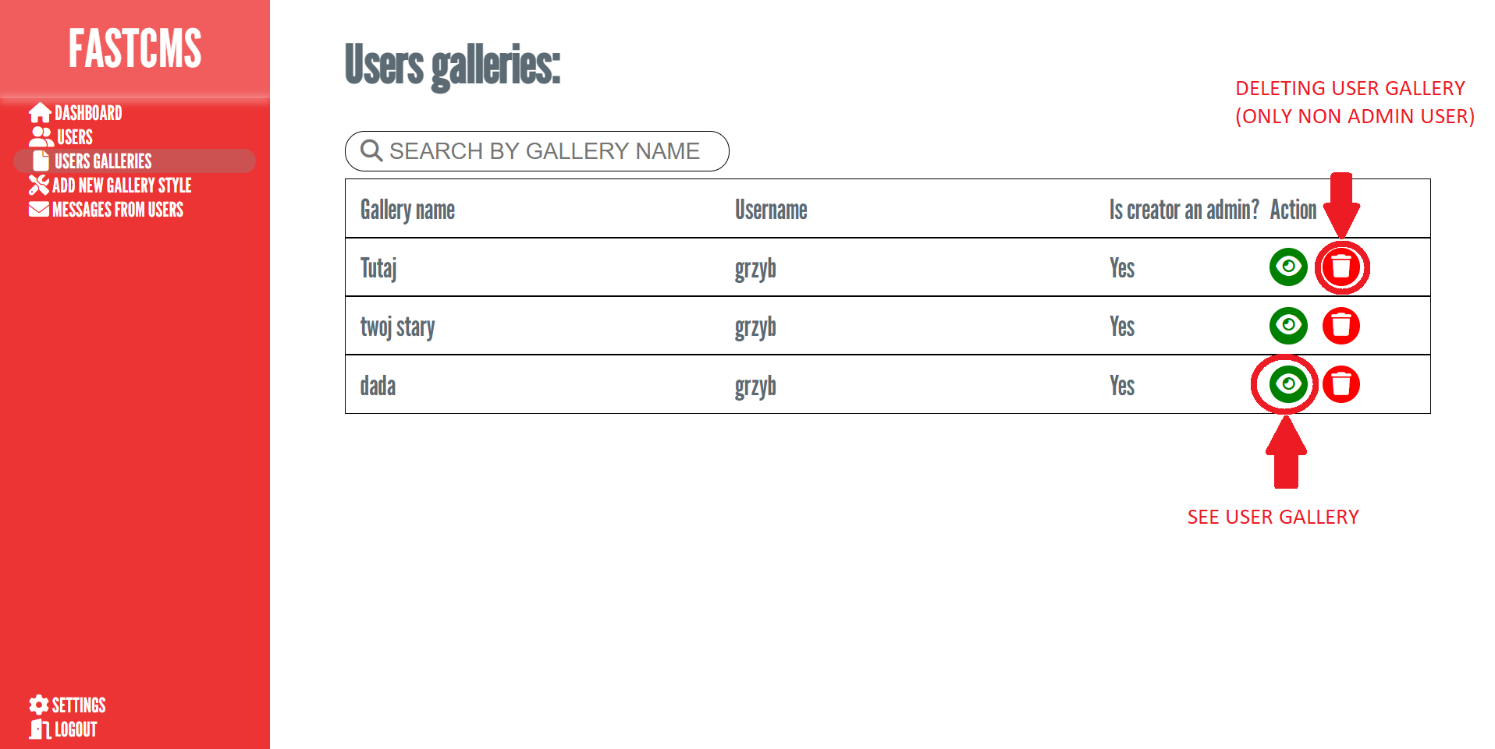

Adding new galery theme (fill all data correct): 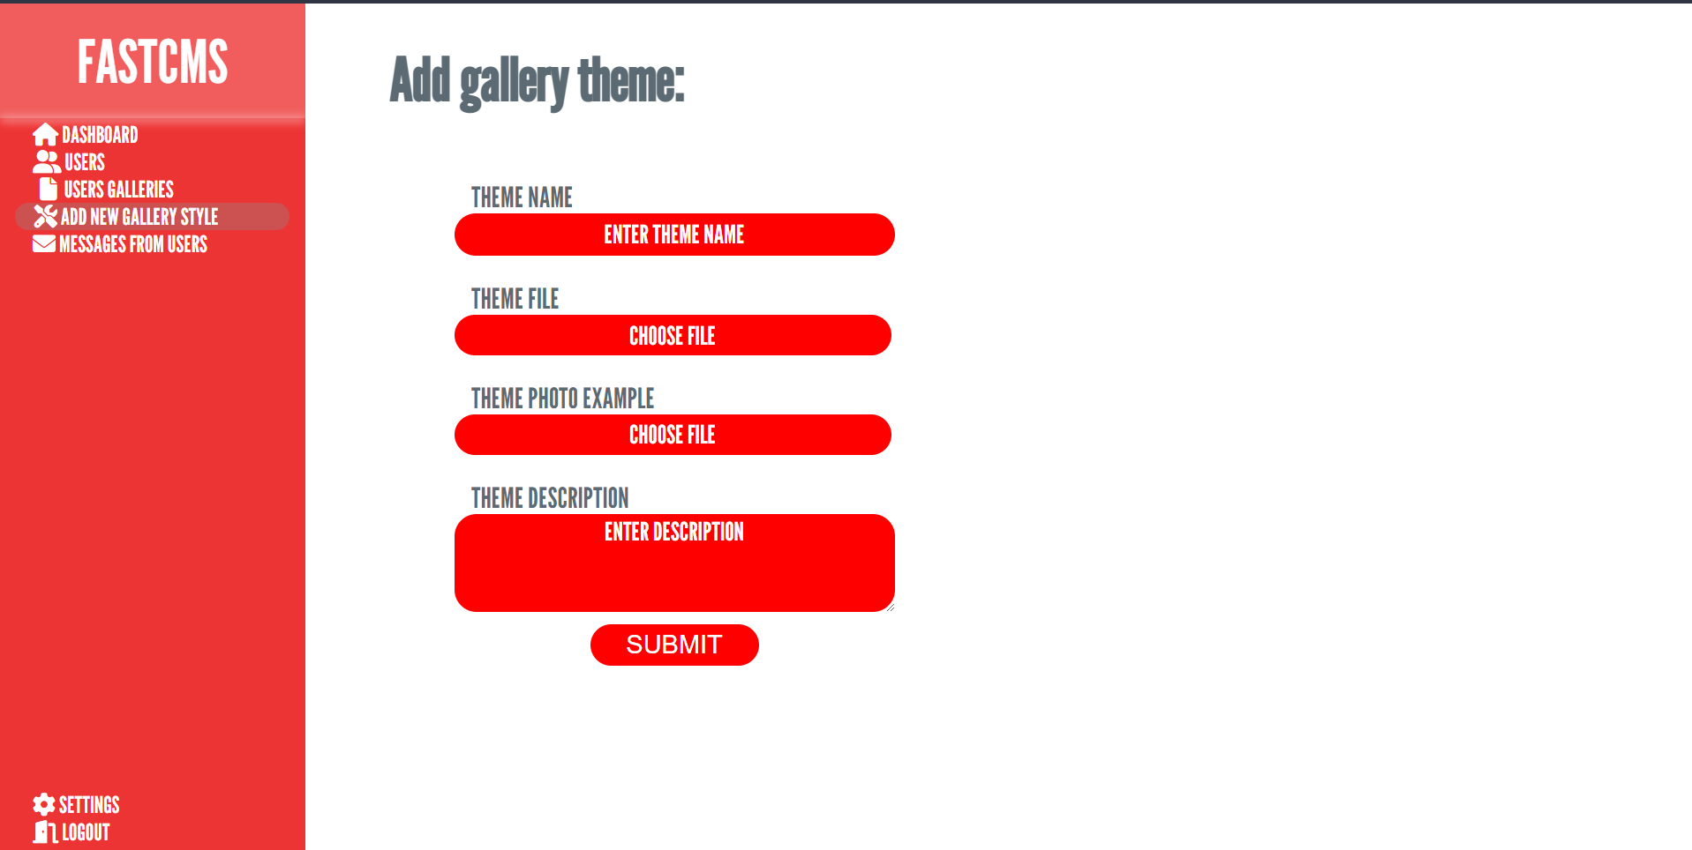

Managing users messages: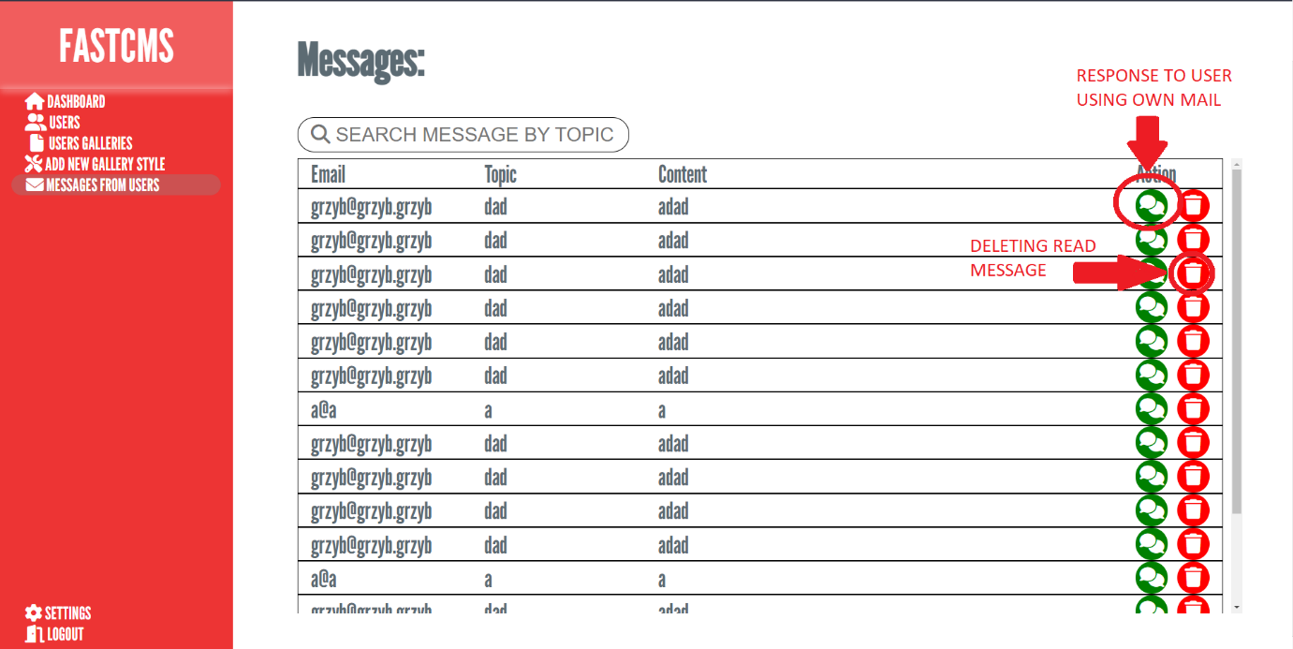

Settings (just read 😊): 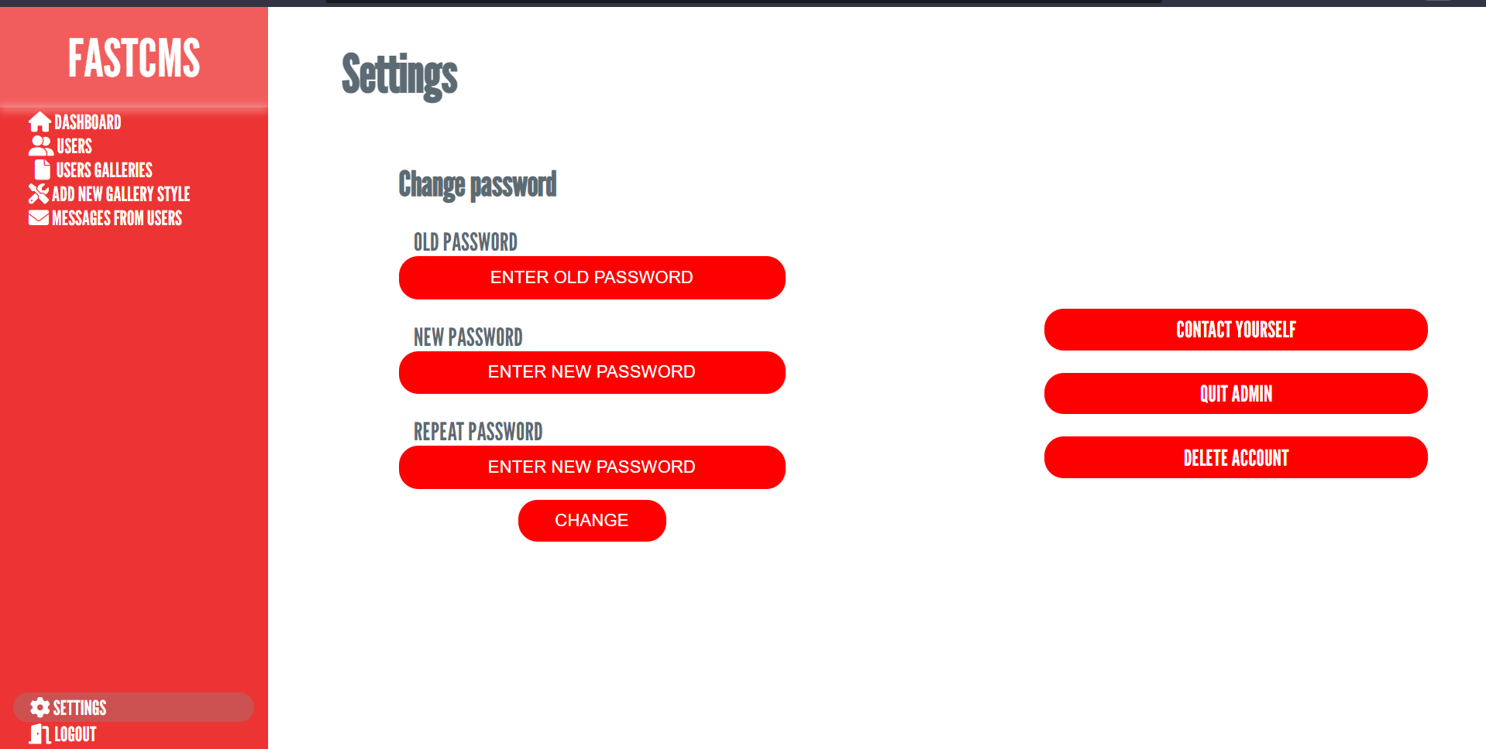

**User docs:**

Creating account and logging in:



Fill all data and click submit:



Next type password and click submit: 

Create gallery (fill all data): 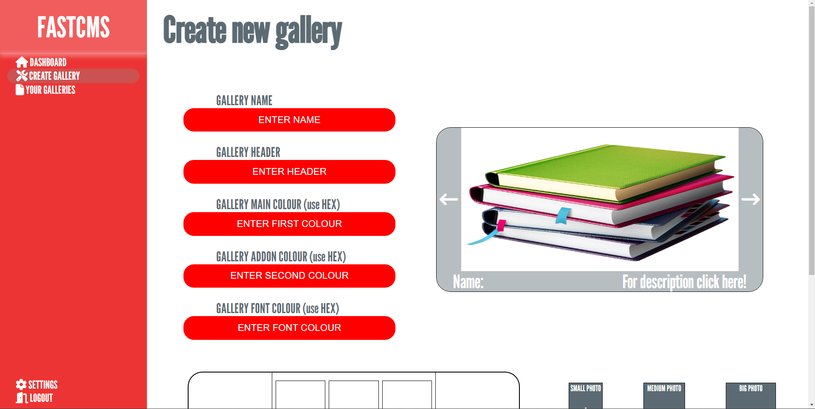

Move icon and click on small ico to give us all data, next click submit: 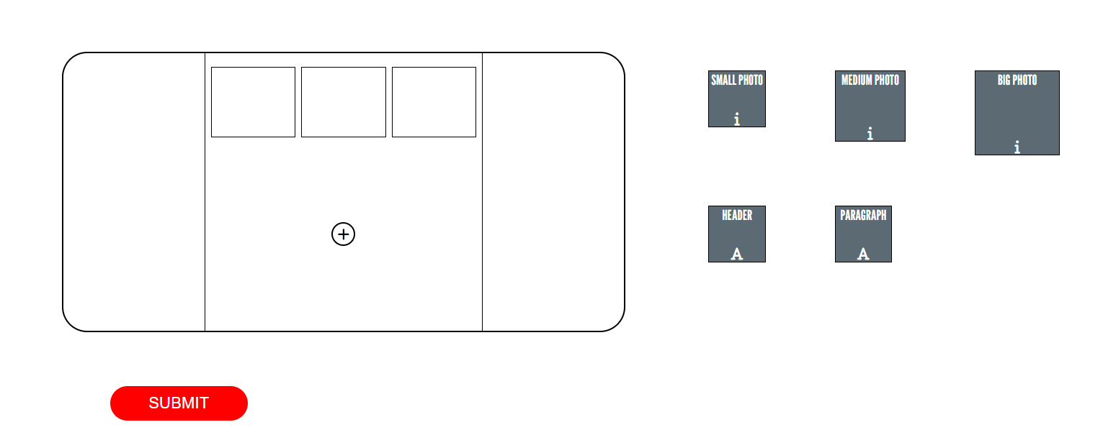

Managing your galleries: 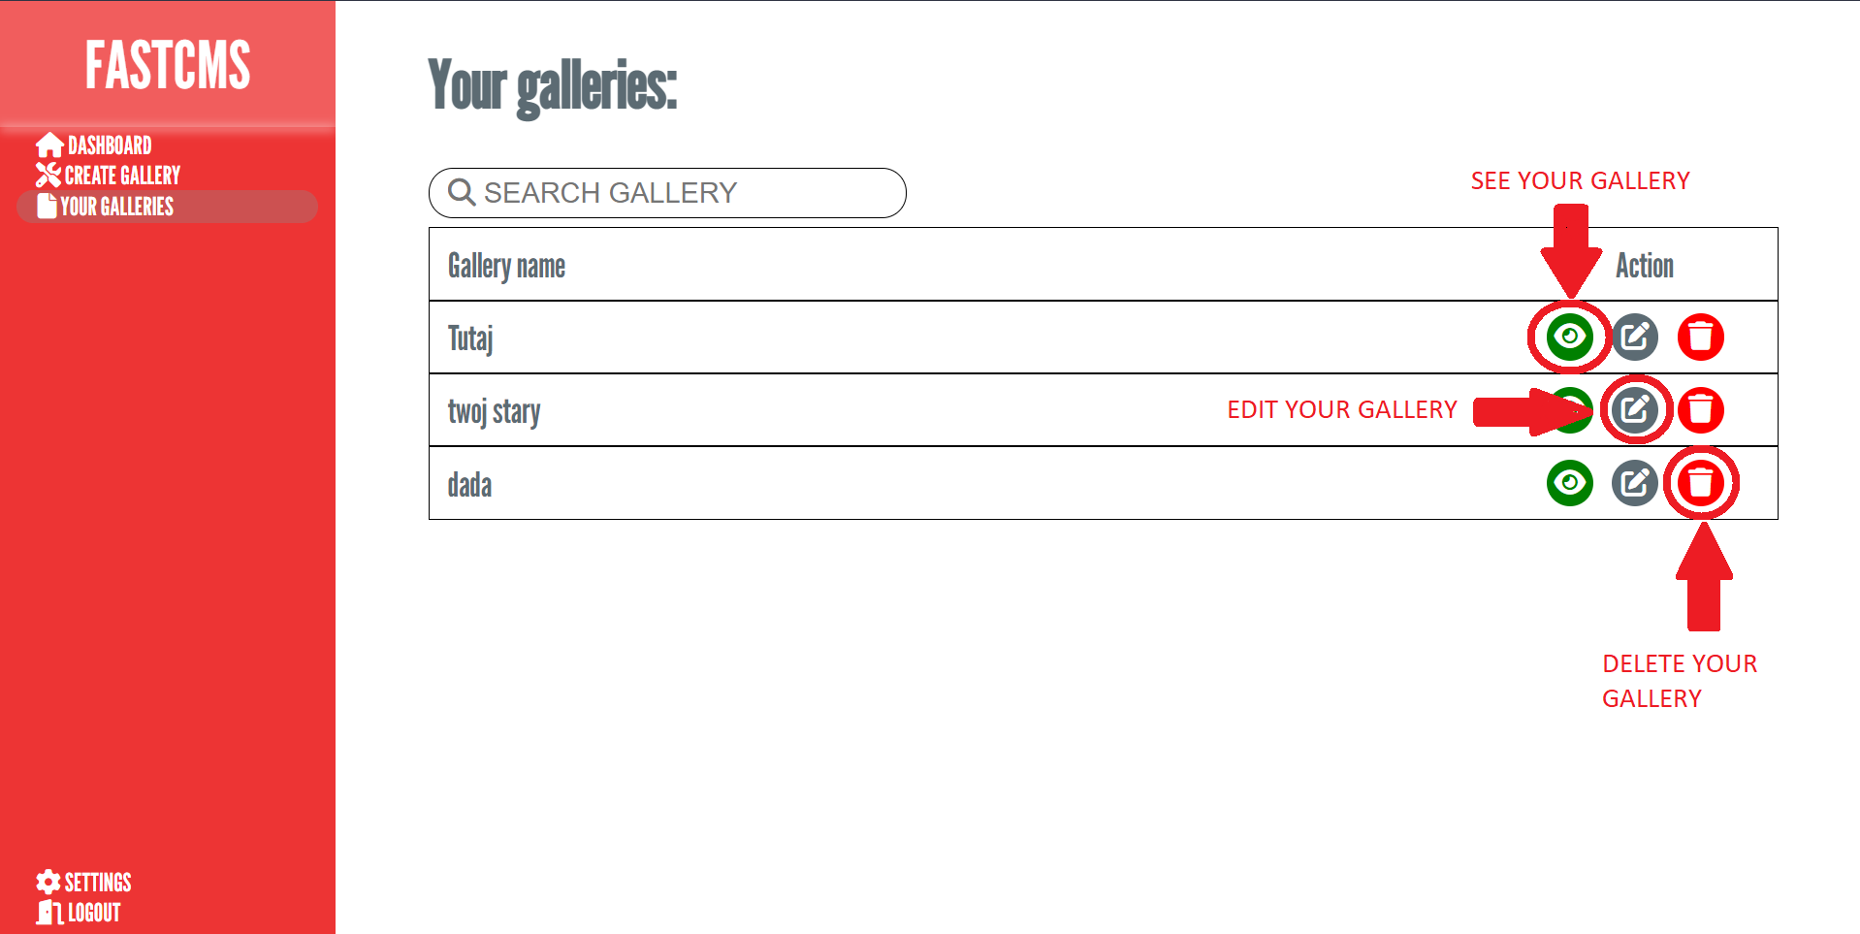

Settings (just read 😊): 