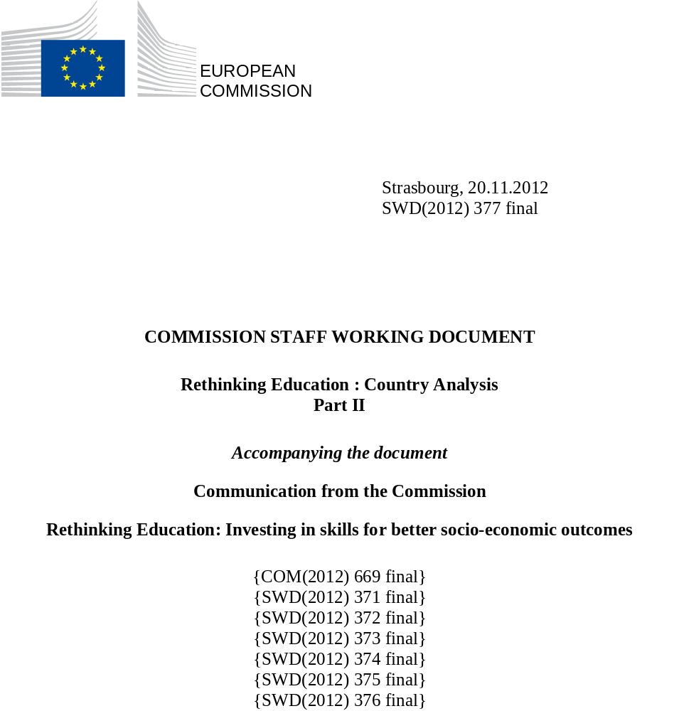
Table of contents

Introduction 3

Lithuania 4
Luxembourg 9
Latvia 14
Malta 19
Netherlands 25
Poland 30
Portugal 35
Romania 40
Sweden 45
Slovenia 50
Slovakia 55
United Kingdom 60

Annexes 65
Annex 1. Summary statistics on the headline target 63
Annex 2. Methodology figures on the headline target 65

Introduction

The following individual country summaries pinpoint the main challenges to skills provision specific to the different European countries and outline the most significant measures adopted to respond to such challenges.
The specific information contained in the summaries underpins the key messages of the Rethinking Education Communication by providing relevant quantitative and qualitative evidence, established through a methodology, building on the commonly accepted Joint Assessment Framework (JAF).
The summaries closely reflect the structure of the Rethinking Education Communication and complement the cross-country analysis presented in the Education and Training Monitor.
The summaries will provide essential elements for monitoring the implementation of the country-specific recommendations (CSRs) resulting from the European Semester under the Europe 2020 strategy.
Part II of this Staff Working Document covers the following Member States: Lithuania, Luxembourg, Latvia, Malta, Netherlands, Poland, Portugal, Romania, Sweden, Slovenia, Slovakia and United Kingdom.
Lithuania
1. Performance summary

1.1 Overview of benchmarks and skill levels
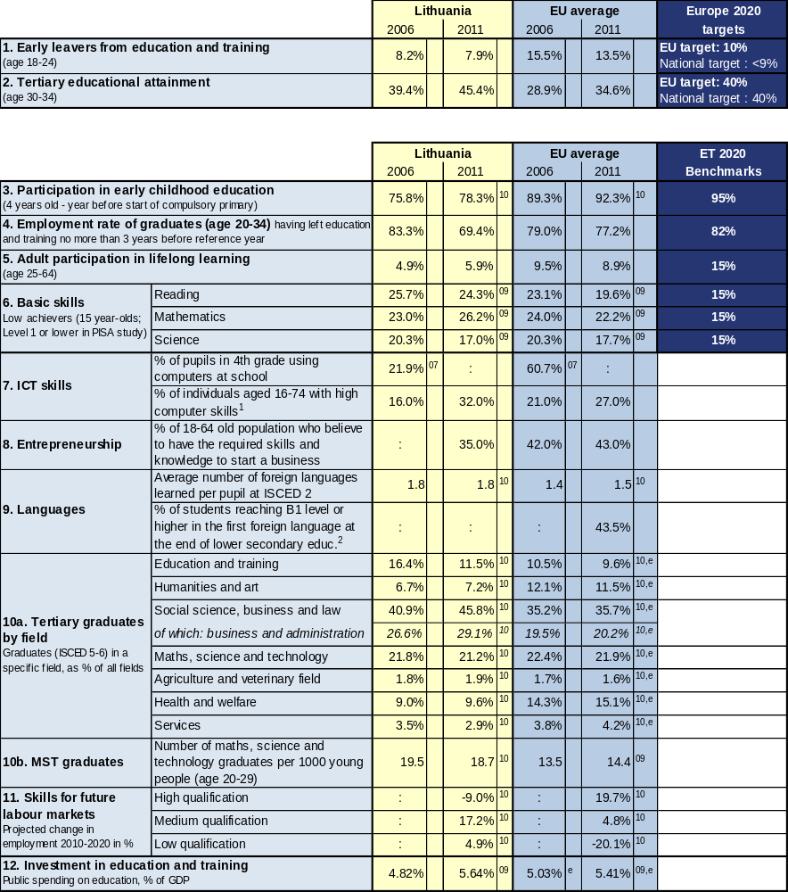

Source: Eurostat (LFS): 1, 2 CRELL (based on Eurostat LFS): 4 Global Entrepreneurship Monitor: 8
Eurostat (UOE): 3, 9a, 10, 12 OECD (PISA): 6 European Survey on Language Competences (ESLC): 9b
Eurostat (ISS): 7b Eurydice (based on IEA TIMSS): 7a Cedefop: 11

Additional notes:
⁰⁷ =2007, ⁰⁸ =2008, ⁰⁹ =2009, ¹⁰ =2010, ¹¹ =2011, e= estimate, b= break, p= provisional
Number of countries included in EU average: PISA=25, Entrepreneurship=18, Language skills=13, ICT/Computers at school=13
¹= having carried out 5-6 specific computer related activities, ²= average of skills tested in reading, listening, writing

1.2 Position in relation to Europe 2020 targets and ET2020 benchmarks
Deviation (%) from EU average and relative position to the EU benchmarks, top performers and low performers in EU27
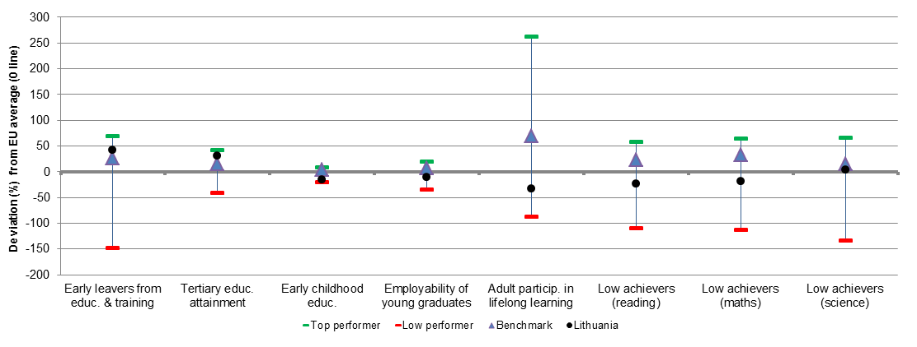
Source: DG EAC

2. Europe 2020 targets: patterns of sub-groups and sub-indicators

2.1 Early leavers from education and training

- Early school leavers of specific population sub-groups (country of birth and gender)
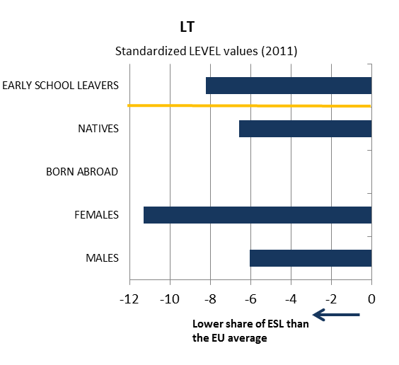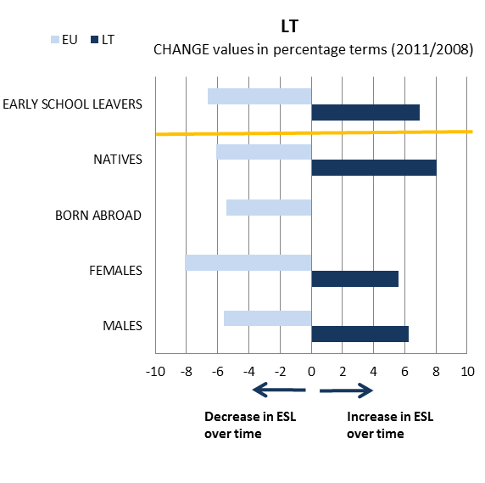

- Early school leavers and sub-indicators
(Difference in employment rate for low/medium education, low education background of the mother, investment in primary and secondary education, participation in vocational education and training [VET] and in early childhood education [ECE])
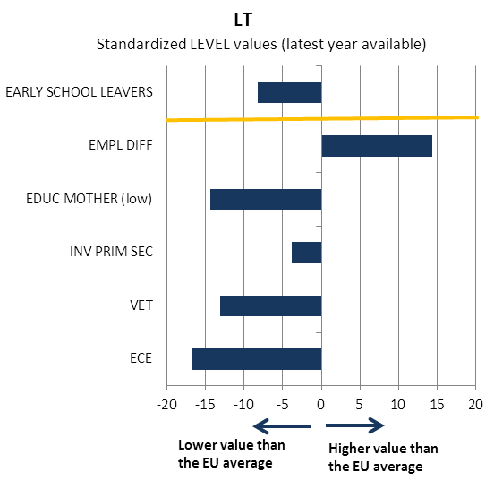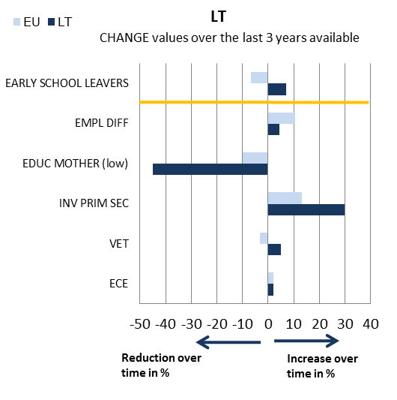
Source: JRC-CRELL

2.2 Tertiary educational attainment

- Tertiary educational attainment of specific population sub-groups (country of birth and gender)
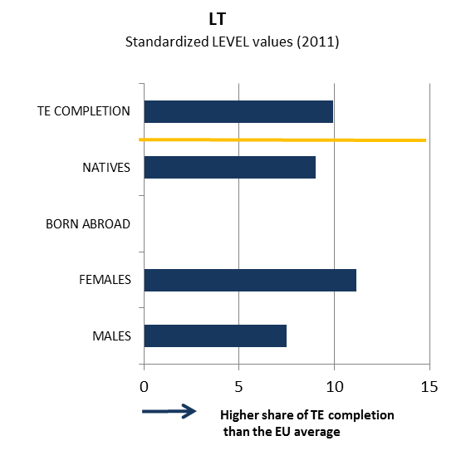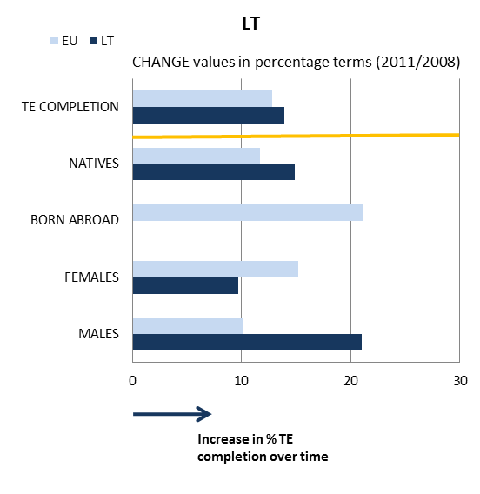

- Tertiary educational attainment and sub-indicators
(Completion rate in higher education, upper secondary educational attainment, investment in tertiary education, high education background of the mother, difference in employment rate for high/medium education)
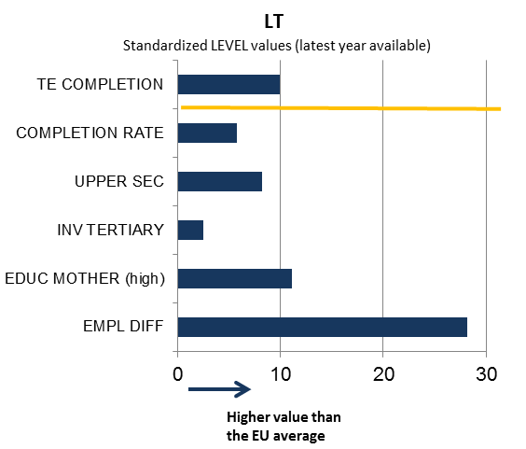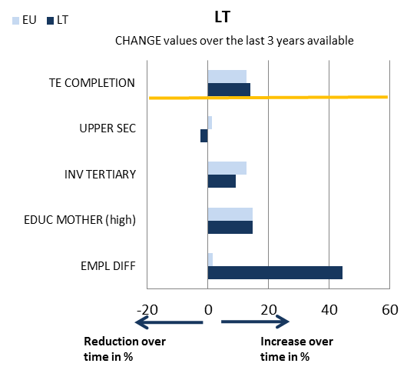

Source: JRC-CRELL

3. Key findings on benchmarks and skills levels
Concerning the Europe 2020 targets, Lithuania performs better than the EU average (7.9% v. 13.5% in 2011) in terms of early school leaving (ESL), after having witnessed a significant decrease in the share of early school leavers over the past decade (from 13.4% in 2002 to below the national Europe 2020 target of 9%). Lithuania's tertiary attainment rate (45.4% in 2011) is significantly above the EU average of 34.6%. The analysis of sub-indicators shows markedly higher returns to education and a more favourable family background than what is observed, on average, at the EU level. As the proportion of 20-24 year olds with at least an upper secondary education is well above the EU average, it is likely that the performance of Lithuania as regards the tertiary educational attainment of the 30-34 years-old group will continue to improve for some time. As regards the other ET 2020 benchmarks, Lithuania performs below the EU benchmark on participation in early childhood education. School education produces relatively weak results in terms of basic skills: 15-year olds' performance on PISA tests remains below the EU average, Lithuania is underperforming in reading (share of low-achievers is 24.3% v. the EU average of 20% in 2009) and maths (share of low-achievers is 26.2% v. the EU average of 22.2% in 2009). Participation of adults in lifelong learning is low in EU comparison (5.9% v. 8.9% in 2011).
ICT skills of the population are slightly above the EU average, although a lower share of pupils used computers at school in 2007 (21.9% of 4th grade pupils in LT, 60.7% in EU). Concerning the distribution of tertiary graduates by field compared with the EU average, Lithuania shows a high share of graduates in social science, business and law (45.8% as against 35.7% in 2010) and a low share of graduates in health and welfare (9.6% vs. 15.1%). As regards entrepreneurship, the share of the population believing to have the required skills and knowledge to start a business (35% in 2011) is among the lowest in the EU, and lower than in the neighbouring countries Latvia (47%) or Poland (52%). Employment in medium level qualification jobs in Lithuania up to 2020 is forecast to increase faster than the EU average (17.2% in Lithuania, 4,8% in the EU), while the forecast shows possible decrease for high level qualification jobs (-9% in Lithuania, 19.7% increase in the EU).
Public spending on education in Lithuania is slightly above the EU average (5.64% in Lithuania, 5.41% of GDP in the EU, 2009); it has been steadily increasing since 2007.

4. Major policy initiatives and reforms

4.1 Initiatives and measures to increase the relevance and level of skills
The updated curricula based on key competences were adopted in 2008 for primary and general education, and in 2011 for upper secondary education. Apart from the focus on the development of key competences, it provides for a more individualised approach to learning and allows for a more flexible planning of the learning process, together with the promotion of creative thinking and entrepreneurship. A number of programmes financed by the European Social Fund (ESF) support the changes in the curriculum, teacher education, initial VET, non-formal training and other areas.
A reform of the apprenticeship system (the new Law on Apprenticeships adopted in 2007) is still on-going, but the measures concerning apprenticeships and skills matching are steps in the right direction.
In 2010, public consultations on the future of education in Lithuania were held with a range of interest groups. In 2012, the new National Education Strategy 2013 - 2022 was developed and presented to the general public.
In order to improve the quality of higher education, a complex reform was launched in 2009. It aims at increasing the quality of higher education, its effectiveness, efficiency and access. The measures taken include improving the governance of universities, opening it to the public and partnership with business. Further measures focus on creating competition between universities for students and the public funding (via the "student's voucher" system) and increasing the quality of study programmes and research. The reform instigated consolidation of some universities. The developments are expected to foster the diversification of funding sources for universities via closer cooperation between higher education institutions and business, and via more effective use of the EU structural funds.

4.2. Initiatives and measures to stimulate open and flexible learning
Lithuania revised its Lifelong Learning Strategy in 2008. The strategy mainly focuses on VET, adult learning, non-formal learning and the development of the qualifications system. The Lithuanian National Qualification Framework was developed with the support of the ESF and adopted in 2011. It provides a description of qualification requirements for the labour market. The main objective of the framework is to ensure better correspondence between labour market needs and the provision of qualifications (in vocational, higher and continuing education and training). It is intended to improve the links and increase the transferability from vocational education and training to higher education, from initial VET to continuing vocational training, and to establish links to non-formal and informal learning. The NQF is also designed to improve quality assurance in qualifications.
The use of ICT is an integral part of the updated curricula for primary, lower and upper secondary education (ISCED 1, 2 and 3). The curricula prescribe the teaching of ICT as a separate subject and they recommend the use of ICT as a general tool across other educational areas of the curriculum. A special institution called ‘Centre of Information Technologies in Education’ is responsible, among other tasks, to provide the education community with the necessary ICT tools to create, communicate and collaborate. The Centre also organises and coordinates in-service training of teachers and other staff of the educational institutions in the application of ICT. A special internet portal "e-School" for educational resources has been set up, and provides the teaching community, learners and parents with new pedagogical materials and tools for learning.

4.3. Initiatives and measures to secure smart funding and developing partnerships
In recent years the public spending on education and training has been increasing in Lithuania and was slightly above the EU average in 2009.
Following the 2009 university reform, there is a variety of possible funding sources for higher education institutions (HEI). The current system is based on a student voucher system, which channels public funds to the institution chosen by the student, whether private or public. Public funding for research to HEI is allocated as a combination of basic funding and competitive (programme-based) funding, the distribution in 2011 reaching 50% basic funding, and 50% competitive funding.
The revision of the legal base in 2010 introduced the possibility to publicly fund privately-organised early childhood education and care through the system of "child vouchers". These measures are designed to help increase the accessibility of early childhood education and care in Lithuania.

Conclusion
While Lithuania is performing above the EU average in tackling early school leaving and tertiary education attainment, it ranks below the EU average for student achievement in basic skills (literacy and numeracy). The effectiveness of the recent curricular reforms as well as the higher education reform will need to be assessed in the medium term. Lithuania needs to focus on the relevance of the outputs of the education and training system for the economy and society, and the overall quality of compulsory education and initial VET. The measures to ensure the provision of necessary labour market relevant skills need to be pursued and reinforced, also through the EU structural funds.
In the context of growth-friendly fiscal consolidation there is a need to preserve an adequate level of expenditure on education and training while increasing its efficiency.
Luxembourg
1. Performance summary

1.1 Overview of benchmarks and skill levels

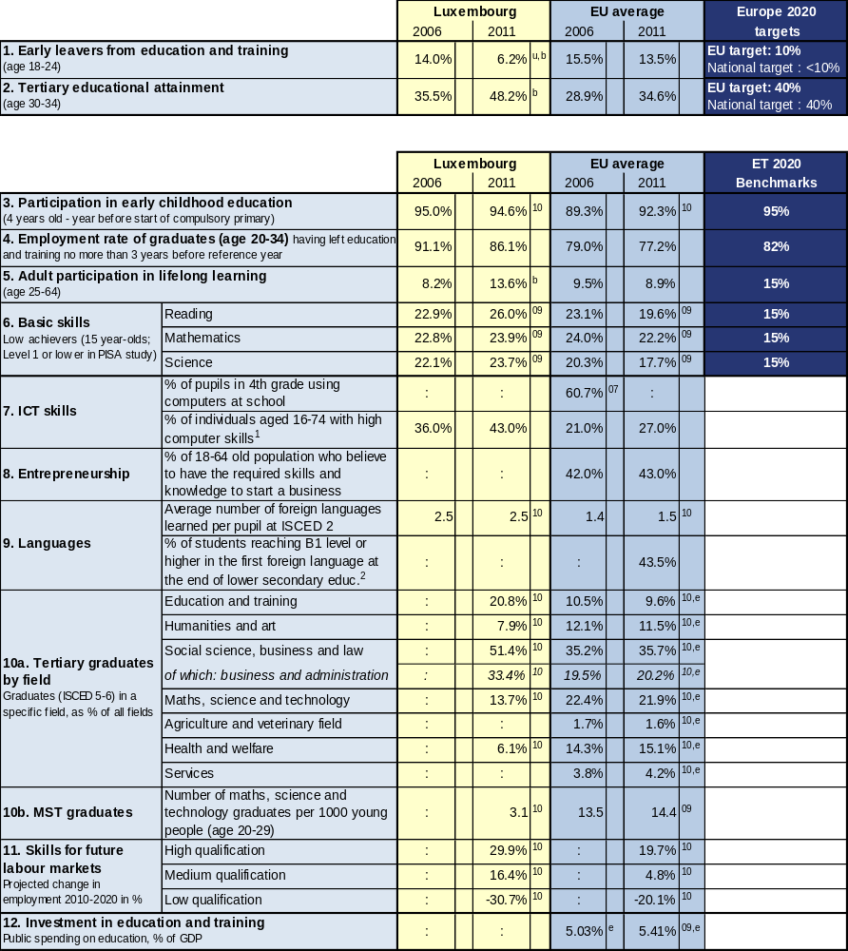

Source: Eurostat (LFS): 1, 2 CRELL (based on Eurostat LFS): 4 Global Entrepreneurship Monitor: 8
Eurostat (UOE): 3, 9a, 10, 12 OECD (PISA): 6 European Survey on Language Competences (ESLC): 9b
Eurostat (ISS): 7b Eurydice (based on IEA TIMSS): 7a Cedefop: 11

Additional notes:
⁰⁷ =2007, ⁰⁸ =2008, ⁰⁹ =2009, ¹⁰ =2010, ¹¹ =2011, e= estimate, b= break, p= provisional
Number of countries included in EU average: PISA=25, Entrepreneurship=18, Language skills=13, ICT/Computers at school=13
¹= having carried out 5-6 specific computer related activities, ²= average of skills tested in reading, listening, writing

1.2 Position in relation to Europe 2020 targets and ET2020 benchmarks
Deviation (%) from EU average and relative position to the EU benchmarks, top performers and low performers in EU27
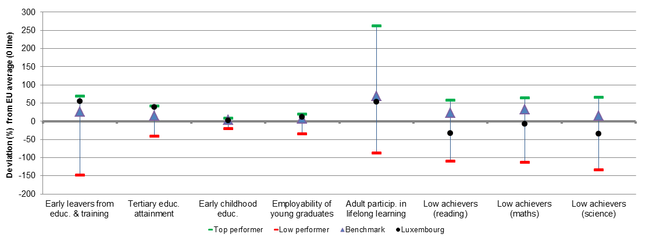
Source: DG EAC

2. Europe 2020 targets: patterns of sub-groups and sub-indicators

2.1 Early leavers from education and training

- Early school leavers of specific population sub-groups (country of birth and gender)
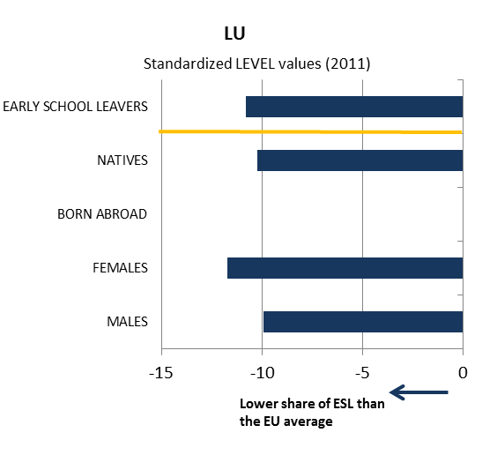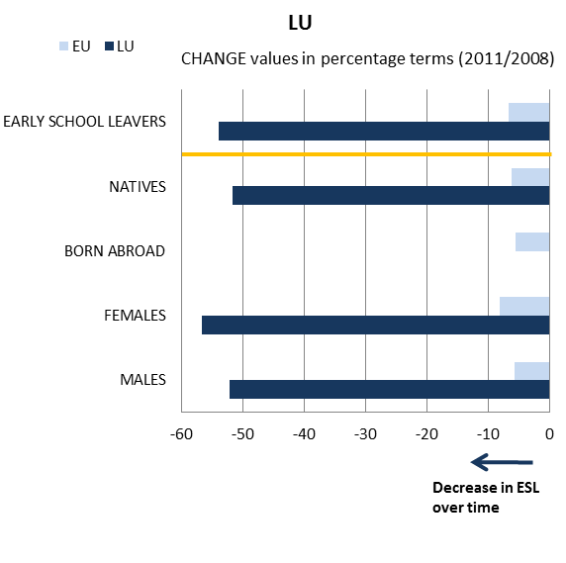
- Early school leavers and sub-indicators
(Difference in employment rate for low/medium education, low education background of the mother, investment in primary and secondary education, participation in vocational education and training [VET] and in early childhood education [ECE])
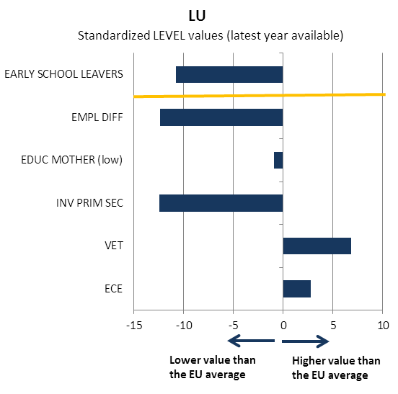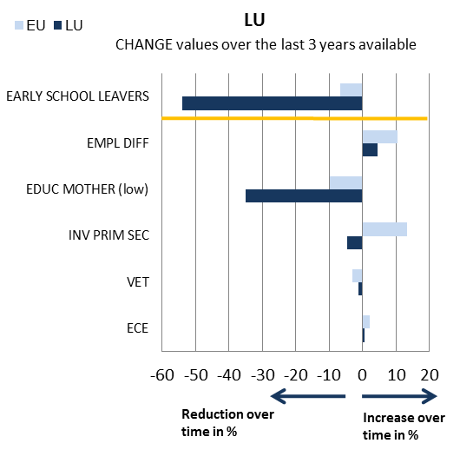
Source: JRC-CRELL

2.2 Tertiary educational attainment

- Tertiary educational attainment of specific population sub-groups (country of birth and gender)
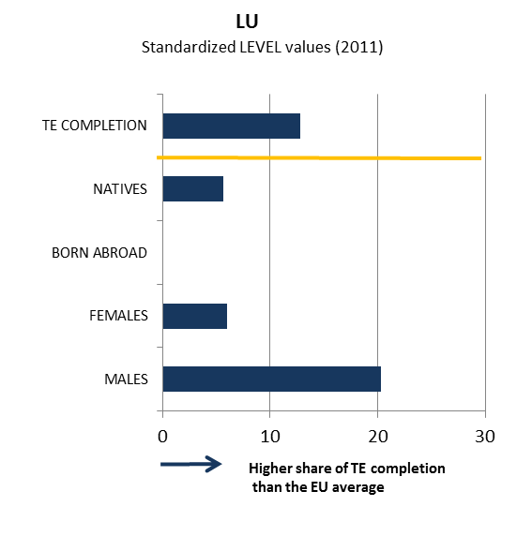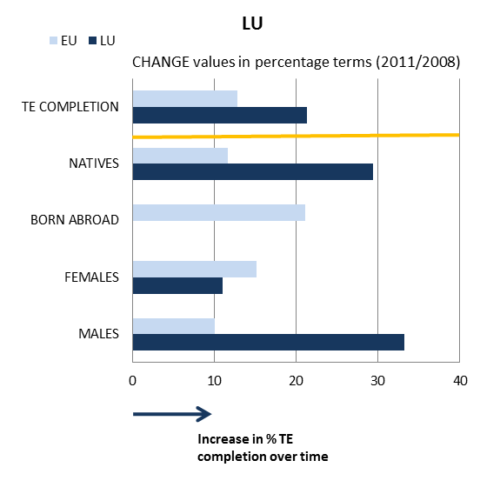

- Tertiary educational attainment and sub-indicators
(Completion rate in higher education, upper secondary educational attainment, investment in tertiary education, high education background of the mother, difference in employment rate for high/medium education)
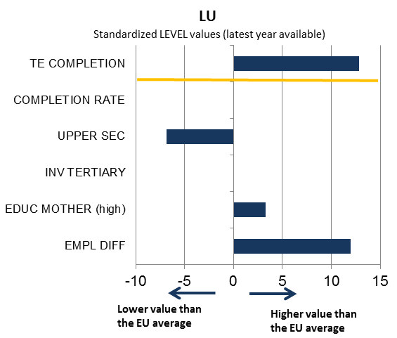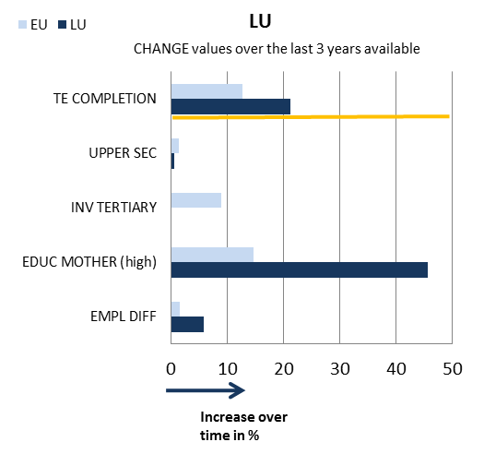

Source: JRC-CRELL

3. Key findings on benchmarks and skills levels
Regarding Europe 2020 targets, Luxembourg has one of the lowest early school leaving rates in Europe – 6.2% in 2011, compared to the 13.5% EU average. However, early school leaving remains a problem among the migrant population. The tertiary education attainment (TEA) rate according to the Eurostat methodology is - at 48.2% in 2011 - well above the EU average of 34.6%. The figure of 48.2% is misleading because Eurostat measures the TEA based on the working population in Luxembourg, but a high percentage of this population is not resident in the country. The tertiary attainment of the resident population is actually lower, currently at about 30%. In its 2012 National Reform Programme, Luxembourg has adopted the Eurostat methodology – thus including also the non-resident workers – but proposes to set the national TEA target at 66% instead of 40%. The analysis of sub-indicators shows positive participation patterns in early childhood and vocational education, favourable family background and higher returns to education, especially for tertiary education.
In 2010, participation in early childhood education stood at 94.6%, marking a slight decrease from the 95% in 2006, but remained above the EU average of 92.3%. Luxembourg scores among the best performers in the EU regarding graduate employment rates – 86,1% in 2011. Luxembourg is also above the EU average in adult participation in lifelong learning (13.6% vs 8.9% in 2011). The performance of Luxembourg’s education system is relatively weak when measured by PISA scores, but the multilingual system somewhat obscures Luxembourg’s true skill level in the test result. There has also been a negative tendency in reading, mathematics and science since 2006 – with rates respectively dropping from 22.9% in 2006 to 26% in 2009; from 22.8% to 23.9% and from 22.1% to 23.7%. These percentages are above the EU average in each discipline.
Luxembourg scores higher in ICT skills and foreign languages knowledge than the EU average. It has a very high share of graduates in social science, business and law and in education and training, as well as a low share in maths, science and technology. The employment pattern in Luxembourg up to 2020 is forecast to be characterised by a strong increase in high and medium qualification jobs and a very sharp decline in low qualification jobs.

4. Major policy initiatives and reforms

4.1 Initiatives and measures to increase the relevance and level of skills
Luxembourg introduced a reform of fundamental schools in 2009. The main aspects include a competence and cycle-based approach, implementation of study plans for each cycle, evaluation according to portfolios, and a strong cooperation between parents, teachers and the Ministry with the objective of identifying problems and skill shortcomings at an early stage. In addition, efforts were made to better integrate immigrant children into the school system. These reforms are currently being implemented so it is too early to assess their impact. In addition, new guidance procedures will be implemented as of 2013, covering Cycle 4 of primary education to the lower secondary school classes.
Particular attention is paid to language competences. German is studied as a compulsory subject from the age of 6. At 7, all pupils start learning French as a compulsory subject. At the age of 12, pupils choosing some educational paths/types of schools have to learn English as a third language. English becomes compulsory for all pupils when they reach 14. The obligation to learn all three languages lasts until pupils are 19. At 15, pupils choosing some educational paths/types of schools study a fourth foreign language as a compulsory subject until they are 19.
Early school leaving remains a problem among the migrant population. For children where none or only one of the official languages is spoken at home, gaining proficiency in all three official languages is difficult. A list of names of early school leavers drawn up on a monthly basis is sent to regional centres of the Local Youth Action group to determine why they dropped out and to help them to find a training programme or integrate them into the labour market. Luxembourg has taken several measures to increase the number of students embarking on higher education studies: allowing validation of prior learning and experience giving access to university studies; offering more varied higher education studies; establishing a link between higher education programmes and companies’ needs in order to promote employability; offering financial support to all students whether they are studying in Luxembourg or outside the country; tutoring of students at the University of Luxembourg.
The reform of Vocational Training reviewed and adapted a total of 118 tailor-made training schemes and has given students the opportunity to obtain three diplomas: the Certificat de capacité professionnelle (CCP - Certificate of Professional Competence), the Diplôme d’aptitude professionnelle (DAP-Professional Qualification Diploma) and the Diplôme de technicien (DT - Technician Diploma). The diplomas now combine a new form of skills acquisition, based on competences, with a focus on practical training with actors from the field with the objective to increase the employability of students.

4.2. Initiatives and measures to stimulate open and flexible learning
The government has put a focus on a global and more coherent lifelong learning (LLL) strategy with a series of reforms and initiatives. As a result, the number of LLL courses has increased in recent years to 4930 in 60 subjects. In November 2011, the National Agency for the European Education and Lifelong Learning programme (ANEFORE) launched the S3L project to investigate how lifelong learning is perceived in Luxembourg. The results will feed into a White Paper on future strategies. From 2012 on, lifelong learning in the private sector will be co-financed by the state at a rate of 20% instead of 14.5% (35% for young unskilled workers and older workers). Greater adult participation in LLL would help to tackle the country’s structural unemployment since residents are facing competition from a large pool of often highly skilled potential workers from neighbouring countries.
Regarding teacher training and motivation, no measures have been announced in recent years. Moreover, in recent years more fixed-term staff (chargés) have been recruited, with a considerably lower remuneration than permanent teachers (professeurs). However, the government has announced it will recruit more teachers in order to meet the current challenges of the ongoing reforms.
Luxembourg has a national strategy on the use of ICT in education. There is also a general national ICT strategy covering, inter alia, the following areas: ICT in schools, e-Inclusion, digital media literacy and e-Skills development.
The E-Bac programme launched by the Luxembourg government focusses on providing adults who do not complete secondary education with the opportunity to get their final qualification (baccalauréat) via distance learning thanks to more flexibility, and to apply for higher education studies. It is currently possible to follow classes for the last three years of secondary education. The “blended learning” concept has been adopted: participants can do 75% of their course work via distance learning and 25% in class.

4.3. Initiatives and measures to secure smart funding and developing partnerships
Education in Luxembourg is mostly funded by the State (59.9%) and the municipal level (22.1%). Other actors such as professional associations or private actors contribute a small amount to general expenditures. The size of the country, the availability of funding and the collaboration between the various actors enable strong partnership at the national level to set up initiatives in the field of education, vocational training, and lifelong learning. Luxembourg has had a long tradition of social dialogue at tripartite level (government, trade unions, and employers’ unions) and major reform proposals are discussed in collective bargaining arenas prior to their implementation.
In the context of the European Social Fund (2007-2013), Luxembourg has defined a series of priorities centering on a double-fold strategy. On the one hand, funds are allocated to promote job creation through reinforcing investments into human capital; on the other hand, efforts are made to help more vulnerable groups, especially in times of crisis (youth, older workers, jobseekers). One example is the 'Perspective 45' initiative the targets older workers and jobseekers and focusses on reskilling priorities.

Conclusion
Luxembourg performs well on most indicators measuring skills. In many cases it performs better than the EU average and, although it has not yet reached the benchmark, it seems to be on the right track to achieving it. What requires attention in this seemingly well performing country is the difference in performance levels between the residents and the immigrant communities. Efforts are needed in the first instance to measure these differences and only afterwards to find the appropriate strategies to address them.
Far-reaching reforms in fundamental, secondary and professional education are in the process of being implemented, with a view to obtaining better school achievement and preparing students for an increasingly competitive employment market. Luxembourg has chosen to define and implement a new teaching and skills acquisition approach with a focus on more individualised tutoring and practical work experience. The knowledge of foreign languages has been identified as a cornerstone of the education system and a strategic positive driver on the employment market. Despite the fact that the government agreed upon increasing the number of teachers and professors in fundamental and secondary education, a large number of fixed-term contracts or less-qualified chargés can hamper the efficient implementation of reforms.

Latvia
1. Performance summary

1.1 Overview of benchmarks and skill levels

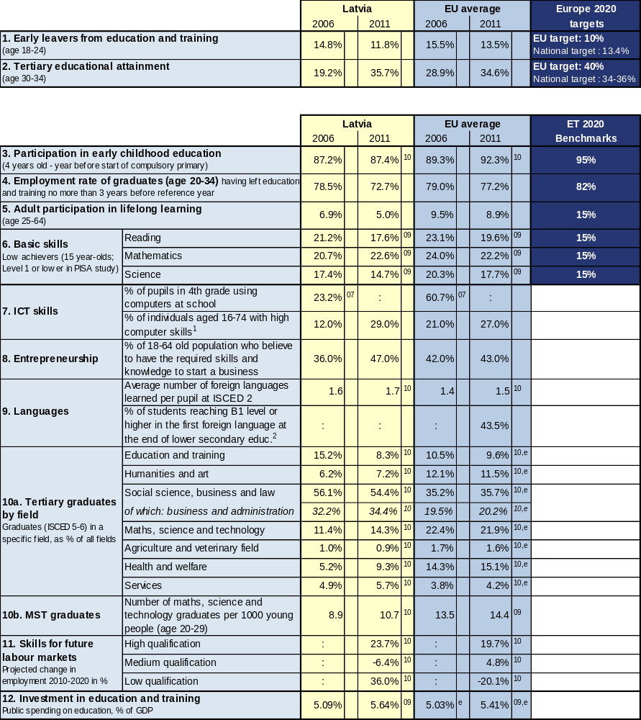

Source: Eurostat (LFS): 1, 2 CRELL (based on Eurostat LFS): 4 Global Entrepreneurship Monitor: 8
Eurostat (UOE): 3, 9a, 10, 12 OECD (PISA): 6 European Survey on Language Competences (ESLC): 9b
Eurostat (ISS): 7b Eurydice (based on IEA TIMSS): 7a Cedefop: 11

Additional notes:
⁰⁷ =2007, ⁰⁸ =2008, ⁰⁹ =2009, ¹⁰ =2010, ¹¹ =2011, e= estimate, b= break, p= provisional
Number of countries included in EU average: PISA=25, Entrepreneurship=18, Language skills=13, ICT/Computers at school=13
¹= having carried out 5-6 specific computer related activities, ²= average of skills tested in reading, listening, writing

1.2 Position in relation to Europe 2020 targets and ET2020 benchmarks
Deviation (%) from EU average and relative position to the EU benchmarks, top performers and low performers in EU27
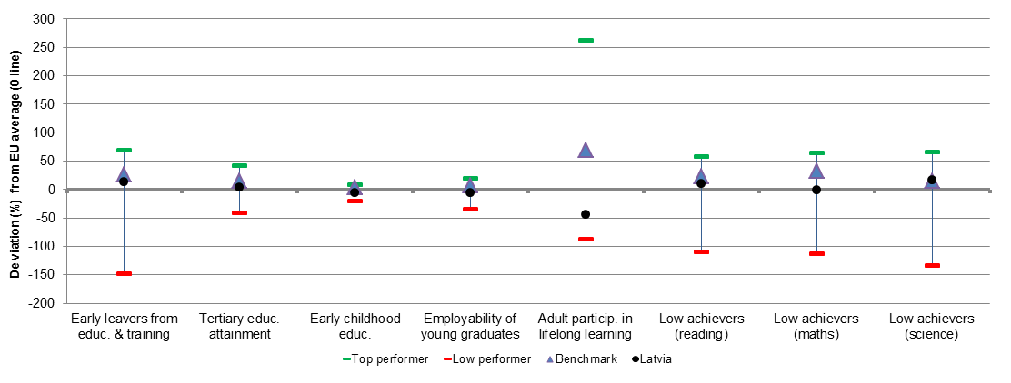
Source: DG EAC

2. Europe 2020 targets: patterns of sub-groups and sub-indicators

2.1 Early leavers from education and training

- Early school leavers of specific population sub-groups (country of birth and gender)
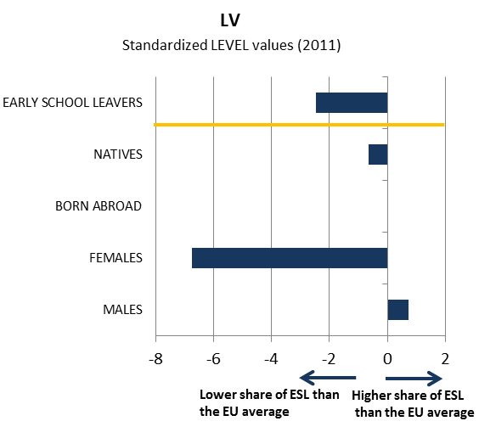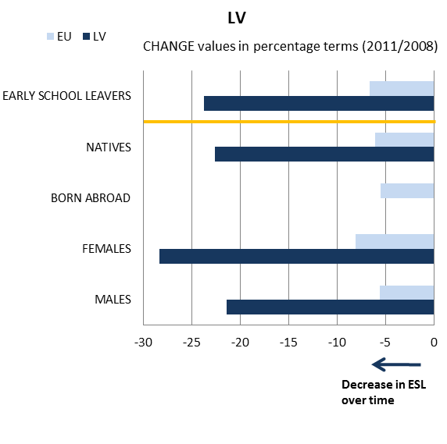

- Early school leavers and sub-indicators
(Difference in employment rate for low/medium education, low education background of the mother, investment in primary and secondary education, participation in vocational education and training [VET] and in early childhood education [ECE])
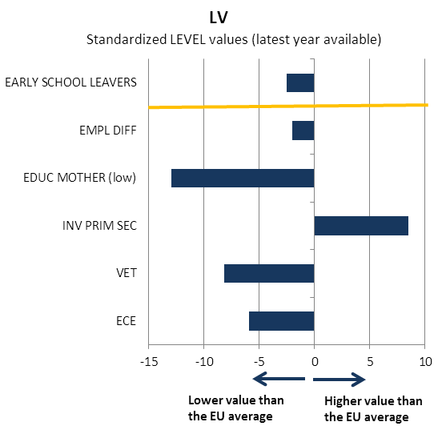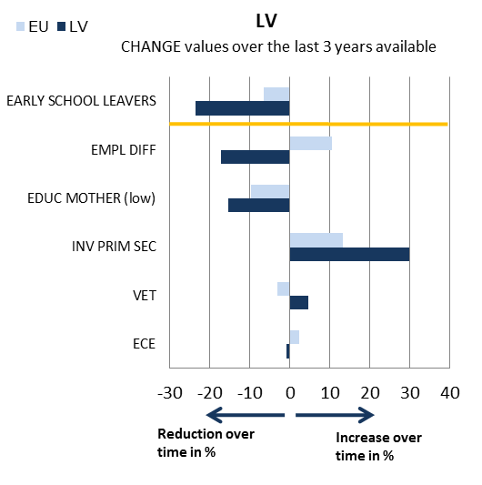
Source: JRC-CRELL

2.2 Tertiary educational attainment

- Tertiary educational attainment of specific population sub-groups (country of birth and gender)
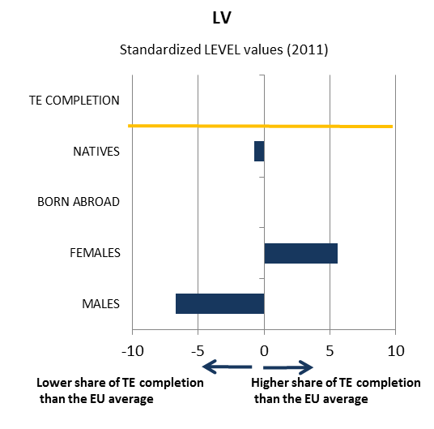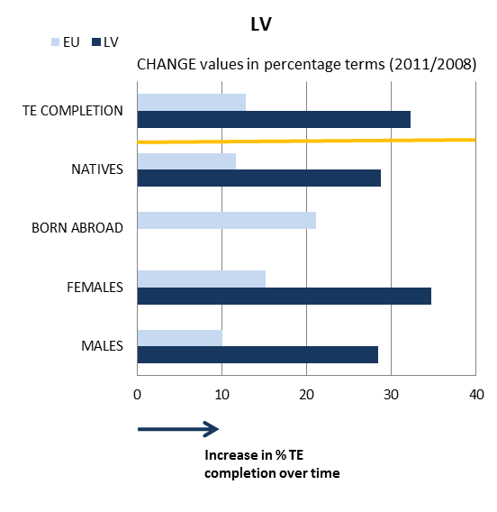

- Tertiary educational attainment and sub-indicators
(Completion rate in higher education, upper secondary educational attainment, investment in tertiary education, high education background of the mother, difference in employment rate for high/medium education)
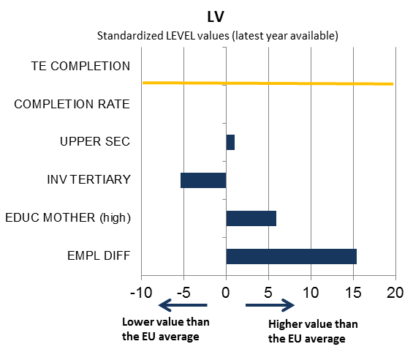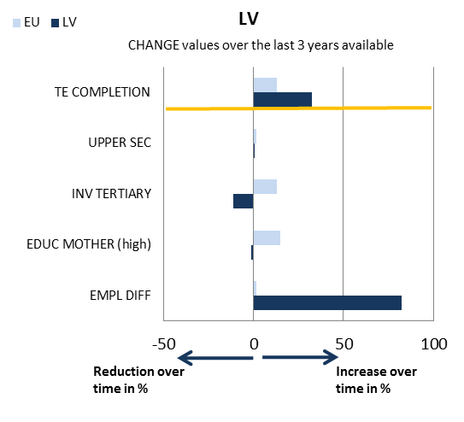

Source: JRC-CRELL

3. Key findings on benchmarks and skills levels
Concerning the Europe 2020 targets, Latvia has showed progress in reducing early school leaving and raising the tertiary attainment rate, and currently performs better than the EU average in both areas, although significant gender gaps persist. As regards the other ET 2020 benchmarks, participation in early childhood education has remained broadly constant in recent years and is below the EU average (87.4% vs. 92.3% in 2010). In terms of basic skills, 15-year olds' performance on PISA tests in reading and science recently improved and continues to outperform the EU average, but worsened in mathematics, where it is now just in line with the EU average. The gender gap is very high in reading, where only 8.7% of girls are low-achievers, compared with 26.6% of boys. The employment rate of graduates suffered from the recent economic crisis, but after a trough of 64.6% in 2010, rebounded in 2011 (72.7%). Participation of adults in lifelong learning is very low in EU comparison (5.0% vs. 8.9% in 2011) and even decreased by around 2 percentage points over the last few years.
ICT skills of the population appear close to the EU average. As regards entrepreneurship, the share of the population believing to have the required skills and knowledge to start a business rose significantly in recent years. As regards the distribution of tertiary graduates by field compared with the EU average, Latvia shows a very high share of graduates in social science, business and law (54.4% as against 35.7% in 2010) and a low share of graduates in mathematics, science and technology (14.3% vs. 21.9%). Latvia's employment pattern up to 2020 is forecast to diverge markedly from the EU average in both medium and low qualification jobs, with a moderate decline in the former and a large increase in the latter. However, low qualification jobs are projected to represent only 16% of total jobs in 2020, still below the EU average (18%). Public spending on education in Latvia is somewhat above the EU average (5.64% vs. 5.41% of GDP in 2009), although expenditure in higher education is considerably lower (0.79% as against 1.22% of GDP in 2009).

4. Major policy initiatives and reforms

4.1 Initiatives and measures to increase the relevance and level of skills
In the area of basic skills, the National Centre for Education is responsible for a comprehensive curriculum reform for 6-11 years old pupils. The aim of the reform is to promote pupil-centred teaching, as well as reading literacy. One of the outcomes of curriculum reform for 6-11 years old pupils is a legislative change implying that from the school year 2012/2013 learning the first foreign language will be compulsory from the 1st grade.
A positive development for monitoring early school leaving has been the setting up of a State Education Information System (SEIS) in the academic year 2010/2011 by the Ministry of Education and Science. SEIS contains information about education institutions, academic programmes, students and teaching staff. It enables efficient tracking of the educational process and provides accurate identification of students who have not commenced studies in the compulsory educational system and also of students who have discontinued studies prematurely. Based on SEIS data, the State Education Service takes steps in cooperation with local authorities to establish the reasons for drop-out. In addition, the Central Statistical Bureau compiles data on the number of students at vocational education institutions and the reasons for leaving them. While compensation measures include pedagogical support to students with learning difficulties, targeted measures to bring early school leavers back into education are not well developed.
One of the main measures implemented in higher education is a large-scale assessment of study programmes that will form the basis for future decisions. Higher education suffers from low international competitiveness (low share of international students, publications and international lecturers) and weak cooperation between universities and businesses.

4.2. Initiatives and measures to stimulate open and flexible learning
Concerning teachers' education and training, two projects, running until end-2012 and co-financed by the European Social Fund, have to be mentioned. The first ("Support to Ensure Sufficiency of General Secondary Education Educators in Priority Subjects") aims to provide teachers of priority subjects at general education institutions and vocational education institutions with grants in exchange for creative approaches to teaching and involvement in research. The second ("Competence Promotion of the Educators Involved in Vocational Education, Teaching Comprehensive Subjects") intends to ensure that vocational educators teaching comprehensive subjects improve their general and specific competences (e.g. foreign languages, ICT skills). The two measures seem to have contributed to the improvement of skills among pupils.
In the area of qualifications, a specific project (Improvement of National Qualification System, Vocational Education Contents and Cooperation among the Bodies Involved in Vocational Education) aims to improve the quality and efficiency of vocational education by, inter alia, creating a sectoral qualification system; implementing a modular approach for acquiring basic profession, speciality and specialisation; and developing the recognition of skills acquired in contexts other than those of formal learning. The measure can be considered as effective since many of the recommendations evolving from the project have already been followed through adopting the appropriate legislative and implementing acts.
Implementing the Lifelong Learning strategy remains a challenge, especially as regards the quality and effectiveness of the existing schemes whose relevance to labour market needs appears insufficient.
Several European Social Fund programmes are carried out with the aim of modernising the learning environment. In particular, the programme “Ensuring the Necessary Material Basis for Quality Acquisition of Natural Sciences”, in cooperation with universities, scientific institutions and entrepreneurs, promotes the use of advanced teaching methods (electronic teaching materials, opportunities of the e-learning environment), so as to give pupils the opportunity to better learn the subjects they are interested in. The measure is being implemented until the end of 2012.

4.3. Initiatives and measures to secure smart funding and developing partnerships
Education and training budgets suffered significant cuts during the crisis and measures are being taken to ensure cost-efficiency: for example, the general education school network has been consolidated and the ‘money follows the pupil’ funding model introduced. Funding from the EU structural funds has been invested in developing specialised vocational schools, modernising higher education and creating competence centres. In 2010–2011, development of a performance indicator-based financing model of higher education was launched. At the moment, an expert group is planned to be established to identify and evaluate some more alternative options for higher education financing and conduct research on financial aspects. By 2014, it is planned to prepare the normative basis for a new higher education financing model and to implement it.
To ensure equal access to higher education, improvements to the mechanism for awarding scholarships and student loans have been introduced. These include broadening study opportunities and promoting more guidance on the choice of subject areas. In 2010 60 % of the total number of scholarship recipients received scholarships for higher education studies based on social criteria (low family income, disability, etc.). From the academic year 2011-2012 a new system of distributing scholarships has come into force, based on academic merits as the main criteria. In the new system social criteria will be taken into account only in the case of equal academic merits. It will be important to monitor the effect of the new system on enrolment and graduation.
Concerning partnerships in education, in 2010 Latvia started to implement a number of measures (also financed by EU Structural Funds) to make higher education more attractive and competitive. An Action Plan for 2010–2012 is being implemented in cooperation with the Latvian Employers’ Confederation, the Latvian Chamber of Commerce and Industry and professional associations.

Conclusion
In recent years Latvia has adopted a number of measures in the areas of education and training with a view to increasing both the levels and relevance of skills. However, the education system faces a number of challenges to better comply with the current labour market needs as well as to help raise the innovation potential of the Latvian economy.
The share of students enrolled in vocational education is among the lowest in EU and adult participation in lifelong learning remains limited. Although Latvia even exceeded its national EU2020 target regarding early school leaving in 2011, this is more due to worsening labour market prospects of young people which compel them to stay longer in education, than to policy actions. If comprehensive measures including targeted measures to bring early school leavers back into education are missing, the level of early school leaving is likely to return to the pre-crises level.
Overall participation and attainment levels do not pose a problem in the Latvian higher education system; nevertheless there are some areas where quality and efficiency could be improved. Latvian universities perform poorly in worldwide rankings, while the higher education network is too large in view of the population served and too generous regarding the study programmes on offer. Evidence from employers and recruitment agencies points to skills' shortages in ITC, pharmaceuticals and engineering: the higher education system has not produced enough graduates in mathematics, science and technology and no quick improvement in this area can be expected in light of recent enrolment rates.

Malta
1. Performance summary

1.1 Overview of benchmarks and skill levels

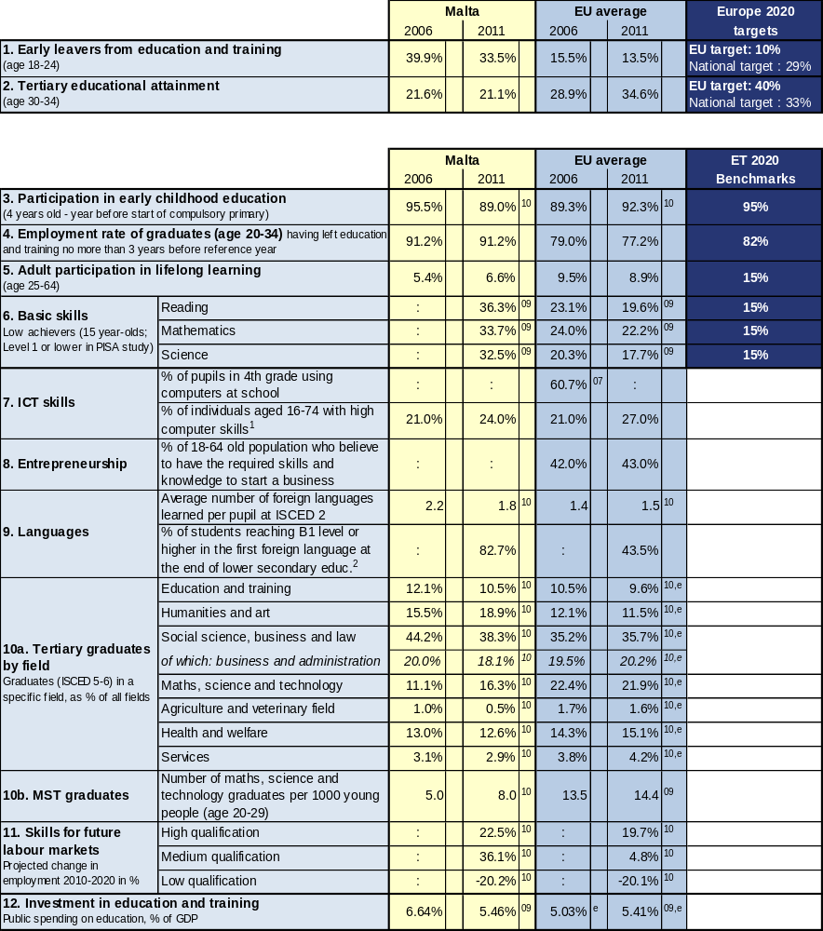

Source: Eurostat (LFS): 1, 2 CRELL (based on Eurostat LFS): 4 Global Entrepreneurship Monitor: 8
Eurostat (UOE): 3, 9a, 10, 12 OECD (PISA): 6 European Survey on Language Competences (ESLC): 9b
Eurostat (ISS): 7b Eurydice (based on IEA TIMSS): 7a Cedefop: 11

Additional notes:
⁰⁷ =2007, ⁰⁸ =2008, ⁰⁹ =2009, ¹⁰ =2010, ¹¹ =2011, e= estimate, b= break, p= provisional
Number of countries included in EU average: PISA=25, Entrepreneurship=18, Language skills=13, ICT/Computers at school=13
¹= having carried out 5-6 specific computer related activities, ²= average of skills tested in reading, listening, writing

1.2 Position in relation to Europe 2020 targets and ET2020 benchmarks
Deviation (%) from EU average and relative position to the EU benchmarks, top performers and low performers in EU27

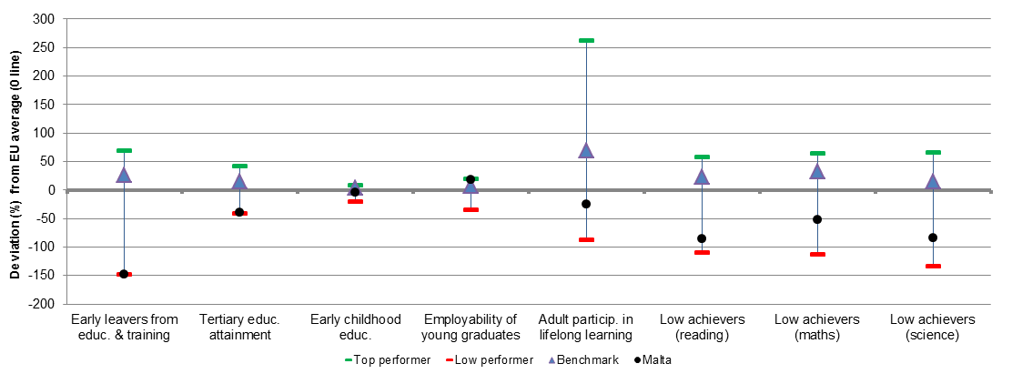
Source: DG EAC

2. Europe 2020 targets: patterns of sub-groups and sub-indicators

2.1 Early leavers from education and training

- Early school leavers of specific population sub-groups (country of birth and gender)

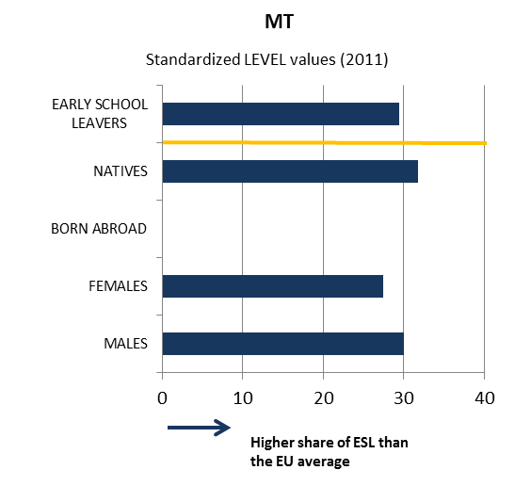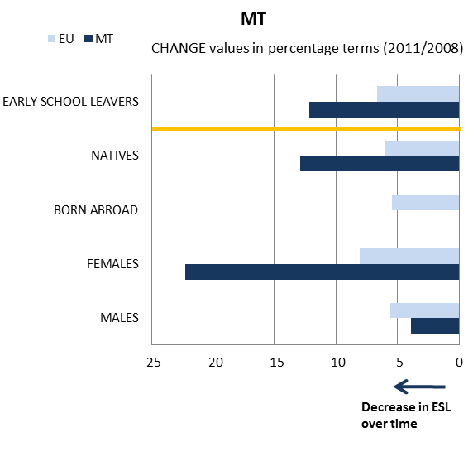

- Early school leavers and sub-indicators
(Difference in employment rate for low/medium education, low education background of the mother, investment in primary and secondary education, participation in vocational education and training [VET] and in early childhood education [ECE])
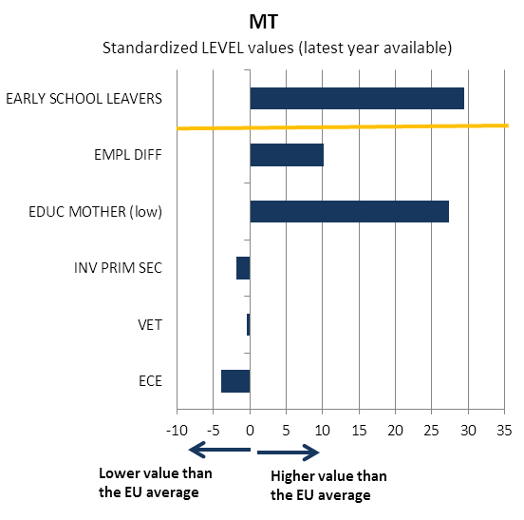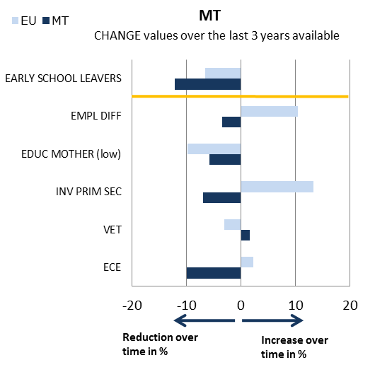
Source: JRC-CRELL

2.2 Tertiary educational attainment

- Tertiary educational attainment of specific population sub-groups (country of birth and gender)
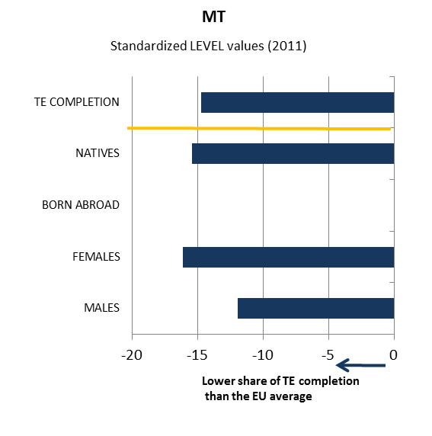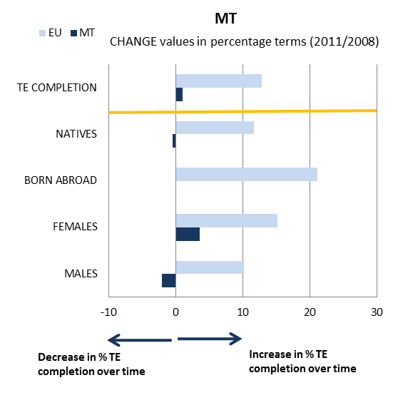

- Tertiary educational attainment and sub-indicators
(Completion rate in higher education, upper secondary educational attainment, investment in tertiary education, high education background of the mother, difference in employment rate for high/medium education)
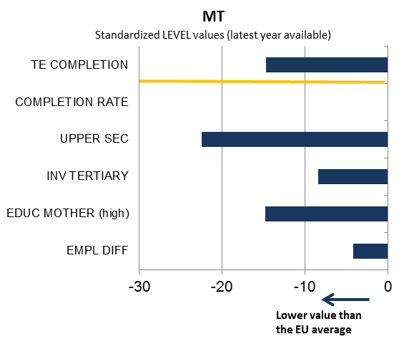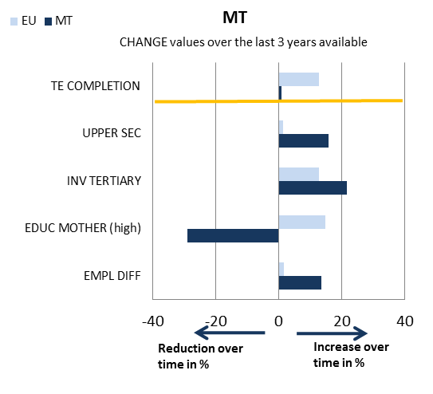

Source: JRC-CRELL

3. Key findings on benchmarks and skills levels
Concerning the Europe 2020 targets, Malta is still the poorest EU performer in terms of the rate of early school leaving (33.5% in 2011), although it showed good progress over the last five years (a 6.4 percentage point decrease), and is one of the countries with the lowest tertiary attainment rate, with no significant recent progress. The analysis of sub-indicators shows that the family background is particularly unfavourable. As regards the other ET 2020 benchmarks, participation in early childhood education decreased in recent years and is now below the EU average (89.0% as against 92.3% in 2010). In terms of basic skills, 15-year olds' performance on PISA 2009+ tests is markedly worse than the EU average in all subjects; girls tend to largely outperform boys also in mathematics. The relatively mild economic crisis experienced by Malta only had a modest impact on the employment rate of graduates, which remains among the highest in the EU (91.2% in 2011). Participation of adults in lifelong learning increased somewhat since 2006, but remains low in EU comparison (6.6% vs. 8.9% in 2011).
ICT skills of the population are close to the EU average. Figures for foreign language skills are positively influenced by the fact that English is Malta's second official language. As regards the distribution of tertiary graduates by field compared with the EU average, Malta shows a very high (and increasing) share of graduates in humanities and arts (18.9% as against 11.5% in 2010) and a still low (albeit rising) share of graduates in mathematics, science and technology (16.3% vs. 21.9%). The employment pattern in Malta up to 2020 is forecast to be characterised by a strong increase in medium qualification jobs. Public spending on education as a share of GDP is at the EU average (5.46% vs. 5.41% in 2009), but declined by more than one percentage point in 2006-2009.

4. Major policy initiatives and reforms

4.1 Initiatives and measures to increase the relevance and level of skills
A National Policy and Strategy for the Attainment of Core Competences in Primary Education has been in place since January 2009. This policy proposes an integrated approach that includes the four components of: (i) the prevention of attainment deficit in core competences through early support; (ii) the early identification of core competences attainment deficit; (iii) the integration into mainstream teaching; (iv) the intervention with respect to core competences attainment deficit in early primary education. This is done in terms of working with the whole range of stakeholders, at school and College level.
Concerning early school leaving, the Research and Development department, the National Commission for Higher Education and other stakeholders set up a working group and discussed improving data collection on early school leavers with the National Statistics Office, which has launched a survey on early school leavers with results expected in the course of 2012. In addition, the University of Malta launched a project at the beginning of 2012 to monitor disadvantaged secondary school students and the reasons why they tend not to finish their studies.
To improve the relevance of skills for the labour market, Malta is introducing vocational subjects in secondary schools, interesting career paths through vocational educational training and higher education in those sectors in demand by industry, and second-chance learning opportunities in key competences.
Overall, the various measures taken in recent years and initiatives now underway demonstrate that the government and the educational institutions are aware of the challenges of the Maltese education and training system. These policy efforts need to be maintained in order to ensure lasting results. At the same time, the issue of early school leaving still has not been fully addressed. In particular, a comprehensive system for collecting and analysing information on early school leaving to underpin targeted policy making and monitoring is not yet in place.

4.2. Initiatives and measures to stimulate open and flexible learning
Measures to stimulate open and flexible learning, especially in higher education, include the creation of the Malta Qualifications Framework and validation of non-formal and informal learning. Students over 25 years-old who lack the minimum qualifications may nevertheless take a higher education degree (through a maturity clause). To improve completion rates, the University of Malta awards a Higher Education Certificate to students who have successfully completed the first year but do not go for a full bachelor’s degree, while the Malta College of Arts, Science and Technology offers Vocational Educational Training degrees at bachelor level as an extension of short-cycle vocational degrees. The government set up a working group in 2011 to explore new possibilities for learning in higher education; the results are expected in the course of 2012. A draft Lifelong Learning Strategy was launched in July 2012 by the Directorate for Lifelong Learning (DLL), created in 2009.
Skill shortages in high value-added areas have been partly addressed by introducing flexible courses in collaboration with industry and higher education institutions, while projects funded by the European Social Fund are addressing sectoral skills needs and qualifications. In addition, a new 2012 Euro Plus Pact commitment establishes a sector skills committee, which will be responsible for examining occupational standards and validation of competences and learning outcomes in order to reduce skill gaps.
Overall, these measures appear promising; their adequate implementation will be key in ensuring positive results.
The Maltese government has invested heavily in ICT-related infrastructure and hardware in schools. Thus, all pre-primary and primary classrooms are connected to the world-wide web, with each pre-primary classroom having two desktop computers to be used by the pupils while in every primary classroom four desktop computers are to be found. As from September 2011 an interactive whiteboard has been installed in each classroom up to lower-secondary school.
Moreover an e-learning platform was established and currently all primary class teachers are being trained in its use. The platform is to provide the right medium for teachers and pupils alike to participate and collaborate with each other. Among other features it includes built-in tools, where pupils can get more personalised feedback on the level of learning they achieve from their teachers. Thus, each pupil can gauge where s/he stands in terms of learning. Another advantage would be that of providing pupils with school/class work that meets their own level of understanding. This may increase pupils’ motivation to learn since the platform will allow them to focus more on their achievement rather than on that of the class as a whole and to work on those areas that they need to improve on.
Finally, the Malta Council for Science and Technology will be building a National Centre for Interactive Science in 2013. This will serve as an educational and entertainment platform for students, parents and professionals with the objective of increasing the interest in science, engineering and technology.

4.3. Initiatives and measures to secure smart funding and developing partnerships
The government has been increasing its investment in the Malta Government Scholarship Scheme, specifically in the area of science and technology, including at postgraduate and doctoral levels. It is also providing more information and guidance on scholarships for prospective tertiary students.
Malta has started developing its partnerships between education and businesses. This is mainly being carried out at tertiary level with the creation of specialised courses as required by the multi-national companies who choose to operate from Malta. This is particularly true for the air-servicing, pharmaceutical and ICT industries. In other areas, partnerships are present but they are less formal in nature, although a considerable amount of students, especially in the areas of care and child care, are allowed to practice in private businesses. Lack of resources for SMEs to invest in partnership initiatives is one of the main problems. Moreover, educational institutions are still traditionally seen as the only places in which learning can take place and the role of workplaces in offering learning experiences is not yet sufficiently promoted.

Conclusion
Since Malta has few natural resources, economic growth is overwhelmingly dependent on the skills of its population. The country is faced with a threefold challenge: a high rate of early school leaving, a relatively modest rate of tertiary education attainment and a vocational training system in need of modernisation.
The Commission and Council in the European Semester 2012 recommended steps to combat early school leaving and to match the skills required by the labour market. The measures which are already in place against early school leaving seem to be pointing in a positive direction, while their proper implementation and the evaluation of their impact will be crucial. Concerning participation in tertiary education, the recent policy efforts need to be maintained in order to ensure lasting results and achieve the ambitious target of a 33% tertiary attainment rate by 2020. Finally, Malta has also been strengthening links with business and industry, in particular in tertiary VET, to improve effectiveness and address specific skill shortages.

Netherlands
1. Performance summary

1.1 Overview of benchmarks and skill levels

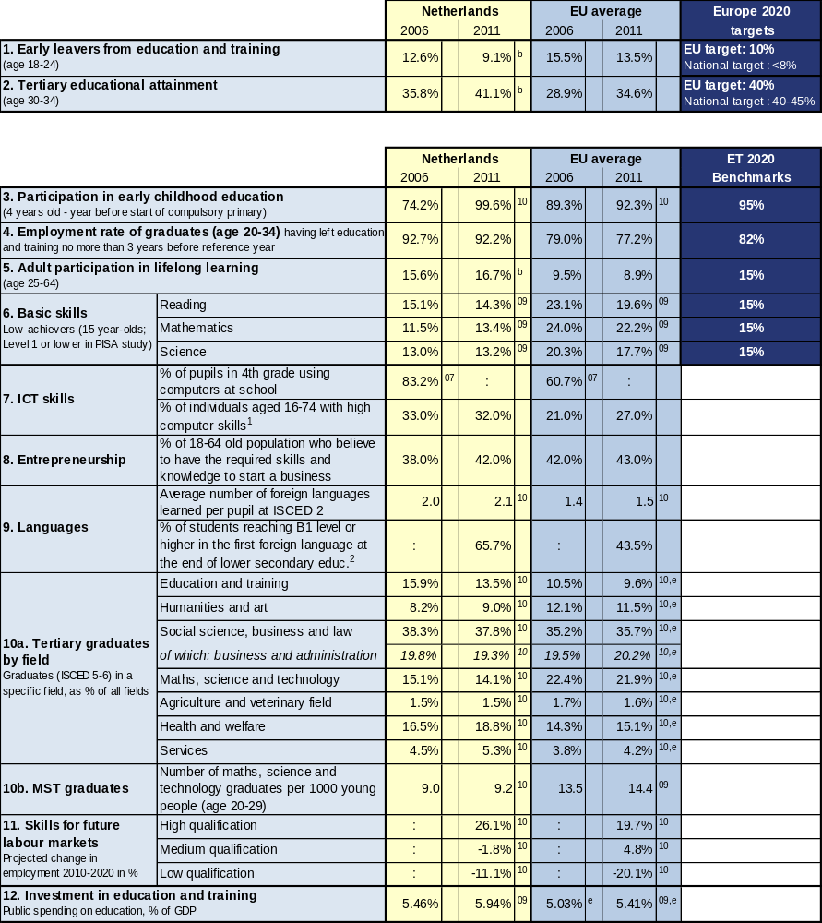

Source: Eurostat (LFS): 1, 2 CRELL (based on Eurostat LFS): 4 Global Entrepreneurship Monitor: 8
Eurostat (UOE): 3, 9a, 10, 12 OECD (PISA): 6 European Survey on Language Competences (ESLC): 9b
Eurostat (ISS): 7b Eurydice (based on IEA TIMSS): 7a Cedefop: 11

Additional notes:
⁰⁷ =2007, ⁰⁸ =2008, ⁰⁹ =2009, ¹⁰ =2010, ¹¹ =2011, e= estimate, b= break, p= provisional
Number of countries included in EU average: PISA=25, Entrepreneurship=18, Language skills=13, ICT/Computers at school=13
¹= having carried out 5-6 specific computer related activities, ²= average of skills tested in reading, listening, writing

1.2 Position in relation to Europe 2020 targets and ET2020 benchmarks
Deviation (%) from EU average and relative position to the EU benchmarks, top performers and low performers in EU27
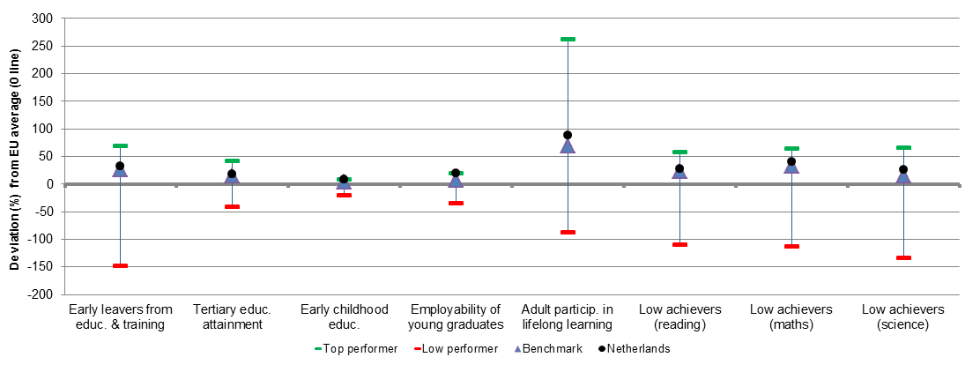
Source: DG EAC

2. Europe 2020 targets: patterns of sub-groups and sub-indicators

2.1 Early leavers from education and training

- Early school leavers of specific population sub-groups (country of birth and gender)
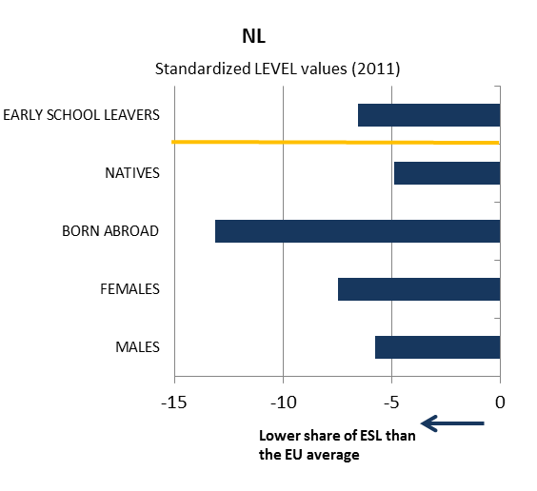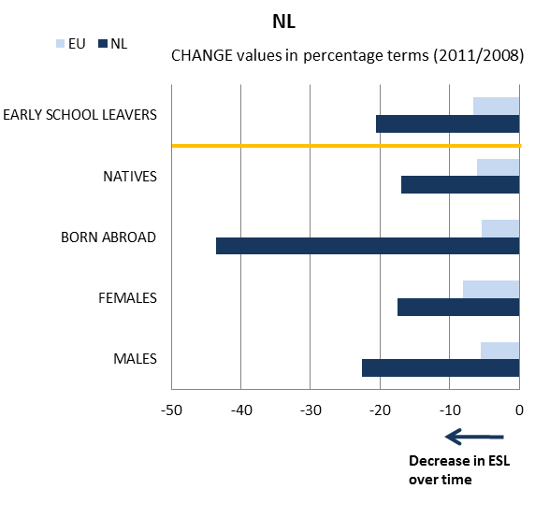

- Early school leavers and sub-indicators
(Difference in employment rate for low/medium education, low education background of the mother, investment in primary and secondary education, participation in vocational education and training [VET] and in early childhood education [ECE])
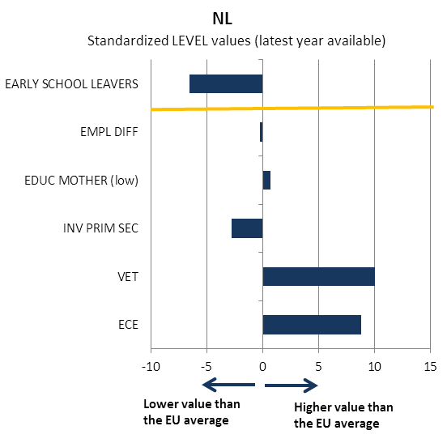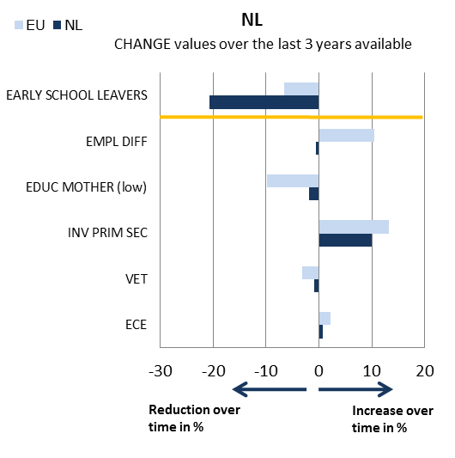
Source: JRC-CRELL

2.2 Tertiary educational attainment

- Tertiary educational attainment of specific population sub-groups (country of birth and gender)
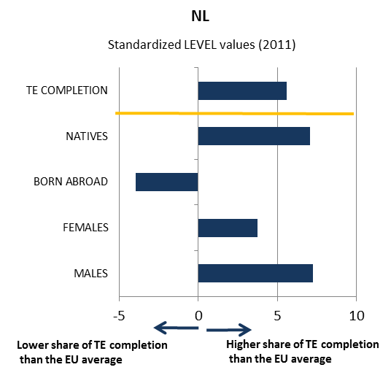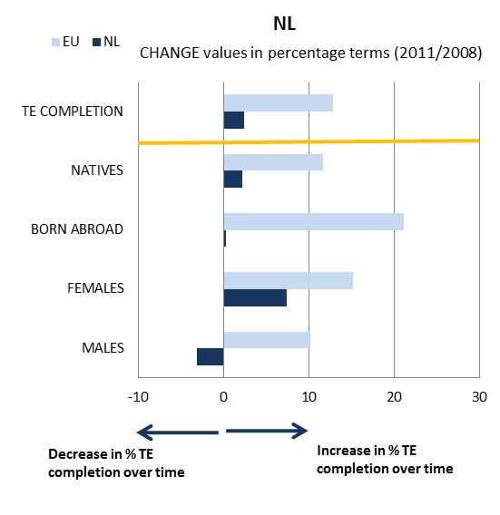

- Tertiary educational attainment and sub-indicators
(Completion rate in higher education, upper secondary educational attainment, investment in tertiary education, high education background of the mother, difference in employment rate for high/medium education)
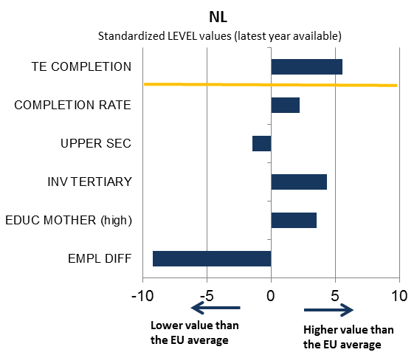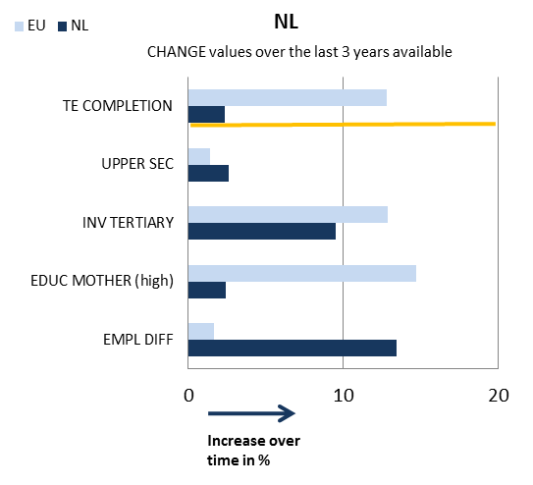

Source: JRC-CRELL

3. Key findings on benchmarks and skills levels
Concerning the Europe 2020 targets, in 2011 the Netherlands already outperformed the EU benchmarks for 2020 on both early school leaving (9.1% compared to 10%) and tertiary attainment rate (41.1% as against 40%). The Netherlands shows a very high rate of early childhood education, having made significant progress since 2006 and approaching full coverage of the target population. School education keeps producing very positive results for reading, mathematics and science as documented by PISA tests for 15 year-olds, despite a slight decline in mathematics in recent years. Language teaching starts generally at a later age in international comparison, but the average number of languages learned at ISCED 2 level (2.1) is far above the EU average (1.5). Moreover, 65.7% of pupils master the first foreign language at end of lower secondary education. The participation in lifelong learning in the Netherlands confirms the overall positive performance, being close to double that of the current EU average.
The share of population with high ICT skills is above the EU average. As regards entrepreneurship, 42% of the population believe to have the required skills and knowledge to start a business. This is the same value as in the UK and is higher than in France (38%) and Germany (37%) but lower than in Spain (51%). The number of graduates in maths, science and technology is low in EU comparison. Employment in high qualification jobs up to 2020 is expected to increase faster than the EU average, whereas a more moderate decline is forecast for jobs requiring low level qualifications. Public spending in education as a share of GDP in the Netherlands has been structurally above the EU average in the last few years (5.94% compared to 5.41% in 2009).

4. Major policy initiatives and reforms

4.1 Initiatives and measures to increase the relevance and level of skills
In February 2011, the government presented a new action plan, covering 2011–2015, for secondary vocational education (MBO), focusing on skills. Therein, the government mandates the newly-created Education-Business Alliance to develop the qualification structure. In order to reduce the drop-out rate from the 2012/2013 school year onwards, students in vocational training will be able to enrol in fields of training containing modules from different courses with related content, rather than following standard courses.
The new strategy "Quality in Diversity" for higher education/ advanced vocational education and training (VET) calls for streamlining the existing system with less but better focused study programmes, including in professional higher education. This includes a requirement for additional training of teachers.
Within the Deltaplan Bètatechniek (2004-2010) and the Masterplan Bèta en Technologie (2011-2016), the National Platform for Science & Technology has been commissioned by the government, education and business sectors to ensure availability of sufficient people with a scientific or technical educational background. It aims not only to make careers in science more appealing, but also to introduce innovation in education that inspires and challenges young people by targeting schools, universities, businesses, ministries, municipalities, regions and sectors. By 2020, it has set out, among other objectives, to increase the share of science and technology students by 15% in higher education and to ensure that 40% of all graduates hold degrees in this area by 2025. According to a 2009 evaluation, this programme has been very successful having achieved results at all levels of education as well as on the labour market and in the different regions.
The programme Improvement in Literacy and Mathematics ("Verbetertrajetecten Taal en Rekenen") aims at improving literacy and mathematics skills of young learners in primary schools through developing a specific approach. It has been in action since 2008 and reached 1831 primary schools in the school year 2010-2011. The evaluation shows the positive effects of the programme. Participating schools have indeed improved the literacy and mathematics skills of their pupils. From 2008-2009 poor performance dropped from 50% to 25%. Also scores of primary school exit exams were better for participating schools than for non- participating schools.

4.2. Initiatives and measures to stimulate open and flexible learning
A measure named Visualisation of Success, Quality agenda for secondary education 2008-2011 ("Success in Beeld, Kwaliteitsgenda voortgezet onderwijs 2008-11") aims to improve the quality and strategic positioning of secondary schools by supporting middle management to identify their own school policy, as well as the weaknesses and strengths of their own quality policy. It seeks to achieve measurable improvement in the areas of language and mathematics and to stimulate young people to develop and use their talents as much as possible, as well as to foster the notion of citizenship. Teachers should be supported to make their own professional choices. Finally the quality of exams ensuring specific knowledge will be improved whilst at the same time safeguarding minimum quality standards in each school.
The Action Plan Teacher 2020 aims at keeping and upgrading the quality of teaching by creating positive career prospects, increasing the educational level of teachers, requiring ideally a master degree and fostering self-commitment of teachers to constantly update their knowledge as well as by structurally introducing peer reviews. Concrete agreements have been established for 2012-2015 including, among others, scholarships for teachers and for promotion purposes.
The Netherlands has a national ICT strategy covering areas such as e-Government, infrastructure and broadband connectivity, ICT Security, e-Learning and ICT in schools, but no overarching strategy for ICT and education.
One of the initiatives was to establish Kennisnet, a public educational organisation creating a platform to support and inspire Dutch primary, secondary and vocational institutions in the effective use of ICT, notably by informing them of the opportunities offered by ICT. The approach is based on balanced and coherent use of four building blocks: vision, expertise, digital learning materials and ICT infrastructure. Kennisnet aims at removing barriers for and between schools and at encouraging interaction within the educational sector.

4.3. Initiatives and measures to secure smart funding and developing partnerships
The Action Plan secondary education "Focus on craftsmanship" ("Focus op vakmanshap 2011-2015) seeks to provide good quality initial vocational education for young people and making vocational education competitive compared with general education. This should be achieved through simplifying the vocational and adult education system, more teaching time by better qualified teachers, better structured exams within the context of a reduced number of qualifications and education and training programmes. Education Networks Enterprise 2009 provides subsidies supporting initiatives to implement entrepreneurship education in partnership with primary, secondary schools, vocational education and local business. Jet-Net Youth and Technology Network Netherlands reached a critical number of actors comprised of national and international companies, representatives of relevant ministries, trade organisations and the national Science and Technology Platform. They aim to assist secondary schools to better understand the role and the attractiveness of industry and technology and cover up to a third of the upper secondary general (HAVO) and pre-university (WVO) schools.
Since 2008 long term agreements with universities and with institutions of professional higher education have been concluded to combat the high dropout rate and generally increase the quality of education. Since 2012, 7% of the budget allocated to the tertiary education sector will be distributed based on performance related to prior agreed targets.

Conclusion
Overall, the education and training system of the Netherlands performs rather positively. The Netherlands outperforms the EU average as regards early school leaving and tertiary attainment rates, as well as students' achievement in basic skills (literacy, numeracy and science). At all levels of education there is room for improvement with regard to the quality of education focusing more on results and on the professionalisation of teachers. Current reforms, therefore, target overall the improvement of the quality of the education system instead of concentrating on quantity. However, a mismatch between labour market needs and the skills obtained in the Dutch education system, in particular in the VET sector, persists. Other areas of concern relate to drop outs and persistently long graduation time in higher education. Current reforms are intended to create institutions with a clearer profile, better structured and targeted courses and more favourable teacher-student ratios. At the same time, in the context of growth-friendly fiscal consolidation there is a need for preserving expenditure in education and training while increasing its efficiency.

Poland
1. Performance summary

1.1 Overview of benchmarks and skill levels

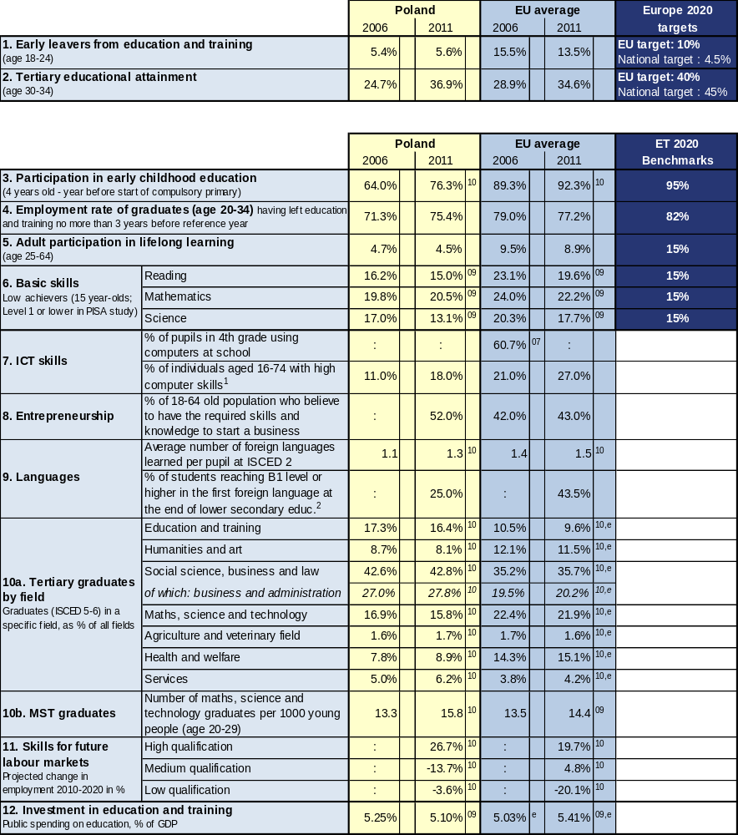

Source: Eurostat (LFS): 1, 2 CRELL (based on Eurostat LFS): 4 Global Entrepreneurship Monitor: 8
Eurostat (UOE): 3, 9a, 10, 12 OECD (PISA): 6 European Survey on Language Competences (ESLC): 9b
Eurostat (ISS): 7b Eurydice (based on IEA TIMSS): 7a Cedefop: 11

Additional notes:
⁰⁷ =2007, ⁰⁸ =2008, ⁰⁹ =2009, ¹⁰ =2010, ¹¹ =2011, e= estimate, b= break, p= provisional
Number of countries included in EU average: PISA=25, Entrepreneurship=18, Language skills=13, ICT/Computers at school=13
¹= having carried out 5-6 specific computer related activities, ²= average of skills tested in reading, listening, writing

1.2 Position in relation to Europe 2020 targets and ET2020 benchmarks
Deviation (%) from EU average and relative position to the EU benchmarks, top performers and low performers in EU27
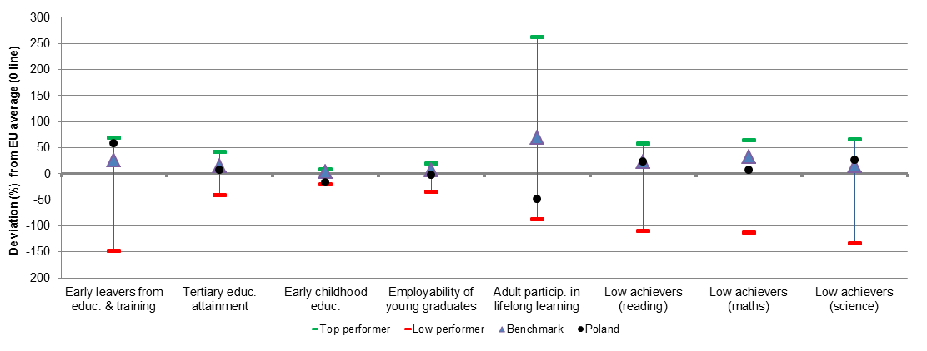
Source: DG EAC

2. Europe 2020 targets: patterns of sub-groups and sub-indicators

2.1 Early leavers from education and training

- Early school leavers of specific population sub-groups (country of birth and gender)
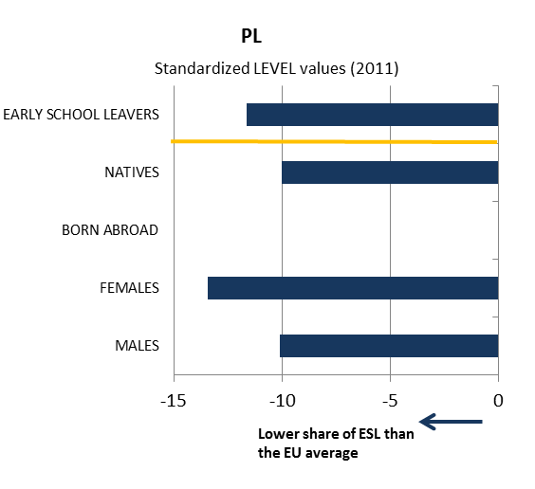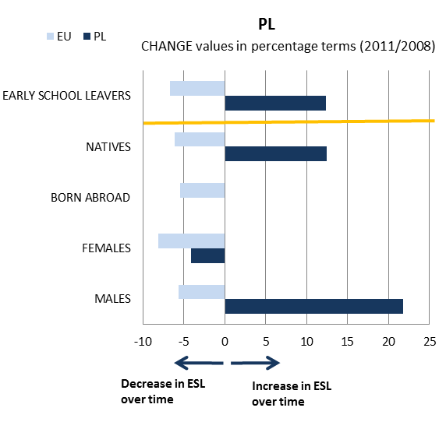
- Early school leavers and sub-indicators
(Difference in employment rate for low/medium education, low education background of the mother, investment in primary and secondary education, participation in vocational education and training [VET] and in early childhood education [ECE])
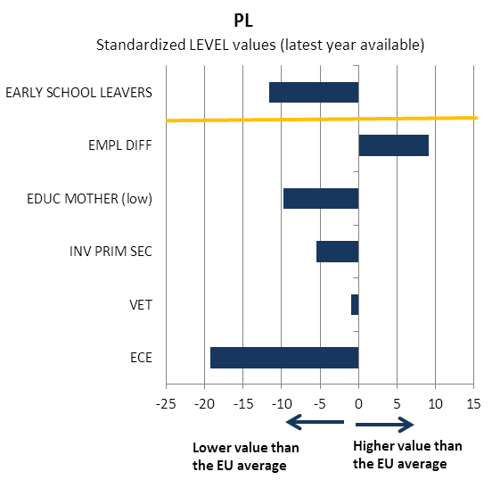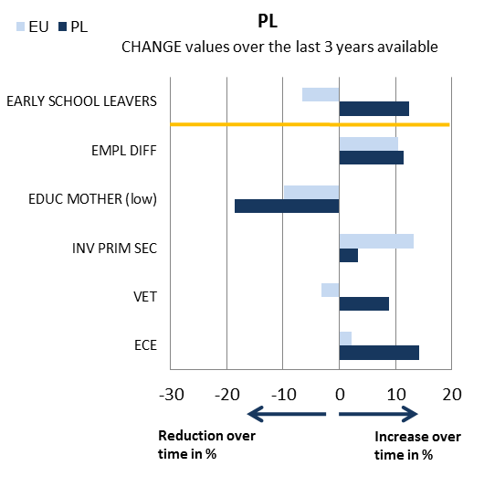

Source: JRC-CRELL

2.2 Tertiary educational attainment

- Tertiary educational attainment of specific population sub-groups (country of birth and gender)
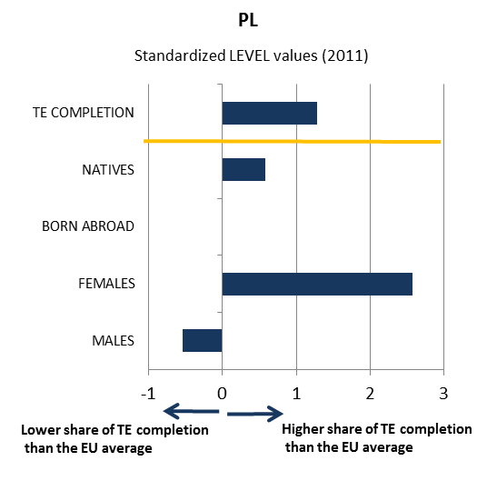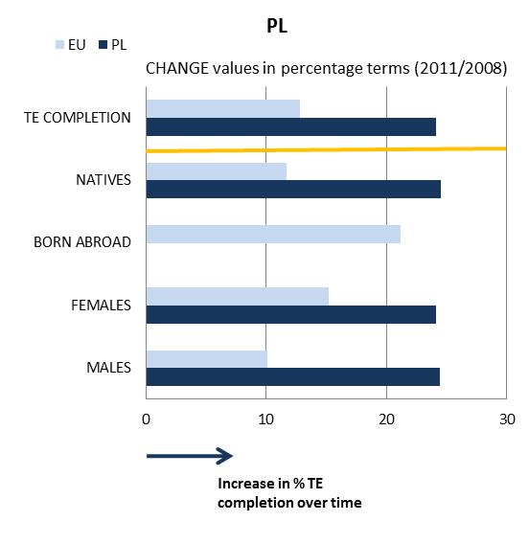

- Tertiary educational attainment and sub-indicators
(Completion rate in higher education, upper secondary educational attainment, investment in tertiary education, high education background of the mother, difference in employment rate for high/medium education)
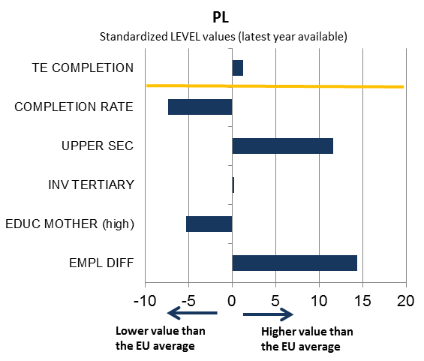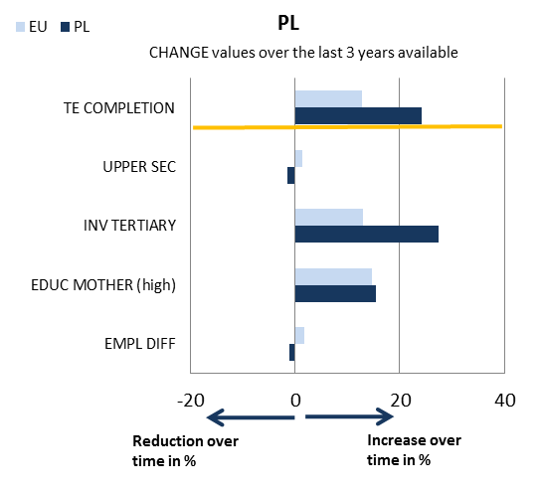

Source: JRC-CRELL

3. Key findings on benchmarks and skills levels
Concerning the Europe 2020 targets, Poland is one of the best performers in the EU regarding early school leaving, with a rate of 5.6% vs. the EU average of 13.5% in 2011. The rate of tertiary education attainment strongly increased over the last decade and was 36.9% in 2011, slightly above the EU average of 34.6%.
As regards the ET 2020 benchmarks, participation in early childhood education is one of the lowest among the EU Member States (76.3 % against the EU average of 92.3 % in 2011), despite a steady increase since 2000. In terms of basic skills, 15-year olds' performance on PISA tests continues to outperform the EU average, while improving in particular in science. The employment rate of graduates has increased by 4.3 percentage points since 2006 and remains slightly below the EU average (75.4% vs. 77.2% in 2011). The participation of adults in lifelong learning has decreased in recent years and remains low in EU comparison (4.5% vs. 8.9% in 2011).
ICT skills of the population are low in comparison with the EU average. Concerning the distribution of tertiary graduates by field compared with the EU average, Poland shows a high share of graduates in social science, business and law and in education and training, and a low share of graduates in science, mathematics and technology and in health and welfare. As regards entrepreneurship, the share of the population believing to have the required skills and knowledge to start a business is higher than the EU average. Foreign language learning remains an issue with a performance below EU average both for students and the adult population. The employment pattern in Poland up to 2020 is forecast to be fairly different from the EU average, with a stronger decrease in medium qualification jobs than in low qualification ones.
The level of public spending on education has remained stable since 2000 and is relatively close to the EU average, at 5.10 % versus EU average of 5.41 % in 2009.

4. Major policy initiatives and reforms

4.1 Initiatives and measures to increase the relevance and level of skills
Three fundamental reforms of the national education system are being implemented in Poland, in general, vocational and higher education respectively.
The goal of the reforms is to address both the mismatch of skills with the needs of the labour market and the adaptation of the Polish education system to the challenges of the knowledge-based economy - changing demographics and social and economic factors, such as the growing need for mathematics, science and technology (MST) as well as engineering graduates.
Organisational and curricular changes have been introduced in order to overcome the current negative trend in mathematics education. In 2010 Poland introduced a compulsory mathematics exam in the matura (exit national examination for upper secondary education). This stemmed from a desire to improve the level of mathematics teaching and to better prepare secondary vocational school graduates to study in the fields of science and technology, which should translate into increased numbers of tertiary or equivalent education students in technical fields. Starting from September 2012, the new core curricula for secondary vocational schools will also be introduced.
In the case of general education, new core curricula are also in the process of implementation.

4.2. Initiatives and measures to stimulate open and flexible learning
To improve the permeability between educational sectors and the flexibility of learning pathways, Poland has decided to undertake a programme called "Vocational School as a Favourable Selection"(2010-12). Although growing interest in the choice of vocational schools by graduates of lower secondary schools has been observed in recent years, the percentage of students continuing their education in general upper secondary schools is rather constant and fluctuates around 44% of the cohort. At the same time, labour market projections for 2020 indicate a constant demand for well-trained technical staff and, in some cases, even sizable temporary increases of this demand in some sectors (e.g. the construction sector). The objective of the programme is to increase the attractiveness of vocational schools, in order to steer the interest of lower secondary school graduates to continue their education in vocational schools of all types. The programme also aims at strengthening and promoting the cooperation between vocational school and employers. This initiative is co-financed by the ESF through the National Operational Programme "Human Capital".
The implementation at national level of the principles of European cooperation developed in the areas of EQF, EQARF, ECVET and EUROPASS will also contribute to reducing barriers to learning mobility.
Poland is implementing the "Distance Learning Project" (2009-14), whose beneficiaries are employees, teaching staff and educational institutions. Its aims are to promote, disseminate and implement a distance learning system in educational institutions, to provide high quality services in the distance education system through the development of standards for designing and conducting on-line courses, and to improve the competence of educational institutions staff in implementing and using distance learning solutions. Its main outcomes are a diagnosis of distance education in Poland and in selected European Union countries (2009), an evaluation of learning needs of teachers and students in the field of distance learning (2010) and the development of a model for implementation and dissemination of distance learning in Poland (2012). The project also comprises the creation of a dedicated web portal for institutions implementing distance learning, including a repository of knowledge for the implementation and dissemination of distance education (2013) and the development of multimedia e-learning courses for selected modular units, and courses for teachers and students (2014). This is particularly important for students in rural and remote areas of the country and happens in conjunction with the rolling-out of internet broadband connection of the Eastern part of Poland thanks to financing from EU Structural Funds. The project itself is co-financed by the ESF.
In 2012, 3,500 Polish primary schools (27% of all potential applicant schools) applied for inclusion in the “Digital School” piloting project. To support the process, the Ministry of National Education has invested heavily in the project and funds are earmarked for hardware, software, interactive boards and multimedia teaching aids. EU Structural Funds are also used in this case e.g. for equipping schools with computers and modern ICT equipment.

4.3. Initiatives and measures to secure smart funding and developing partnerships
In Poland the cooperation between schools, vocational education and training institutions, higher education institutions and external actors (industry, NGO’s, professional organisations etc.) is traditionally quite limited.
Current reforms of the education system aim at changing this status through the integration of educational institutions with the labour market actors. For instance, the on-going higher education reform is intended to encourage universities to provide more flexible, higher-quality curricula, which would reduce the skills mismatch by involving employers in the education process and by strengthening university-business links, in order to ensure an appropriate range of fields of studies that meet the needs of the job market.
In addition, the on-going works on the Polish Qualification Framework (NQF), to be referenced to the EQF in 2012, and the ECVET system, are designed to ensure greater flexibility and openness of the education system.

Conclusion
The future national strategy called Lifelong Learning Perspective (2012-20) and its accompanying Action Plan represent significant progress towards developing a comprehensive approach to lifelong learning, including the provision of skills in the future. This initiative is set to be adopted in the course of 2012 and could play a key role in fostering human capital development and constitute a guiding principle for all Polish sectoral economic strategies.
In 2012–13 Poland is starting to modernise its vocational training system. This should enable an increase in the provision of apprenticeship places and to promote dedicated vocational training aimed at developing the necessary skills of the older and the unskilled workforce.
Poland is also implementing a new higher education reform, in force since 2011, intended to reduce skills mismatches, in line with the 2011 European Semester recommendation, by introducing a novel approach based on learning outcomes, which is consistent with the objectives of the European Qualifications Framework (EQF).
In the future one of the major challenges for Poland will remain the provision of a skills response which is better adapted to the needs of the labour market, given in particular a high unemployment rate among young people, including higher education graduates. In this respect Poland will have to invest, in particular, in the development of future skills forecasting and effective mechanisms for reducing existing skills mismatches.

Portugal
1. Performance summary

1.1 Overview of benchmarks and skill levels

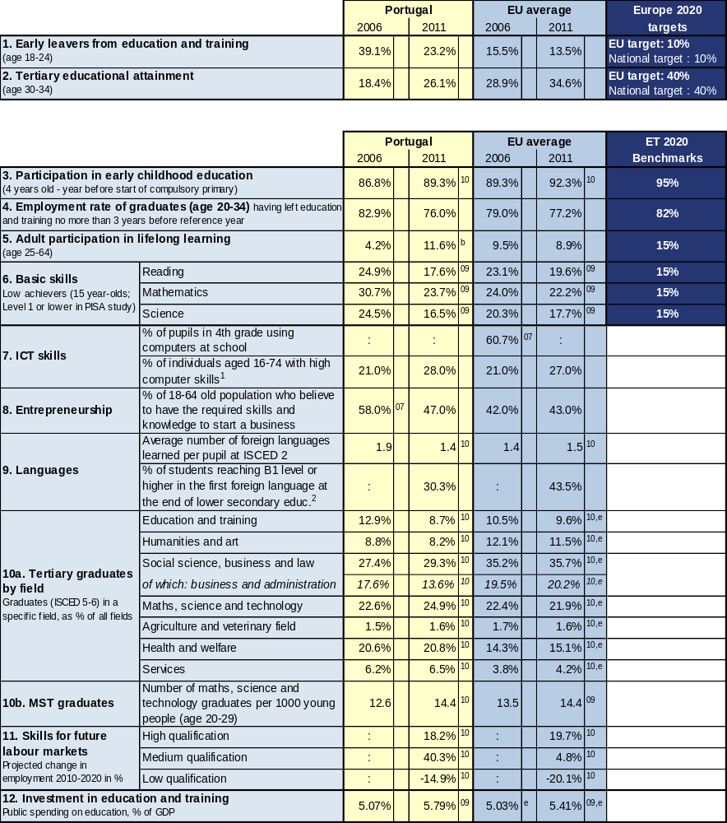

Source: Eurostat (LFS): 1, 2 CRELL (based on Eurostat LFS): 4 Global Entrepreneurship Monitor: 8
Eurostat (UOE): 3, 9a, 10, 12 OECD (PISA): 6 European Survey on Language Competences (ESLC): 9b
Eurostat (ISS): 7b Eurydice (based on IEA TIMSS): 7a Cedefop: 11

Additional notes:
⁰⁷ =2007, ⁰⁸ =2008, ⁰⁹ =2009, ¹⁰ =2010, ¹¹ =2011, e= estimate, b= break, p= provisional
Number of countries included in EU average: PISA=25, Entrepreneurship=18, Language skills=13, ICT/Computers at school=13
¹= having carried out 5-6 specific computer related activities, ²= average of skills tested in reading, listening, writing

1.2 Position in relation to Europe 2020 targets and ET2020 benchmarks
Deviation (%) from EU average and relative position to the EU benchmarks, top performers and low performers in EU27
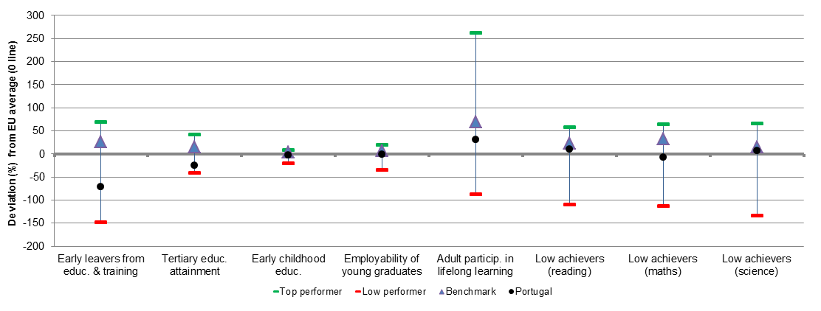
Source: DG EAC

2. Europe 2020 targets: patterns of sub-groups and sub-indicators

2.1 Early leavers from education and training

- Early school leavers of specific population sub-groups (country of birth and gender)
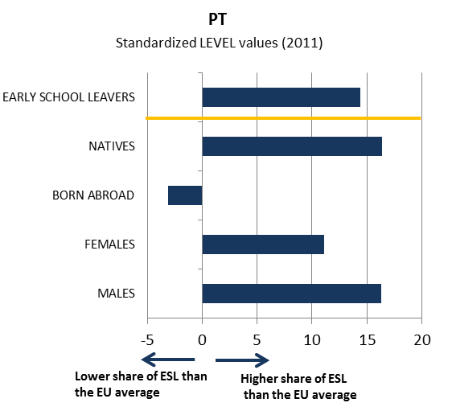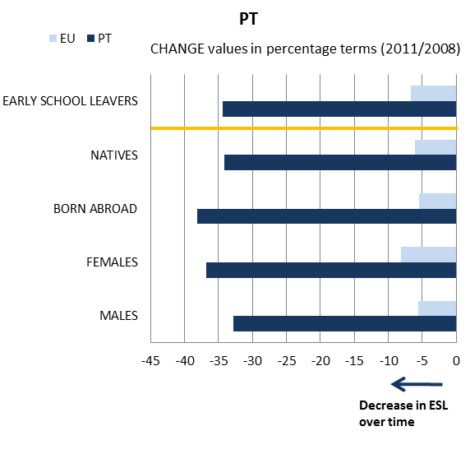

- Early school leavers and sub-indicators
(Difference in employment rate for low/medium education, low education background of the mother, investment in primary and secondary education, participation in vocational education and training [VET] and in early childhood education [ECE])
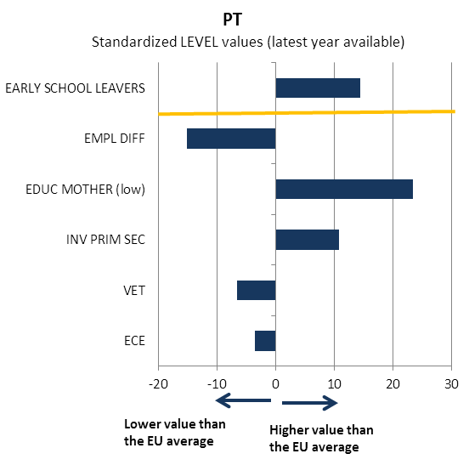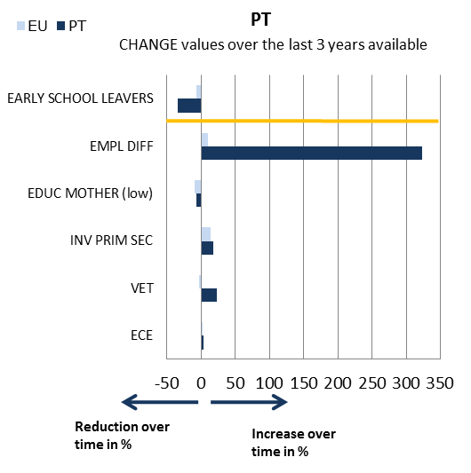
Source: JRC-CRELL

2.2 Tertiary educational attainment

- Tertiary educational attainment of specific population sub-groups (country of birth and gender)
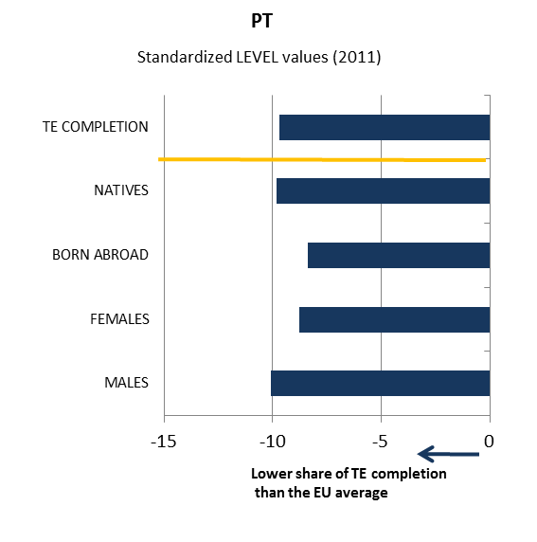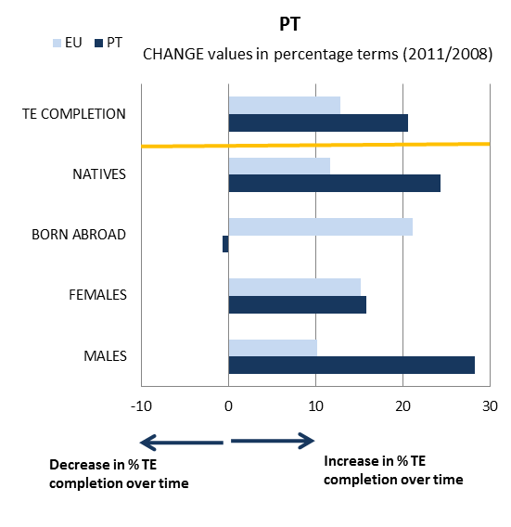

- Tertiary educational attainment and sub-indicators
(Completion rate in higher education, upper secondary educational attainment, investment in tertiary education, high education background of the mother, difference in employment rate for high/medium education)
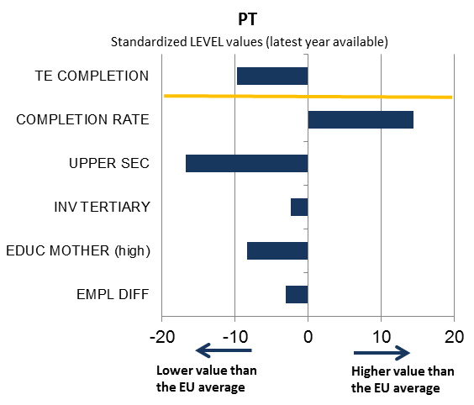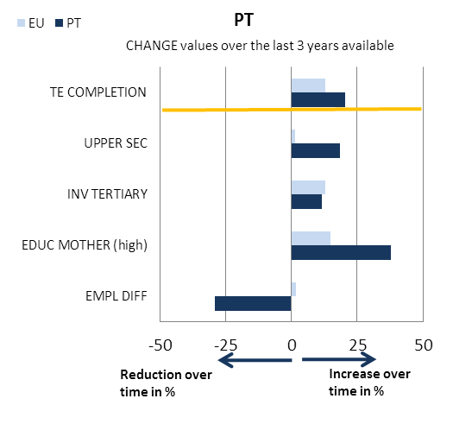

Source: JRC-CRELL

3. Key findings on benchmarks and skills levels
Concerning the Europe 2020 targets, Portugal performs below the EU average in the area of early school leaving (ESL) (23.2% vs. 13.5% in 2011) although its performance has improved significantly during the period 2006-2011 (39.1% in 2006). The examination of sub-indicators reveals that the family background of the 18-24 years old cohorts is particularly unfavourable. Portugal has also made significant progress in tertiary educational attainment; even if the share of tertiary graduates is still below the EU average (26.1% vs. 34.6%), it has practically doubled since 2006 (18.4%). As regards the other ET 2020 benchmarks, participation in early childhood education is below the EU average (89.3% vs. 92.3% in 2010). In terms of basic skills, 15-year olds' performance on PISA tests has evolved positively in the last decade. While in the PISA 2000 and 2006 surveys the percentage of low achievers was significantly higher than the EU average in all three areas assessed, in 2009 that percentage for reading and science literacy was already lower than the EU average. Only in mathematics did Portugal fail to perform better the EU average, despite the significant progress achieved. The employment rate of graduates has decreased since 2006 from the level of the ET 2020 target to slightly below EU average. Participation of adults in lifelong learning is above the EU average (11.6% vs. 8.9% in 2011); this significant progress over the past 5 years should, however, be interpreted with some caution, following a break in the series.
ICT skills have progressed and are consistently above EU average, while perception of entrepreneurship skills has declined but remains higher than the EU average. In what concerns the distribution of tertiary graduates by field compared with the EU average, Portugal shows a high share of graduates in engineering, manufacturing and construction (18.3% against 12.3% in 2010) and in health and welfare (20.8% against 15.2% in 2010), and a low share of graduates in science, mathematics and computing (6.5% against 9.1% in 2010) but remains above EU average (even if decreasing since 2008) in percentage of graduates in mathematics, science and technology per 1000 of the population aged 20-29 (14.4% against 12.5% in 2010). Finally, Portugal performs below EU average in percentage of students reaching B1 level or higher in the first foreign language at the end of lower secondary education (30.3% vs. 43.5%). Employment in high qualified jobs in Portugal up to 2020 is forecast to increase somewhat less than the EU average, while in medium qualified jobs a stronger increase is expected. Employment in low qualified jobs should decrease less than EU average. On investment in education as % of GDP, Portugal performed slightly above EU average from 2000 (5.42%) to 2007 (5.10%); while in 2008 the share decreased to 4.89%, it was up at 5.79% in 2009.

4. Major policy initiatives and reforms

4.1 Initiatives and measures to increase the relevance and level of skills
In 2010/2011, the government has started implementing a curricular reform with the aim to strengthen teaching and learning of the following subjects: Portuguese, foreign languages, mathematics, and natural and social sciences. It introduces significant changes in the curricular structure of the 2nd and 3rd cycles of basic and secondary education, reducing curricular dispersion, reinforcing the teaching of the above subjects and defining for each of them and for each cycle a set of learning outcomes and their development by grade. External assessment and monitoring of the learning process is ensured through the introduction of nationally standardised tests and examinations in more grades and subjects.
Several previously launched initiatives continue to be supported, like the national reading literacy strategy (Plano Nacional de Leitura), focusing on the development of reading and writing skills, and the Action Plan for Mathematics to improve mathematics skills of primary and basic level students and under which the following aspects were developed during the 2011/2012 school year: generalisation of the mathematics curriculum, development of a database of educational resources for mathematics, the assessment of mathematics textbooks, and the development of schools' projects for the improvement of mathematics learning from 1st to 9th grades. To address low achievement, the government implements the 'Programme for more Success in School' (Programa Mais Sucesso Escolar) supporting the implementation of alternative school and curriculum management models through four year contracts with a view to increase students' success rates mainly in Portuguese, mathematics and English.
The government has also initiated a major restructuring of the VET system including a review of current VET offers and curricula to eliminate overlaps and to adapt them to future labour market needs; the creation of professional schools of reference in economic sectors relevant to employment creation and in partnership with private stakeholders; the development of incentives for companies to create openings for on the job training and apprenticeships and the implementation of a network of vocational centres aimed at providing education and training guidance to both youngsters and adults and at liaising with companies at local level.
In order to fight youth unemployment, the programme 'Youth Impulse' (Impulso Jovem) has recently been launched and supports a number of on the job training activities such as the 'Passport for jobs' six-month internships in companies, nationally or internationally, in social-economy institutions, in youth and sports associations, in agricultural exploitations and in public sector bodies. Finally, the programme 'Stimulus 2012' (Estímulo 2012) aims at promoting the return to the labour market of the unemployed through support to companies hiring and providing adequate training to those with higher employability difficulties.

4.2. Initiatives and measures to stimulate open and flexible learning
A major step in the modernisation of the Portuguese education and training system was the development of the National Qualifications System from 2007 onwards. It is composed of the National Agency for Qualification, the National Council for Vocational Training, Sectoral Councils for Qualification and entities delivering certified training. Its main instruments are the National Qualifications Catalogue, providing a repository of all market relevant training courses and permanently updated in association with stakeholders, the National Qualifications Framework referenced to the European Qualifications Framework and the System for Recognition, Validation and Certification of non-formal and informal competences. Its main aims include strengthening integration between the general and the professional education and training offer; building certification mechanisms into the system for school and professional competences acquired in informal and non-formal ways and promoting the relevance, certification and recognition of the education and training offer; facilitating the qualification of lifelong learning, promoting flexibility of the offer by organising it into short modular units that can be independently certificated and credited and building up the oversight and quality control mechanisms for the education and training pathways in the National Qualifications System.
Also Portugal's renewed and more diversified framework for higher education has been opened to new layers of society. Between 2005 and 2009, the number of higher education graduates increased by about 20%. The on-going measures which are expected to contribute to attain the national Europe 2020 target set for tertiary attainment include the extension of compulsory education until the age of 18, the Confidence Contract signed in 2010 by the government and all public universities, polytechnics and higher education institutions, the increase in the number of students enrolled in technical specialisation courses, the extension of the distance learning supply network, and the increased diversification of 3rd cycle courses in cooperation with the private sector.
The Technological Plan for Education 2007-2010 aimed at reinforcing the role of information and communication technologies (ICT) as basic tools for teaching and learning and at promoting educational success among students. The present national strategy on the use of ICT in education relies on the infrastructure (high-speed broadband, Internet access in classrooms) and equipment (desktop computers, video projectors and interactive whiteboards) deployed in schools in the last few years. The strategy is steered by the Educational Resources and Technology Unit of the Ministry of Education and includes initiatives covering curricula and extra-curricular activities, distance collaboration, digital learning resources, e-safety, curriculum integration, dissemination and continuing professional development. Particularly noteworthy is the Schools Portal educational repository, which holds about 1800 learning resources uploaded in their majority by teachers, and its catalogue of education blogs which provides a source of information for sharing best practice with regard to the use of blogs as educational tools and services.

4.3. Initiatives and measures to secure smart funding and developing partnerships
The education system faces the significant challenge of seeking to sustain and improve current performance levels while undergoing a substantial budget reduction due to the implementation of the economic and financial assistance programme under the Memorandum of Understanding signed with the European Commission, the IMF and the ECB. It can be estimated that from 2010 to 2011, expenditure by the Ministry of Education (excluding higher education) fell 11.2%.
Curriculum restructuring, re-organisation of the school network and improvement in human resources management are some of the areas where efficiency gains could be obtained. As 90% of the current educational expenditure is concentrated in staff costs, flexibility to reduce expenditure is very limited. Therefore, achieving an effective school network is of extreme importance. A possible path is linking funding to performance.

Conclusion
Although Portugal still performs below or close to the EU average in several of the most important indicators, including ESL and tertiary attainment, its progress in recent years has been quite significant and consistent, including the investment in expanding and diversifying training opportunities to low qualified adults under the framework of the modernisation of the National Qualifications System. The challenge it faces is, however, extremely difficult as it should continue to improve organisational effectiveness and increase performance while maintaining or, even, reducing funding. The main priorities should continue to be: the improvement of young students' basic skills, foreign language learning and transversal subjects such as entrepreneurship; the reduction of early school leaving; the restructuring of secondary education including the reorganisation of the schools network and the restructuring of VET; and, finally, the improvement of the qualifications level of the adult population under a coherent lifelong learning strategy. In this context, it is fundamental that Portugal takes the best advantage possible of the opportunities provided by the next structural funds programming phase for the modernisation of the education and training system.
Romania
1. Performance summary

1.1 Overview of benchmarks and skill levels

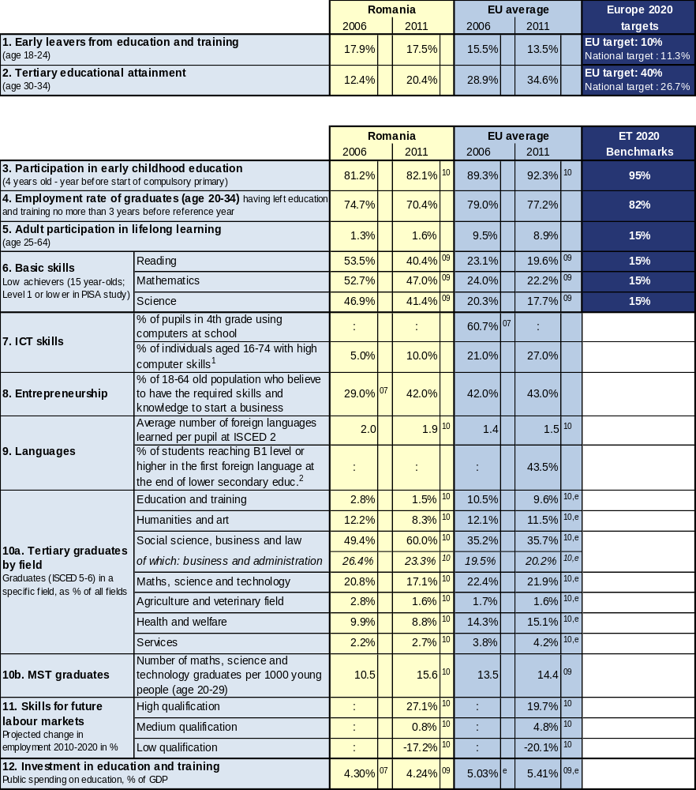

Source: Eurostat (LFS): 1, 2 CRELL (based on Eurostat LFS): 4 Global Entrepreneurship Monitor: 8
Eurostat (UOE): 3, 9a, 10, 12 OECD (PISA): 6 European Survey on Language Competences (ESLC): 9b
Eurostat (ISS): 7b Eurydice (based on IEA TIMSS): 7a Cedefop: 11

Additional notes:
⁰⁷ =2007, ⁰⁸ =2008, ⁰⁹ =2009, ¹⁰ =2010, ¹¹ =2011, e= estimate, b= break, p= provisional
Number of countries included in EU average: PISA=25, Entrepreneurship=18, Language skills=13, ICT/Computers at school=13
¹= having carried out 5-6 specific computer related activities, ²= average of skills tested in reading, listening, writing

1.2 Position in relation to Europe 2020 targets and ET2020 benchmarks
Deviation (%) from EU average and relative position to the EU benchmarks, top performers and low performers in EU27
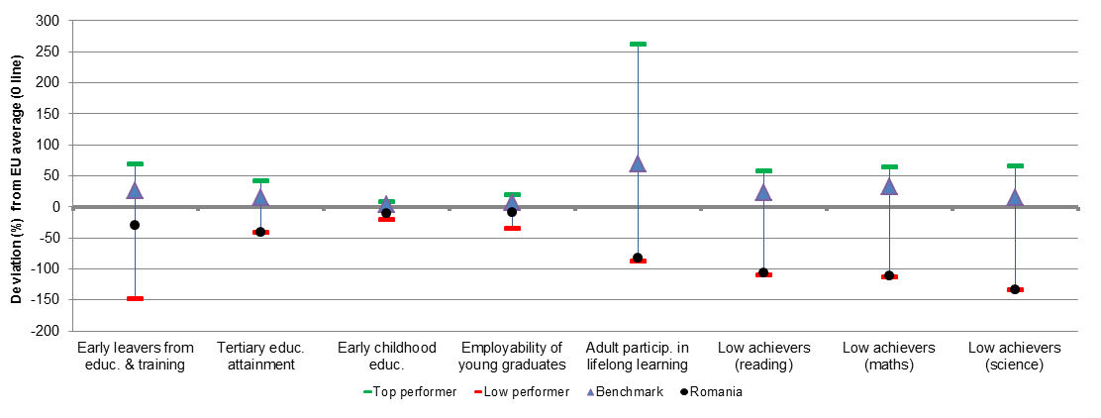
Source: DG EAC

2. Europe 2020 targets: patterns of sub-groups and sub-indicators

2.1 Early leavers from education and training

- Early school leavers of specific population sub-groups (country of birth and gender)
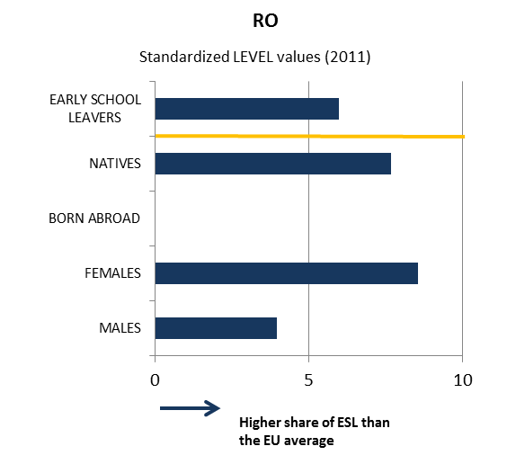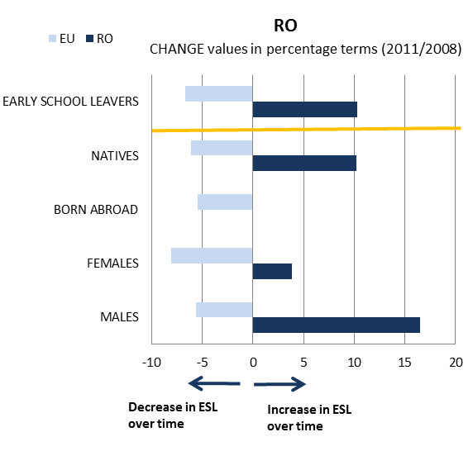

- Early school leavers and sub-indicators
(Difference in employment rate for low/medium education, low education background of the mother, investment in primary and secondary education, participation in vocational education and training [VET] and in early childhood education [ECE])
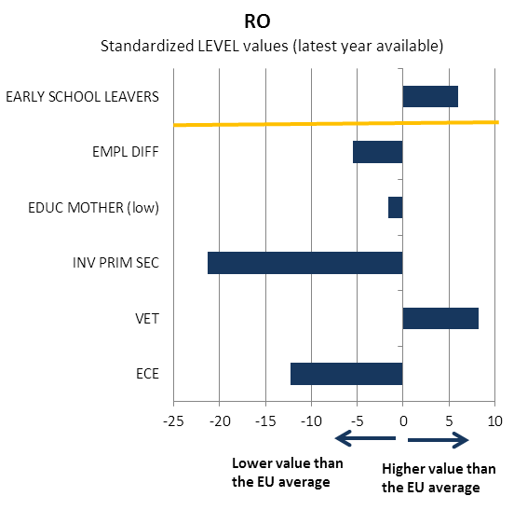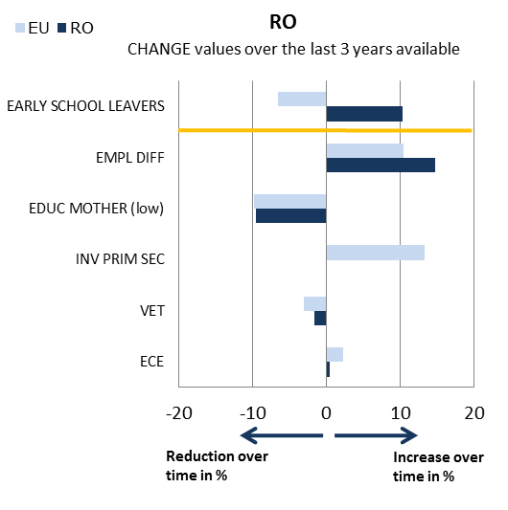
Source: JRC-CRELL

2.2 Tertiary educational attainment

- Tertiary educational attainment of specific population sub-groups (country of birth and gender)
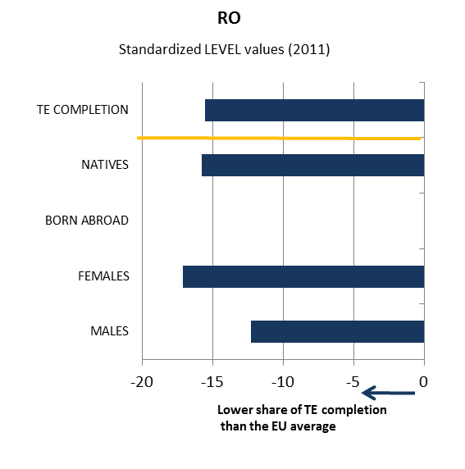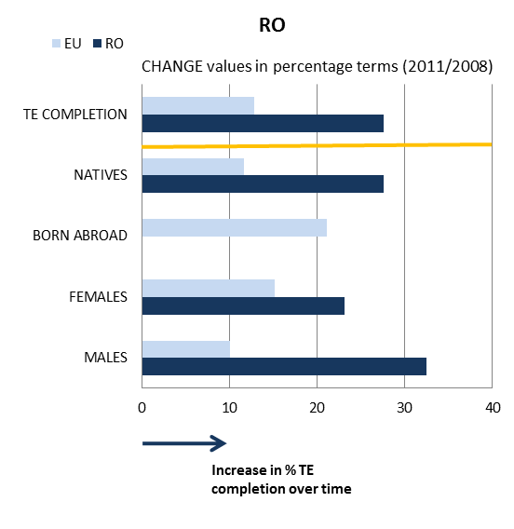

- Tertiary educational attainment and sub-indicators
(Completion rate in higher education, upper secondary educational attainment, investment in tertiary education, high education background of the mother, difference in employment rate for high/medium education)
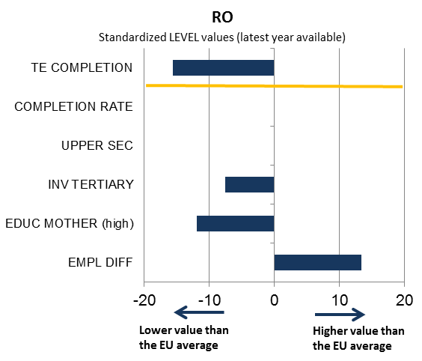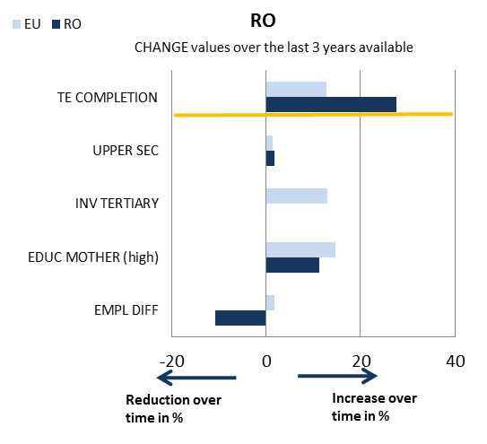

Source: JRC-CRELL

3. Key findings on benchmarks and skills levels
Romania performs below the EU average in both Europe 2020 headline indicators. The early school leaving rate (17.5% in 2011) is well above both the EU average (13.5%) and the 10% EU benchmark. Tertiary or equivalent attainment rate (20.4% in 2011) is over 14 percentage points below the EU average (34.6%), despite some rapid progress over the past 5 years. As regards the other ET 2020 benchmarks, participation in early childhood education (82.1% in 2010) is far below the EU average. Romania is among the worst performers in the EU on basic skills. More than two out of five 15 year-olds do not have adequate levels in reading, maths and science to equip them for adult life. Nevertheless, the latest PISA survey shows fast improvement in reducing low achievement. The employment rate of graduates has further decreased during the economic crisis and is well below the EU average (70.4% vs. 77.2%). There is also a significant mismatch between the education offer of universities and the labour market needs and this is also visible in the unemployment rates which are particularly high among young university graduates. For the age group 20-24, 29.4% of tertiary graduates were unemployed in 2011 compared to 22.9% of secondary graduates. Over-qualification representing 39.8% of job mismatches is widespread. Adult participation in lifelong learning remains stagnant at very low levels (1.6% in 2011), registering a significant gap compared to EU27 average (8.9%). Participation rates are particularly low among low skilled adults. Only 0.3% of adults with less than upper secondary education participated in education and training in 2011, compared to 3.6% of adults with tertiary education.
ICT skills of adults are low. Concerning the distribution of tertiary graduates by field compared with the EU average, Romania has a very high (and increasing) share of graduates in social science, business and law, as well as a low share of graduates in education and training and in health and welfare. As regards entrepreneurship, the share of the population believing to have the required skills and knowledge to start a business is close to the EU average. According to CEDEFOP skill forecasts, Romania will register a deficit of medium and high level skills in 2020. A particularly difficult challenge is lower achievement and higher early school leaving in rural areas. As regards investment in education, Romania has the lowest share of GDP allocated to education in the EU (2009 data). The education sector at all levels was hit particularly hard by the economic crisis.

4. Major policy initiatives and reforms

4.1 Initiatives and measures to increase the relevance and level of skills
The new education act adopted in January 2011 is a major reform of the education system at all levels. An on-going reform of the curriculum, in accordance with the new education act adopted in January 2011, aims to reinforce basic and transversal skills, aligning the curriculum to European key competences. In order to develop evidence on student performance, Romania intends to develop and implement national summative tests in 3rd, 6th and 9th grades. The law introduces a unitary system of early childhood education and care (0-6 years), curriculum-based, under the authority of the Ministry of Education, with specific educational requirements for staff (university education required for teachers at ages 3-6). A compulsory preparatory class for 6 year olds has been established in primary schools in September 2012. A reformed vocational education and training path, with a stronger work related practical dimension started in September 2012.
Building on a strong tradition in the teaching of foreign languages, the new education law strengthens the compulsory teaching of two foreign languages. The baccalaureate examination will include the compulsory examination of two foreign languages. Romania is one of the few EU countries in which entrepreneurship is taught as a compulsory subject in secondary education. A large number of programmes aim to stimulate entrepreneurship education, notably a programme for simulated training firms, with take-up in one thousand VET schools.
The on-going higher education reform aims at strengthening quality in higher education. It overhauls the management of higher education institutions and raises requirements for the organisation of masters and doctoral courses. A new university ranking published in 2011 is a first step towards more strategic use of funding in supporting quality.
A number of programmes financed by the European Social Fund support the changes in early childhood education and care, in curriculum, assessment and teacher education. A new programme launched in the spring of 2012 aims to train teachers in the use of assessment and in implementing national standardised assessments.
Implementing a large package of reforms needs both broad political support and extensive consultation with stakeholders. The envisaged decentralisation of the education system would also require a strategic, long term implementation commitment from all political actors. Administrative capacity in education policymaking, both in central and in decentralised structures, is uneven and remains a major challenge. There is very limited use of evidence based policymaking, little data for monitoring the quality of education and such data is not used for informing policymaking.

4.2. Initiatives and measures to stimulate open and flexible learning
The new education law reforms initial teacher education, introducing two-year pedagogical master degrees. Implementation is still in early phases. Teachers will also have a compulsory one year induction in the profession. A structure for quality assurance of continuing professional development of teachers has been set up. There has been good progress in developing a variety of continuing professional development opportunities for teachers. A number of structural funds programmes target updating the competences of teachers, including vocational teachers or aim to strengthen the school guidance network, seriously affected by the consequences of the economic crisis.
Regarding flexible pathways, the new education law reforms the structure of vocational education, allowing more permeability and flexibility between vocational, technical and academic tracks. The new law also explicitly encourages the participation of non-traditional learners in tertiary education and supports the recognition of prior learning. Romania has not adopted yet a lifelong learning strategy. Romania continues progress towards the National Qualifications Framework, and plans to revise the Occupations Classification. Many legal provisions are still to be implemented, as secondary regulation has not yet been adopted.
There has been progress in establishing an accreditation system for adult education and a number of programmes in this area have been financed from the structural funds. The second chance schools could be further supported in order to reach the low skilled. Further incentives for employers engaging in continuing vocational training and closer integration with active labour market policies are needed for scaling up participation, particularly for low skilled adults.
Romania has invested considerable effort in upgrading the material basis for ICT in schools and the broadband connections of schools. A compulsory digital competence certification is part of the Baccalaureate Examination. The role of ICT competences in the secondary curriculum has been strengthened. A number of portals for teachers allow the sharing of teacher developed educational materials. Nevertheless, a restrictive policy on official textbooks and a prescriptive curriculum act as barriers to teachers’ development of their own teaching materials.
Several on-going programmes use digital resources for the continuing professional development of teachers. While the course modules are quality assured, their effectiveness compared to other forms of provision is unclear.
In higher education, there has also been a significant rise in distance and online provision.

4.3. Initiatives and measures to secure smart funding and developing partnerships
Romania has introduced a number of measures aiming to increase private investment in education. The new education act opens the possibility to publicly fund privately organised education in early childhood and compulsory education.
The state funds a limited share of tuition fees in higher education, based on merit, while a large number of students pay tuition fees. There are a large number of private higher education institutions, contributing to the rapidly rising graduation rates. Nevertheless, the national ranking of universities classified these institutions as belonging to the lowest quality category.
A system of skills councils exists at regional and local level, aimed at increasing the relevance of vocational education and training. There are a limited number of partnerships between industry and higher education institutions.

Conclusion
Romania faces a major challenge in raising the quality of education and training. Current performance on basic skills is very low at school level and there is no data on the level of basic skills of the adult population. Quality issues and skills mismatches with labour market demand affect a large share of vocational and tertiary education.
The new education law adopted in 2011 is a major reform of the entire education system, setting a long term agenda for upgrading the quality of education at all levels. Implementation needs to be continued, based on a broad political consensus and on an effort to build up administrative capacity and evidence-based policymaking at both central and local level.
The main challenge in increasing the supply of skills remains the underfinancing of the sector. While Romania faces some of the most serious problems in skills supply in the EU and is currently implementing one of the most ambitious reform agendas, the budget allocated to education is the lowest in the EU.
Sweden
1. Performance summary

1.1 Overview of benchmarks and skill levels

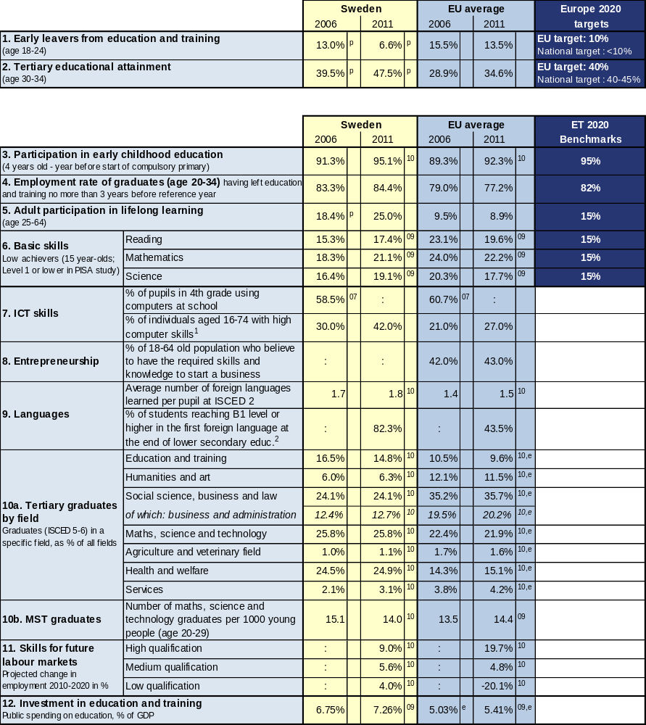

Source: Eurostat (LFS): 1, 2 CRELL (based on Eurostat LFS): 4 Global Entrepreneurship Monitor: 8
Eurostat (UOE): 3, 9a, 10, 12 OECD (PISA): 6 European Survey on Language Competences (ESLC): 9b
Eurostat (ISS): 7b Eurydice (based on IEA TIMSS): 7a Cedefop: 11

Additional notes:
⁰⁷ =2007, ⁰⁸ =2008, ⁰⁹ =2009, ¹⁰ =2010, ¹¹ =2011, e= estimate, b= break, p= provisional
Number of countries included in EU average: PISA=25, Entrepreneurship=18, Language skills=13, ICT/Computers at school=13
¹= having carried out 5-6 specific computer related activities, ²= average of skills tested in reading, listening, writing

1.2 Position in relation to Europe 2020 targets and ET2020 benchmarks
Deviation (%) from EU average and relative position to the EU benchmarks, top performers and low performers in EU27
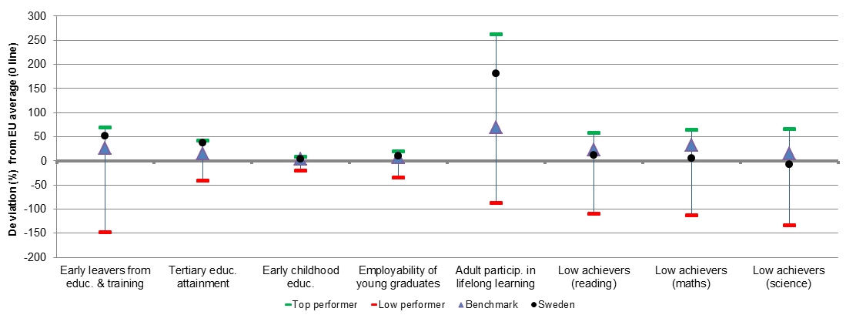
Source: DG EAC

2. Europe 2020 targets: patterns of sub-groups and sub-indicators

2.1 Early leavers from education and training

- Early school leavers of specific population sub-groups (country of birth and gender)
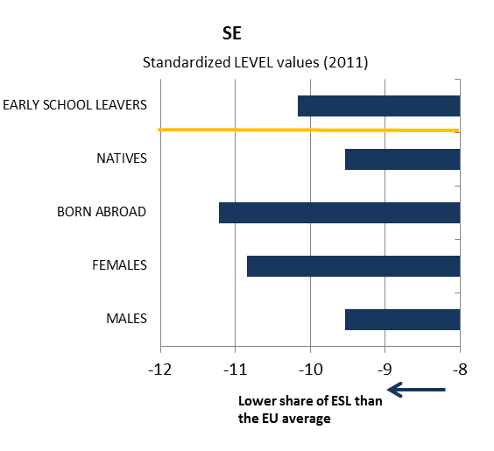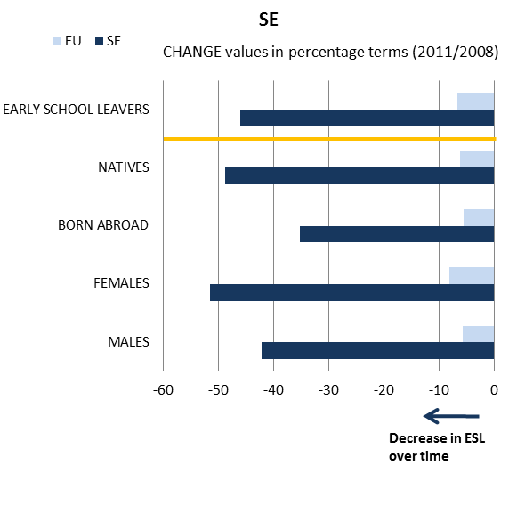

- Early school leavers and sub-indicators
(Difference in employment rate for low/medium education, low education background of the mother, investment in primary and secondary education, participation in vocational education and training [VET] and in early childhood education [ECE])
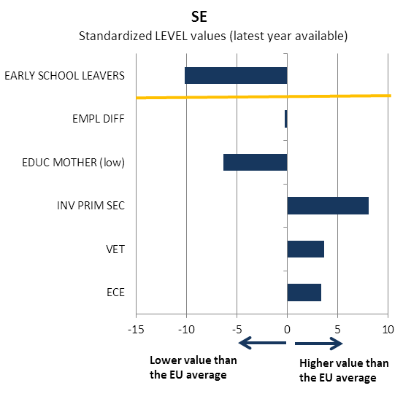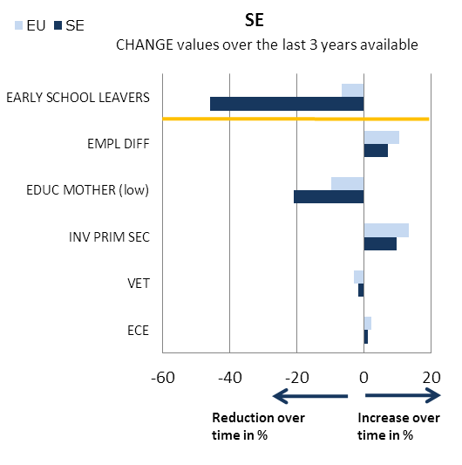
Source: JRC-CRELL

2.2 Tertiary educational attainment

- Tertiary educational attainment of specific population sub-groups (country of birth and gender)
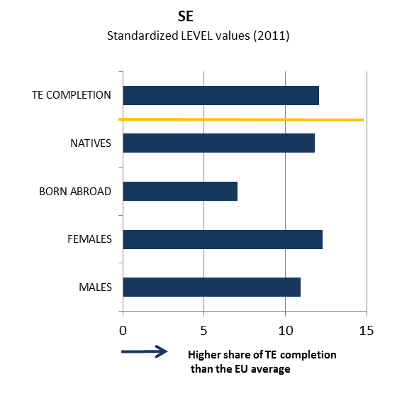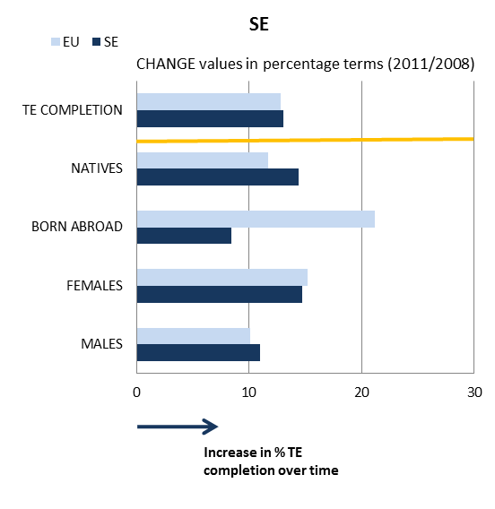

- Tertiary educational attainment and sub-indicators
(Completion rate in higher education, upper secondary educational attainment, investment in tertiary education, high education background of the mother, difference in employment rate for high/medium education)
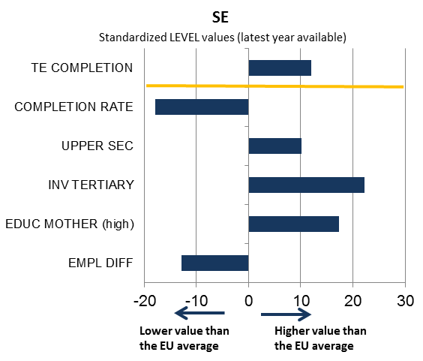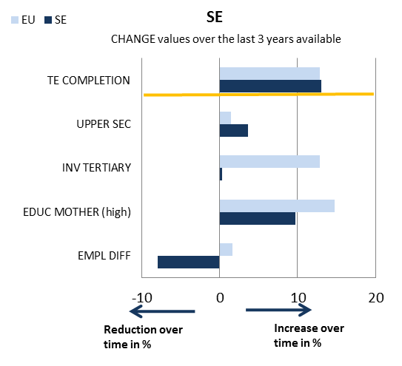

Source: JRC-CRELL

3. Key findings on benchmarks and skills levels
Sweden outperforms the EU average for both Europe 2020 headline indicators. The early school leaving rate (6.6% vs. 13.5% in 2011) is well below the 10% EU benchmark and continued to decrease over the past 5 years. Tertiary or equivalent attainment rate (47.5% vs. 34.6% in 2011) is at all-time heights and is over 10 percentage points higher than the EU average. The analysis of sub-indicators shows high investment in education, favourable family backgrounds, better participation and/or completion patterns in early childhood education and VET, as well as in upper secondary education. As regards the other ET 2020 benchmarks, participation in early childhood education is above the EU average and is just above the 95% EU target set for 2020. In terms of basic skills, 15-year olds' performance in PISA tests worsened between 2006 and 2009 in all three areas, nevertheless Sweden still performed better than the EU average in reading and in mathematics in 2009. There is however a significant gender gap in reading, with 24.2% of boys being low-achievers compared to 10.5% of girls. The employment rate of graduates remained stable despite the economic crisis and is well above the EU average (84.4% vs. 77.2% in 2011). The rate has even increased by over 1 percentage point since 2006. The traditionally high adult participation in lifelong learning further increased in the last 5 years and is over 16 percentage points higher than the EU average (25% vs. 8.9% in 2011).
ICT skills of the adult population are far above the EU average. In EU comparison, Sweden has a very high share of graduates in health and welfare (24.9% as against 15.1% in 2010) and a rather low share of graduates in social science, business and law (24.1 vs. 35.7%). Foreign language learning starts in primary education, all primary school pupils (100%) learn English as a first foreign language. Figures indicate excellent English language skills; Sweden is only outperformed by Malta where English is the country's second official language. Sweden's employment pattern up to 2020 is forecast to be fairly different from the EU average in high and low qualification jobs, with a modest increase in both, while the increase in medium qualification jobs is close to the EU average. Public spending on education in Sweden is above the EU average (7.26% vs. 5.41% of GDP in 2009). Among the EU Member States, only Denmark and Cyprus allocate a higher share of GDP to education.

4. Major policy initiatives and reforms

4.1 Initiatives and measures to increase the relevance and level of skills
The declining performance of pupils in international surveys such as PISA, PIRLS and TIMSS, paired with the growing number of adults with low basic skills, have called for extensive reforms in Sweden.
On 1 July 2011, the new Education Act came into force, introducing a wide range of measures at all levels of the education system, including pre-primary, primary, secondary, upper secondary and adult education. The Act introduces new curricula for schools and for early childhood education and it foresees more national tests of basic skills in schools. One important innovation of the Act is granting special support to pupils who run the risk of not reaching the achievement targets set. The Act also increases the power of school authorities, headmasters and teachers, including in identifying the pupils in need of special support and in designing the programme of action. In this vein, the majority of schools have teachers specialised in supporting pupils in reading literacy. In addition, to improve pupils' basic skills, a new programme for strengthening mathematics education, natural sciences and technology was introduced in the 2012 budget. In upper secondary education, the reform aims at ensuring that more pupils leave upper secondary school with pass grades and improving pupils' skills both for the labour market and further studies. To this end, the vocational track has been further differentiated and the apprenticeship system has been introduced as an alternative route to attain a Vocational Diploma.
Sweden continues to modernise its higher education, by introducing a new quality evaluation system, consolidating the quality assurance system and by introducing from 2013 quality based resource allocation for higher education institutions. The recently established higher vocational education programmes at post-secondary level have high demand, and high insertion rates for graduates on the labour market.

4.2. Initiatives and measures to stimulate open and flexible learning
With regard to flexible pathways, the reformed upper secondary education brings in higher levels of differentiated pathways, with greater curriculum differentiation between the academic, vocational and apprenticeship tracks. Vocational programmes are also advised and supported by tripartite National and Local Programme Councils, which also track successful graduates. While the majority of vocational programmes in the new upper secondary system no longer provide automatic entry to higher education, graduates from vocational programmes are entitled to further education in upper secondary schools or in municipal adult education in order to gain access to higher education institutions.
The National Agency for Higher Vocational Education (NAHVE), established in 2009, monitors the standards of vocational programmes. It also collects information about skills needs and ensures that higher vocational education programmes are aligned with labour market needs.
The continuing lack of attractiveness of the teaching profession remains an important bottleneck to increasing the quality of education in Sweden. To raise the status of the teaching profession and to strengthen the competence of teachers, the Government currently implements the reform of initial teacher education. The new teacher education programme, which came into force as part of the Education Act in 2011, puts more emphasis on in-depth subject studies and imposes tougher requirements for being qualified to teach particular subjects. Furthermore, additional resources are being made available for continuing professional development of teachers, under the so-called 'Boost for Teachers' initiative, and measures are implemented for ensuring more progression in the teaching career and moving towards a clear enforcement of a qualifications framework for teachers.
In the area of ICT, Sweden implements a major strategic reform "ICT for Everyone – A Digital Agenda for Sweden". The aim of the programme is to group all on-going activities in a horizontal, comprehensive strategy to make the most of the opportunities offered by digitalisation both to the individuals and businesses. Regarding education, under a specific chapter of the "Digital Agenda", called "A National Broadband Strategy", the objective is that on completing primary and lower secondary education, every pupil is able to use ICT tools for knowledge-seeking, communication and learning.
To this end, in the new school curriculum ICT skills are taught cross-curricular and the core content of a number of subjects, including history, social science, mathematics and natural science require the use of ICT. The National Agency for Education (Skolverket) implements a number of projects supporting the integration of ICT both in the teaching and in the new curricula: i. "ICT in the school" spreads knowledge across schools about the use and design of digital learning tools; ii. "Check-out the Source" provides day-to-day support to teachers on information retrieval, copyright and secure internet usage whereby raising teachers' digital competences; iii. teachers and headmasters receive continuing professional development in ICT in 200 communities. The Swedish government made considerable funding available for these activities and the National Agency for Education also monitors the project outcomes in terms of teachers' use of ICT and ICT skills obtained in the education system.

4.3. Initiatives and measures to secure smart funding and developing partnerships
Sweden has a long tradition of promoting the redistributive role of the state, social inclusion and equality, underpinned by high levels of taxation and public spending. However, there is an on-going debate on how to establish funding mechanisms in education that improve the efficiency and quality of the provision. Expert opinion is divided on whether the introduction of so-called "independent schools" in 1992 has enhanced educational achievement or in these privately-run, publicly funded schools, profit takes precedence over quality.
A further challenge the system faces is an increased decentralisation over the past decade. While it is the Ministry for Education that sets the framework for education at all levels i.e. key objectives and the curriculum are defined in the Education Act, local municipalities are responsible for providing and operating schools. Within this framework, schools and teachers are free to select teaching methods and materials.
Establishing partnerships in vocational education and training has been long overdue. In 2008 the OECD recommended that a National Commission for VET is established, composed of different government ministries and the social partners. Currently, social partners play a significant role in VET for adults through joint business-labour occupation advisory committees (yrkesråd) and they also oversee the certification of most VET occupations at sectoral level.

Conclusion
Sweden faces the challenge of skills supply. Due to demographic changes, the number of people retiring exceeds the number of young people entering the labour market. Until now, Sweden has addressed this challenge using its rather flexible wage-setting system and providing incentives also via the tax system for inactive or unemployed people to return to full-time or part-time employment.
Nevertheless, the challenge of low labour market integration of young people and immigrants remains important. Labour market participation of these groups is often hampered by their lack of skills needed at the Swedish labour market.
To address this challenge, the Swedish government embarked on a comprehensive reform of the education system in 2010. The New Education Act, which replaces the Act from 1985, has introduced reforms which are both relevant and ambitious. It is however too early to assess if the policy responses offered by the Act will be successful and deliver the intended results. While the implementation of the measures will need to be closely monitored, it should also be borne in mind that the increased decentralisation of the Swedish education system makes it more challenging to implement comprehensive national strategies on the ground.

Slovenia
1. Performance summary

1.1 Overview of benchmarks and skill levels

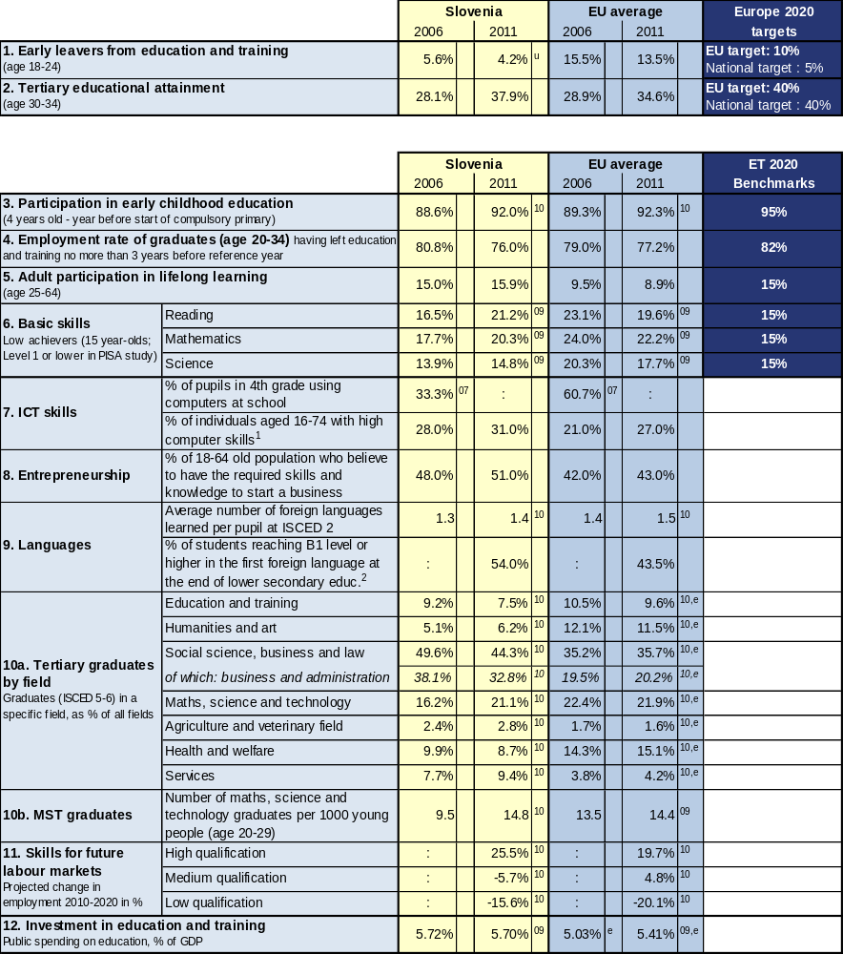

Source: Eurostat (LFS): 1, 2 CRELL (based on Eurostat LFS): 4 Global Entrepreneurship Monitor: 8
Eurostat (UOE): 3, 9a, 10, 12 OECD (PISA): 6 European Survey on Language Competences (ESLC): 9b
Eurostat (ISS): 7b Eurydice (based on IEA TIMSS): 7a Cedefop: 11

Additional notes:
⁰⁷ =2007, ⁰⁸ =2008, ⁰⁹ =2009, ¹⁰ =2010, ¹¹ =2011, e= estimate, b= break, p= provisional
Number of countries included in EU average: PISA=25, Entrepreneurship=18, Language skills=13, ICT/Computers at school=13
¹= having carried out 5-6 specific computer related activities, ²= average of skills tested in reading, listening, writing

1.2 Position in relation to Europe 2020 targets and ET2020 benchmarks
Deviation (%) from EU average and relative position to the EU benchmarks, top performers and low performers in EU27
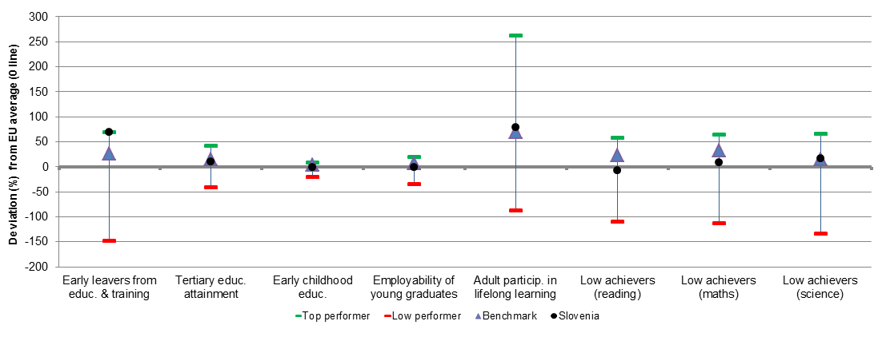
Source: DG EAC

2. Europe 2020 targets: patterns of sub-groups and sub-indicators

2.1 Early leavers from education and training

- Early school leavers of specific population sub-groups (country of birth and gender)
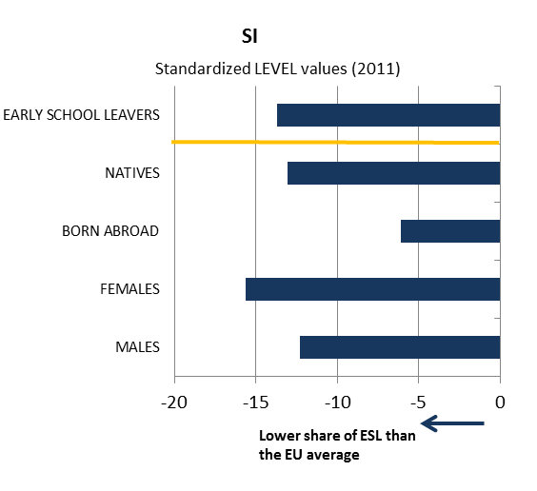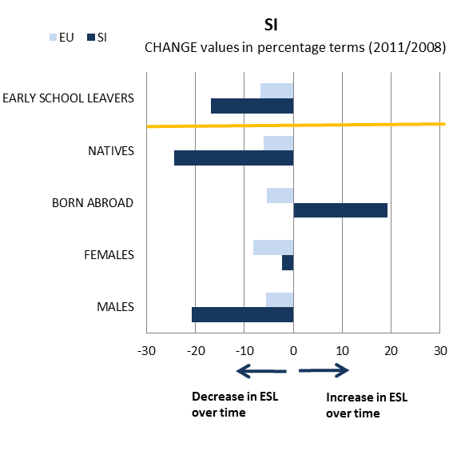

- Early school leavers and sub-indicators
(Difference in employment rate for low/medium education, low education background of the mother, investment in primary and secondary education, participation in vocational education and training [VET] and in early childhood education [ECE])
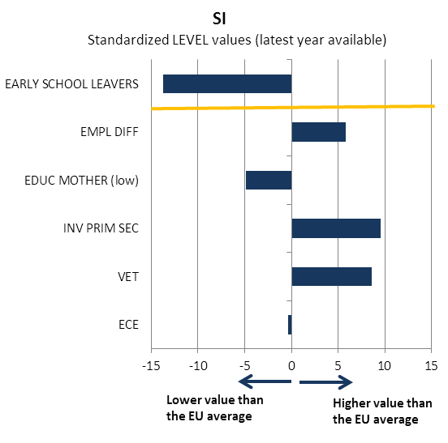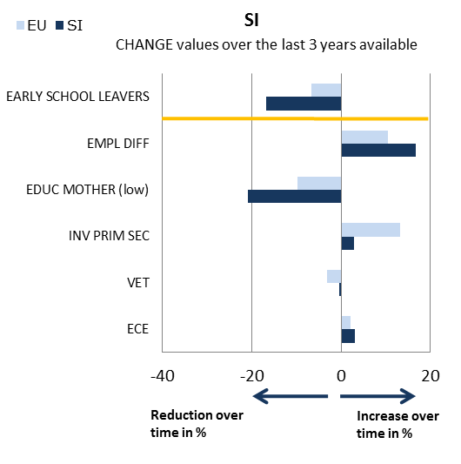
Source: JRC-CRELL

2.2 Tertiary educational attainment

- Tertiary educational attainment of specific population sub-groups (country of birth and gender)
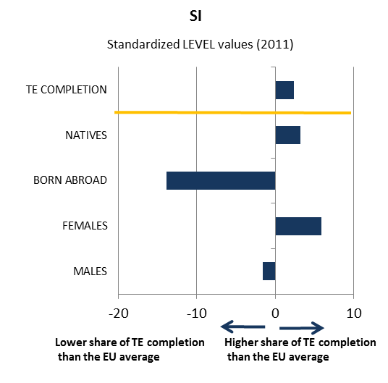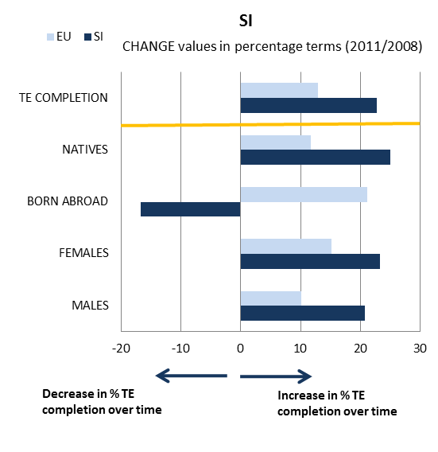

- Tertiary educational attainment and sub-indicators
(Completion rate in higher education, upper secondary educational attainment, investment in tertiary education, high education background of the mother, difference in employment rate for high/medium education)
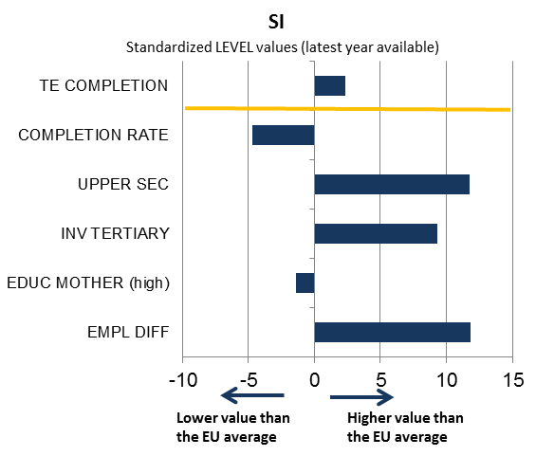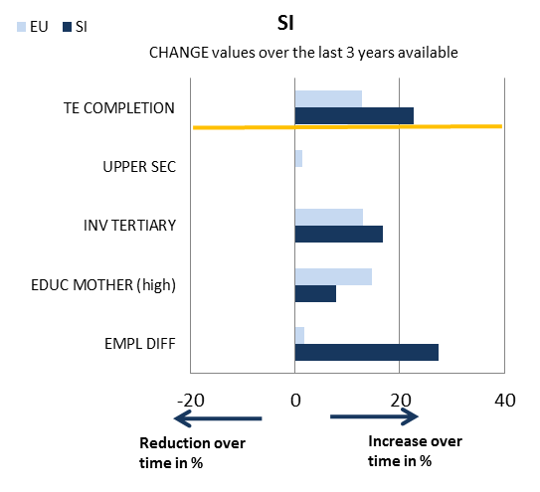

Source: JRC-CRELL

3. Key findings on benchmarks and skills levels
Concerning the Europe 2020 targets, Slovenia strongly outperforms the EU average in terms of early school leaving (ESL) (4.2% compared to the EU average of 13.5% in 2011). In the past 3 years (2008-2011), the country has made progress towards reducing the ESL rate except for the sub-group of born abroad. As far as tertiary attainment is concerned, Slovenia (37.9%) is above the EU average of 34.6% but has not yet reached the Europa 2020 benchmark and its national 2020 target of 40%. As regards the other ET 2020 benchmarks, participation in early childhood education is close to the EU average (92% in 2010). While the performance of school education worsened in the last years, Slovenia still outperforms the EU average, with the exception of reading. Whilst the share of 15 year-old low achievers in mathematics and science is respectively 2 and 3 percentage points lower than the EU average, in reading it is 1.5 percentage points higher. Girls perform better than boys in reading and science. The employment rate of graduates (76%) is a little lower than the EU average (77.2%) and declined by close to 5 percentage points in the last 5 years due to the economic crisis. Adult participation in lifelong learning (15.9% in 2011) is nearly double that of the EU average (8.9%) and has already surpassed the ET 2020 benchmark.
ICT skills of the adult population are above the EU average. In EU comparison, Slovenia has a high (although declining) share of graduates in social science, business and law (44.3% vs. 35.7% in 2010) and a low share of graduates in health and welfare (8.7% as against 15.1%). As regards entrepreneurship, the share of the population believing to have the required skills and knowledge to start a business (51%) is among the top 2 performing countries, jointly with Spain and distinctively higher than in Germany (37%), France (38%) or the UK (42%). Employment in high qualification jobs in Slovenia up to 2020 is forecast to increase faster than the EU average, whereas comparatively less medium qualification jobs are expected to be created. Public spending on education in Slovenia remained broadly stable between 2006 and 2009 (5.70%) and above the EU average.

4. Major policy initiatives and reforms

4.1 Initiatives and measures to increase the relevance and level of skills
Weaknesses in the Slovenian education system, identified also in the 2011 White Paper on Education, are currently being addressed with a variety of measures. Measures concentrate mainly on the modernisation of the curricula (2008-2012) in mathematics, natural sciences (physics, biology and chemistry) as well as in the three nationally recognised languages (Slovenian, Italian and Hungarian). Curriculum is reformed at all pre-university education levels, through updating their content and through introducing innovative didactical approaches, including new teaching methods. Actions also seek improving the quality of teachers but also target developments in specific subjects, and are implemented by specific development teams or in entire schools. With respect to literacy, the school related approach is important given the widely differing results between different schools. In-class room activities are complemented by initiatives addressed to the general public such as, "Read books, move it" ("Knijgajamo migajmo"), which contribute to improving the reading habits of upper secondary school pupils. Additional projects address the competences of pre-school and school teachers to improve their "learning to learn" skills as well as introducing a competence–based "learning to learn" approach into their teaching.
The government intends to continue reforming vocational education and training (VET), including by making it more attractive and more relevant for the needs of the labour market. The main challenge remains to overturn the decline in enrolment and to intensify co-operation with employers both in defining the curricula and providing short apprenticeships.
Adult learning receives special attention in Slovenia. Since 2011, a National Programme of Adult Education has aimed to improve the educational level, skills and employability of adults within a philosophy of adult learning. It looks to increase adult participation in the labour market and targets 180.000 participants. The programme is accompanied by a project, Education and training of educators of adults, intending to raise the motivation of educators, course planning and teaching skills.

4.2. Initiatives and measures to stimulate open and flexible learning
Slovenia has an education system that is generally considered to be efficient and open, which facilitates changes between different tracks. Drop-outs and early school leavers have access to second chance education and there is a flexible path between vocational education and general education.
Slovenia has progressed in developing a national qualifications framework (NQF). The proposal for a comprehensive NQF includes all nationally recognised qualifications and supports validation of non-formal and informal learning. The NQF will be referenced to the European Qualifications Framework (EQF) with the referencing report still expected to be finalised in 2012. These developments are paired with strengthening the use of instruments such as Europass, ECVET and EQARF. In addition, efforts are being made to better connect various services active in the areas of career guidance, counselling and validation. The Labour Market Act adopted in January 2011 puts particular emphasis on guidance and counselling with guidance services being introduced throughout the whole cycle of education.
A current, on-going programme on the "Development of literacy and recognition and validation of the results of non–formal education 2011-2014" is developing a methodology including descriptors in order for allowing the recognition and validation of skills acquired by early school leavers in the context of non-formal education.
Highly educated teachers are civil servants and are rather young (majority between 35-45 years). The above mentioned curricula reform also includes the continuous modernisation of teaching methods.
Slovenia has a national strategy on the use of ICT in education dating from 2006. 92% of households with children have access to a computer. 62% of individuals aged 16-24 declare having high computer skills, which is far above the EU average of 45%. It is likely that this positive development is the result of a policy that promotes ICT from primary school. Whilst ICT is not foreseen as a separate subject in ISCED 1, it is optional in ISCED 2 and compulsory in ISCED 3. The on-going curriculum reforms at primary, secondary and vocational school and training level ensure a competence oriented approach developing all key competences. In 2011 the National Foundation Institute published the Baselines for the preparation of Electronic Textbooks. The first e-textbooks for primary education have been approved by the National Expert Council for General Education. The ESF and the government finance jointly a number of projects, for instance for CPD or e-textbooks.

4.3. Initiatives and measures to secure smart funding and developing partnerships
In 2009 Slovenia invested 5.70% of its GDP in education, which is slightly above the EU average. 0.56% is directed to pre-school education, 2.49% to basic education, 1.26% to upper secondary education and 1.36% to tertiary education. So far the financing of education follows rather traditional and centralised patterns with private funding levels being slightly below the EU average.
Efforts to close the gap between the school system and the labour market have led to the "Unified Regional Scholarship scheme" that has been implemented recently. It links secondary school pupils, pre-graduate and graduate students to employers of a specific region. The programme "Pre-graduate Activate" encourages students just before graduation to seek training with a potential employer. Combined with mentoring, this programme allows also for the creation of partnerships between universities and the business sector.

Conclusion
While the Slovenian education system performs well, there are shortcomings with matching the skills obtained in the education system to the needs of the labour market. Skills mismatch is a challenge both for the low-skilled but also for the high-skilled tertiary graduates. Although Slovenia recognises the importance of a national forecast of future skills needs on the labour market, a comprehensive system to identify current and projected labour market needs is yet to be developed.
In addition, the performance of 15-year olds', as measured by international tests has failed to improve and has even deteriorated. In order to reverse this trend and to remedy apparent weaknesses, for example in literacy, reform efforts need to be continued and eventually intensified. The completion of a national qualifications framework that is referenced to the European Qualifications Framework will be an important development to this end. Furthermore, special attention will have to be devoted to more efficient inclusion of vulnerable groups.
The current context of consolidation of public expenditure in Slovenia, with an impact on teacher pay inter alia, risks leading to a less favourable situation in the field of education in the near future. In the context of growth-friendly fiscal consolidation there is a clear need to preserve expenditure in education and training while increasing its efficiency.

Slovakia
1. Performance summary

1.1 Overview of benchmarks and skill levels

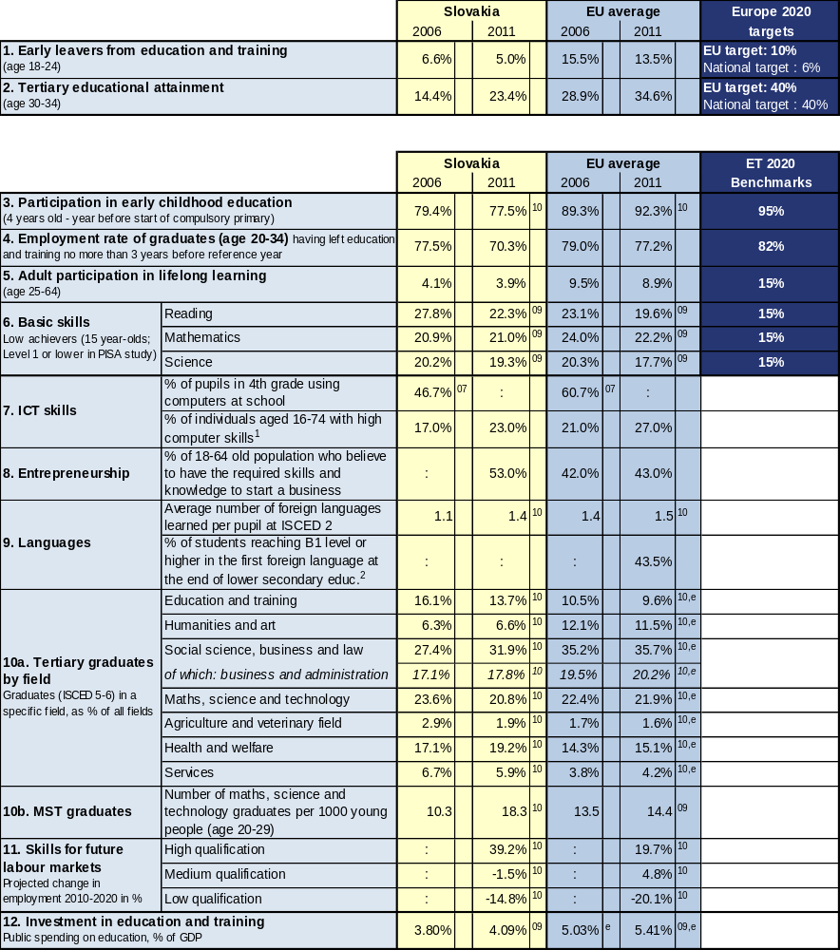

Source: Eurostat (LFS): 1, 2 CRELL (based on Eurostat LFS): 4 Global Entrepreneurship Monitor: 8
Eurostat (UOE): 3, 9a, 10, 12 OECD (PISA): 6 European Survey on Language Competences (ESLC): 9b
Eurostat (ISS): 7b Eurydice (based on IEA TIMSS): 7a Cedefop: 11

Additional notes:
⁰⁷ =2007, ⁰⁸ =2008, ⁰⁹ =2009, ¹⁰ =2010, ¹¹ =2011, e= estimate, b= break, p= provisional
Number of countries included in EU average: PISA=25, Entrepreneurship=18, Language skills=13, ICT/Computers at school=13
¹= having carried out 5-6 specific computer related activities, ²= average of skills tested in reading, listening, writing

1.2 Position in relation to Europe 2020 targets and ET2020 benchmarks
Deviation (%) from EU average and relative position to the EU benchmarks, top performers and low performers in EU27
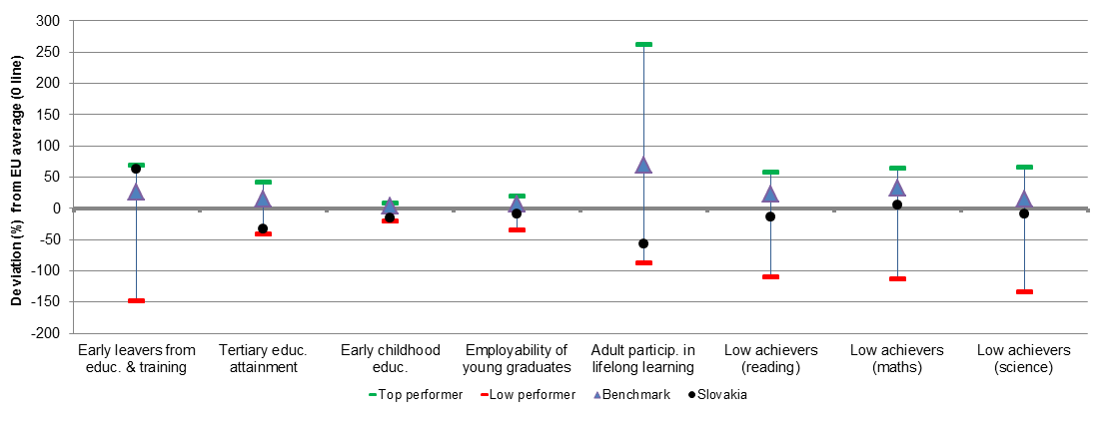
Source: DG EAC

2. Europe 2020 targets: patterns of sub-groups and sub-indicators

2.1 Early leavers from education and training

- Early school leavers of specific population sub-groups (country of birth and gender)
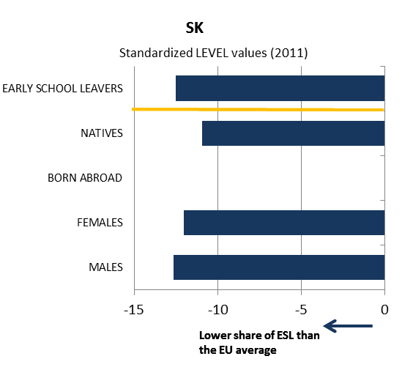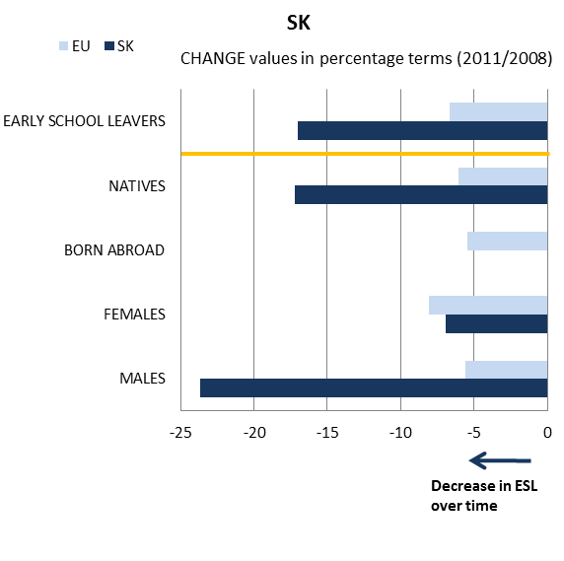

- Early school leavers and sub-indicators
(Difference in employment rate for low/medium education, low education background of the mother, investment in primary and secondary education, participation in vocational education and training [VET] and in early childhood education [ECE])
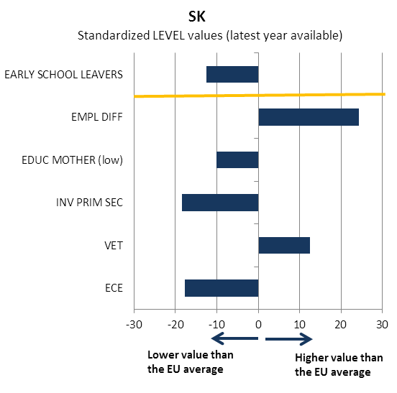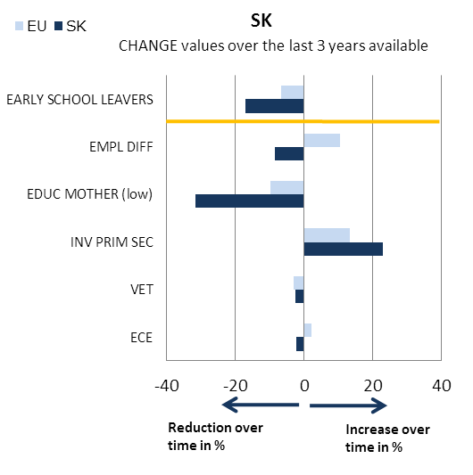
Source: JRC-CRELL

2.2 Tertiary educational attainment

- Tertiary educational attainment of specific population sub-groups (country of birth and gender)
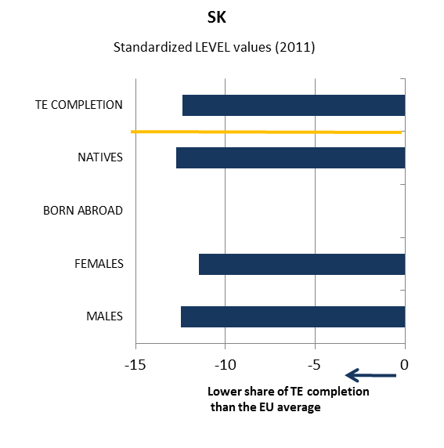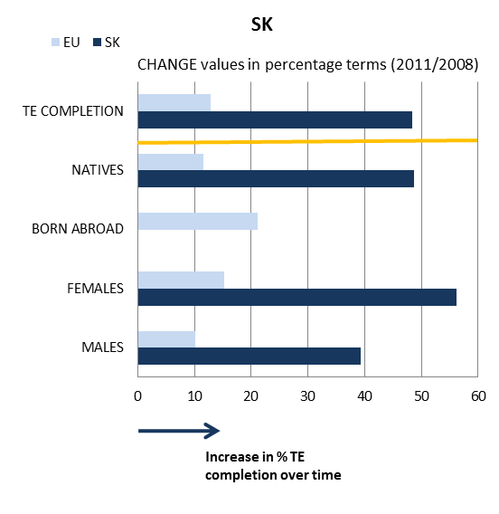

- Tertiary educational attainment and sub-indicators
(Completion rate in higher education, upper secondary educational attainment, investment in tertiary education, high education background of the mother, difference in employment rate for high/medium education)
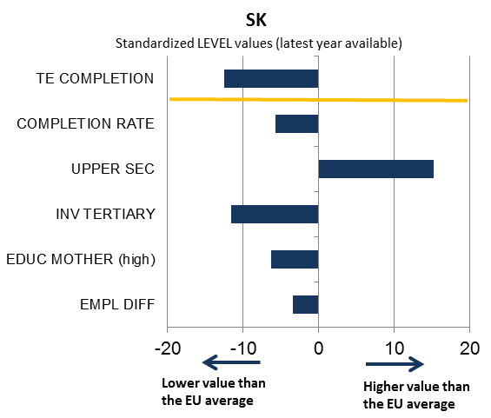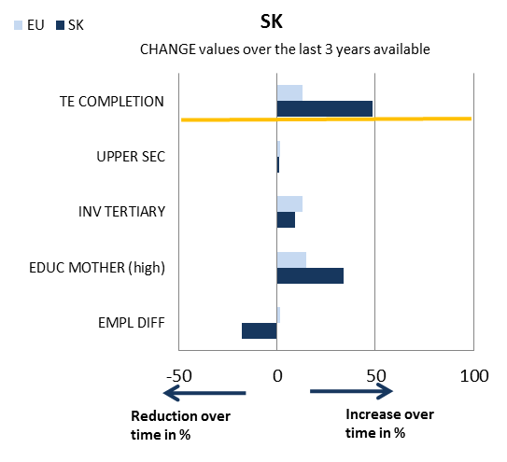

Source: JRC-CRELL

3. Key findings on benchmarks and skills levels
Concerning the Europe 2020 targets, Slovakia is one of the EU best performers in the area of early school leaving (5.0% compared to the EU average of 13.5% in 2011) and already meets its 2020 national target (6%). The younger age group benefits from a favourable family background in comparison to the EU average. Slovakia's tertiary attainment rate (23.4%) is significantly lower than the EU average of 34.6%, but the number of new students in tertiary education has risen rapidly and the country is making good progress towards the attainment of its national target (40%). Participation in early childhood education (77.5%) is low compared to the EU average (92.3%) and has a slightly negative trend. School education in Slovakia has mixed results in terms of basic skills: despite improvements in reading and science, 15 year-olds' performance on PISA tests remains below average, while results in mathematics remain slightly above an EU average. Low employment rate of graduates (70.3% in 2011) points to a problem of skills mismatches in Slovakia. Participation of adults in lifelong learning is very low in EU comparison and continues to decrease (3.9% vs. 8.9% in 2011). This is particularly an issue for the long-term unemployed.
ICT skills of the population are slightly below the EU average. As regards entrepreneurship, the share of the population believing to have the required skills and knowledge to start a business (53%) is the highest in the EU. The average number of foreign languages learned per pupil is close to the EU average (1.4 vs. 1.5). The number of graduates in mathematics, science and technology is high in EU comparison. Employment in low and medium qualification jobs in Slovakia until 2020 is forecast to decrease, while employment in high qualification jobs is expected to increase much faster than the EU average (39.2% as against 19.7%). Public spending on education as a share of GDP in Slovakia, despite recent increases, continues to be the lowest in the EU (4.09% in 2009).

4. Major policy initiatives and reforms

4.1 Initiatives and measures to increase the relevance and level of skills
In the area of primary and secondary education, Slovakia is implementing a curricular reform from 2008 which has introduced two-level (state and school) curricula and provided schools with more autonomy and a framework to better reflect local and regional labour market needs. The reform has created conditions for flexibility and innovation at school level. This is generally welcomed by stakeholders but further support in ensuring schools utilise these opportunities is needed. The reform was also aimed at supporting key competences of pupils and addressing low performance in the area of reading and writing skills for children and young people. In relation to future skills shortages (need for more STEM graduates), Slovakia is considering re-introducing mathematics as an obligatory part of the secondary school leaving exam ("maturita"). Given the openness of the Slovak economy, an important emphasis is placed on language skills with two compulsory foreign languages (from 3rd/6th grade). Emphasis is also put on ICT with a specific national strategy but substantial improvements have not yet been achieved. Entrepreneurship is integrated in the curricula supported by a number of very good projects in this field. The reform has strengthened the role of pre-primary education. The last year of kindergarten is free of charge, with the aim to increase participation (in particular that of children from marginalised, Roma communities). The kindergartens are now covered by school legislation and are supposed to develop their own curricula.
A specific challenge in the system is the integration of children from marginalised Roma communities. Most Roma receive inadequate education: only one in five 18–24 year-olds has completed secondary, post-secondary or vocational education and training (VET). Access to pre-school education is limited and pre-school enrolment among Roma children is very low (18 % vs the national average of 72 % in 2011). Moreover, the education system fosters segregation.
The issue of youth unemployment has been a challenge in Slovakia for a long time. In relation to the E&T system, it points to the problem of skills mismatches. The main approach to address this issue is to raise the proportion of work-based learning in both VET and higher education (HE) and promote lifelong learning for the unemployed. While the legislative changes in 2009 provided a framework for the active involvement of employers in the organisation of VET, a dual apprenticeship scheme is missing. According to the last national reform programme, Slovakia plans to develop such a scheme with a greater involvement of companies in providing apprenticeship places.
The number of students in HE has risen rapidly from a low level and Slovakia is making good progress towards the tertiary education attainment target. However, the situation of higher education graduates in the labour market has changed and the unemployment rate more than doubled between 2008 and 2010. The main reason is structural mismatches, both horizontal (with estimated 34% of graduates being in jobs which required only upper-secondary level), as well as vertical (with 25% being in jobs which do not correspond to the field of their studies). Another shortcoming is the focus on theoretical preparation and lack of practical experience. In contrast to other EU countries, where bachelor degrees are labour-market-relevant and a cost-effective alternative to master degrees, only a small share of students in Slovakia enters the labour market with just a bachelor degree (0.7% of all graduates).

4.2. Initiatives and measures to stimulate open and flexible learning
The main bottleneck in raising quality remains a lack of attractiveness around the teaching profession (masters level qualification is required in order to become a teacher in Slovakia) and hence a failure to attract talented young people into the profession. Some measures (a new career system for teachers with focus on professional development) have established a positive basis for strengthening the position. A national system for the testing of the mother tongue language and mathematics (3 stages in the 4th, 9th grade and at the upper secondary leaving exam) provides a good basis for analysis and evidence-based policy. Furthermore, the National school inspection body developed a system of indicators to monitor teaching methods and pedagogies with respect to the development of key competences (particularly communication in mother tongue, digital competence and the situation of students/pupils from socio-economically disadvantaged backgrounds) in a cross-curricular manner. However, the attractiveness of the profession, mainly due to salary levels, remains low.
While it is possible to move within the formal education system there are very few alternative ways to achieve formal qualifications. It is possible to move from general education to VET and vice versa, from VET to HE and also from one higher education institution to another. However, for early school leavers, the only way to achieve a formal qualification is by completing a given programme and the assessment. Despite existing legal basis, there are practically no possibilities for the validation of non-formal an informal learning.
The national qualifications framework (NQF) and the related register is expected to be the complementary tool to National System of Occupation (described below) to improve the labour market relevance of the education and training system. However, the development of the Slovak NQF is still in early stages despite the fact that it was already defined in the 2009 Act on lifelong learning. For the moment, it does not exist and the actual work on its development is to start in 2012.
In general, lifelong learning/continuous training is a weakness of the Slovak education and training system – it is underfinanced and inefficient. There are no incentives (for individuals or employers) to stimulate participation in lifelong learning and continuing training. There is very little publicly funded provision and ESF funding in this field is mostly used for active labour market policies. The inefficiencies are linked, among other factors, to the absence of a complex system of labour market research. Similarly, little efforts seem to be placed on the role of guidance in this field.
There is a national strategy on ICT in education which aims to integrate ICT in education (2007). Actions cover students (digital competence as part of education), teachers (teacher training and standards for ICT) as well as infrastructure (improving IT equipment). National school inspection notes a range of shortcomings in the implementation of this strategy and limitations in integration of ICT into education.

4.3. Initiatives and measures to secure smart funding and developing partnerships
Expenditure in education and training in Slovakia is one of the lowest (using different indicators) in the EU at all levels (primary, secondary, VET and higher education). There has been a recent change in higher education to strengthen the link between research performance and public funding (with a split of 60% per capita and 40% per research performance). The area of continuing training is largely underfunded. Basically all the reform efforts, as well as the modernisation of education infrastructure, are financed through structural funds.
The national system of occupations (NSO), currently being built up, will provide an overview of the occupational profiles of different professions in various sectors. One of the elements of this initiative is the setting up of national sectoral councils with the main role to define skills needs. However, it has created some duplications and overlaps in governance structure, in particular in relation to the new VET governance which has separate skills councils at different levels (national, regional, sectoral).

Conclusion
Due to the alarming rate of youth unemployment and skills shortages reported by companies, the education and training system receives the increasing attention of policy makers, business, media and the gneral public. Slovakia is well on track to reach its national targets in the area of early school leaving and tertiary attainment, but more efforts to increase quality and expenditure in education and training may be necessary. The main reforms in school education focused on basic skills and key competences seem to be heading in the right direction; however, it is too soon to assess their impact. What seems to be a major bottleneck in increasing overall quality and implementation of these reforms is the lack of support for teachers and the low level of attractiveness of the teaching profession. The announced measures in the area of VET (dual apprenticeship) and HE (focus on employability, promotion of STEM studies) are positive, but require support in terms of increased funding, improved systems of quality assurance and better quality of teaching staff. In terms of funding, the over-reliance on ESF as the main tool to support reforms does not appear sustainable. In general, while efforts are mainly focused on addressing the needs of the majority population, the situation of vulnerable groups (particularly marginalised Roma communities) calls for greater action.
United Kingdom
1. Performance summary

1.1 Overview of benchmarks and skill levels

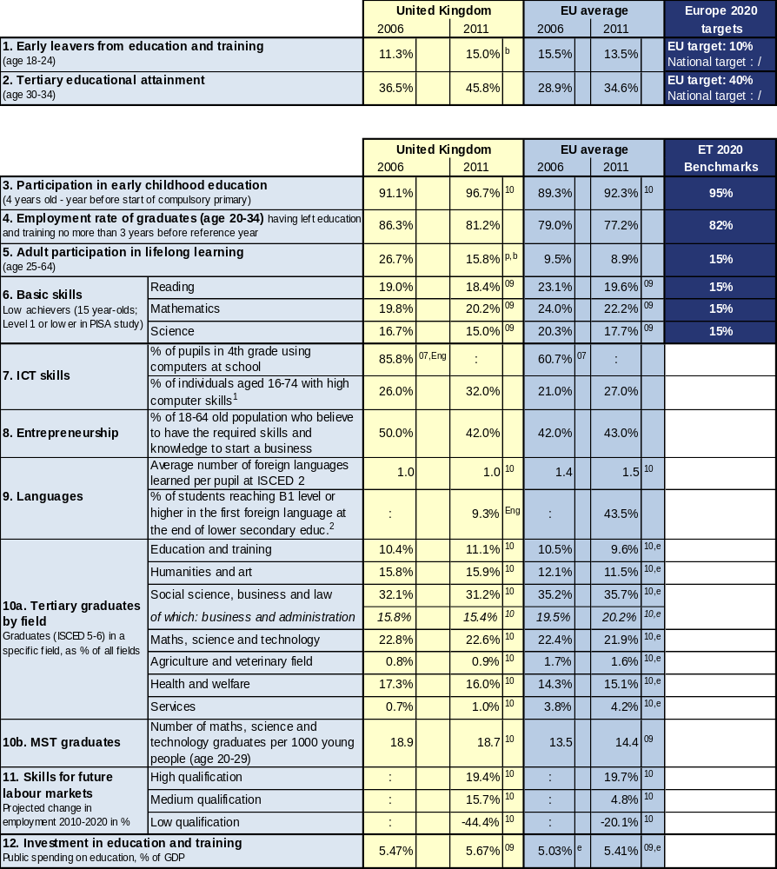

Source: Eurostat (LFS): 1, 2 CRELL (based on Eurostat LFS): 4 Global Entrepreneurship Monitor: 8
Eurostat (UOE): 3, 9a, 10, 12 OECD (PISA): 6 European Survey on Language Competences (ESLC): 9b
Eurostat (ISS): 7b Eurydice (based on IEA TIMSS): 7a Cedefop: 11

Additional notes:
⁰⁷ =2007, ⁰⁸ =2008, ⁰⁹ =2009, ¹⁰ =2010, ¹¹ =2011, e= estimate, b= break, p= provisional
Number of countries included in EU average: PISA=25, Entrepreneurship=18, Language skills=13, ICT/Computers at school=13
¹= having carried out 5-6 specific computer related activities, ²= average of skills tested in reading, listening, writing

1.2 Position in relation to Europe 2020 targets and ET2020 benchmarks
Deviation (%) from EU average and relative position to the EU benchmarks, top performers and low performers in EU27
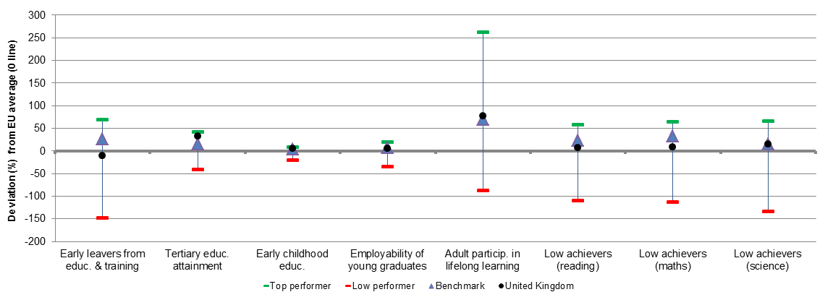
Source: DG EAC

2. Europe 2020 targets: patterns of sub-groups and sub-indicators

2.1 Early leavers from education and training

- Early school leavers of specific population sub-groups (country of birth and gender)
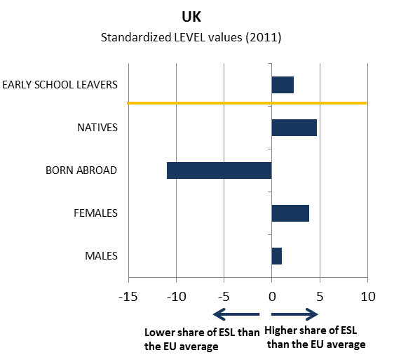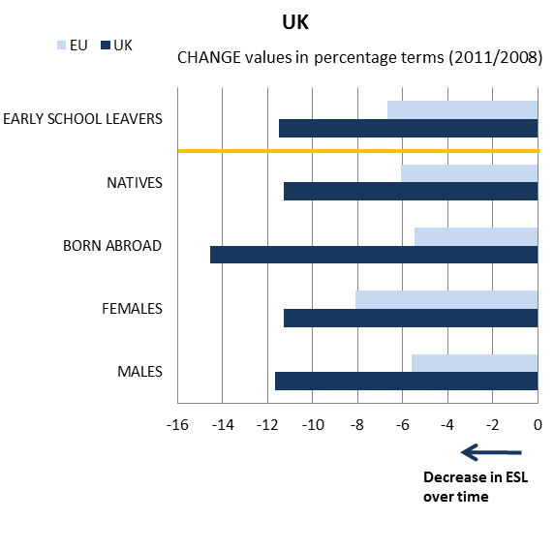

- Early school leavers and sub-indicators
(Difference in employment rate for low/medium education, low education background of the mother, investment in primary and secondary education, participation in vocational education and training [VET] and in early childhood education [ECE])
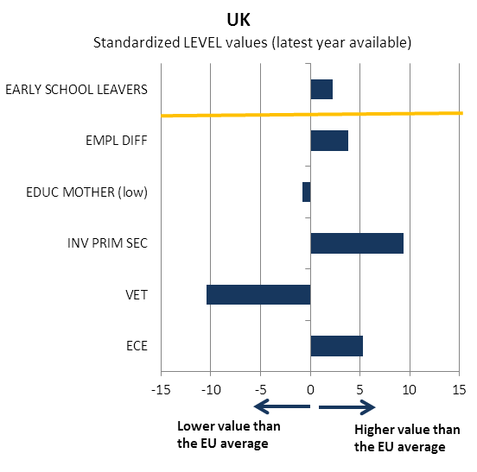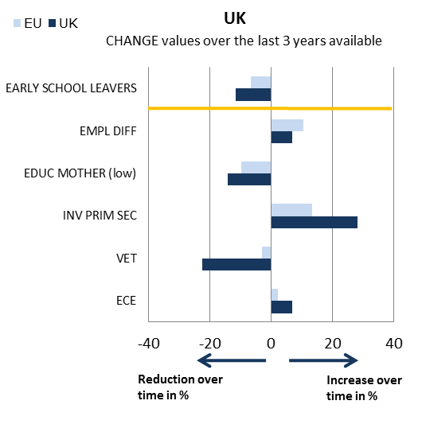
Source: JRC-CRELL

2.2 Tertiary educational attainment

- Tertiary educational attainment of specific population sub-groups (country of birth and gender)
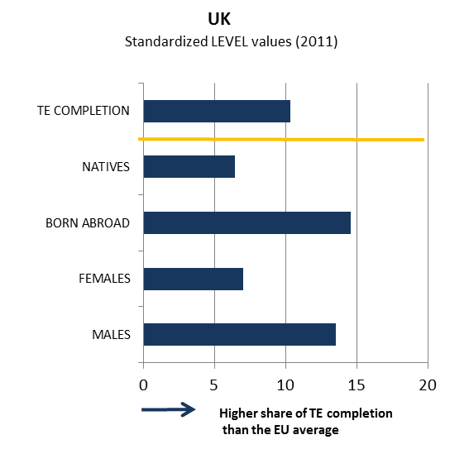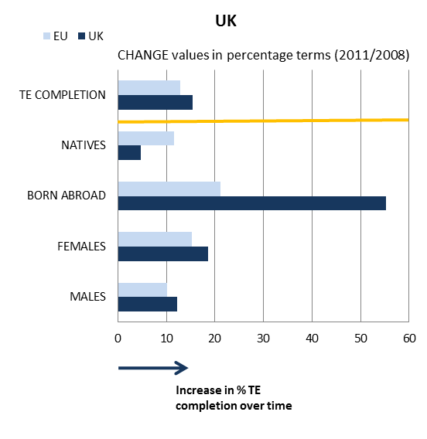

- Tertiary educational attainment and sub-indicators
(Completion rate in higher education, upper secondary educational attainment, investment in tertiary education, high education background of the mother, difference in employment rate for high/medium education)
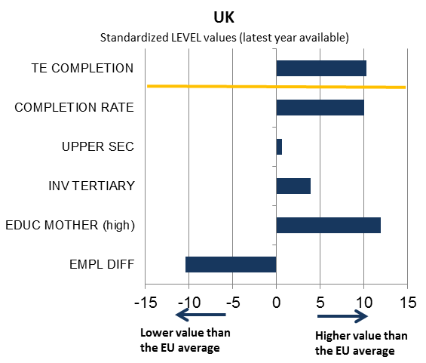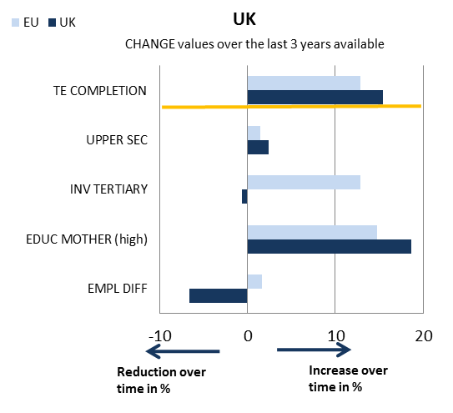

Source: JRC-CRELL

3. Key findings on benchmarks and skills levels
Concerning the Europe 2020 targets, the UK performs below the EU average for the early school leaving rate (15.0% vs. 13.5% in 2011), but significantly above for the tertiary attainment rate (45.8% as against 34.6% in 2011). As regards the other ET 2020 benchmarks, participation in early childhood education is above the EU average. In terms of basic skills, 15 year-olds' performance on PISA tests continues to outperform the EU average, although it remained broadly constant in recent years in readings and mathematics and only modestly improved in science. The employment rate of graduates suffered from the recent economic crisis and decreased by 5 percentage points since 2006, but remains well above the EU average (81.2% vs. 77.2% in 2011). Also participation of adults in lifelong learning decreased in recent years (although the figures are affected by breaks in series), while remaining high in EU comparison (15.8% vs. 8.9% in 2011).
Concerning ICT skills of young people, a very high share of pupils in the 4th grade uses computers at school. As regards entrepreneurship, the share of the population believing to have the required skills and knowledge to start a business is close to the EU average. Having English as mother tongue, foreign language skills are not very developed in the UK. The number of graduates in mathematics, science and technology is high in EU comparison. The employment pattern in the UK up to 2020 is forecast to be fairly different from the EU average in medium and low qualification jobs, with a stronger increase in the former and a very large decrease in the latter, which are expected to represent only 11% of total jobs in 2020 (compared with an EU average of 18%). Public spending on education in the UK is above the EU average (5.67% vs. 5.41% of GDP in 2009.

4. Major policy initiatives and reforms

4.1 Initiatives and measures to increase the relevance and level of skills
In the area of basic skills, a review of the National Curriculum in England is currently under way and new programmes of study are planned to be introduced in September 2014. While its primary aim is to give schools greater freedom over the curriculum, the review is also driven by the view that students in England specialise at too early a stage. The proposals published in June 2012 by the Department for Education concerning primary schools include more demanding programmes in English, mathematics and science, as well as making a foreign language compulsory from the age of seven. In Wales, starting from September 2012, the National Literacy and Numeracy Framework sets out annual expected outcomes in literacy and numeracy for learners aged 5 to 14. It also includes new reading and numeracy tests to support teachers in understanding skill development. In the long-term, the framework is expected to provide a much stronger feedback loop to teachers to plan effective and sufficient literacy and numeracy teaching across the curriculum.
To fight early school leaving, the government is, inter alia, raising the age for leaving compulsory education in England from 16 to 17 in 2013 and to 18 from 2015. Although this measure is very significant, it remains to be seen whether students will be endowed with the right skills for the labour market. In 2010 Scotland launched 16+ Learning Choices, a new model for organising and supporting post-16 transitions covering learning, planning and delivery, personalised and financial support. It is a universal offer for all 15-18 year olds, but it targets those more likely to drop out of education at the end of compulsory education; however it is too early to assess its impact.

4.2. Initiatives and measures to stimulate open and flexible learning
Segmentation of the education system has been a long-standing challenge across the UK. Successive attempts at qualification reform have attempted to promote comparability of and transferability between academic and vocational routes. Since 2010, the government has used a performance measure for the English Baccalaureate, which is not a qualification in itself – but, rather is a way of focusing of school achievement across a core set of subjects. Implicitly, this aims to move schools away from increasingly offering vocational subjects that may not be relevant for entry to higher education or for the labour market and marks a reappraisal of the role of vocational learning in secondary schools.
Recent measures to improve skills forecasting have included a series of proposals with increased focus on basic skills, simplifying funding arrangements and reducing central bureaucratic control over colleges and training organisations. In Scotland, an integrated employment and skills (IES) service has been put in place to make it quicker and easier for job-seekers to access professional advice, and a new Labour Market Intelligence framework will set out a clear strategy for improving provision of information and access.
In general, all schools have a range of ICT tools available for use by teachers and pupils. These may include computers, tablet PCs, digital cameras, mobile devices and robots. Interactive teaching with electronic whiteboards is widespread as is access to virtual learning environments and other digital resources.
The new curriculum for schools in Scotland from age 3-18 (Curriculum for Excellence), gradually implemented over 2008-2012, ultimately aims at developing four ‘capacities’ in young people to become: successful learners; confident individuals; responsible citizens; effective contributors. The approach is to capture the ‘totality of experiences’ in designing, planning and delivering learning, including recognising the contribution of experiences outside of the classroom. Early evidence at the draft outcomes and experience stage showed that stakeholders (teachers, school leaders and local authority officers) welcomed the openness and flexibility of the new approach; however more time is probably needed to exploit the potential of the new curriculum in terms of personalised pathways and blended forms of learning.

4.3. Initiatives and measures to secure smart funding and developing partnerships
As the government is expecting universities to rely more and more on the income they receive from students, it is reducing direct funding accordingly. As from the academic year 2012-13, tuition fees paid by students are increasing to up to GBP 9 000 per year in England and Wales. In its place, the government will provide institutions with up-front loans of GBP 3.6 billion in 2012-13, rising to GBP 5 billion in 2013-14. The premium that universities receive for taking in students from poorer backgrounds remains unchanged. It will be important to monitor the effect of increased tuition fees on enrolment and graduation, as well as the way in which the mix of graduate skills fits with the needs of the economy.
In England the Employer Ownership of Skills Programme, piloted in 2012, tests the potential to raise business engagement and investment by routing public investment directly to employers rather than via providers. Businesses have been invited to set out the public investment they need to support their own investment in skills, training and apprenticeship opportunities. While it is too early to assess the effectiveness of the approach, it is worth noting that the design of the pilot supports investment that can show a return on public expenditure. The challenge to be addressed in this area is the still limited supply of work-based apprenticeships, as there is relatively little tradition among UK employers of commitment to providing vocational training opportunities for young people.
The Academies Programme and the Free Schools Programme in England are the most relevant initiatives concerning partnerships in school education. Academies were first introduced in 2002 targeting poorly-performing schools, then the programme was extended to all schools (starting with those offering outstanding provision) from 2010. Free schools are a more recent development, as they were launched in September 2011. Both programmes are on-going and target potentially all primary and secondary schools. Academies are free from local authority control and have the ability to set their own pay and conditions for staff. Part of the academy programme targets underperforming schools (which may be forced rather than choose to become academies). In these cases, sponsors are introduced to improve performance and lead the new academies. These sponsors can come from a variety of places – businesses, charities, faith bodies, other successful schools etc. The free schools programme offers similar freedoms to parents and local communities that wish to join together to set up new education establishments. According to the National Audit Office, most academies are achieving improvements in academic attainment for their pupils compared with their predecessor schools; however, the gap in attainment between more disadvantaged students and other pupils has increased in academies more than in comparable maintained schools.

Conclusion
The skills challenges faced in the UK are rather long-standing in nature. The notion that a significant minority of young people leave secondary education without the skills and qualifications to compete in the labour market is not a new one. Yet it is a policy concern that is amplified by the economic crisis, which has disproportionately affected young people (especially low-skilled).
A key priority articulated in the skills strategy for England is to achieve more shared responsibility for learning between government, individuals and employers. This also implies asking individuals to contribute more directly to learning with a view to making education and training more responsive and higher-quality. The approaches being trialled to support employer leadership in skills are interesting and, if successful, may finally provide the step change in the perceived value of vocational training. What is clear is that these providers will have to become increasingly responsive, as will the universities looking to attract students paying significant fees.
The focus on system reform – rather than discrete measures or initiatives – is also seen strongly at school level. It is not yet clear whether the reforms in England, notably raising the length of compulsory education, will lead to an effective balance between academic and other forms of learning; the approach is different in Scotland, where no legal requirement to continue learning after 16 years of age exists but there is a new curriculum explicitly set within a broader notion of the ‘capacities’ of young people. Time will tell which approach is more effective in raising basic skills through increased and more sustained participation in learning.

Annexes

Annex 1. Summary statistics on the headline target

1.1 Early leavers from education and training

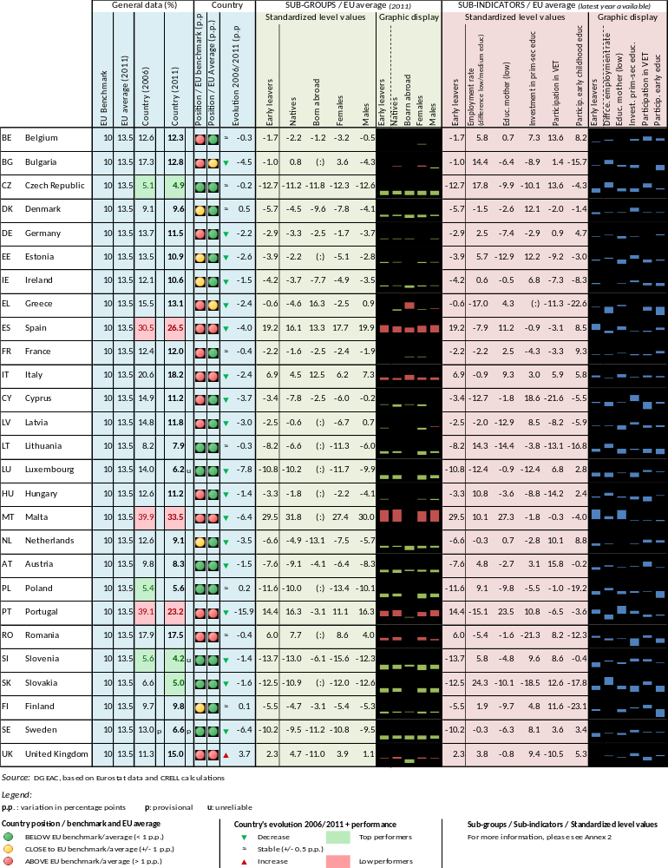

1.2 Tertiary educational attainment

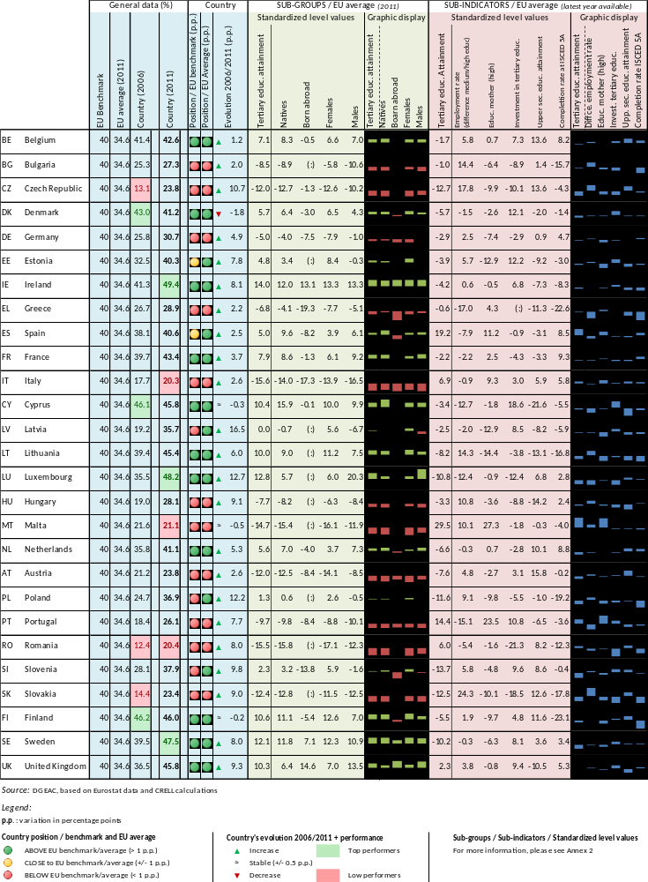

Annex 2. Methodology figures on the headline target

This annex contains further information on the methodology behind the figures used for both components of the Europe 2020 headline target: early school leaving and tertiary attainment. These figures are featured in section 2 of each country sheet.

When comparing sub-groups and sub-indicators to the corresponding EU average, standardized values are adopted. These standardized values are based on the following calculation:

Firstly, the charts focus on specific population sub-groups: native-born, foreign-born, female, male. The figures for foreign-born students are not always provided, following the approach of EUROSTAT, which does not provide figures for the subset of the foreign-born population for the following countries: Bulgaria, Estonia, Hungary, Latvia, Lithuania, Luxemburg, Malta, Poland, Romania and Slovakia.

Secondly, sub-indicators are used to shed light on the countries’ performance in the domain of educational attainment. Although most sub-indicators do not constitute policy levers that can be used as such to reach national targets by 2020, they are measures that help to explain behaviour in the medium and long term.

The sub-indicators for early school leaving
EMPL DIFF | Difference in employment rates | Difference in the employment rate in percentage points between individuals aged 20 to 64 with an educational attainment corresponding to ISCED 3 or 4 and those with an educational level corresponding to ISCED 0-2 (year 2011)
EDUC MOTHER (low) | Educational attainment of females aged 45-54 | Proportion of females aged 45 to 54 whose educational attainment corresponds to ISCED 0-2 (year 2011)
INV PRIM SEC | Investment in primary and secondary education | Annual expenditure on public and private educational institutions in EUR PPS at primary and secondary levels (ISCED 1 to 4) divided by the size of the cohort aged 6-18 compared to the GDP per capita in EUR PPS (year 2009)
VET | Participation in Vocational Education and Training (VET) | Proportion of ISCED level 3 students who participate in VET (year 2010)
ECE | Early childhood education | Proportion of pupils aged between 4-years-old and the starting age of compulsory education who are participating in early childhood education (year 2010)

The differences in employment rates are indications of labour market returns to upper secondary and to high education. A higher return is believed to increase the incentives to stay longer in the educational system. The educational attainment of females aged 45-54 and 55-64 are proxies for the family background of the target population of each headline indicator. A vast literature highlights mother‘s education as a key determinant for explaining differences in educational attainment.

Spending per individual in the relevant age-group for each level of education compared to the GDP per capita constitutes the measure of investment in education and training systems and is a proxy for the quality of the supply of education. The indicators employed here are slightly different from the more common “spending as a percentage of GDP” or “spending per student” in order to take into account demographic effects and not penalize countries with a high share of students but that spend less on a per capita basis compared to other countries that spend more on relatively fewer students.
The sub-indicators for tertiary educational attainment
EMPL DIFF | Difference in employment rates | Difference in percentage points in employment rate between individuals whose educational attainment is equal to ISCED5-6 and those whose educational attainment corresponds to ISCED3-4 (year 2011)
EDUC MOTHER (high) | Educational attainment of females aged 55-64 | Percentage of the females aged 55-64 having completed ISCED 5-6 (year 2011)
INV TERTIARY | Investment in tertiary education | Annual expenditure on the tertiary education (ISCED 5-6) divided by the size of the cohort aged 20-24 compared to the GDP per capita expressed in PPS) (year 2009)
UPPERSEC | Upper secondary educational attainment | Percentage of population aged 20-24 having completed at least upper secondary education (year 2009)
COMPLETION RATE | Completion rate at ISCED level 5A | Proportion of those who enter a tertiary-type A programme and go on to graduate from at least a first tertiary-type A programme (reference year: 2008)

The participation in pre-primary education and the number of students enrolling in VET programmes are believed to be associated with subsequent school outcomes. Vocational programmes help reducing early leaving from education and training and can help to make educational systems more socially inclusive. Early childhood education is associated with better performance later in life. Rising skill demands in European countries have made qualifications at the upper secondary level the minimum credential for successful entries in the labour market. Upper secondary education completion informs about the pool for new entrants into higher education while the completion rate in tertiary education allows contrasting countries in terms of the internal efficiency of the tertiary educational system.

See annex 2.
See annex 2.
See annex 2.
See annex 2.
The Maltese series on ESL are under review by the Maltese Statistical Office and Eurostat. The review concerns the classification of certain qualifications at secondary level. The revision applies to all years covered (2006-2011) and would mean a reduction of about 9 percentage points for the 2011 rate of early school leavers.
See annex 2.
See annex 2.
See annex 2.
See annex 2.
See annex 2.
http://www.ifau.se/Upload/pdf/se/2012/wp12-01-Evaluation-of-the-Swedish-earned-income-tax-credit.pdf
See annex 2.
See annex 2.
See annex 2.
This methodology is based on the Joint Assessment Framework (JAF) introduced by the Directorate-General Employment, Social Affairs and Inclusion (DG EMPL). Sub-groups and sub-indicators for the twofold Europe 2020 target on education and training are based on data provided by EUROSTAT and were developed by the Centre for Research on Lifelong Learning (CRELL), which is co-ordinated by the Joint Research Centre of the European Commission (DG JRC). For more details about the methodology, see: http://crell.jrc.ec.europa.eu/download/ReqNo_JRC70190_monitoring_the_eu_headline_target_pubsy.pdf.
Data for COMPLETION RATE comes from OECD (2010, table A4.1).

