Neuroinformatics laboratory 0

Name: Radek Bartyzal
Email: rbartyzal1@gmail.com
Code: https://github.com/BartyzalRadek/neuroinformatics-course/blob/master/datasets.ipynb

1. Dataset: Basic 4x4 grid with 2 classes
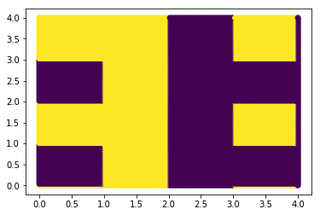

2. Dataset: Boolean function of 5 variables = 32 possible values
These values [0,3,7,12,14,15,16,17,25,30] belong to the class 1, the rest to the class 0.

3. Dataset: Polygon shape dividing the 2D space into 2 classes

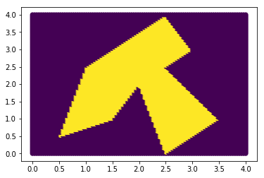

4. Dataset: 2D space divided into 8 classes

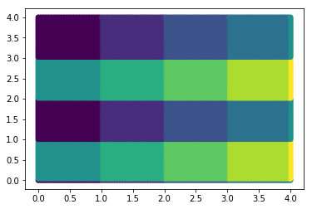

5. Dataset: Moderately complicated 1D function
f(x) = sin(x*x)

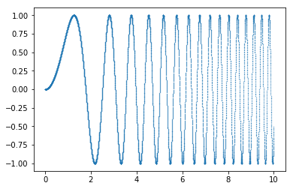

6. Dataset: 1D function with memory
