Neuroinformatics laboratory 1

Name: Radek Bartyzal
Email: rbartyzal1@gmail.com
Code of MLP: https://github.com/BartyzalRadek/neuroinformatics-course/blob/master/MLP.ipynb
Code of training a single perceptron with delta rule: https://github.com/BartyzalRadek/neuroinformatics-course/blob/master/Perceptron.ipynb

Target image:
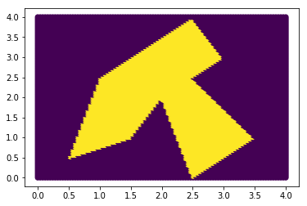

First network:

Layer 0 neuron 0 :
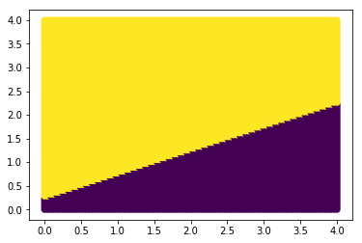

Layer 0 neuron 1 :
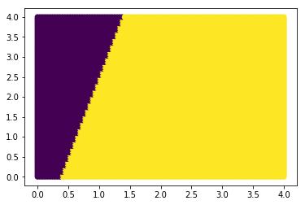
Layer 0 neuron 2 :
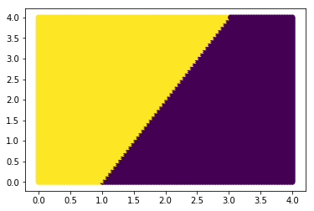
Layer 0 neuron 3 :
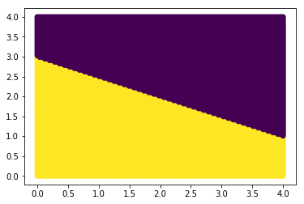

Layer 1 neuron 0 :
= AND neuron with 4 input dimensions. Cannot plot.

Output of the first network:

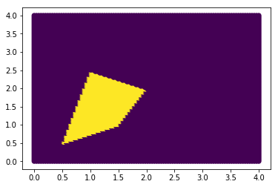
Second network:

Layer 0 neuron 0 :
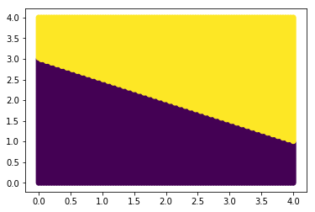
Layer 0 neuron 1 :
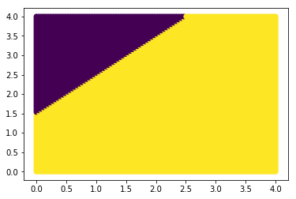

Layer 0 neuron 2 :
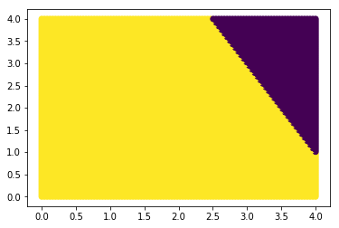
Layer 0 neuron 3 :
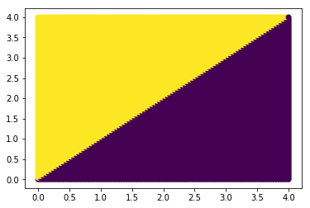
Layer 1 neuron 0 :
= AND neuron with 4 input dimensions. Cannot plot.

Output of the second network:
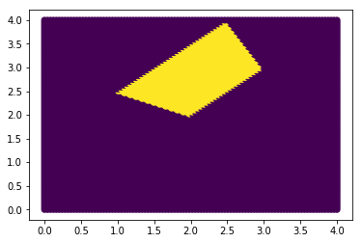

Third network:

Layer 0 neuron 0 :
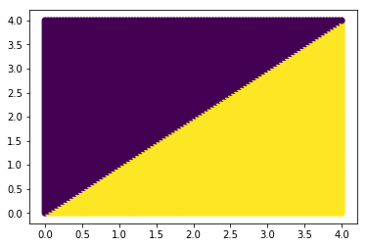
Layer 0 neuron 1 :
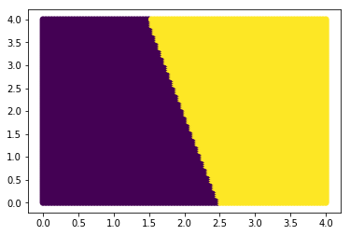
Layer 0 neuron 2 :
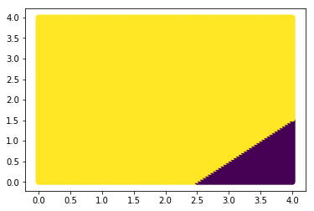

Layer 0 neuron 3 :
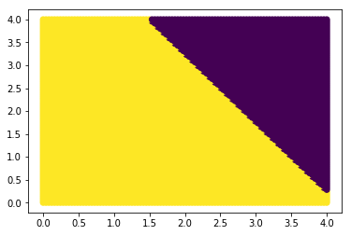
Layer 1 neuron 0 :
= AND neuron with 4 input dimensions. Cannot plot.

Output of the third network:
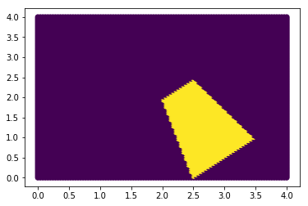

Final network combining the previous networks with OR neuron:

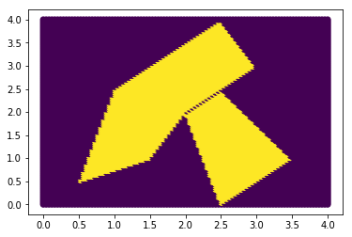

Training perceptron with delta rule:

Dataset:

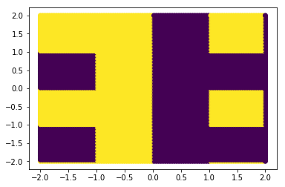
Training with 10000 examples and batch size = 100
After training:
W = [-4.81212121 1.82222222]
b = 0
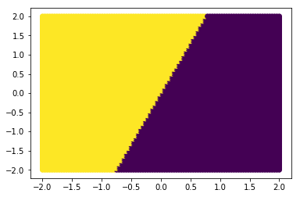

Dataset:

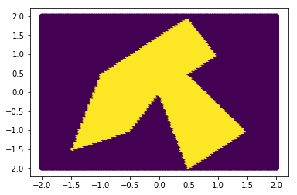
Before training:
W = [ 0. 0.]
b = 0

Training with 10000 examples and batch size = 1
After training:
W = [ 0.0040404 -0.39191919]
b = 0
