**JHENRICH D. ROQUIOS**

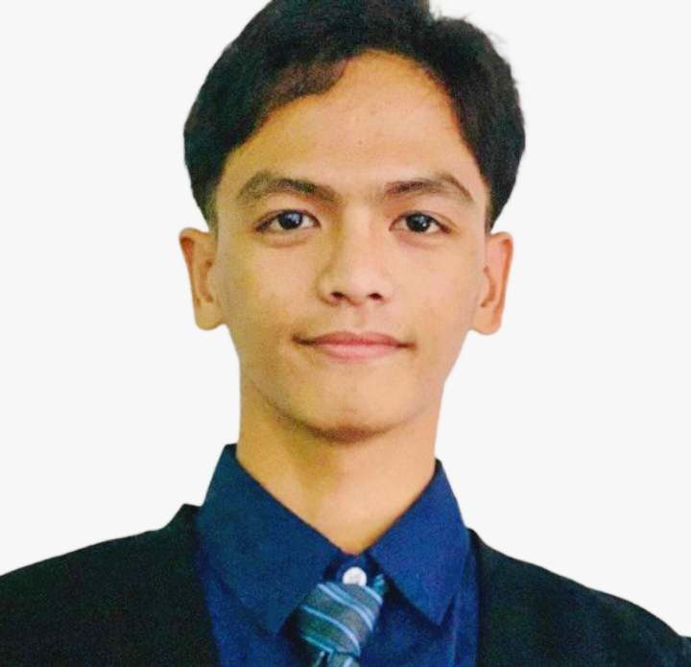

Phone: +63 950-473-8498

Email: [jhenrichroquios000@gmail.com](mailto:jhenrichroquios000@gmail.com)

Portfolio: <https://bartzabelll.github.io/Portfolio/>

Address: Blk 37 Lot 4 Pulido, GMA, Cavite, 4117, Philippines

**CAREER OBJECTIVE**

Seeking a position where I can use and enhance my development skills, administrative abilities, and communication skills. Eager to work on team projects and grow professionally while continuously improving my technical knowledge, problem-solving abilities, and overall expertise.

**EDUCATION**

Bachelor of Science in Computer Science (September 2020 – September 2024)

Cavite State University – Carmona

Maduya, Carmona, Cavite

Science and Technology Engineering and Mathematics (June 2018 – March 2020)

Bulihan National High School

Bulihan, Silang, Cavite

**SKILLS**

**Programming Languages**: HTML, CSS, PHP, TAILWIND CSS, PYTHON, JAVA, JAVASCRIPT

**Human Languages:** English, Tagalog

**Web development Skills**:

* **Laravel Framework:** Experience in developing web applications using the Laravel framework, following a TALL stack approach (Tailwind CSS, Alpine.js, Laravel, Livewire ).
* **Database Management:** Skilled in database migrations and designing database schemas using MySQL and SQLite. Proficient in using Laravel's database migration tools.
* **Version Control:** Proficient in using Git for version control, including creating and managing repositories, branches, and collaborative workflows.
* **Website Deployment and Hosting:** Knowledgeable in deploying and hosting websites.

**Software Development Skills:**

* Experience in creating user stories, creating diagrams and documentations, and working through the Software Development Life Cycle (SDLC).
* Knowledge of collaborative development practices and tools.
* Proficient in creating diagrams for system and data relationships.

**Hardware and IT support skills:**

* Capable of building computers, installing software, and performing minor troubleshooting and networking tasks.
* IT Help Desk Support: Experience in system cloning, computer setup and relocation, and cleaning system units.