

Time Series Forecasting: Comparative Analysis of Exponential Smoothing and ARIMA Models for Online Retail Sales Prediction

Winter Semester 25/26

Topic creator: Leubner, C., Dr., Prof.
Supervisor : Leubner, C., Dr., Prof.

Submitted by: Saurab Barua
Matriculation number: 30348215

Submission Date: 01.02.2026

Contents
Introduction 3
Research Objectives 4
Theoretical background 5
Time Series Analysis 5
Stationarity 5
The Augmented Dickey-Fuller (ADF) 5
Exponential Smoothing Methods: 5
ARIMA Models 7
Model performance Evaluation Metrics 8
Methodology 9
Data Source and Description 9
Data preparation and cleaning 10
Aggregation Strategy 10
Exploratory Data Analysis (EDA) 11
Data Splitting Strategy 13
Stationary Testing 13
Differencing Analysis 14
ACF/PACF Analysis 14
Model Development 15
Double Exponential Smoothing 15
Triple Exponential Smoothing (Holt-Winters) 15
ARIMA Models 16
Practical Application and Results 17
Double exponential Smoothing 17
Triple Exponential Smoothing 17
Manual ARIMA(2,1,0) Model 18
Quantitative Performance Evaluation 18
Double Exponential smoothing Performance 18
Triple Exponential Smoothing Performance 19
Manual ARIMA(2,1,0) Performance 19
Future Forecast with ARIMA 20
Key Findings 21
Conclusion 21
Limitations: 22
References 22

Introduction
Digital Transformation of retail commerce has changed the Business drastically. In today’s business there is huge amount of transactional data. The biggest challenge of modern supply chain and business processes is to predict the trend of future sales and give possible forecasting. Firms that are successful in predicting their future sales get competitive advantage in the competitive market. For instance, correct inventory management, cost reduction, customer satisfaction and profitability.
Time series forecasting has emerged as an indispensable tool for business to analyze historical data and predict the future values for business operating in dynamic markets. Unlike traditional statistical approaches that assume independence among observations, time series methods explicitly recognize and model the temporal dependencies inherent in sequential data. This temporal structure contains valuable information that can be leveraged to make accurate predictions about future sales patterns, market trends, and customer behavior.
The Online Retail Dataset used in this project is a real-world scenario faced by thousands of e-commerce organizations worldwide. The dataset contains transactional records from a UK-based online retail store, capturing detailed information about customer purchases, product characteristics, geographical distribution, and temporal patterns spanning a 12-month period. This dataset's authenticity, combined with its complexity and size (over 500,000 transactions), provides an ideal platform for evaluating sophisticated forecasting methodologies

Research Objectives
The objectives of this project are:
- To evaluate the comparative performance of time series forecasting models (Double Exponential Smoothing, Triple Exponential Smoothing, and ARIMA) when applied to real-world online retail sales data.
- To identify the model that delivers the highest forecast accuracy using multiple evaluation metrics (Mean Absolute Error, Root Mean Squared Error and Mean Absolute Percentage Error).
- To provide actionable recommendations for practitioners implementing forecasting systems in retail environments.
- Demonstrating proper data preprocessing techniques for time series analysis.
- Providing future sales forecasts for practical decision-making.

The research addresses the following specific questions:
1. How do exponential smoothing methods (double and triple) compare in accuracy for short-term (10-week) sales forecasting?
2. What is the performance of ARIMA models with automatic and manual parameter selection when applied to retail sales data?
3. Does incorporating seasonality into forecasting models improve prediction accuracy for this dataset?
4. What is the optimal forecast horizon for each methodology?
5. How do different accuracy metrics influence model selection and interpretation?

Theoretical background
Time Series Analysis
A time series is a statistical method to analyze sequential data points of specific time interval to identify insightful trends, patterns and characteristics. This method focuses on chronological order of data to understand the change of the variable over the course of time and forecast the Future. (Robert H & David S, 2017)
Time series data typically exhibits several key characteristics:
- Trend: Systematic long-term movement upward or downward
- Seasonality: Regular patterns repeated at fixed intervals
- Cyclicality: Long-term oscillations without fixed periodicity
- Irregular Fluctuations: Random variations unexplained by trend, seasonality, or cycles
- Autocorrelation: Correlation between observations separated by specific time lags

Stationarity
A fundamental concept of time series analysis is stationarity. If statistical properties like mean, variance and autocovariance are constant over time then the data is stationary. For many time series models like ARIMA stationarity of data is crucial to avoid false autocorrelation and unreal forecasts. ( Noble, n.d.)

The Augmented Dickey-Fuller (ADF)
Tools like ADF are used to measure the stationarity of the data, where it checks if the series contains unit roots. The null hypothesis is considered non-stationarity and otherwise stationarity. P value less than 0.05 typically the rejection of null hypothesis, which indicates the stationarity of the data. ( Noble, n.d.)

Exponential Smoothing Methods:
- Simple Exponential Smoothing(SES) denotes the exponential decrease in weight of historical observations, weighted more heavily with recent data. For data without trend and seasonal pattern, this model is suitable. (Charles, 2004)
$${\overset{ˆ}{y}}_{t+1}=αy_{t}+(1-α){\overset{ˆ}{y}}_{t}$$

Where $α$controls the degree of smoothing. Higher $α$ gives more weight to recent observations and lower $α$ gives long term patterns.

- Double Exponential Smoothing (Holt’s Method) extends the simple exponential smoothing by considering trend in the data. This approach makes the model suitable for the data with trend but not seasonality. (Charles, 2004)
Level equation:
$$l_{t}=αy_{t}+(1-α)(l_{t-1}+b_{t-1})$$
Trend equation:
$$b_{t}=β(l_{t}-l_{t-1})+(1-β)b_{t-1}$$
Forecast equation:
$${\overset{ˆ}{y}}_{t+h}=l_{t}+hb_{t}$$
where:
- $l_{t}$ is the level (intercept)
- $b_{t}$ is the trend component
- $α$ is the level smoothing parameter
- $β$ is the trend smoothing parameter
- $h$ is the forecast horizon

- Triple Exponential smoothing(Holt-Winters Method)
This method extends the double exponential method where it also considers the seasonal pattern of the data, making it suitable for the data which have trend as well as seasonal pattern. (Charles, 2004)

Additive Model (used when seasonal variations are constant):
$${\overset{ˆ}{y}}_{t+h}=l_{t}+hb_{t}+s_{t+h-m}$$
Multiplicative Model (used when seasonal variations increase with level):
$${\overset{ˆ}{y}}_{t+h}=(l_{t}+hb_{t})⋅s_{t+h-m}$$
where:
- $s_{t}$ represents seasonal components
- $m$ is the seasonal period
- Other parameters are as previously defined
The method maintains three smoothing equations for trend, level and seasonality, where careful parameter estimation is required.

ARIMA Models
Autoregressive(AR) Process : p
This component considers its own previous values or lags. It considers the next value based on the previous values.

$$y_{t}=ϕ_{1}y_{t-1}+ϕ_{2}y_{t-2}+⋯+ϕ_{p}y_{t-p}+ϵ_{t}$$

The parameter p represents the included lag observations in the model.

I(Integrated) :d
To make statistical values like mean and variance constant, in other words stationary; these steps take place.
$$Y_{t}^{'}=Y_{t}-Y_{t-1}$$

The value of d represents the number of times it differenced to make the data stationary.

Moving Average(MA): q
A moving average process models a variable as a linear combination of current and past random errors. It models the dependency of current values rather than previous or lagged values.

$$y_{t}=ϵ_{t}+θ_{1}ϵ_{t-1}+θ_{2}ϵ_{t-2}+⋯+θ_{q}ϵ_{t-q}$$

Where $θ_{i}$ are moving average coefficient.

ACF and PACF for model Identification
To identify the best parameter, it is important to plot the Autocorrelation Function(ACF) and Partial Autocorrelation Function(PACF).
ACF Plot: It indicates the correlation between the series and previous lags.
PACF Plot: It excludes the intermediate effects and sees the relation with its lags.
Characteristic patterns:
Model | ACF | PACF
AR(p) | Decays exponentially | Cuts off after lag p
MA(q) | Cuts off after lag q | Decays exponentially
ARMA(p,q) | Decays exponentially | Decays exponentially

Model performance Evaluation Metrics
To evaluate the model accurately multiple evaluation metrics are required, each capturing different aspects of forecast accuracy:
Mean Absolute Error (MAE)
MAE measures the average absolute prediction error without considering their direction. After considering the absolute difference of the actual and predicted values it averages error.
$$\text{MAE}=\frac{1}{n}\sum_{i=1}^{n}{ }\left|y_{i}-{\overset{ˆ}{y}}_{i}\right|$$

Pros: It gives the same value as original data, making it intuitive to interpret.
Key feature: Positive and negative values do not cancel each other as it considers the absolute error.
Root Mean Squared Error (RMSE)
It calculates the residuals or error between actual and predicted values and squares that error to ensure that negative errors do not cancel out positive errors.
$$\text{RMSE}=\sqrt{\frac{1}{n}\sum_{i=1}^{n}{ } (y_{i}-{\overset{ˆ}{y}}_{i})^{2}}$$
Pros : Heavily penalizes the large errors. Useful when big mistakes are particularly costly.
Cons : Highly sensitive to outliers, extreme value can significantly inflate the RMSE.

Mean Absolute Percentage Error (MAPE)
Mape measures the percentage of average absolute error, which allows scale independent comparisons.
$$\text{MAPE}=\frac{100}{n}\sum_{i=1}^{n}{ }\left|\frac{y_{i}-{\overset{ˆ}{y}}_{i}}{y_{i}}\right|$$
Pros : Interpretable as percentage error and emphasizes relative accuracy.
Cons : when the actual values are 0, meaning it biased to models that underestimate.

Methodology

Data Source and Description
Dataset Overview
The project is carried out on the UCI Online Retail Dataset, a real-world transactional dataset from a UK-based online retail store. The data set contains the transactions from 1st December 2010 to 9th December 2011, which contains 5419909 transactions across 4,372 unique products and 17,946 customer accounts distributed across 38 countries
Key columns include:
• Invoice No
• Stock Code
• Description
• Quantity
• Invoice date
• Unit Price
• Customer ID
• Country

Data preparation and cleaning
Data cleaning Steps
In the process of data cleaning involved following stages:
- Removal of null values: Entries that are contained null value of quantity, customer ID, price has been eliminated.
- Date-Time Conversion: Set the Invoice date to date time format for proper indexing.
- Sales Calculation: Created new features by multiplying product price and unit for target variable.
- Filtering Date: Since the data for the month of December 2011 is incomplete, December data has been filtered out. Although weekly data is considered later.

Aggregation Strategy
The data has been aggregated to weekly sales value for more data points using the pandas:

resample() function.
weekly_sales= df_f.set_index('InvoiceDate')['Sales'].resample('W').sum()
weekly_sales.plot(kind='line', title= 'Weekly Sales Trend')
plt.show()
That resulting weekly sales time series contained 51 observations spanning the one-year period.

Exploratory Data Analysis (EDA)
EDA showed several important patterns in the retail sales data:
- Weekly sales trend: Substantial variability in weekly sales. The range is from around 10000 to 100000 per week.
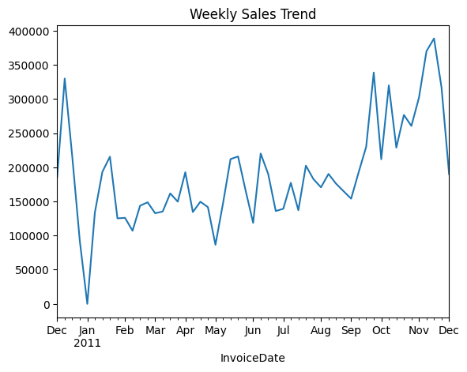
Seasonal Pattern: Particularly in 4th quarter, which is holiday period, an increase in sales observed.
Growth pattern: Overall positive trend throughout the period, suggesting business growth.
- Monthly aggregation: when aggregated to monthly level, patterns became clearer with peaks during holiday shopping periods.
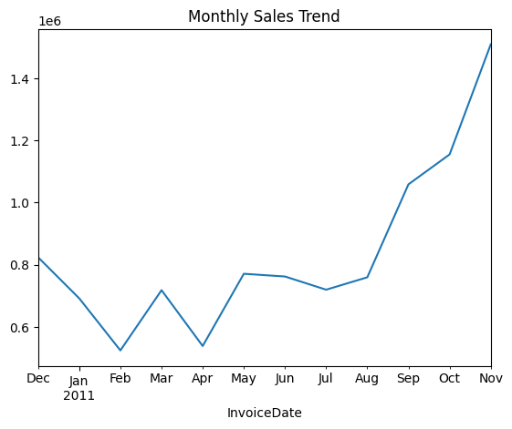

- Geographic Distribution
Top Market: United Kingdom is the largest market, followed by Netherlands, EIRE, Germany and France.
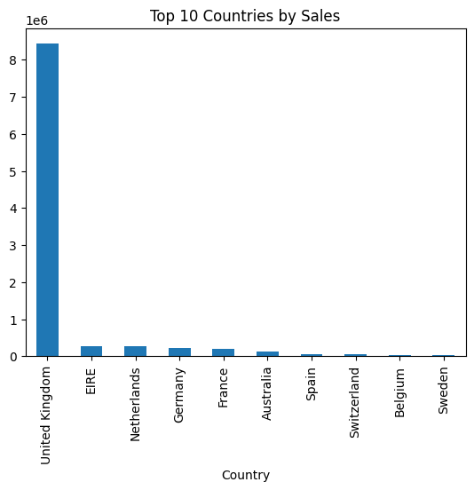
Market Concentration: top 10 countries accounted for approximately 60-70 % of total sales.
Geographic Diversity: Sales distributed across 38 countries, indicating global customer base.

- Product Analysis
Top Products: Traditional decorative items( top storage Jar, Gliders ASSTD, Red Retrospot, heart-light holder, cake case.
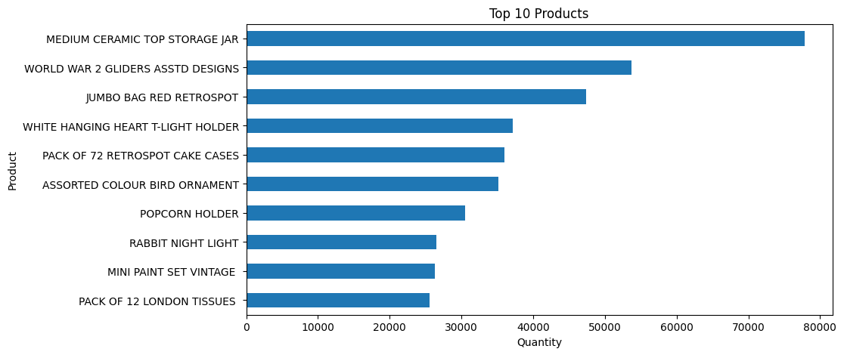
Product Diversity: 4372 unique stock codes indicating highly diversified product portfolio.
Sales distribution: Top 7-10 products generating most of the sales volume.

Data Splitting Strategy
The weekly observations were divided into train and test data following chronological order.
Training Set: First 41 weeks of data.
Test Set: last 10 weeks of data.
This approach confirms the model will be trained with the data of first 41 weeks and test it in the last 10 weeks to see the result.

Stationary Testing
Augmented Dickey-Fuller (ADF) Test
adf_result = adfuller(train)

print("ADF Statistic:", adf_result[0])
print("p-value:", adf_result[1])
print("Critical Values:", adf_result[4])

if adf_result[1] < 0.05:
print("Data is stationary")
else:
print("Data is NOT stationary")

ADF test was applied to training data to check the stationary.
- ADF Statistic: -3.398
- p-value: 0.0110
- Result: p-value < 0.05 → Data is Stationary
This result indicates the weekly sales series contains no unit root and exhibits stationary behavior, satisfying a key assumption for ARIMA modeling.

Differencing Analysis
Although statistically the data was stationary, differencing (d=1) has been applied in the model to improve the model fit and follow the upward trend, which results in less error and more accuracy.
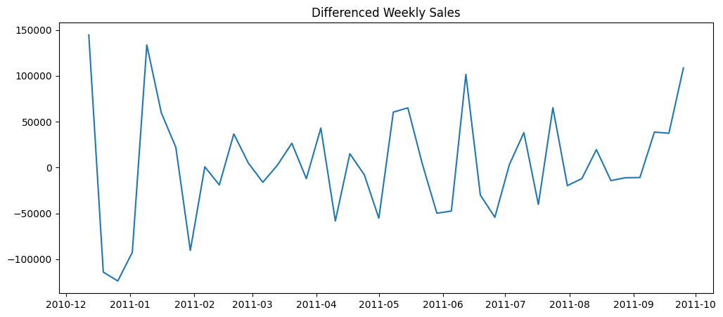
- First-Order Difference ADF Test:
  - ADF Statistic: -5.641
  - p-value: 1.04 × 10⁻⁶
  - Result: Highly stationary after differencing
Differencing enhanced stationarity further, suggesting that d=1 would benefit the ARIMA model.

ACF/PACF Analysis
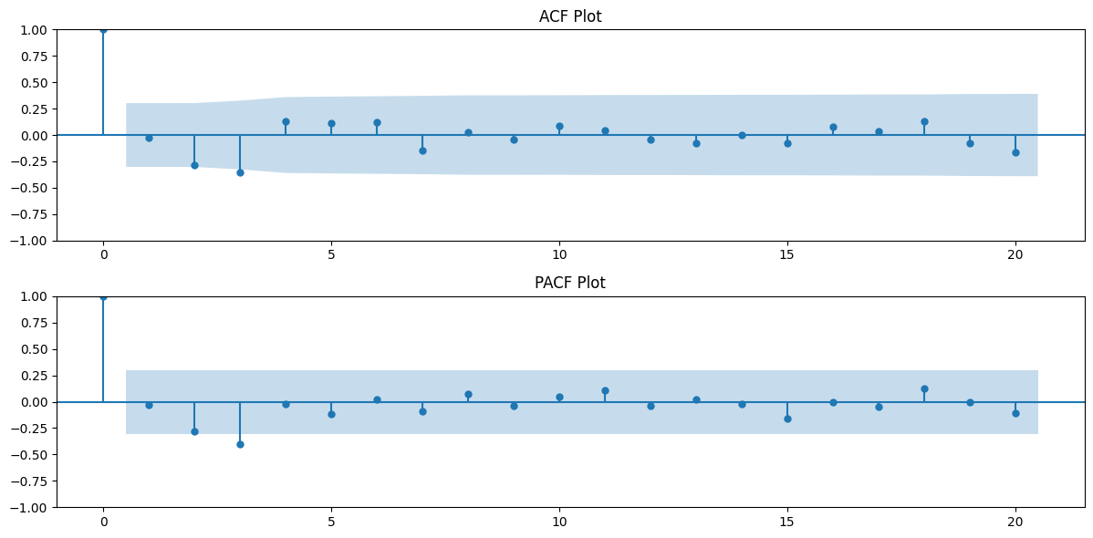
These two components are useful for time series analyzing models like ARIMA to understand how many lags are to be considered for the model.
- ACF(Autocorrelation Function) measures the correlation between values of a particular time and different lags. Suggesting the lag of the model or q value.

- PACF(Partial Autocorrelation Function) measures direct correlation, excluding the time in the middle. For example, correlation of today’s sales with the day before yesterday’s sales. Suggesting the p value.

Model Development

Double Exponential Smoothing
Model specification:
Trend: Additive
Seasonal: None
Implementation:
# fit model
model = ExponentialSmoothing(train, trend='add', seasonal=None).fit()
# Forecast and model
prediction = model.forecast(len(test))

Triple Exponential Smoothing (Holt-Winters)
Model Specification:
Trend: Additive
Seasonal: Additive
Seasonal period: 4 weeks
Implementation:
model2 = ExponentialSmoothing(train, trend= 'add', seasonal ='add', seasonal_periods= 4).fit()
prediction2 =model2.forecast(len(test))

ARIMA Models
- Auto ARIMA Implementation:
With the library Pmdarima automatic ARIMA parameter selection used to search minimum AIC. The auto-ARIMA tested multiple combinations of parameters.

ARIMA Order | AIC Value | Status
(2,0,2) | inf | Invalid
(0,0,0) | 1162.68 | Baseline
(1,0,0) | 1073.74 | -
(2,0,0) intercept | 1056.75 | Selected
(3,0,0) intercept | 1057.59 | -

Best parameter selected: ARIMA(2,0,0) with intercept (AIC = 1056.75)

- Manual ARIMA Implementation:
Analyzing ACF/PACF plots, manual ARIMA(2,1,0) model was selected.
manual_arima_model = ARIMA(train, order=(2, 1, 0))
manual_arima_result = manual_arima_model.fit()
manual_arima_pred= manual_arima_result.forecast(steps=len(test))
This specification incorporates:
- P = 2: Two autoregressive terms (captures recent history)
- d = 1: One differencing (removes trend)
- q = 0: No moving average terms (simpler, parsimonious model)

Practical Application and Results
All three models generate the last 10 weeks forecast on the test data. Results and performance of the models are as follows:

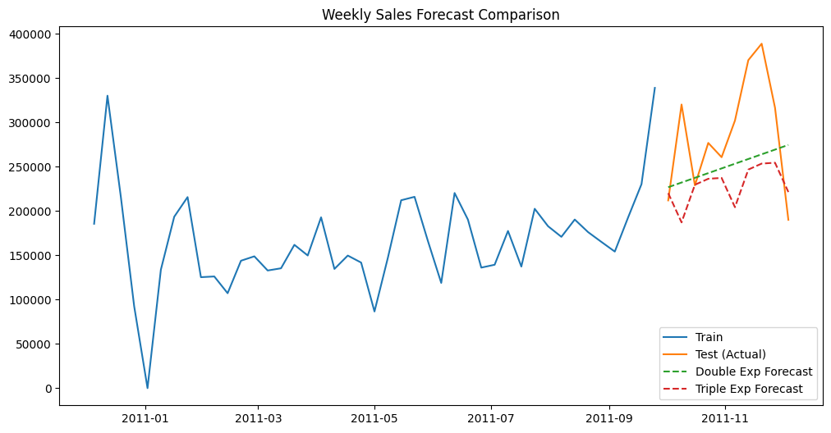

Double exponential Smoothing
- Forecast pattern: It followed a linear upward trend.
- Visual alignment: Alignment with the actual observations is moderate.
- Peak Capture: It could not capture the large spike of the test data and underestimated.

Triple Exponential Smoothing
- Forecast pattern: It tried to follow the upward trend with fluctuations.
- Visual alignment: Compared to Double exponential, it tried to match the speed of actual data.
- Peak Capture: though it tried to capture the fluctuating pattern, failed to catch the increase in sales in November.

Manual ARIMA(2,1,0) Model
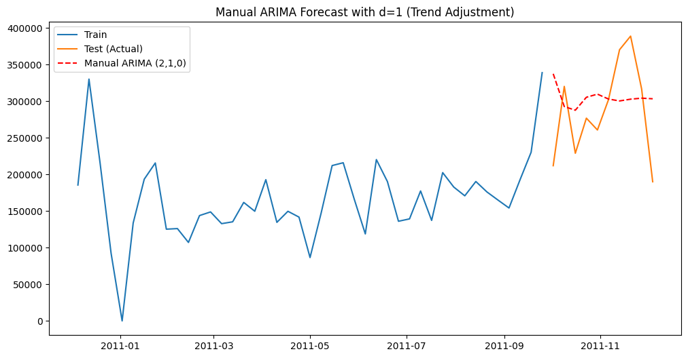
- Forecast Pattern: It incorporates trend in the model by differencing(d=1)
- Trend Capture: better trend prediction than Auto ARIMA.
- Visual Alignment: it produced upward sloping forecasts reflecting recent trends.

Quantitative Performance Evaluation

Double Exponential smoothing Performance

Metric | Value
MAE | £57,499.31
RMSE | £70,094.03
MAPE | 19.33%
Interpretation:
- Metric Values: In the model MAE is £57,499.31, RMSE is £70,094.03 and MAPE is 19.33%.
- Error Interpretation: Every week there are residuals of £57,499.31 on average.
- Penalty of Deviations: Higher RMSE £70,094.03 indicates that the model penalized big error.
- Relative Accuracy: 19.33% MAPE indicates that for trend-based forecasting this model is satisfactory.

Triple Exponential Smoothing Performance
Metric | Value
MAE | £65,575.88
RMSE | £82,394.31
MAPE | 20.61%
Interpretations:
- Metric values: MAE is £65,575.88, RMSE is £82,394.31and MAPE is 20.61 %.
- Comparison with Double Smoothing: Residual is larger than the Double exponential model.
- Sensitivity to Large Errors: Significant RMSE £82,394.3 indicates that this model is sensitive to big error.
- Seasonal Complexity: Slightly more MAPE (20.61%) indicates that adding seasonal pattern made the model complicated and accuracy has not improved.

Manual ARIMA(2,1,0) Performance

Metric | Value
MAE | £57,152.43
RMSE | £69,572.43
MAPE | 22.74%
Interpretation:
- Metric Values: In this Model MAE is £57,152.43, RMSE is £69,572.43 And MAPE is 22.74%.
- Comparison with Double Smoothing: MAE of this model(£57,152.43) is almost same as Double exponential model.
- Error Minimization: RMSE (£69,572.43) less than Double exponential which indicates it is effective to reduce large Error.
- Relative Accuracy: Higher MAPE (22.74%) suggests that percentage error increased, though Absolute Error are same.
- Trend and Volatility: Although differencing (d=1) incorporates the trend, it did not substantially improve accuracy.

Future Forecast with ARIMA
Next 10 weeks sales value has been forecasted with three model.
1. Double Exponential Smoothing (Full Data)
final_double_model = ExponentialSmoothing(weekly_sales, trend='add', seasonal=None).fit()
future_double_pred = final_double_model.forecast(10)

2. Triple Exponential Smoothing (Full Data)
final_triple_model = ExponentialSmoothing(weekly_sales, trend='add', seasonal='add', seasonal_periods=4).fit()
future_triple_pred = final_triple_model.forecast(10)

3. ARIMA (Full Data)
# We use the order (2,1,0) that you found effective
final_arima_model = ARIMA(weekly_sales, order=(2, 1, 0))
final_arima_result = final_arima_model.fit()
future_arima_pred = final_arima_result.forecast(steps=10)

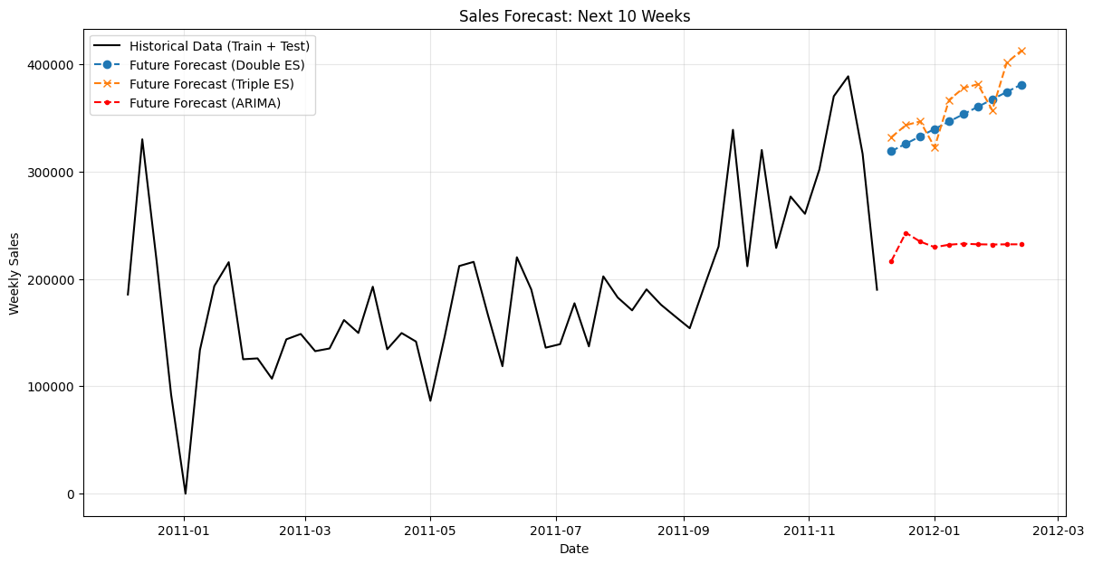

Key Findings
- No Dominant Model: No single model dominates across all metrics.
- Advantages of Exponential Smoothing based on Percentage: Double exponential smoothing showed best metric on MAPE, which suggests that model is more effective in proportional accuracy than actual accuracy.
- Advantages of ARIMA (2,1,0) in Absolute terms: Manual ARIMA succeeded in reducing the absolute error (MAE, RMSE), benefiting from Differencing the model.
- Ineffectiveness of the seasonal pattern: Triple Exponential model has worse performance result, which indicates that the 4 weeks seasonal patterns in the model are not appropriate with the actual data seasonality.
- Importance of Trend: In this dataset including the trend is more important than the seasonality.

Conclusion
Three time-series models have been applied to a real world online-retail dataset and analyzed their performance. Main results are following:
- Complexity in Model selection: in case of time-series forecasting, there should be balance in model’s simplicity, accuracy and explanation. No universally optimal model exists across all evaluation metrics.
- Appropriateness of Double exponential smoothing: Exponential smoothing method with trend component provides high interpretability, and accuracy with good baseline forecasting. Model’s MAE(19.33%) suggests reasonable accuracy for practical business applications.
- Limited Seasonal Benefit: Accuracy of forecasting has decreased after adding 4 weeks seasonal components. That indicates that the actual seasonal pattern of the data has not been matched with the model or effect of seasonal pattern is less than the trend.
- Effectiveness of ARIMA: With two autoregressive terms and first-order differencing, the ARIMA(2,1,0) model achieved the lowest absolute error(MAE = £57,152.43, RMSE= £69,572.43). Differencing confirms the importance of explicit term removal.
- Stationarity Confirmation: Though ADF testing suggested the training data is stationary, data differenced further to enhance the stationarity, supporting both ARIMA applicability and the benefit of the d=1 component.
- Trade-offs Error Metric: Different Metric for accuracy ranks the models, so it is important to select appropriate metric based on the business goal.
  - Absolute errors: ARIMA(2,1,0) superior
  - Percentage errors: Double exponential smoothing superior
  - Large deviation penalties: Manual ARIMA also superior

Limitations:
- Short sample period: Only one year data does not allow long term pattern, seasonality and the observations are also limited to capture.
- No External Variables: Models incorporate only historical sales data; external factors like marketing, competition, economic indicators are not included.
- Fixed Seasonal Period: The 4-week seasonal specification was predetermined; data-driven seasonal period identification might yield different results.
- Model Combinations Unexplored: This analysis did not explore SARIMA (seasonal ARIMA) or advanced methods like exponential smoothing state space models; these might yield better performance.

References
Noble, J. (n.d.). Introducing: ARIMA models. Retrieved from IBM : https://www.ibm.com/de-de/think/topics/arima-model
Charles, C. (2004). Forecasting seasonals and trends by exponentially weighted.
Hyndman, R. &. ((2021)). Forecasting: Principles and Practice. OTexts: Melbourne, Australia. Retrieved from https://otexts.com/fpp3/
Pandas Developement Team. (2014). Retrieved from pandas: Powerful Python Data Analysis Toolkit.: https://pandas.pydata.org/pandas-docs/version/1.3/
Preprocessing data. (n.d.). Retrieved from scikit-learn : https://scikit-learn.org/stable/modules/preprocessing.html
Robert H, S., & David S, S. (2017). Time Series Analysis and Applications.
Score functions, performance metrics, pairwise metrics and distance computations. (n.d.). Retrieved from sklearn.metrics: https://scikit-learn.org/stable/api/sklearn.metrics.html#
UCI Machine Learning Repository. (2015). Online Retail. Retrieved from https://archive.ics.uci.edu/dataset/352/online+retail
Wes, M. (2022). Python for Data Analysis.

