Device‑Bound PIN + Challenge/Response Verification – Full Technical POC Documentation

1. Executive Summary
This document provides a full technical explanation of the Proof of Concept (POC) for implementing a secure device‑bound authentication model using:
• Local device PIN (not stored on server)
• Locally generated ECDSA P‑256 private key
• Backend-based challenge generation
• Challenge signing on mobile
• Signature verification on backend
This method aligns with industry best practices (FIDO2-like, PSD2 SCA, banking-grade mobile security).

2. Solution Overview
The POC demonstrates a strong authentication workflow where the mobile application uses a device‑bound private key to securely sign a server‑issued challenge. The server validates the signature using the stored public key and authorizes the action.
Key principles:
• PIN stays on device only.
• Private key never leaves device.
• Backend validates signatures using public key.
• Challenge is one-time, time-limited, and tied to user/device.

3. High-Level Architecture
The architecture consists of the following components:
1. Mobile App (Flutter):
• Stores hashed PIN locally using PBKDF2.
• Generates ECDSA P-256 keypair.
• Sends public key to backend during registration.
• Signs challenge using private key.
2. Backend (Spring Boot):
• Stores user/device public keys.
• Issues unique challenges.
• Verifies signatures using stored public key.
• Returns SUCCESS/FAILED based on verification.
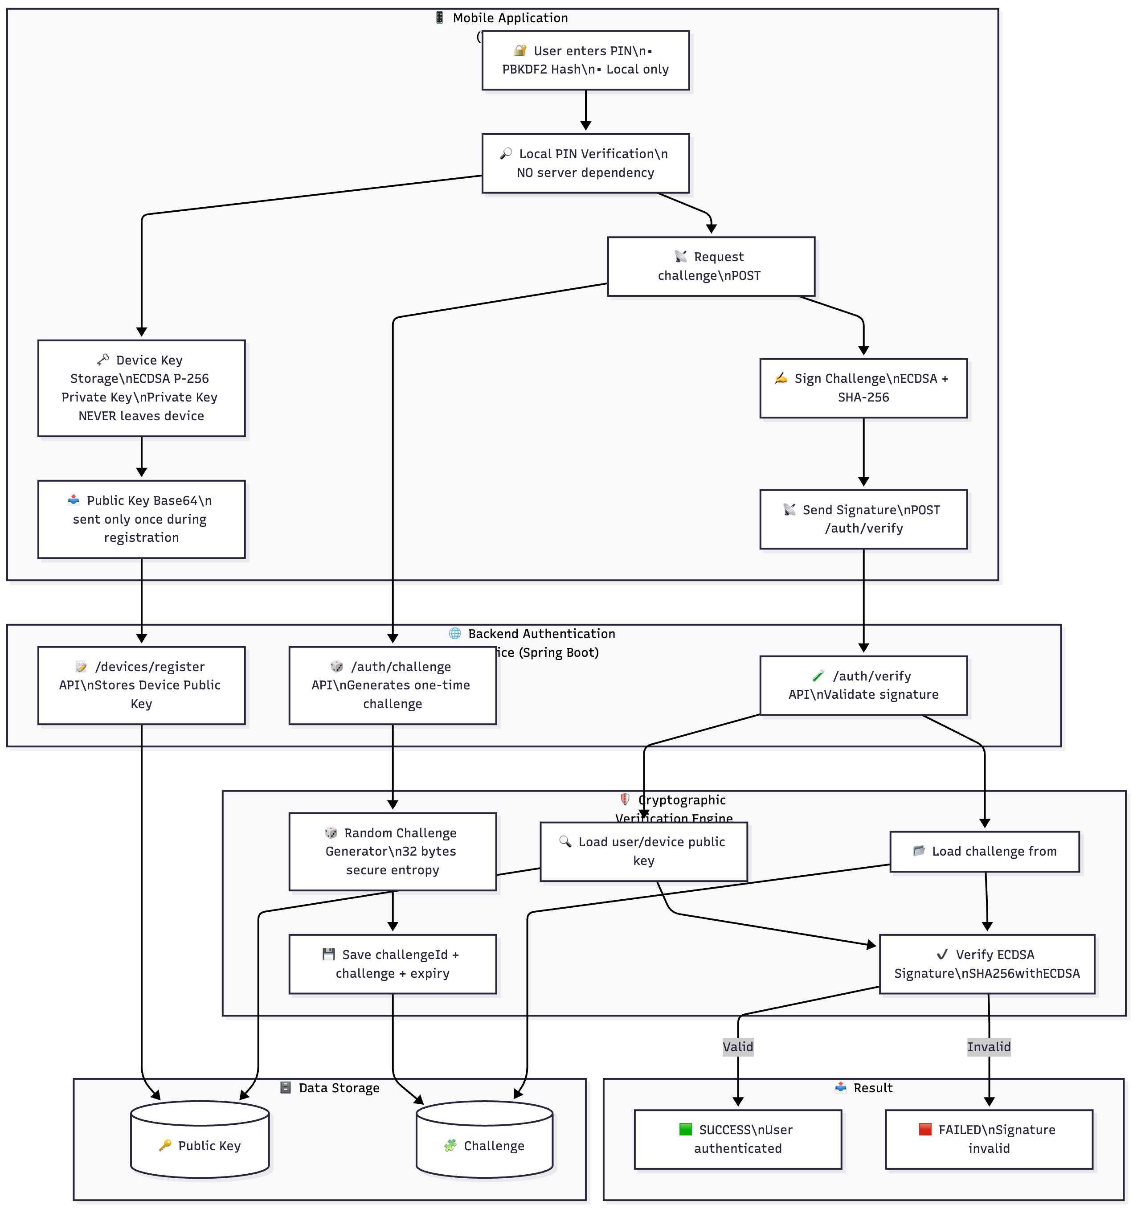

4. Complete Flow Diagram (Mermaid Format)
flowchart LR
A[User enters PIN] --> B[Mobile verifies PIN locally]
B -->|OK| C[Mobile retrieves device private key]
C --> D[Backend: /api/auth/challenge request]
D --> E[Backend returns: challengeId + challengeBase64]
E --> F[Mobile signs challenge using private key]
F --> G[Mobile sends: challengeId + signature to /verify]
G --> H[Backend loads stored public key]
H --> I[Backend verifies ECDSA signature]
I -->|Valid| J[Return SUCCESS + token]
I -->|Invalid| K[Return FAILED]
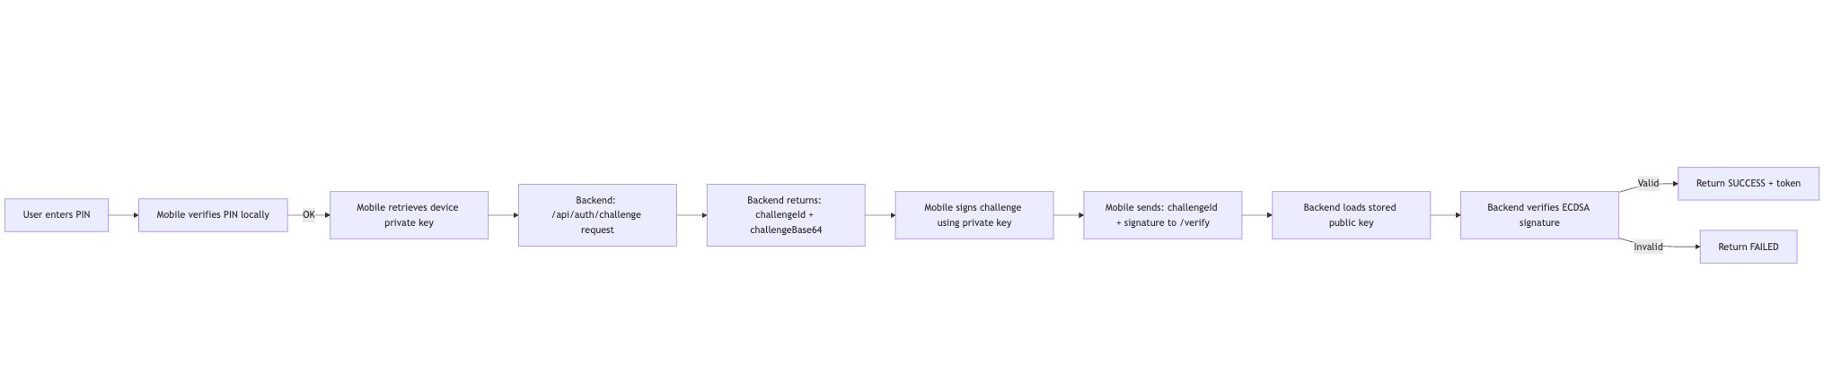

5. Full Sequence Diagram (Mermaid Format)
sequenceDiagram
participant User
participant Mobile
participant Backend
participant DB
User->>Mobile: Enter PIN
Mobile->>Mobile: Verify PIN (PBKDF2)
Mobile->>Backend: POST /api/devices/register (publicKey)
Backend->>DB: Store public key
Backend-->>Mobile: {status: REGISTERED}
User->>Mobile: Do Secure Action
Mobile->>Backend: POST /api/auth/challenge
Backend->>DB: Save challengeId + challenge
Backend-->>Mobile: challengeId + challenge
Mobile->>Mobile: Sign challenge (ECDSA P‑256)
Mobile->>Backend: POST /api/auth/verify
Backend->>DB: Lookup challenge & publicKey
Backend->>Backend: Verify ECDSA signature
Backend-->>Mobile: SUCCESS / FAILED
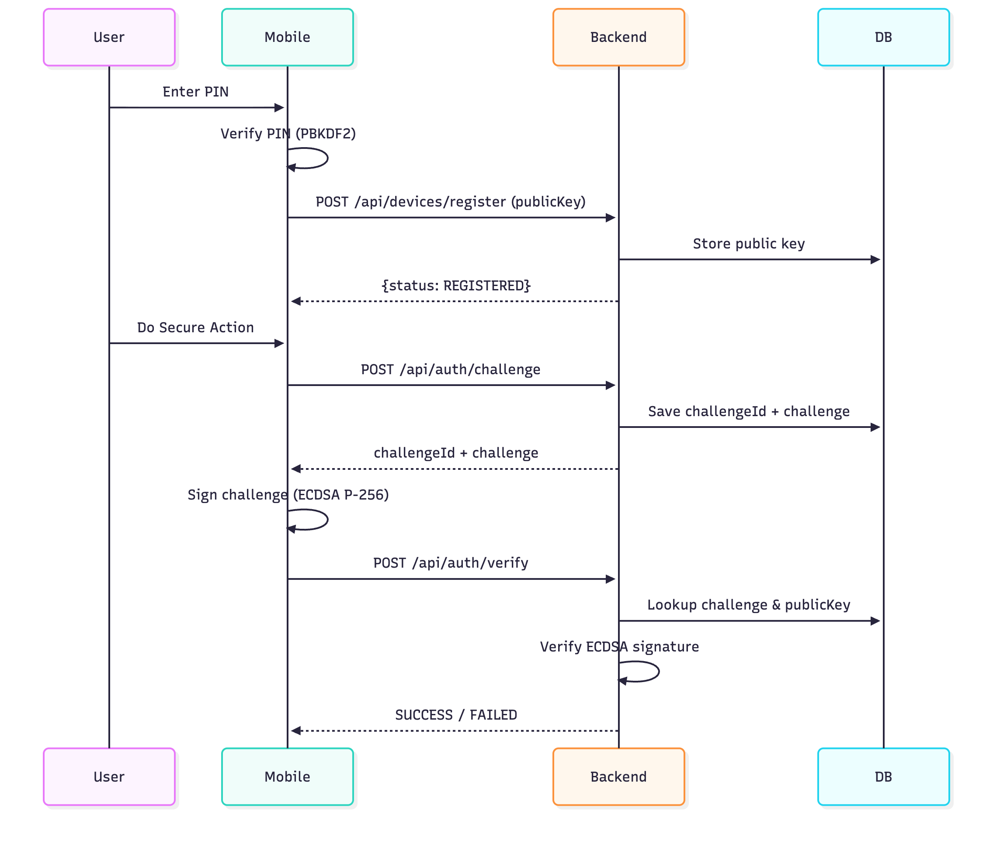

6. Detailed Technical Flow Description
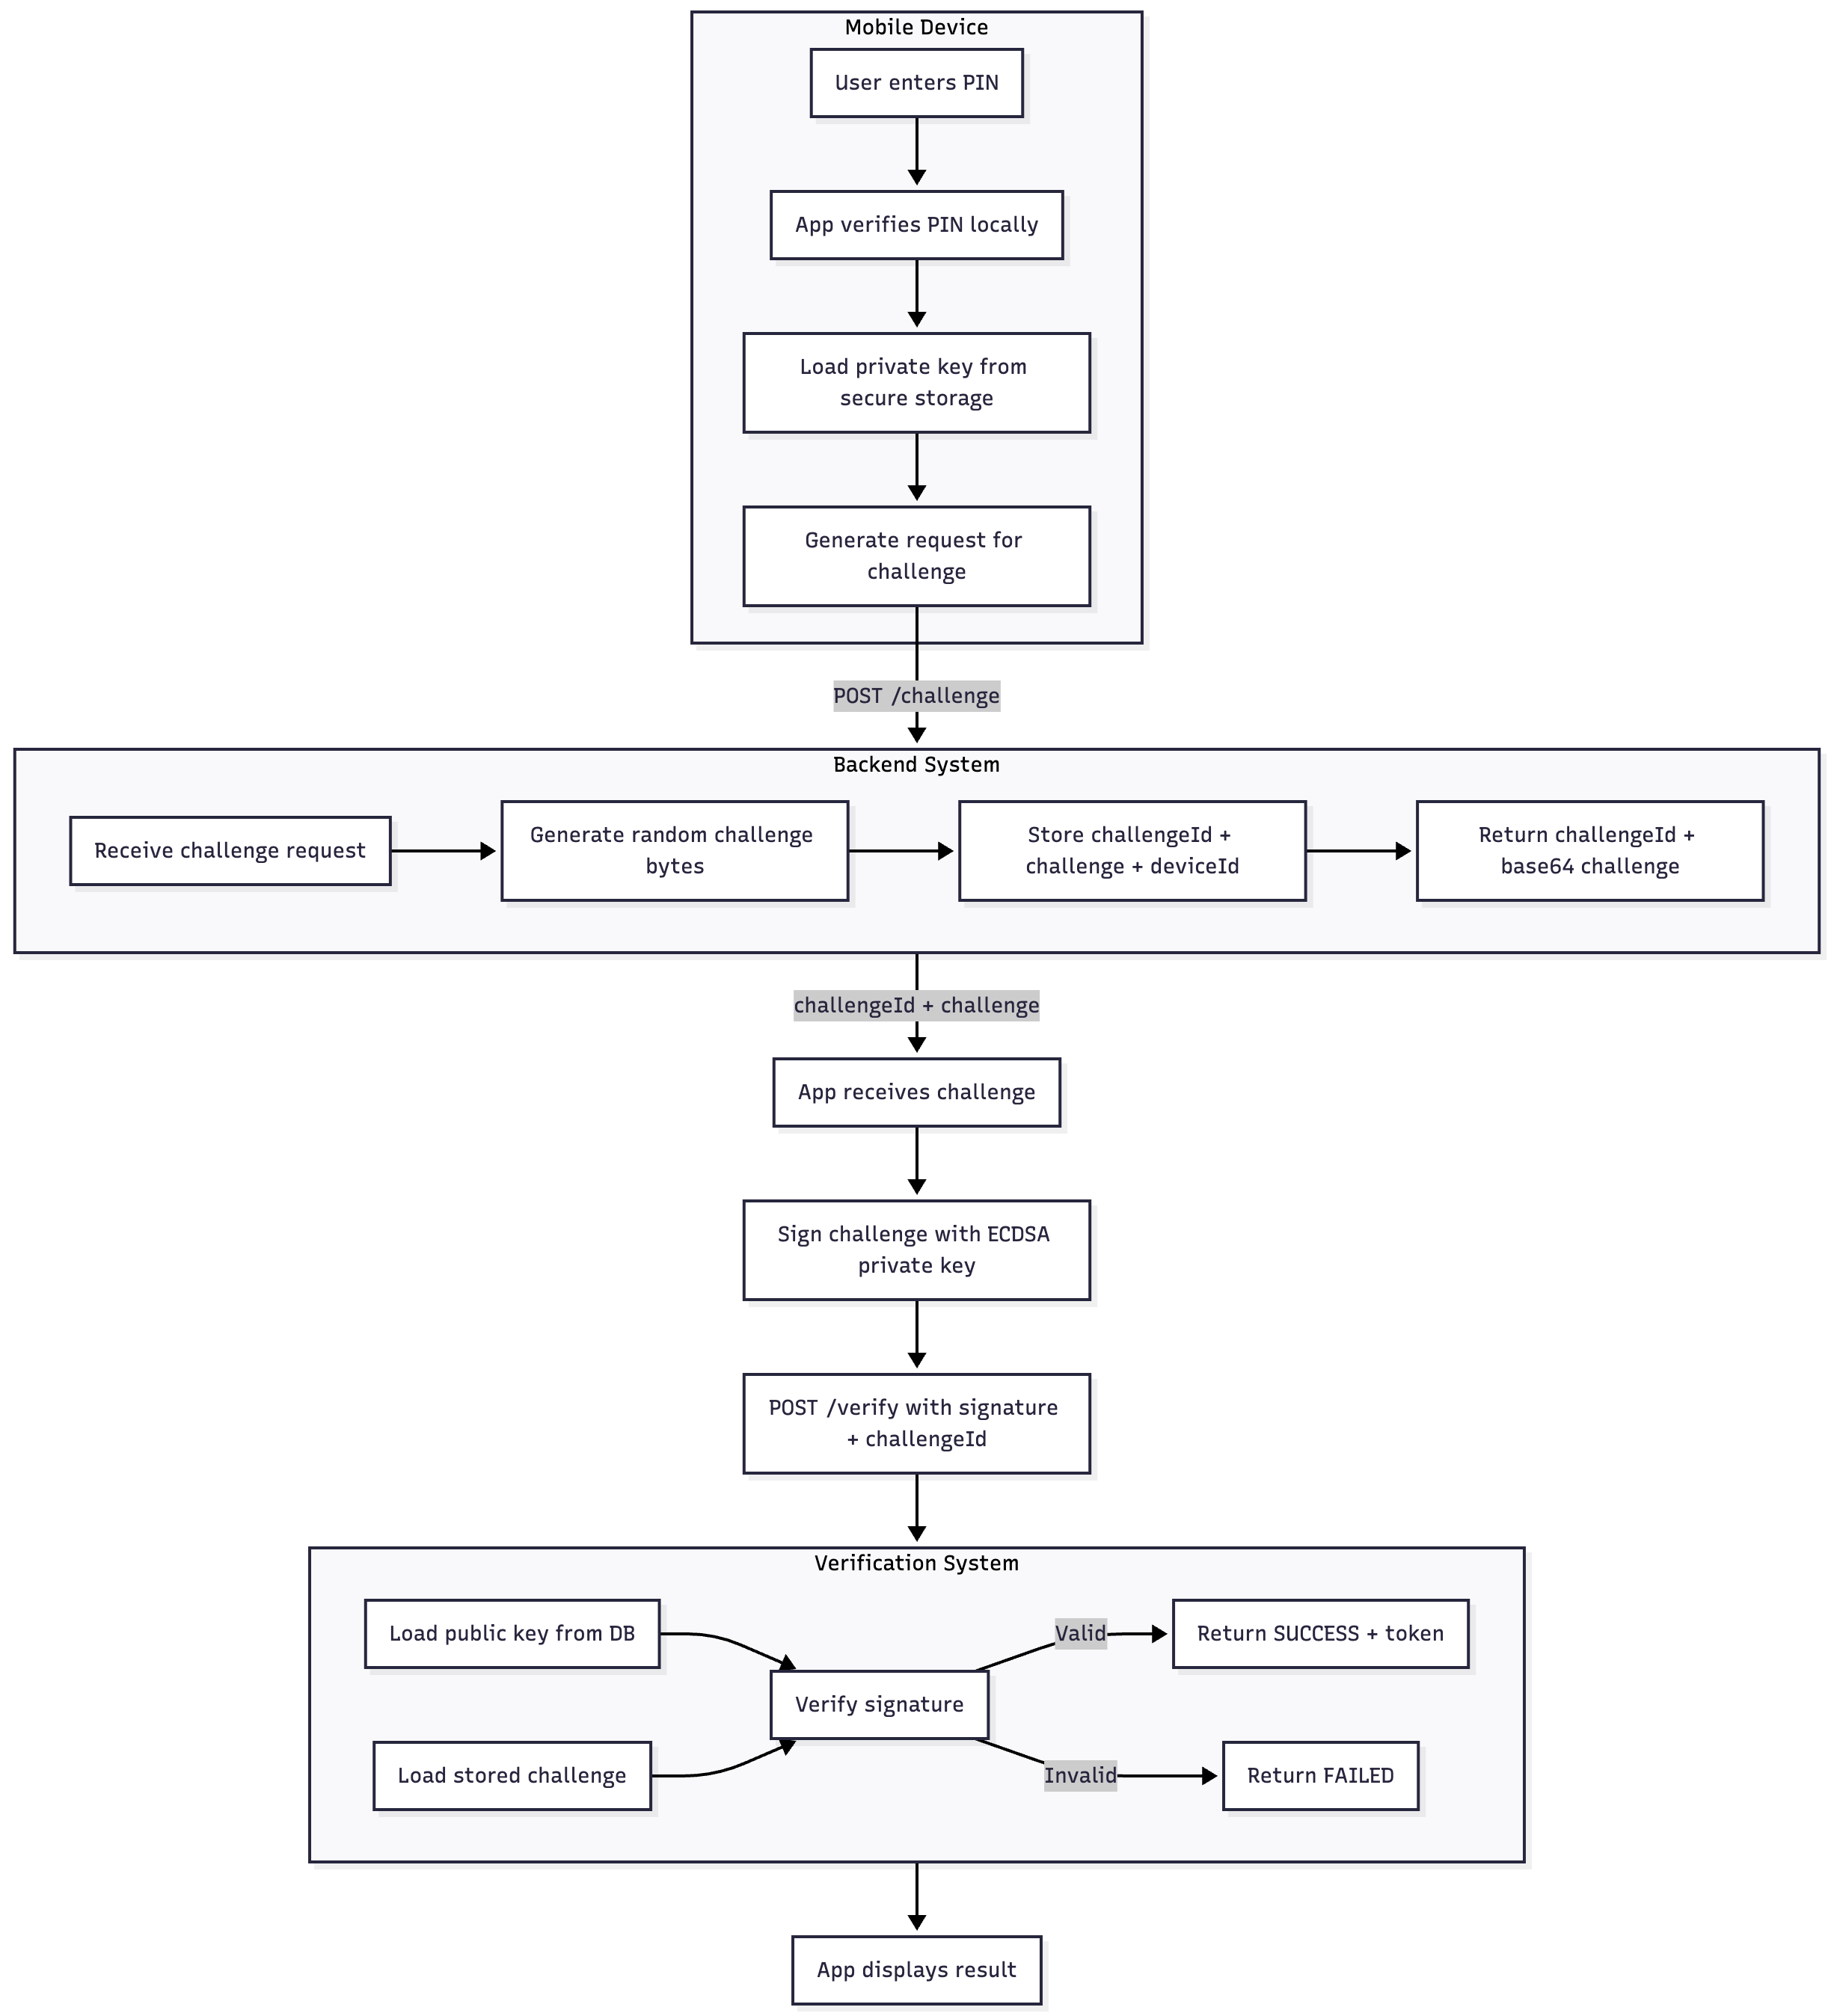

6.1 Device PIN Setup
• User creates a PIN.
• PIN is hashed with PBKDF2 + random salt.
• Only hash is stored (SharedPreferences for POC; Keychain/SecureStorage in production).
• PIN is used only to allow private key usage.

6.2 Device Keypair Generation
• App generates ECDSA P‑256 (prime256v1) keypair.
• Private key stored locally only.
• Public key Base64 encoded and sent to backend.

6.3 Device Registration API
Request:
{
"customerId": "123456",
"deviceId": "987654",
"publicKey": "BASE64"
}
The backend stores this in DB for later signature verification.

6.4 Challenge Request
Mobile calls /api/auth/challenge, server returns:
{
"challengeId": "uuid...",
"challenge": "BASE64_RANDOM_BYTES"
}
This challenge is stored in DB and expires after 60 seconds.

6.5 Challenge Signing
• App decodes challenge from Base64.
• Loads private key.
• Signs challenge bytes using SHA‑256/ECDSA.
• DER-encoded signature returned as Base64 string.

6.6 Verification API
Request:
{
"customerId": "123456",
"deviceId": "987654",
"challengeId": "uuid...",
"signature": "BASE64_SIGNATURE"
}
Backend loads:
• challenge bytes
• stored public key
Verification: successful = user authenticated.

7. Backend Verification Logic (Java Spring Boot)
Java verification logic:
Signature ecdsaVerify = Signature.getInstance("SHA256withECDSA");
ecdsaVerify.initVerify(publicKey);
ecdsaVerify.update(challengeBytes);
boolean valid = ecdsaVerify.verify(signatureBytes);
If valid → SUCCESS, else → FAILED.
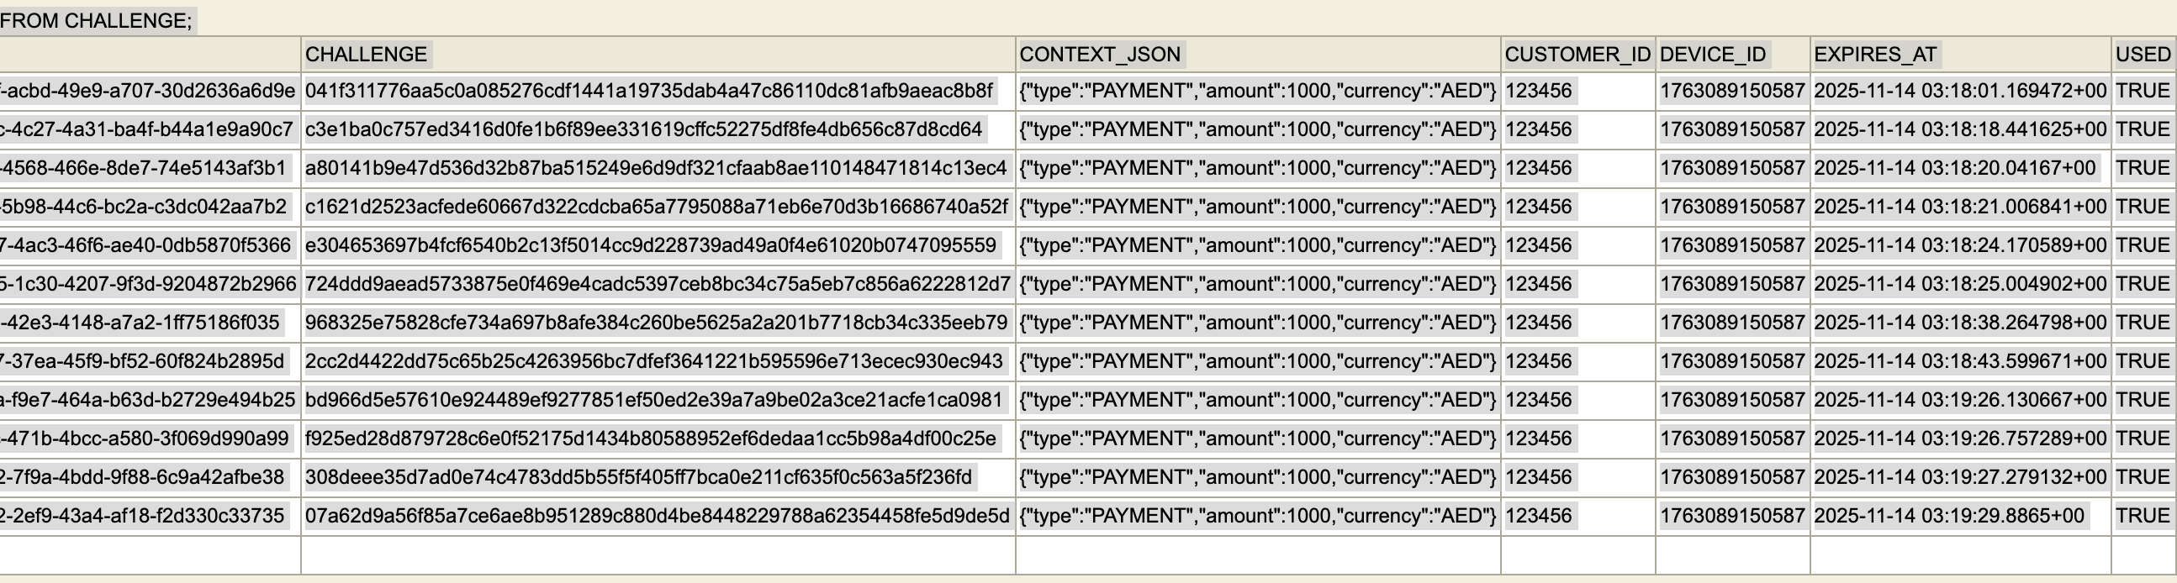

8. Security Model
• PIN never sent to server.
• Private key never leaves device.
• Challenge is one-time-use.
• Server-side verification prevents manipulation.
• Same model used by banking soft tokens.

9. Threat Model
Threats mitigated:
• Replay attacks → challenge one-time.
• MITM → signing verifies authenticity.
• Device clone → private key non-exportable.
• PIN brute force → local rate limits.
• Backend breach → cannot forge signatures.

10. Future Enhancements
• Bind challenge with amount + beneficiary.
• Use Secure Enclave / KeyStore.
• Add biometrics.
• Add push approval.
• Replace PIN with passkey for production.

11. Conclusion
This POC provides a complete, secure, and modern challenge/response authentication model that does not depend on proprietary SDKs. It is suitable for mobile banking, payments, soft tokens, and high-security workflows.
All Mermaid for Documentations: -

✅ 1. End-to-End Flow (High-Level Overview)
What happens from PIN entry → backend approval
flowchart TD

subgraph User_Device[Mobile Device]
A1[User enters PIN] --> A2[App verifies PIN locally]
A2 --> A3[Load private key from secure storage]
A3 --> A4[Generate request for challenge]
end

subgraph Backend_System[Backend System]
B1[Receive challenge request] --> B2[Generate random challenge bytes]
B2 --> B3[Store challengeId + challenge + deviceId]
B3 --> B4[Return challengeId + base64 challenge]
end

A4 -->|POST /challenge| Backend_System
Backend_System -->|challengeId + challenge| A5[App receives challenge]

A5 --> A6[Sign challenge with ECDSA private key]
A6 --> A7[POST /verify with signature + challengeId]

A7 --> Backend_System_Verify[Backend Verification]

subgraph Backend_System_Verify[Verification System]
C1[Load public key from DB]
C2[Load stored challenge]
C1 --> C4[Verify signature]
C2 --> C4[Verify signature]
C4 -->|Valid| C5[Return SUCCESS + token]
C4 -->|Invalid| C6[Return FAILED]
end

Backend_System_Verify --> A8[App displays result]

✅ 2. Sequence Diagram (Detailed Technical Flow)
Shows exact order of each action, API call, and signature verification.
sequenceDiagram
autonumber

participant User
participant Mobile
participant Backend
participant DB

User->>Mobile: Enter PIN
Mobile->>Mobile: Verify PIN locally (PBKDF2)
Mobile->>Mobile: Load private key

Mobile->>Backend: POST /api/auth/challenge
Backend->>DB: Save challengeId + challenge + deviceId
DB-->>Backend: OK
Backend-->>Mobile: challengeId + base64Challenge

Mobile->>Mobile: Decode challenge
Mobile->>Mobile: Sign using ECDSA private key
Mobile->>Backend: POST /api/auth/verify\n{challengeId, signature}

Backend->>DB: Fetch publicKey + challenge
DB-->>Backend: Data

Backend->>Backend: Verify signature with publicKey

alt Signature valid
Backend-->>Mobile: SUCCESS + token
Mobile->>User: Show approval successful
else Invalid signature
Backend-->>Mobile: FAILED
Mobile->>User: Show error
end

✅ 3. Device Registration Flow (One-Time Setup)
Only happens once per device
flowchart LR

U[User Opens App] --> G1[Generate ECDSA P-256 Keypair]
G1 --> G2[Store Private Key (Local Only)]
G2 --> G3[Encode Public Key (Base64)]

G3 -->|POST /devices/register| B[Backend]
B --> D[(DB: Store publicKey + deviceId)]
D --> B
B --> U2[Return REGISTERED]

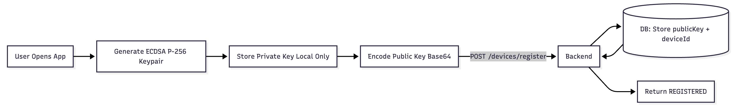

✅ 4. Challenge Signing Flow (Critical Part)
Mobile does NOT verify; only signs. Backend always validates.
flowchart LR
C1[App receives challengeId + challengeBytes]
C1 --> C2[Decode Base64 challenge]
C2 --> C3[Load ECDSA private key]
C3 --> C4[SHA-256 hash + ECDSA sign]
C4 --> C6[DER encode signature]
C6 --> C7[Base64 encode signature]
C7 -->|POST /verify| S[Backend Verification]

✅ 5. Backend Verification Flow (Cryptographic Check)
flowchart TD

V1[Receive challengeId + signature] --> V2[Load challenge from DB]
V2 --> V3[Load device public key]
V3 --> V4[Convert signature from Base64 DER]
V4 --> V5[Verify ECDSA(SHA-256)]

V5 -->|Valid| V6[Return SUCCESS + token]
V5 -->|Invalid| V7[Return FAILED]
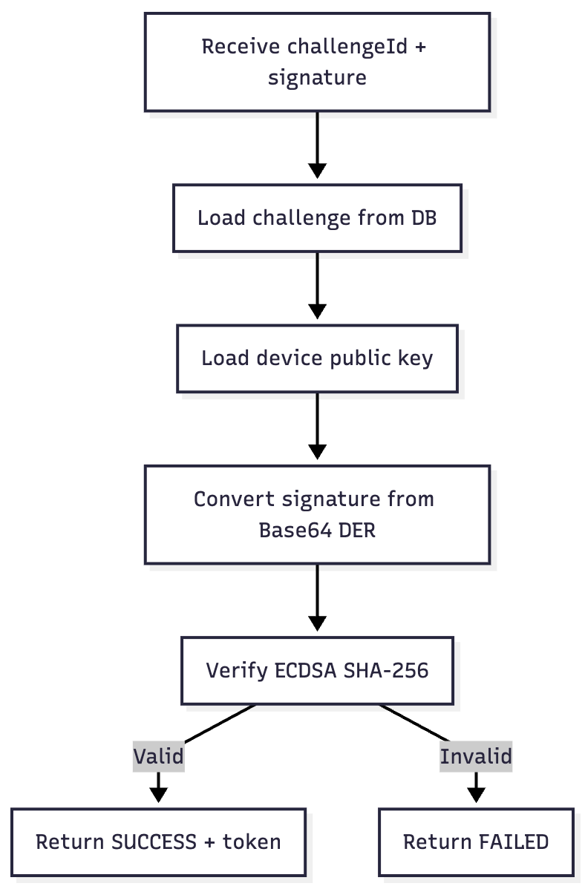

✅ 6. Security Architecture Diagram
flowchart LR

subgraph Device
PIN[PIN Local Only]
PK[Private Key Local Only]
PUB[Public Key Uploaded Once]
CHALLENGE[Sign Challenge]
end

subgraph Server
DB[(Public Key Store)]
GEN[Generate Challenge]
VERIFY[Verify Signature]
end

PIN --> PK
PK --> CHALLENGE
CHALLENGE --> VERIFY
DB --> VERIFY
GEN --> CHALLENGE
PUB --> DB
