EXPERIMENT 3:
Aim: Write the SQL queries to demonstrate the application of DDL commands like ALTER, DROP, and TRUNCATE.
ALTER Command-
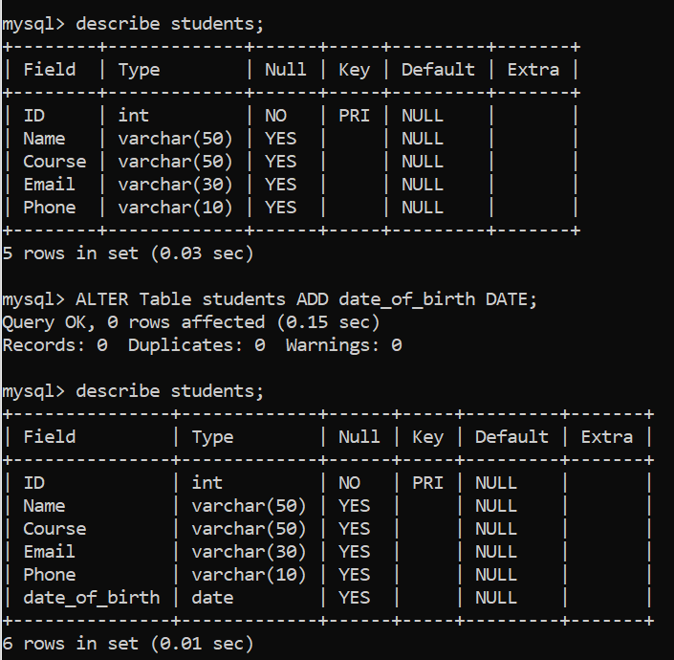
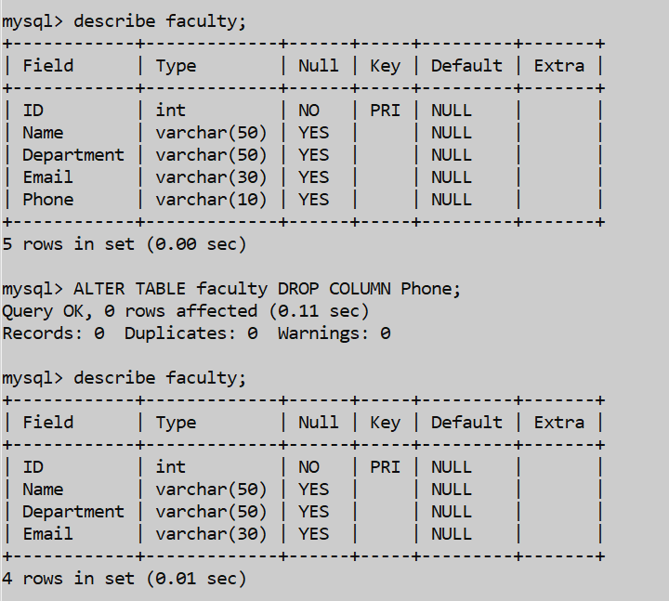
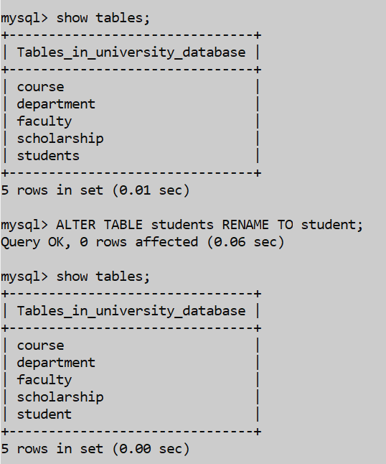
DROP Command-
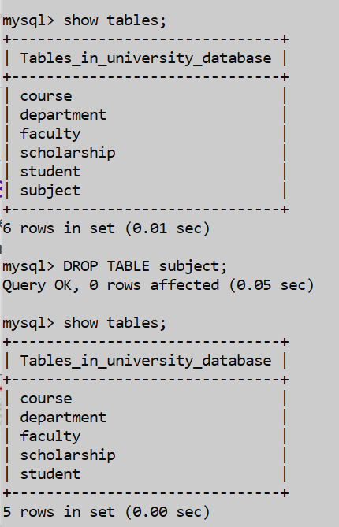

TRUNCATE Command-
