**Just spend 15 min to complete Xamarin and Azure Functions Challenge**

I have successfully completed Xamairn Azure Function Challenge and the goal of challenge is to create a serverless Azure Function and connect it to a Xamarin mobile app. You can refer one of my [previous](https://www.c-sharpcorner.com/article/building-serverless-mobile-app-with-azure-functions-using-xamarin-forms/) article for Building Serverless Mobile App With Azure Functions Using Xamarin.Forms.

Are you interested to do? if xamairn setup is ready in your machine then spend only 15 min for complete the challenge, otherwise it required some prerequisites installation setup. Follow the below steps.

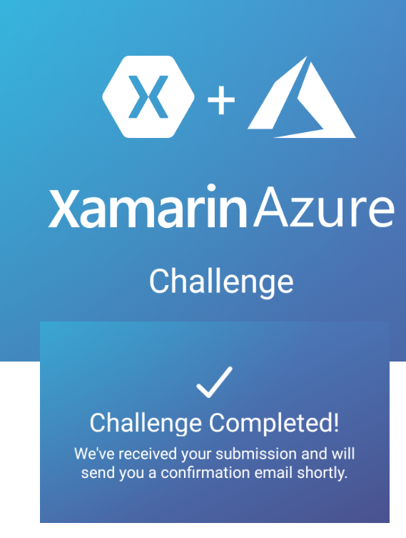

**Challenge Information:**

* **Duration**: The challenge begins 23 September 2019, and ends on 23 October 2019.
* **Prize:** 
  + Ten (10) Grand Prizes:Each winner will receive Microsoft Surface Headphones
  + One Thousand (1,000) Prizes: Each winner will receive a 3-month Xbox Game Pass

**Prerequisites:**

* You can use any Windows or macOS for development.
* On Windows, Download and install Visual Studio 2019 Community (i.e. free) with the Xamarin workload using our Xamarin-optimized installer.
* On macOS, Download and install Visual Studio 2019 Community for Mac.
* To deploy and run your Azure Functions, you first need an Azure account. You can sign up for a FREE account [here](https://azure.microsoft.com/en-us/free/dotnet/).

**Start the Azure Functions Challenge:**

**Task 1**: Clone Xamarin Azure Challenge project from [github](https://github.com/xamarin/XamarinAzureChallenge.git) repository.

**Task 2**: On Windows Machine, refer [here](https://github.com/xamarin/XamarinAzureChallenge#2a-use-visual-studio-on-pc) for publish the Azure function or if mac machine, refer [here](https://github.com/xamarin/XamarinAzureChallenge#2b-use-visual-studio-for-mac) for publish the Azure function

**Task 3**: [Configure](https://github.com/xamarin/XamarinAzureChallenge#task-2-configure-azure-function) the Azure function to the Azure portal.

**Task 4**: [Configure](https://github.com/xamarin/XamarinAzureChallenge#task-3-configure-the-xamarin-app) the Xamarin App.

**Task 5**: [Run](https://github.com/xamarin/XamarinAzureChallenge#task-4-run-the-xamarin-app) the Xamarin application using iOS or Android Platform .

**Congratulations:**

Provide the Basic your information, accept the terms and click on submit. You've successfully completed the Xamarin Azure Challenge. You will get email very shortly. All the best

