80 PWM generation and regulation of DC to DC converter using fuzzy logic controller
Author(s)
Affiliation

Abstract
DC–DC converter plays prominent roles today in generating smooth switching of the electrical and electronic circuit switches. The ON-OFF switching of the gates of the converters is electronically triggered by generation of pulse width modulation (PWM) either through controllers such as conventional proportional-integral-derivative (PID) controller or fuzzy logic controller using suitable algorithms. In this study a dc/dc buck/boost converter has been used for regulation of output-voltage using fuzzy logic controller. With the appropriate fuzzy logic based algorithms the required PWM and its duty cycle have been smoothly and successfully generated with the help of which the required output voltage of the converter circuit for both the buck and boost mode have been achieved. The scheme has the vast scope of implementing using DSP/PIC microcontroller future for the smooth turning ON-OFF with high switching frequency which will be suitable regulation of solar PV output voltage.
Keywords: Fuzzy Logic Controllers, pulse-width modulation, Proportional-Integral-Derivatives

I. Introduction
With the use of suitable controlling technique, dc/ dc converter has high potential of being used as switching regulator to regulate the desired DC output-voltage by use of pulse-width-modulation to control the way of switching to metal oxide field effect transistor (MOSFET) of Buck/Boost circuit. By altering the duty-cycle (D) of the MOSFET with appropriate switching-frequency, the outputvoltage (V₀) across the load can be increased or decreased depending upon our requirement [1. 2]. Using a particular reference voltage, the output voltage has been compared thereby making the DC/DC buck-boost converter closed loop as it has high performance efficient than that of open loop. With the feedback of output voltage, the uncertainties and disturbances occurred in power semiconductors leading to fluctuating output is regulated by controlling the PWM. Such type of scheme can be easily implementing using hardware of DSP processor for the proper ON-OFF of MOSFET with high switching frequency for the regulation of solar PV output voltage. There are various algorithms to generated PWM to control the converter and these techniques include PID control. However, the PID controller is linear one due to which it finds difficult for controlling the non-linear signals occurs in the DC-DC converter [3, 4]. Fuzzy-logiccontroller (FLC) being a nonlinearity in controlling is most commonly applied techniques for nonlinear applications particularly in photovoltaic (PV) controlling and is much better than PID controller. Fuzzy logic controllers do not require precise information about the system but it works based on approximation in modeling. FLC is flexible and robust one as more and more new fuzzy rules can be supplemented /added onto it. Hence fuzzy logic control provides smooth and enhanced switching pulse control which in turns controls the output of the converter which is more robust than other controls techniques. [5–10]. The fuzzy logic controller with appropriate fuzzy rules coupled with suitable method for diffuzification is nonlinear but easy and faster that too without going through details of the system parameters as that of other methods involves which includes PID controller associating with complicated circuit parameters of system like photovoltaic cell etc.
In this paper, Fuzzy logic controller with control rules of fuzzy based on Mamdani type with center of gravity for defuzification have been used for achieving the required PWM so that duty cycle of for keeping ON-OFF to MOSFET is easily made for the smooth regulation of the voltage-output of DC converter for a value of reference-voltage (V_{ref}). The DC-DC buck boost converter having a static loads has been provided in section 2 and 5 Membership-functions (MF) and a fuzzy-rule Table have been discussed in the Section 3 [7, 8]. Hence unlike linearity in conventional controller finding difficult for handling non-linear signals, Fuzzy-logic-controller (FLC) due to its nonlinearity in nature is preferably accepted applied techniques in controlling the nonlinear uses and have bright scope of doing further researches in fuzzy world. For convenient this paper has been organized into five sections ahead namely Section 1–5, respectively.

II. DC–DC Buck-Boost converter
The DC-DC converter-model having the parameters as provided in Table 80.1 have been used for the purpose of simulation in Sim-Power-Systemtool box of the Matlab library. The converter has input-voltage-source (V_{in}) a MOSFET-M, inductor-L, diode-D₁ a capacitor-C for filtering and a load-resistance (R₀). When M is turned On, the input/voltage (V_{in}) linked to L. The D being in its reverse biased mode does not conduct. Hence the voltage drop across the element L is equal to input voltage.
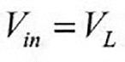 (1) Thereafter, the current flowing the inductor (L) starts increasing and hence the capacitor (C) produces output voltage (V₀) across the load (R₀). The moment switch (M) is turned-OFF, Then the diode (D) is in forward-biased and the D₁ start conducting and thereby provides a complete circuit for the flow of current through the inductor (L) [11–18]. Then voltage (V_{L}) across the inductor(L) is equal to output voltage.
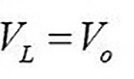 (2)
The change in the inductor (L) current should be zero over one-switching complete cycle. Hence the voltage-second balance equation as
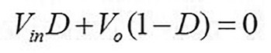 (3)
D being the duty ratio expressed as 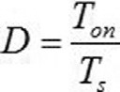, T_{on}
being ON-STATE-time of M and T_{s} is the switching-time-period. Using Equation (3), we got

Buck-Boost converter
Input power | 55 W
Output power | 52.3 W
Min. input voltage | 12 V
Max input voltage | 14 V
Output voltage | 12 V
Output current | 4.35 A
Load resistance | 2.75 Ω
Switching frequency | 10 khz;
Diode volt drop 0.6 V
Min inductor (L) at D=0.5 34.5 μH
Capacitor (C) 145 μF,
Initial voltage of capacitor -2 V
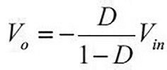
Table 80.1 Details of the converter
(4)

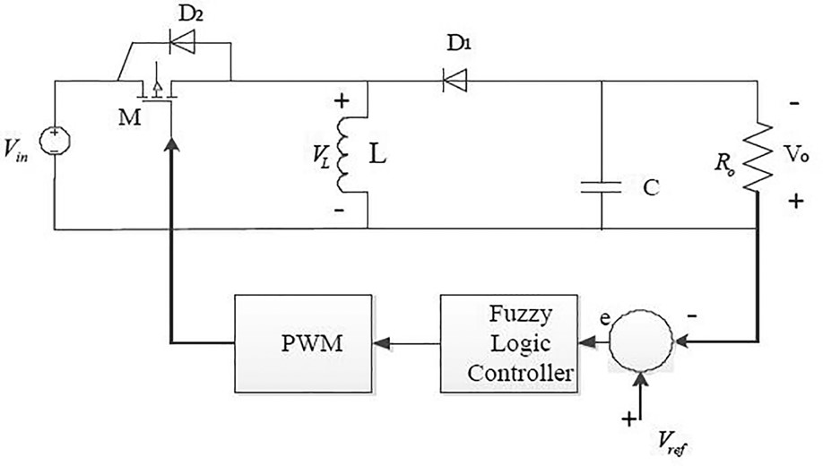
Figure 80.1 DC-DC buck-boost converter with static load

Hence, the Equations 1 and 2 indicates the energy being transferred from L to R₀ via C. Figure 80.1 shows the closed loop DC/DC converter with fuzzy logic block. The V₀ and V_{ref} are compared for the generation of error-signal. Now comparing these signals with a given saw tooth signal, required PWM which drives the switching of MOSFET. For the purpose of simulations, the required parameters of DC/DC converter being used were taken in Table 80.1 and converter is shown in Figure 80.1.

III. Fuzzy logic controller
The FLC have been used for PWM generation in concurrent with the tracking of corresponding response in a given reference value of voltage. The indicative block-diagram (BD) for FLC with the converter is as provided at Figure 80.2 [10].
The desired output-voltage of buck/boost converter is achieved by controlling the duty cycle using fuzzy algorithms. Here error means the difference of reference-voltage (V_{ref}) and the out-put voltage (V₀). If is V_{ref} and y(k) is Vo values then the error of voltage signal is expressed as follows:
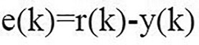 (5)
The change in error of voltage signal (∆e) is also given by

458 PWM generation and regulation of DC to DC converter using fuzzy logic controller
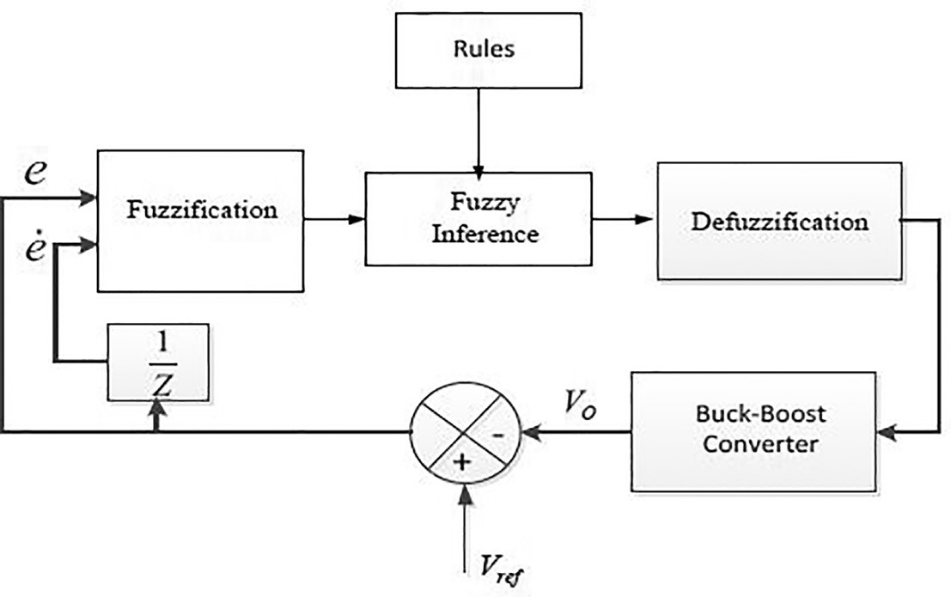
Figure 80.2 BD of fuzzy logic controller
Table 80.2 Fuzzy rules-Mamdani fuzzy rules with center of gravity method for defuzzification
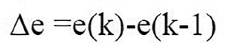
(6)

the output (duty-cycle). The generated PWM are
provided in Figures 80.7– 80. 80.9.

e
PB
e
∆
PS
Z
NS
NB
NB
NS
Z
PS
PB
Z
Z
Z
Z
Z
PL
PL
PH
PH
NL
PL
PL
PH
NL
NL
PL
PL
PL
NL
NL
NH
NH
NH
NL
NL

In this fuzzy techniques, first the error and the change in error are made compatible for generation of fuzzy sets in the fuzzifier. Duty cycle signals output and resultant fuzzy sets is then converted into the corresponding CRISP values having highest degree of membership function (MF) being 1.0 in the fuzzy sub-sets. The input membership functions being NB-Negative Big, NS-Negative Small, Z means Zero, PS – Positive Small, PB – Positive Big and the output membership functions being NH means negative high, NL means negative low, Z means zero, PL means positive low and PH positive High respectively. The MF of Input and Output fuzzy-variables are provided in Figures 80.3– 80. 80.5, respectively.
The FLC flowchart and control rules of fuzzy algorithms provided in Figure 80.6 and Table 80.2 of Mamdani fuzzy rules with adoption of centroid method for defuzzification is adopted to determine

IV. Results and discussions
- For Buck-mode: Taking Vref = 13 V and Vin = 14 V the output-voltage (V₀) is calculated. Rise time (T_{r}), peaktime (T_{p}), peak overshoot (M_{p}) and settling time (τ_{s}) the simulation-result of output, the output-voltage (V₀) of the converter using FLC shown in Figure 80.10.
Results: T_{r}= 0.0011s, T_{p}= 0.00175 s, M_{p} = 0.1V, τ_{s}= 0.005 s.
Discussions: Hence the output voltage have been successfully tracked as per reference voltage of 13 volt and thereby buck mode of the converter is regulated.
- For Boost-mode: Taking Vref = 29 V and Vin = 14 V the output-voltage (V₀) is calculated. The

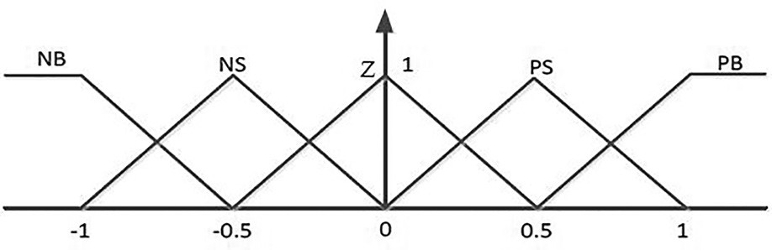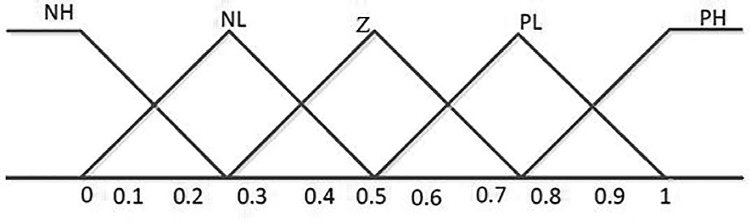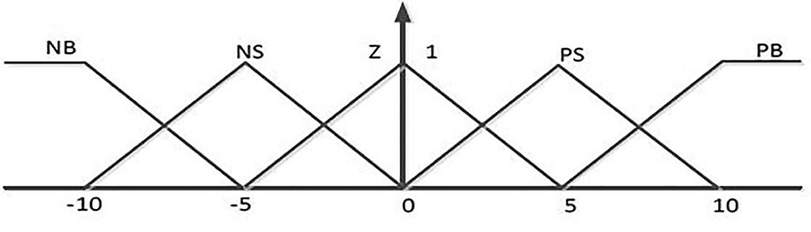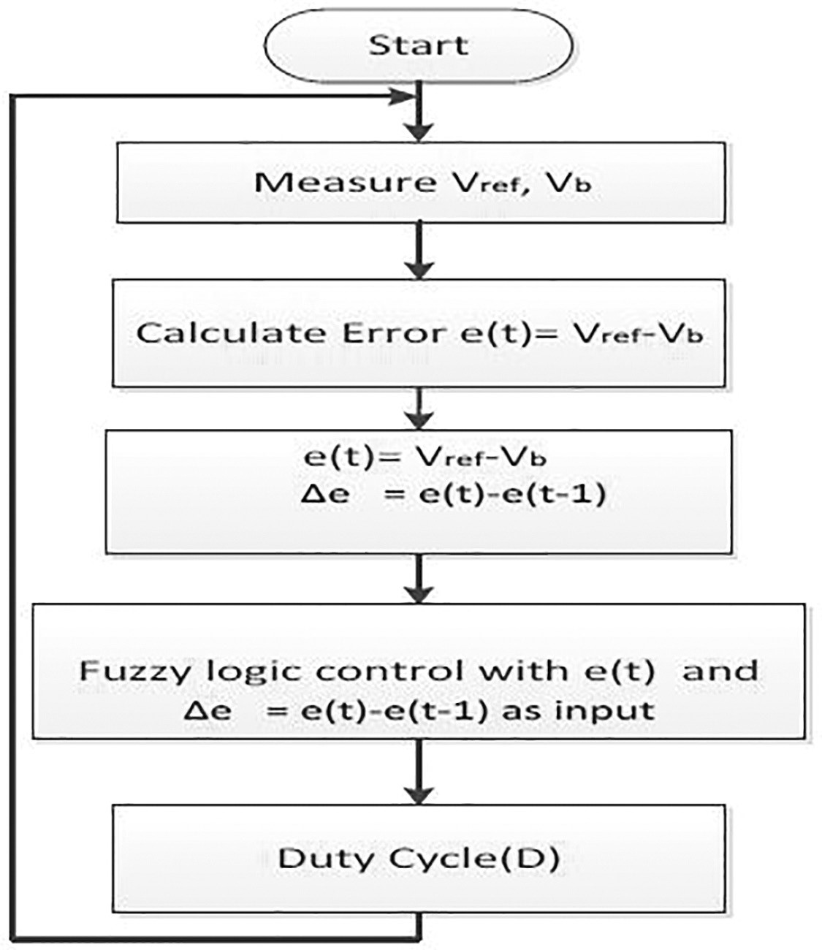
Figure 80.4

MF of change in error
Figure 80.3

MF of error
Figure 80.6

FLC algorithm flow chart
Figure 80.5 Membership function (MF) of outputduty cycle
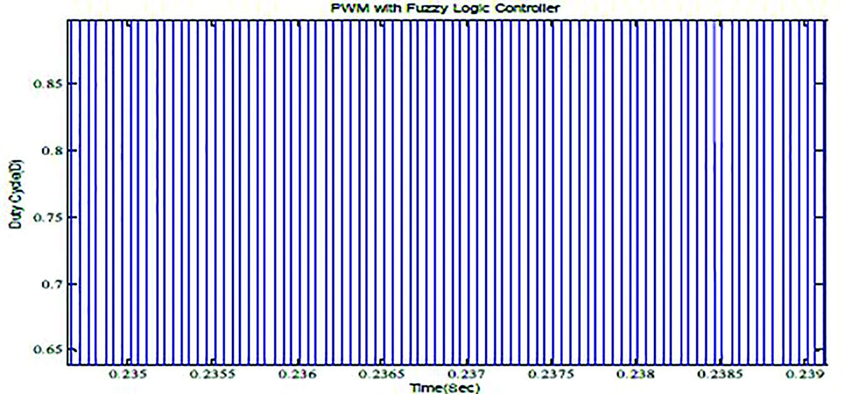
Figure 80.7 PWM output FLC

Figure 80.8 PWM output with fuzzy logic controller at 14.8% duty cycle

460 PWM generation and regulation of DC to DC converter using fuzzy logic controller
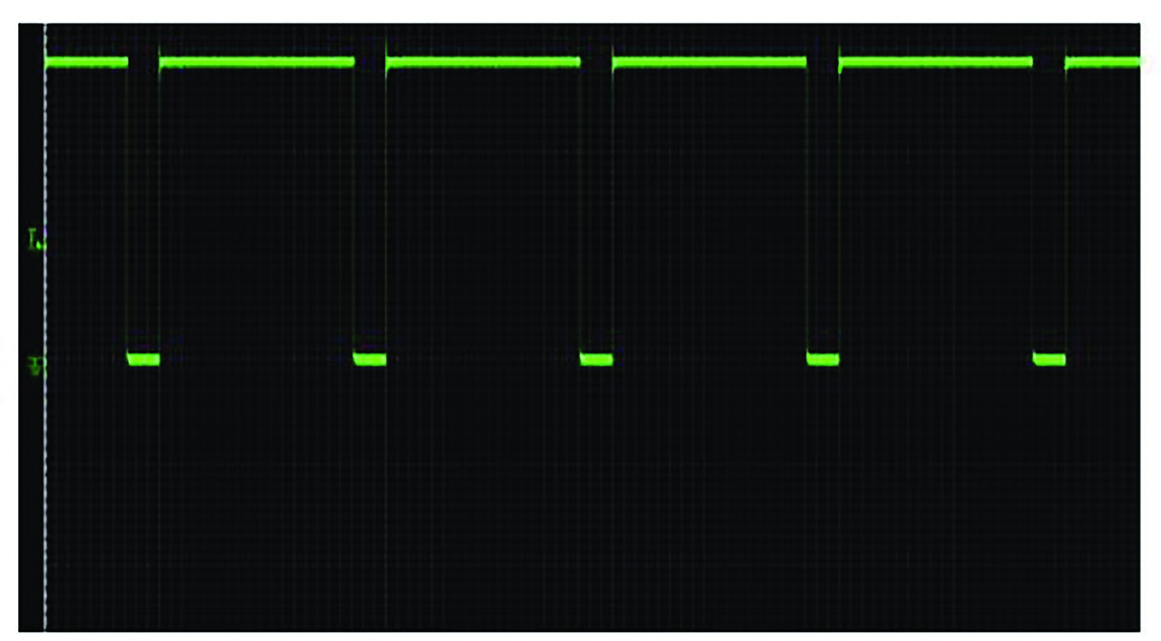
Figure 80.9 PWM output with fuzzy logic controller at 85.8% duty cycle
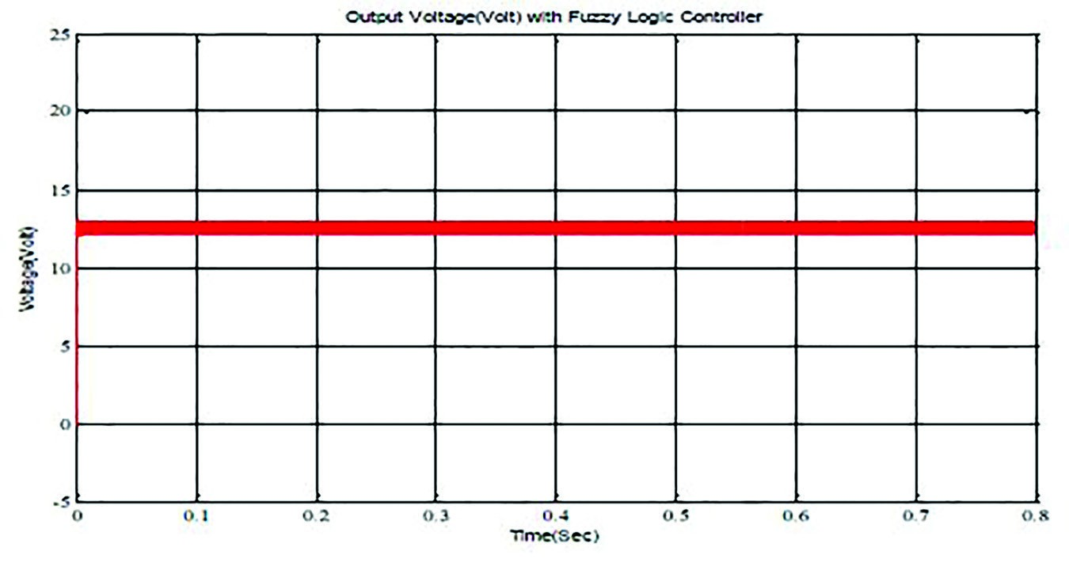
Figure 80.10 Output-voltage with Vref =12 V
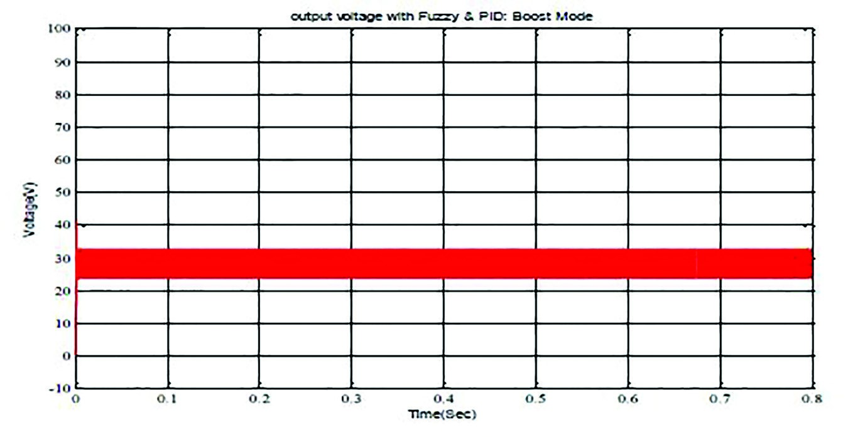

Figure 80.11 Output-voltage with Vref =29 V
simulation-result of voltage output of the converter is provided at Figure 80.11.
The result: T_{r}=0.0018s, T_{p}=0.00205s, M_{p}= 10.5V, τ_{s} = 0.0032s.
Discussion: Hence the output voltage have been successfully tracked as per reference voltage of 29 volt and thereby output voltage for boost mode of the converter is regulated (Figure 80.12).

V. Conclusions
In this study, Buck-Boost DC/DC Converter has been used for the generation of PWM and the regulation of output voltage thereof. A fuzzy logic controller based algorithm have been applied to achieve PWM and duty cycle for proper switching pulse of gating of the DC/DC Buck/Boost converter with a resistor. The modeling and simulations were carried out on Sim-Power-System and Mamdani type fuzzy based algorithm was implemented on Fuzzy-Tool-Box on Matlab/Simulink platform. With the appropriate fuzzy logic based algorithms, smooth PWM, duty cycle for different duty cycle of the getting signal and the output voltage have been successfully achieved. From the results it is observed that there is smooth generation of PWM with which the response of output voltage of the converter is tracked successfully as per given reference voltage with faster settling time having less overshooting and ripple. Hence the scheme with fuzzy logic controller technique is easy, faster and can be very useful for regulation of output voltage in an application where the input voltage changes besides having the vast scope of implementing on DSP to regulate output voltage solar PV. At the same time FLC is very quick and useful for system of nonlinear without going the complicated system parameters complicated circuit parameters due to which the fuzzy technique has been adopted.

Acknowledgement
We gratefully acknowledge the students, staff, and authority of electrical engineering department for their cooperation in the research.

References
- Ceelho, R. F., Concer, F., and Martins, D. C. (2009). A study of the basic of DC-DC converters applied in maximum power point tracking power. Electronics, 673–678.
- Chihchiang, H. and Shen, C. (1998). Study of maximum power tracking techniques and control of DC/ DC converters for photovoltaic power system. Power Elec. Spec. Conf., 1, 86.
- Stokes, J. and Sohie, G. R. (n.d.). Implementation of PID ontrollers on the Motorola DSP56000/ DSP56001. 1–84.
- Coelho, R. F., Concer, F. M., and Martins, D. C.
(2010). Analytical and experimental analysis of DCDC converters in photovoltaic maximum Power Point Tracking applications. IECON 2010 - 36th Ann. Conf. IEEE Indus. Elec. Soc., 2778–2783.
- Altas, H. and Sharaf, A. M. (2007). A generalized direct approach for designing fuzzy logic controllers in Matlab/Simulink GUI Environment. Inter. J. Inform. Technol. Intell. Comput., 1(4), 1–27.
- Radak, B., Mahanta, C., and Gogoi A. K. (2019). DSP based photovoltaic hardware development for controlling voltage and current. IEEE 3rd Inter. Conf. Recent Dev. Control Autom. Power Engg. 1–104.
- Radak, B., Mahanta, C., and Gogoi A. K. (2015). MPPT of solar photovoltaic cell using perturb & observe and fuzzy logic controller algorithm for Buck-Boost DC-DC converter. Inter. Conf. Ener. Power Environ. Towards Sutain. Growth (ICEPE). 87–92.
- Wu, Y., Zhang, B., Lu, J., Du, K. L. (2011). Fuzzy logic and neuro-fuzzy system: A systematic introduction. Int. J. Artif. Intell. Expert Sys. (IJA), 47–80.
- Sharaf, M. and Sahin, M. E. (2011). A novel photovoltaic PV-powered battery charging scheme for electric vehicles. ICEAS IEEE Conf., India, 2011. 176–192.
- Reshmi, R. and Babu, S. (2013). Design and control of DC-DC converter using hybrid fuzzy PI controller. Inter. J. Res. Engg. Technol., 1(3), 73–78.
- Mohan, N., Undulant, T. M., and Robbins, W. P. (1995). Power Electronics, John Wiley. 1–820.
- Kuo, B. C. (1995). Automatic control systems. New Jersey: Prentice-Hall. 1–189.
- Masoum, M. A., Dehbonei, H., Fuchs, E. F. (2002). Theoretical and experimental analyses of photovoltaic systems with voltage and current-based maximum power-point tracking. IEEE Trans. Ener. Conver., 17(4), 514–522.
- Hansen, D., Sørenson, P., Hansen, L. H., and Bindner, H. (2000). Models for a stand-alone PV system. Risø National Laboratory, Roskilde. 231–245.
- Nevruzov, V. (2010). Computer controlled solar house for measurement Rize city solar energy potential. NURER, Ankara. 404–414.
- Vijayalakshmil, S., Arthika, E., Shanmuga Priya, G. (2015). Modeling and simulation of interleaved BuckBoost converter with PID controller. IEEE Sponsored 9th Inter. Conf. Intell. Sys. Control (ISCO). 231–243.
- Kurokawa, F. and Ishibashi, T. (2009). Dynamic characteristics of digitally controlled buck-boost DC-DC converter. Power Elec. Drive Sys., 300–303.
- Chao, P. C.-P., Wei-Dar, C. and Chih-Kuo, C. (2012). Maximum power tracking of a generic photovoltaic system via a fuzzy controller and a two-stage DC– DC converter. Microsys. Technol., 18, 1267–1281.

