feedFood
Software Requirements Specification


EXILANT Technologies Private Limited
#18 & 18/1, P. Kalinga Rao Road
Bangalore 560 018, INDIA

Document Details

Document-ID | 1
Version # & Date | FeedFood v1.O
Prepare by | Exilant Technologies

Document History

Version # | Date | Reviewed by | Approved by
0.1
1

Table of Contents
1 Overview
1.1 Purpose
1.2 Scope
1.3 Business context
1.4 Current system
1.5 Proposed system
1.6 References
2 Functional Requirements
3 Non Functional Requirements
4 Dependencies
5 Requirements discussed but deferred
6 User Stories
7 Use Cases
8 Flow Chart
9 Screen shots
  - Home page
  - Donor Login
- Donor Registration
- Donor Home page
- Make post
- NGO Responded
- NGO Information
- Set location
  - NGO Login
- New Registration
- NGO Home Page
- Search Food
- Donor List
- Food information
- Call screen
- Chat screen
- Navigation

Introduction

Purpose
feedFood is an iOS App that puts surplus food to the best use. It helps one to share his excess food to people who are in need. We approach the issue of hunger with a sharing-economy model: the donation of excess food enables a vital, yet often wasted, resource to be used to its full capacity. For example, a Donor - has leftover food in either their cafeteria or following a work or any family related event. Donor could request a food pickup via feedFood and we would match the surplus food to a nearby NGO's in need and send notification to NGOs, NGOs can communicate with Donor using chat or call option then they can collect the surplus.

Scope
This application will be for iOS that will enable for common people to feed hunger one through NGOs. This application allows the donor to donate the surplus and NGOs to collect the surplus from donors:
- User can post the surplus details like photos, quantity, location ,etc..
- NGOs can identify the nearest surplus through notification or map and reach specified donor.
- NGOs and User can communicate with each other through chat or call.

Business Context
Currently the surplus is wasting by using feedFood, surplus can be helpful for hunger ones.
feedFood can help the society in the following ways:-
- Common people can share the surplus with the needy people by posting its picture and information.
- NGOs can communicate with the donors in their locality by chat or call means.
- NGOs can get the excess amount of food from donors and distribute it to the needy people.

Current System

Current food collection and distribution system is manual with the below stages involved in it:
- Donors need to manually contact the needy people which may be sometimes tedious task
- There is no proper communication between the NGOs and Donor.
- It will be not easy for the NGOs to go in search of surplus.
Below points identify the drawbacks of the current system.
- Manually donating the surplus will take more time in search of NGOs.
- NGOs will not be aware of donors until they directly contact them.
- The surplus may not reach the needy people on time.
- There may be communication gap between the donors and NGOs.

Proposed System

Common people can donate surplus using Donor option.
- Donors need to provide information about surplus like
  - Picture of the surplus.
  - Amount of people that it can serve to.
  - Type of food like veg,nonveg etc.
  - Whether packaged or not.
- Need to specify pick up time and date.
- Donors can specify the location either current location through map or remote location manually.
- Common people can share there donated surplus in there social network.

NGOs can collect surplus using receive option.
- NGOs should register before using proposed system like
  - NGOs name, NGOs registeration ID, NGOs location etc...
- NGOs can find surplus which was posted by donors and communicate through
chat or call option.
- NGOs can find donor location through map option.
- NGOs can track their receieved or pending surplus.

References
NGOs Manual searching surplus process.

Functional Requirements
The Functional requirements of the application have been identified as follows:
Requirement ID | Module | Sub - module | Description
FeedFood 1 | Donor | User Registration | The user can register as a new user or using any of social networks like Gmail, Facebook etc...
FeedFood 2 | Donor | Donor Login | Login by providing valid credentials
FeedFood 3 | Donor | Make Post | The user can donate surplus.
FeedFood 4 | Donor | Set Location | Set the location of the food
FeedFood 5 | Donor | NGO List | Find the list of NGO's
FeedFood 6 | Donor | Chat/Call | Donor can communicate with NGO
FeedFood 7 | NGO | NGO registration | NGO can register by providing NGOs information.
FeedFood 8 | NGO | Search Food | NGOs can see the available food
FeedFood 9 | NGO | Donor list | Get the list of available Donors
FeedFood 10 | NGO | Food Details | NGO can get the information of food
FeedFood 11 | NGO | Acceptance | NGO can accept the food
FeedFood 12 | NGO | Chat/Call | NGO can communicate with Donor
FeedFood 13 | NGO | Direction | NGOs can get the location of food

Non Functional Requirements

Performance :
- The application shall fasten the process of delivering the surplus.
- The application shall fasten the process of locating the donor and reach them.

Usability :

- The application shall be user friendly, so that a user who has basic mobile knowledge can use the application and donate surplus.
- The application shall prevent wastage of surplus by providing communication between donor and NGOs.
- This app simplifies the process of donating surplus and is user friendly.

Availability:

- The application in its operational state shall be available for use 24 hours per day and 365 days per year.

Dependencies

- Donors
- NGOs

Requirements discussed but deferred

The following requirement(s) have been discussed but are deferred:

• Integrating the application with mobile payments services for donating the money to NGOs.
- NGOs can request the surplus to the registered users.
- Same user can behave like both like NGOs or Donor.

User Stories
The following User Stories are written by referring the NGOs (manual) process and considering the needs of the user during the donation process.

User Story | 1
As a | Donor
I want | To register my self giving my personal information
So that | I can login whenever I want to post the surplus.

User Story | 2
As a | NGO
I want | To register by giving NGO information
So that | I can login whenever I want to receive the surplus which is posted by Donor.

Use cases
Use Case Element | Description
Use Case Number | 1
Application | feedFood
Use Case Name | Register User
Use Case Description | User can register himself as donor by specifying user information or through any of social media like Facebook, Gmail, etc...
Primary Actor | User
Precondition | None
Trigger | User clicks on Donor button.
Basic Flow | - User launches the application.  - The registration page will be shown to the user.  - To register provide name, phone number, email id and password.  - If user wants to register through any of social site then click on the sign in with facebook or sign in with google.  - User gets confirmation after getting registered.
Alternate Flows | N/A

Use Case Element | Description
Use Case Number | 2
Application | feedFood
Use Case Name | Login as User
Use Case Description | Registered User needs to login by giving user name and password,
Primary Actor | User
Precondition | Registered User.
Trigger | User clicks on Donor button.
Basic Flow | - Give user name in user name field  - Give valid password in password field  - Click on login button  - If valid user, gets logged in  - If Invalid user, gets Error massage
Alternate Flows | N/A

Use Case Element | Description
Use Case Number | 3
Application | feedFood
Use Case Name | Make Post
Use Case Description | User can post the surplus which he wants to donate.
Primary Actor | User
Precondition | User needs to be logged in.
Trigger | User has to click on Make Post button.
Basic Flow | - User selects the pic of food which he has taken.  - Enters the details of the food like Quantity, Type, etc...  - Set the location  - Click on submit button to post the food.
Alternate Flows | N/A
N

Use Case Element | Description
Use Case Number | 4
Application | feedFood
Use Case Name | NGO Responded
Use Case Description | User can find the list of Responded NGO's.
Primary Actor | User
Precondition | User needs to be logged in.
Trigger | User has to click on NGO Responded button.
Basic Flow | - User gets the list of NGO  - User needs to select the particular NGO to get its contact information.  - Donor can communicate with NGO through Chat or Call option
Alternate Flows | N/A

Use Case Element | Description
Use Case Number | 5
Application | feedFood
Use Case Name | Register NGO
Use Case Description | User can register himself as NGO by specifying NGO information.
Primary Actor | NGO
Precondition | None
Trigger | User clicks on NGO button.
Basic Flow | - User launches the application.  - The registration page will be shown to the user.  - To register provide NGO name, NGO phone number, email id, password and NGO registration number.  - After validating the NGO by NGO's registration number NGO gets registered.
Alternate Flows | N/A

Use Case Element | Description
Use Case Number | 6
Application | feedFood
Use Case Name | Login as NGO
Use Case Description | NGO needs to login by providing user name and password
Primary Actor | NGO
Precondition | Registered NGO
Trigger | Click on NGO button
Basic Flow | - Give NGO user name and password.  - Click on login button.  - If valid NGO, NGO gets logged in  - If invalid NGO, gets error massage
Alternate Flows | N/A

Use Case Element | Description
Use Case Number | 7
Application | feedFood
Use Case Name | Receive food
Use Case Description | NGO can find the food which is posted by Donor.
Primary Actor | NGO
Precondition | NGO should be logged in
Trigger | Select the available food from map by tapping on it.
Basic Flow | - Login as NGO.  - Search food which is shown in the map  - Tap on the food which you like to receive  - Get the details of the selected food and confirm the acceptance  - NGO can communicate with Donor through Chat or Call option  - NGO can find the location of the food through Direction option
Alternate Flows | N/A
n
Use Case Element | Description
Use Case Number | 8
Application | feedFood
Use Case Name | Donor List
Use Case Description | NGO can find the list of Donors who posted the surplus recently.
Primary Actor | NGO
Precondition | NGO should be logged in
Trigger | Click on Donor list button
Basic Flow | - NGO gets the list of Donors  - NGO needs to select the particular Donor to get food details and contact information.  - NGO can communicate with Donor through Chat or Call option  - NGO can find the location of the food through Direction option
Alternate Flows | N/A

8.Flow Chart
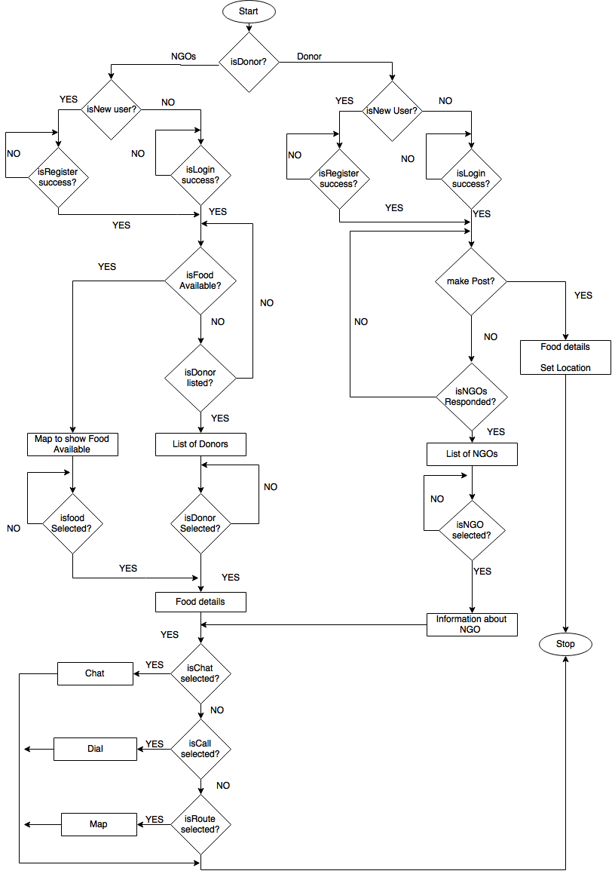

9. Screen shots
Screenshots of the application can be found below.
Home page
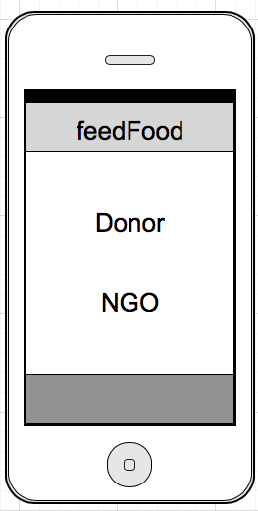
Donor login Donor Registration
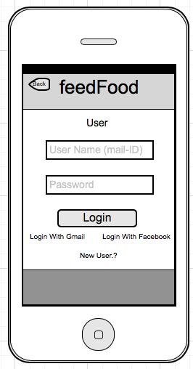
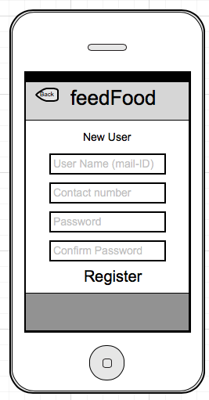
Donor Home page Post Food
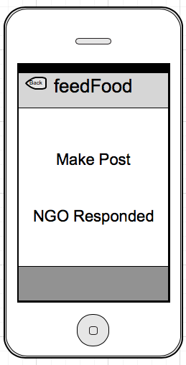
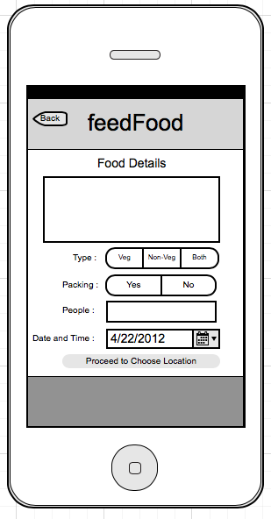

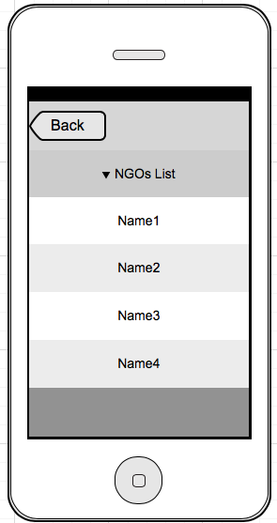
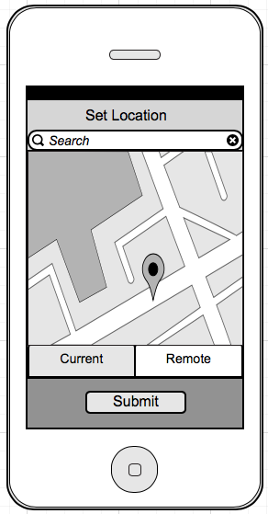
Set Location NGO Responded

NGO Information NGO Login
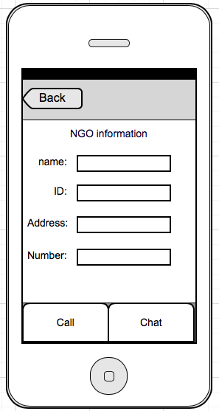
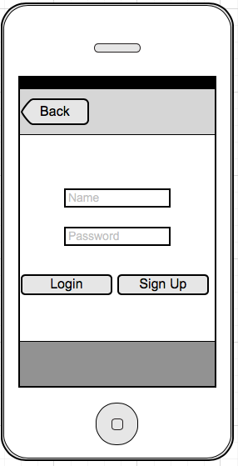
NGO Registration NGO Home page
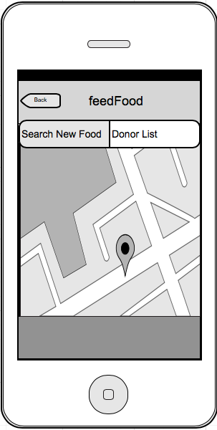
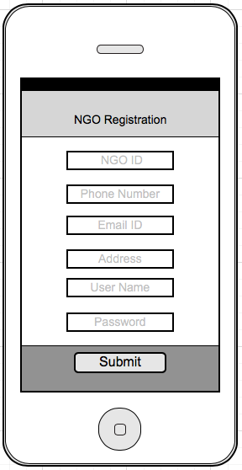

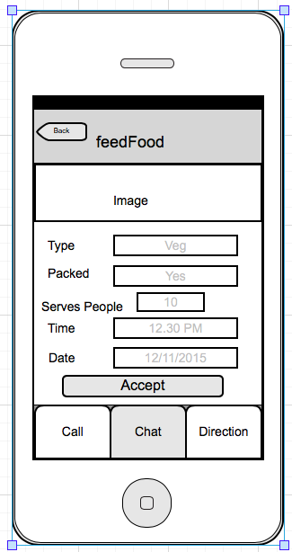
Donor List Food Information
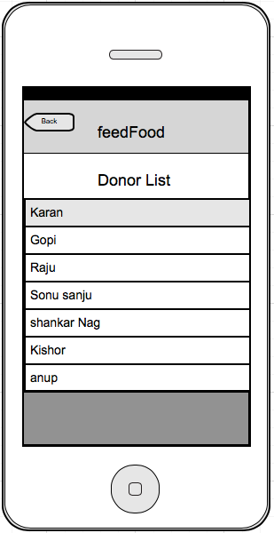
Chat Screen Navigation screen
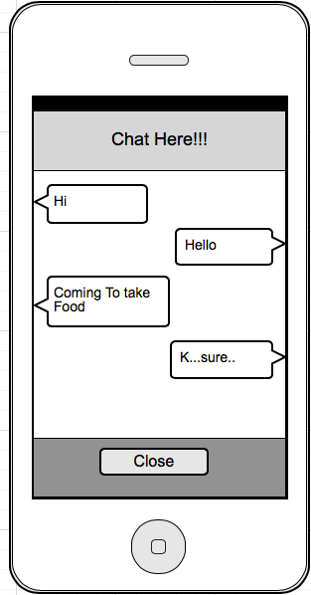
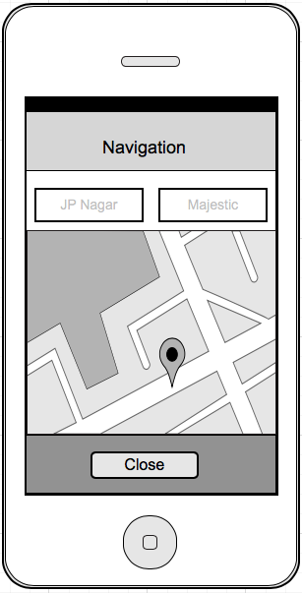
Call Screen
