Atari Breakout Arcade Game
Course: EL2003 – Computer Organization & Assembly Language
Submitted to: Respected Ma'am Gul E Zahra
Semester: Fall 2025

Group Members
Roll Number | Name | Contribution
24F-0039 | Muhammad Abdullah | Game Logic, Collision Detection, Interrupt Handling
24F-0025 | Basam Babar | Graphics Rendering, Sound System, Scoring & Timer

1. Project Overview
Atari Breakout is a classic arcade game faithfully recreated in x86 Assembly Language for DOS. This project demonstrates mastery of low-level programming, interrupt handling, memory management, and real-time graphics rendering—all written entirely in assembly.
✨ Project Philosophy: "From bricks to bytes—a tribute to the golden age of arcade gaming, written in the language of the machine itself."

2. Program Flowchart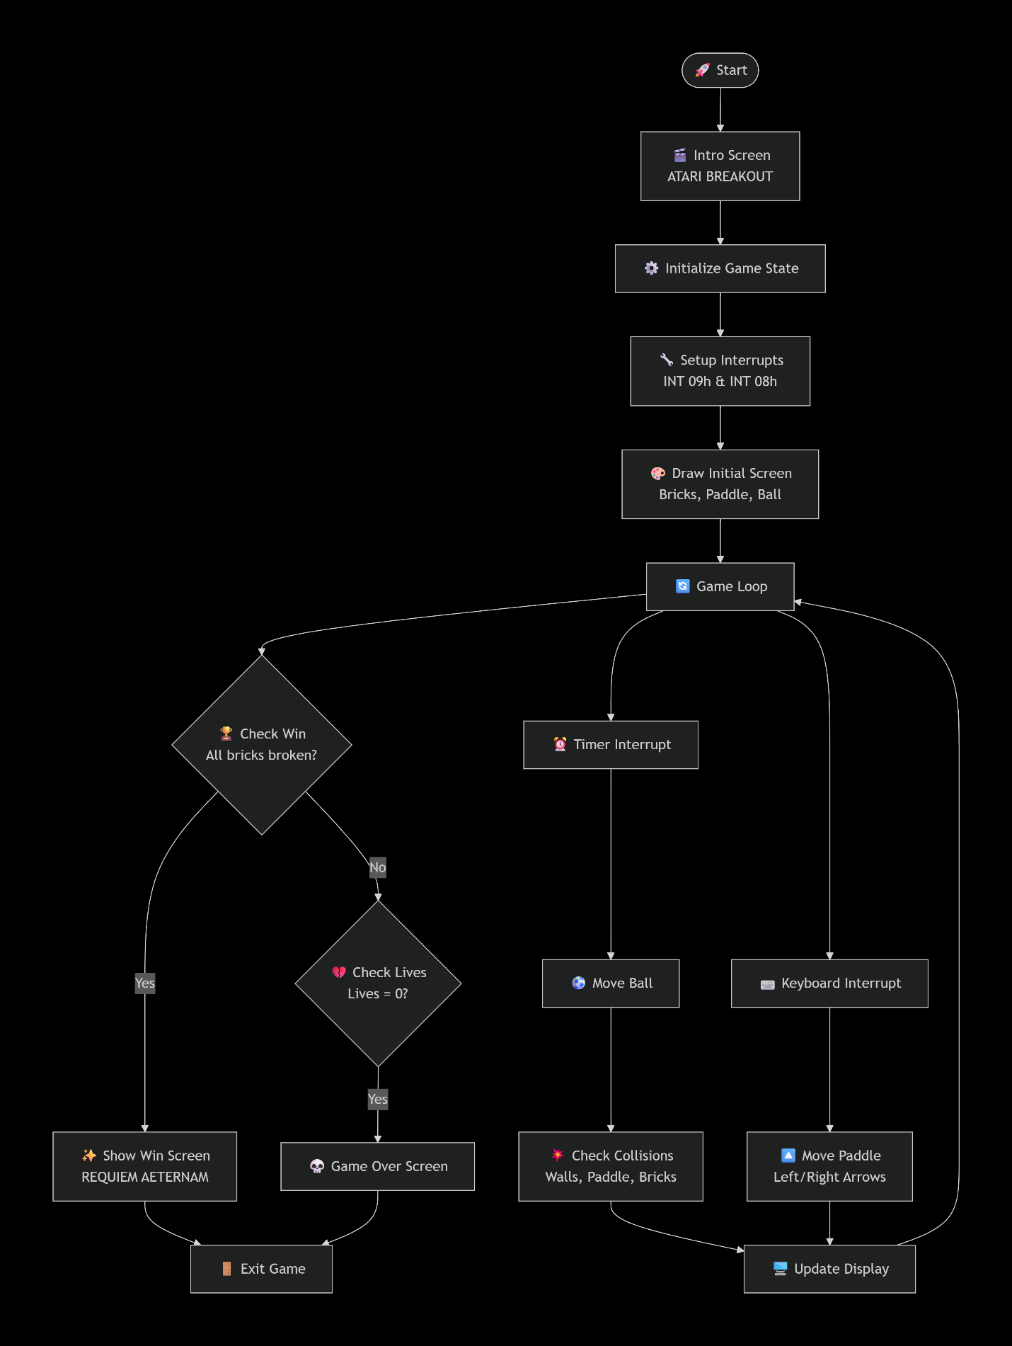
3. Interrupt Usage & System Architecture
3.1 Keyboard Interrupt (INT 09h)

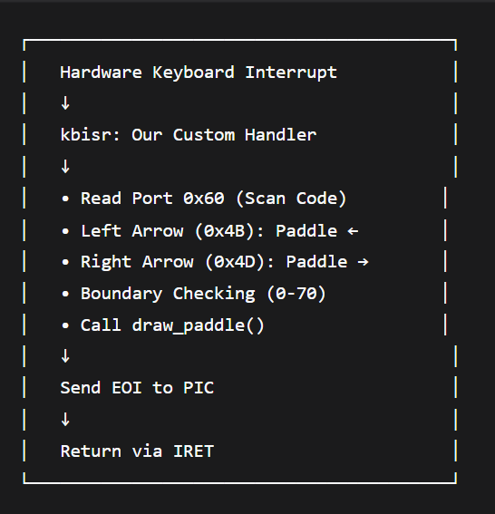

Preservation: Original ISR saved in oldisr (4 bytes)

3.2 Timer Interrupt (INT 08h)

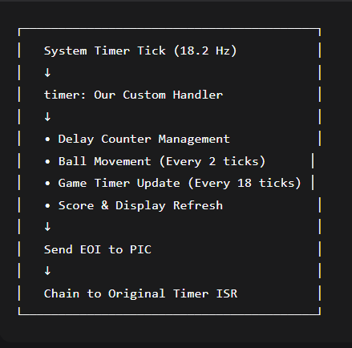

Preservation: Original ISR saved in oldtimer (4 bytes)

3.3 Interrupt Initialization Code

Save original interrupts
mov ax, [es:9*4] ; Keyboard ISR
mov [oldisr], ax
mov ax, [es:8*4] ; Timer ISR
mov [oldtimer], ax

; Install our handlers
cli ; Disable interrupts
mov word [es:9*4], kbisr ; Keyboard handler
mov word [es:8*4], timer ; Timer handler
sti ; Enable interrupts

4. Scoring & Gameplay Mechanics

4.1 Scoring System
Action | Points | Visual Feedback | Sound
Break Red Brick | +10 | Brick disappears | Beep
Break Green Brick | +10 | Brick disappears | Beep
Break Blue Brick | +10 | Brick disappears | Beep
Maximum Score | 180 | All bricks cleared | Win Screen

4.2 Lives System

Initial: ❤️ ❤️ ❤️ (3 lives)
After miss: ❤️ ❤️ (2 lives)
Game Over: 💀 (0 lives)

4.3 Brick Layout & Colors
┌─────────────────────────────────────────────────────┐
│ Row 4-5: RED (Attributes: 0x4458) │
│ Row 6-7: GREEN (Attributes: 0x2258) │
│ Row 8-9: BLUE (Attributes: 0x1158) │
│ │
│ Each Brick: 10 chars wide, 2 rows tall │
│ Spacing: 2 chars between bricks │
│ Total: 3 rows × 6 bricks = 18 bricks │
└─────────────────────────────────────────────────────┘

4.4 Ball Physics
Collision Type | Response | Sound
Brick Hit | Reverse Y direction + Remove brick | 🔊 Beep
Paddle Hit | Reverse Y + Directional bounce | 🔊 Beep
⬅️ Left Wall | Reverse X direction (dx = 1) | 🔊 Beep
➡️ Right Wall | Reverse X direction (dx = -1) | 🔊 Beep
⬆️ Ceiling | Reverse Y direction (dy = 1) | 🔊 Beep
⬇️ Bottom Miss | Lose life + Reset ball | 🔊 Beep

5. Display System

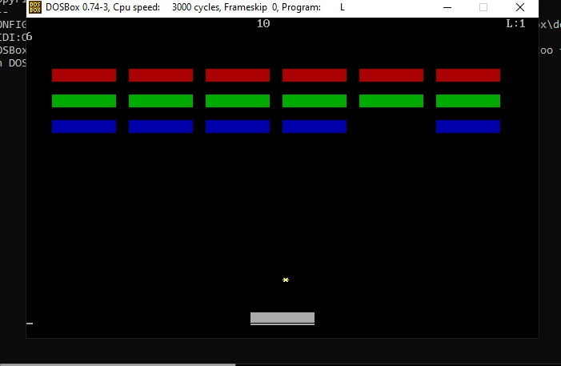

5.2 Display Functions
Function | Purpose | Key Instructions
clrscr | Clear entire screen | REP STOSW
print_score | Update score/lives/timer | DIV, PUSH/POP
draw_bricks | Render active bricks | IMUL, CMP, REP STOSW
draw_paddle | Draw paddle at position | SHL, Boundary checks
draw_ball | Draw ball at (x,y) | MUL, SHL

6. Sound System
6.1 beep Function Implementation

beep:
in al, 61h ; Read speaker port
or al, 3 ; Turn speaker on (bits 0 & 1)
out 61h, al
mov cx, 3000 ; Duration counter
sound_delay:
loop sound_delay ; Wait
in al, 61h
and al, 0xFC ; Turn speaker off
out 61h, al
ret

6.2 Sound Events
- ✅ Brick Break – Celebration beep
- ✅ Wall/Ceiling Hit – Feedback beep
- ✅ Paddle Hit – Confirmation beep
- ✅ Life Lost – Warning beep

7. Lose Conditions
Trigger: Lives = 0
GAME OVER SEQUENCE:
1. Restore original interrupts
2. Clear screen
3. Display: "GAME OVER"
4. Wait for key press
5. Clean exit
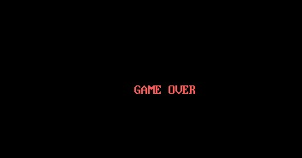

7. Features Checklist
Gameplay Features
- ✅ Full brick-breaking mechanics
- ✅ Real-time score tracking
- ✅ Lives system with visual display
- ✅ Game timer
- ✅ Sound effects for all events
- ✅ Smooth paddle control
- ✅ Realistic ball physics
- ✅ Win/lose conditions with screens
- ✅ Intro screen with branding
Technical Features
- ✅ 100% x86 Assembly implementation
- ✅ Proper interrupt handling
- ✅ Efficient screen buffer management
- ✅ Modular, commented code
- ✅ Boundary checking on all movements
- ✅ Clean program termination

8. Learning Outcomes
Technical Skills Developed
- x86 Assembly Programming – Mastery of low-level instructions
- Interrupt Handling – Hardware/software interrupt management
- Memory Management – Direct video memory access
- Real-time Systems – Timer-based game loops
- Hardware Interaction – PC speaker control via ports
Conceptual Understanding
- Interrupt Vector Table (IVT) structure
- Programmable Interrupt Controller (PIC) operation
- DOS memory segmentation model
- Real-mode programming constraints
- Game physics simulation in assembly

9. Acknowledgments
We extend our sincere gratitude to Ma'am Gul E Zahra for her excellent guidance throughout the EL2003 course. Her clear explanations of complex assembly concepts made this project possible.
Special Thanks To:
- Our classmates for testing and feedback
- DOSBox developers for preservation of legacy computing
- Atari for the original Breakout inspiration (1976)

10. Conclusion
This project successfully demonstrates that even with the constraints of 16-bit real-mode assembly, complex interactive applications with graphics, sound, and real-time response can be created. The Atari Breakout implementation serves as both a tribute to classic gaming and a practical demonstration of low-level computer organization principles taught in EL2003.
Final Thought: "In the dance of electrons and instructions, we found not just a game, but an understanding of the machine's soul."

