Assignment 4:

Pseudocode and Flowchart for Sorting Algorithm - Write pseudocode and create a flowchart for a bubble sort algorithm. Provide a brief explanation of how the algorithm works and a simple array of integers to demonstrate a dry run of your algorithm.

Flow chart:

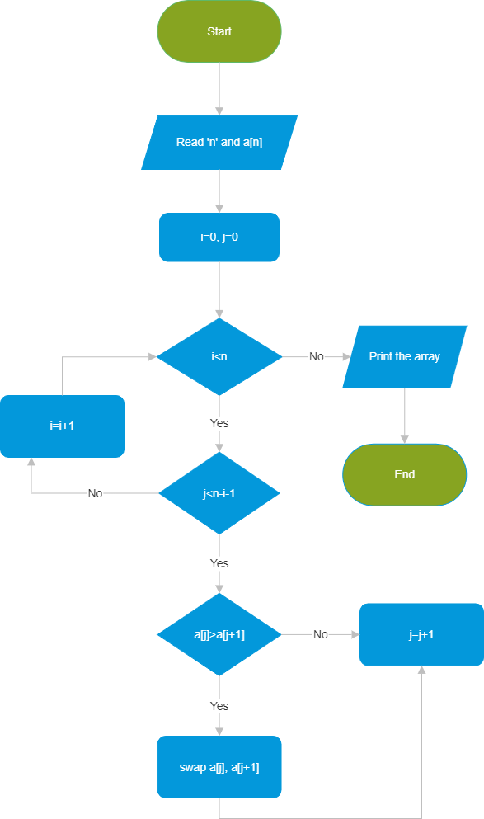

Pseudo code :

1 - Check the first index number is greater than then second index number.

2 - If greater swap both the values.

3 – Repeat the above condition till reaches the last element.

4 – check an array is sorted if not sorted continue the same process.

5 – Final output we will get a sorted array.

Working of the algorithm:

Step 1:

i=0

6 0 3 5

i=1

0 6 3 5

i=2

0 3 6 5

I=3

0 3 5 6 🡪Sorted