**Entities**

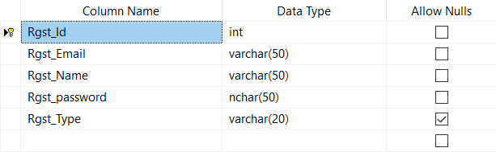1.Table: Register

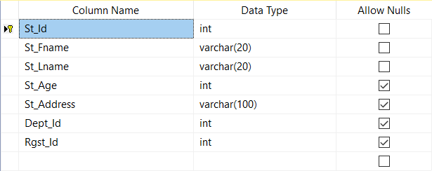2.Table: Student

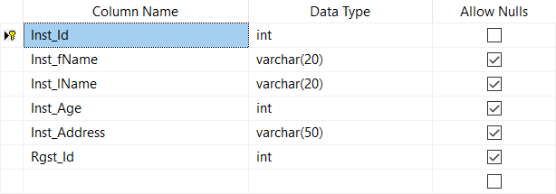3.Table: Instructor

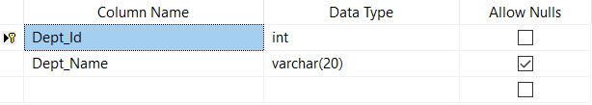4.Table: Department

5.Table: Course

6.Table: Topic

7.Table: Question

8.Table: Exam

**Relationships**

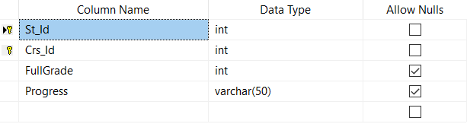1.Table: Stud_Course

2.Table: Exam_Ques

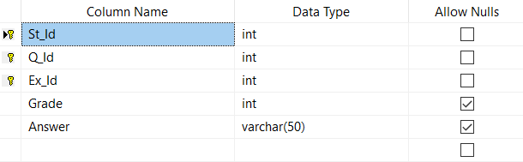3.Table: Stud_Answers

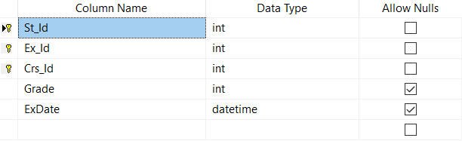

4.Table: Stud_Exam

**Database Diagram**

