**Name:** Basant Tarik Salah   
**Instructor:** Eng. Mohamed Abo-Khalil

SIC7_Task.Phase1

Part1: Tasks

1. 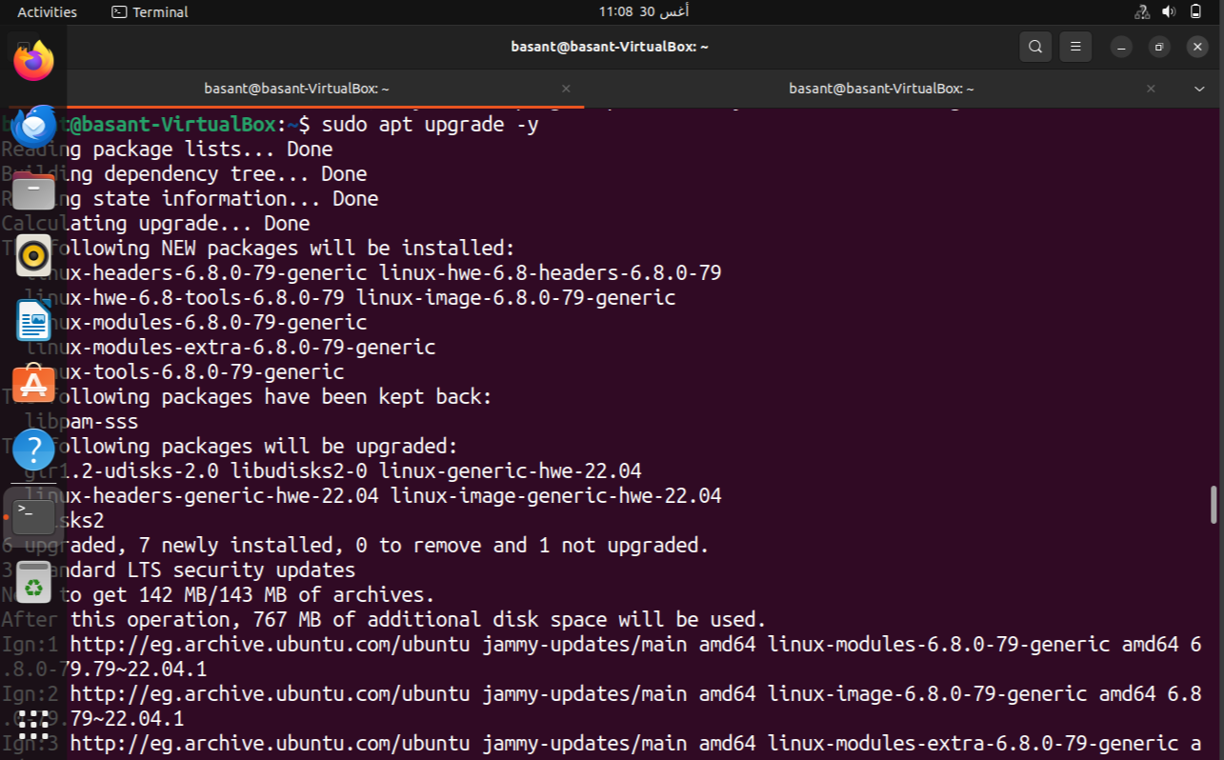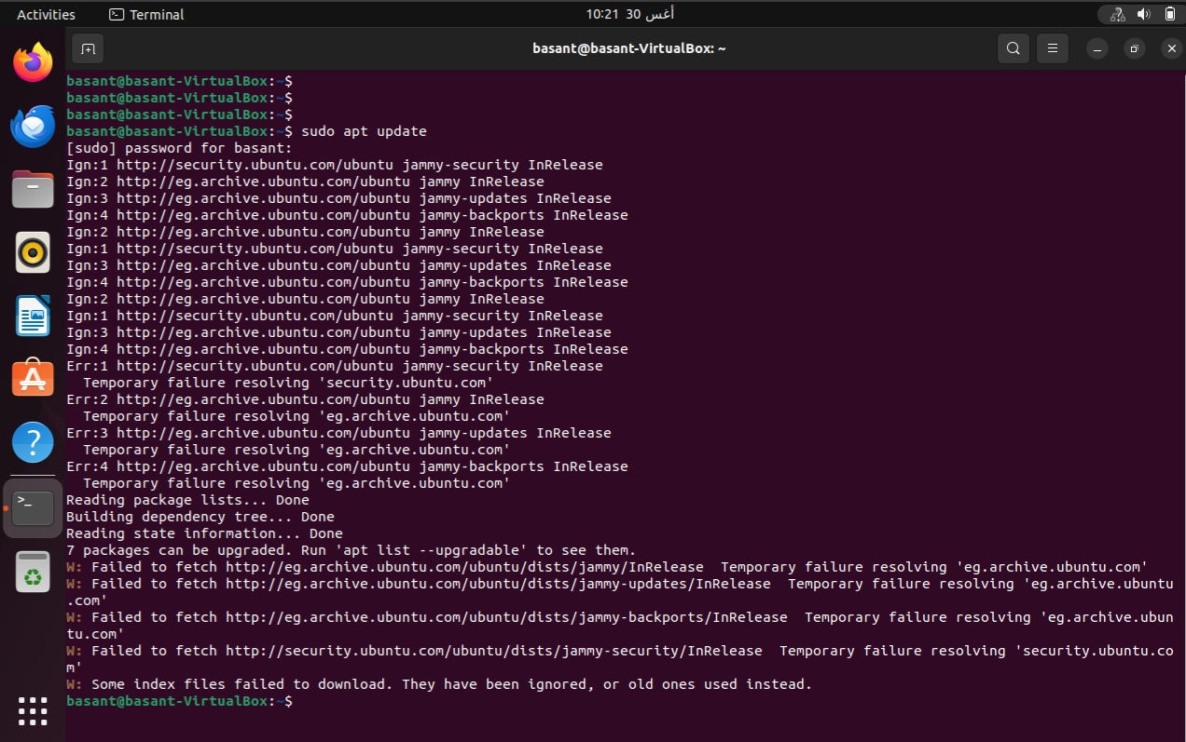Refresh package lists and upgrade the system:

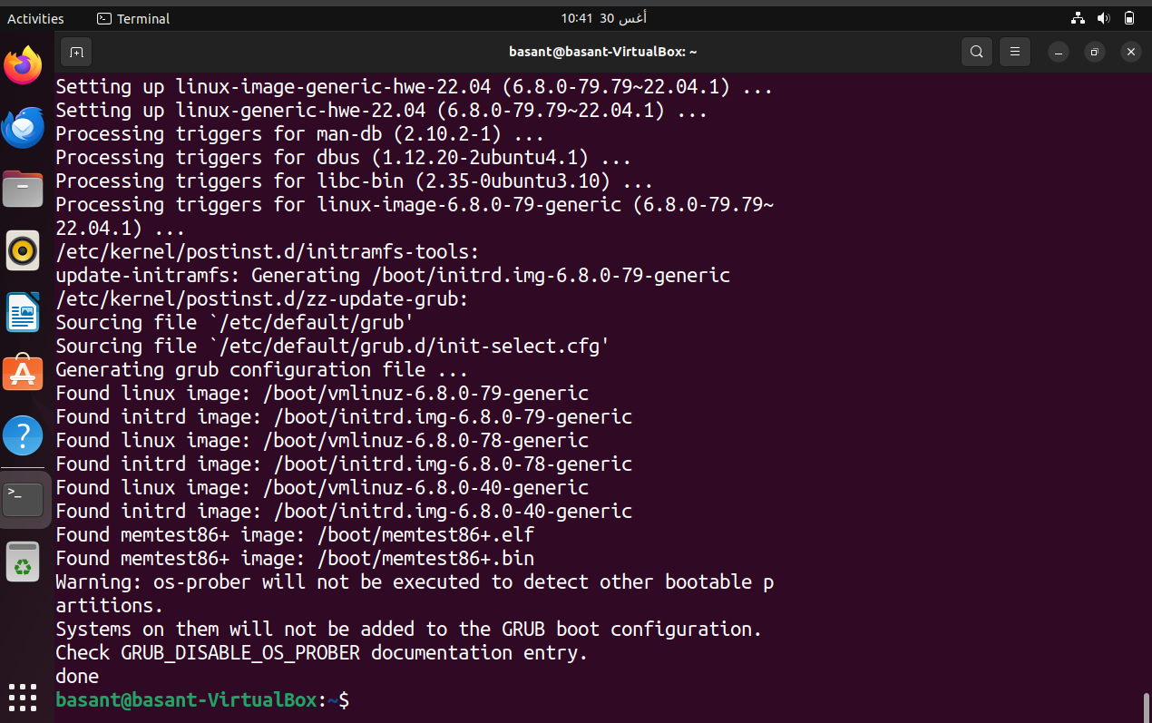

1. 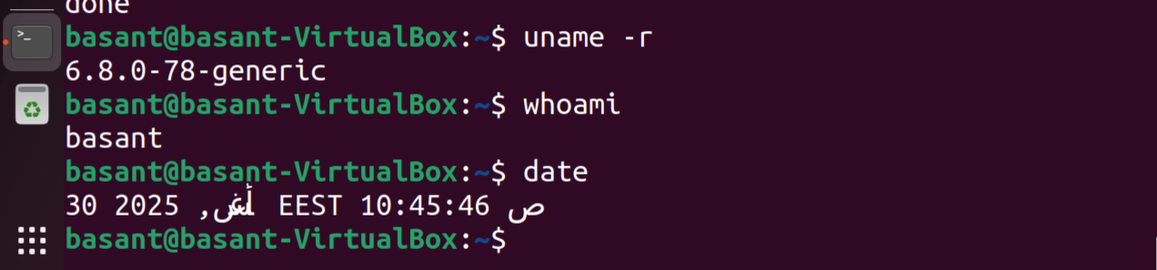Verify system details:
2. 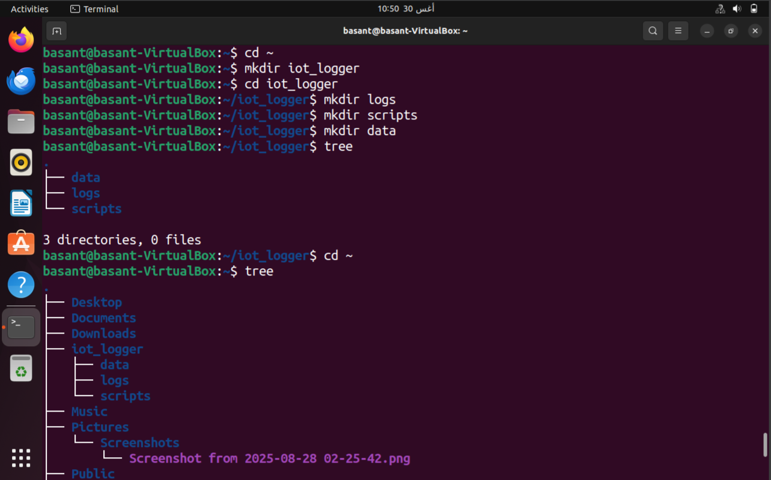Create directory and Subdirectories:

Part 2: Open Ended Questions

1. **Draw or describe the Linux architecture layers (hardware → kernel → shell → user space). Where do system calls fit:**

Ans.

The Linux is a layered structure operating system consisting of:

* Hardware: the first layer containing all the hard components like the CPU, memory, hard disk, devices, etc.
* Kernel: the core or the heart of the OS which manages the hardware directly. Where the **system calls** are executed.
* Shell: the interface between the user and the kernel where the commands are written to be translated to **system call** to be executed by the kernel.
* User Space: the applications and utilities the user deal with.

1. **Explain the purpose of these directories: /, /bin, /sbin, /usr, /etc, /var:**

**/:** the root of everything where everything starts.

**/bin:** the toolbox of everyone including the basic tools that can be needed like ls, cp, mv.

**/sbin:** the toolbox for admins including the tools used only for system administration.

**/usr:** includes all the installed programs and applications.

**/etc:** includes the configuration files and the settings

**/var:** include the changing data

1. **Why does Linux treat everything as a file? Explain the difference between a program and a process:**

Ans.

* Treating everything as a file creates a uniform interface to enable accessing everything using the same file operation (using the same commands)
* Program is the written instructions stored on the disk
* Process is the running or the execution of the program on the memory