**Name:** Basant Tarik Salah   
**Instructor:** Eng. Mohamed Abo-Khalil

SIC7_Task.Phase2

Part1: Tasks

1. 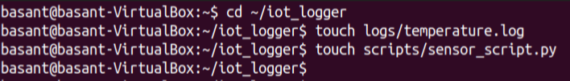Inside iot_logger, create logs/temperature.log and scripts/sensor_script.py:
2. 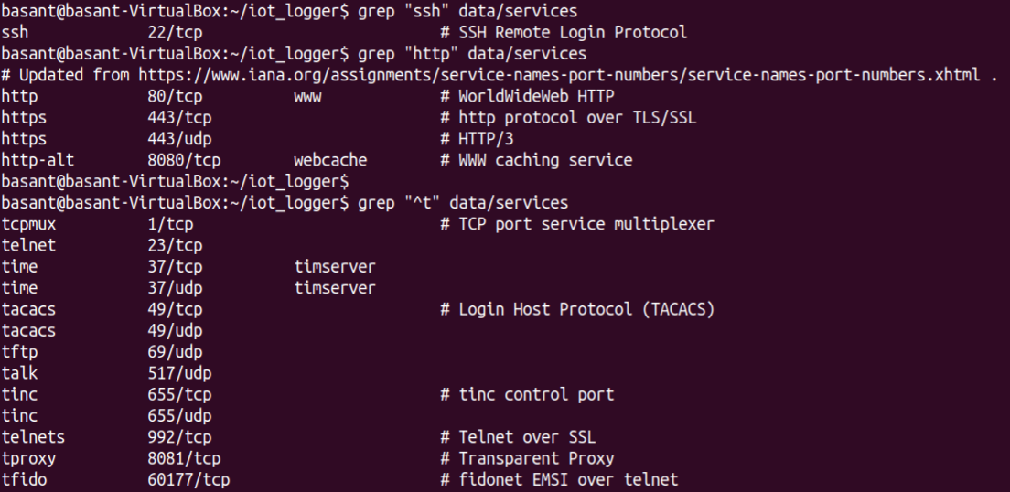Copy /etc/services into data and search for patterns like ssh or http:
3. 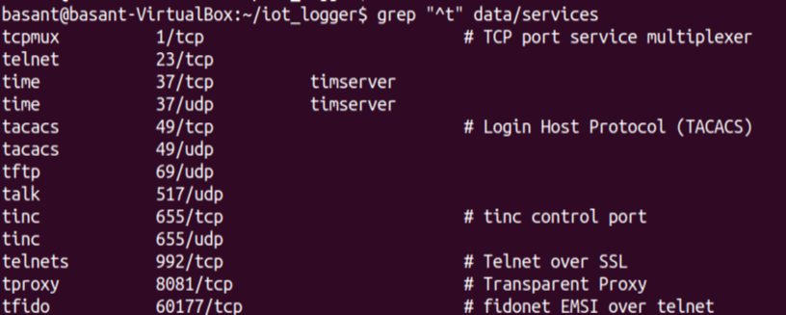Use regex to find lines starting with t or containing numbers:

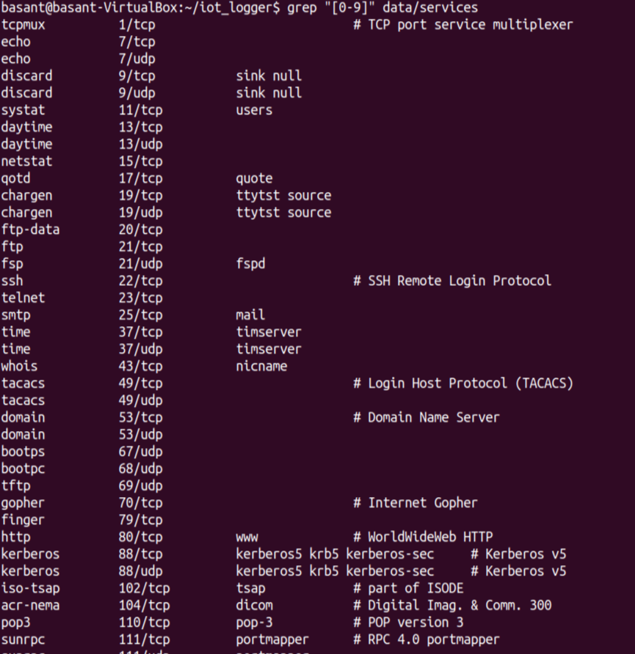

1. 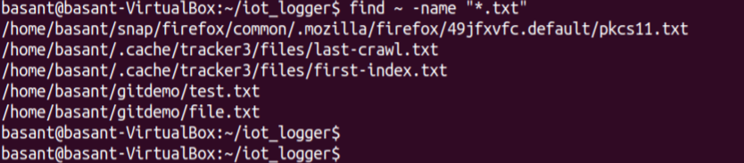Locate .txt files in /home/ and remove temporary ones if needed:
2. Create hard and symbolic links for temperature.log:



1. Display directory structure to confirm organization: 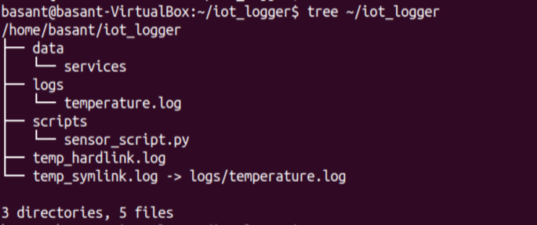

Part 2: Open Ended Questions

1. **Explain the different types of files in Linux (regular, directory, symbolic link, device, etc.) and how to check them with commands.**

Ans.

Regular files are the normal files used usually like text files, programs, scripts.

Directory is a like a folder that contains a list of other files.

Symbolic link is a shortcut points to another file.

Device files are special files enables Linux to talk to hardware.

Pipes lets processes talk to each other by enabling direct data transfer

Sockets are used for network communication.

To check their type with commands: **ls –l**

The first letter of the line refers to different file type as follows:

- = regular file

d = directory

l = symbolic link

c = character device

b = block device

p = pipe

s = socket

1. **What’s the difference between a hard link and a symbolic link? Give real examples of when to use each.**

Hard link is giving the same file **two names**. Both names point to the exact same data on the disk. If one is deleted, the other still works.

* **It is used to create** a second permanent copy for the file.

**Symbolic link** is creating a **shortcut** points to another file. If the original file is deleted, the created file becomes broken.

* **It is used to create** a shortcut that always points to the latest version of the file.

1. **Is rmdir the same as rm -r when deleting directories? Explain**

No, they are different.

* + rmdir deletes a directory **only if it is empty.** It works only if there are no files inside.
* rm –r deletes a directory **and everything inside it** like files or subfolders.