NAME – BASANT POKHREL

SERIAL NO. = 29

BATCH = A

**Q 1 Java program to print welcome message.**

ans-->

package day2assignment;

public class question1 {

public static void main(String[] args) {

// TODO Auto-generated method stub

System.out.println("WELCOME");

}

}

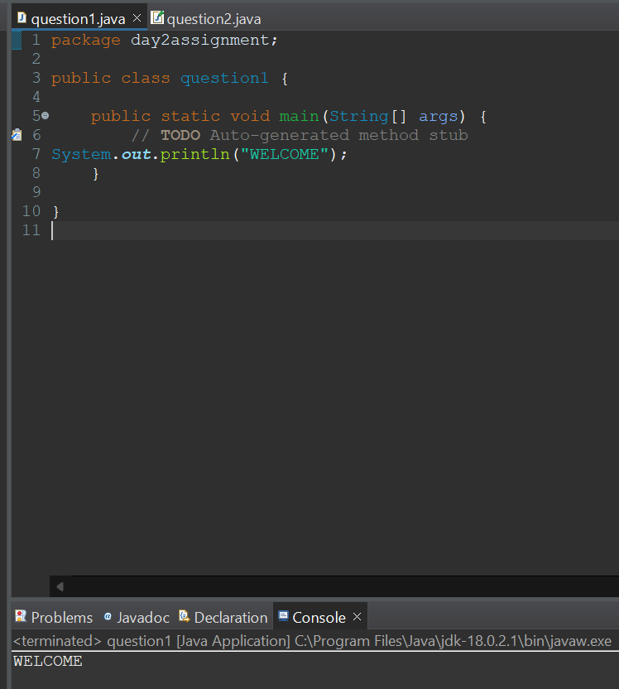

==========================================================================================

//Q 2 Java program to print sum of three float numbers

package day2assignment;

public class question2 {

public static void main(String[] args) {

float a = 10.2f;

float b = 20.4f;

float c = 30.1f;

float sum = a+b+c;

System.***out***.println("sum=" +sum);

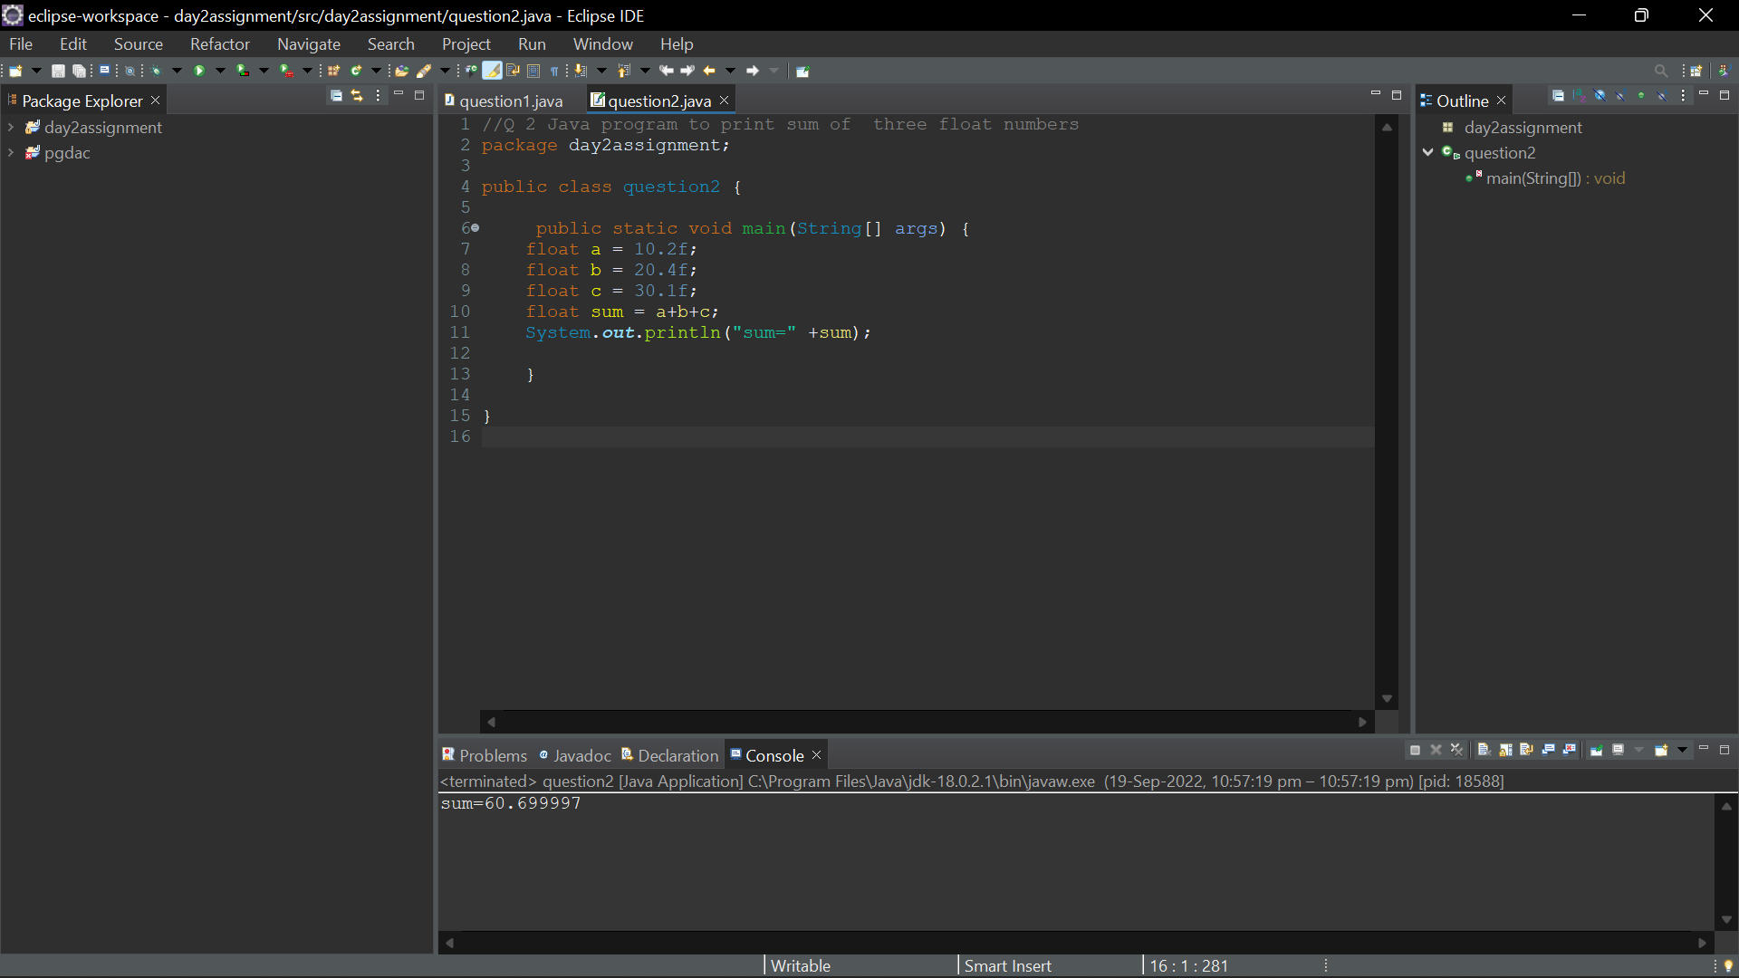}

Qstn3

package day2assignment;

import java.util.Scanner;

public class qstn3 {

public static void main(String[] args) {

int a;

int b;

Scanner s=new Scanner(System.***in***);

System.***out***.println("Enter a");

a=s.nextInt();

System.***out***.println("Enter b");

b=s.nextInt();

System.***out***.println("Before Swapping: a= "+a+" b= "+b);

//Swapping

int temp;

temp=a;

a=b;

b=temp;

System.***out***.println("After Swapping: a= "+a+" b= "+b);

}

}

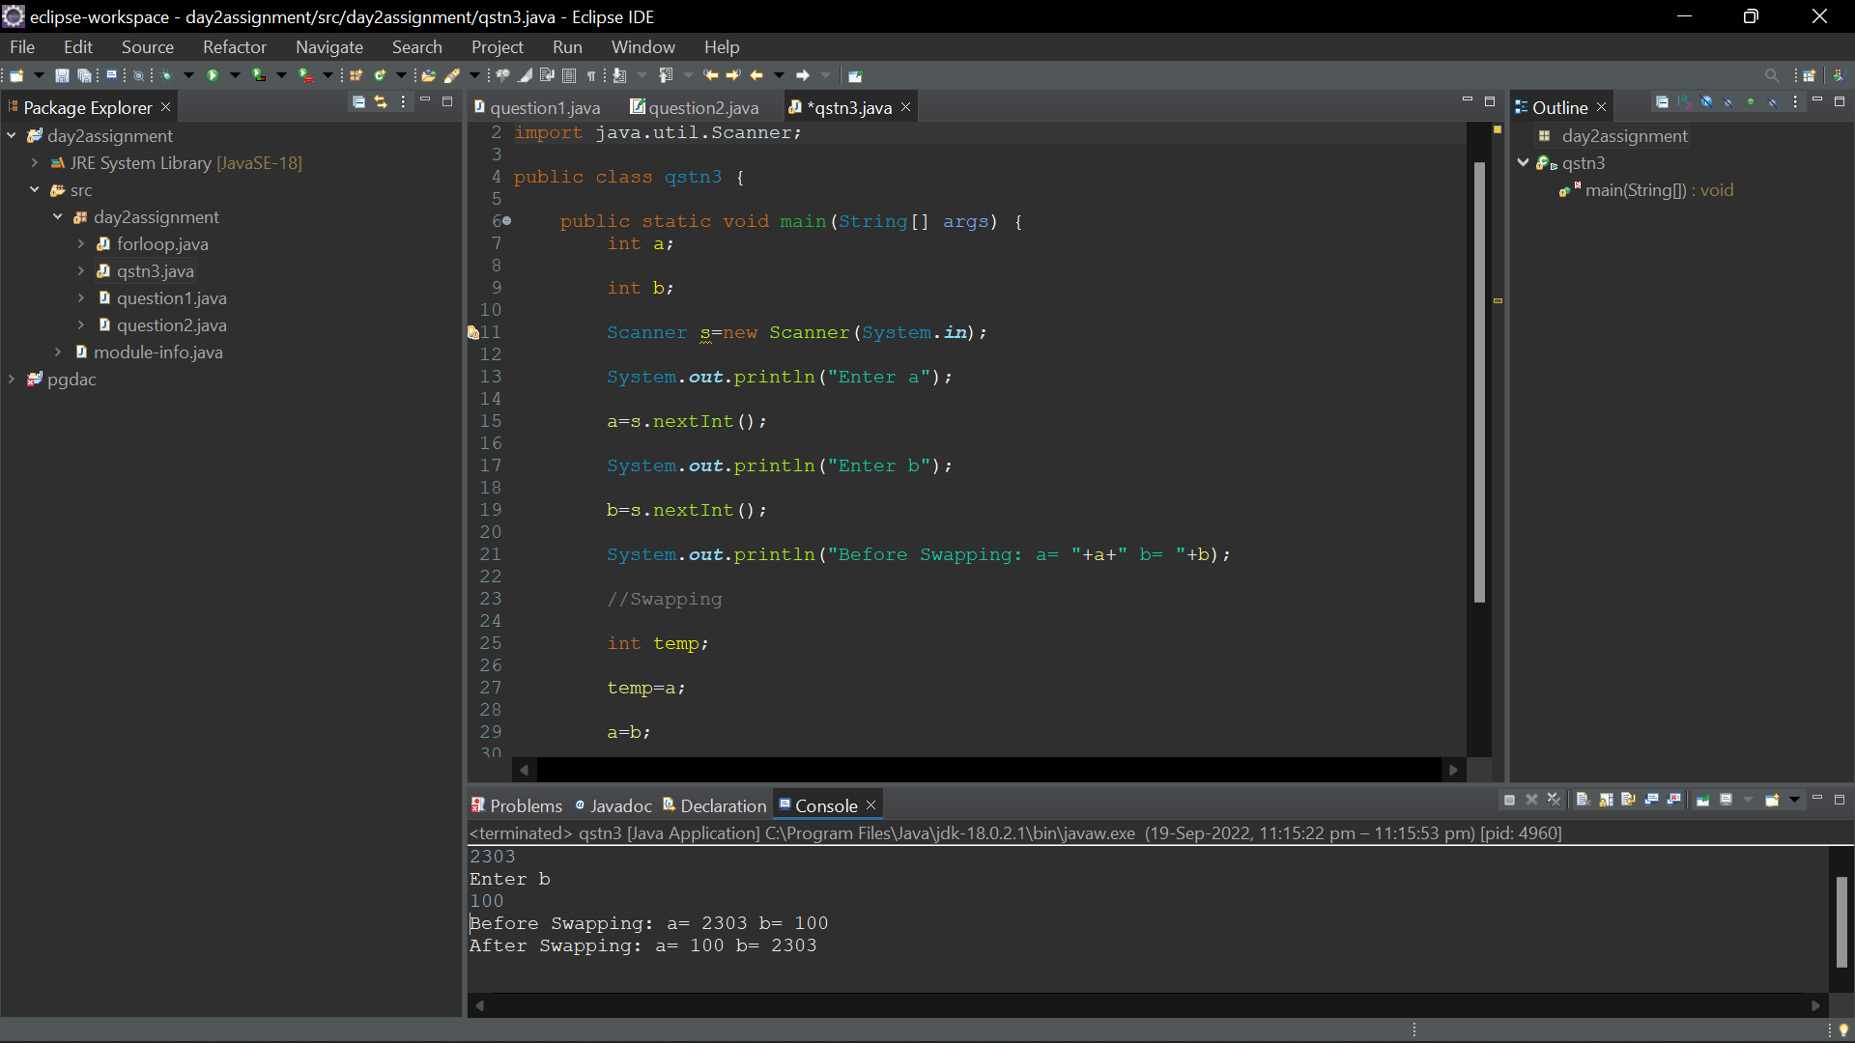

=================================================================================================================

**//Q4 Check if given number is Even or Odd**

package day2assignment;

import java.util.Scanner;

public class qstn4 {

public static void main(String[] args) {

int n;

System.***out***.println("Enter any number\n ");

Scanner r=new Scanner(System.***in***);

n=r.nextInt();

if(n%2==0)

{

System.***out***.println("Even Number ");

}

else

{

System.***out***.println("Odd Number ");

}

}

}

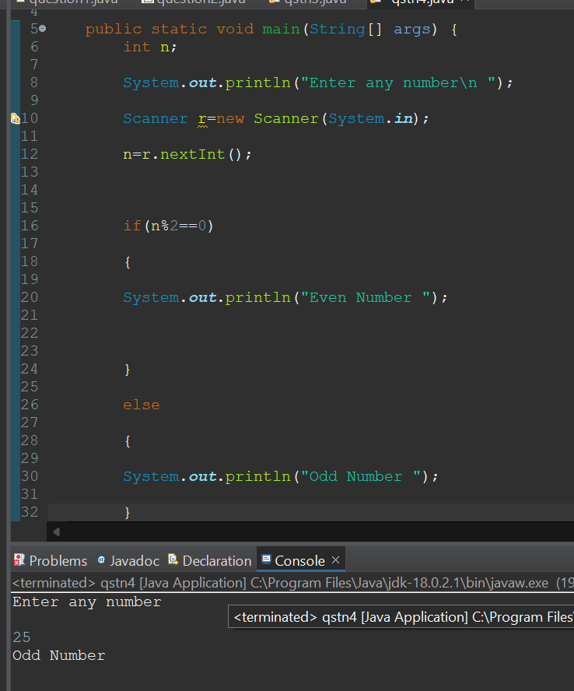

========================================================================================================

**Q 5 wap to check from three given number  that whether a number is greater**

**than or equal to 20 and less than other numbers .print appropriate message .**

package day2assignment;

public class qstn5 {

public static void main(String[] args) {

int a= 30;

int b=45;

int c=19;

System.***out***.println("Given numbers are a="+a +"b=" +b +"c="+c);

if(a>=20 && a<b && a<c) {

System.***out***.println("Given number is greater than 20");

}

else {

System.***out***.println("Given numen is less than 20");

}

}

}

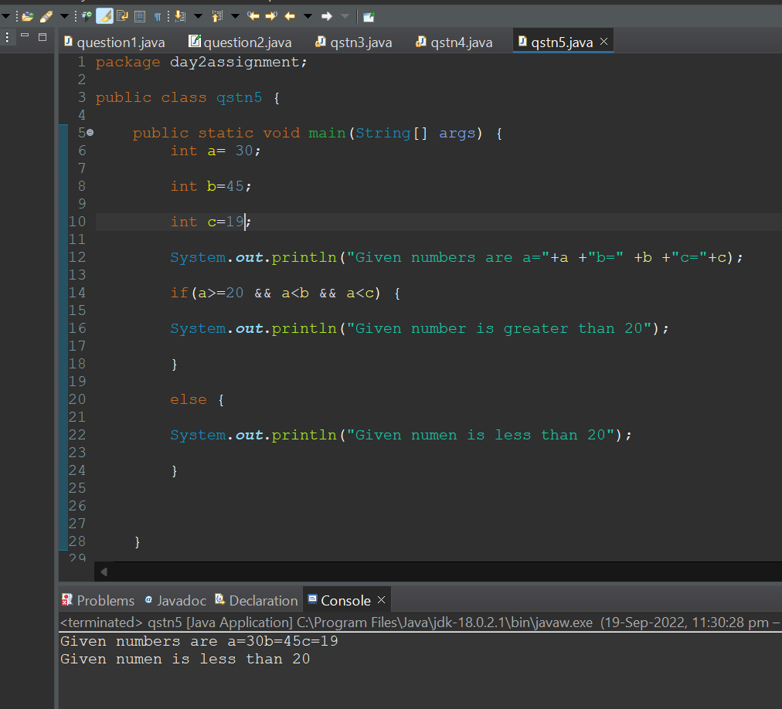

============================================================================================

**Q 7 wap to check if sales of a person is greater than 10000 then eligible for bonus**

**else not eligible calculate bonus as 20% of sales .**

package day2assignment;

import java.util.Scanner;

public class qstn7 {

public static void main(String[] args) {

float sales;

float bonus;

System.***out***.println("Enter the Sales\n ");

Scanner r=new Scanner(System.***in***);

sales= r.nextInt();

if(sales>1000)

{

System.***out***.println("Eligible for bonus of 20 %\n");

bonus= (sales*20/100);

System.***out***.println("\nbonus "+bonus);

}

else

{

System.***out***.println("Not Eligible for Bonus");

}

}

}

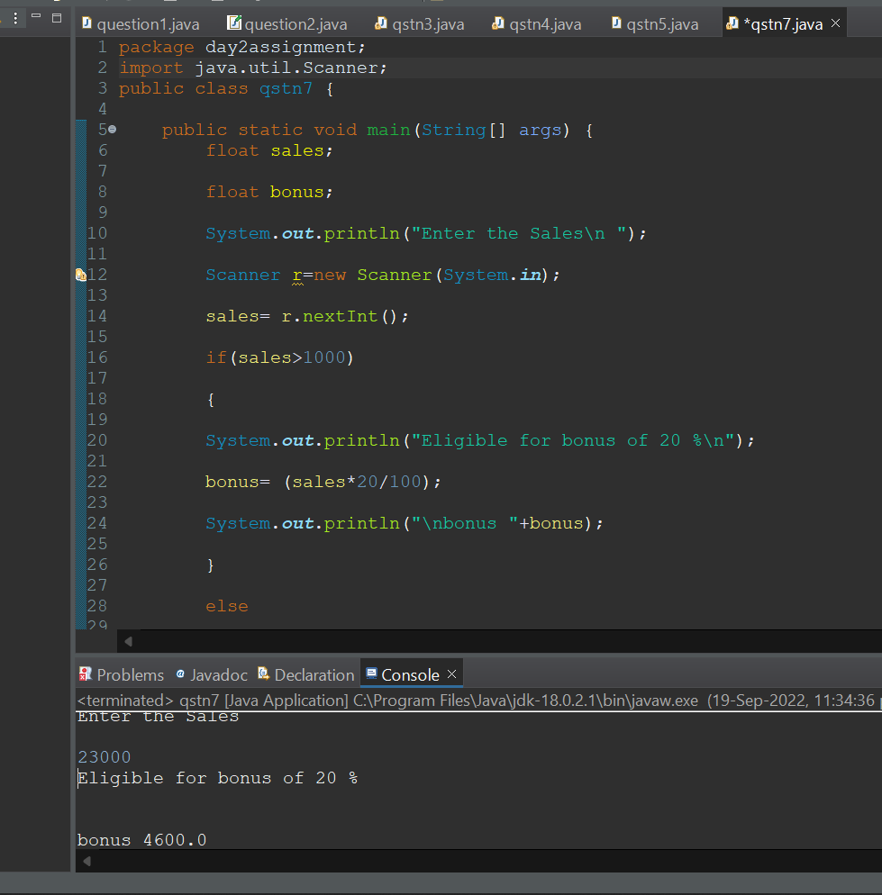

**=============================================================================================**

**Q 8 wap to check if two given integer value is in range of 18 and 100 print eligible for voting else not eligible .**

package day2assignment;

import java.util.Scanner;

public class qstn8 {

public static void main(String[] args)

{

int n;

System.***out***.println("Enter Age\n");

Scanner r=new Scanner(System.***in***);

n=r.nextInt();

if(n<100 && n>18 )

{

System.***out***.println("Eligible for Voting\n");

}

else

{

System.***out***.println("Not Eligible\n");

}

}

}

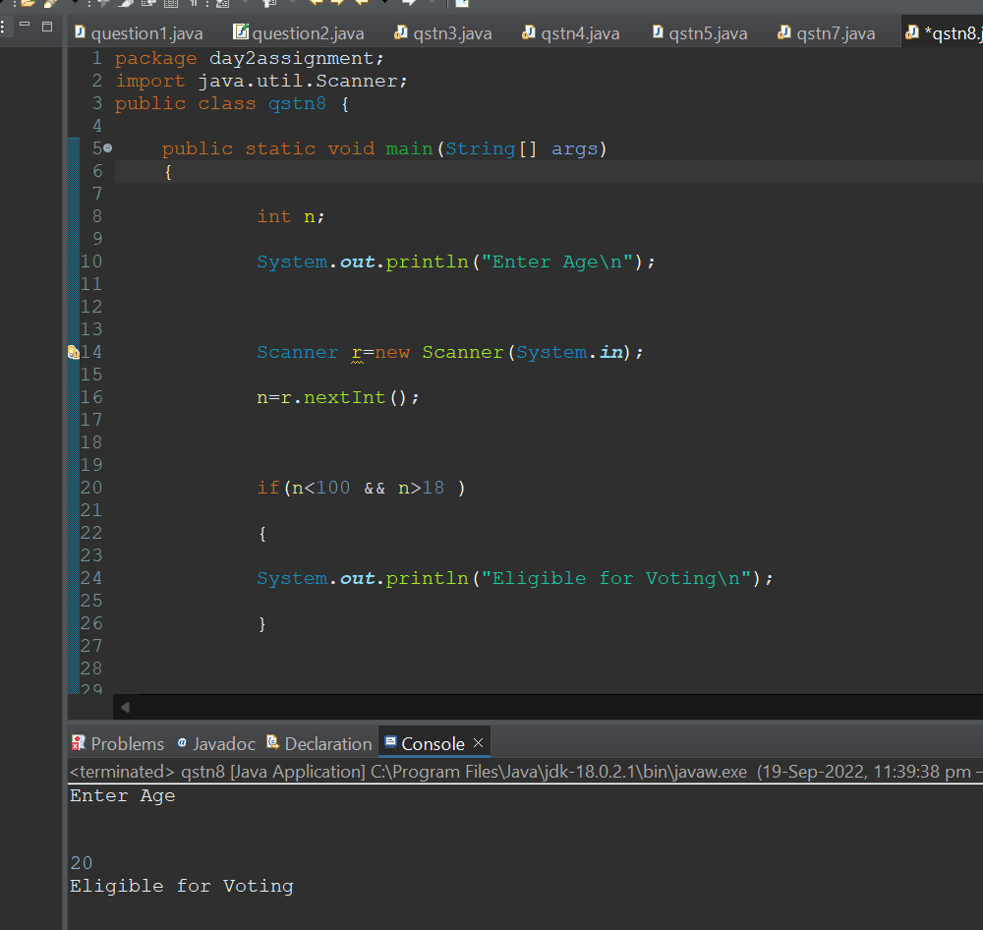

**====================================================================================================**

**Q 9 wap to print average of  given five subjects marks of student and check if average >=40 print Pass else print fail**

package day2assignment;

import java.util.Scanner;

public class qstn9 {

public static void main(String[] args) {

int a,b,c,d,e;

float avg;

Scanner input=new Scanner(System.***in***);

System.***out***.println("Enter maths Marks \n");

a=input.nextInt();

System.***out***.println("Enter english Marks \n");

b=input.nextInt();

System.***out***.println("Enter hindi Marks \n");

c=input.nextInt();

System.***out***.println("Enter science Marks \n");

d=input.nextInt();

System.***out***.println("Enter computer Marks \n");

e=input.nextInt();

avg=a+b+c+d+e/5;

if(avg>=40)

{

System.***out***.println("Pass");

}

else

{

System.***out***.println("Fail");

}

}

}

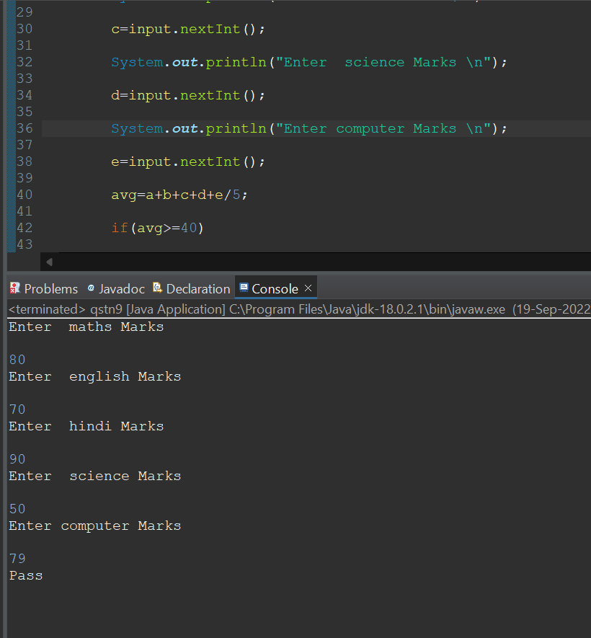

======================================================================================

**Q10 WAP to ask name ,age and salary of an employee and print on console.**

package day2assignment;

import java.util.Scanner;

public class qstn10 {

public static void main(String[] args) {

float salary,age;

char name;

Scanner r=new Scanner(System.***in***);

System.***out***.println("Enter Name\n");

name=r.next().charAt(0);

System.***out***.println("Enter Age \n");

age=r.nextFloat();

System.***out***.println("Enter Salary \n ");

salary=r.nextFloat();

}

}

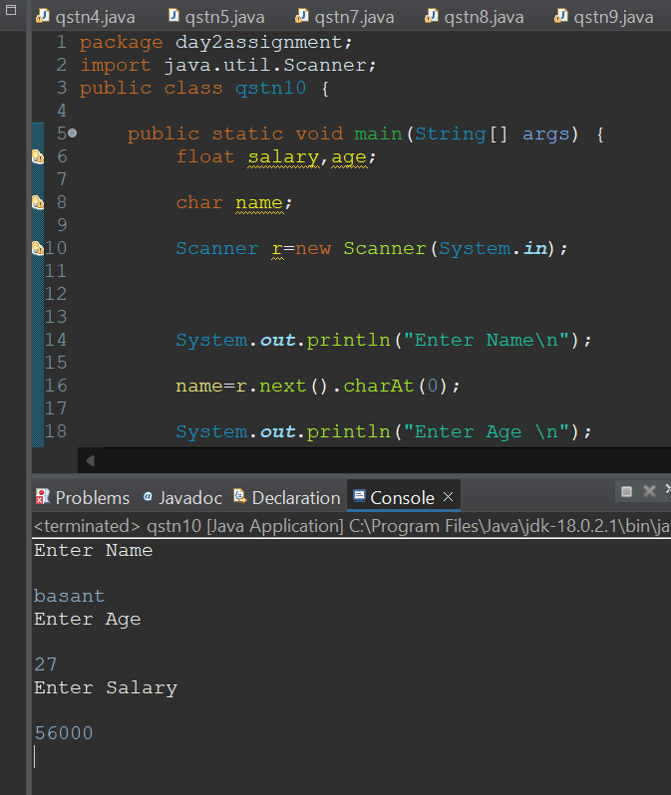

**===================================================================**

**Q 11 wap  that ask two numbers from user and print greater number among two**

package day2assignment;

import java.util.Scanner;

public class qstn11 {

public static void main(String[] args) {

int a, b;

System.***out***.println("Enter two number");

Scanner r=new Scanner(System.***in***);

a=r.nextInt();

b=r.nextInt();

if(a>b)

{

System.***out***.println("a is greater");

}

else

{

System.***out***.println("b is greater");

}

}

}

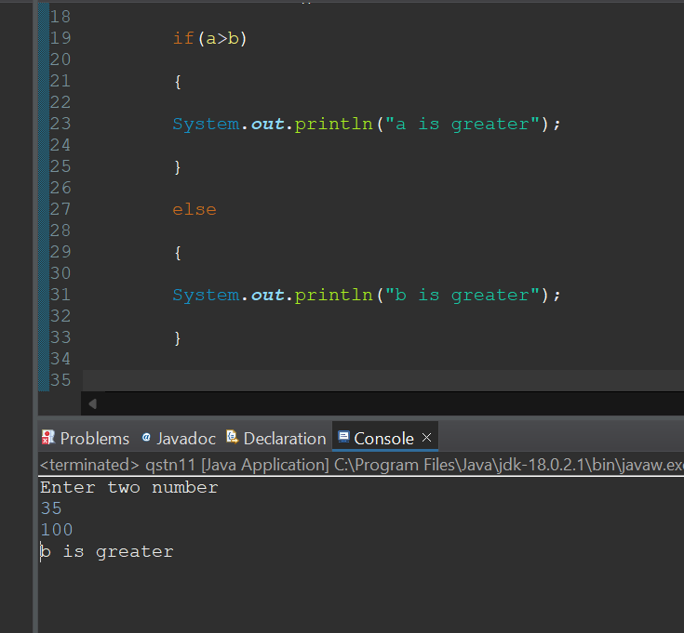

==============================================================================================

**Q 12  wap to ask product name and price of product from user and calculate discount i.e**

**if price > 2000 then discount is 10 percent of price**

**else discount is 7 % of price**

 package day2assignment;

import java.util.Scanner;

public class qstn12 {

public static void main(String[] args) {

char productname;

float productprice,discount;

Scanner r=new Scanner(System.***in***);

System.***out***.println("Enter product name");

productname=r.next().charAt(0);

System.***out***.println("Enter product price");

productprice=r.nextFloat();

if(productprice>2000)

{

discount= productprice*10/100;

System.***out***.println("\n discount = "+discount);

}

else

{

discount=productprice*7/100;

System.***out***.println("\ndiscount = "+discount);

}

}

}

