**Name -BASANT POKHREL**

**ASSIGNMENT**

**AGILE METHODOLOGY : JIRA TOOL**

**Create the project for any web application example using agile**

**methodology (SCRUM TEMPLATE).**

**(6 ISSUES)&gt;&gt;&gt;&gt; 4 STORY  , 1 TASK, BUG**

**I. Create components**

**II. Plan the version with release dates**

**III.Create sprint backlog, start sprint and complete sprint**

**IV.Create different types of issues in the backlog.**

**-Epic –provide epic link also**

**- Story**

**Initialize story point, Associate with Version, component**

**---**

**Divide into sub-tasks :::::Give estimate time**

**Give time log work and comment it as well. -Clone**

**the story.**

**-task**

**-bug - Link with issues story**

**View workflows also.**

**V. Evaluate burn down, burn up, analyse the sprint report and**

**velocity charts.**

**Submit the screen shoots of Backlog, burn down, burn up, sprint**

**report and velocity charts for the sprint.(From your login only)**

I. Create Component

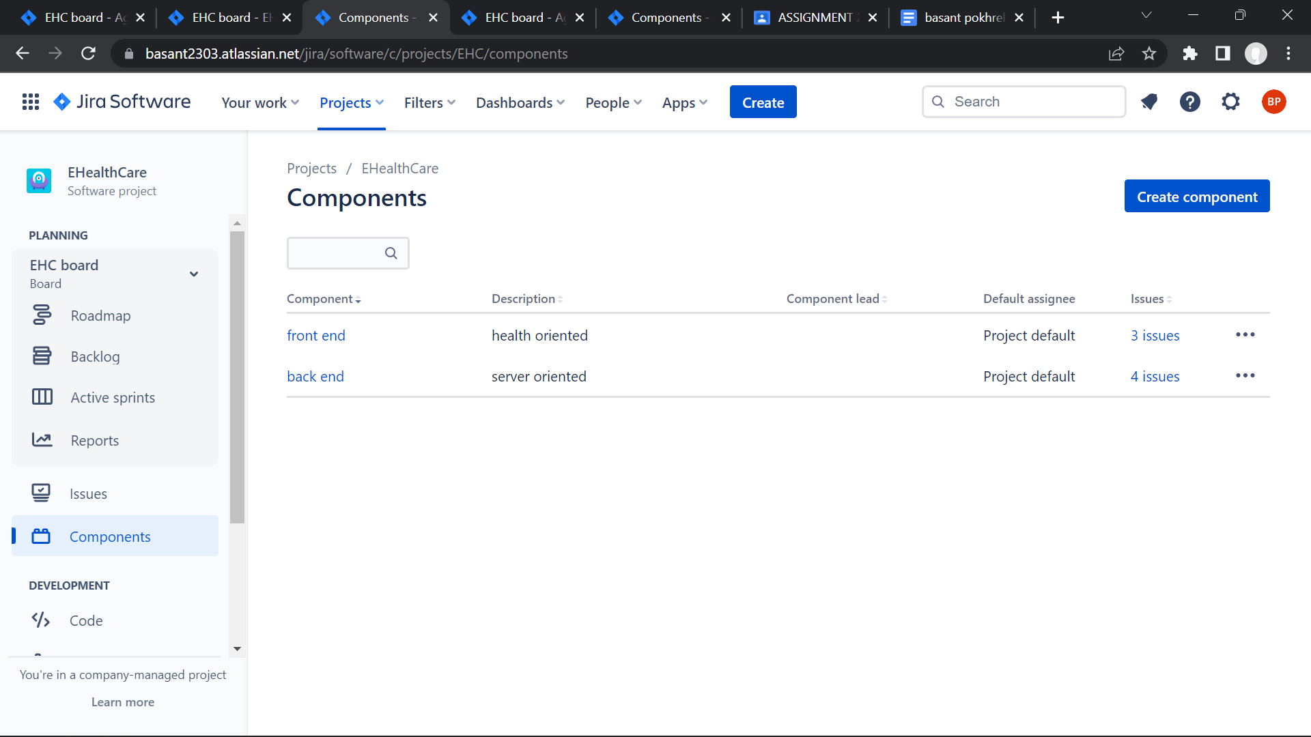

==================================================================================================================================================

II. Plan the version with release dates

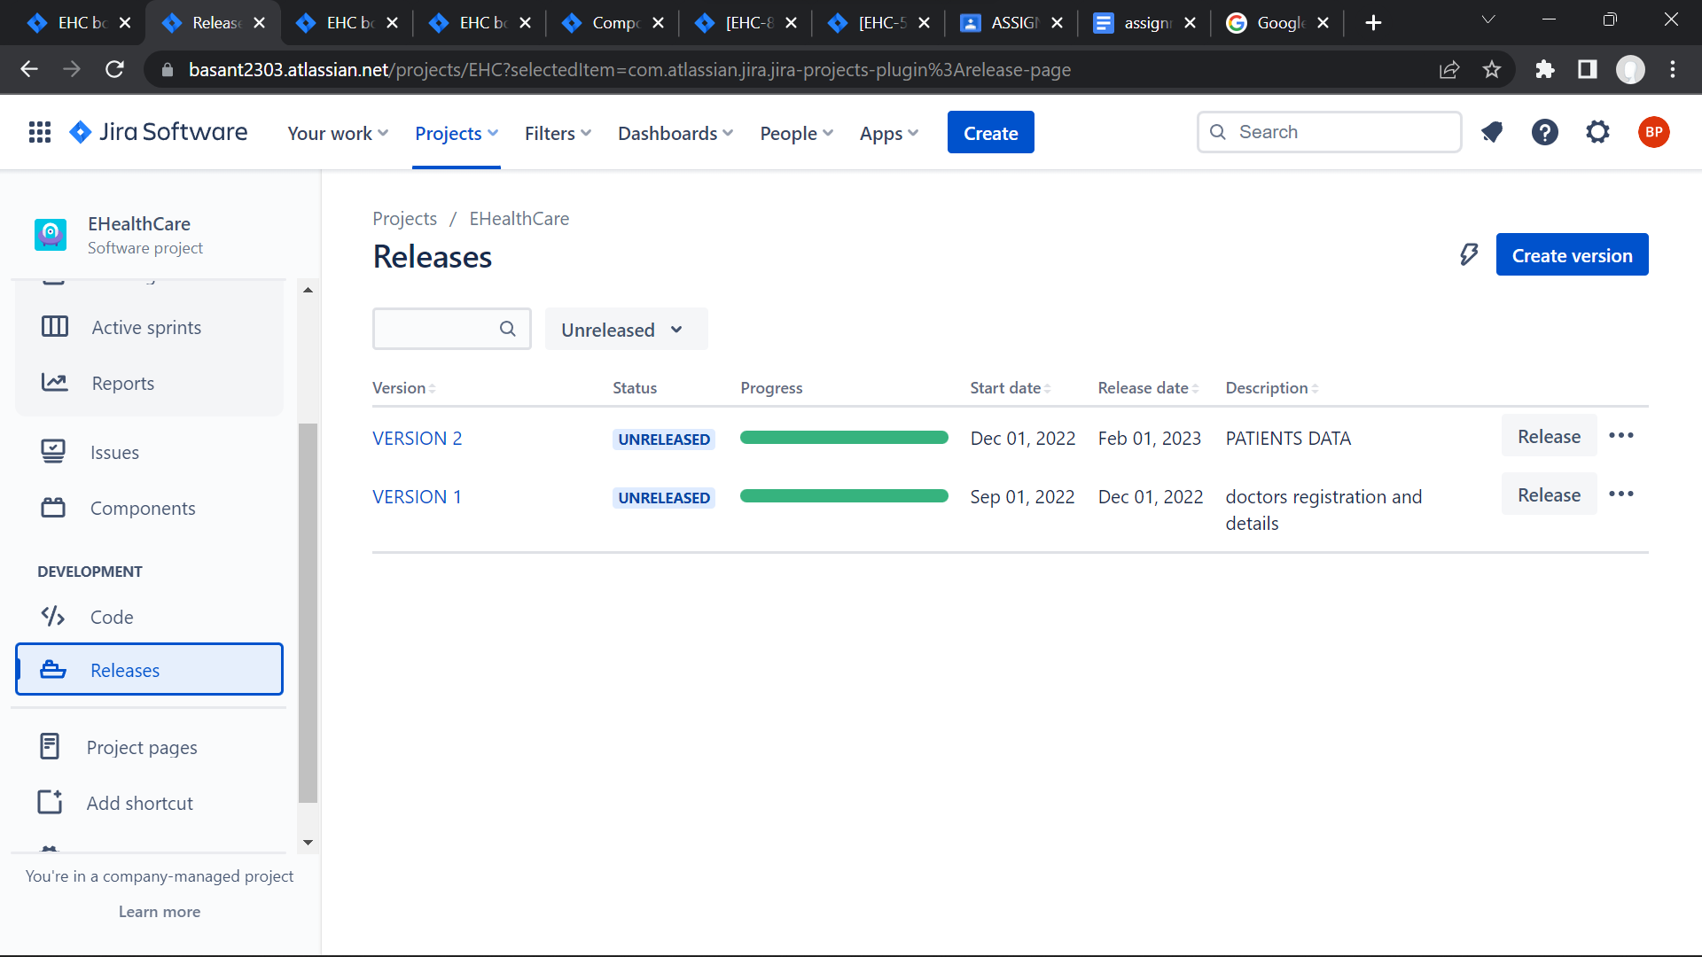

III.Create sprint backlog, start sprint and complete sprint

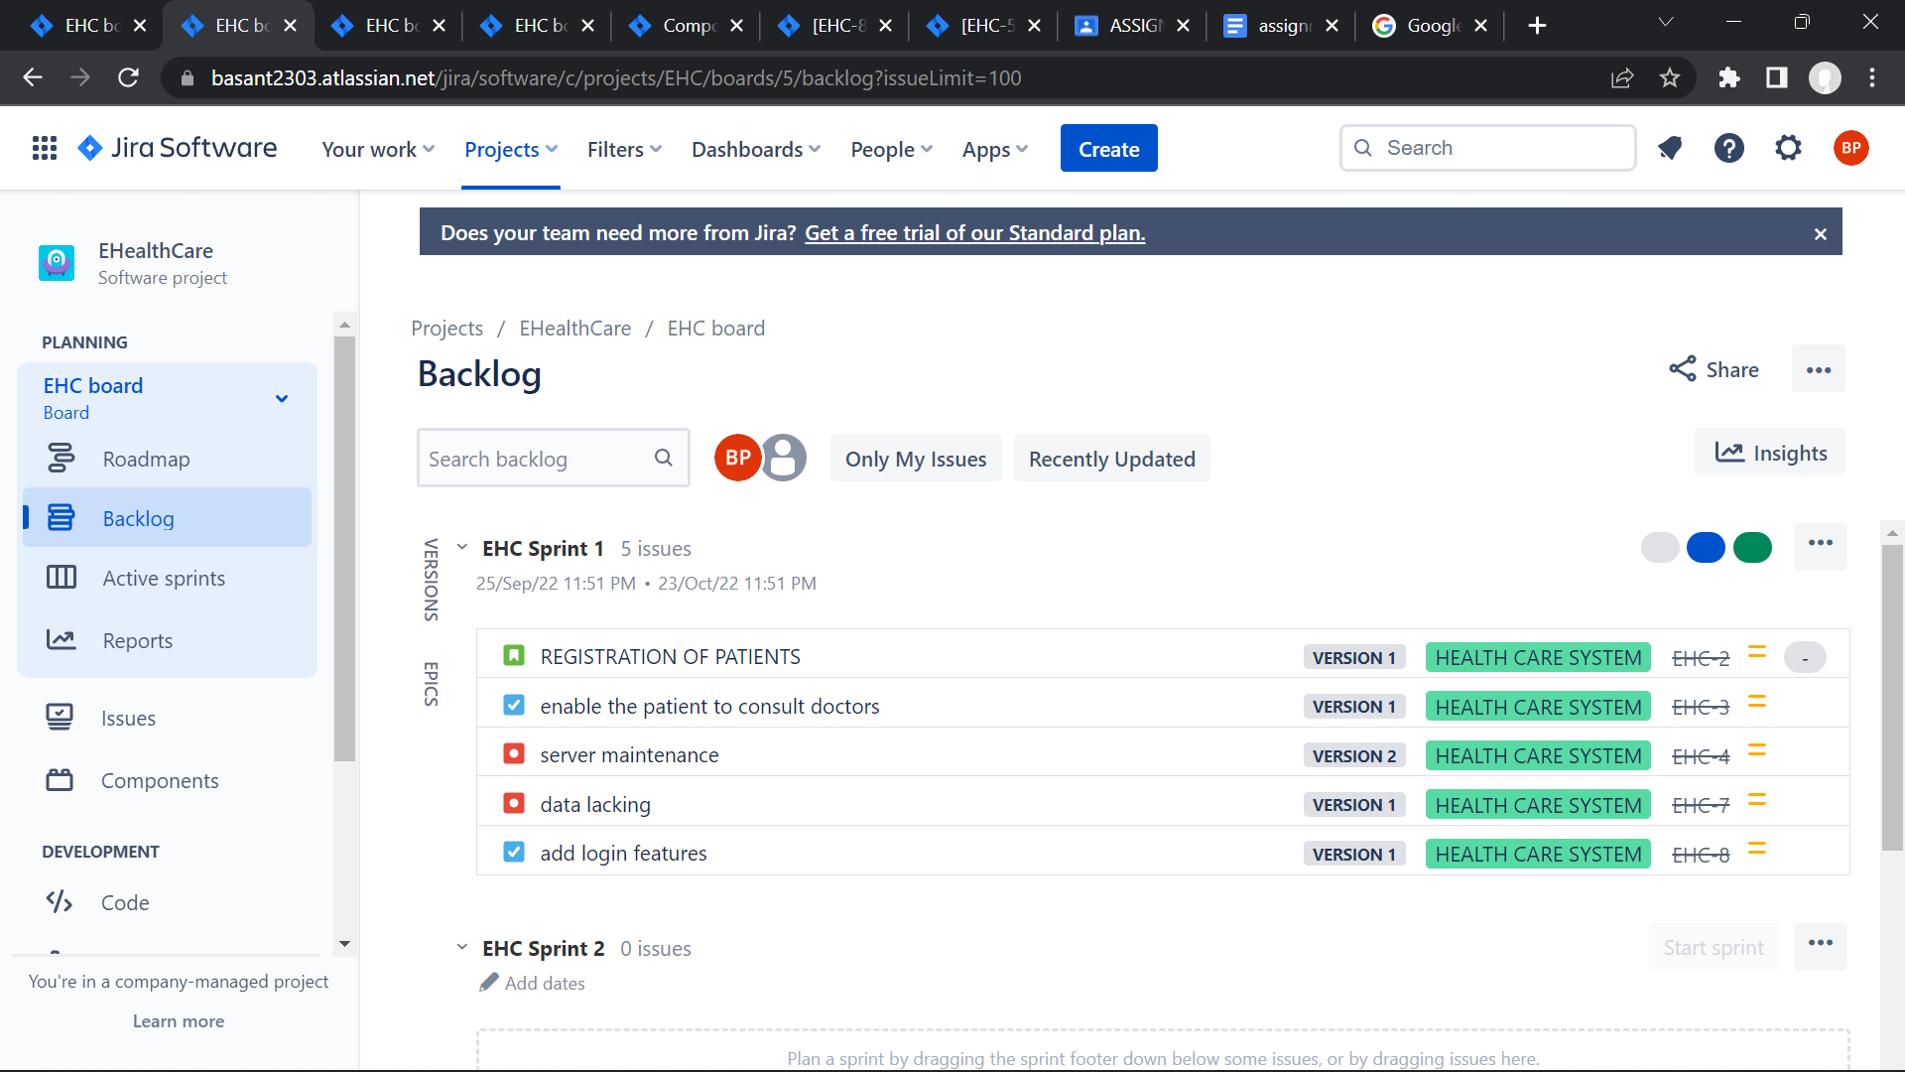 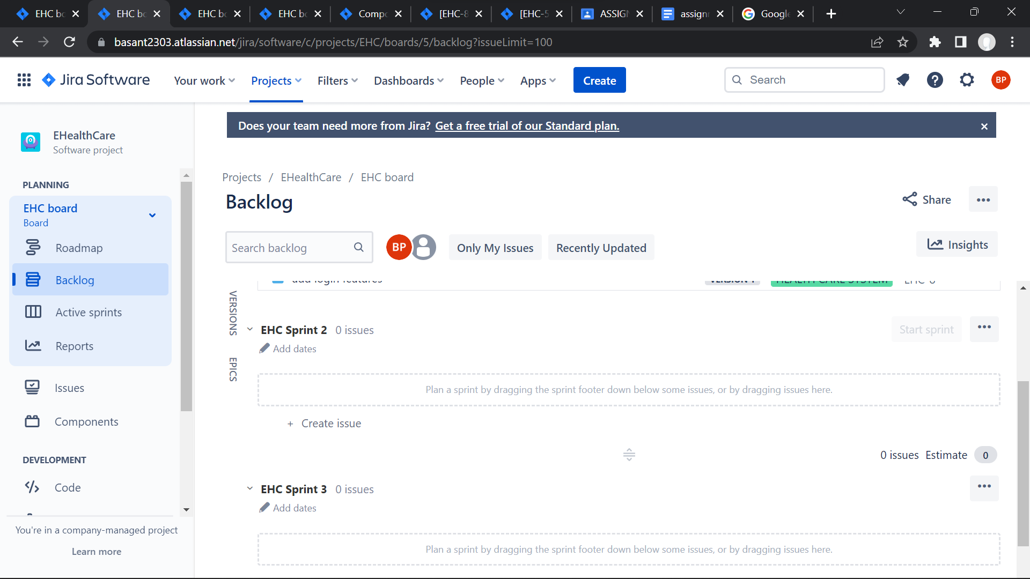

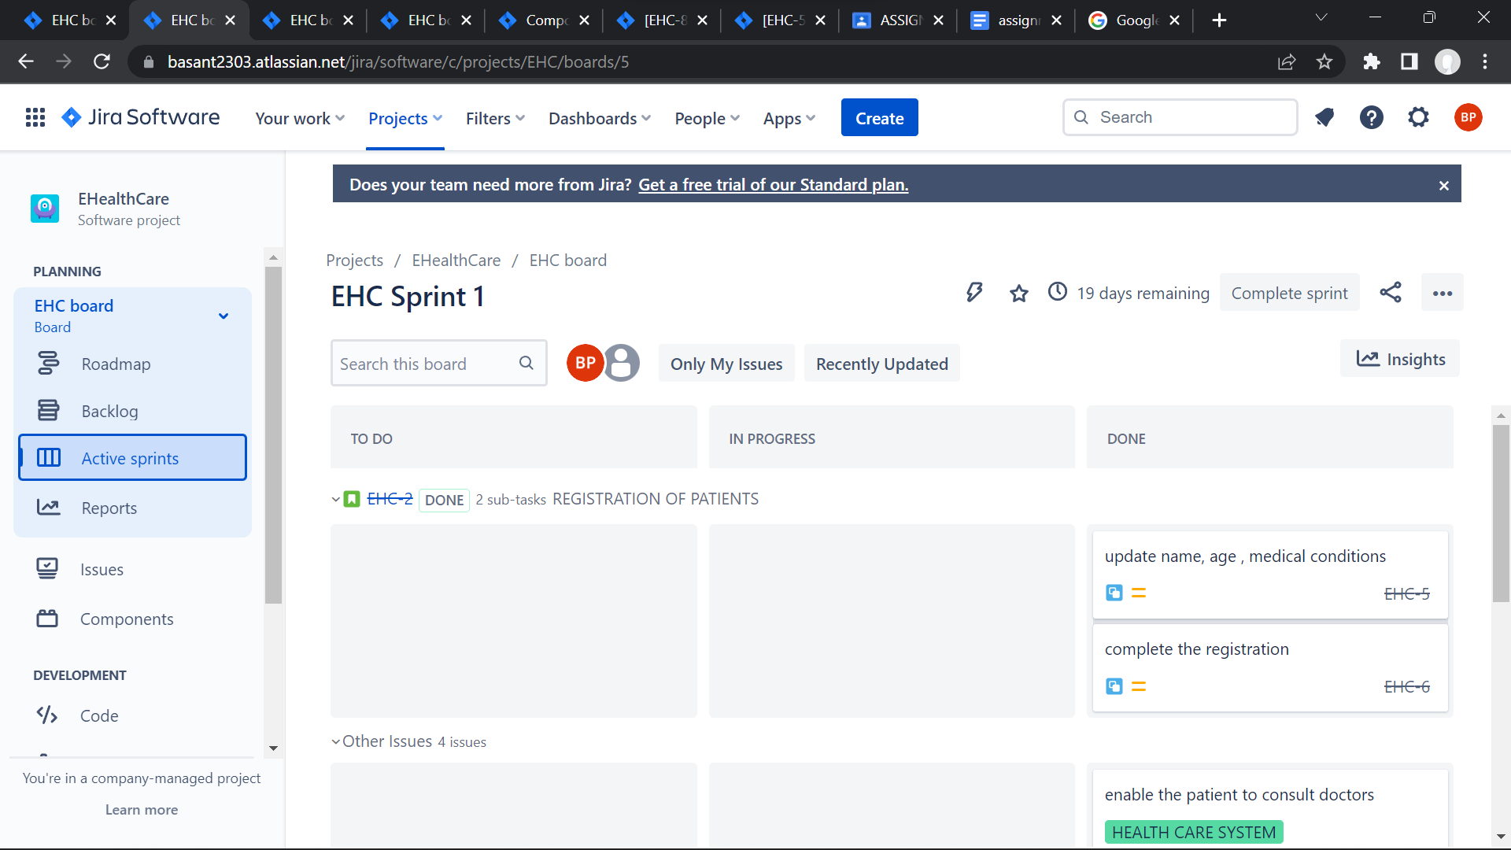

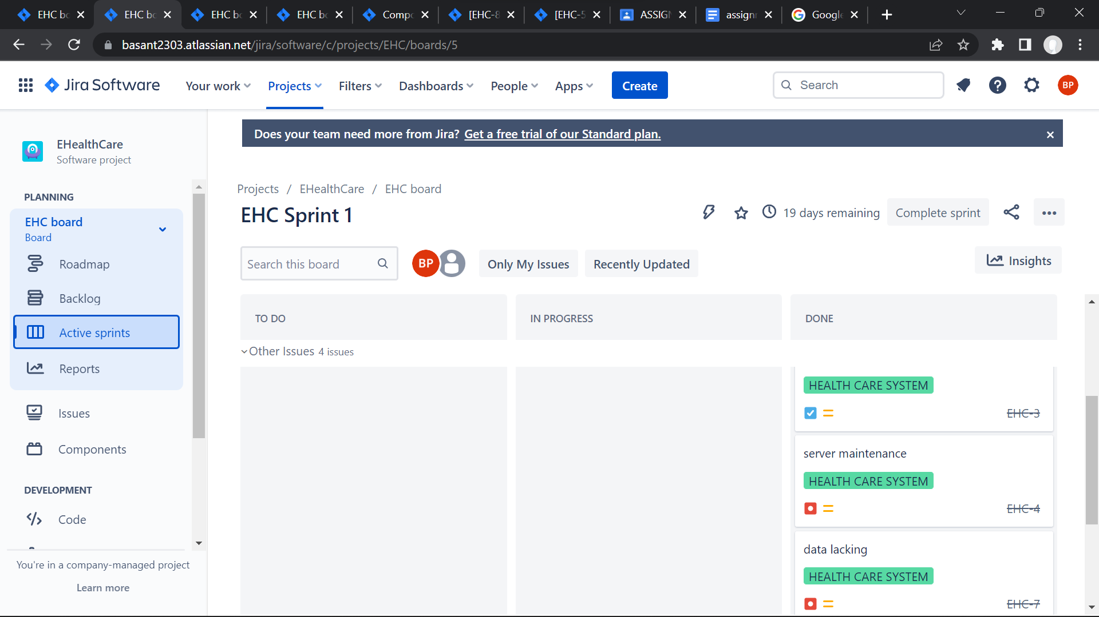

IV.Create different types of issues in the backlog.

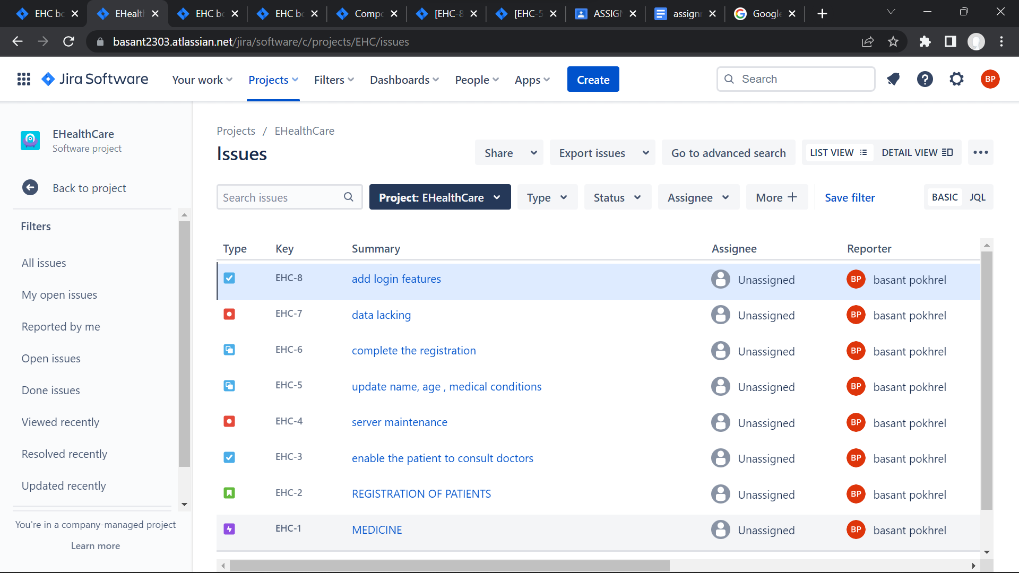

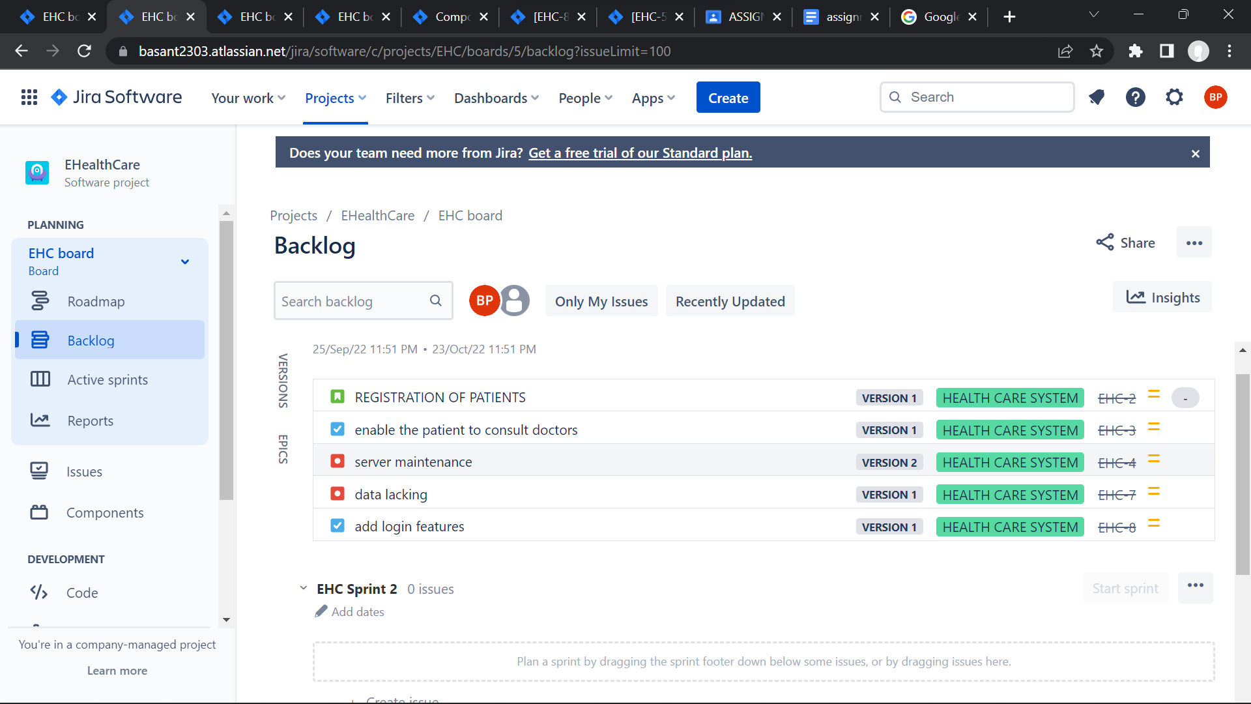

V. Evaluate burn down, burn up, analyse the sprint report and velocity charts.

