KNN

SMOTE

Distance 3 and Manhattan -- Smote

Distance 5 and Manhattan -- Smote

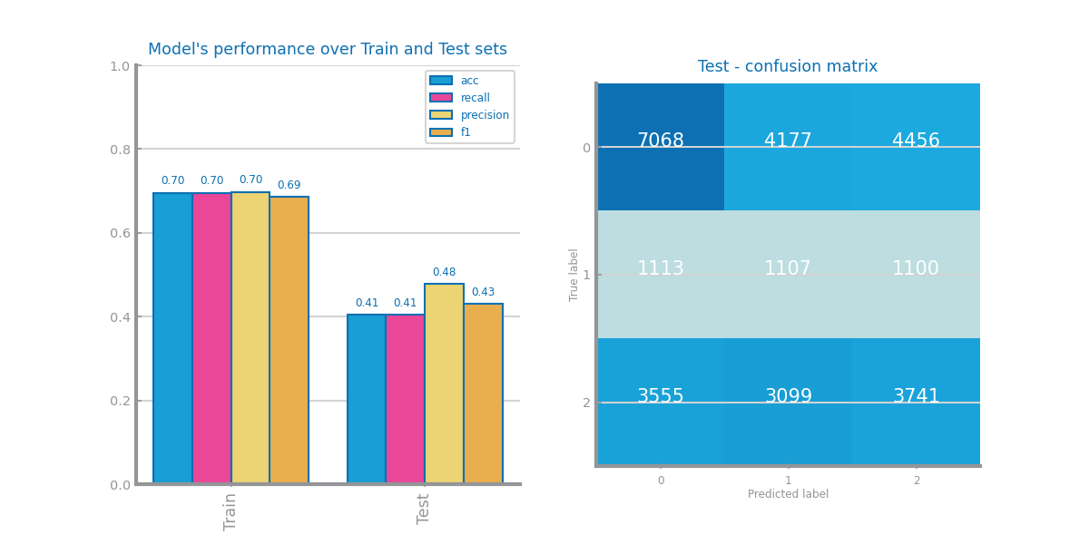

Distance17 and Manhattan -- Smote

UNDERSAMPLING

Distance 1 and Manhattan – Under

Distance 13 and Manhattan – Under

Distance 9 and Manhattan – Under

