SDM

Ouestion1:

Solution1:

**package** BASANT;

**import** org.openqa.selenium.By;

**import** org.openqa.selenium.WebElement;

**import** org.openqa.selenium.chrome.ChromeDriver;

**public** **class** Program1 {

ChromeDriver driver;

**public** **void** open()

{

System.*setProperty*("webdriver.chrome.drive","C:\\Users\\rkshn\\Advanced_java\\Libraries\\chromedriver_win32\\chromedriver.exe");

driver = **new** ChromeDriver();

driver.get("https://in.pinterest.com/"); // to open link

driver.manage().window().maximize();

}

**public** **void** signIn()

{

driver.findElement(By.*xpath*("//input[@id='email']")).sendKeys("chaudashi@gmail.com");

driver.findElement(By.*cssSelector*("#password")).sendKeys("Basant7@");

driver.findElement(By.*cssSelector*("button[type='submit']")).click();

}

**public** **void** map()

{

driver.get("https://www.google.com/maps");

driver.manage().window().maximize();

driver.findElement(By.*xpath*("//input[@id='searchinput']")).sendKeys("cdac");

driver.findElement(By.*xpath*("//button[@id='searchbox-searchbutton']")).click();

**try** {

Thread.*sleep*(8000);

}**catch**(InterruptedException e)

{

e.printStackTrace();

}

}

**public** **static** **void** main(String[] args) {

Program1 p = **new** Program1();

p.open();

p.signIn();

p.map();

}

}

Question2:

Solution2:

class Linkedlist{

Node head;

class Node{

    int data;

    Node next;

    Node(int d)

    {

        data =d;

        next=null;

    }

}

public static Linkedlist insert (Linkedlist list, int data)

{

    Node new_node= new Node(data);

    if(list.head==null)

    {

        list.head=new_node;

    }

    else{

        Node last=list.head;

        while(last.next!=null)

        {

            last=last.next;

        }

        last.next = new_node;

    }

    return list;

}

public static void print(Linkedlist list)

{

    Node currNode=list.head;

    System.out.print("Linkedlist: ");

    while(currNode !=null)

    {

        System.out.print(currNode.data+" ");

        currNode = currNode.next;

    }

}

public static void main(String args[])

{

    Linkedlist list= new Linkedlist();

    list=insert(list,1);

    list=insert(list,2);

    list=insert(list,3);

    list=insert(list,4);

     print(list);

}

}

File :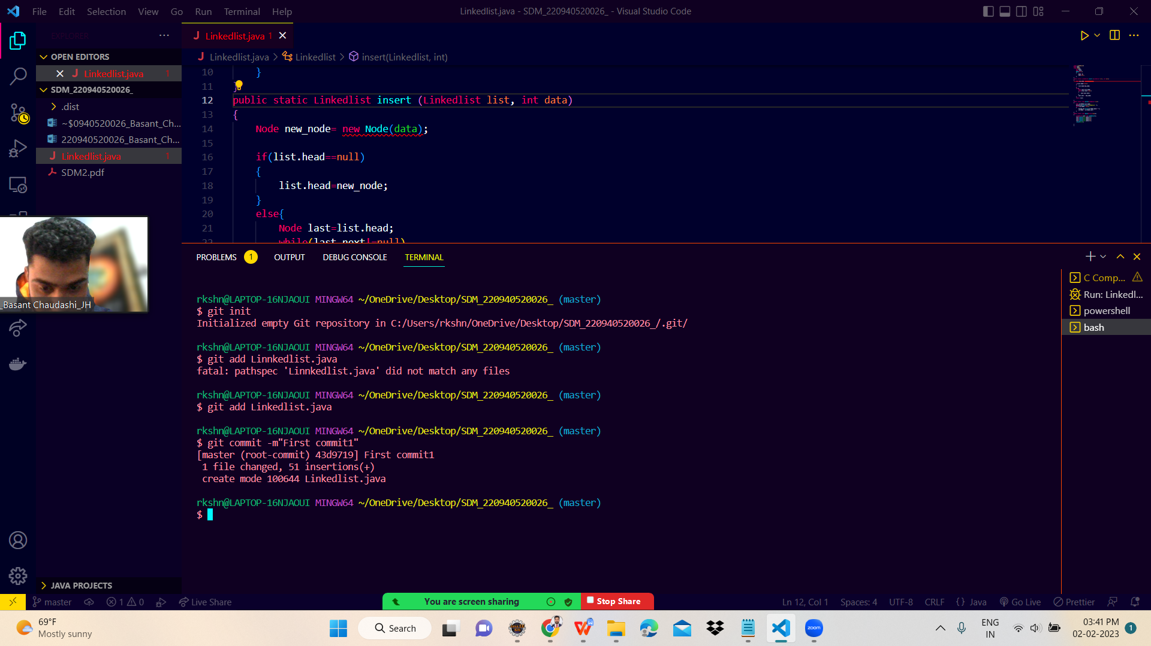

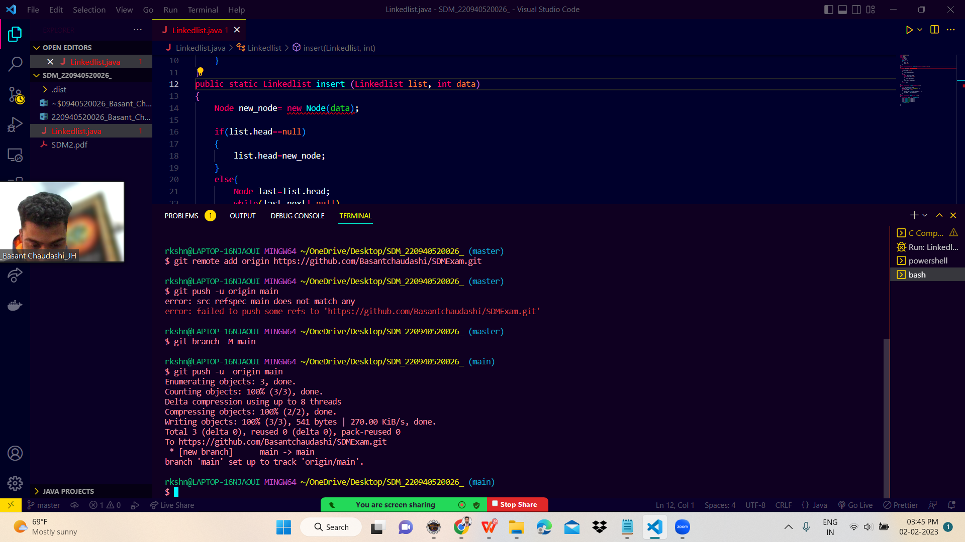

Branches: